Stachyose improves the anti-diabetic effects of berberine by regulating intestinal microbiota and SCFAs in spontaneous type 2 diabetic KKAy mice
Hui Cao†, Cai-Na Li†, *, Lei Lei, Xing Wang, Shuai-Nan Liu, Quan Liu, Yi Huan, Su-Juan Sun, Zhu-Fang Shen*

State Key Laboratory of Bioactive Substance and Function of Natural Medicines, Key laboratory of Polymorphic Drugs of Beijing, Institute of Materia Medica, Chinese Academy of Medical Sciences & Peking Union Medical College, Beijing, China

*Correspondence: Zhu-Fang Shen: shenzhf@imm.ac.cn; Cai-Na Li: leecaina@imm.ac.cn.
† Hui Cao and Cai-Na Li contributed equally to this work.

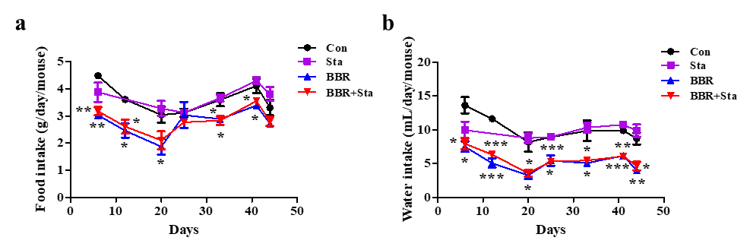
Figure S1 Effects of berberine with stachyose on food intake and water intake. (a). Food consumption. (b). Water consumption. Data are expressed as mean ± SEM (n=10-12). *p < 0.05, **p < 0.01, ***p < 0.001 vs. Con. Con, control; Sta, stachyose; BBR, berberine.

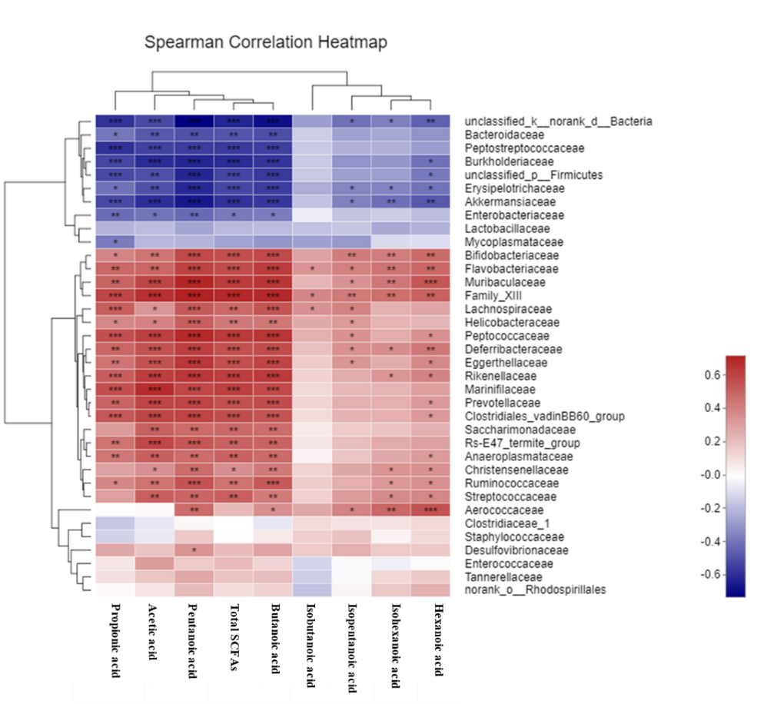
Figure S2 Correlation analysis of SCFAs and gut microbiota at the family level. R value was shown in different colors in the diagram. R and P values were obtained through Spearman’s rank correlation on the platform of Majorbio I-Sanger Cloud. The blue represents negative correlation, and red represents positive correlation. *p < 0.05, **p < 0.01, ***p < 0.001.

Table S1 Primer sequences for qRT-PCR
Gene | Primer sequence (5’—3’)
IL-1β | Forward: CCAGCTTCAAATCTCACAGCAG  Reverse: CTTCTTTGGGTATTGCTTGGGATC
IL-6 | Forward: ACAACGATGATGCACTTGCAGA  Reverse: GATGAATTGGATGGTCTTGGTC
IL-10 | Forward: TGGCCCAGAAATCAAGGAGC  Reverse: CAGCAGACTCAATACACACT
MCP-1 | Forward: CCCTAGAAGCTCACCAAGGC  Reverse: GGTCTAGCCTCAACACCACC
Muc2 | Forward: CCTGAAGACTGTCGTGCTGT  Reverse: GGGTAGGGTCACCTCCATCT
Muc3 | Forward: GCTGGCTTTCATCCTCCACT  Reverse: CCTCCATCCCACACACTTCC
Occludin | Forward: ATGTCCGGCCGATGCTCTC  Reverse: TTTGGCTGCTCTTGGGTCTGTAT
Reg3g | Forward: TTCCTGTCCTCCATGATCAAAA  Reverse: CATCCACCTCTGTTGGGTTCA
TLR4 | Forward: CGCTTTCACCTCTGCCTTCACTACAG  Reverse: ACACTACCACAATAACCTTCCGGCTC
TNF-α | Forward: CACAGAAAGCATGATCCGCGACGT  Reverse: CGGCAGAGAGGAGGTTGACTTTCT
ZO-1 | Forward: ACCCGAAACTGATGCTGTGGATAG  Reverse: AAATGGCCGGGCAGAACTTGTGTA
β-actin | Forward: TGTGATGGTGGGAATGGGTCAG  Reverse: TTTGATGTCACGCACGATTTCC

