Supplementary Materials
The impact of biosolids biochar on biomethane production from the anaerobic digestion of chicken manure
By Soulayma Hassan et al.
A- Change in TAN (mg L ⁻¹) and TAN Reduction (%) equations
Change in TAN (mg L⁻¹) = TAN at day 18 (mg L⁻¹) – TAN at day 0 (mg L⁻¹)
TAN Reduction (%) = [(TAN _{control} at day 18 – TAN _{biochar treatments} at day 18)/ TAN _{control} at day 18] x100

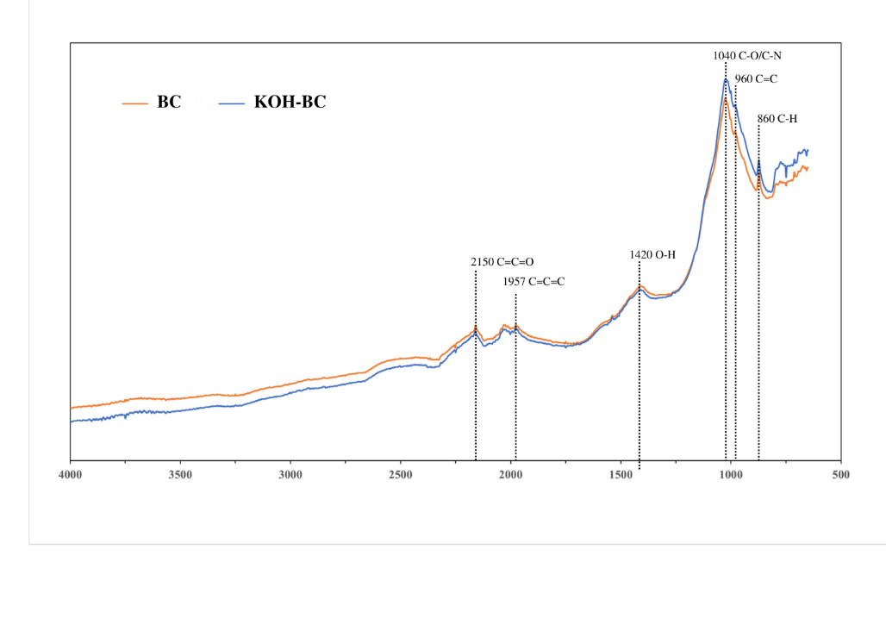
Supplementary Figures
B. Fourier Transformed Infrared (FTIR) spectra of biosolids biochar (BC) and modified biochar (KOH-BC).

Supplementary Tables
C. The main surface functional groups of biosolids biochar (BC) and modified biochar (KOH-BC) identified from FTIR spectra
Waveband (cm⁻¹) | Functional group
2150 | C=C=O stretching
1900-2000 | C=C=C stretching
1330-1420 | O-H bending
1040-1050 | CO-O-CO stretching
1020-1250 | C-N stretching
960-980 | C=C bending
860-900 | C-H bending

