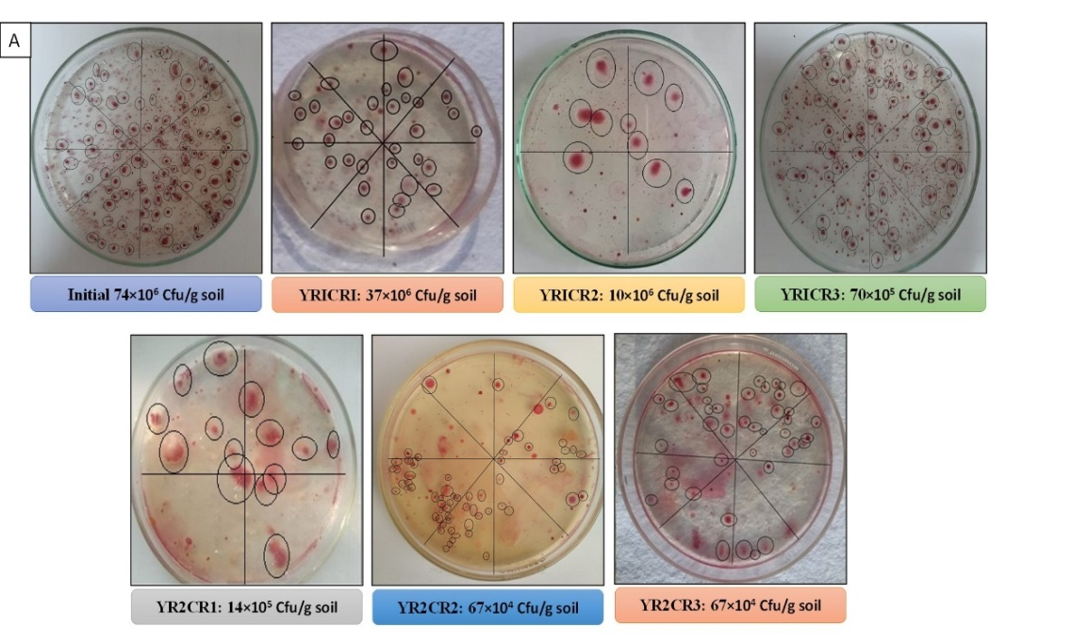
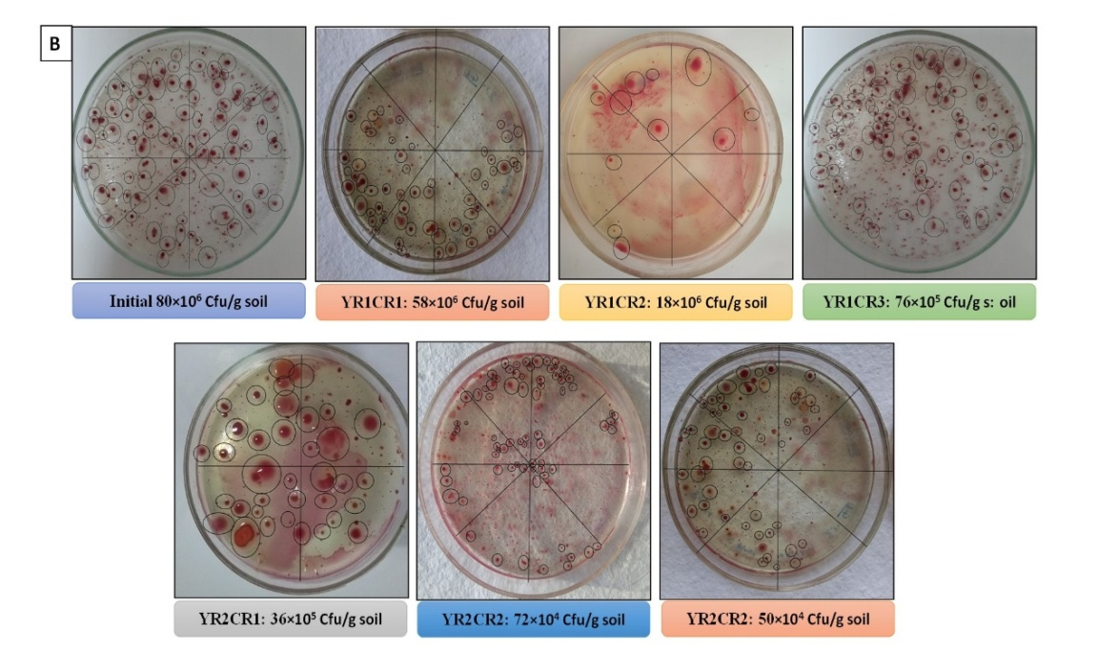
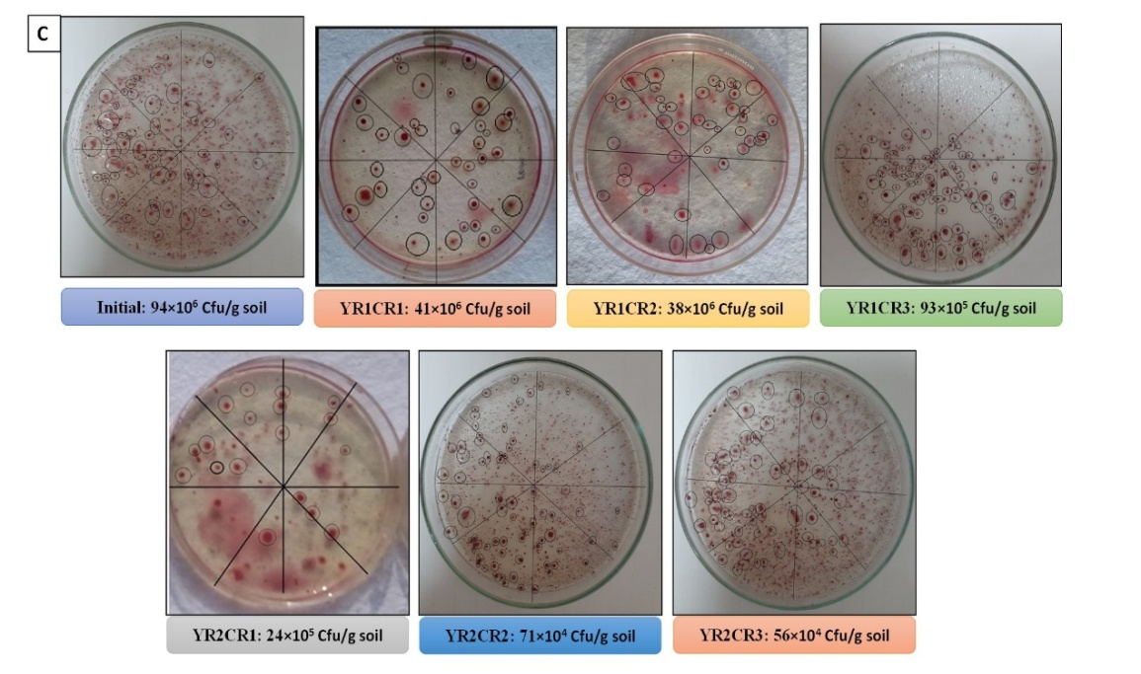

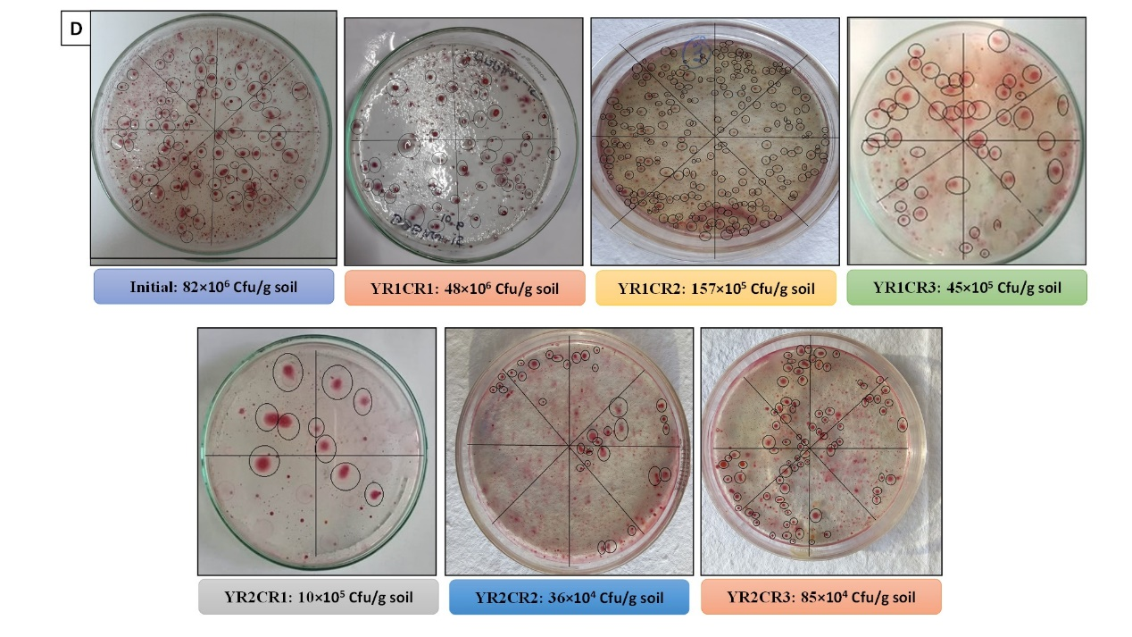
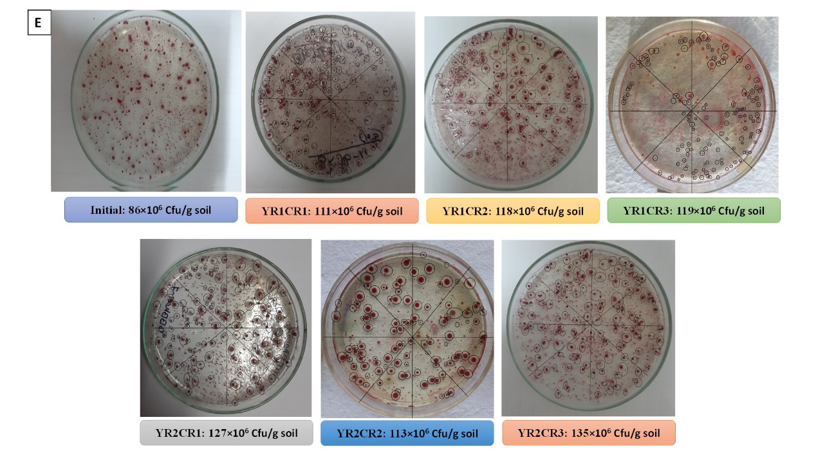

Supplementary figure 1. Glimpses of change in culturable population of R. solanacearum under different crop rotation systems, A: P1 (MMB), B: P2 (MOB), C: P6 (OMB), D: P20 (SMB) and E: P28 (BBB).

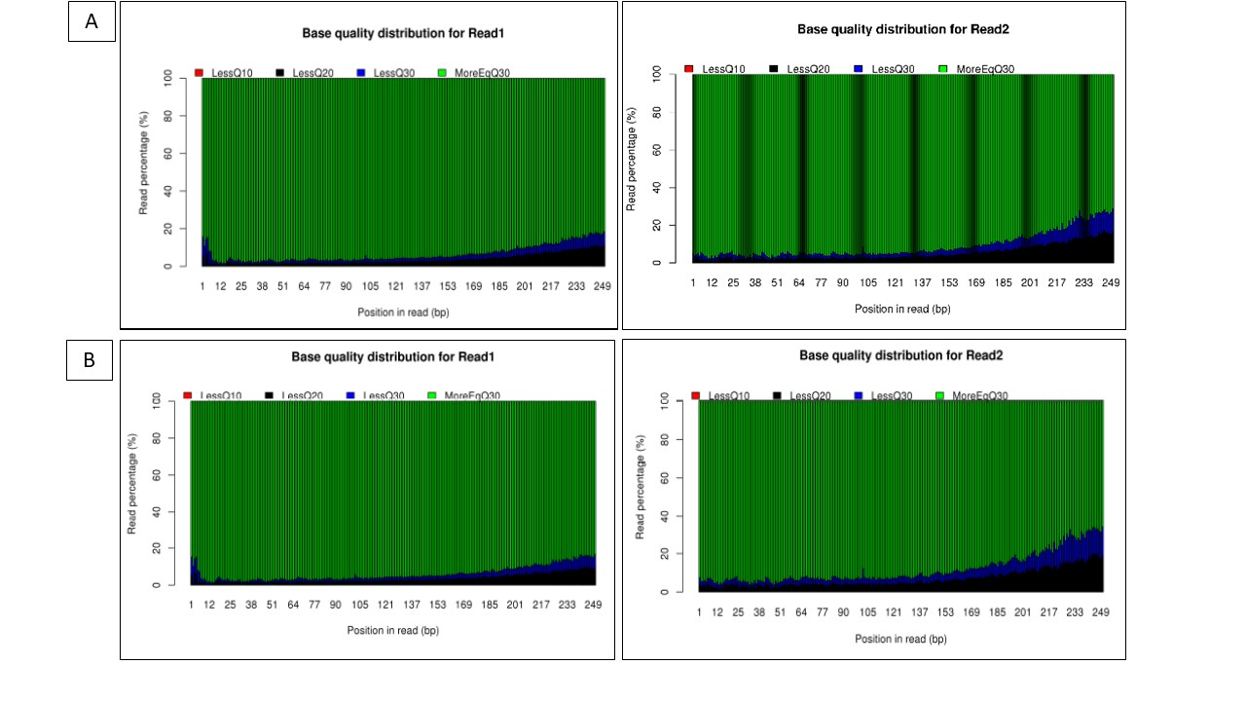
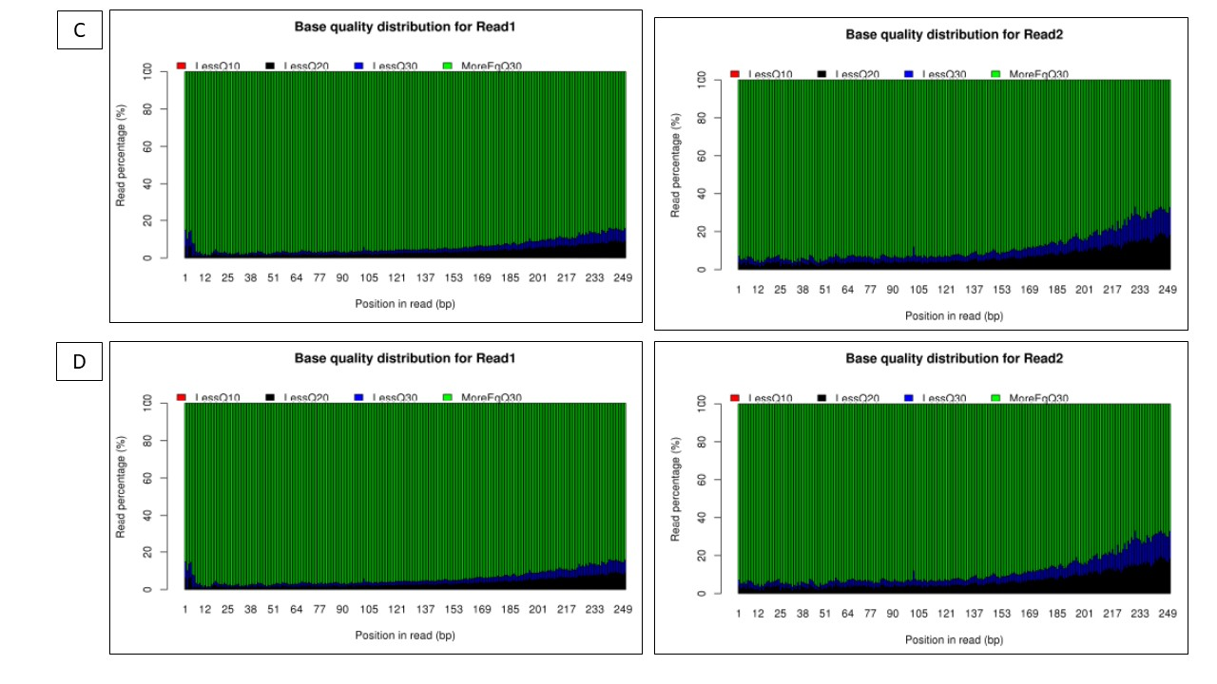

Supplementary figure 2. Graphs representing base quality distribution of A: P-1 (MMB), B: P-6 (OOB), C: P-20 (SMB) and D: P-28 (BBB) in YR2CR3 cropping

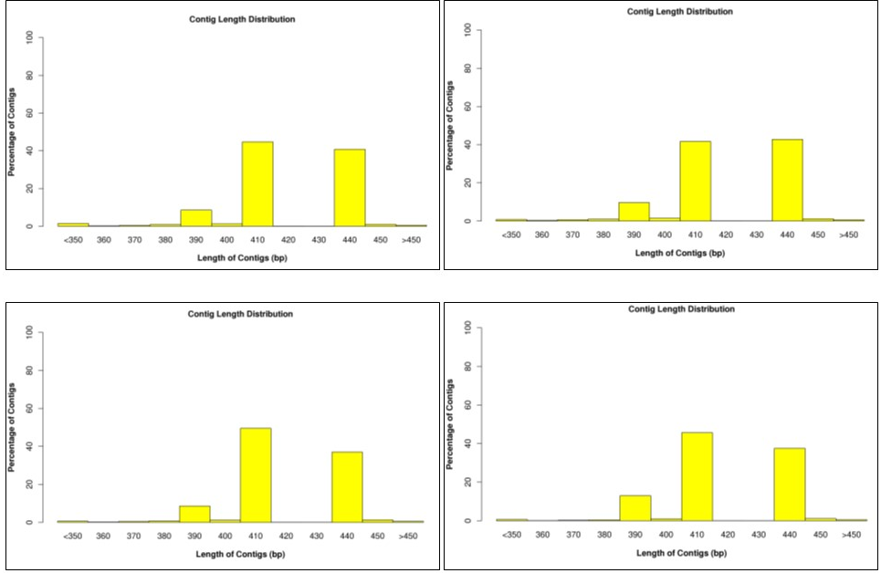

Supplementary figure 3. Contig length plot of rhizosphere soil samples of P-1 (MMB), B: P-6 (OOB), C: P-20 (SMB) and D: P-28 (BBB) in YR2CR3 cropping
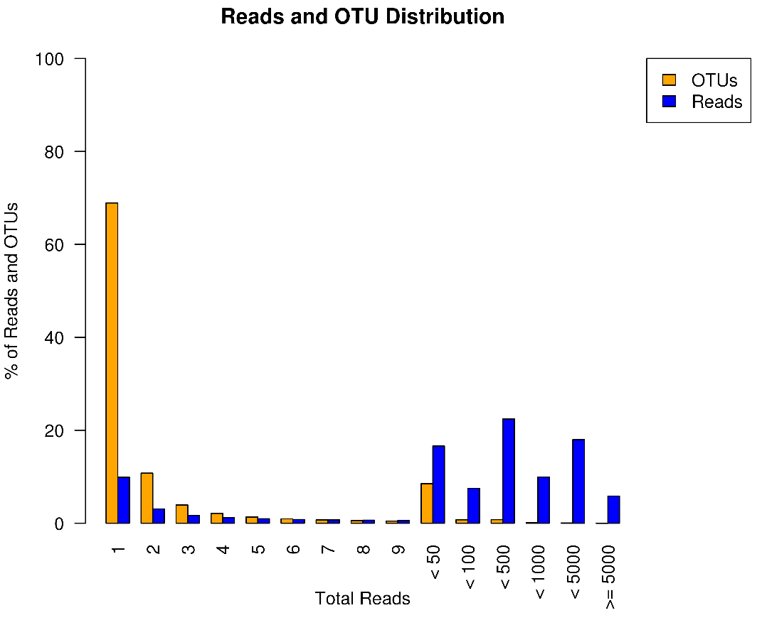

Supplementary figure 4. Bar plot showing a graphical representation of reads and OTU proportion. The blue bar represents percentage of total OTUs in the read-count groups. The orange bar represents percentage of total read contributed by the OTUs in the read-count group.

