Electronic Supplementary Materials

A novel fluorescent sensor for rifampicin based on the bio-inspired molecularly imprinted polymer-AgInS₂/ZnS quantum dots

Farzaneh Rasoulzadeh, Mohammad Amjadi*
Department of Analytical Chemistry, Faculty of Chemistry, University of Tabriz, Tabriz 5166616471, Iran

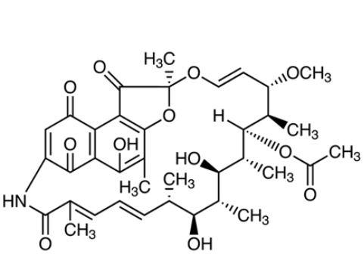
Fig. S1.Molecular structure of rifampicin.

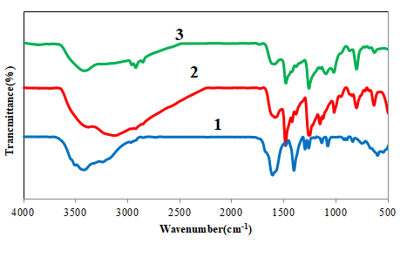
Fig.S2. FT-IR spectrum of: (1) ZAIS QDs, (2) NIP@ZAIS QDs and (3) MIP@ZAIS QDs.

Fig. S3. The influence of pH on the FL intensity of MIP@QDs in the presence of RFP (150 nM).

Fig.S4. The influence of incubation time on the FL intensity of MIP@QDs in the presence of RFP (150 nM).

Fig. S5. The influence of MIP@QDs concentration on the FL intensity in the presence of RFP (150 n M).

