Supplemental Figures 1-2

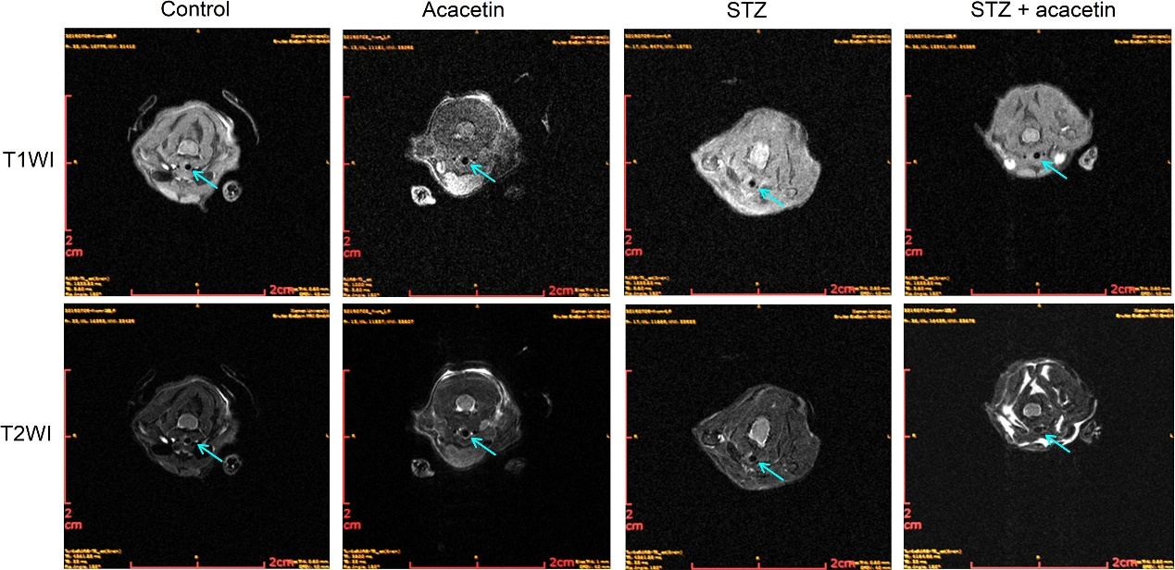

Figure S1. Magnetic resonance imaging (MRI) of the cervical arteries. T1-weighted gradient echo images (T1WI) and T2-weighted gradient echo images (T2WI) of carotid artery from control ApoE^{-/-} mice with and without acacetin administration, and STZ induced diabetic ApoE^{-/-} mice with and without acacetin administration. Acacetin attenuates carotid artery stenosis in STZ-diabetic ApoE^{-/-} mice.

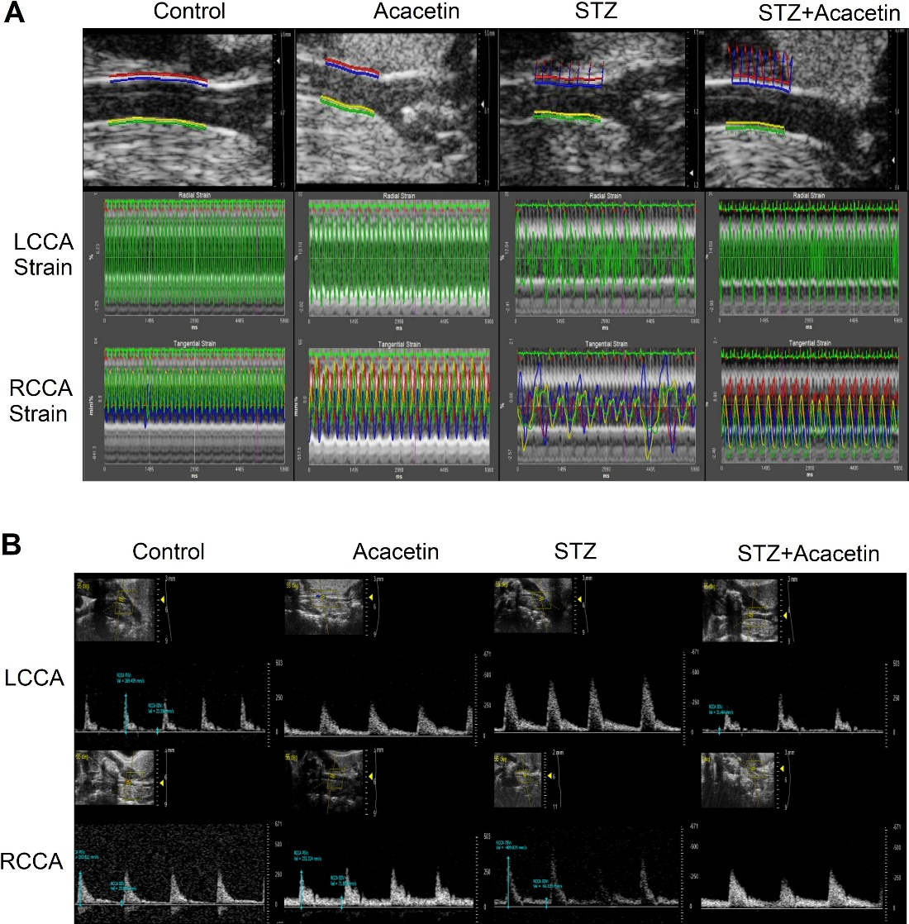

Figure S2. Effect of acacetin on vascular strain and blood flow in diabetic atherosclerotic mice. (A) ultrasound graphs of vascular strain in control ApoE^{-/-} mice with and without acacetin administration, and STZ induced diabetic ApoE^{-/-} mice with and without acacetin administration. (B) ultrasound graphs of blood flow in control ApoE^{-/-} mice with and without acacetin administration, and STZ induced diabetic ApoE^{-/-} mice with and without acacetin administration. LCCA, left common carotid artery; RCCA, left common carotid artery.

