Supplementary Figure 1 (A-B): Principal component analysis of biomarkers of treatment naïve patients.
1A.
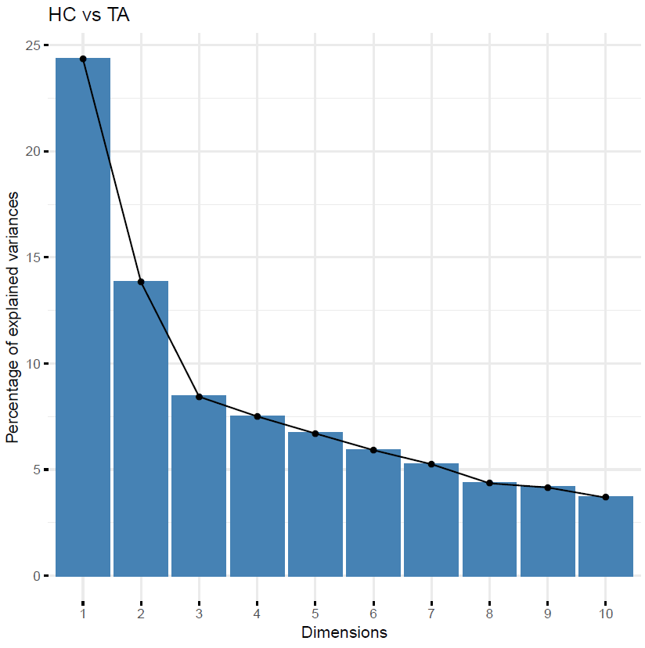

1B.

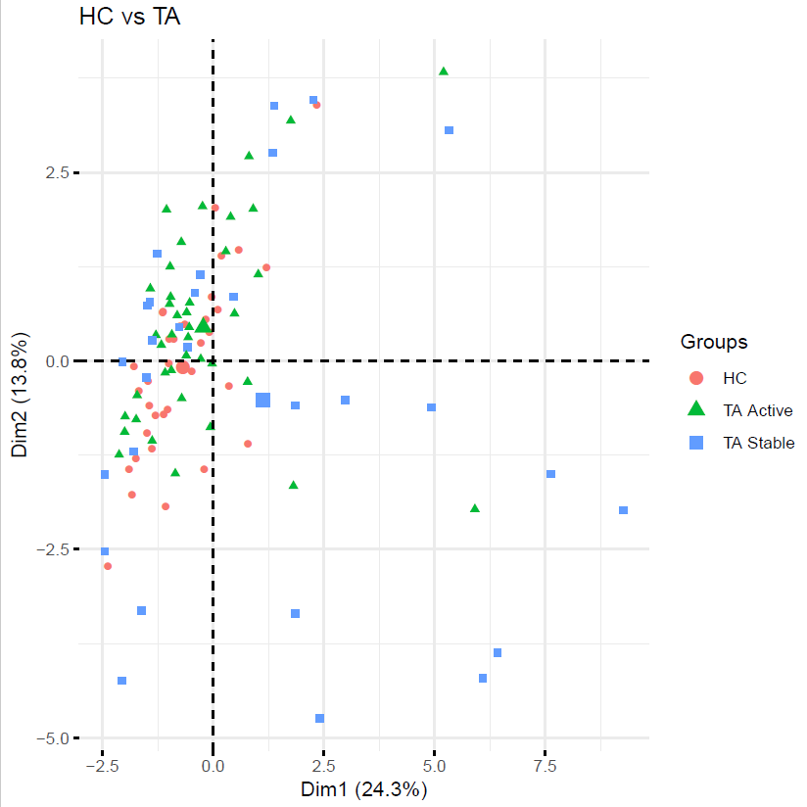

Supplementary figure-2: Dendrogram representing hierarchical clustering of TA patients based on their baseline cytokine profiles
