Supplementary file
Suppl figure 1 (A-B): Principal component analysis of biomarkers of treatment naïve patients.

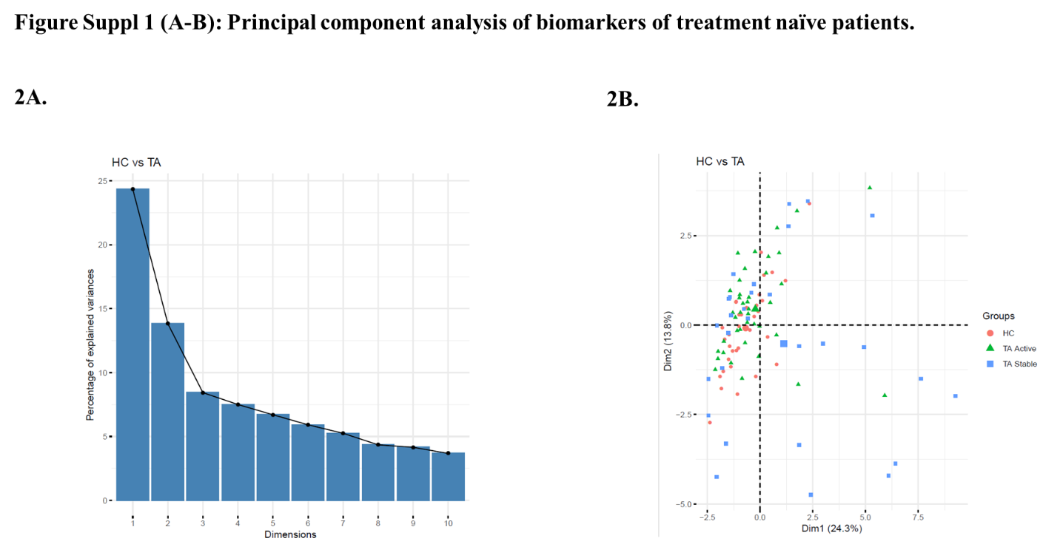

Supplementary figure-2: Dendrogram representing hierarchical clustering of TA patients based on their baseline cytokine profiles

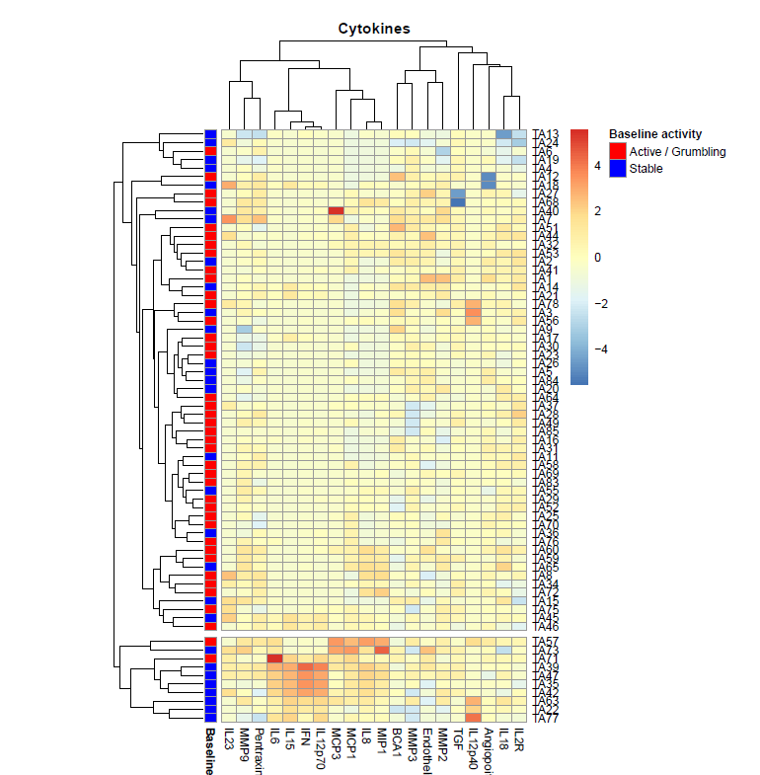

Table S1: Concentration of biomarkers in patients with progression as compared with non-progression in angiography
Analyte | Angiographic progression | Non progression | Angiographic progression | Non progression after R1
 | Baseline (pg/ml) | Baseline (pg/ml) | R1 (pg/ml) | R1 (pg/ml)
BCA-1 | 15.9 (8.3-21.4) | 22.7 (12.0-50.4) | 13.9 (8.6-26.1) | 28.1 (11.9- 103.1)
IL6 | 0.68 (0.49-1.04) | 0.67 (0.58-1.22) | 0.75 (0.7- 1.1) | 0.6 (0.5- 0.8)
IL8 | 1.2 (0.0-15.9) | 1.7 (0-18.6) | 5.6 (0.0- 26.8) | 2.5 (0.0- 0.96)
IFNγ | 0.05 (0.0-0.47) | 0.1 (0-0.23) | 0.03 (0- 1.2) | 0.05 (0.0- 0.16)
MCP-1 | 1.4 (0.0-11.5) | 4.3 (0-10.3) | 2.2 (0.0- 11.8) | 7.0 (0.0- 19.1)
MIP1α | 0.37 (0.0-1.98) | 0.72 (0-1.44) | 0.9 (0.0- 2.1) | 0.65 (0.25- 4.3)
IL2Rα | 39.1 (13.95-101.1)* | 87.3(59.2-126.1)* | 45.6 (32.1-120.1) | 65.06 (47.7- 116.7)
IL12 p70 | 0.75 (0.0-0.47) | 0.15 (0.0-0.87) | 0.3 (0.0-1.2) | 0.08 (0-0.96)
IL18 | 41.08 (12.45-70.03) | 57.1 (37.4-68.8) | 46.7 (20.2- 68.9) | 53.08 (40.0-75.4)
MMP-2 | 11959.0 (5831.1-31430.6) | 12004.2 (8429.4-22075.3) | 21569.4 (9115.8- 27072.9) | 14775.5 (9434.9- 22281.1)
MMP-3 | 2734.1 (2102.4-9759.6) | 1760.5 (528.8-7852.5) | 6033.7 (4166.6- 17815.4) | 6991.4 (2164.6- 144456.9)
MMP-9 | 7865.7 (4148.2- 20097.7) | 5538.5 (2765.6-12543.7) | 8454.2 (5386.9 – 15229.9) | 8454.2 (5387.0- 15229.9)
Pentraxin3 | 7085.8 (5646.8-9691.6) | 5367.6 (3540.0-8174.5) | 5836.2 (4490.0- 9372.9) | 4240.0 (2802.5- 6369.4)
Angiopoietin 2 | 1634.1 (1129.3-2312.0) | 2392.1 (1411.0-4148.0) | 654.2 (537.5- 2939.5) | 1556.8 (1053.5- 2327.9)
Endothelin-1 | 1.03 (0.85-1.24) | 1.5 (1.2-1.9) | 1.15 (0.9- 1.2)* | 1.5 (1.1- 2.0)*
TGFβ1 | 14527.1 (8491.6- 27671.8) | 18010.2 (7249.2-26452.9) | 17128.3 (10428.6- 32092.2) | 22024.2 (8431.7- 31650.5)
*p<0.05

