Title: Tacrolimus improves therapeutic efficacy of mesenchymal stem cells in diabetic retinopathy by suppressing DRP1-mediated mitochondrial fission
Hang Hyo Jo^{1,2,a}, Yeong-Seok Goh^{3,a}, Hye Jih Kim^{1,2}, Dae Hyun Kim^{1,2}, Hyemin Kim^{3,}, Jiyi Hwang^{3,} , Ji Seung Jung^{3,} , Nanyoung Kang^{3,} , Sang-Eun Park^{3,} , Kyung-Mee Park^{3, *}, and Hyun Jik Lee^{1,2, *}

Affiliation
¹Laboratory of Veterinary Physiology, College of Veterinary Medicine and Veterinary Medicine Center, Chungbuk National University, Cheongju 28644, Korea
²Institute for Stem Cell & Regenerative Medicine (ISCRM), Chungbuk National University, Cheongju 28644, Korea
³Laboratory of Veterinary Surgery and Ophthalmology, College of Veterinary Medicine, Chungbuk National University, Cheongju 28644, Korea

ª These authors contributed equally to this work

*Corresponing authors are Kyung-Mee Park and Hyun Jik Lee.

*Kyung-Mee Park, D.V.M., Ph.D.
Laboratory of Veterinary Surgery and Ophthalmology, College of Veterinary Medicine, Chungbuk National University, Cheongju 28644, Korea
Tel: +82-43-261-2985 / E-mail: parkkm@cbnu.ac.kr
*Hyun Jik Lee, D.V.M., Ph.D.
Laboratory of Veterinary Physiology, College of Veterinary Medicine and Veterinary Medicine Center, Chungbuk National University, Cheongju 28644, Korea
Institute for Stem Cell & Regenerative Medicine (ISCRM), Chungbuk National University, Cheongju 28644, Korea
Tel: +82-43-261-2597 / E-mail: leehyunjik@chungbuk.ac.kr
Running Title: Therapeutic effect of tacrolimus-pretreated MSCs on diabetic retinopathy
Key words: Diabetic retinopathy, Mesenchymal stem cells, Tacrolimus, Mitochondrial dynamics, O-GlcNAc transferase, Apoptosis
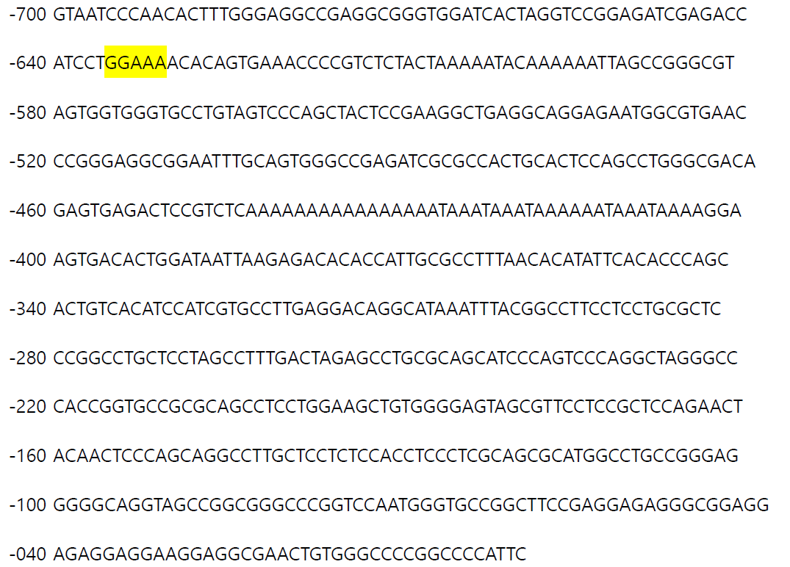
Fig. S1. The NFAT binding site in the DNML1L_1 promoter is shown. The yellow shaded box represents the consensus sequences of NFATC1.

Fig. S2. Full-length gel images for key data in figures 1F-2D. All western blot images are full-length blot images of key blot data in the figures 1F-2D. Dash line box indicates cropped blot image in the figures 1F-2D.
Fig. S3. Full-length gel images for key data in figures 3A-3G. All western blot images are full-length blot images of key blot data in the figures 3A-3G. Dash line box indicates cropped blot image in the figures 3A-3G.
Fig. S4. Full-length gel images for key data in figures 4D-6D. All western blot images are full-length blot images of key blot data in the figures 4D-6D. Dash line box indicates cropped blot image in the figures 4D-6D.

Table. S1. Sequences of primers used for real-time PCR
Gene | Identification | Sequence (5'-3') | Size (bp)
DRP1 | Sense | CAGTGTGCCAAAGGCAGTAA | 212
DRP1 | Antisense | GATGAGTCTCCCGGATTTCA | 212
FIS1 | Sense | CTTGCTGTGTCCAAGTCCAA | 213
FIS1 | Antisense | CCACAGCCCCGTTTTATTTA | 213
MFN1 | Sense | TTGGAGCGGAGACTTAGCAT | 163
MFN1 | Antisense | TTCGATCAAGTTCCGGATTC | 163
OPA1 | Sense | GGCCAGCAAGATTAGCTACG | 154
OPA1 | Antisense | ACAATGTCAGGCACAATCCA | 154
ACTB | Sense | CCACCATGTACCCTGGCATT | 189
ACTB | Antisense | CGGACTCGTCATACTCCTGC | 189

