Supporting information

Occurrence and characterisation of naphthenic acid fraction components in oil residues stranded on the shoreline of Chedabucto Bay, Nova Scotia, Canada

Zeyu Yang*, Gong Zhang, Chun Yang, Keval Shah, Bruce P. Hollebone, Sonia Laforest, Patrick Lambert, and Carl E. Brown
Emergencies Science and Technology Section (ESTS),
Environment & Climate Change Canada,
Ottawa, ON, Canada

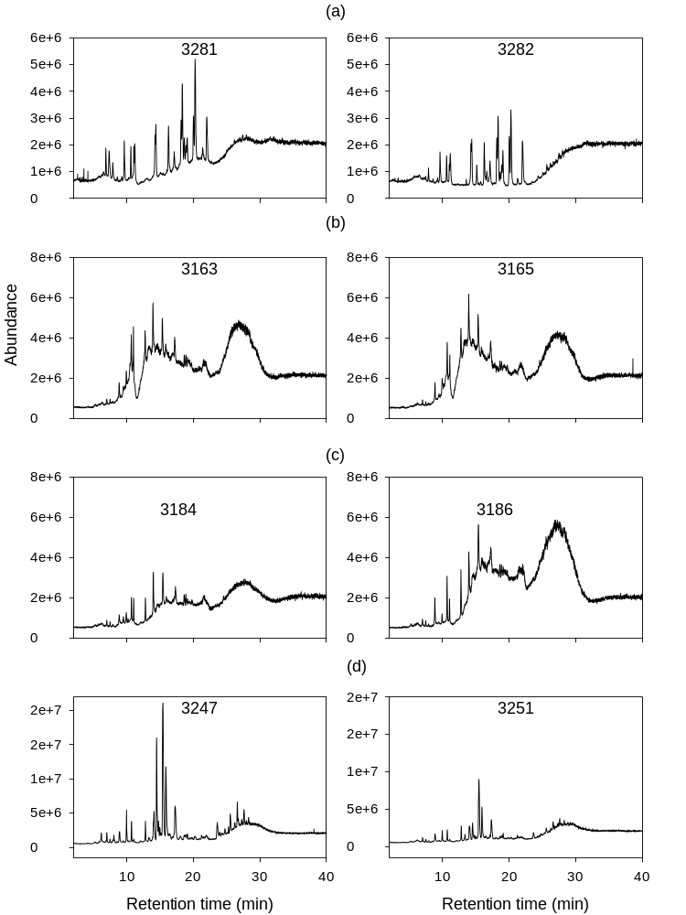
Fig. S1. Total ion chromatograms of representative samples. (a) Source oil from the Arrow spill; (b) Arrow oil residues collected from Cape Auguet and India Cove; (c) Arrow oil residues collected from Black Duck Cove; (d) sediments from the Port Hawkesbury marina area.
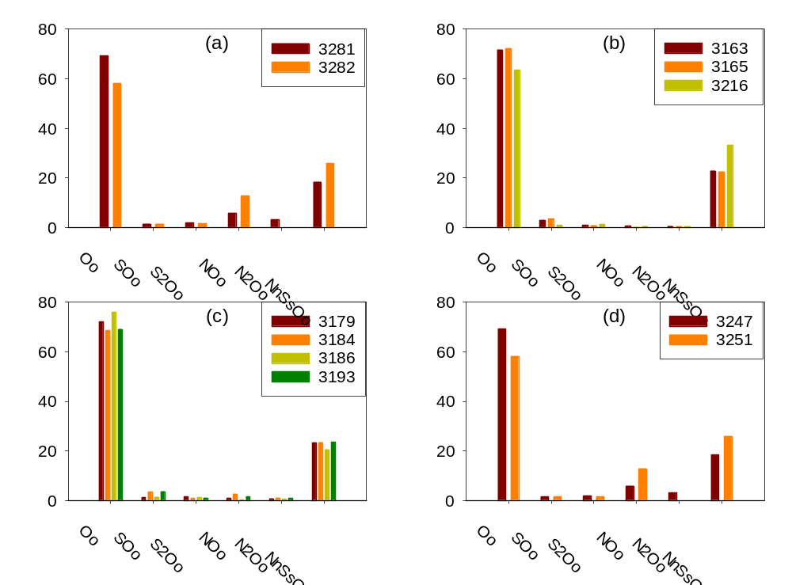Fig. S2 . Relative percentage (%) of various heteroatom species to total NAFC. (a) Source oil from the Arrow spill; (b) Arrow oil residues collected from Cape Auguet and India Cove; (c) Arrow oil residues collected from Black Duck Cove; (d) sediments from the Port Hawkesbury marina area.
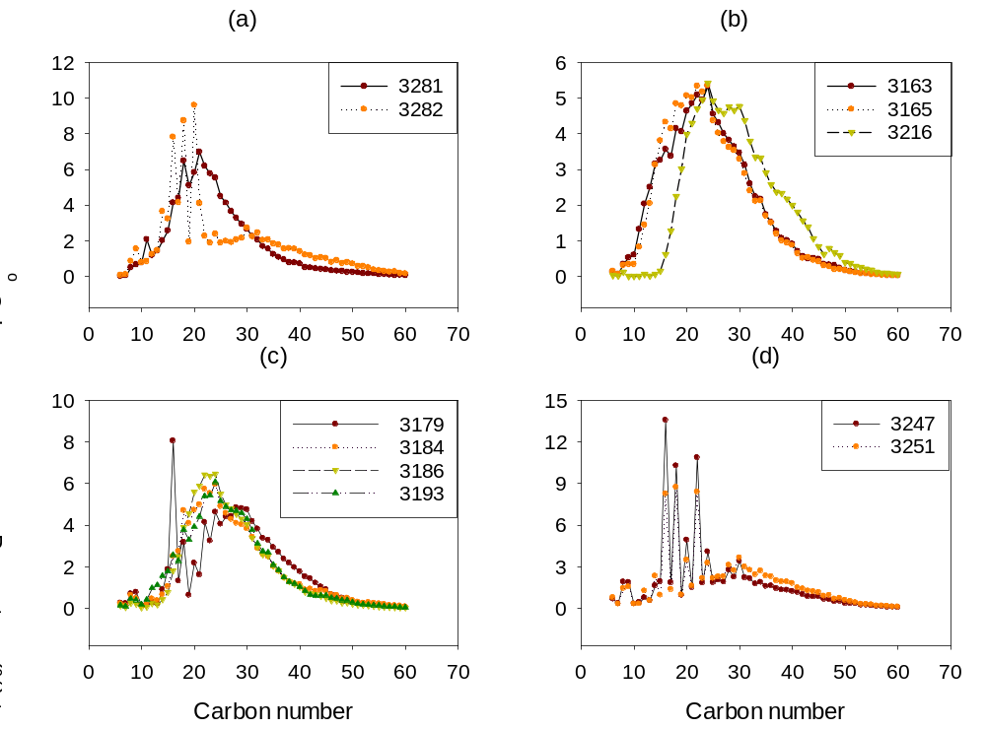
Fig. S3 . Distribution of total O species in relation to carbon number, normalised to 100%. (a) Source oil from the Arrow spill; (b) Arrow oil residues collected from Cape Auguet and India Cove; (c) Arrow oil residues collected from Black Duck Cove; (d) sediments from the Port Hawkesbury marina area.

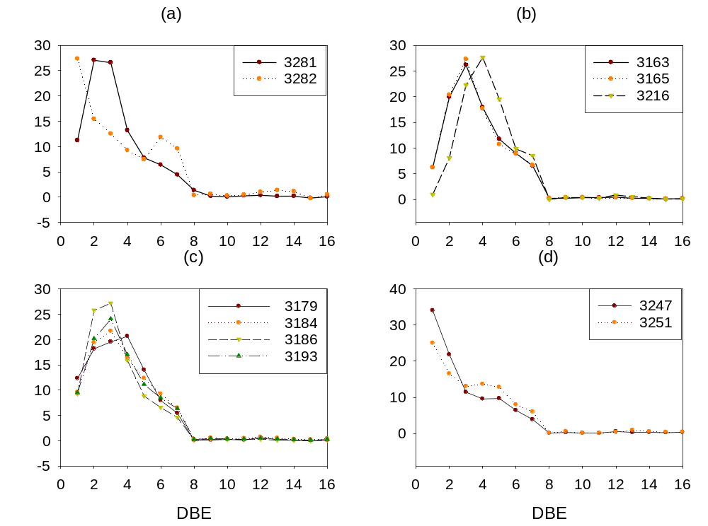
Fig. S4 . Distribution of total O species relative to DBE number, normalised to 100%. (a) Source oil from the Arrow spill; (b) Arrow oil residues collected from Cape Auguet and India Cove; (c) Arrow oil residues collected from Black Duck Cove; (d) sediments from the Port Hawkesbury marina area.
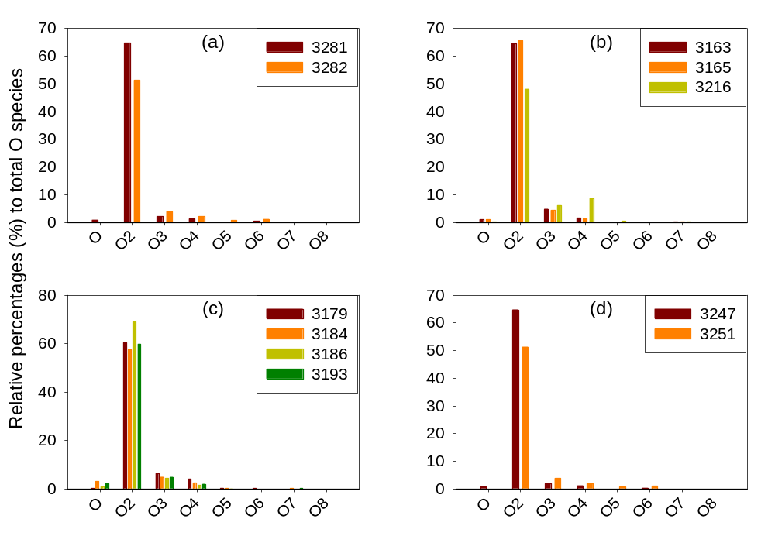
Fig. S5 . Relative percentage (%) of individual O species to total O species. (a) Source oil from the Arrow spill; (b) Arrow oil residues collected from Cape Auguet and India Cove; (c) Arrow oil residues collected from Black Duck Cove; (d) sediments from the Port Hawkesbury marina area.

* Corresponding author at: Emergencies Science & Technology Section, Environment and Climate Change Canada, 335 River Road, Ottawa, ON, K1A0H3, Canada. E-mail: zeyu.yang@canada.ca (Z. Yang).

