Supplementary Data
Effects of KD on blood pressure, body weight, and biochemistry of DM rats
Supplementary Table 1 summarizes the blood pressure (BP), body weight (BW), heart weight (HW), and blood biochemistry in control rats (control), diabetes mellitus (DM) rats on a normal diet (DM+ND), and DM rats on the ketogenic diet (DM+KD). Heart rate (HR), BP, BW, and HW were lower in DM+ND than in control and DM+KD. BW and HW were similar between DM+KD and control. However, HW/BW ratio was higher in DM+ND than in control and DM+KD, whereas it was similar between control and DM+KD.

Supplementary Table 1. Physical characteristics, blood pressure, and weights in control, DM+ND, and DM+KD.
 | Control (N=8) | DM+ND (N=8) | DM+KD (N=8)
Baseline FBG (mg/dL) | 101.1 ± 4.5 | 100.8 ± 4.1 | 102.0 ± 2.1
FBG (mg/dL) | 100.9 ± 3.0 | 433.9 ± 12.0ª | 284.3 ± 6.2^{a,b}
SBP (mmHg) | 116.5 ± 2.1 | 99.0 ± 4.1ª | 110.5 ± 3.1^{b}
DBP (mmHg) | 61.3 ± 3.6 | 40.8 ± 3.0ª | 52.0 ± 2.0^{b}
HR (bpm) | 426.0 ± 15.1 | 322.8 ± 17.0ª | 402.0 ± 18.8^{b}
Baseline BW (g) | 365.1 ± 3.8 | 367.1 ± 3.4 | 368.8 ± 5.3
BW (g) after KD | 503.6 ± 10.5 | 382.8 ± 25.6ª | 422.4 ± 21.1^{b}
HW (g) | 1.79 ± 0.05 | 1.48 ± 0.07ª | 1.69 ± 0.05^{b}
HW/BW (mg/g) | 3.63 ± 0.11 | 4.58 ± 0.22ª | 3.87 ± 0.22^{b}
Abbreviations: Control: control rats; DM+ND: DM rats on a normal diet; DM+KD: DM rats on ketogenic diet; N: number of rats; FBG: fasting blood glucose; SBP: systolic blood pressure; DBP: diastolic blood pressure; HR: heart rate; bpm: beats per minute; BW: body weight; HW: heart weight. Values are expressed as mean ±standard error of the mean (SEM). Statistical significance was assessed using a one-way analysis of variance (ANOVA) with Tukey's Honest Significant Difference (HSD) test. ª P < 0.05 vs. control; ^{b} P < 0.05 vs. DM+ND.
. 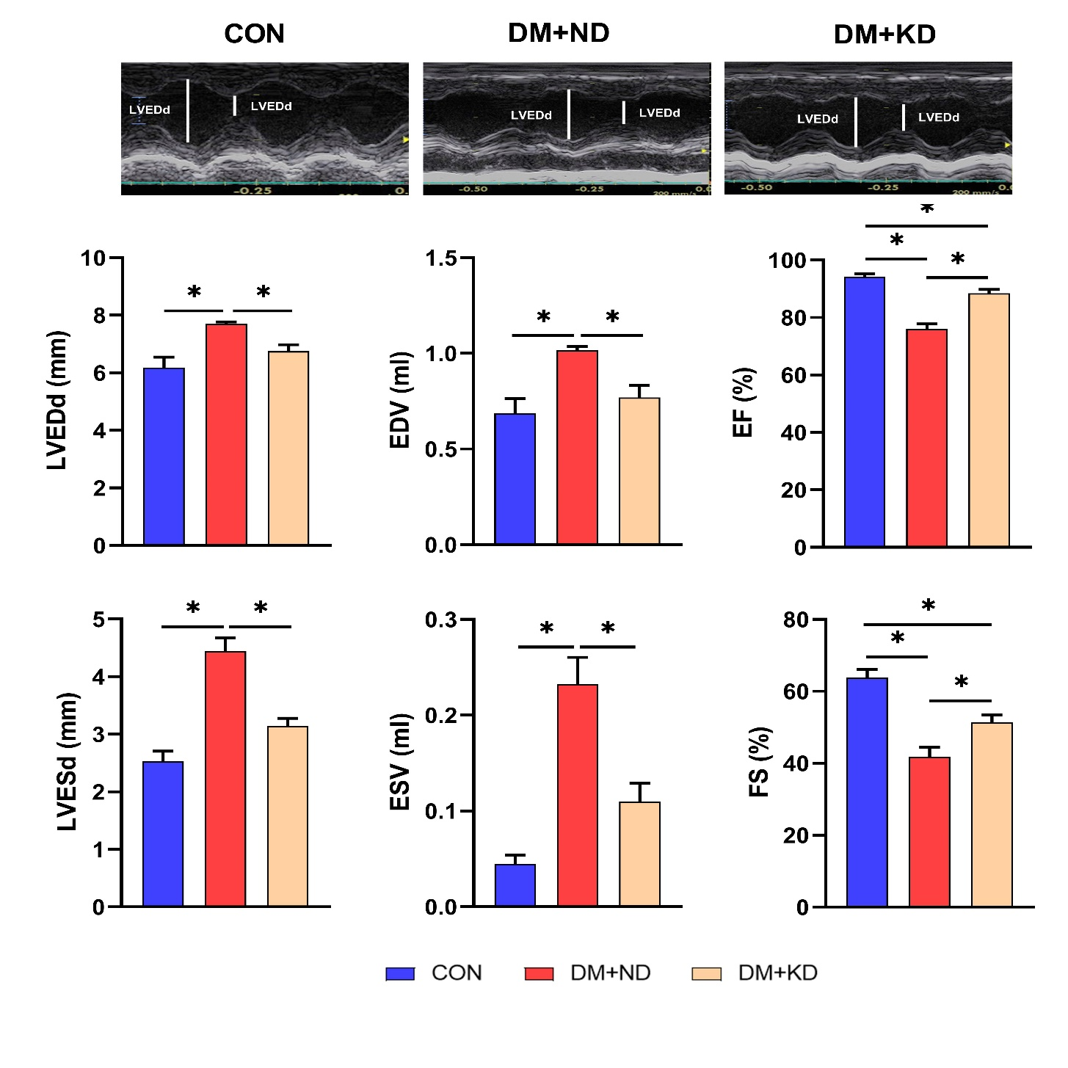
Supplementary Fig. 1. Effects of KD on echocardiograms of in control rats (control), diabetes mellitus (DM) rats on a normal diet (DM+ND), and DM rats on ketogenic diet (DM+KD): average data of the left ventricular end-diastolic diameter (LVEDd), left ventricular end-systolic diameter (LVESd), end-diastolic volume (EDV), end-systolic volume (ESV), ejection fraction (EF), and fractional shortening (FS); Number of rats (N) = 8 per group. Statistical significance was assessed using a one-way analysis of variance (ANOVA) with Tukey's Honest Significant Difference (HSD) test. * p < 0.05.

