Supplementary Information

Super-stretchable and negative-Poisson-ratio meta-aerogels

Xiaoyu Zhang¹, Qi Sun¹, Xing Liang¹, Puzhong Gu¹, Zhenyu Hu¹, Xiao Yang¹, Muxiang Liu¹, Zejun Sun¹, Jia Huang¹, Guangming Wu², Guoqing Zu*^{,1}

¹Interdisciplinary Materials Research Center, Department of Polymeric Materials, School of Materials Science and Engineering, Tongji University, Shanghai, 201804, P. R. China
²Shanghai Key Laboratory of Special Artificial Microstructure Materials and Technology, School of Physics Science and Engineering, Tongji University, Shanghai 200092, P. R. China
*Corresponding author: guoqingzu@tongji.edu.cn

This file includes:
Captions for Movies S1 to S10
Methods
Figures S1 to S36
Tables S1-S5
Supplementary Text
Supplementary References (1-59)

Other Supplementary Materials for this manuscript include:
Movies S1 to S10

Movie list:
Movie S1. A tensile test in x direction on rGO/PPy/PUF1-UHP, showing an elongation at break of 810%.
Movie S2. A tensile test in x direction on rGO/PPy/PUF2-UHP, showing an elongation at break of 1250%.
Movie S3. A stretching-releasing test in x direction on rGO/PPy/PUF1-UHP with 700% tensile strain.
Movie S4. A stretching-releasing test in x direction on rGO/PPy/PUF2-UHP with 800% tensile strain.
Movie S5. A tensile test in x direction on rGO/PPy/PUF1-BHP with 300% tensile strain.
Movie S6. A stretching-releasing test in y direction on rGO/PPy/PUF1-BHP with 300% tensile strain.
Movie S7. A tensile test in y direction on rGO/PPy/PUF1-THP, showing an elongation at break of 340%.
Movie S8. FEA simulation of the structure variation of the aerogel during uniaxial hot pressing.
Movie S9. FEA simulation of the structure variation of the aerogel during biaxial hot pressing.
Movie S10. Monitoring the large tensile strain (0-300%) of a chest developer during exercise by using the strain sensor based on rGO/PPy/PUF1-UHP.

Methods
Materials
Graphene oxide (GO, 4 mg/mL) was purchased from Institute of Coal Chemistry, Chinese Academy of Science. Ethylenediamine (EDA, AR) was purchased from Sinopharm Chemical Reagent Co., Ltd. Pyrrole (99%) and Iron chloride (FeCl₃, 98%) was purchased from Adamas. Polyvinyl alcohol (PVA, n=1750±50) was purchased from Tokyo Chemical Industry Co., Ltd. Polyurethane (PU) dispersion (Dispercoll U42, 50 wt% in water) was purchased from Covestro. 3-Aminopropyltriethoxysilane (APTES, 98%) was purchased from Energy Chemical. The PU foams (PUF1 and PUF2) were purchased from Jiangsu Huayi Foam Technology Co., Ltd and Yuechang Foam. The melamine foam (MF) was provided by Zhejiang Yadina New Material Technology Co., Ltd.
Preparation of rGO/PUF-based aerogel
The rGO/PPy/PUF composite aerogels were prepared by in-situ formation of rGO aerogel in PUF followed by the deposition of PPy. 0.032 mL EDA (AR) was mixed with 4 mL GO (4 mg mL⁻¹) under continuous stirring for 5 min. PUF1 or PUF2 strips were completely immersed into the above mixture followed by repeated squeezing. The PUF strips impregnated with the GO sol were then sealed and heated at 90 ℃ for 6 h to afford rGO/PUF composite hydrogels. After ambient pressure drying (APD) at 80 ℃ for at least 2 h, the rGO/PUF composite aerogels were obtained.
PPy was then deposited in the aerogels via the following method. 0.2268 g of FeCl₃ (98%) was dissolved in 8 mL of H₂O (DIW). 0.066 mL of Pyrrole (99%) was mixed with the above FeCl₃ solution in an ice bath under stirring for 20-30 s. Then, the rGO/PUF composite aerogels were immersed into the above mixture and squeezed repeatedly. After polymerization at room temperature for 6 h, the rGO/PPy/PUF composite hydrogels were formed. The rGO/PPy/PUF composite aerogels (rGO/PPy/PUF1 and rGO/PPy/PUF2) were obtained after APD at 80 ℃ for at least 2 h. The preparation parameters of the rGO/PPy/PUF composite aerogels were presented in Table S1.
Preparation of rGO/PU-based aerogel
The rGO/PU-based aerogel rGO/PPy/PU was prepared via the following steps. As shown in Table S2, 0.096 mL APTES was added into the mixture of 8 mL H₂O (DIW), 8 mL GO (4 mg mL⁻¹), and 1.28 mL PU dispersion (50 wt% in water) under continuous stirring for 1 min. After gelation at room temperature, the obtained hydrogel was sealed and aged at 80 ℃ for 6 h. The hydrogel was freeze-casted at -17 ℃ for at least 6 h followed by freeze drying for at least 12 h to afford the rGO/PU composite aerogel. PPy was then deposited in the rGO/PU aerogel to form an rGO/PPy/PU composite hydrogel via the same method as that for the deposition of PPy in the rGO/PUF composite aerogels except for the drying process. The rGO/PPy/PU composite aerogel was obtained by freeze drying, followed by heat treatment in vacuum at 120 ℃ for 1 h.
Preparation of rGO/MF-based aerogel
The rGO/PVA/MF composite aerogel was prepared by in-situ formation of rGO/PVA aerogel in MF. As shown in Table S3, 4 mL GO (4 mg mL⁻¹), 0.16 mL PVA (0.05 g mL⁻¹), and 0.032 mL EDA (AR) were mixed and continuously stirred for 10 min. MF strips were completely immersed into the above mixture followed by repeated squeezing. The MF strips impregnated with the GO sol were then sealed and heated at 90 ℃ for 24 h to form rGO/PVA/MF composite hydrogels. The rGO/PVA/MF composite aerogels were obtained by freeze-casting at -17 ℃ for at least 6 h followed by freeze drying for at least 12 h. To further reduce the rGO, the rGO/PVA/MF composite aerogels were then thermally treated at 150 ℃ for 5 h in a tube furnace in N₂ atmosphere.
Preparation of hot-pressed rGO/polymer composite aerogels
Hot pressing of the rGO/polymer nanocomposite aerogels was readily performed using a home-made apparatus (Figure 1c, Figures S3-S8). In the case of uniaxial hot pressing (Figure S3 and Figure S6), a monolithic rGO/polymer aerogel was first sandwiched with two pieces of glass and then compressed with 66.7-87.5% strain (75% for rGO/PPy/PUF1 and rGO/PPy/PU, 87.5% for rGO/PPy/PUF2, and 66.7% for rGO/PVA/MF) in x direction using other two pieces of glass. After that, they were fixed and heated at 120 ℃ or 140 ℃. rGO/PVA/MF and rGO/PPy/PU were heated at 120 ℃ (heated for 5 h for rGO/PVA/MF and 0.5 h for rGO/PPy/PU) to afford rGO/PVA/MF-UHP and rGO/PPy/PU-UHP, respectively, while rGO/PPy/PUF1 and rGO/PPy/PUF2 were heated at 140 ℃ for 5 h to afford rGO/PPy/PUF1-UHP and rGO/PPy/PUF2-UHP, respectively.
In the case of biaxial hot pressing (Figure S4 and Figure S7), a monolithic rGO/polymer aerogel was first compressed with 50% strain in x direction using two pieces of glass and then compressed with 50% strain in y direction using other two pieces of glass, followed by fixing and heat treatment. rGO/PPy/PUF1 was biaxially compressed and heated at 140 ℃ for 5 h to afford rGO/PPy/PUF1-BHP, while rGO/PPy/PU was biaxially compressed and heated at 120 ℃ for 0.5 h to afford rGO/PPy/PU-BHP. In the case of triaxial hot pressing (Figure S5 and Figure S8), a monolithic rGO/polymer aerogel was first compressed with 50% strain in z direction and then compressed with 50% strain along both x and y directions, followed by fixing and heat treatment. rGO/PPy/PUF1 was triaxially compressed and heated at 140 ℃ for 5 h to afford rGO/PPy/PUF1-THP, while rGO/PPy/PU was triaxially compressed and heated at 120 ℃ for 0.5 h to afford rGO/PPy/PU-THP.
Preparation of rGO/polymer composite aerogel-based sensors
As shown in Figure 5a, the flexible strain sensors were constructed by attaching two copper electrodes on both ends of the hot-pressed rGO/polymer composite aerogels (coplanar electrode structure). For the flexible pressure sensors, the hot-pressed rGO/polymer composite aerogels were sandwiched by two copper electrodes (vertical electrode structure).
Structural characterizations
The morphologies of different samples were observed by a scanning electron microscope (SEM, NOVA NANOSEM 450, FEI, USA) and an optical microscope (6XB-PC, Shang Guang, P. R. China). The in-situ morphologies of the hot-pressed aerogels during stretching and compression were observed by the same optical microscope. X-ray diffraction (XRD) patterns were recorded on an X-ray diffractometer (5-80°, 2° min⁻¹) (DX-2701BH, Haoyuan, P. R. China). Raman spectra were studied with a Raman spectrometer with an argon ion laser excitation wavelength of 532 nm at room temperature (LabRAM HR Evolution, HORIBA Scientific, Japan). Fourier transform infrared (FTIR) spectra in the range of 4000-400 cm⁻¹ were investigated using an FTIR spectroscope (FTIR, Nicolet iS20, ThermoFisher, USA).
Mechanical tests
Tensile and compressive stress-strain curves of different samples were measured by a micro-computer controlled electronic universal testing machine (LD23.104, Lishi (Shanghai) Instruments Co., Ltd., P. R. China). The stretching speed was fixed at 120 mm min⁻¹ for the cyclic stretching-releasing tests of the rGO/polymer aerogels and the strain sensors based on the aerogels. For the cyclic compression-decompression tests of the rGO/polymer aerogels and the pressure sensors based on the aerogels, the compression speed was fixed at 80 mm min⁻¹. For other stretching and compression tests, the speed was fixed at 40 mm min⁻¹. In the case of three-point bending tests, the speed was fixed at 10 mm min⁻¹ and the span of the fixture was kept at 13 mm.
Mechanical simulations via FEA
FEA software ABAQUS was used to simulate the mechanical performances of the rGO/polymer composite aerogels. The simulations of the structure variation and stress/strain distributions of the aerogels during uniaxial (or biaxial) hot pressing and stretching were carried out via the explicit dynamic analysis method. A model containing seven interconnected annuluses with the same size was used for the simulation. The annuluses were connected with each other at each contact point. Each annulus was deformable and elastic and possessed the same modulus. The aerogel was modelled by plane strain elements (CPE4R), while the compression plate was modelled by rigid bodies (R2D2). The density, elastic modulus, and Poisson’s ratio of the annuluses used in simulation were 1 g cm⁻³, 6 MPa, and 0.47, respectively.
For the simulation of uniaxial hot pressing of the aerogel, the annulus model was compressed 75% in x direction, followed by the elimination of the internal stress to afford a fixed compressed structure. For the simulation of biaxial hot pressing of the aerogel, the annulus model was first compressed 50% in x direction and then compressed 50% in y direction, followed by the elimination of the internal stress. In the case of stretching simulation, the compressed annulus model was stretched in x direction with different tensile strains (0-500% for the uniaxially hot-pressed aerogel and 0-200% for the biaxially hot-pressed aerogel). The internal stress of the compressed annulus model was eliminated before the stretching simulation.
Sensing tests
The tensile strain and pressure sensing properties of different samples were investigated by a micro-computer controlled electronic universal testing machine (LD23.104, Lishi (Shanghai) Instruments Co., Ltd., P. R. China) combined with a LCR meter (TH2840A, Tonghui Insrument Co., Ltd., P. R. China). The strain and pressure sensors were fixed between the top and bottom clamps (or plates) of the micro-computer controlled electronic universal testing machine and their electrodes were connected to a LCR meter. In addition, the rGO/polymer aerogel-based strain/pressure sensors were attached to a volunteer’s body, a balloon, a chest developer, and fingers of a bionic hand to monitor different signals. The experiments were approved by the ethical committee of Tongji University. Xiaoyu Zhang provided written informed consent to participate in the body sensing tests.
Thermal management tests
The hot-pressed aerogel rGO/PPy/PUF1-UHP with different tensile strains (in the range of 0-200%) was placed on the surface of a hot plate (JF-956, 51 ℃, Dongguan Changan Jinfeng Electronic Tools Factory, P. R. China). The real-time infrared thermal images of the aerogel at different tensile strains were recorded using a thermal imager (626-L28, Fotric, P. R. China). Temperatures of the top surface of the aerogel under different tensile strains during 0-30 s were obtained from the video recorded by the thermal imager.
EMI shielding tests
The EMI SE (in z direction) of rGO/PPy/PUF1-UHP with different tensile strains was measured by a rectangular waveguide (32117) using a 2-port network analyzer (3672B-S, Ceyear, P. R. China) in the frequency range of 8.2-12.4 GHz. The power coefficients of reflection (R), transmission (T), and absorption (A) were calculated from the scattering parameters of the reflection coefficient S₁₁ and the transmission coefficient S₂₁ based on the following equations,
$R= {\left|S_{11}\right|}^{2}$ (1)
$T={\left|S_{21}\right|}^{2}$ (2)
$A=1-\left(T+R\right)$ (3)
The total EMI SE (SE_{T}), reflection effectiveness (SE_{R}), and absorption effectiveness (SE_{A}) were calculated by the following equations,
${SE}_{T}=10\log{\frac{1}{T}}$ (4)
${SE}_{R}=10\log\left(\frac{1}{1-R}\right)$ (5)
${SE}_{A}=10\log\left(\frac{1-R}{T}\right)$ (6)
${SE}_{T}={SE}_{R}+{SE}_{A}$ (7)
The conductivities (σ) were calculated via the following equation,
$σ=\frac{L}{R×S}$ (8)
where R is the resistance, L is the length, S is the cross-sectional area of the sample.

Figures
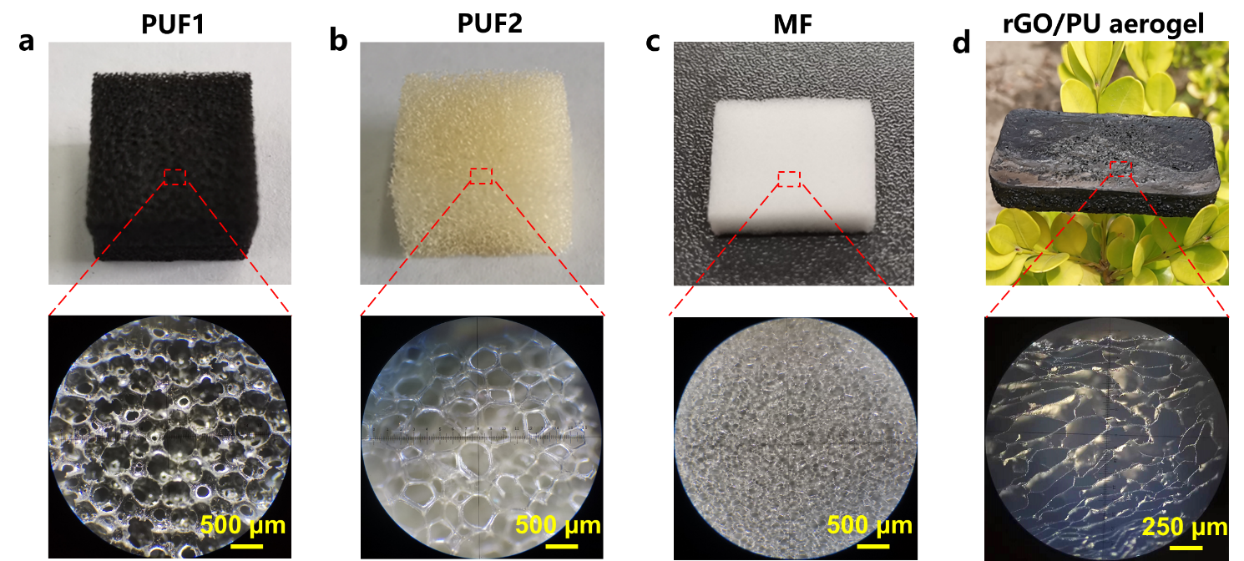
Figure S1. Photographs and optical microscope images of a) PUF1, b) PUF2, c) MF, and d) the rGO/PU aerogel. Two PUFs with different bulk densities (79 mg cm⁻³ for PUF1 and 18 mg cm⁻³ for PUF2) were used in this work.

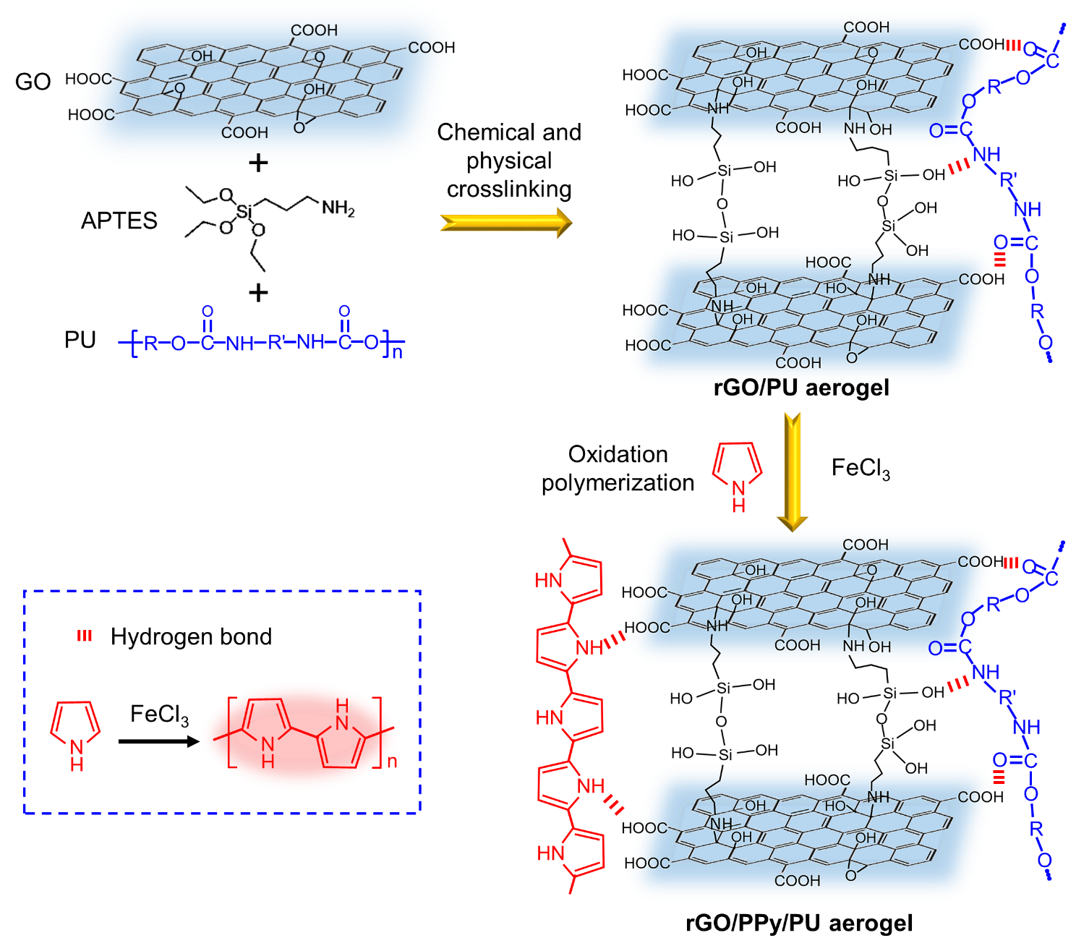
Figure S2. Schematic of the crosslinking and molecular-scaled microstructure variation during the preparation of the rGO/PPy/PU aerogel.

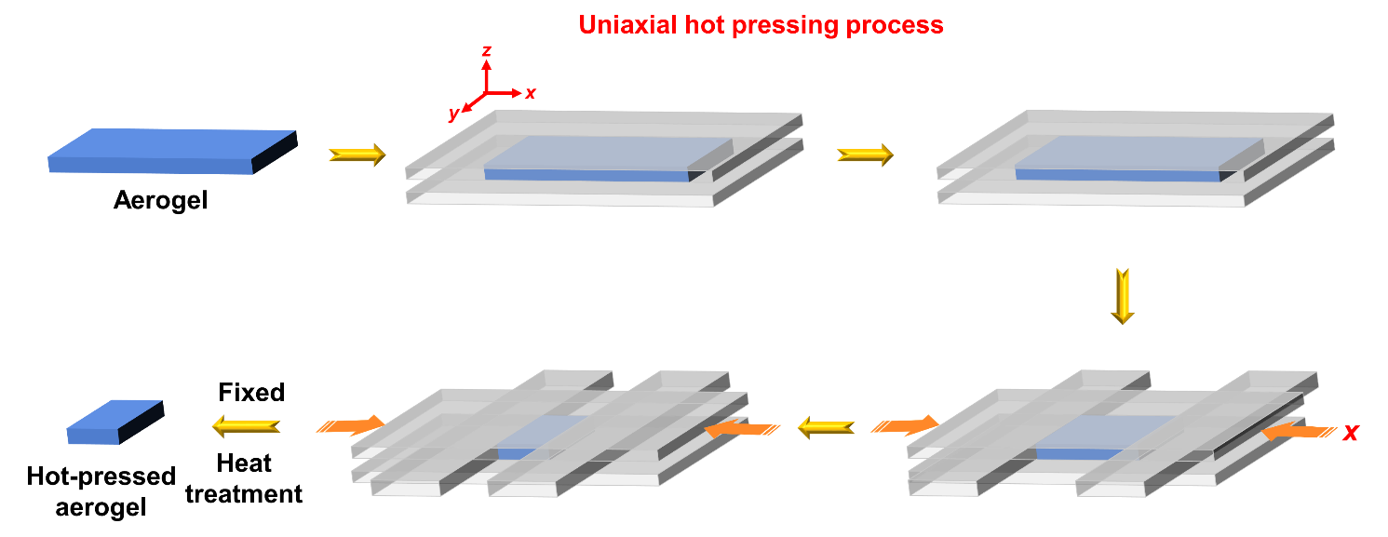
Figure S3. Schematic of the uniaxial hot pressing process of the aerogel.

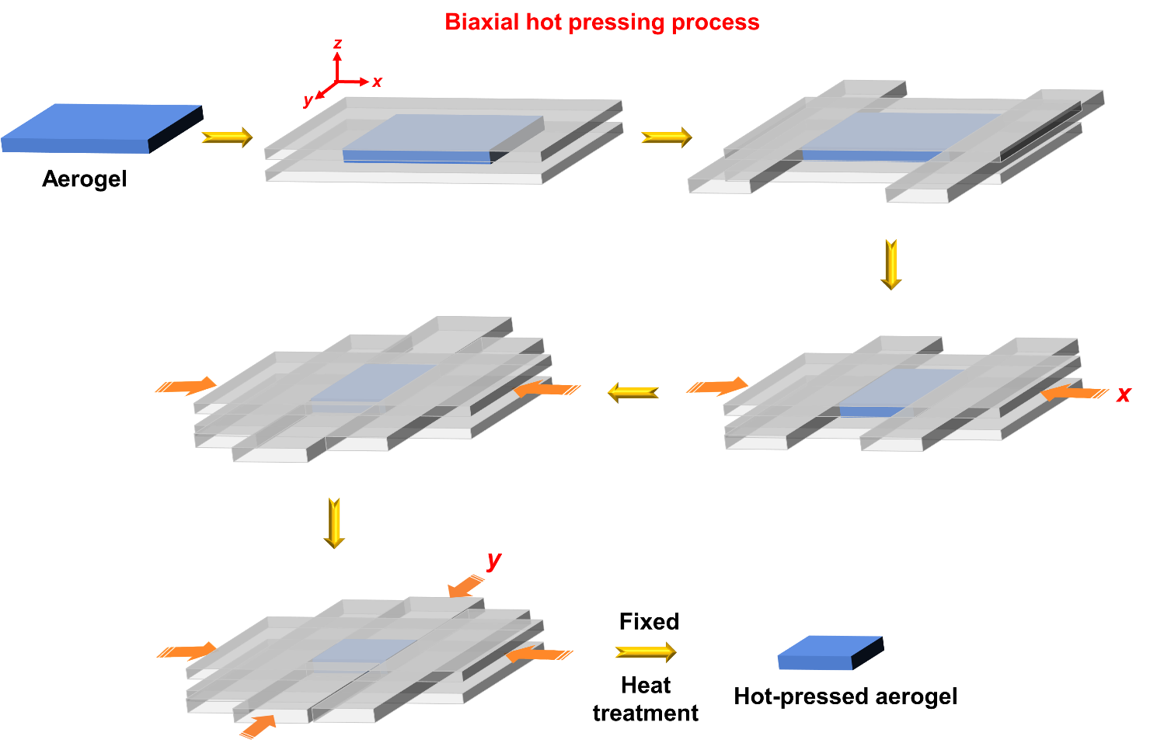
Figure S4. Schematic of the biaxial hot pressing process of the aerogel.

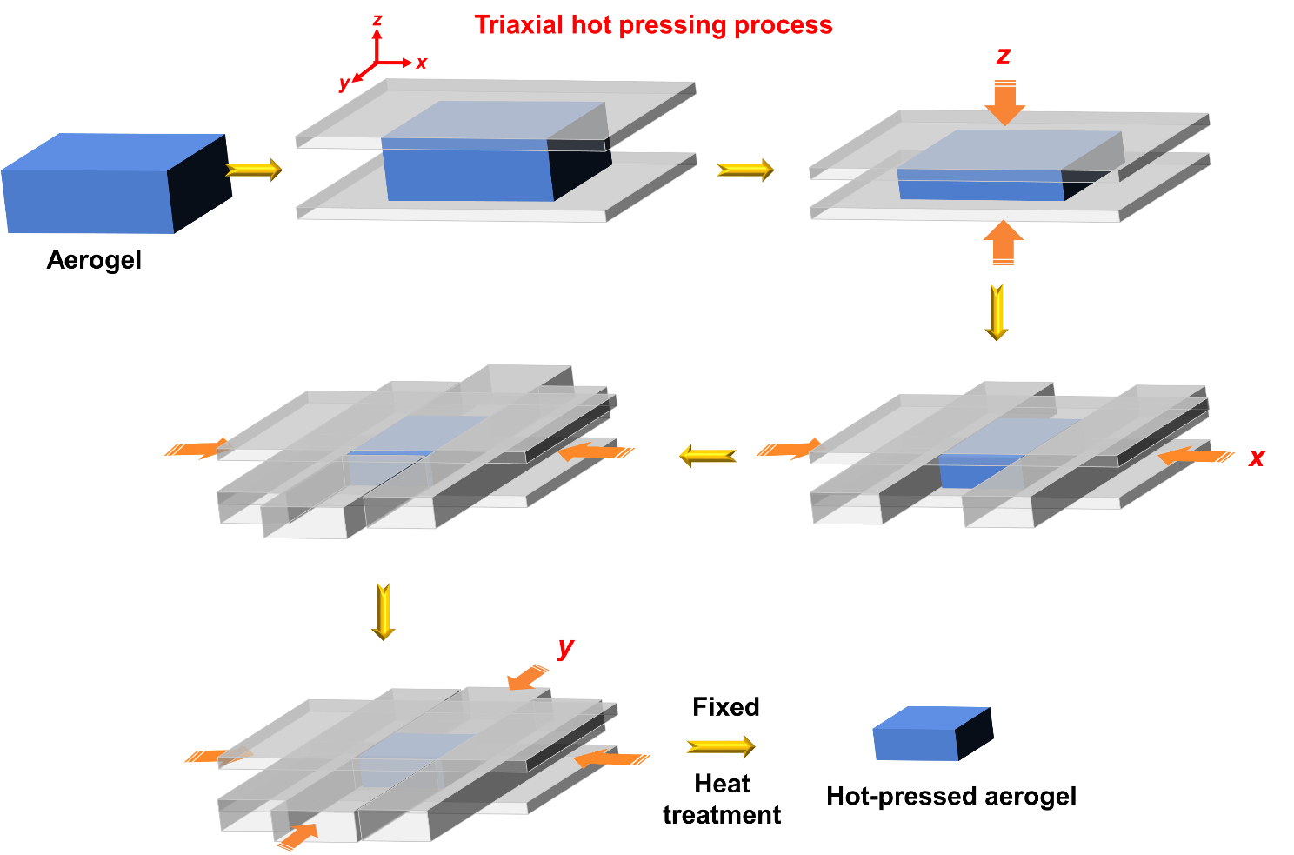
Figure S5. Schematic of the triaxial hot pressing process of the aerogel.

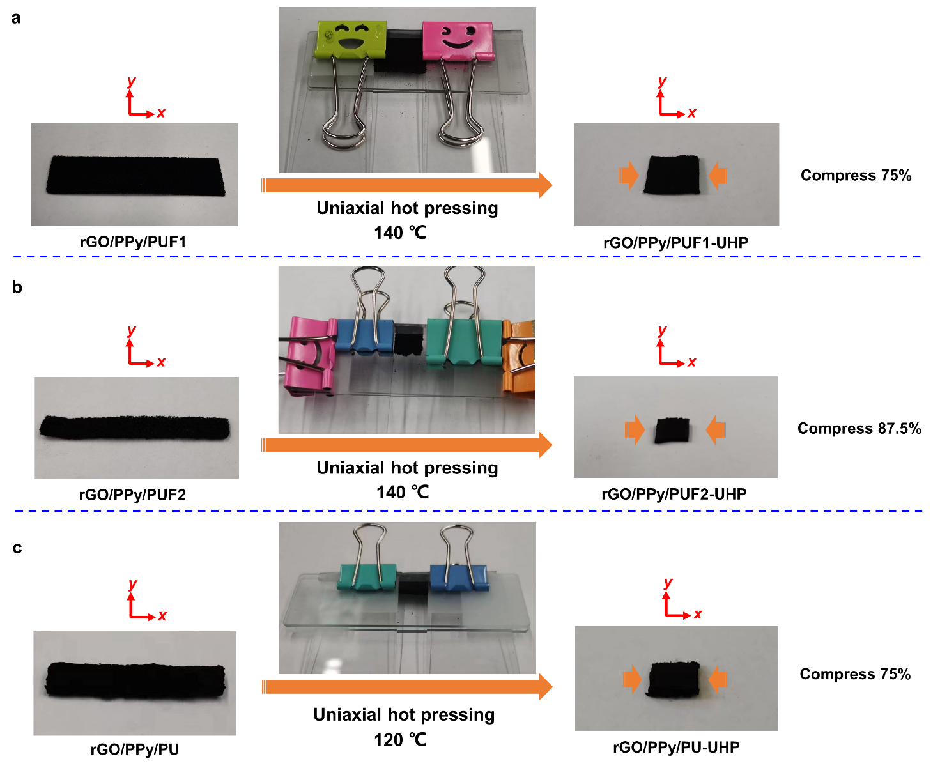
Figure S6. Photographs of the rGO/polymer aerogels before and after uniaxial hot pressing. a) rGO/PPy/PUF1-UHP. b) rGO/PPy/PUF2-UHP. c) rGO/PPy/PU-UHP.

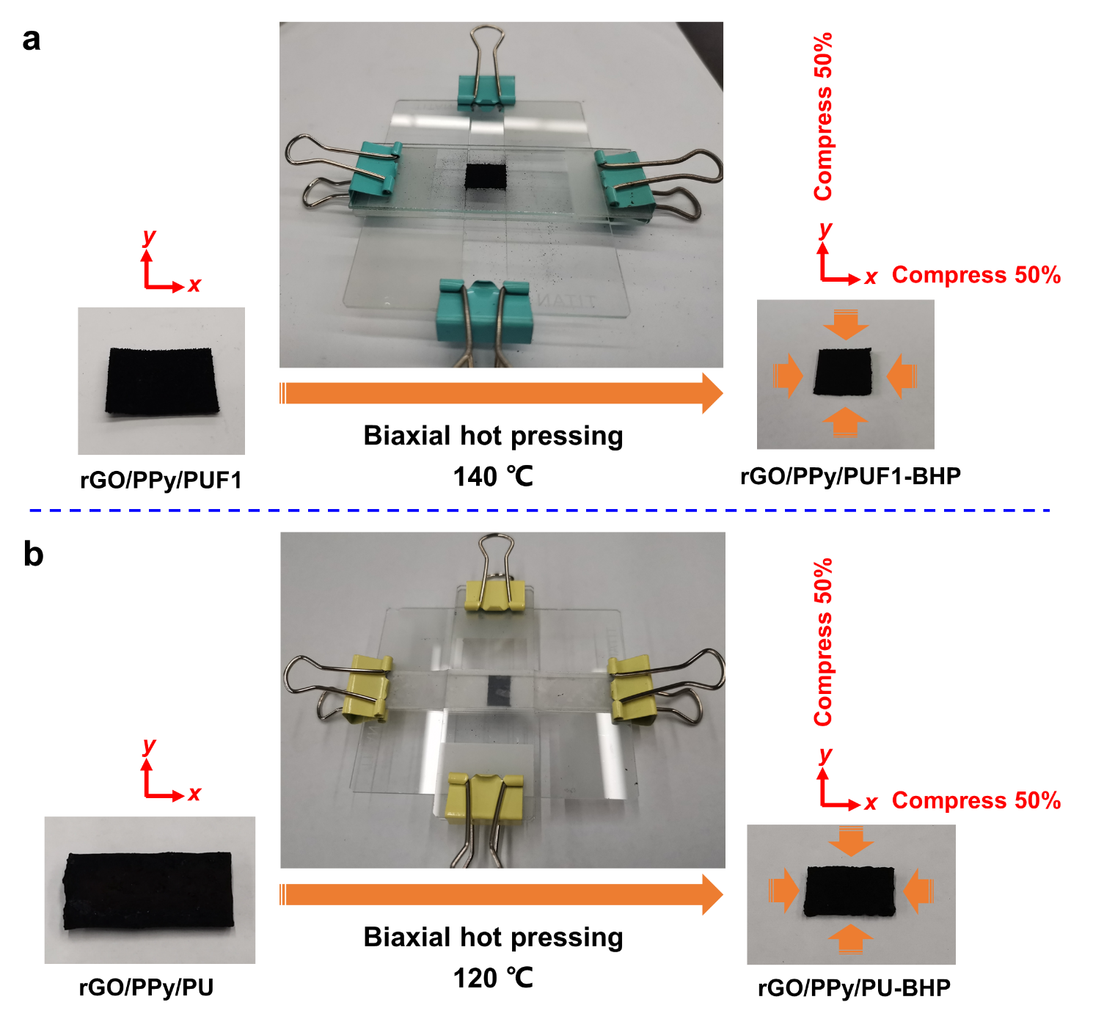
Figure S7. Photographs of the rGO/polymer aerogels before and after biaxial hot pressing. a) rGO/PPy/PUF1-BHP. b) rGO/PPy/PU-BHP.

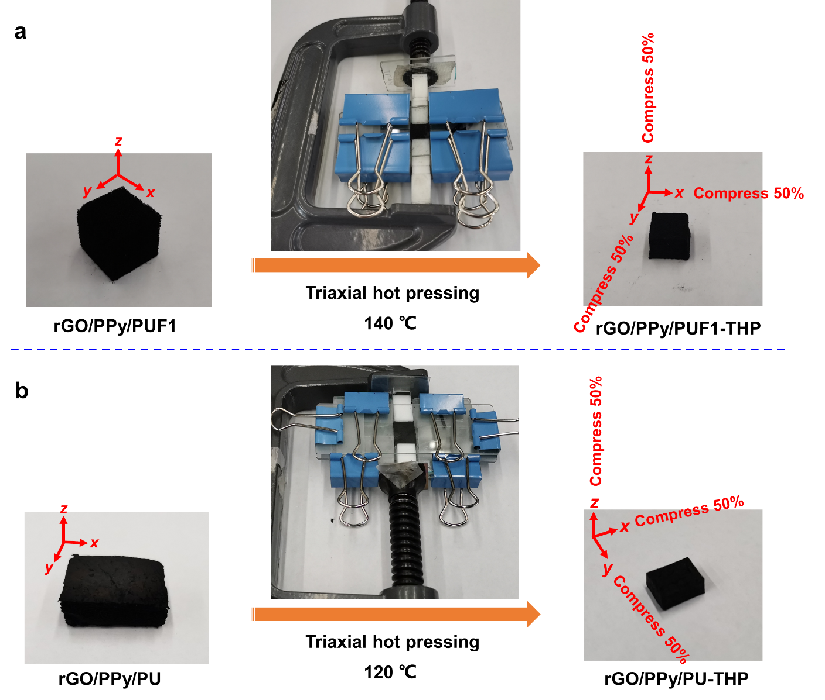
Figure S8. Photographs of the rGO/polymer aerogels before and after triaxial hot pressing. a) rGO/PPy/PUF1-THP. b) rGO/PPy/PU-THP.

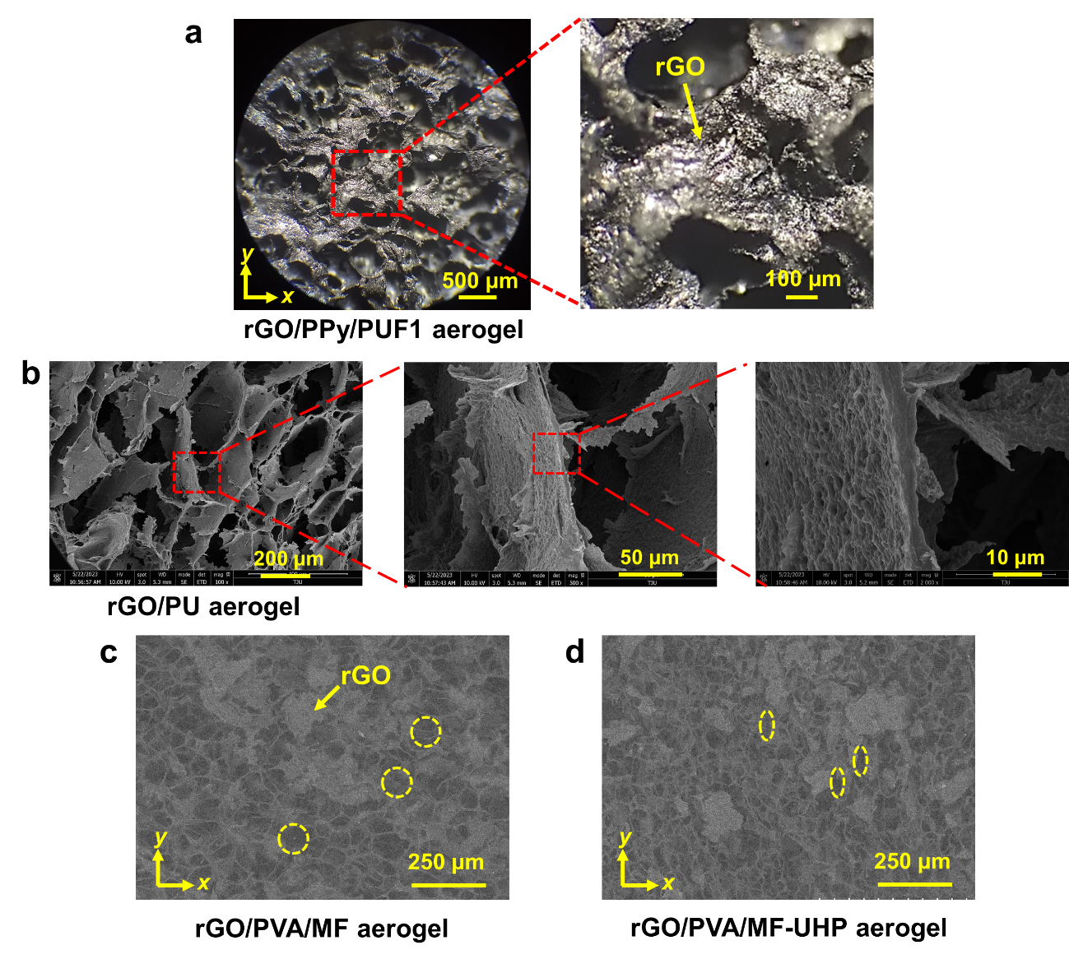
Figure S9. Morphologies of typical rGO/polymer aerogels before and after uniaxial hot pressing. a) Optical microscope image of the rGO/PPy/PUF1 aerogel without hot pressing. b) SEM images of the rGO/PU aerogel. SEM images of the c) pristine rGO/PVA/MF aerogel and d) uniaxially hot-pressed rGO/PVA/MF-UHP aerogel. The uniaxially hot-pressed rGO/PVA/MF-UHP exhibited compressed and folded porous structures with smaller pores compared with those of pristine aerogels.

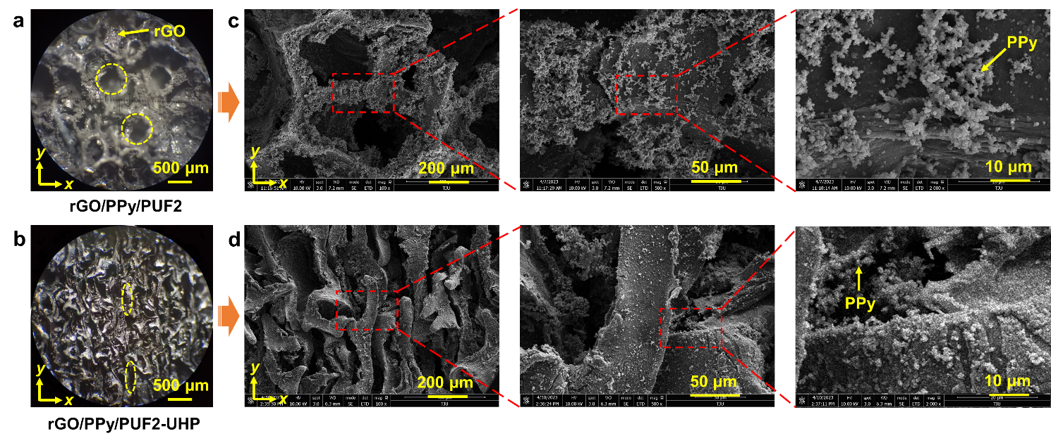
Figure S10. Morphologies of rGO/PPy/PUF2-UHP before and after uniaxial hot pressing. a,b) optical microscope images. c,d) SEM images. The rGO nanosheets and PPy particles were observed in the aerogels rGO/PPy/PUF2 and rGO/PPy/PUF2-UHP. The uniaxially hot-pressed aerogel rGO/PPy/PUF2-UHP exhibited compressed and folded porous structures with smaller pores compared with those of pristine rGO/PPy/PUF2.

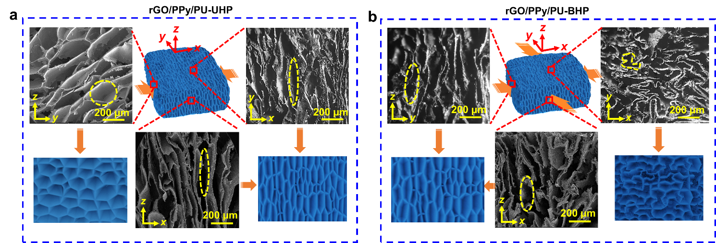
Figure S11. SEM images of the uniaxially and biaxially hot-pressed rGO/PU-based aerogels. a) SEM images of the uniaxially hot-pressed rGO/PPy/PU-UHP in the xy, xz, and yz planes. b) SEM images of the biaxially hot-pressed rGO/PPy/PU-BHP in the xy, xz, and yz planes.

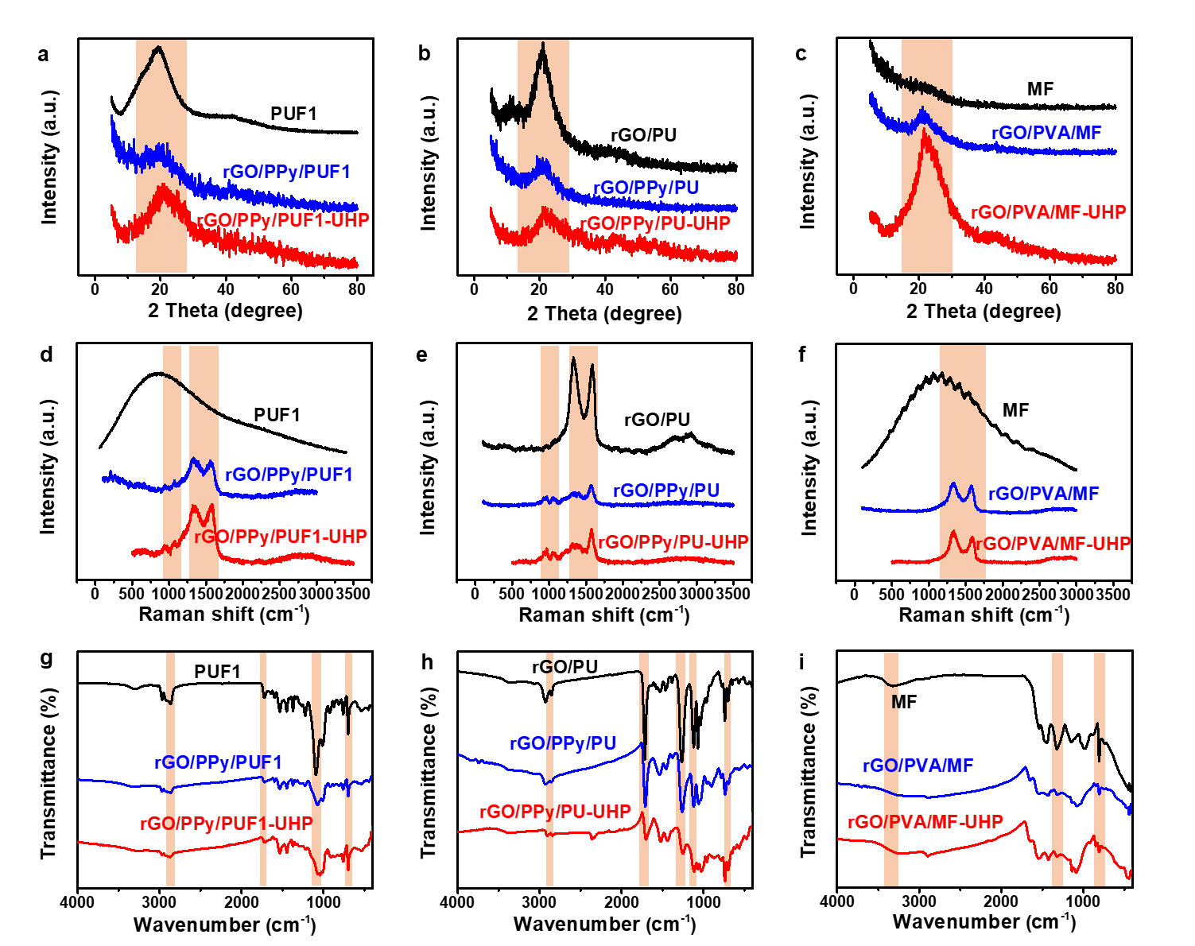
Figure S12. Chemical structures of typical rGO/polymer aerogels. a-c) XRD patterns of the polymers and the aerogels before and after hot pressing. d-f) Raman spectra of the polymers and the aerogels before and after hot pressing. g-i) FTIR spectra of the polymers and the aerogels before and after hot pressing.

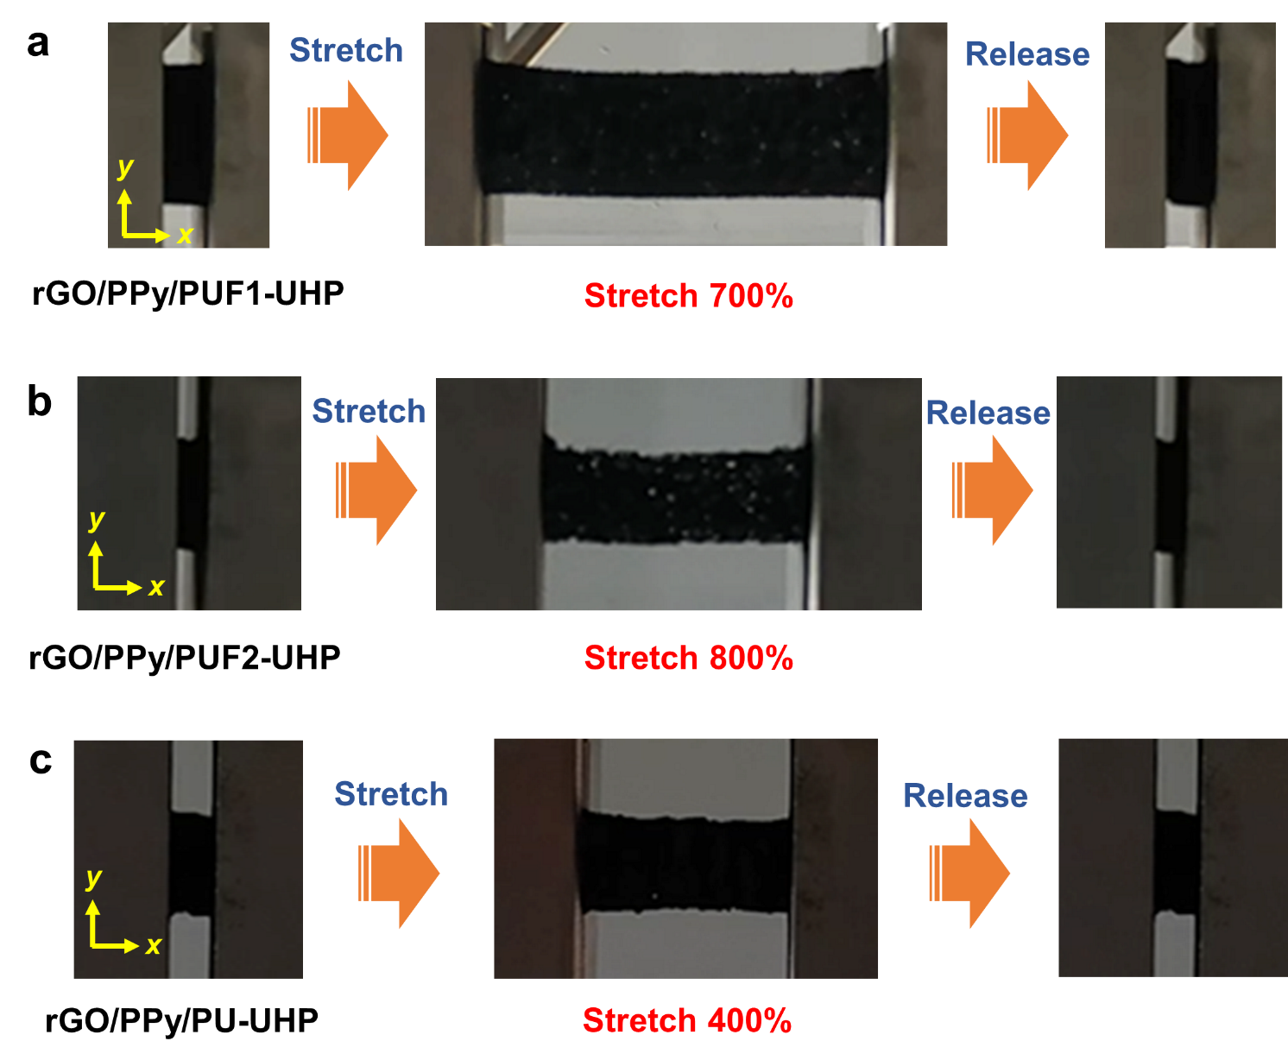
Figure S13. Photographs of the stretching-releasing tests on uniaxially hot-pressed rGO/polymer aerogels with different tensile strains in x direction. a) rGO/PPy/PUF1-UHP. b) rGO/PPy/PUF2-UHP. c) rGO/PPy/PU-UHP. All these aerogels can be stretched with 400-800% tensile strains without fracture and recover their original shapes after being released, indicating the high stretchability and high elasticity of the uniaxially hot-pressed aerogels.

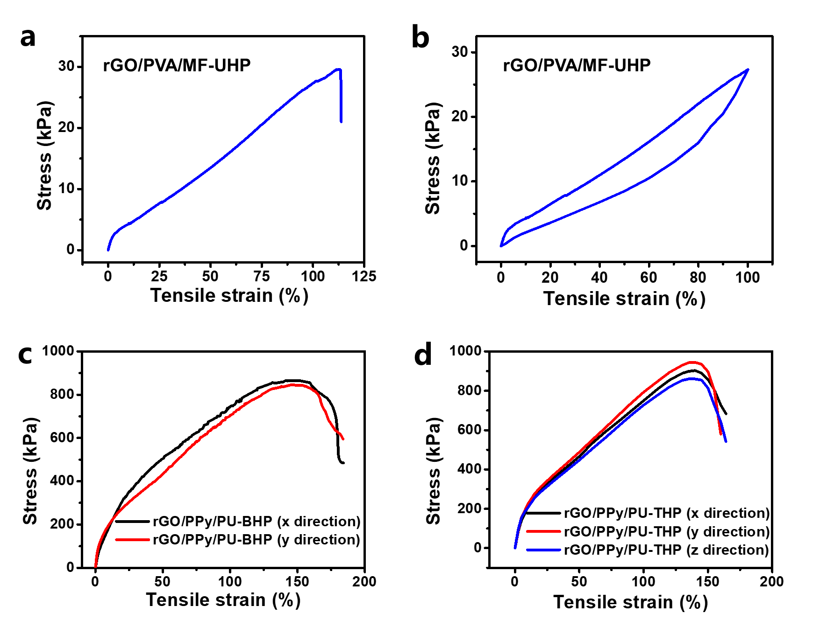
Figure S14. Stress-strain curves of the tensile tests on the uniaxially, biaxially, and triaxially hot-pressed aerogels. a,b) Stress-strain curves of the tensile tests in x direction on rGO/PVA/MF-UHP. c,d) Stress-strain curves of the tensile tests in different directions on c) rGO/PPy/PU-BHP and d) rGO/PPy/PU-THP. rGO/PVA/MF-UHP exhibited an elongation at break of 112% and can be reversibly stretched with 100% tensile strain. The elongations at break of rGO/PPy/PU-BHP and rGO/PPy/PU-THP were approximately 160% and 140%, respectively.

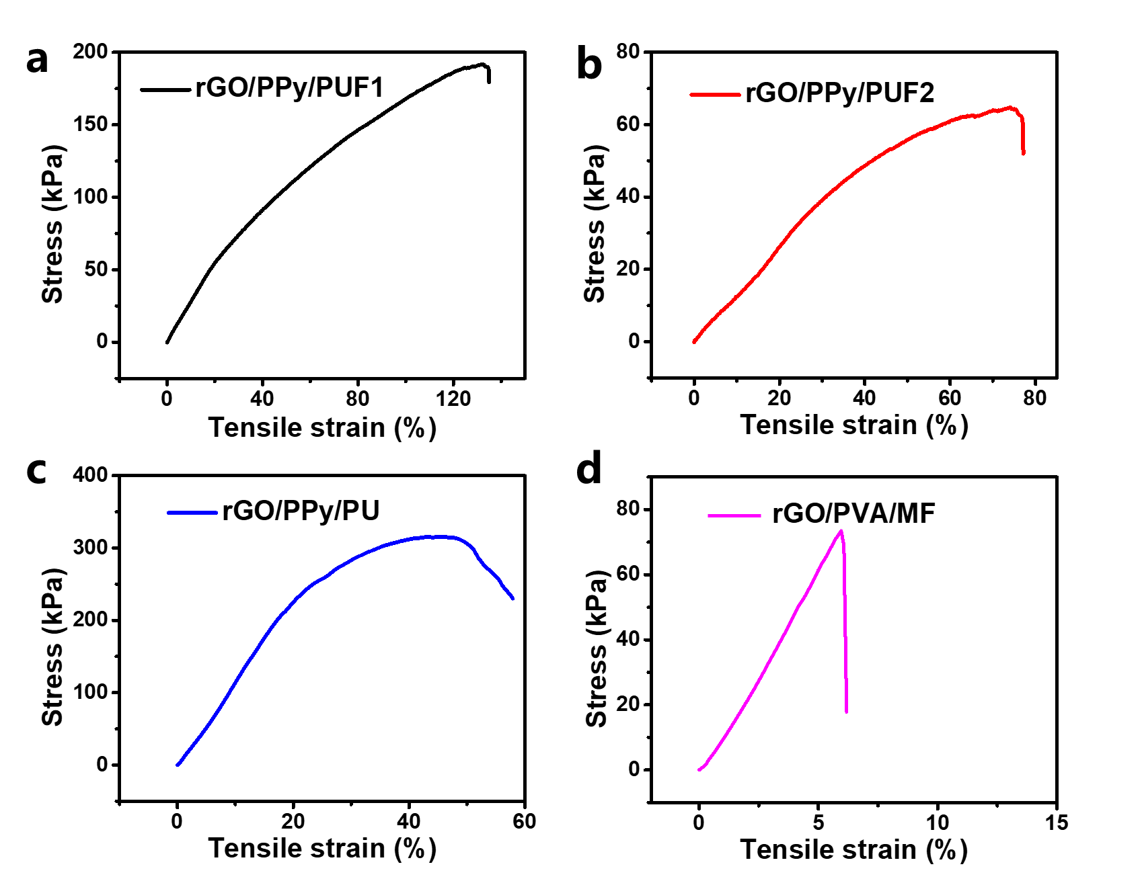
Figure S15. Stress-strain curves of the tensile tests on the pristine rGO/polymer aerogels without hot pressing. a) rGO/PPy/PUF1. b) rGO/PPy/PUF2. c) rGO/PPy/PU. d) rGO/PVA/MF. The elongations at break of rGO/PPy/PUF1, rGO/PPy/PUF2, rGO/PPy/PU, and rGO/PVA/MF were 130%, 76%, 51%, and 6%, respectively.

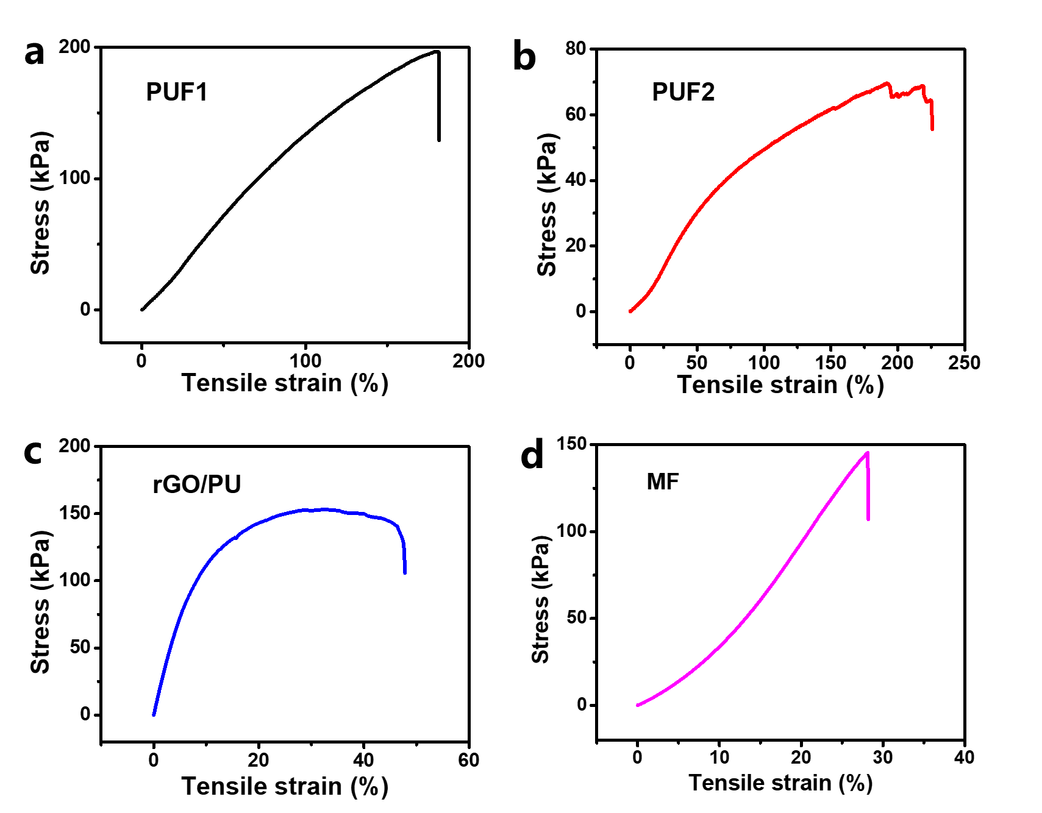
Figure S16. Stress-strain curves of the tensile tests on the foams and rGO/PU aerogel. a) PUF1. b) PUF2. c) rGO/PU aerogel. d) MF. The elongations at break of PUF1, PUF2, MF, and the rGO/PU aerogel were 180%, 193%, 28%, and 47%, respectively.

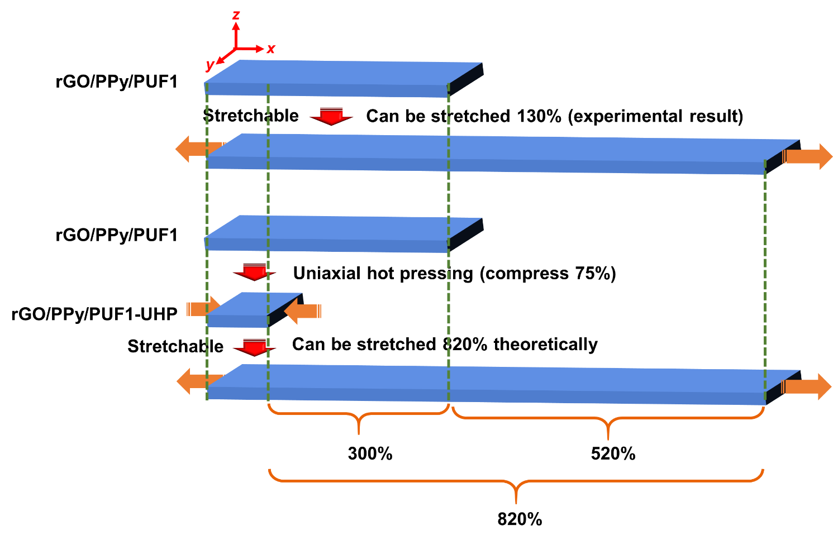
Figure S17. Illustration showing the calculation of the theoretical value of the elongation at break for the uniaxially hot-pressed aerogel rGO/PPy/PUF1-UHP.

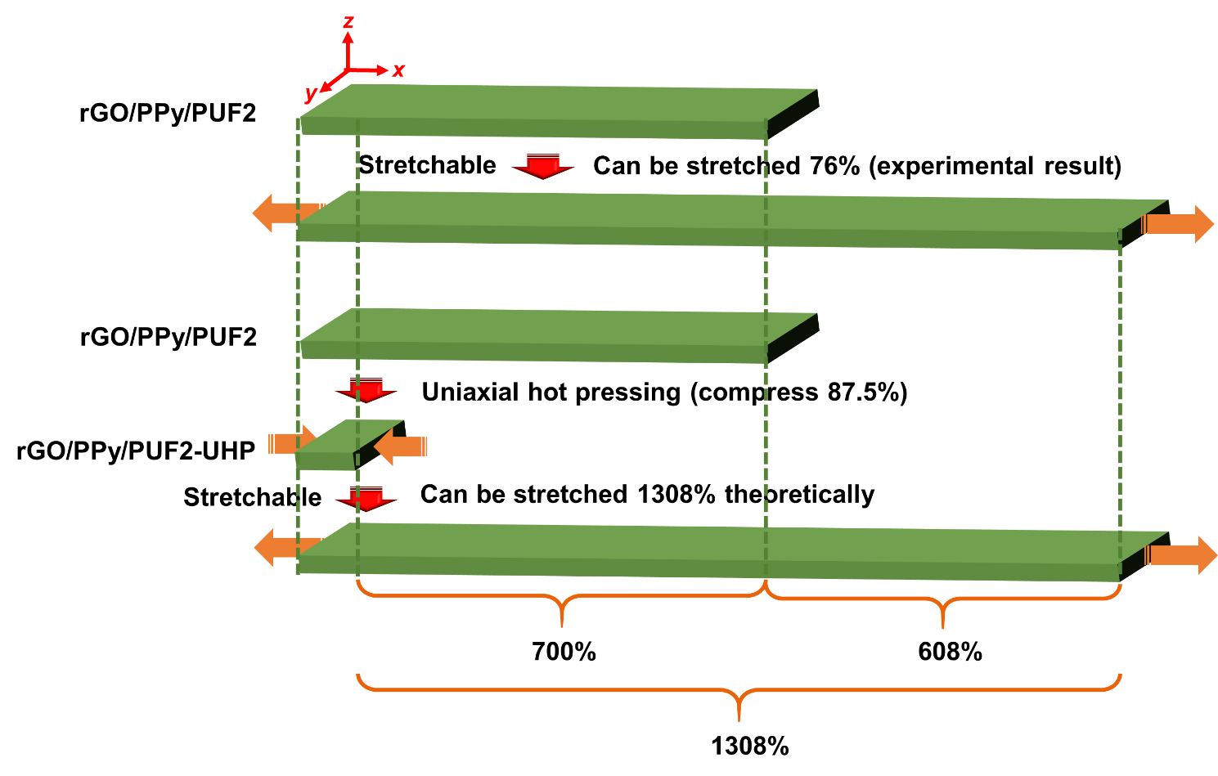
Figure S18. Illustration showing the calculation of the theoretical value of the elongation at break for the uniaxially hot-pressed aerogel rGO/PPy/PUF2-UHP.

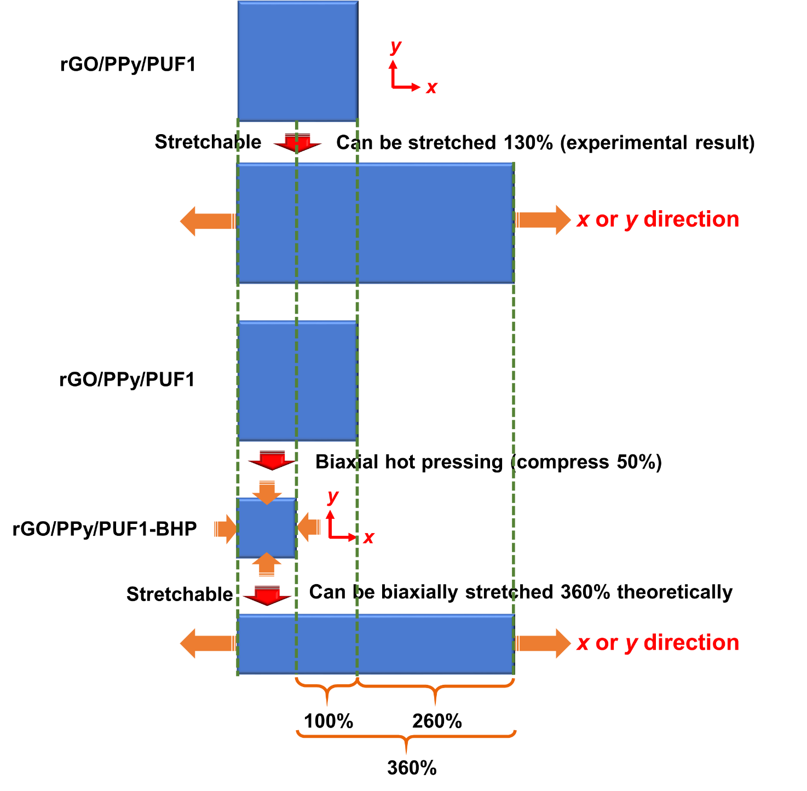
Figure S19. Illustration showing the calculation of the theoretical value of the elongation at break for the biaxially hot-pressed aerogel rGO/PPy/PUF1-BHP.

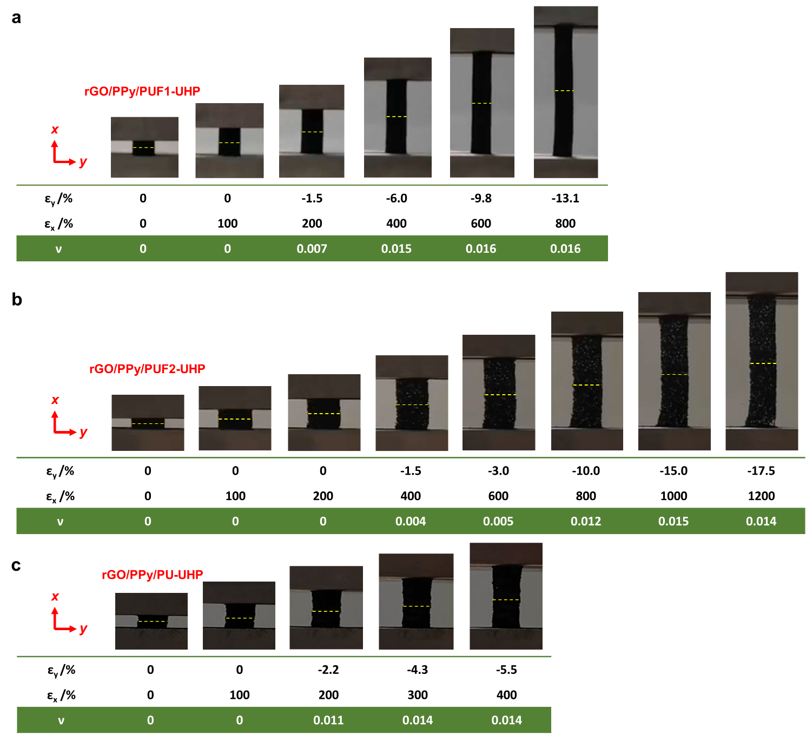
Figure S20. Photographs and Poisson’s ratios (ν) of the uniaxially hot-pressed rGO/polymer aerogels upon stretching with different tensile strains in x direction. a) rGO/PPy/PUF1-UHP. b) rGO/PPy/PUF2-UHP. c) rGO/PPy/PU-UHP. The uniaxially hot-pressed aerogels showed zero or low Poisson’s ratios upon stretching over a wide range of tensile strains.

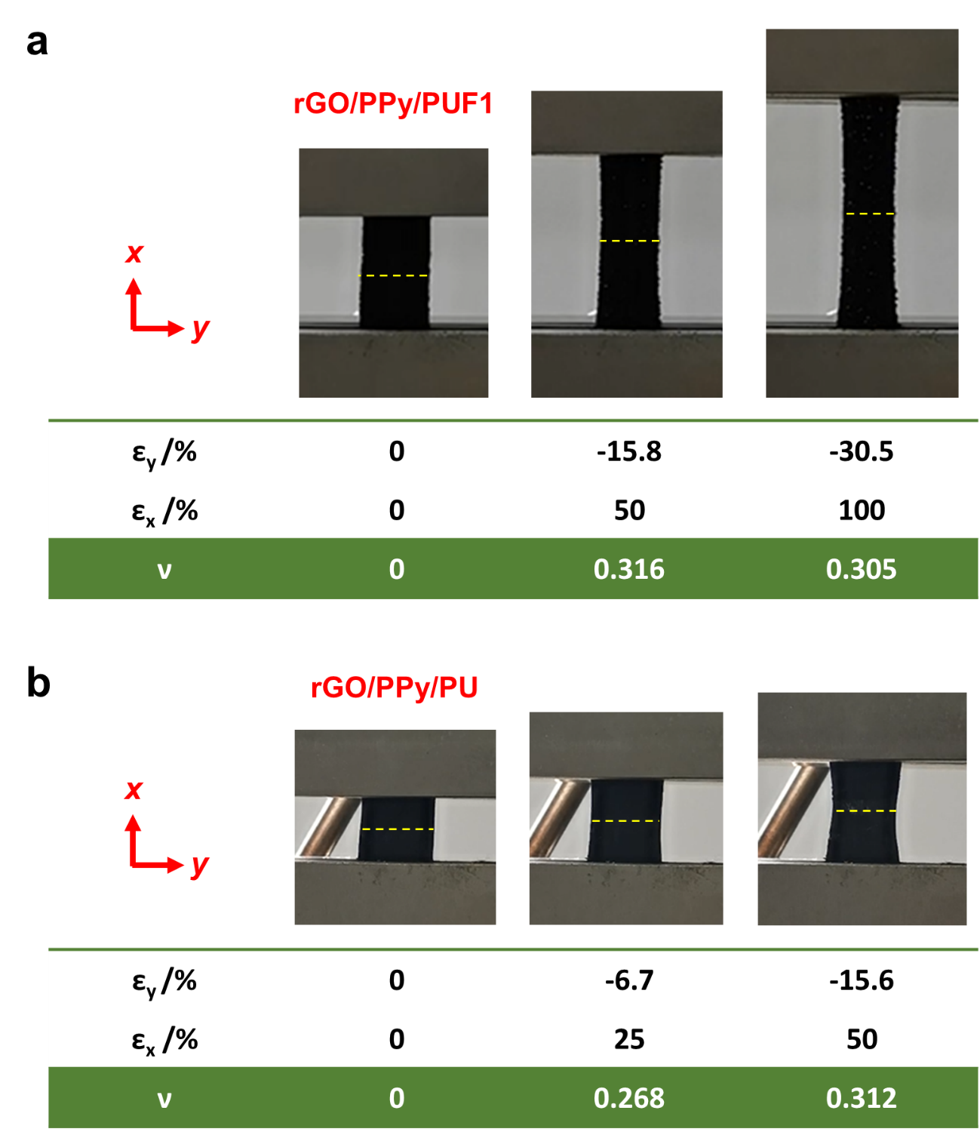
Figure S21. Photographs and Poisson’s ratios (ν) of the rGO/polymer aerogels without hot pressing upon stretching. a) rGO/PPy/PUF1. b) rGO/PPy/PU. It was shown that the Poisson’s ratios of the rGO/polymer aerogels without hot pressing were much higher than those of the uniaxially hot-pressed rGO/polymer aerogels upon stretching in x direction.

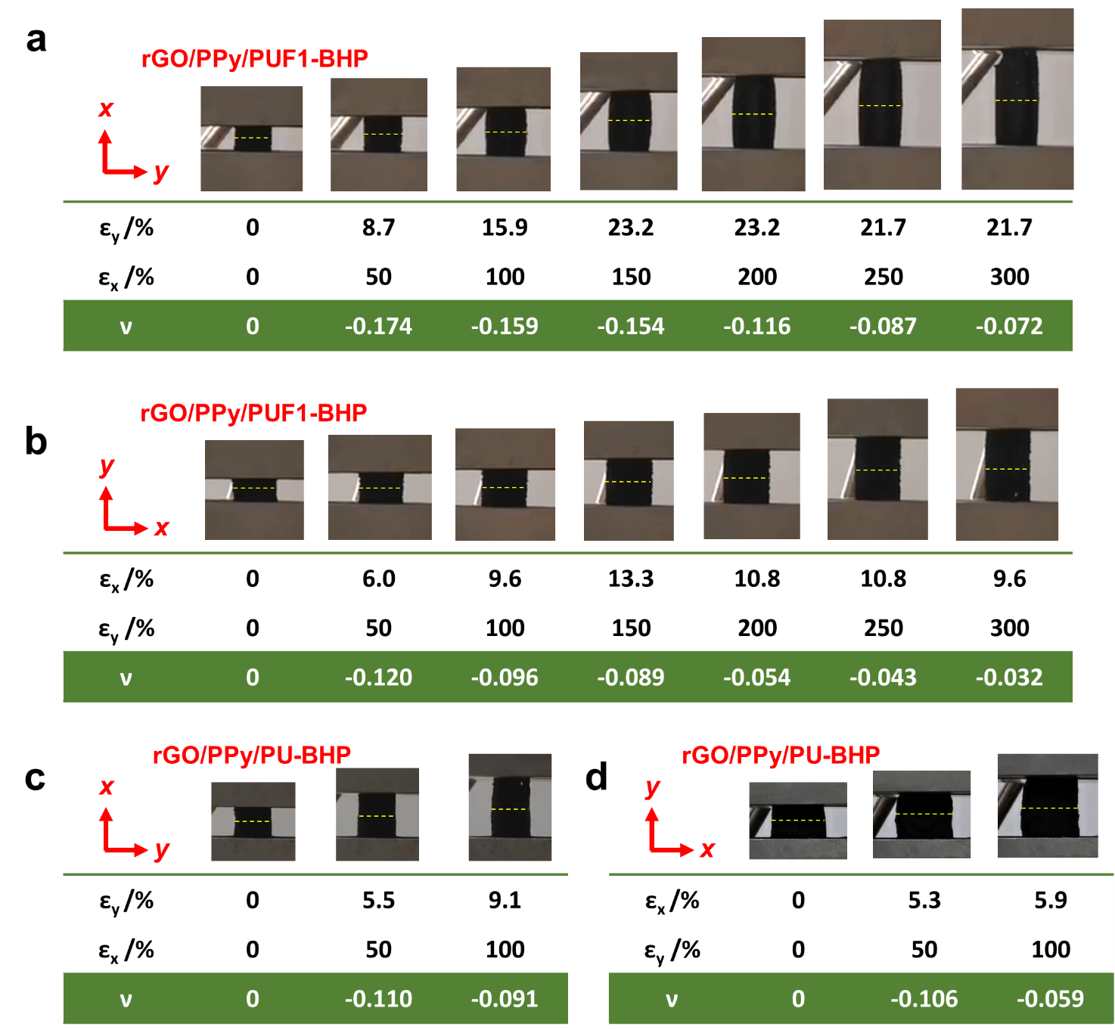
Figure S22. Photographs and Poisson’s ratios (ν) of the biaxially hot-pressed rGO/polymer aerogels upon stretching in x and y directions with different tensile strains. a) rGO/PPy/PUF1-BHP stretched in x direction. b) rGO/PPy/PUF1-BHP stretched in y direction. c) rGO/PPy/PU-BHP stretched in x direction. d) rGO/PPy/PU-BHP stretched in y direction. The biaxially hot-pressed rGO/polymer aerogels showed negative Poisson’s ratios upon stretching in both x and y directions over a wide range of tensile strains.

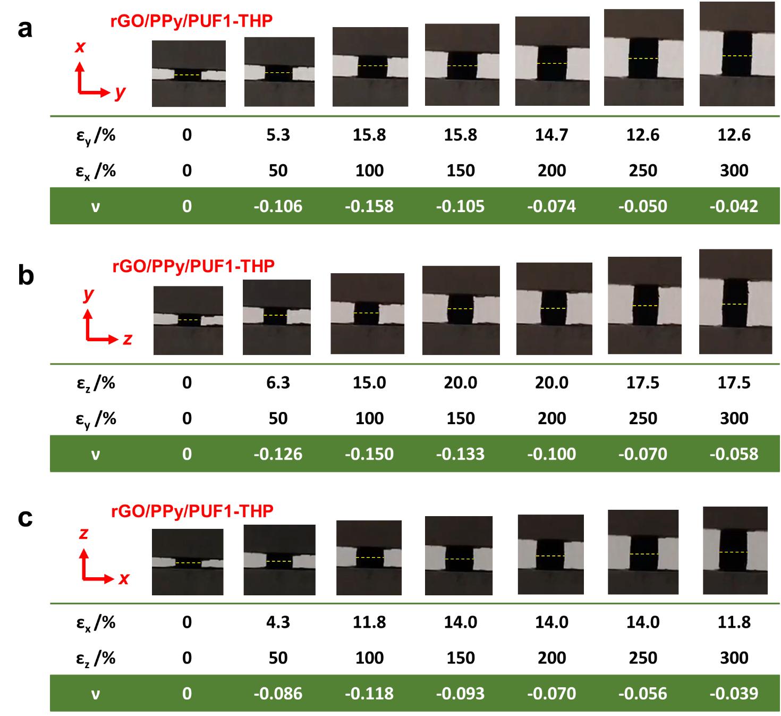
Figure S23. Photographs and Poisson’s ratios (ν) of the triaxially hot-pressed rGO/polymer aerogel rGO/PPy/PUF1-THP upon stretching in x, y, and z directions with different tensile strains. a) Stretch in x direction. b) Stretch in y direction. c) Stretch in z direction. The triaxially hot-pressed rGO/polymer aerogel showed negative Poisson’s ratios upon stretching in x, y, and z directions over a wide range of tensile strains.

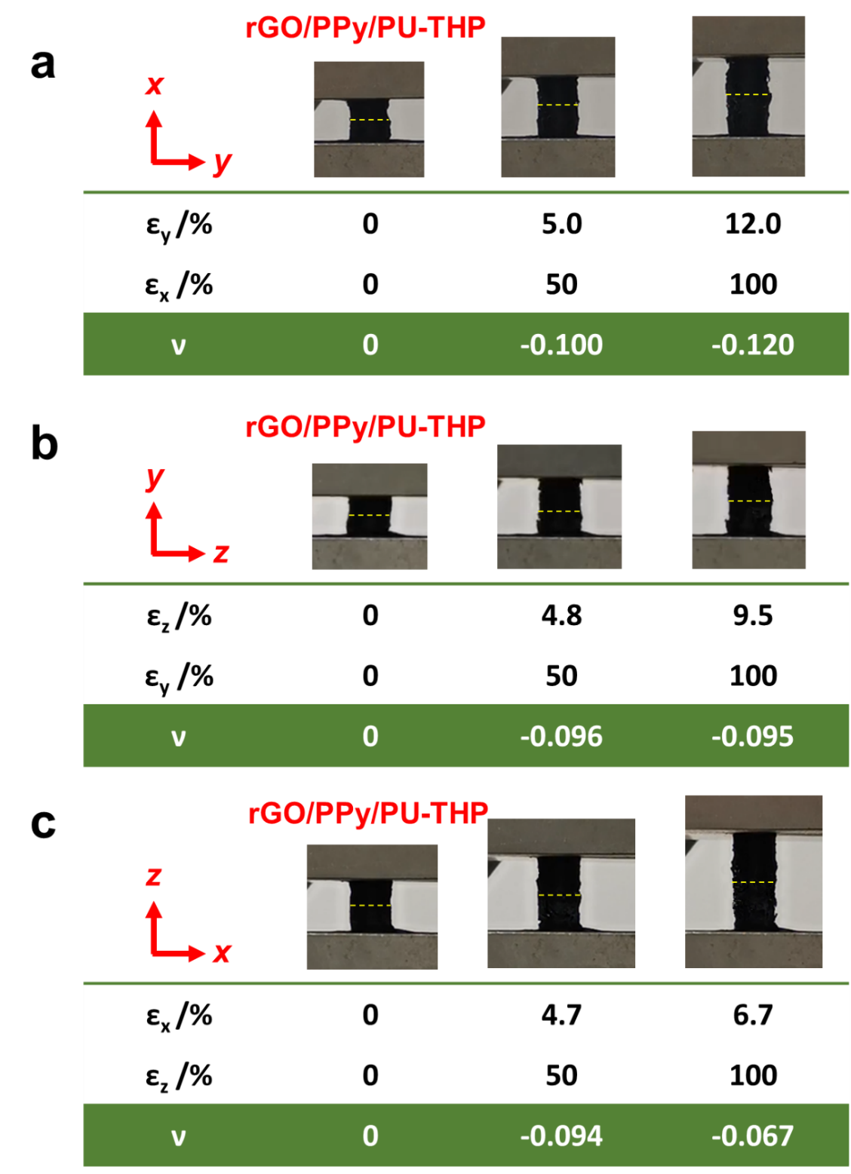
Figure S24. Photographs and Poisson’s ratios (ν) of the triaxially hot-pressed rGO/polymer aerogel rGO/PPy/PU-THP upon stretching in x, y, and z directions with different tensile strains. a) Stretch in x direction. b) Stretch in y direction. c) Stretch in z direction. The triaxially hot-pressed rGO/polymer aerogel rGO/PPy/PU-THP showed negative Poisson’s ratios upon stretching in x, y, and z directions.

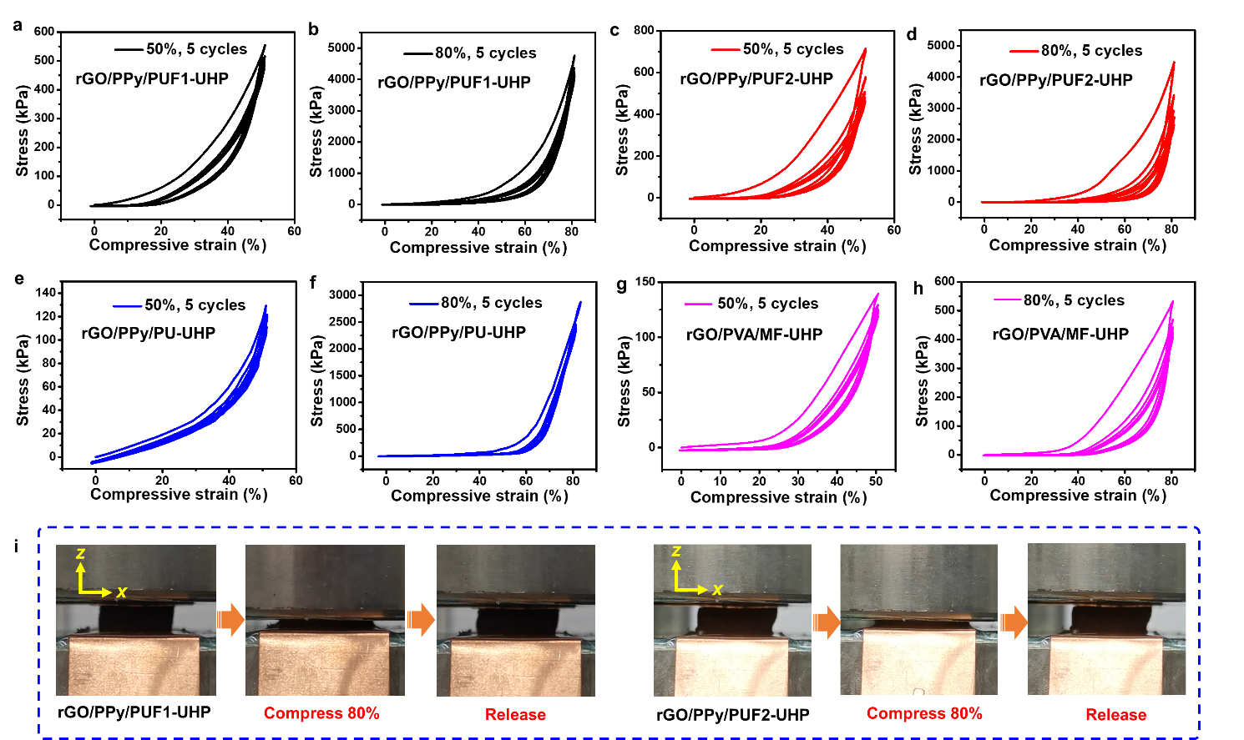
Figure S25. Stress-strain curves and photographs of the compression-decompression tests in z direction on the uniaxially hot-pressed rGO/polymer aerogels with strains of 50% and 80%. a,b) rGO/PPy/PUF1-UHP. c,d) rGO/PPy/PUF2-UHP. e,f) rGO/PPy/PU-UHP. g,h) rGO/PVA/MF-UHP. i) Photographs of the compression-decompression tests on rGO/PPy/PUF1-UHP and rGO/PPy/PUF2-UHP. The compressive stresses of rGO/PPy/PUF1-UHP, rGO/PPy/PUF2-UHP, rGO/PPy/PU-UHP, and rGO/PVA/MF-UHP at 80% strain in z direction were 4.7 MPa, 4.4 MPa, 2.8 MPa, 8.2 MPa, and 530 kPa, respectively.

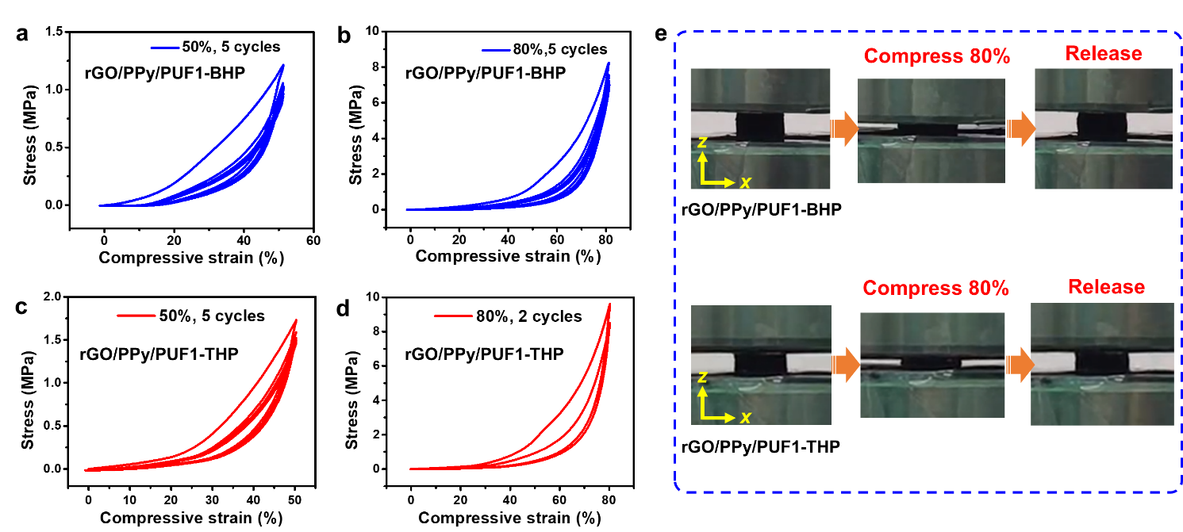
Figure S26. Compression-decompression tests in z direction on biaxially and triaxially hot-pressed rGO/polymer aerogels with strains of 50% and 80%. a,b) rGO/PPy/PUF1-BHP. c,d) rGO/PPy/PUF1-THP. e) Photographs of the compression-decompression tests on rGO/PPy/PUF1-BHP and rGO/PPy/PUF1-THP. The compressive stresses of rGO/PPy/PUF1-BHP and rGO/PPy/PUF1-THP at 80% strain in z direction were 8.2 MPa and 9.5 MPa, respectively.
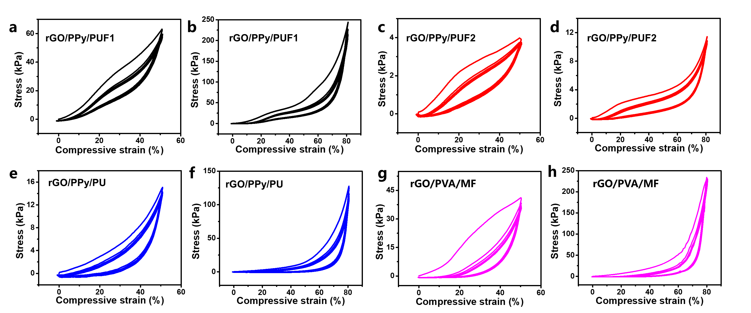
Figure S27. Stress-strain curves of the compression-decompression tests (5 cycles) in z direction on the pristine rGO/polymer aerogels without hot pressing with strains of 50% and 80%. a,b) rGO/PPy/PUF1. c,d) rGO/PPy/PUF2. e,f) rGO/PPy/PU. g,h) rGO/PVA/MF. The compressive stresses of rGO/PPy/PUF1, rGO/PPy/PUF2, rGO/PPy/PU, and rGO/PVA/MF at 80% strain were 242 kPa, 11.5 kPa, and 126 kPa, and 225 kPa, respectively.

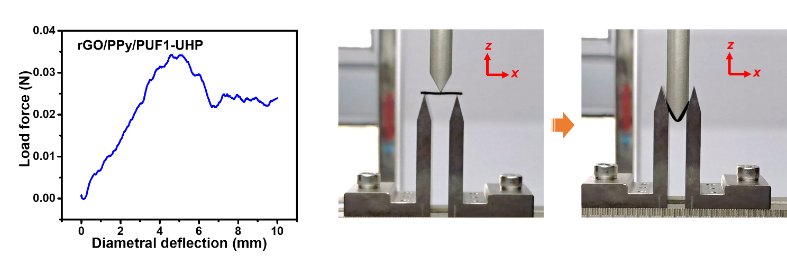
Figure S28. Three-point bending test on the uniaxially hot-pressed aerogel rGO/PPy/PUF1-UHP.

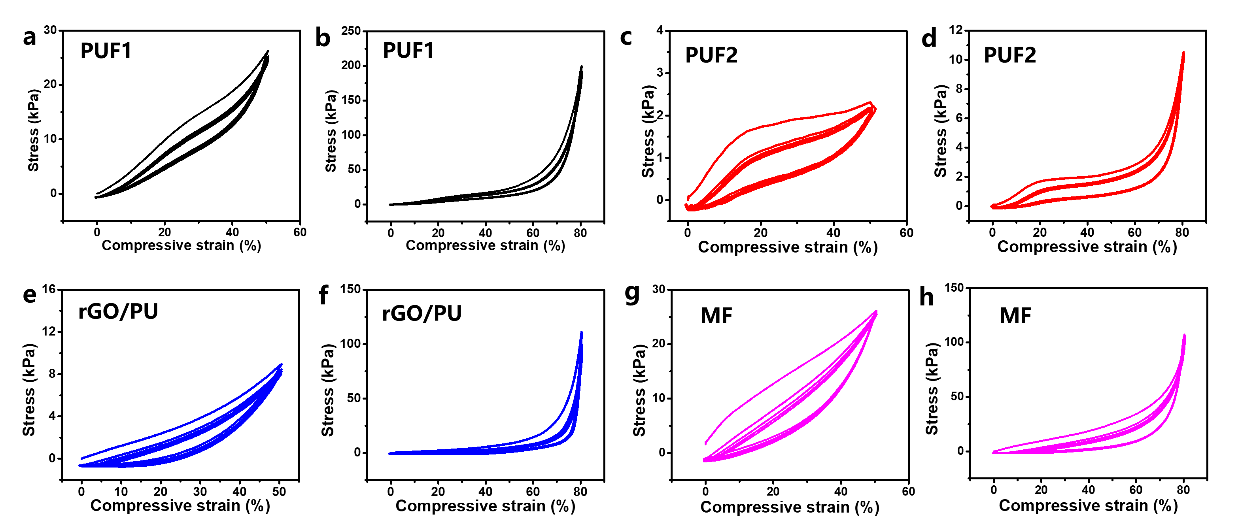
Figure S29. Stress-strain curves of the compression-decompression tests (5 cycles) in z direction on the foams and the rGO/PU aerogel with strains of 50% and 80%. a,b) PUF1. c,d) PUF2. e,f) rGO/PU aerogel. g,h) MF.

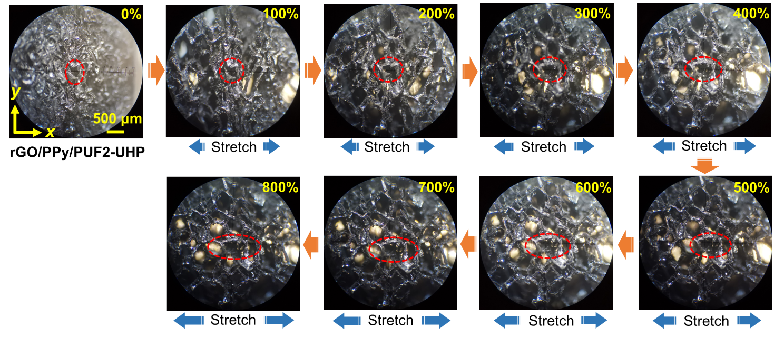
Figure S30. In-situ optical microscope images of rGO/PPy/PUF2-UHP upon stretching in x direction in the range of 0-800% tensile strain.

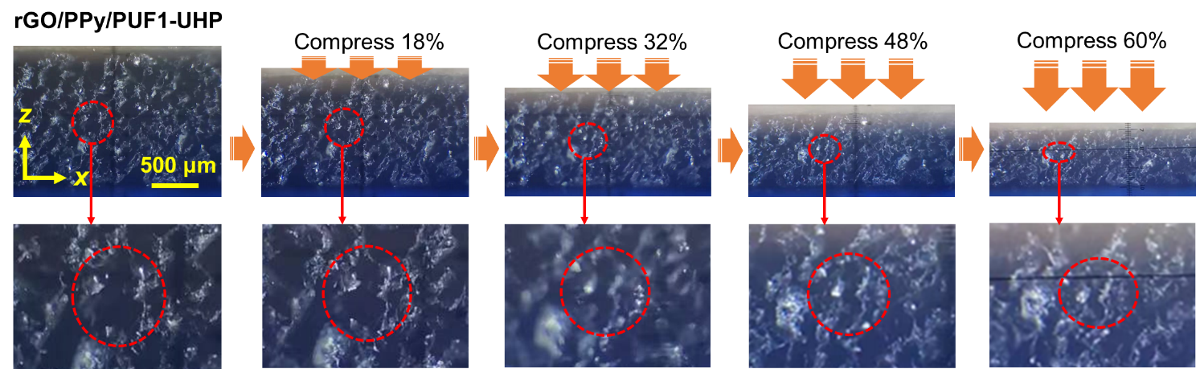
Figure S31. In-situ optical microscope images of rGO/PPy/PUF1-UHP upon compression in z direction in the range of 0-60% compressive strain.

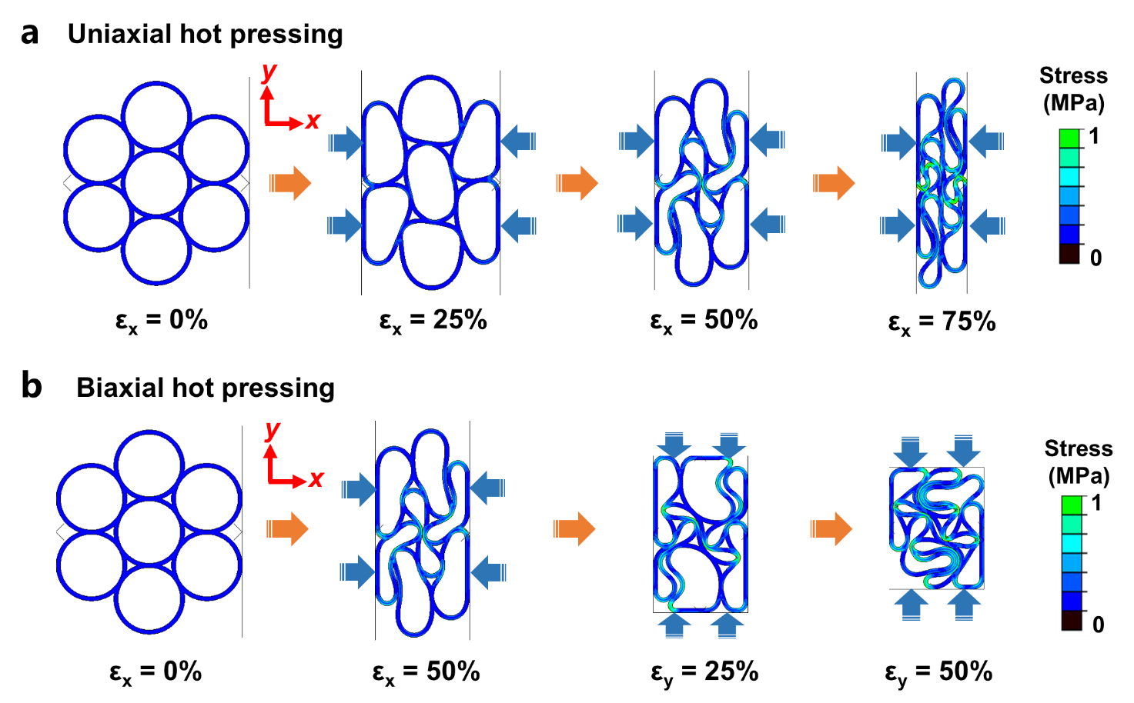
Figure S32. FEA simulations of the structure variations and stress distributions of the rGO/polymer composite aerogels during a) uniaxial and b) biaxial hot pressing.

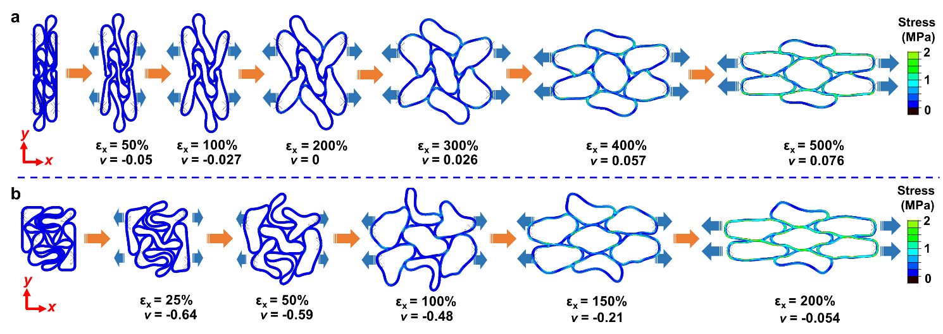
Figure S33. FEA simulations of the structure variations and stress distributions of the a) uniaxially and b) biaxially hot-pressed rGO/polymer composite aerogels during stretching.

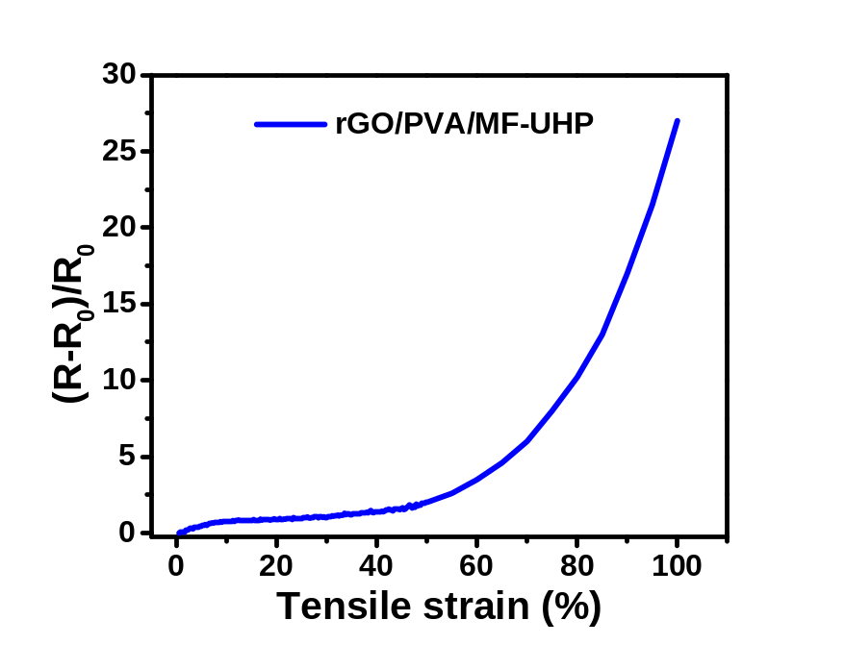
Figure S34. Relative resistance changes versus tensile strain in x direction for the strain sensor based on rGO/PVA/MF-UHP.

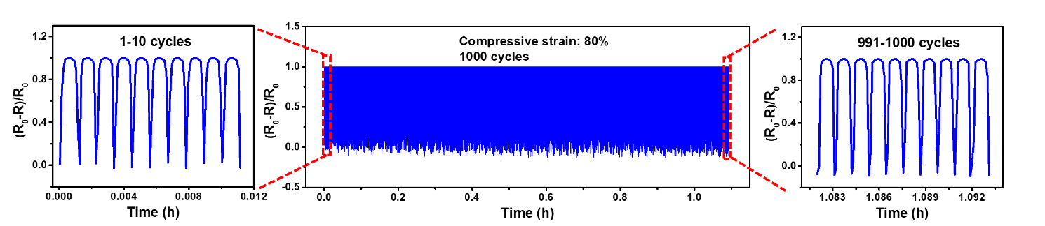
Figure S35. Compression durability test of the rGO/PPy/PUF1-UHP-based pressure sensor with 80% compressive strain in z direction for 1000 cycles.

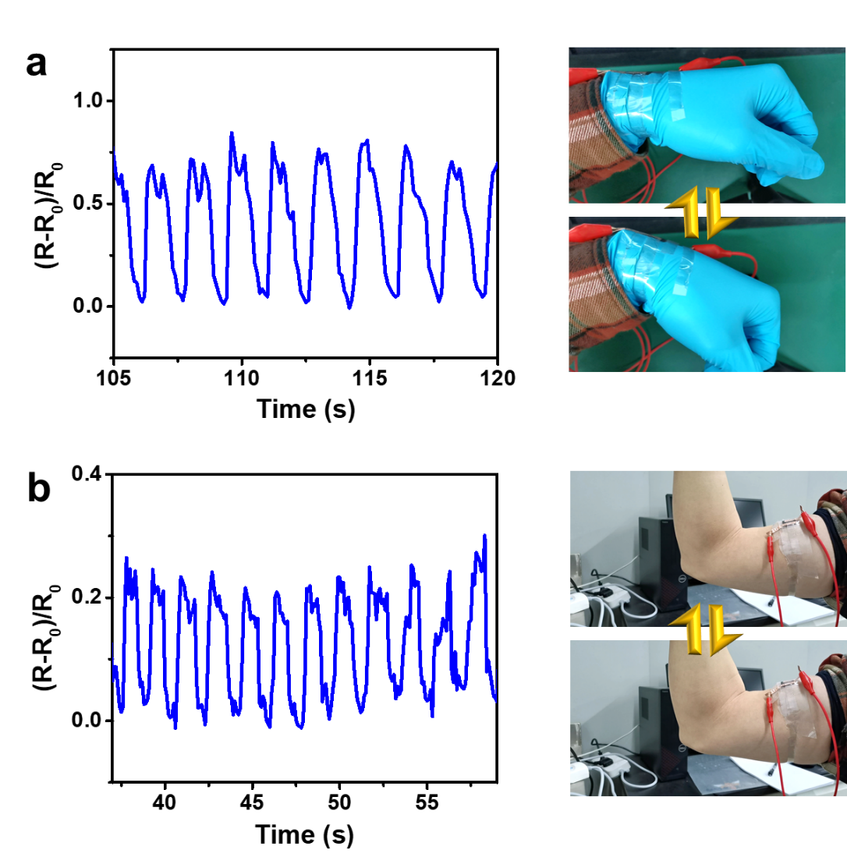
Figure S36. Monitoring a) wrist bending and b) muscular movement by the rGO/PPy/PUF1-UHP-based strain/pressure sensors.

Tables

Table S1. Starting compositions of the rGO/PUF-based aerogels (rGO/PPy/PUF1 and rGO/PPy/PUF2).
 | Preparation of rGO/PUF aerogel |  | Deposition of PPy
Reagent | GO  (4 mg mL⁻¹) | EDA  (AR) | FeCl₃ (98%) | H₂O  (DIW) | Pyrrole (99%)
Amount | 4 mL | 0.032 mL | 0.2268 g | 8 mL | 0.066 mL

Table S2. Starting compositions of the rGO/PU-based aerogel (rGO/PPy/PU).
 | Preparation of rGO/PU aerogel |  |  |  | Deposition of PPy
Reagent | GO  (4 mg mL⁻¹) | PU dispersion  (50 wt% in water) | H₂O  (DIW) | APTES  (98%) |  | FeCl₃ (98%) | H₂O  (DIW) | Pyrrole (99%)
Amount | 8 mL | 1.28 mL | 8 mL | 0.096 mL |  | 0.2268 g | 8 mL | 0.066 mL

Table S3. Starting compositions of the rGO/PVA/MF aerogel.
Reagent | GO  (4 mg/mL) | PVA  (0.05 g/mL) | EDA  (AR)
Amount | 4 mL | 0.16 mL | 0.032 mL

Table S4. Comparison of the stretchability of our aerogels and the reported intrinsically stretchable aerogels.
Ref. | Published year | Composition | Elongation at break (%) | Reversible elongation (%)
1 | 2021 | Poly(isocyanurate-urethane) | 120 | -
2 | 2020 | Poly(caprolactone) | 275 | -
3 | 2021 | Polyimide | 25 | -
4 | 2022 | Cellulose | 50 | -
5 | 2020 | Cellulose nanofiber/polyurethane(PU) | 25 | -
6 | 2019 | Poly(3,4-ethylenedioxythiophene): polystyrene sulfonate (PEDOT:PSS) | 100 | 60
7 | 2018 | MXene/polyimide | 35 | 20
8 | 2015 | Graphene/polyimide | 16 | -
9 | 2022 | Aramid nanofiber/carbon nanotube (CNT) /polypyrrole | 26 | -
10 | 2023 | Reduced graphene oxide (rGO)/PU | 100 | -
11 | 2021 | Carbon | 80 | 60
12 | 2020 | Graphene | 20 | -
13 | 2023 | Graphene | 420 | 400
14 | 2021 | SiC-SiOx nanowire | 22 | 20
15 | 2022 | Aramid nanofiber composite | 30 | -
16 | 2023 | Silica nanofiber | 220 | -
17 | 2022 | Ceramic nanofiber | 100 | 40
18 | 2022 | Hypocrystalline ceramic nanofiber | 40 | -
19 | 2023 | Si₃N₄ nanofiber | 80 | 20
This work |  | rGO/PPy/PUF composite | 1250 | ≥800

Table S5. Stretchability of the reported intrinsically stretchable porous materials (mainly foams and sponges) other than aerogels.
Ref. | Published year | Composition | Elongation at break (%) | Reversible elongation (%)
20 | 2021 | Si₃N₄ Nanofiber | 30 | 10
21 | 2017 | Graphene/nickel particle | 160 | -
22 | 2014 | CNT/graphene/ poly(dimethylsiloxane) (PDMS) | 80 | 50
23 | 2017 | CNT/PDMS | 140 | 120
24 | 2015 | Graphene/PDMS | - | 77
25 | 2019 | Graphene/modified silicone rubber | ≥100 | 40
26 | 2018 | Graphene/PDMS | 64 | 56
27 | 2020 | Single-wall CNT/PDMS | 62 | 50
28 | 2016 | Metal/PDMS | - | 50
29 | 2022 | Graphene nanoplate/PDMS | ~140 | 70
30 | 2018 | CNT/polyurethane (PU) | 320 | 300
31 | 2020 | CNT/PU | 350 | ~60
32 | 2020 | CB/TPU | ~600 | ~200
33 | 2020 | Polystyrene/PU | 70 | 40
34 | 2021 | Fe₃O₄/PU | 184 | 20
34 | 2021 | CNT/ Fe₃O₄/PU | ~90 | 20
35 | 2022 | CNT/PU | ~900 | 900
36 | 2020 | CNT/PU foam | 275 | 40
37 | 2018 | rGO/AgNWs/PU | - | 60
38 | 2021 | Liquid metal/PUF | 170 | -
39 | 2020 | GO/PU | ~700 | -
40 | 2015 | TPU/graphene | ~900 | ~400
41 | 2019 | Liqiud metal/polydopamine-modified PU sponge | ~150 | 50
42 | 2020 | AgNW/TPU | - | ~55
43 | 2020 | PVDF-HFP foam with Ni particles | ~240 | -
44 | 2019 | Polyacrylate-based polymer | 650 | -
45 | 2015 | Graphene/PEDOT:PSS/PDMS | 80 | 50
46 | 2021 | Porous polyetheretherketone fibers | 235 | -
47 | 2021 | Polysulfone/PVDF composite fibrous sponge | ~110 | -
48 | 2021 | PEMP/OEGDA polyHIPE fibers | 155 | -
49 | 2018 | Graphene foam/PPy | - | 50
50 | 2021 | Wavy graphene foam/TPU | 400 | 200
51 | 2014 | Graphene/AgNW hybrid foam | 54 | 40
52 | 2020 | CNT-GO@melamine sponge | 50 | 10
53 | 2019 | Silicon sponge | 50 | 25
54 | 2020 | PEDOT:PSS/graphene composite sponge | - | 50

Supplementary Text
Analyses on chemical structures revealed by XRD patterns, Raman spectra, and FTIR spectra
As presented in the XRD patterns (Fig. S12a-c), PUF1 showed a broad peak at approximately 19.5°, corresponding to the carbon chains with regular interplanar spacing in PUF1, while MF exhibited no obvious characteristic peak.^{[10]} The rGO/polymer aerogels (rGO/PPy/PUF1, rGO/PPy/PU, and rGO/PVA/MF) presented an obvious peak at approximately 21°, resulting from the synergistic effect of rGO and the polymers (Fig. S12a-c). For the hot-pressed rGO/polymer aerogels, the intensity of this characteristic peak became higher, probably because rGO was further reduced during hot pressing.
The Raman spectra of the rGO/polymer aerogels exhibited the D band at approximately 1327 cm⁻¹ and G band at approximately 1580 cm⁻¹, corresponding to the characteristic bands of rGO, confirming the successful incorporation of rGO in the composite aerogels (Fig. S12d-f). ^{[10]} For rGO/PPy/PUF1, rGO/PPy/PUF1-UHP, rGO/PPy/PU, and rGO/PPy/PU-UHP, there were two new bands at approximately 957 and 1055 cm⁻¹, which corresponded to the ring deformation vibration of PPy and the in-plane deformation of C-H and in-plane bending of N-H in PPy, respectively. ^{[55]}
As shown in the FTIR spectra (Fig. S12g-i), the peaks of PUF1 and the rGO/PU aerogel at 2870, 1721, 1086, and 700 cm⁻¹ corresponded to the stretching vibration of C-H, C=O, C-O, and in-plane vibration of C-H, respectively.^{[8,10,56]} These peaks were also observed but became weaker in rGO/PPy/PUF1, rGO/PPy/PUF1-UHP, rGO/PPy/PU, and rGO/PPy/PU-UHP because of the incorporation of rGO and PPy. In the case of MF, the broad peak at approximately 3325 cm⁻¹ corresponded to the stretching vibration of N-H, which was not obvious for rGO/PVA/MF and rGO/PVA/MF-UHP because of the incorporation of PVA and rGO (Fig. S12i). The peaks at approximately 1315 cm⁻¹ and 808 cm⁻¹ corresponded to the bending vibration of C-H and triazine ring, respectively.^{[57]}
Analyses on thermal conductivities of aerogels with different tensile strains
The thermal conductivity (λ_{total}) of aerogel was mainly composed of thermal conductivities of solid (λ_{s}), gas (λ_{g}), and radiation (λ_{r}). λ_{s} was given by λ_{s} = λ_{s,s}ρv/(ρ_{s}v_{s}) (1), where λ_{s,s} was thermal conductivity of solid of the basic material, ρ was apparent density, v was phonon velocity, ρ_{s} was true density, and v_{s} was estimated by the vibration of phonon in the skeleton.^{[58]} The apparent density of the hot-pressed rGO/polymer aerogel decreased with increasing tensile strain, which would result in lower λ_{s}. λ_{g} was given by λ_{g} = ϕλ_{g,0}/[1+2βlp₀ (pD)⁻¹] (2), where ϕ was porosity, λ_{g,0} was thermal conductivity contributed by free gas without convection, β was a constant, l was mean free path of gas molecules, p was pressure of gas, p₀ was pressure of reference gas, and D was mean pore diameter of aerogels.^{[56,59]} The pore size of the hot-pressed rGO/polymer aerogel increased with increasing tensile strain, which would lead to higher λ_{g}. λ_{r} was given by λ_{r} = 16σn²T³/[3ρe(T)] (3), where σ was Stefen-Boltzmann constant, n was complex refractive index, T was absolute temperature, and e(T) was specific extinction coefficient.^{[59]} The decreased apparent density of the hot-pressed aerogel with a larger tensile strain would result in higher λ_{r}. The increased λ_{g} and λ_{r} probably contributed to the lower thermal insulation of the hot-pressed rGO/polymer aerogel with larger tensile strains.

Supplementary References
[1] Malakooti, S., Rostami, S., Churu, H. G., Luo, H., Clark, J., Casarez, F., Rettenmaier, O., Daryadel, S., Minary-Jolandan, M., Sotiriou-Leventis, C., Leventis, N. & Lu, H. Scalable, hydrophobic and highly-stretchable poly(isocyanurate–urethane) aerogels. RSC Adv. 8, 21214-21223 (2018).
[2] Wang, C., Wang, M., Ying, S. & Gu, J. Fast chemo-responsive shape memory of stretchable polymer nanocomposite aerogels fabricated by one-step method. Macomol. Mater. Eng. 305, 1900602 (2020).
[3] Li, X., Dong, G., Liu, Z. & Zhang, X. Polyimide aerogel fibers with superior flame resistance, strength, hydrophobicity, and flexibility made via a universal sol−gel confined transition strategy. ACS Nano 15, 4759-4768 (2021).
[4] Li, Q., Yuan, Z., Zhang, C., Hu, S., Chen, Z., Wu, Y., Chen, P., Qi, H. & Ye, D. Tough, highly oriented, super thermal insulating regenerated all-cellulose sponge-aerogel fibers integrating a graded aligned nanostructure. Nano Lett. 22, 3516-3524 (2022).
[5] Wang, Y., Li, X., Cheng, H., Wang, B., Feng, X., Mao, Z. & Sui, X. Facile fabrication of robust and stretchable cellulose nanofibers/polyurethane hybrid aerogels. ACS Sustainable Chem. Eng. 8, 8977-8985 (2020).
[6] Chen, G., Rastak, R., Wang, Y., Yan, H., Feig, V., Liu, Y., Jiang, Y., Chen, S., Lian, F., Molina-Lopez, F., Jin, L., Cui, K., Chung, J. W., Pop, E., Linder, C. & Bao, Z. Strain- and strain-rate-invariant conductance in a stretchable and compressible 3D conducting polymer foam. Matter 1, 205-218 (2019).
[7] Liu, J., Zhang, H. -B., Xie, X., Yang, R., Liu, Z., Liu, Y. & Yu, Z. -Z. Multifunctional, superelastic, and lightweight MXene/polyimide aerogels. Small 14, 1802479 (2018).
[8] Qin, Y., Peng, Q., Ding, Y., Lin, Z., Wang, C., Li, Y., Xu, F., Li, J., Yuan, Y., He, X. & Li, Y. Lightweight, superelastic, and mechanically flexible graphene/polyimide nanocomposite foam for strain sensor application. ACS Nano 9, 8933-8941 (2015).
[9] Huang, J., Li, J., Xu, X., Hua, L. & Lu, Z. In situ loading of polypyrrole onto aramid nanofiber and carbon nanotube aerogel fibers as physiology and motion sensors. ACS Nano 16, 8161-8171 (2022).
[10] Zhang, X., Hu, Z., Sun, Q., Liang, X., Gu, P., Huang, J. & Zu, G. Bioinspired gradient stretchable aerogels for ultrabroad-range-response pressure-sensitive wearable electronics and high-efficient separators. Angew. Chem. Int. Ed. 62, e202213952 (2023).
[11] Gao, H. -L., Wang, Z. -Y., Cui, C., Bao, J. -Z., Zhu, Y. -B., Xia, J., Wen, S. -M., Wu, H. -A. & Yu, S. -H. A highly compressible and stretchable carbon spring for smart vibration and magnetism sensors. Adv. Mater. 33, 2102724 (2021).
[12] Pang, K., Song, X., Xu, Z., Liu, X., Liu, Y., Zhong, L., Peng, Y., Wang, J., Zhou, J., Meng, F., Wang, J. & Gao, C. Hydroplastic foaming of graphene aerogels and artificially intelligent tactile sensors. Sci. Adv. 6, eabd4045 (2020).
[13] Yang, G., Zhang, X., Wang, R., Liu, X., Zhang, J., Zong, L. & Yang, H. Ultra-stretchable graphene aerogels at ultralow temperatures. Mater. Horiz. 10, 1865-1874 (2023).
[14] Su, L., Wang, H., Jia, S., Dai, S., Niu, M., Ren, J., Lu, X., Cai, Z., Lu, D., Li, M., Xu, L., Guo, S. -W., Zhuang, L. & Peng, K. Highly stretchable, crack-insensitive and compressible ceramic aerogel. ACS Nano 15, 18354-18362 (2021).
[15] He, H., Wei, X., Yang, B., Liu, H., Sun, M., Li, Y., Yan, A., Tang, C. Y., Lin, Y. & Xu, L. Ultrastrong and multifunctional aerogels with hyperconnective network of composite polymeric nanofibers. Nat. Commun. 13, 4242 (2022).
[16] Gao, F., Tong, Z., Xiao, W., Liu, Q., Lu, J., Hou, Y., He, Q., Gao, X., Cheng, D., Zhan, X., Ma, Y. & Zhang, Q. Structural engineering of hierarchical aerogels hybrid networks for efficient thermal comfort management and versatile protection. Small 2301164 (2023).
[17] Cheng, X., Liu, Y. –T., Si, Y., Yu, J. & Ding, B. Direct synthesis of highly stretchable ceramic nanofibrous aerogels via 3D reaction electrospinning. Nat. Commun. 13, 2637 (2022).
[18] Guo, J., Fu, S., Deng, Y., Xu, X., Laima, S., Liu, D., Zhang, P., Zhou, J., Zhao, H., Yu, H., Dang, S., Zhang, J., Zhao, Y., Li, H. & Duan, X. Hypocrystalline ceramic aerogels for thermal insulation at extreme conditions. Nature 606, 909-916 (2022).
[19] Li, M., Xiao, L., Guo, P., Ni, H., Lu, D., Xu, L., Wang, L., Zhang, J., Su, L. & Wang, H. Resilient and antipuncturing Si₃N₄ nanofiber sponge. Nano Lett. 23, 1289-1297 (2023).
[20] Li, M., Su, L., Wang, H., Wan, P., Guo, P., Cai, Z., Gao, H., Zhang, Z. & Lu D. Stretchable and compressible Si₃N₄ nanofiber sponge with aligned microstructure for highly efficient particulate matter filtration under high-velocity airflow. Small 17, 2100556 (2021).
[21] Yang, C., Xu, Y., Man, P., Zhang, H., Huo, Y., Yang, C., Li, Z., Jiang, S. & Man, B. Formation of large-area stretchable 3D graphene–nickel particle foams and their sensor applications. RSC Adv. 7, 35016-35026 (2017).
[22] Chen, M., Zhang, L., Duan, S., Jing, S., Jiang, H. & Li, C. Highly stretchable conductors integrated with a conductive carbon nanotube/graphene network and 3D porous poly(dimethylsiloxane). Adv. Funct. Mater. 24, 7548-7556 (2014).
[23] Fan, Y. J., Meng, X. S., Li, H. Y., Kuang, S. Y., Zhang, L., Wu, Y., Wang, Z. L., Zhu, G. Stretchable porous carbon nanotube-elastomer hybrid nanocomposite for harvesting mechanical energy. Adv. Mater. 29, 1603115 (2017).
[24] Jeong, Y. R., Park, H., Jin, S. W., Hong, S. Y., Lee, S. -S. & Ha, J. S. Highly stretchable and sensitive strain sensors using fragmentized graphene foam. Adv. Funct. Mater. 25, 4228-4236 (2015).
[25] Xu, M., Li, F., Zhang, Z., Shen, T., Zhang, Q. & Qi, J. Stretchable and multifunctional strain sensors based on 3D graphene foams for active and adaptive tactile imaging. Sci. China Mater. 62, 555-565 (2019).
[26] Long, Y., Zhao, X., Jiang, X., Zhang, L., Zhang, H., Liu, Y. & Zhu, H. A porous graphene/polydimethylsiloxane composite by chemical foaming for simultaneous tensile and compressive strain sensing. FlatChem 10, 1-7 (2018).
[27] Liang, J., Wang, S., Yu, H., Zhao, X., Wang, H., Tong, Y., Tang Q. & Liu, Y. Solution-processed PDMS/SWCNT porous electrodes with high mass loading: toward high performance all-stretchable-component lithium ion batteries. Sustainable Energy Fuels 4, 2718-2726 (2020).
[28] Liang, S., Li, Y., Yang, J., Zhang, J., He, C., Liu, Y. & Zhou, X. 3D stretchable, compressible, and highly conductive metal-coated polydimethylsiloxane sponges. Adv. Mater. Technol. 1, 1600117 (2016).
[29] Hu, H., Ma, Y., Yue, J. & Zhang, F. Porous GNP/PDMS composites with significantly reduced percolation threshold of conductive filler for stretchable strain sensors. Compos. Commun. 29, 101033 (2022).
[30] Wang, X., Sun, H., Yue, X., Yu, Y., Zheng, G., Dai, K., Liu, C. & Shen, C. A highly stretchable carbon nanotubes/thermoplastic polyurethane fiber-shaped strain sensor with porous structure for human motion monitoring. Compos. Sci. Technol. 168, 126-132 (2018).
[31] Fan, H., Li, Q., Li, K., Hou, C., Zhang, Q., Li, Y. & Wang, H. Stretchable electrothermochromic fibers based on hierarchical porous structures with electrically conductive dual-pathways. Sci. China Mater. 63, 2582-2589 (2020).
[32] Yue, X., Jia, Y., Wang, X., Zhou, K., Zhai, W., Zheng, G., Dai, K., Mi, L., Liu, C. & Shen, C. Highly stretchable and durable fiber-shaped strain sensor with porous core-sheath structure for human motion monitoring. Compos. Sci. Technol. 189, 108038 (2020).
[33] Wu, H., Li, Y., Zhao, L., Wang, S., Tian, Y., Si, Y., Yu, J. & Ding, B. Stretchable and superelastic fibrous sponges tailored by “stiff−soft” bicomponent electrospun fibers for warmth retention. ACS Appl. Mater. Interfaces 12, 27562-27571 (2020).
[34] Zheng, J., Wei, X., Li, Y., Dong, W., Li, X., E, S., Wu, Z. & Wen, J. Stretchable polyurethane composite foam triboelectric nanogenerator with tunable microwave absorption properties at elevated temperature. Nano Energy 89, 106397 (2021).
[35] Zhu, G., Li, H., Peng, M., Zhao, G., Chen, J. & Zhu, Y. Highly-stretchable porous thermoplastic polyurethane/carbon nanotubes composites as a multimodal sensor. Carbon 195, 364-371 (2022).
[36] Huang, K., Chen, M., He, G., Hu, X., He, W., Zhou, X., Huang Y. & Liu, Z. Stretchable microwave absorbing and electromagnetic interference shielding foam with hierarchical buckling induced by solvent swelling. Carbon 157, 466–477 (2020).
[37] Luan, Y., Zhang, S., Nguyen, T. H., Yang, W. & Noh, J. S. Polyurethane sponges decorated with reduced graphene oxide and silver nanowires for highly stretchable gas sensors. Sens. Actuators, B 265, 609-616 (2018).
[38] Cho, D., Bhuyan, P., Sin, D., Kim, H., Kim, E. & Park, S. Stretchable, soft, and variable stiffness elastomer foam with positive and negative piezoresistivity enabled by liquid metal inclusion. Adv. Mater. Technol. 7, 2101092 (2022).
[39] Song, B., He, W., Wang, X., Zeng, X., Cheng, M., Wu, F., Moon, K. & Wong, C. P. Fabrication of stretchable and conductive polymer nanocomposites based on interconnected graphene aerogel. Compos. Sci. Technol. 200, 108430 (2020).
[40] Chen, Y., Li, Y., Xu, D. & Zhai, W. Fabrication of stretchable, flexible conductive thermoplastic polyurethane/graphene composites via foaming. RSC Adv. 5, 82034-82041 (2015).
[41] Huang, Y., Yu, B., Zhang, L., Ning, N., & Tian, M. Highly stretchable conductor by self-assembling and mechanical sintering of a 2D liquid metal on a 3D polydopamine-modified polyurethane sponge. ACS Appl. Mater. Interfaces 11, 48321-48330 (2019).
[42] Zhou, W., Yao, S., Wang, H., Du, Q., Ma, Y. & Zhu, Y. Gas-permeable, ultrathin, stretchable epidermal electronics with porous electrodes. ACS Nano 14, 5798-5805 (2020).
[43] Guo, H., Tan, Y. J., Chen, G., Wang, Z., Susanto, G. J., See, H. H., Yang, Z., Lim, Z. W., Yang, L. & Tee, B. C. K. Artificially innervated self-healing foams as synthetic piezo-impedance sensor skins. Nat. Commun. 11, 5747 (2020).
[44] Hou, Y., Fang, G., Jiang, Y., Song, H., Zhang, Y. & Zhao, Q. Emulsion lyophilization as a facile pathway to fabricate stretchable polymer foams enabling multishape memory effect and clip application. ACS Appl. Mater. Interfaces 11, 32423-32430 (2019).
[45] Chen, M., Duan, S., Zhang, L., Wang, Z. & Li, C. Three-dimensional porous stretchable and conductive polymer composites based on graphene networks grown by chemical vapour deposition and PEDOT: PSS coating. Chem. Commun. 51, 3169-3172 (2015).
[46] Li, M., Tian, F., Jiang, J., Zhou, M., Chen, Q., Zhao, D. & Zhai, W. Robust and multifunctional porous polyetheretherketone fiber fabricated via a microextrusion CO₂ foaming. Macromol. Rapid Commun. 42, 2100463 (2021).
[47] Feng, Y., Zong, D., Hou, Y., Yin, X., Zhang, S., Duan, L., Si, Y., Jia, Y. & Ding, B. Gradient structured micro/nanofibrous sponges with superior compressibility and stretchability for broadband sound absorption. J. Colloid Interface Sci. 593, 59-66 (2021).
[48] Jiang, B., Zhang, T., Xu, Z. & Zhao, Y. Wet‐spun porous fibers from high internal phase emulsions: Continuous preparation and high stretchability. J. Polym. Sci. 59, 1055-1064 (2021).
[49] Ren, J., Ren, R. P. & Lv, Y. K. Stretchable all-solid-state supercapacitors based on highly conductive polypyrrole-coated graphene foam. Chem. Eng. J. 349, 111-118 (2018).
[50] Wang, L., Wu, Y., Li, Z., Jiang, N. & Niu, K. Wavy graphene foam reinforced elastomeric composites for large-strain stretchable conductors. Composites, Part B 224, 109179 (2021).
[51] Wu, C., Fang, L., Huang, X. & Jiang, P. Three-dimensional highly conductive graphene–silver nanowire hybrid foams for flexible and stretchable conductors. ACS Appl. Mater. Interfaces. 6, 21026-21034 (2014).
[52] Liu, P. & Chen, W. Microwave-assisted selective heating to rapidly construct a nano-cracked hollow sponge for stretch sensing. J. Mater. Chem. C 8, 9391-9400 (2020).
[53] Li, L., Hu, T., Yang, Y. & Zhang, J. Strong, compressible, bendable and stretchable silicone sponges by solvent-controlled hydrolysis and polycondensation of silanes. J. Colloid Interface Sci. 540, 554-562 (2019).
[54] Yan, W., Li, J., Zhang, G., Wang, L. & Ho, D. A synergistic self-assembled 3D PEDOT: PSS/graphene composite sponge for stretchable microsupercapacitors. J. Mater. Chem. A 8, 554-564 (2020).
[55] Yin, Y., Prabhakar, M., Ebbinghaus, P., da Silva, C. C. & Rohwerder, M. Neutral inhibitor molecules entrapped into polypyrrole network for corrosion protection. Chem. Eng. J. 440, 135739 (2022).
[56] Zu, G., Shimizu, T., Kanamori, K., Zhu, Y., Maeno, A., Kaji, H., Shen, J. & Nakanishi K. Transparent, superflexible doubly cross-linked polyvinylpolymethylsiloxane aerogel superinsulators via ambient pressure drying. ACS Nano 12, 521-532 (2018).
[57] Ji, C., Zhang, K., Li, L., Chen, X., Hu, J., Yan, D., Xiao, G. & He, X. High performance graphene-based foam fabricated by a facile approach for oil absorption. J. Mater. Chem. A 5, 11263-11270 (2017).
[58] Zu, G., Zeng, S., Yang, B. & Huang, J. Transparent, ultraflexible, and superinsulating nanofibrous biocomposite aerogels via ambient pressure drying. J. Mater. Chem. A 9, 5769-5779 (2021).
[59] Lu, X., Arduini-Schuster, M. C., Kuhn, J., Nilsson, O., Fricke, J. & Pekala, R. W. Thermal conductivity of monolithic organic aerogels. Science 255, 971-972 (1992).

