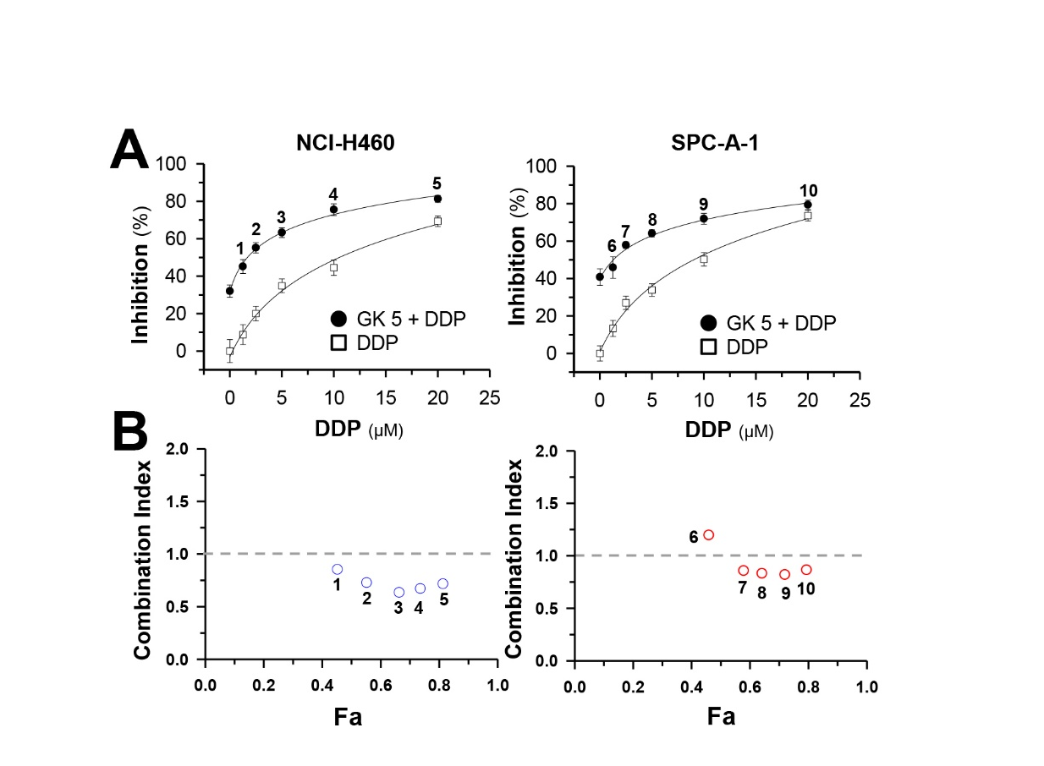

Supplementary Figure 1. Synergy of ginkgetin and DDP in NCI-H460 and SPC-A-1 cells.
(A): Cells were seeded in 96-well plates (3 X 10³ cells/well). Different concentrations of DDP (1.25, 2.5, 5, 10, 20 µM) with or without ginkgetin (5 µM) were added for 48 hours. Values are in percentage of cell growth inhibition. (B): Combination Index (CI) of 5 combinations were calculated using CompuSyn software. CI values <1, =1 and >1 indicate synergism, additive effect and antagonism, respectively. Each point represents the mean ± SEM, n = 3. GK: ginkgetin.

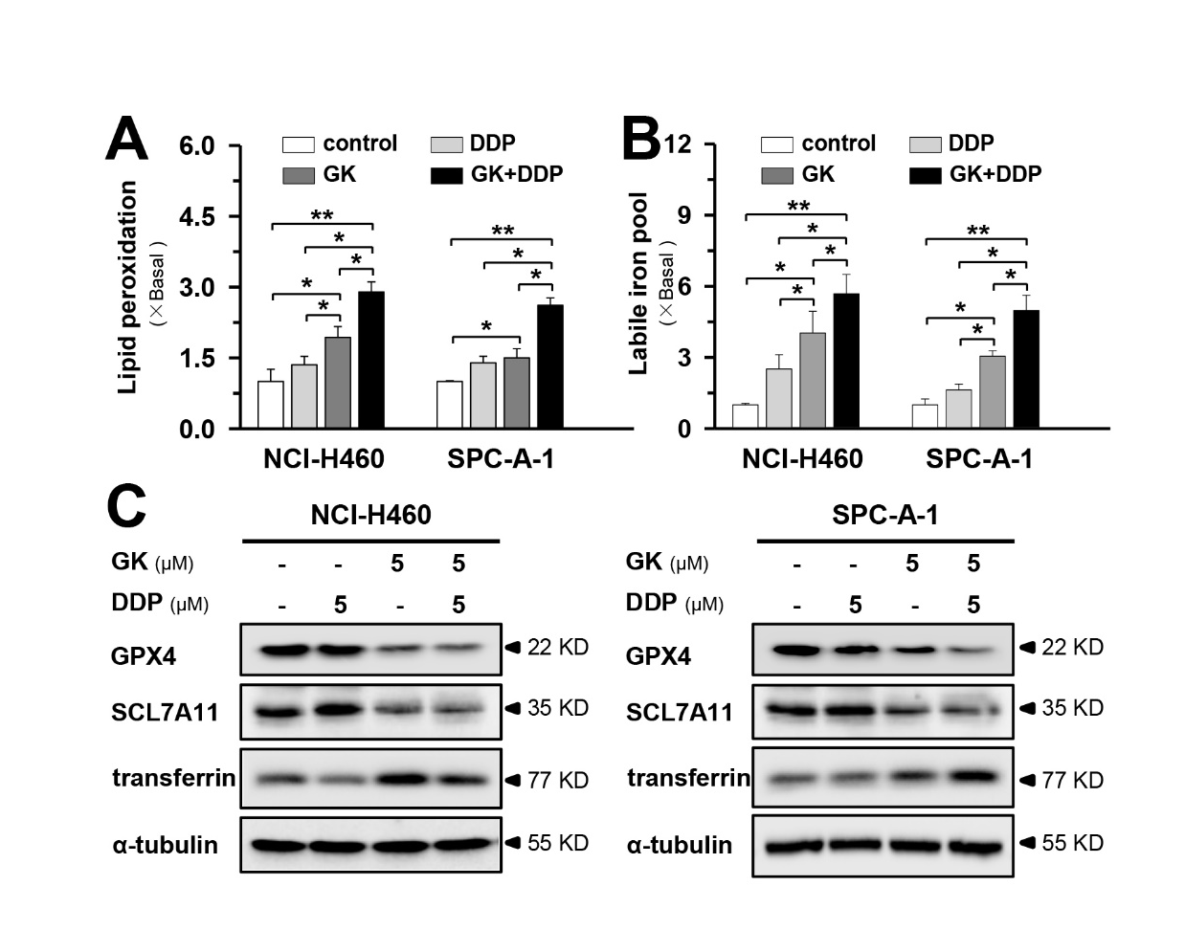

Supplementary Figure 2. Ginkgetin induces ferroptosis in DDP-treated NCI-H460 and SPC-A-1 cells
(A): Cultured NCI-H460 and SPC-A-1 cells were treated with ginkgetin (5 µM), DDP (5 µM), and ginkgetin + DDP (5 µM+5 µM) for 48 hours. Cells were stained with BODIPY™ 581/591 C11 (10 μM) for 30 min, the level of lipid peroxidation was detected by flow cytometry. (B): Cells were treated as in (A), then CA-AM was added to cells at the final concentration of 0.25 µM, followed by adding iron chelator deferiprone (100 μM) for 1 hour or left untreated. The mean fluorescence was detected fluorescence microplate reader (Exc=488 nm, Em=525 nm). The amount of LIP was reflected via difference on mean fluorescence of each sample with or without deferiprone. (C): Cells were treated as in (A), the protein expression of GPX4, SLC7A11 and transferrin were detected by western blot. Each point represents the mean ± SEM, n = 3. *p < 0.05, **p < 0.01. GK: ginkgetin.

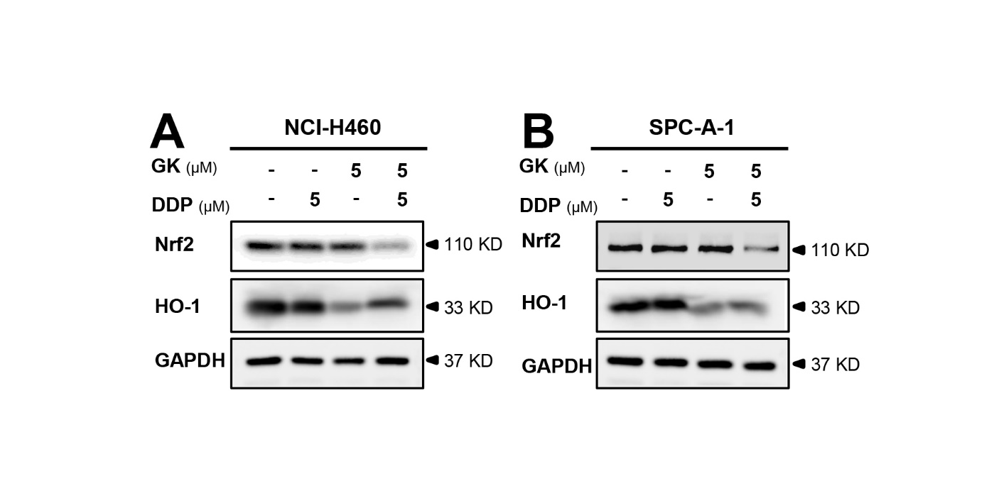

Supplementary Figure 3. Ginkgetin downregulates Nrf2/HO-1 in DDP-treated NSCLC cells.
Culture NCI-H460 (A) and SPC-A-1 (B) cells were treated with ginkgetin (5 µM), DDP (5 µM), and ginkgetin + DDP (5 µM+5 µM). The protein expressions of Nrf2 and HO-1 were analyzed by western blot. GK: ginkgetin.

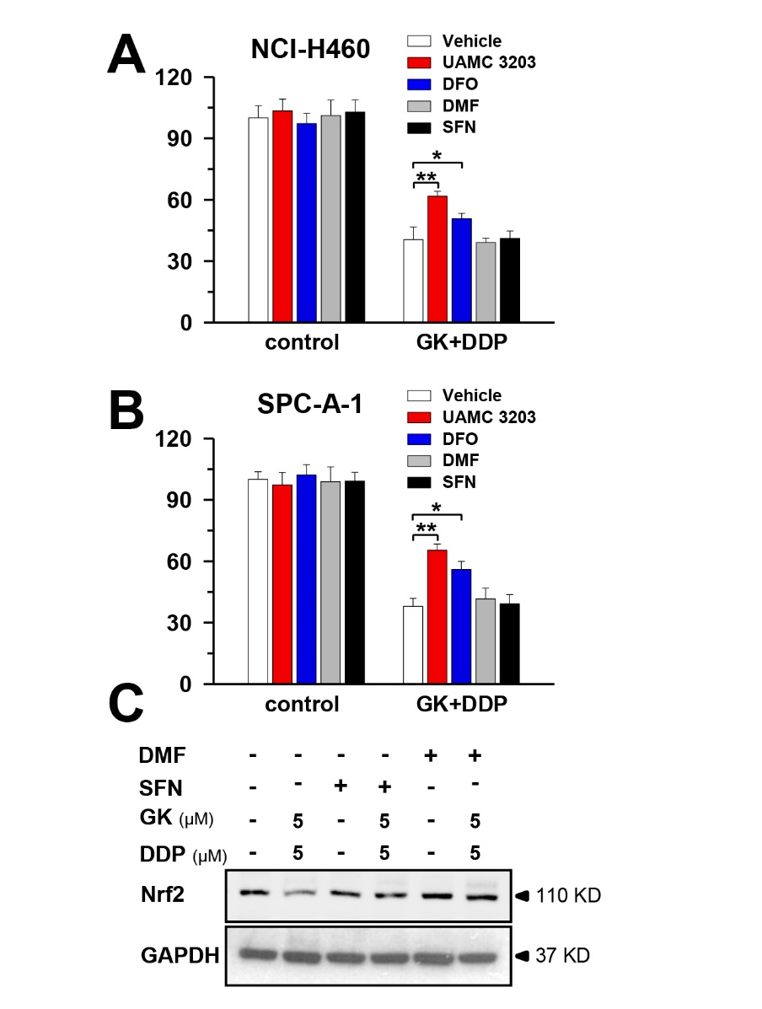

Supplementary Figure 4. Blocking ferroptosis reversed ginkgetin+DDP induced cytotoxicity in NCI-H460 and SPC-A-1
(A&B): Cultured NCI-H460 (A) cells or SPC-A-1 (B) were seeded in 96-well plate. Cells were treated with ginkgetin + DDP (5 µM+5 µM) in the presence and absence of UAMC 3203 (25 nM), or DFO (200 µM), or DMF (100 nM), or SFN (10 µM). Cell viability was detected by MTT assay. Values are in percentage of cell growth inhibition. (C): Cultured A549 cells were treated with ginkgetin + DDP (5 µM+5 µM) in the presence and absence of DMF (100 nM), or SFN (10 µM). The protein expressions of Nrf2 were analyzed by western blot. Each point represents the mean ± SEM, n = 3. *p < 0.05, **p < 0.01. GK: ginkgetin.

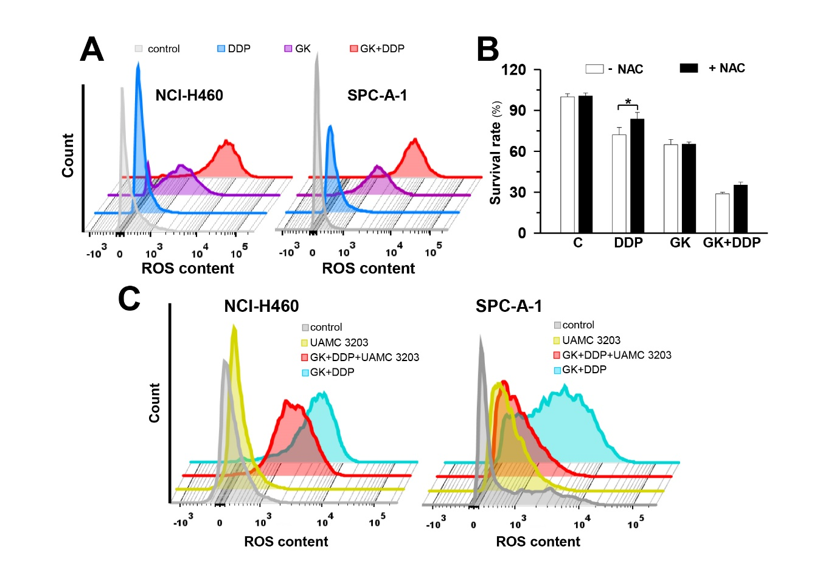

Supplementary Figure 5. Ferroptosis inhibition mitigates ginkgetin induced ROS increase in DDP-treated NSCLC cells.
(A): Cultured NCI-H460 and SPC-A-1 cells were treated with ginkgetin (5 µM), DDP (5 µM), and ginkgetin + DDP (5 µM+5 µM) for 48 hours. Cells were stained with DCFH-DA (15 μM) for 30 min. The ROS formation were detected by flow cytometry. (B): Cultured A549 cells were seeded in 96-well plate and incubated 24 hours for cell attachment. ginkgetin (5 µM), DDP (5 µM), and ginkgetin + DDP (5 µM+5 µM), with or without NAC (5 mM) were added for 48 hours. Cell viability was detected by MTT assay. Values are in percentage of cell growth inhibition. (C): Cells were treated with ginkgetin + DDP (5 µM+5 µM) with or without UAMC 3203 (25 nM), then stained with DCFH-DA (15 μM) for 30 min. The ROS formation were detected by flow cytometry. Each point represents the mean ± SEM, n = 3. *p <0.05. GK: ginkgetin. NAC: N-acetylcysteine.

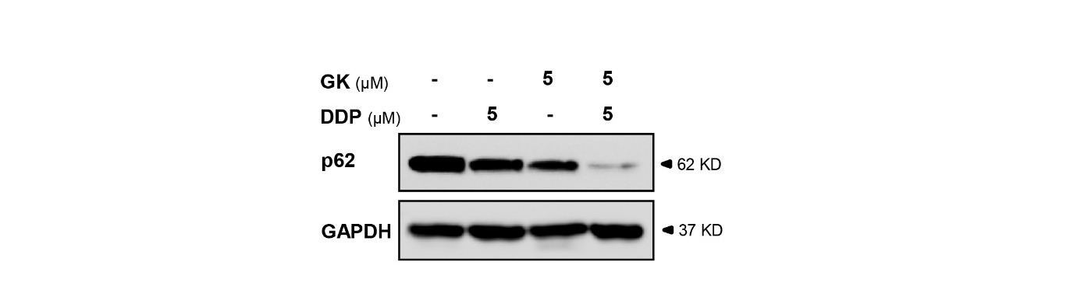
Supplementary Figure 6. Ginkgetin combine with DDP decreases p62 expression.
Cultured A549 cells were treated with ginkgetin (5 µM), DDP (5 µM), and ginkgetin + DDP (5 µM+5 µM) for 48 hours, the protein expression of p62 was detected by western blot. Expression of GAPDH served as a control. GK: ginkgetin.

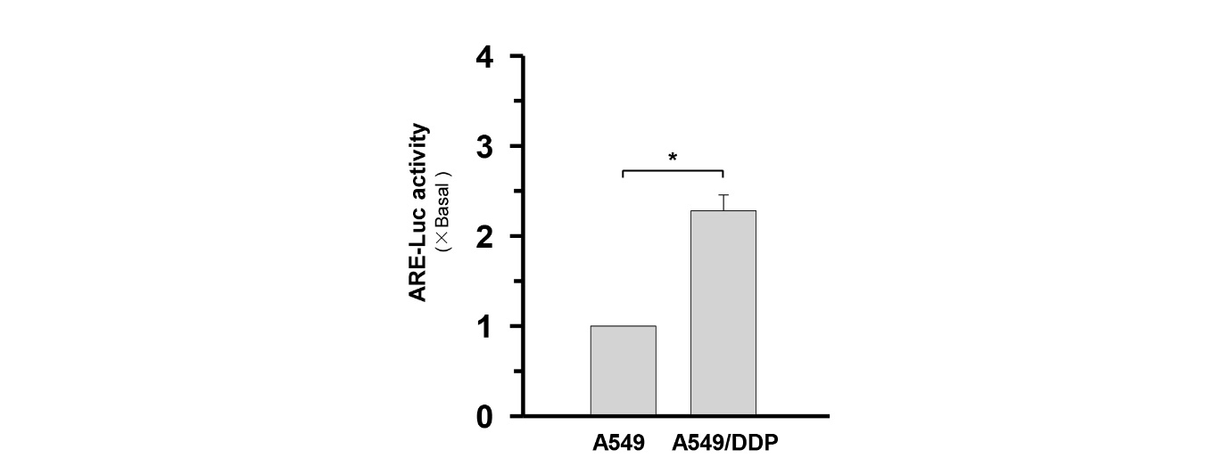

Supplementary Figure 7. A549/DDP cells exhibit higher ARE-mediated activity than A549 cells.
Cultured A549 and A549/DDP cells were seeded in in 6-well plates, and pARE-Luc was transfected for 4 hours, then DDP (10 µM) were applied. pARE-Luc activity was detected by luciferase assay. Each point represents the mean ± SEM, n = 3. *p <0.05.

