Supplementary Figures and Methods

The genome architecture of a copepod invading novel habitats

Zhenyong Du*
ORCID: 0000-0002-4569-6713

Gregory Gelembiuk
ORCID: 0000-0001-7369-9287

Wynne Moss
ORCID: 0000-0002-2813-1710

Andrew Tritt
ORCID: 0000-0002-1617-449X

Carol Eunmi Lee*
ORCID: 0000-0001-6355-0542

Department of Integrative Biology, 430 Lincoln Drive, Birge Hall, University of Wisconsin, Madison, WI 53706, U.S.A.

*Corresponding Authors:
Zhenyong Du, zdu53@wisc.edu; Carol E. Lee, carollee@wisc.edu

Table of Contents:

Fig. S1. K-mer coverage frequency plots for two different Illumina sequencing datasets and k-mer sizes for the copepod Eurytemora carolleeae (Atlantic clade of the Eurytemora affinis species complex).
Fig. S2. Two different cells showing the karyotype of the copepod Eurytemora carolleeae.
Fig. S3. Synteny among three chromosome-level copepod genomes.
Fig. S4. Distribution plot of synonymous substitutions per site (Ks) among paralogous genes within the Eurytemora carolleeae genome.
Fig. S5. Venn diagram showing the number of shared gene families among four pancrustacean species.
Fig. S6. KEGG enrichment of expanded genes in the copepod Eurytemora carolleeae genome.
Fig. S7. Distributions of gene distance of (a) key ion transporter genes and (b) all identified genes with ion transport function.
Fig. S8. Distributions of gene distance of (a) key ion transporter genes and (b) all genes identified with ion transporting function (red bars), relative to functionally conserved genes (blue bars).
Fig. S9. Localization of ion transporter genes onto the four chromosomes of Eurytemora carolleeae.
Fig. S10. Localization of ion transporter genes on Chromosome 3.
Fig. S11. Hi-C contact map for three chromosomes of the Eurytemora carolleeae genome.

Fig. S1. K-mer coverage frequency plots for two different Illumina sequencing datasets and k-mer sizes for the copepod Eurytemora carolleeae (Atlantic clade of the Eurytemora affinis species complex). The top two graphs plot the k-mer coverage are for the Illumina-seq data generated previously in Eyun et al. (2017), whereas the bottom two graphs are for the Illumina-seq data generated in the present study. Left plots: k=21 and right plots: k = 25. The estimated genome size, proportion of non-repetitive unique sequences, homozygosity and heterozygosity are shown in the plots. These results indicate that the E. carolleeae genome has a genome size of 509~540 Mb, with 0.5~0.7% heterozygosity and 37~43% repetitive sequence.
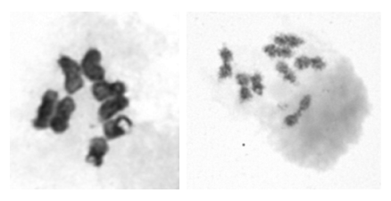

Fig. S2. Two different cells showing the karyotype of the copepod Eurytemora carolleeae. In each photograph, four pairs of chromosomes are clearly shown.

Fig. S3. Synteny among three chromosome-level copepod genomes. Ecar: Eurytemora carolleeae, Tcal: Tigriopus californicus, Lsal: Lepeophtheirus salmonis. The links for the genome sequences and annotations are available in Additional file 2: Table S18.

Fig. S4. Distribution of synonymous substitutions per site (Ks) among paralogous genes within the Eurytemora carolleeae genome. The Ks distribution was analyzed with all 20,262 protein-coding genes in the E. carolleeae genome. The Ks plot is truncated at Ks = 2 arbitrarily on the y-axis for ease of visualization. The high frequency of low Ks values indicates that the largest proportions of gene duplication events occurred quite recently (Ks = 0–0.04).
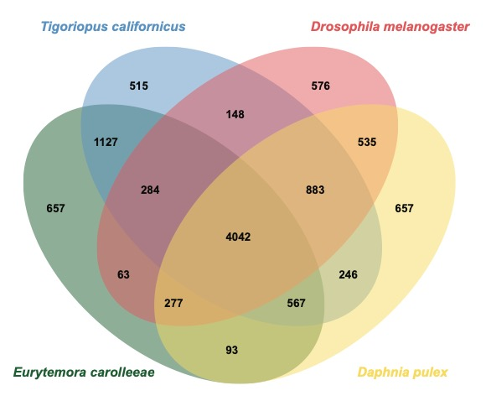

Fig. S5. Venn diagram showing the number of shared gene families among four pancrustacean species.

Fig. S6. KEGG enrichment of expanded genes in the copepod Eurytemora carolleeae genome. These KEGG pathways were sorted by the P-value (with higher P-value downward). The complete list of enriched KEGG pathways is shown in Additional file 2: Table S12.
Fig. S7. Distributions of gene distance of (a) key ion transporter genes and (b) all identified genes with ion transport function. (a) 83 key ion transporter paralogs that showed evolutionary shifts in gene expression and/or signatures of selection in prior studies (shown as vertical lines and circles in Fig. 6). (b) All 490 ion transporter genes identified based on genome annotation (shown as vertical light blue lines in Fig. 6). Gene distances were calculated between adjacent target genes on the same chromosomes. Red dashed lines indicate the hypothetical mean distance between genes, if the genes had a uniform distribution across the genome. The sets of 83 key ion transporter genes and 490 identified genes with ion transport function on the chromosomes both deviate significantly from a uniform distribution and tend to be more clustered than expected (P = 0.00).
Fig. S8. Distributions of gene distance for (a) key ion transporter genes and (b) all genes identified with ion transporting function (red bars), relative to functionally conserved genes (blue bars). (a) 83 key ion transporter gene paralogs that showed evolutionary shifts in gene expression and/or signatures of selection in prior studies (Fig. 6, vertical colored lines and dots). (b) 490 ion transporter genes identified from genome annotation (Fig. 6, vertical light blue lines). Gene distances were calculated between adjacent target genes on the same chromosomes. The functionally conserved genes (blue bars) refer to genes with the highest CpG_{o/e} values identified in the E. carolleeae genome (Additional file 2: Table S14) and are enriched with RNA processing and DNA binding related functions, which tend to be functionally conserved housekeeping genes. High frequencies of closely spaced genes were found for both the 83 key ion transporter genes (distance < 1e6 bp) and 490 genes identified with ion transporting function (distance < 1e5 bp). The distributions of gene distance differed significantly from those of functionally conserved genes for both the 83 key ion transporter genes (Chi-square goodness of fit test, P = 6.2e-5) and 490 genes with ion transporting function (Chi-square goodness of fit test, P = 1.3e-9).
Fig. S9. Localization of ion transporter genes onto the four chromosomes of Eurytemora carolleeae. Vertical colored lines and dots indicate the 83 key ion transporter gene paralogs that showed evolutionary shifts in gene expression and/or signatures of selection between saline and freshwater populations in previous studies (Lee 2021). In addition, 490 ion transporter genes were identified from genome annotation (vertical light blue lines). See Posavi et al. (2020) for a more detailed list of ion transporter gene paralogs that showed evolutionary shifts in gene expression and Stern & Lee (2020), Stern et al. (2022), and Diaz et al. (2023) for ion transporter gene paralogs that showed signatures of natural selection in response to salinity change. NKA-α = Na⁺/K⁺ ATPase α subunit, NKA-β = Na⁺/K⁺ ATPase β subunit, NHE = Na⁺/H⁺ exchanger, NHA = Na⁺/H⁺ antiporter, NKCC = Na⁺/K⁺/Cl⁻ cotransporter, CA = Carbonic anhydrase, AMT = Ammonia transporter, Rh = Rh protein, SCL4 = Solute carrier family 4 of bicarbonate transporters, including Cl⁻/HCO₃⁻ exchangers (AE) and Na⁺-driven HCO₃⁻ transporters (NBC, NDCBE), VHA = Vacuolar-type H⁺ ATPase.

Fig. S10. Localization of ion transporter genes on Chromosome 3. The magnified portion shows the region near the centromere.

Fig. S11. Hi-C contact map for three chromosomes of the Eurytemora carolleeae genome. The stars indicate the positions of the centromeres.
Online Methods
CTAB extraction method
The copepods were homogenized in 800 μl CTAB solution (2% w/v, Teknova, Hollister, CA, USA, Catalogue number: C2190) and 30 μl proteinase K (Invitrogen, Waltham, MA, USA, Catalogue number: 25530049), and incubated in a water bath at 56°C overnight. The homogenized sample was treated with RNase (Invitrogen, Catalogue number: AM2271) and incubated at 37°C for 30 min. 800 μl Tris-Phenol: Chloroform: Isoamyl alcohol 25:24:1 (Sigma-Aldrich, Catalogue number: P2069) was added and centrifuged at 12000 rpm for 15 min. The upper phase was transferred into a new microtube with 800 μl Chloroform: Isoamyl alcohol 24:1 (Sigma-Aldrich, Catalogue number: C0549) added and centrifuged at 12000 rpm for 15 min. The upper phase was transferred into a new microtube followed by 600 μl isopropanol (Sigma-Aldrich, Catalogue number: W292907) precipitation at –20°C for 2h and centrifuged at 12000 rpm for 30 min. The pellet was rinsed twice with 70% ethanol, air-dried, and resuspended overnight at room temperature in TE buffer (Invitrogen, Catalogue number: AM9849).

Transcriptome sequencing
To supplement the genome annotation, two transcriptomes were sequenced using samples of two other clades of Eurytemora affinis complex, specifically inbred lines from the Gulf clade and Europe clade (Lee 1999). The Gulf clade copepods were collected from Blue Hammock Bayou, Louisiana, USA, and then inbred for 20 generations by full-sib mating. The Europe clade copepods (E. affinis proper) (Poppe 1880) were collected in Stockholm, Sweden, and then inbred for 10 generations through full-sib mating. All these copepods were maintained in the laboratory following the methods and conditions described in Methods section of the main text. Total RNA was isolated using TRIzol reagent (Invitrogen, Catalogue number: 15596026) using ~100 pooled individuals according to the manufacturer’s instructions and subjected to quality control using Nanodrop Spectrophotometer, gel electrophoresis, and Agilent 2100 Bioanalyzer. RNA samples were used for library preparation and sequenced on the Illumina Hiseq X Ten platform with the 100 bp PE mode. 377.9 million reads were generated for the Gulf clade and 372.4 million reads for the Europe clade.

