Antimicrobial and phytotoxic secondary metabolites produced by Xylaria necrophora, an emerging pathogen of soybean, play key roles in infection biology.
José E. Solórzano ^{1, 2, *}, Moshood O. Ganiu ³, Fabrizio Donnarumma ³, Teddy Garcia-Aroca ⁴, Rendy Kartika ³, Jonathan K. Richards ¹, Joshua P. Van Houten ³, Michelle R. Gremillion ¹, Paul P. Price ⁵, Vinson P. Doyle ^{1, *}

¹ Louisiana State University, Department of Plant Pathology and Crop Physiology, Baton Rouge, LA, 70803, USA.
² University of Minnesota, Department of Plant Pathology, Saint Paul, MN, 55108, USA.
³ Louisiana State University, Department of Chemistry, Baton Rouge, LA, 70803, USA.
⁴ University of Nebraska-Lincoln, Department of Plant Pathology, Lincoln, NE, 68583, USA.
⁵ Louisiana State University, Department of Plant Pathology and Crop Physiology, Winnsboro, LA, 71295, USA.

Corresponding authors:
* J. E. Solórzano, e-mail: ortiz432@umn.edu
* V. P. Doyle, e-mail: VDoyle@agcenter.lsu.edu

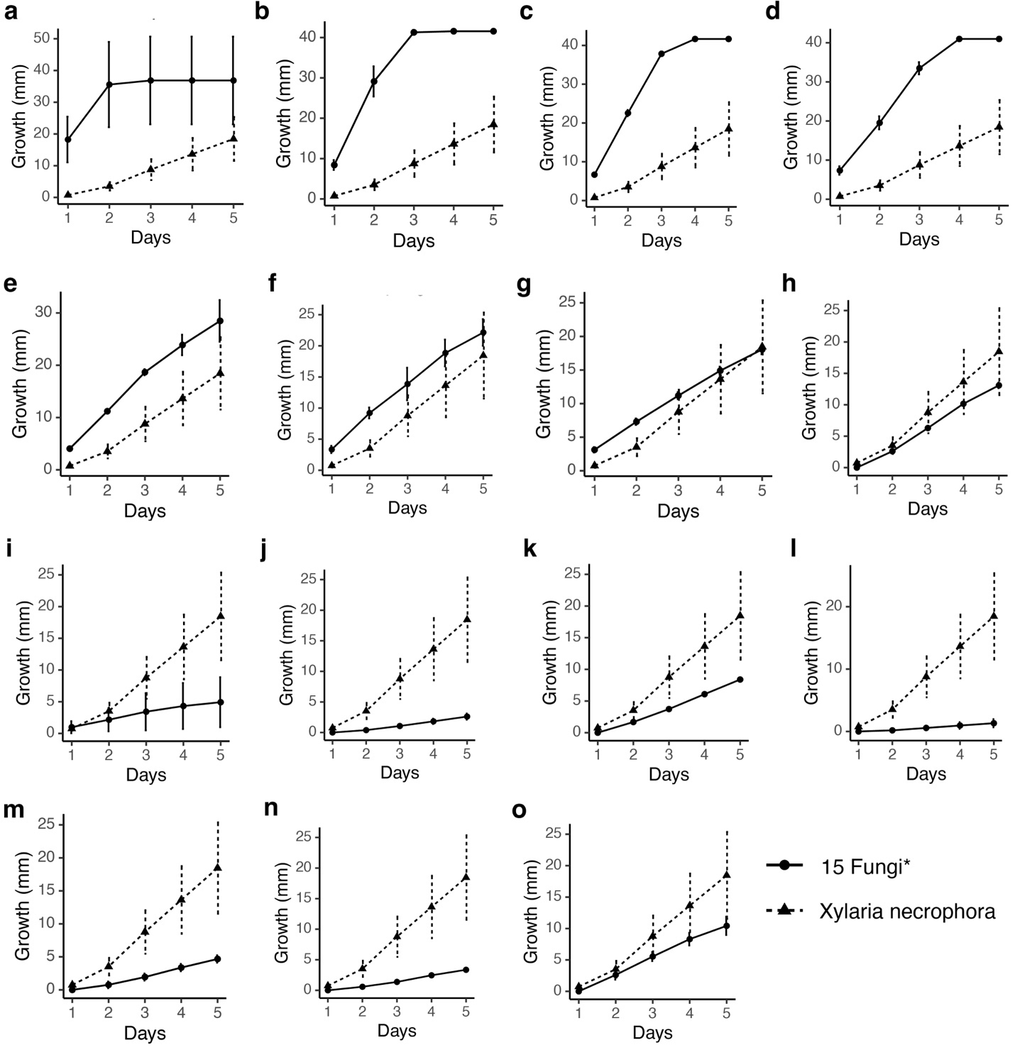
Supplementary Fig. 1 Growth rates of 15 fungal pathogens (Table 1)* in relation to the growth of Xylaria necrophora. Fungi were grown individually on potato dextrose broth for five days and radial growth was measured daily. From these comparisons, three growth types were assigned: group 1 (a to d), group 2 (e to i), and group 3 (j to o) for a dual interaction assay. (a) Rhizopus stolonifer, (b) Rhizoctonia solani, (c) Macrophomina phaseolina, (d) Sclerotium rolfsii, (e) Glomerella cingulata, (f) Aspergillus flavus, (g) Curvularia lunata, (h) Magnaporthe oryzae, (i) Exserohilum tursicum, (j) Cercospora zeae-maydis, (k) Cercospora cf. flagellaris, (l) Monilochaetes infuscans, (m) Cercospora sojina, (n) Cercospora janseana, and (o) Ceratocystis fimbriata.
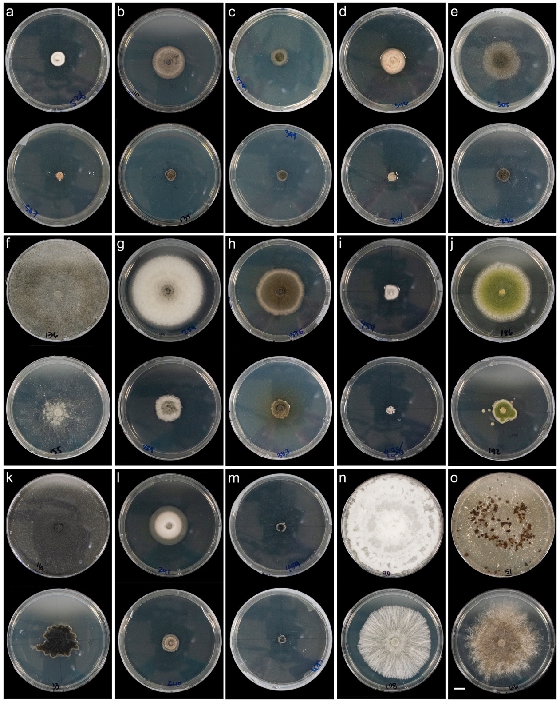
Supplementary Fig. 2 Representation of growth inhibition of 15 fungal pathogens (Table 1) caused by Xylaria necrophora cell-free culture filtrates (CFs) at 50% (v/v). Colony morphology variation of the 15 plant pathogens on control broth amended to PDA+ (a to o) (top row) and on CFs amended to PDA+ (a to o) (lower row) five days after inoculation. (a) Cercospora zeae-maydis, (b) Ceratocystis fimbriata, (c) Cercospora sojina, (d) Cercospora cf. flagellaris, (e) Exserohilum tursicum, (f) Rhizopus stolonifer, (g) Glomerella cingulata, (h) Curvularia lunata (i) Cercospora janseana (j) Aspergillus flavus (k) Macrophomina phaseolina (l) Magnaporthe oryzae (m) Monilochaetes infuscans (n) Sclerotium rolfsii (o) Rhizoctonia solani. Bar = 1 cm.
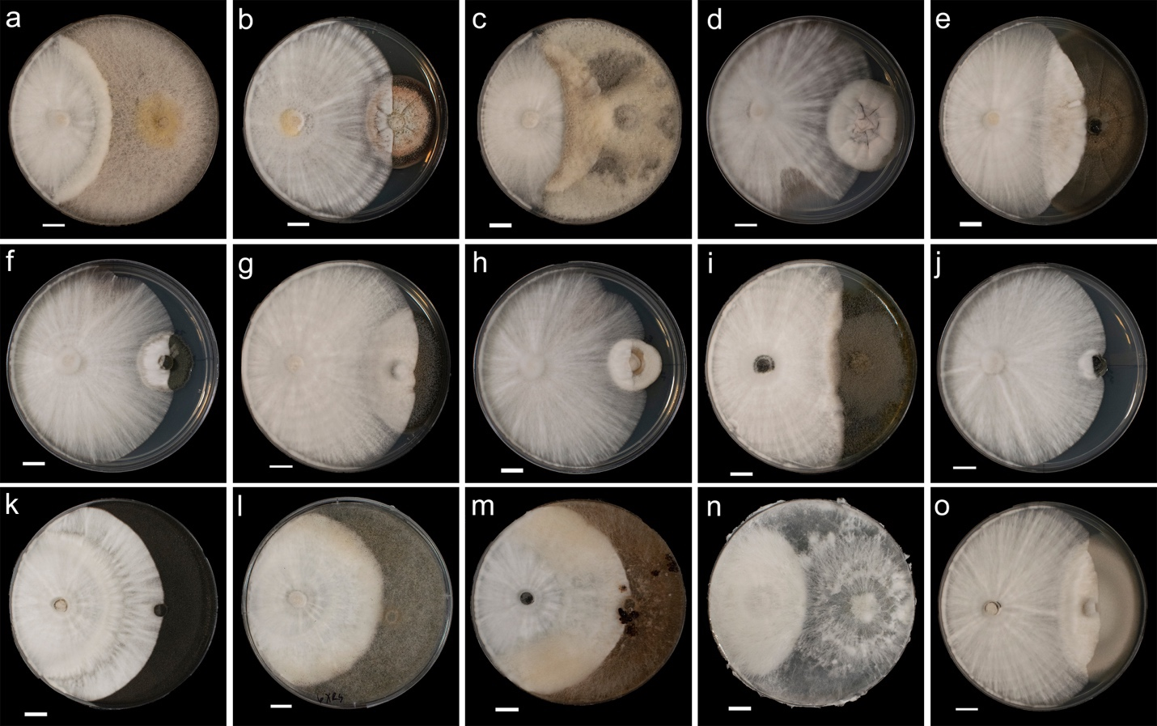
Supplementary Fig. 3 Schematic representation of the growth inhibition of 15 fungal pathogens (Table 1) caused by Xylaria necrophora during dual interaction. (a to o) Colony morphology variation of the 15 fungi (right on the plate): (a) Aspergillus flavus, (b) Cercospora cf. flagellaris, (c) Glomerella cingulata, (d) Cercospora janseana, (e) Curvularia lunata, (f) Cercospora sojina, (g) Ceratocystis fimbriata, (h) Cercospora zeae-maydis, (i) Exserohilum tursicum, (j) Monilochaetes infuscans, (k) Macrophomina phaseolina, (l) Rhizopus stolonifer, (m), Rhizoctonia solani, (n) Sclerotium rolfsii, (o) Magnaporthe oryzae. X. necrophora is shown to the left on all the plates. Bars = 1 cm.

Preliminary experiments for identification of SMs produced by Xylaria necrophora.
Electrospray ionization time-of-flight (ESI-TOF) LC-MS analyses to identify secondary metabolites produced by Xylaria species (Cytochalasin C and D).

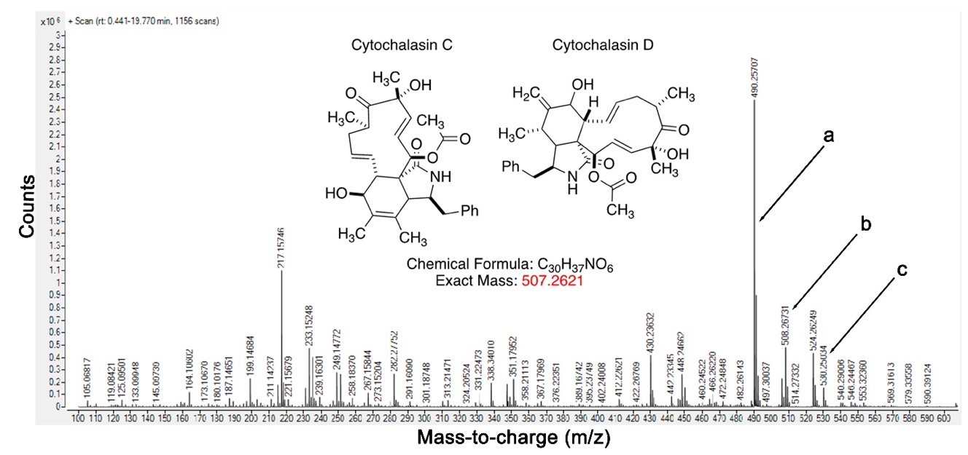
Supplementary Fig. 4 Chromatogram from high-resolution mass spectrometry of the dichloromethane (DCM) fraction showing the counts vs. mass-to-charge (m/z) of secondary metabolites produced by Xylaria necrophora. Cytochalasin (C or D) masses are indicated by black arrows. (a) indicates the peak of the mass of cytochalasin C/D minus water (H₂O), (b) indicates the peak of the molecular ion of cytochalasin C/D, and (c) indicates the peak of the mass of cytochalasin C/D plus sodium.

Secondary metabolites 5 (Cytochalasin C) to 6 (Cytochalasin D)
ESI ion trap, LC-MS/MS analyses – a comparison using standards of cytochalasin C and D
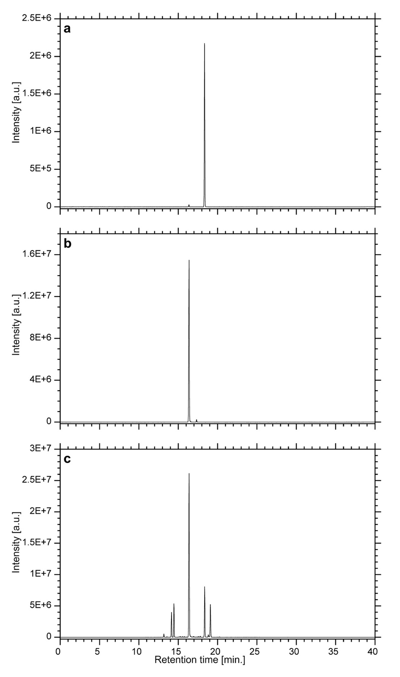
Supplementary Fig. 5 Comparison chromatogram of intensity vs retention time (min) of the dichloromethane (DCM) extracted fraction from Xylaria necrophora cell-free culture filtrates vs standards of cytochalasin C and D (Validation of Supplementary Fig. 4) (a) indicates peaks of cytochalasin C. (b) indicates peaks of cytochalasin D. C indicates peaks of the DCM extract. In this case, we were developing the LC-MS method and therefore the two standards were injected separately to find out what the retention time of each one was.
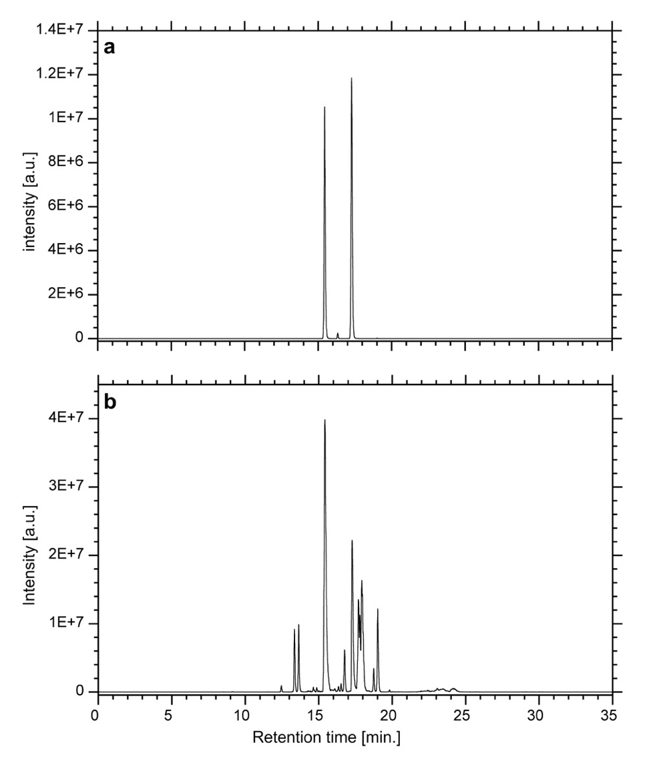
Supplementary Fig. 6 Comparison chromatogram of intensity vs retention time (min) of the diethyl ether Et₂O extracted fraction from Xylaria necrophora cell-free culture filtrates vs standards of cytochalasin C and D (Validation of Supplementary Fig. 4). (a) indicates peaks of cytochalasin C (left) and D (right). (b) indicates peaks of the Et₂O extract. In this case, the standards were injected at the same time.
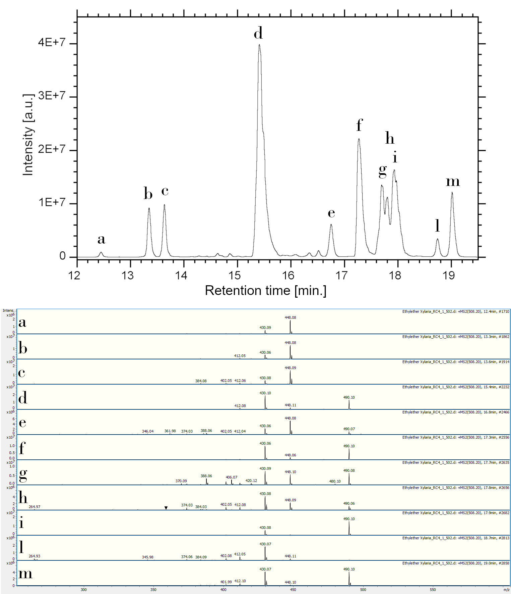

Supplementary Fig. 7 Potential homologs of cytochalasins were detected from the Et₂O extract of Xylaria necrophora cell-free culture filtrates, although their structures are unknown. Peaks labeled from (a to m) have a mass between 506 and 510 Da., which was the mass window used to monitor the ESI ion trap. All these peaks produce fragments: 430.1, 490.1, 448.1, and 412.1 m/z strongly suggesting that the structures are closely related to cytochalasins and may be different stereoisomers.
Identification of secondary metabolites (SM) using ESI-TOF LC-MS data compared to the database: https://github.com/jsolorzano734/Xylaria_necrophoraSMs

Secondary metabolites 1 to 4 and 7 to 10
Identification of SM (1). 18-Deoxy-19,20-epoxycytochalasin Q
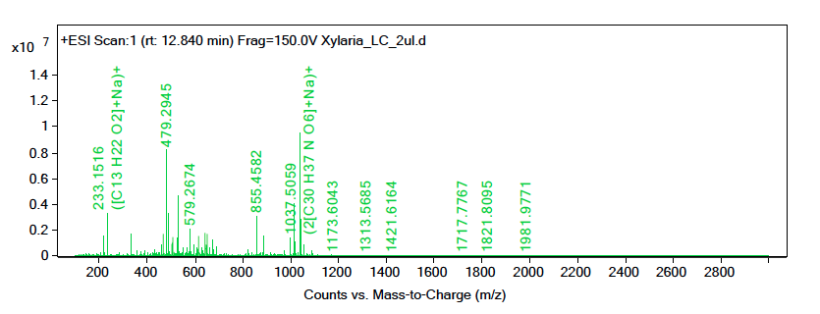
Supplementary Fig. 8. Et₂O
m/z = 490.255, Ion = (M+H)+[-H2O]
m/z = 530.2477, Ion = (M+Na)
m/z = 1015.523, Ion = (2M+H)
m/z = 1037.5059, Ion = (2M+Na)
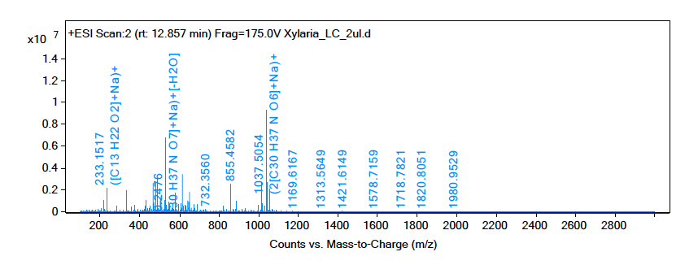
Supplementary Fig. 9. Et₂O
m/z = 490.2548, Ion = (M+H)+[-H2O]
m/z = 1015.5228, Ion = (2M+H)
m/z = 1037.5054, Ion = (2M+Na)

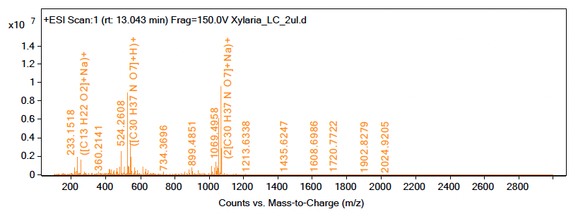
Supplementary Fig. 10. Et₂O
m/z = 490.255, Ion = (M+H)+[-H2O]

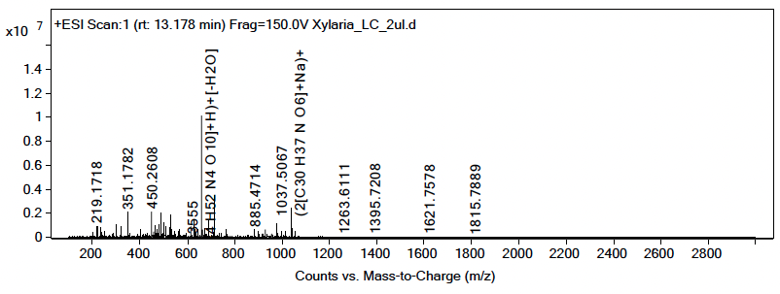
Supplementary Fig. 11. Et₂O
m/z = 490.2558, Ion = (M+H)+[-H2O]
m/z = 530.2493, Ion = (M+Na)
m/z = 1037.5067, Ion = (2M+Na)

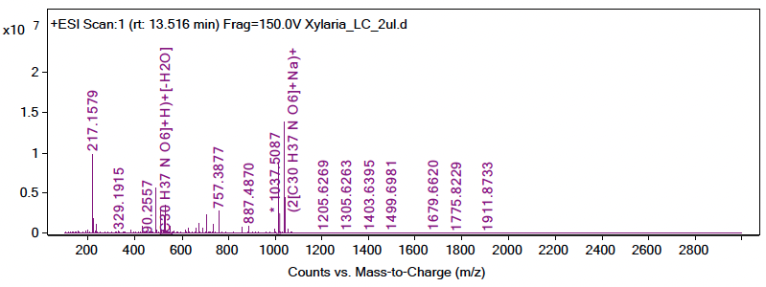
Supplementary Fig. 12. Et₂O
m/z = 490.2557, Ion = (M+H)+[-H2O]
m/z = 508.2658, Ion = (M+H)
m/z = 530.2481, Ion = (M+Na)
m/z = 1015.5257, Ion = (2M+H)
m/z = 1037.5087, Ion = (2M+Na)
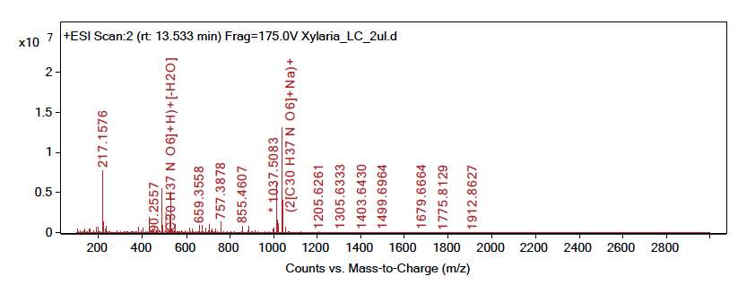
Supplementary Fig. 13. Et₂O
m/z = 490.2557, Ion = (M+H)+[-H2O]
m/z = 508.2658, Ion = (M+H)
m/z = 530.2482, Ion = (M+Na)
m/z = 1015.5251, Ion = (2M+H)
m/z = 1037.5083, Ion = (2M+Na)

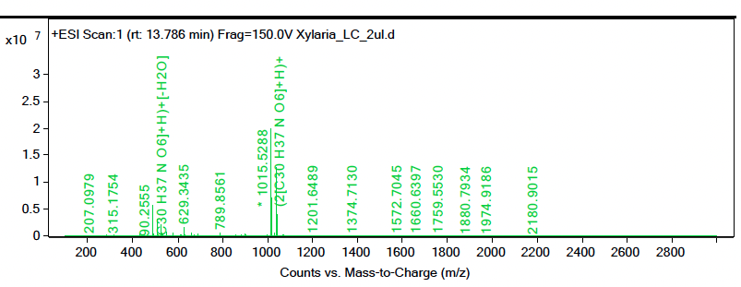
Supplementary Fig. 14. Et₂O
m/z = 490.2555, Ion = (M+H)+[-H2O]
m/z = 508.2657, Ion = (M+H)
m/z = 1015.5288, Ion = (2M+H)
m/z = 1037.508, Ion = (2M+Na)

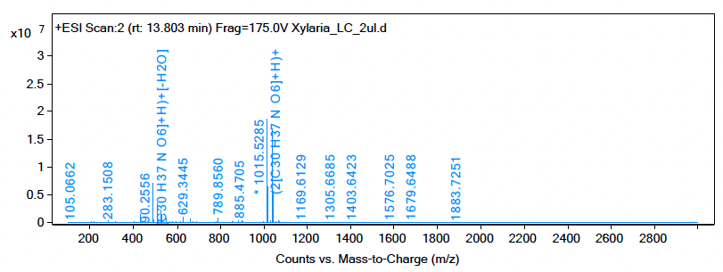
Supplementary Fig. 15. Et₂O
m/z = 490.2556, Ion = (M+H)+[-H2O]
m/z = 508.2656, Ion = (M+H)
m/z = 1015.5285, Ion = (2M+H)
m/z = 1037.5093, Ion = (2M+Na)

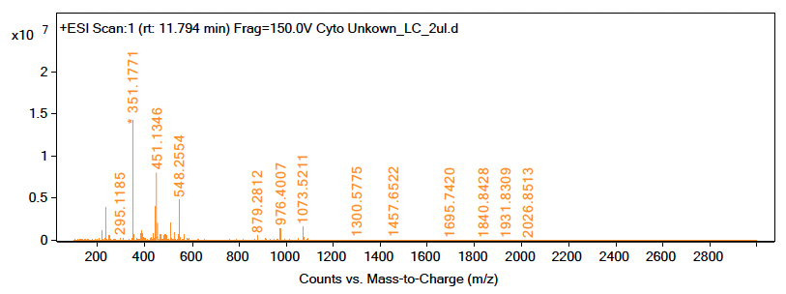
Supplementary Fig. 16. DCM
m/z = 508.2632, Ion = (M+H)

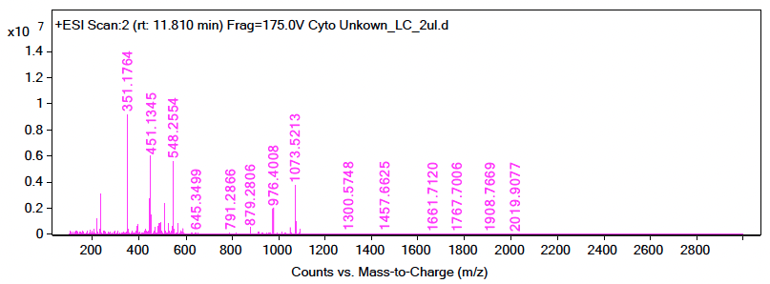
Supplementary Fig. 17. DCM
m/z = 508.2632, Ion = (M+H)

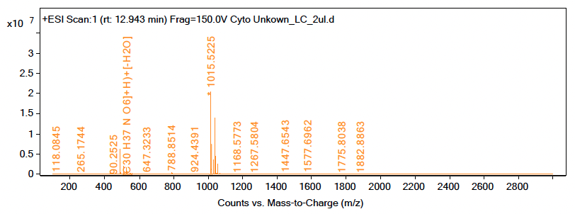
Supplementary Fig. 18. DCM
m/z = 490.2525, Ion = (M+H)+[-H2O]

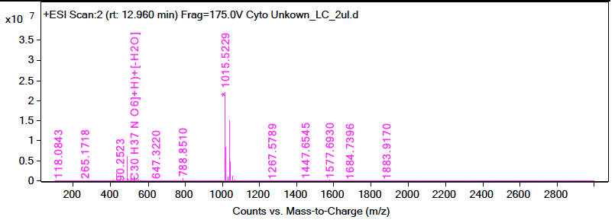
Supplementary Fig. 19. DCM
m/z = 490.2523, Ion = (M+H)+[-H2O]

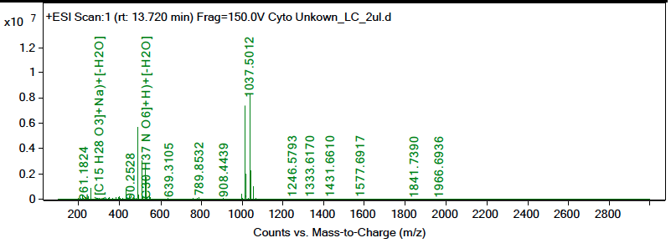
Supplementary Fig. 20. DCM
m/z = 490.2528, Ion = (M+H)+[-H2O]
m/z = 508.2631, Ion = (M+H)

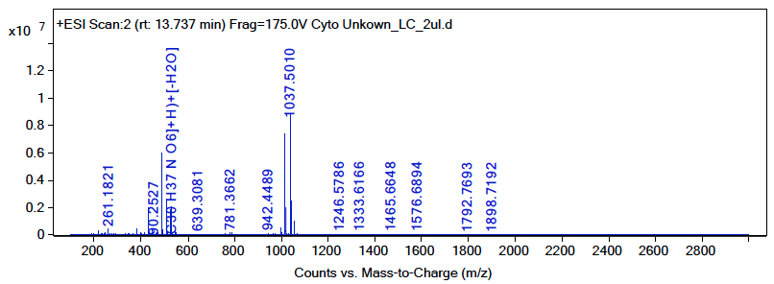
Supplementary Fig. 21. DCM
m/z = 490.2527, Ion = (M+H)+[-H2O]
m/z = 508.2628, Ion = (M+H)
m/z = 530.2446, Ion = (M+Na)

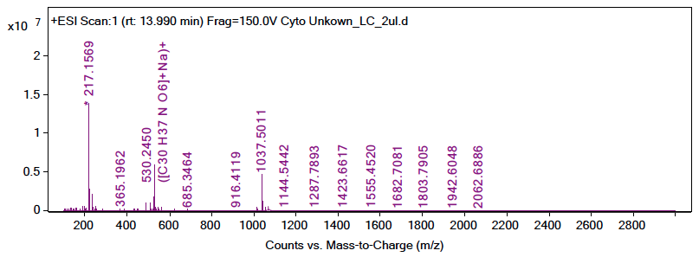
Supplementary Fig. 22. DCM
m/z = 508.2639, Ion = (M+H)
m/z = 530.245, Ion = (M+Na)

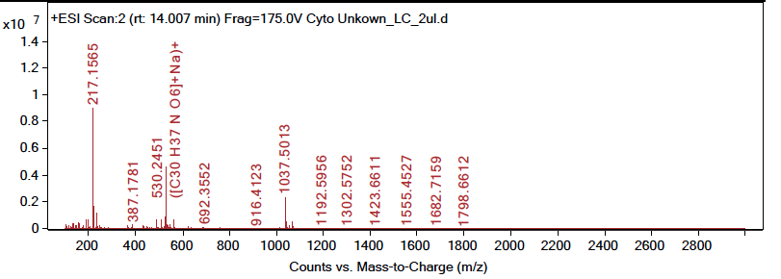
Supplementary Fig. 23. DCM
m/z = 490.2539, Ion = (M+H)+[-H2O]
m/z = 530.2451, Ion = (M+Na)

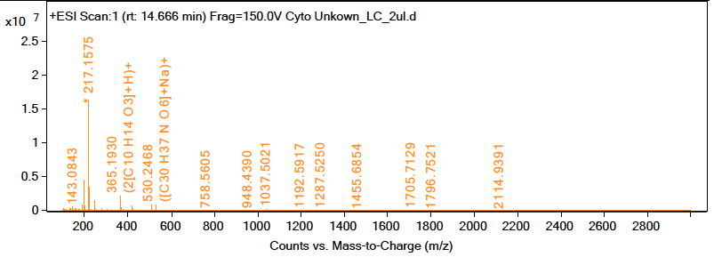
Supplementary Fig. 24. DCM
m/z = 508.2649, Ion = (M+H)
m/z = 530.2468, Ion = (M+Na)

Identification of SM (2). 19,20-epoxycytochalasin Q

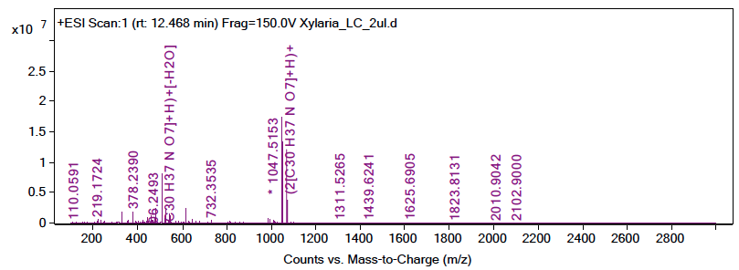
Supplementary Fig. 25. Et₂O
m/z = 506.2493, Ion = (M+H)+[-H2O]
m/z = 1047.5153, Ion = (2M+H)
m/z = 1069.4949, Ion = (2M+Na)

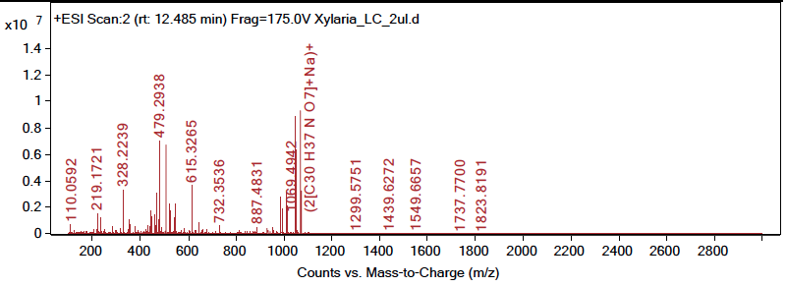
Supplementary Fig. 26. Et₂O
m/z = 506.2492, Ion = (M+H)+[-H2O]
m/z = 1047.5126, Ion = (2M+H)
m/z = 1069.4942, Ion = (2M+Na)

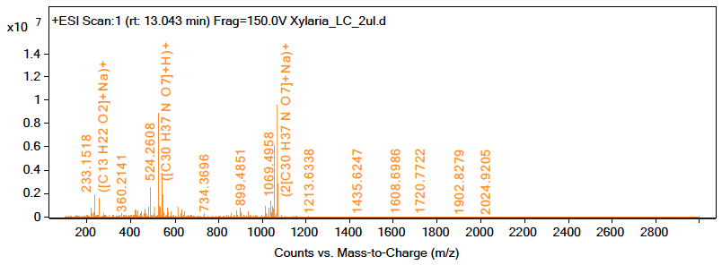
Supplementary Fig. 27. Et₂O
m/z = 524.2608, Ion = (M+H)
m/z = 546.2422, Ion = (M+Na)
m/z = 1069.4958, Ion = (2M+Na)

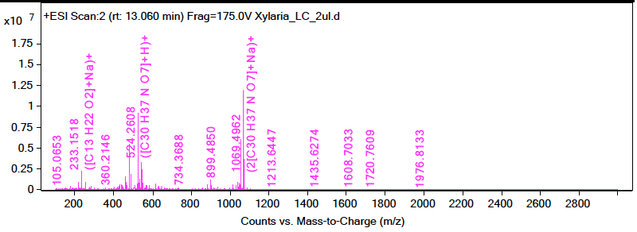
Supplementary Fig. 28. Et₂O
m/z = 524.2608, Ion = (M+H)
m/z = 546.2419, Ion = (M+Na)
m/z = 1069.4962, Ion = (2M+Na)

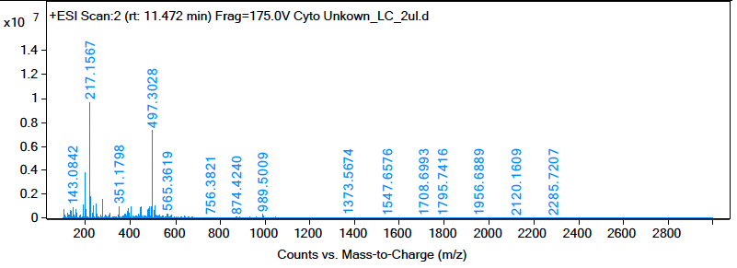
Supplementary Fig. 29. DCM
m/z = 506.2463, Ion = (M+H)+[-H2O]

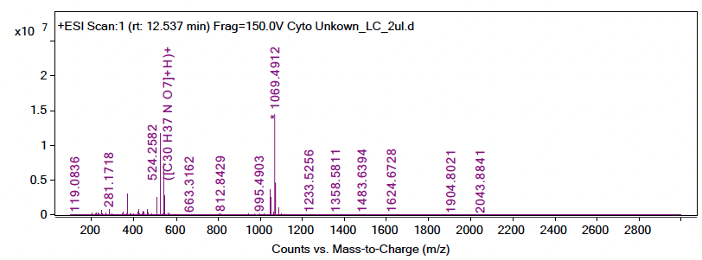
Supplementary Fig. 30. DCM
m/z = 524.2582, Ion = (M+H)
m/z = 546.2391, Ion = (M+Na)

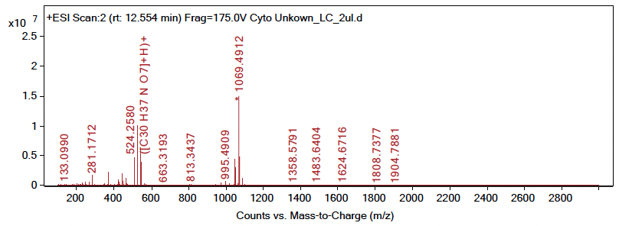
Supplementary Fig. 31. DCM
m/z = 506.2472, Ion = (M+H)+[-H2O]
m/z = 524.258, Ion = (M+H)
m/z = 546.2391, Ion = (M+Na)

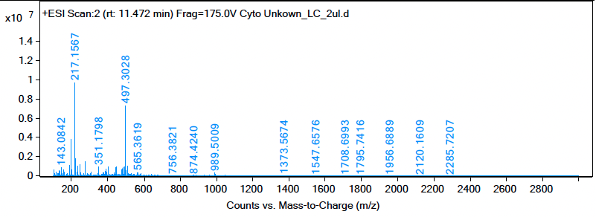
Supplementary Fig. 32. DCM
m/z = 506.2463, Ion = (M+H)+[-H2O]
Identification of SM (3). 5-(1-Hydroxybutyl)-6-(hydroxymethyl)-2H-pyran-2-one

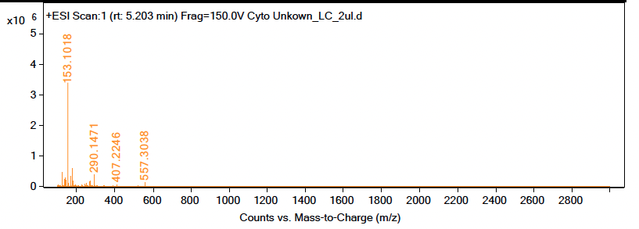
Supplementary Fig. 33. DCM
m/z = 181.0838, Ion = (M+H) +[-H2O]

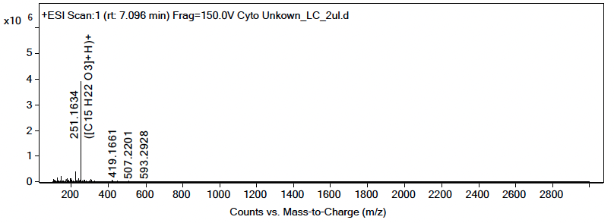
Supplementary Fig. 34. DCM
m/z = 199.0955, Ion = (M+H)
m/z = 221.0788, Ion = (M+Na)

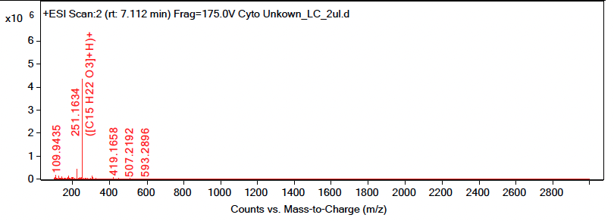
Supplementary Fig. 35. DCM
m/z = 221.0789, Ion = (M+Na)
Identification of SM (4). 6-[(1R)-1-Hydroxypentyl]-4-methoxy-2H-pyran-2-one

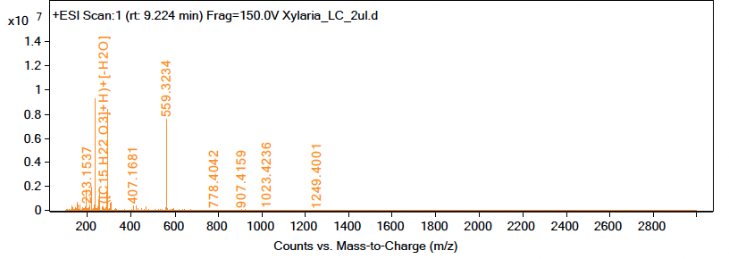
Supplementary Fig. 36. Et₂O
m/z = 195.0989, Ion = (M+H)+[-H2O]

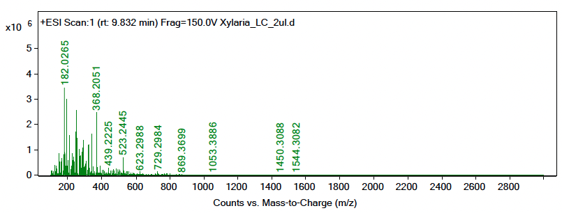
Supplementary Fig. 37. Et₂O
m/z = 195.1001, Ion = (M+H)+[-H2O]

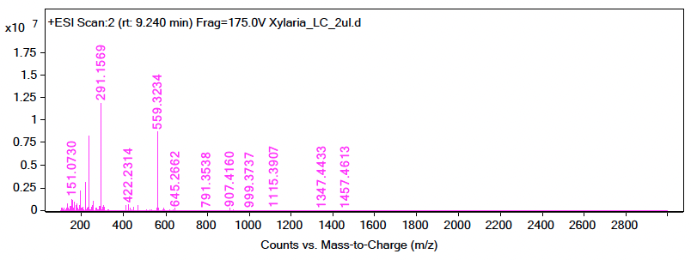
Supplementary Fig. 38. Et₂O
m/z = 195.0987, Ion = (M+H)+[-H2O]

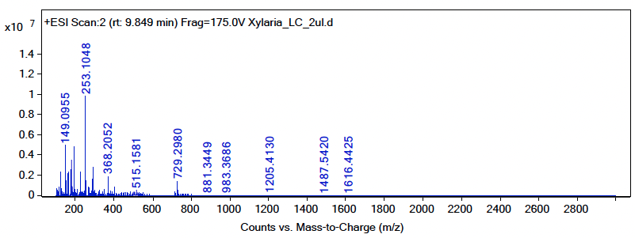
Supplementary Fig. 39. Et₂O
m/z = 195.0996, Ion = (M+H)+[-H2O]

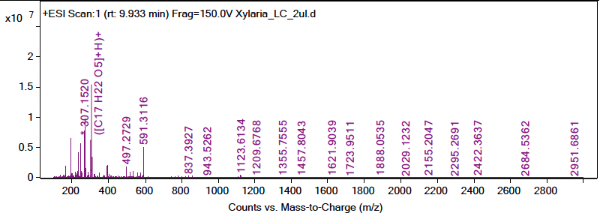
Supplementary Fig. 40. Et₂O
m/z = 195.0987, Ion = (M+H)+[-H2O]

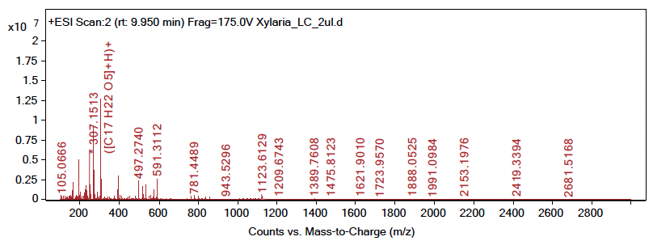
Supplementary Fig. 41. Et₂O
m/z = 195.0988, Ion = (M+H)+[-H2O]

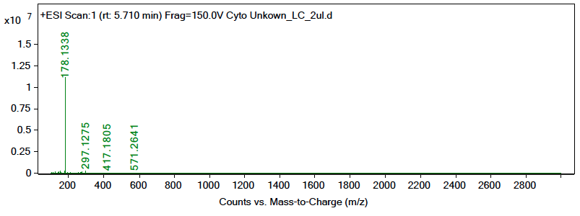
Supplementary Fig. 42. DCM
m/z =213.1096, Ion = (M+H)+

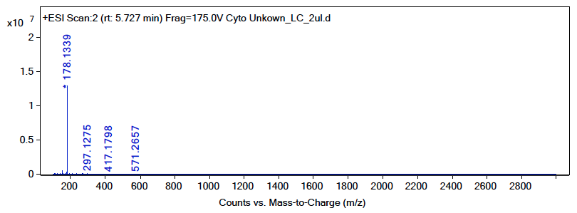
Supplementary Fig. 43. DCM
m/z = 195.0989, Ion = (M+H)+[-H2O]
m/z = 235.0914, Ion = (M+Na)+

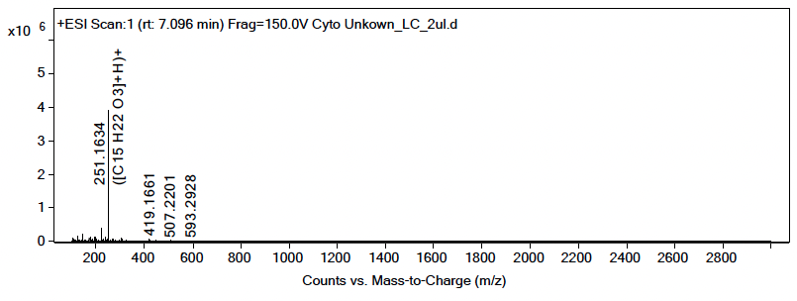
Supplementary Fig. 44. DCM
m/z =195.1036, Ion = (M+H)+[-H2O]

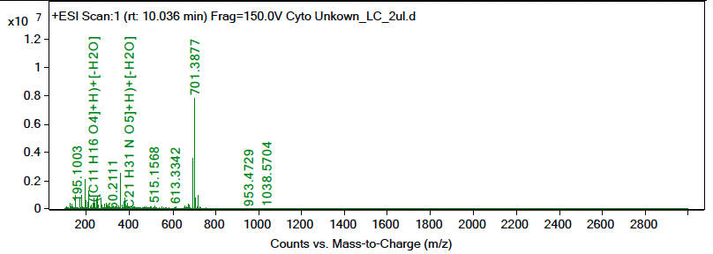
Supplementary Fig. 45. DCM
m/z =195.1003, Ion = (M+H)+[-H2O]
m/z = 213.1115, Ion = (M+H)
Identification of SM (7). Xylopimarane

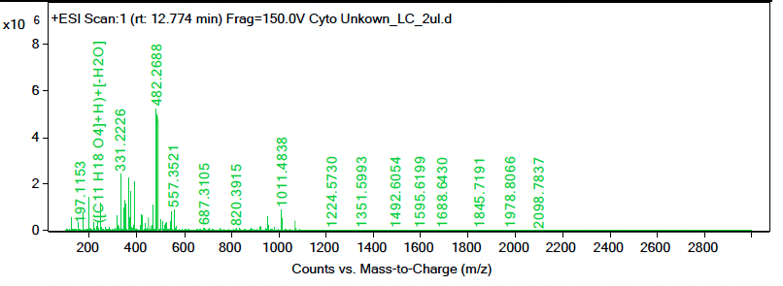
Supplementary Fig. 46. DCM
m/z = 487.2244, Ion = (M+Na)

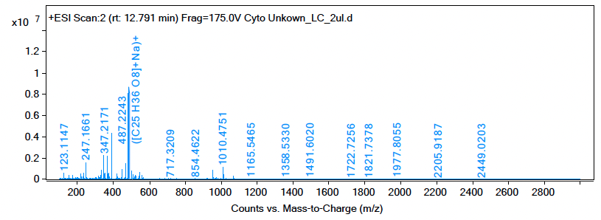
Supplementary Fig. 47. DCM
m/z = 465.2426, Ion = (M+H)
m/z = 487.2243, Ion = (M+Na)
Identification of SM (8). Hirsutatin A

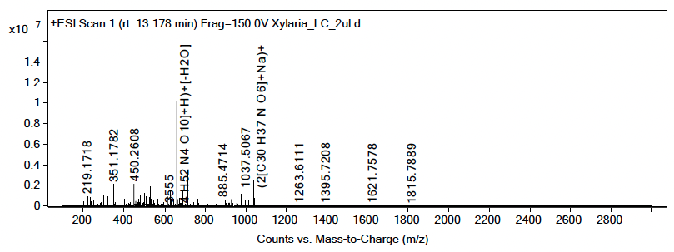
Supplementary Fig. 48. Et₂O
m/z = 659.3555, Ion = (M+H)+[-H2O]

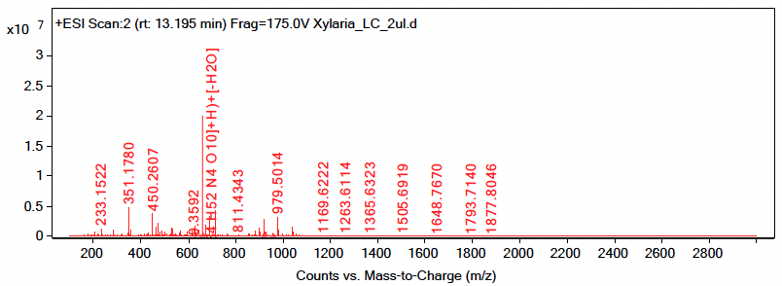
Supplementary Fig. 49. Et₂O
m/z = 659.3592, Ion = (M+H)+[-H2O]

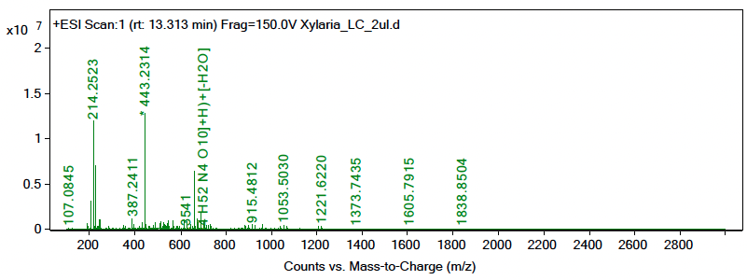
Supplementary Fig. 50. Et₂O
m/z = 659.3541, Ion = (M+H)+[-H2O]
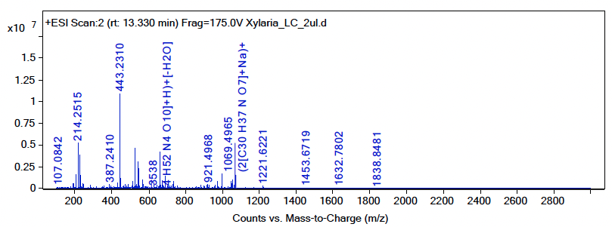
Supplementary Fig. 51. Et₂O
m/z = 659.3538, Ion = (M+H)+[-H2O]

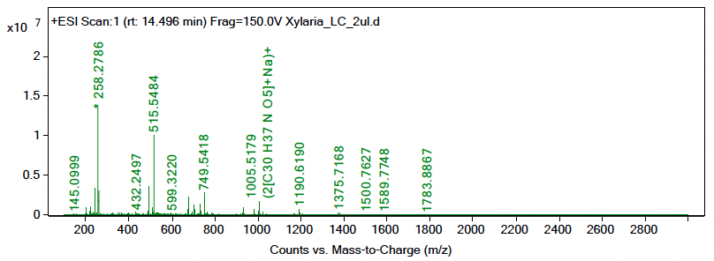
Supplementary Fig. 52. Et₂O
m/z = 677.3716, Ion = (M+H)

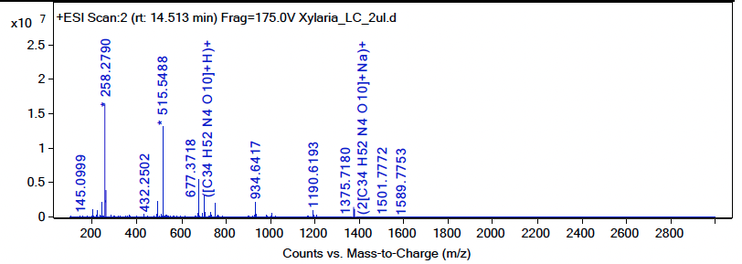
Supplementary Fig. 53. Et₂O
m/z = 677.3718, Ion = (M+H)
m/z = 699.3533, Ion = (M+Na)

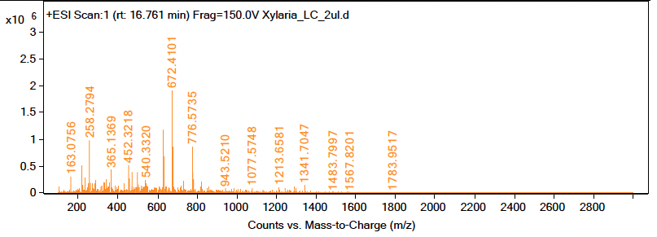
Supplementary Fig. 54. Et₂O
m/z = 677.3674, Ion = (M+H)
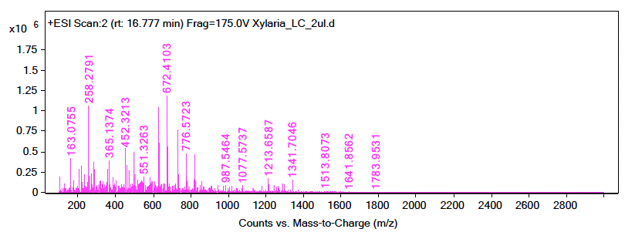
Supplementary Fig. 55. Et₂O

m/z = 677.3668, Ion = (M+H)
Identification of SM (9). Xylaric acid C

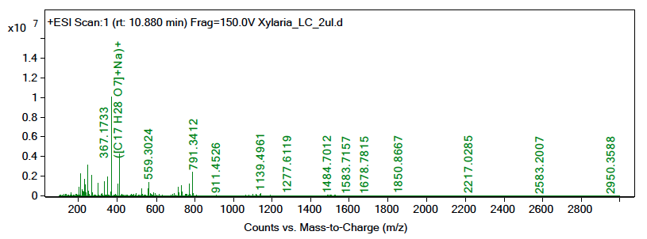
Supplementary Fig. 56. Et₂O
m/z = 349.1631, Ion = (M+Na)+[-H2O]
m/z = 367.1733, Ion = (M+Na)

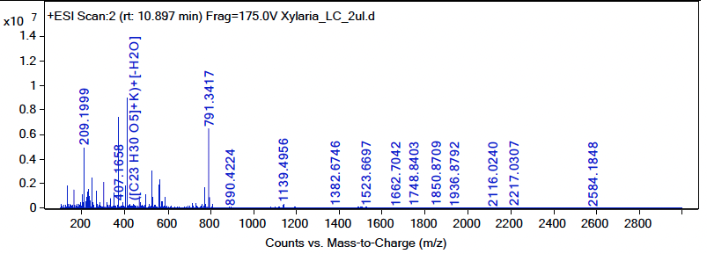
Supplementary Fig. 57. Et₂O
m/z = 367.1733, Ion = (M+Na)

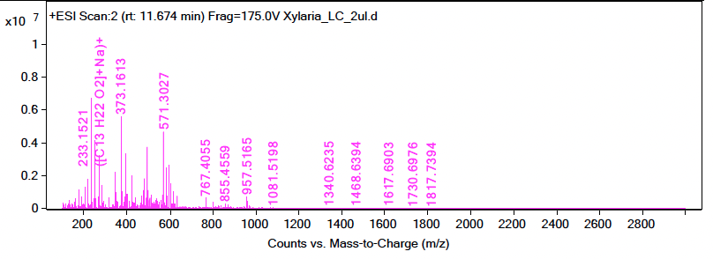
Supplementary Fig. 58. Et₂O
m/z = 345.1854, Ion = (M+H)

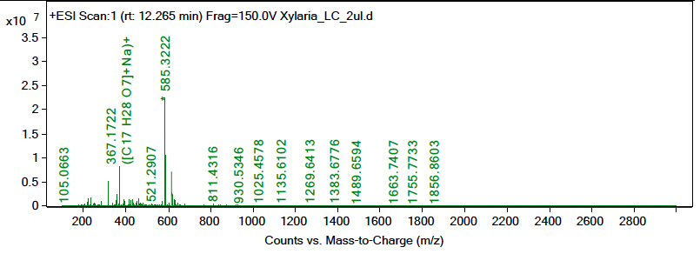
Supplementary Fig. 59. Et₂O
m/z = 367.1722, Ion = (M+Na)

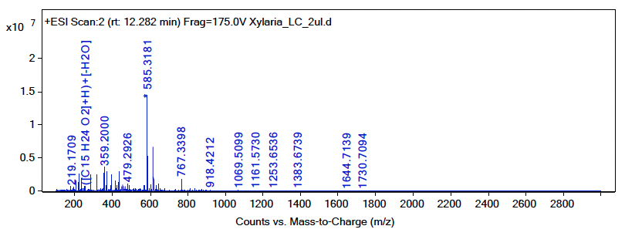
Supplementary Fig. 60. Et₂O
m/z = 367.1727, Ion = (M+Na)
Identification of SM (10). Zygosporin E

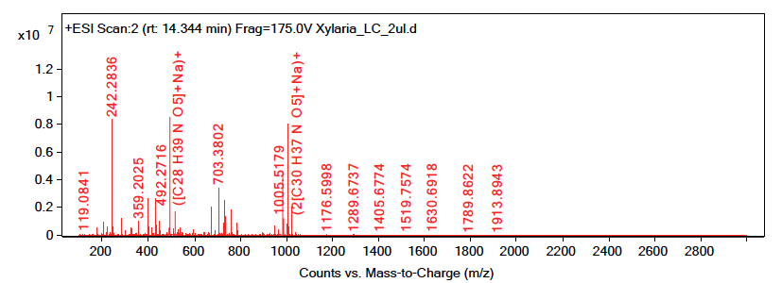
Supplementary Fig. 61. Et₂O
m/z = 983.5352, Ion = (2M+H)
m/z = 1005.5179, Ion = (2M+Na)

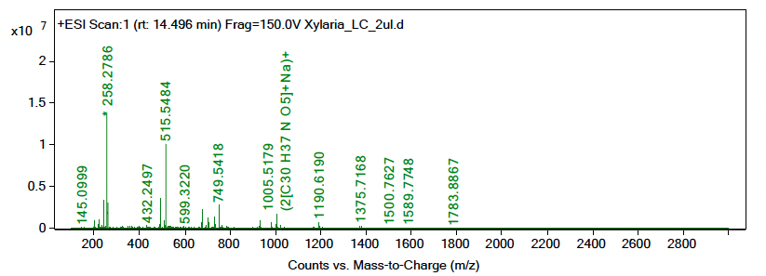
Supplementary Fig. 62. Et₂O
m/z = 1005.5179, Ion = (2M+Na)

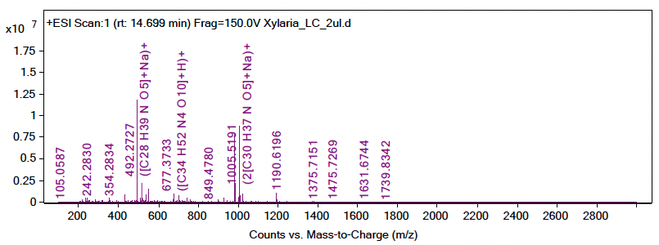
Supplementary Fig. 63. Et₂O
m/z = 514.254, Ion = (M+Na)
m/z = 983.5356, Ion = (2M+H)
m/z = 1005.5191, Ion = (2M+Na)

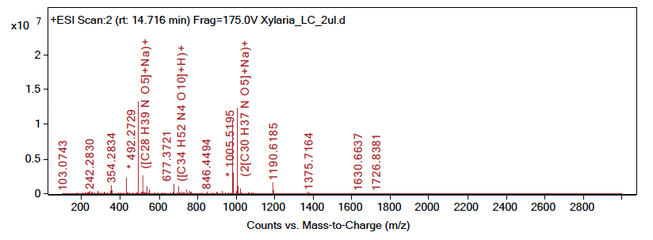
Supplementary Fig. 64. Et₂O
m/z = 514.2537, Ion = (M+Na)
m/z = 983.5368, Ion = (2M+H)
m/z = 1005.5195, Ion = (2M+Na)

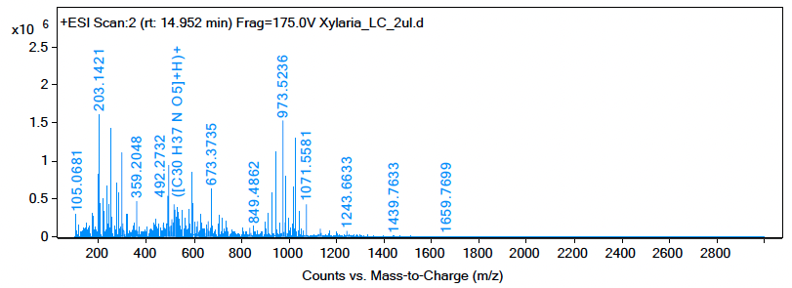
Supplementary Fig. 65. Et₂O
m/z = 492.2732, Ion = (M+H)

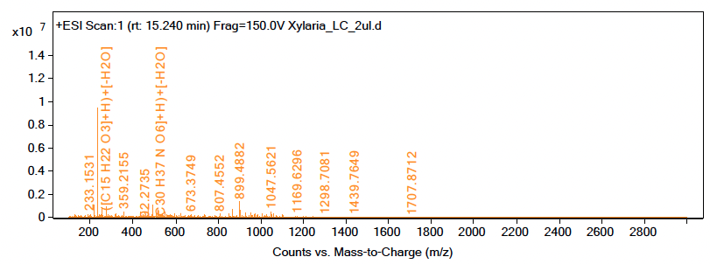
Supplementary Fig. 66. Et₂O
m/z = 514.2585, Ion = (M+Na)
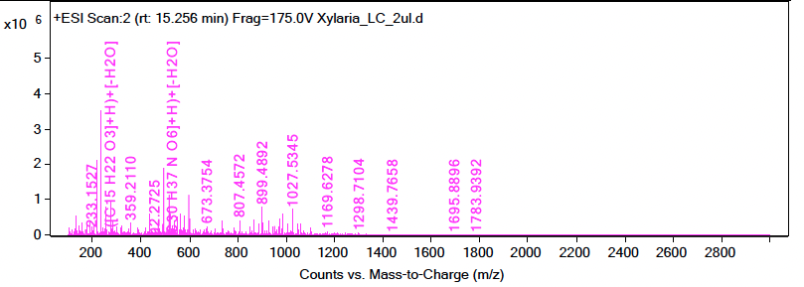
Supplementary Fig. 67. Et₂O
m/z = 514.2571, Ion = (M+Na)

