SURPPORTING INFORMATION

Text 1
Description of a possible model for the blinking of PSI
In our recent report, we proposed a tentative mechanism for the fluorescence blinking of PSI.(1) In this model, the fluctuation in the branching ratios of the EET flowing either to Red Chls or to the RC was assumed to lead to intermittent changes in the fluorescence intensity of PSI at 80 K. PSI fluorescence shows high brightness when the EET preferentially flows to Red Chls, whereas it is dimmed when the EET biasedly flows to the RC. Here, a fluorescence-quenching mechanism via P700⁺ was considered. P700⁺ acts as a principal quencher to excitations formed in the antenna Chl system of PSI.(2) In our SMS experiments, laser excitation with a high intensity induced an inevitable high-excitation frequency for single PSIs. In the present work, laser intensities of 2.88 kW/cm² and 0.96 kW/cm² were used to measure single PSI monomers and trimers, respectively. Taking the average molar extinction coefficient of a Chl ~ 50,000 M^{－1}cm^{－1} in the excitation wavelength region and the number of antenna Chls of PSI ~ 96 into account, the excitation frequencies of P700 in the measurement of monomers and trimers were estimated to be 5.4×10⁸ and 1.8×10⁸ s^{－1}, respectively. Such a high-excitation frequency causes much faster electron transfer from P700 to the secondary electron acceptor A₁ than the recovery of the neutral form of P700. Therefore, a P700⁺A₁－ radical pair was mainly populated even when adding an external reductant in the SMS experiments. Thus, P700 is practically oxidized during SMS measurement and acts as an efficient quencher.

Text 2
Optical Stability of the Cryo-ESM
The spatial resolution of the cryo-ESM was estimated to be about 0.56 μm for the lateral direction and 1.1 μm for the axial direction.(3) The spectral resolutions are about 0.6 nm and 0.3 nm for the excitation and emission spectra, respectively.
To test the influence of the drift in our cryo-ESM, we repeated the imaging of fluorescence beads with a 40 nm diameter 1 hour after the sample was cooled to 80 K. Figure S1A shows the time course of fluorescence images of a selected bead. All images of beads were fitted to a 2D Gaussian function, and the displacements of the beads from their initial positions were calculated (Fig. S1B for 296 K and Fig. S1C for 80 K). Here, the spatial drift of the individual beads in the focus plane was estimated to be below 200 nm for 400 s at both 296 K and 80 K. Such small dislocation in the lateral plane is negligible because it is sufficiently lower than the spatial resolution of our system. The fluorescence intensities of individual beads relative to the initial measurement are plotted in Fig. S1D and E. We hardly observed any intensity change in any beads, indicating that the drift does not affect a time-course measurement for 400 s. Subsequently, we observed changes in the excitation spectra of beads for 884 s via cryo-ESM. As can be seen in Fig. S2, the spectral profile of the beads remained similar to that of the ensemble sample. The estimation of the optical stability of the cryo-ESM ensured adequate observation of the single PSIs.

Text 3
Quantitative Analysis of the 2D-EEM Inclination
We used the variance and covariance matrix of raw 2D-EEMs to quantify the inclination of the 2D-EEM profiles. This method is essentially the same as the principal component analysis. The correlation (Corr) coefficient between excitation and emission for the 2D-EEM was given according to the following formulas (1-4):
$$\begin{aligned}Cov \left(λ_{exc ,} λ_{emi}\right)=\sum_{i=1}^{m}{\sum_{j=1}^{n}{\left(λ_{exc,i}-{\overline{λ}}_{exc}\right)\left(λ_{emi,j}-{\overline{λ}}_{emi}\right)}}×F\left(λ_{exc,i ,} λ_{emi, j}\right),\#\left(1\right)\end{aligned}$$
$$\begin{aligned}Var \left(λ_{exc}\right)=\sum_{i=1}^{m}{\sum_{j=1}^{n}{{\left(λ_{exc,i}-{\overline{λ}}_{exc}\right)}^{2}}}×F\left(λ_{exc,i ,} λ_{emi, j}\right),\#\left(2\right)\end{aligned}$$
$$\begin{aligned}Var \left(λ_{emi}\right)=\sum_{i=1}^{m}{\sum_{j=1}^{n}{{\left(λ_{emi,j}-{\overline{λ}}_{emi}\right)}^{2}}}×F\left(λ_{exc,i ,} λ_{emi, j}\right),\#\left(3\right)\end{aligned}$$
$$\begin{aligned}Corr\left(λ_{exc ,} λ_{emi}\right)=\frac{Cov \left(λ_{exc ,} λ_{emi}\right)}{\sqrt{var\left(λ_{exc}\right)*var\left(λ_{emi}\right)}}.\#\left(4\right)\end{aligned}$$

Here λ_{exc} and λ_{emi} indicate the excitation and emission wavelengths, respectively. F(λ_{exc}, λ_{emi}) is the signal intensity at λ_{exc} and λ_{emi}. F(λ_{exc}, λ_{emi}) is normalized so that $\sum_{i=1}^{m}{\sum_{j=1}^{n}{F(λ_{exc,i ,} λ_{emi, j})}=1}$. ${\overline{λ}}_{exc}$ and ${\overline{λ}}_{emi}$are the averages of λ_{exc} and λ_{emi} and are given by ${\overline{λ}}_{exc}=\sum_{i=1}^{m}{\sum_{j=1}^{n}{λ_{exc,i }×F(λ_{exc,i ,} λ_{emi, j})}}$ and ${\overline{λ}}_{emi}=\sum_{i=1}^{m}{\sum_{j=1}^{n}{λ_{emi,j }×F(λ_{exc,i ,} λ_{emi, j})}}$, respectively.

$$\begin{aligned}Variance-Covariance Matrix=\left[\begin{matrix}Var(λ_{exc}) & Cov(λ_{exc ,} λ_{emi}) \\ Cov(λ_{exc ,} λ_{emi}) & Var(λ_{emi})\end{matrix}\right]\#\left(5\right)\end{aligned}$$
The variance-covariance matrix of a 2D-EEM is given above. The two eigenvectors of the variance-convenience matrix give the inclination of the 2D-EEM. We defined the inclination $α$ (falls in the $-45°$ to $+45°$ range) as the angle between the eigenvector and the vertical ($λ_{emi}$) axis of the 2D-EEM (Fig. 3).

Table S1. The parameters of the Gaussian fitting to the histograms in Fig. 2C.
 | Peak (Exc.) / nm | Width (Exc.) / nm | Peak (Emi.) / nm | Width (Emi.) / nm | Peak (exc.- emi. separation) / cm⁻¹ | Width (exc.- emi. separation) / cm⁻¹
Monomer | 670 | 6.1 | 721  729 | 7.9  4.6 | 1164 | 194
Trimer | 674 | 3.4 | 722  726 | 8.5  3.6 | 1044 | 143

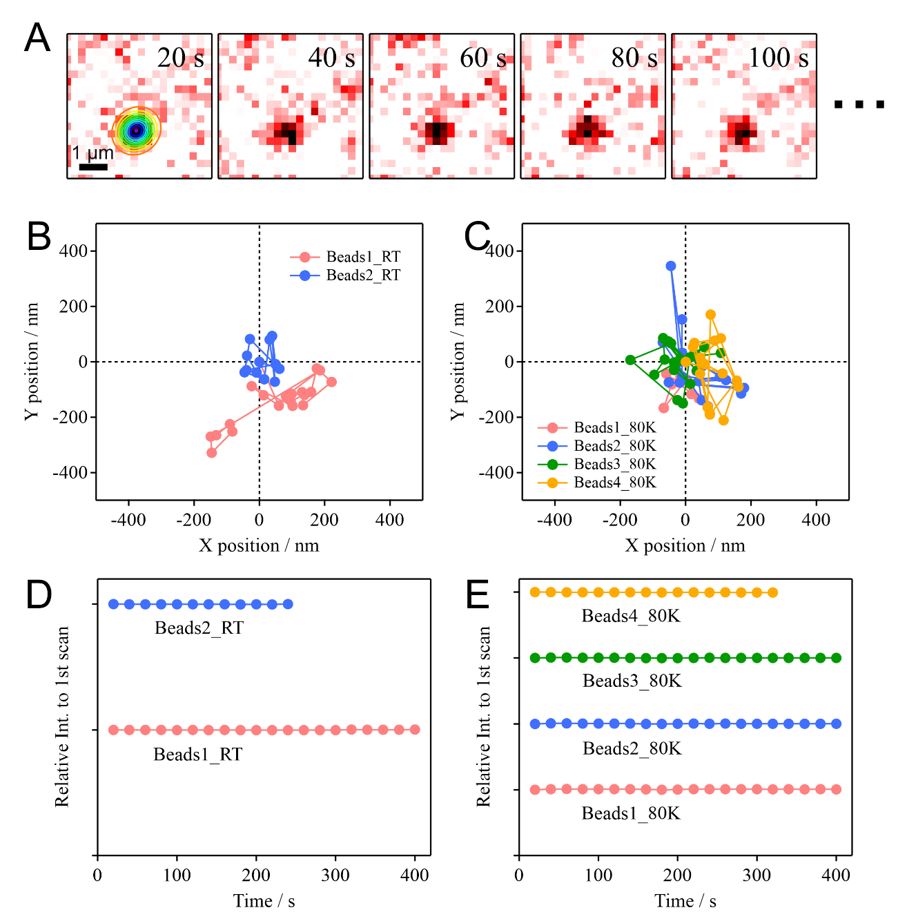
Figure S1. (A) Time-course of fluorescence images of a bead. The 2D Gaussian function fitted to the profile in the 20 s image is indicated by the contours. (B) and (C) indicate the variations in the lateral position of individual beads for 400 s at room temperature and at 80 K, respectively. (D) and (E) indicate variations in the intensity of individual beads at room temperature and at 80 K, respectively. The data in (D) and (E) are given as values relative to the first scan and are vertically offset as a visual guide.

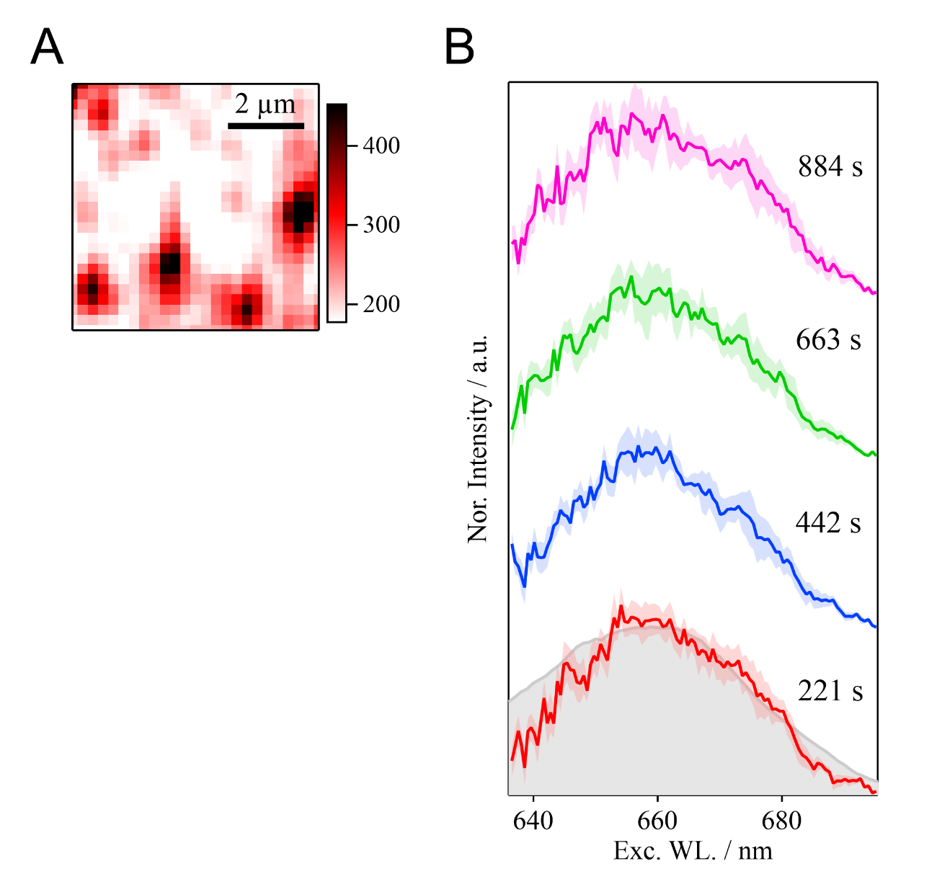

Figure S2. (A) Fluorescence image at 80 K showing the beads with a 40 nm diameter spin-coated on a quartz cover slip. (B) Time course of average excitation spectra of fluorescence beads (n=15); the standard deviations are shown in pale colors. The excitation spectrum of the bead suspension measured by the conventional fluorometer is shown as a gray curve.
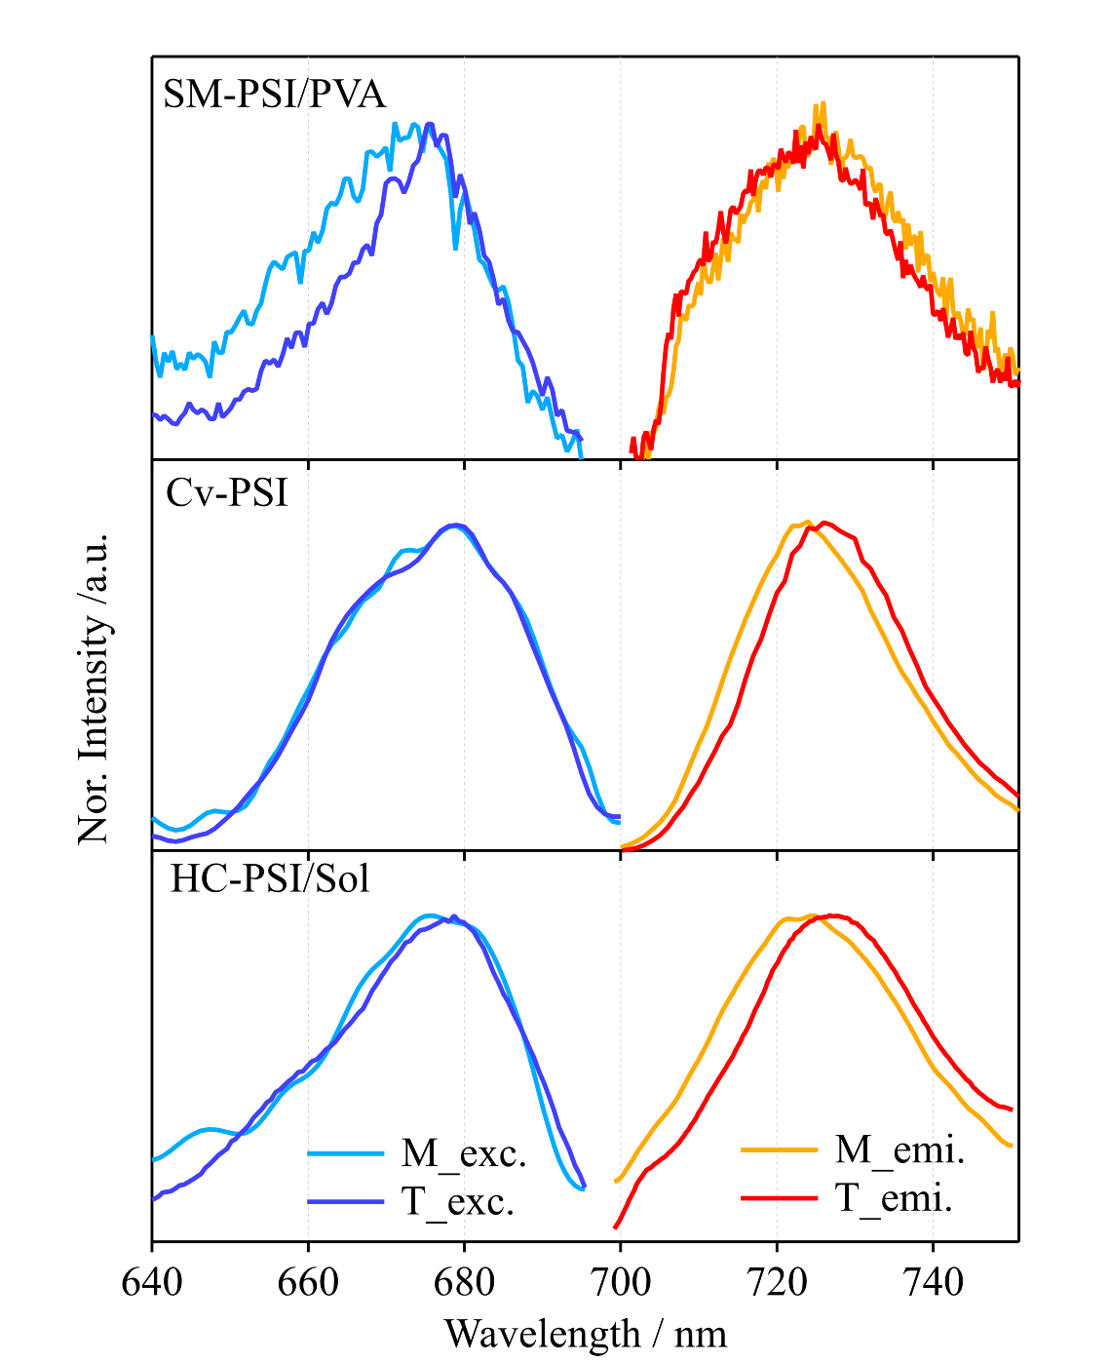
Figure S3. (A) The excitation and emission spectra averaged over all the measured single PSIs. The results are also shown in Fig. 2A. (B) The excitation and emission spectra of PSI solutions measured by the conventional fluorometer. (C) The excitation and emission spectra of the PSI solutions upon microscopic measurement.

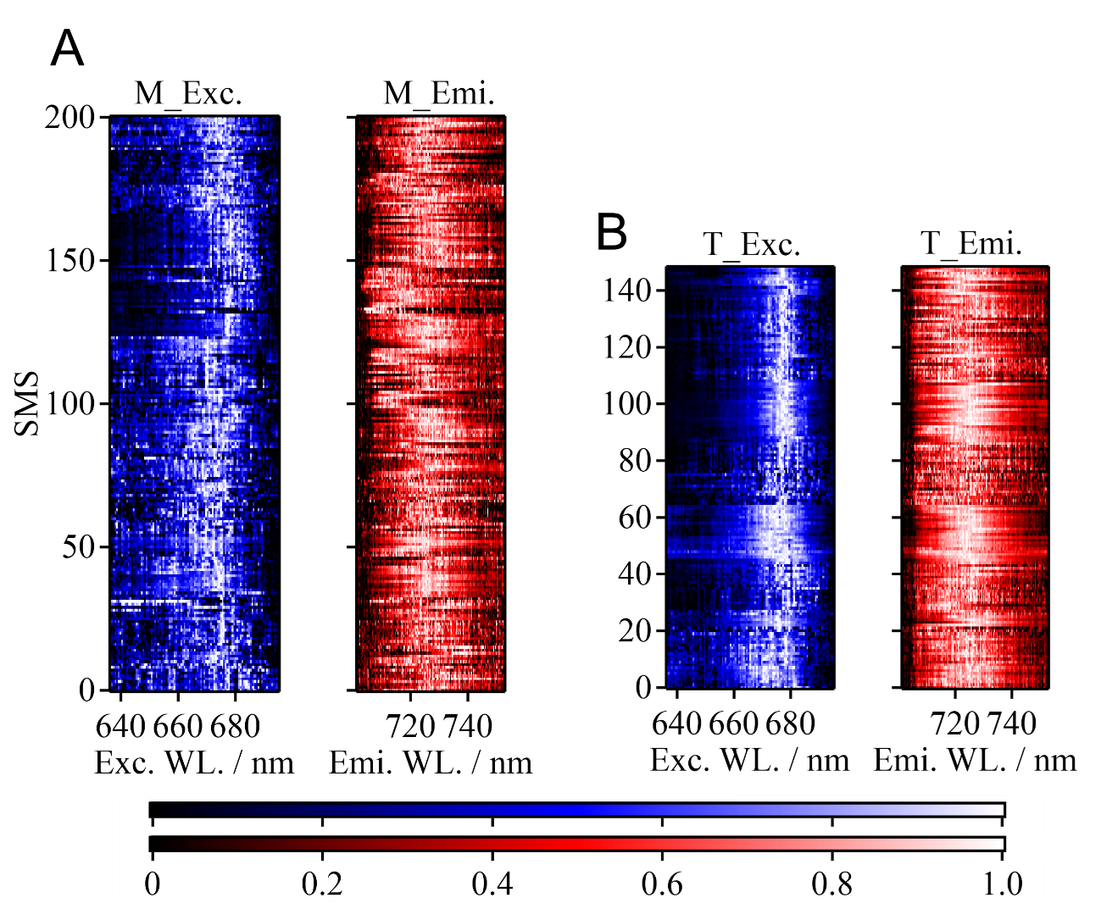

Figure S4. (A) Normalized excitation (blue) and emission (red) spectra of all the observed monomers (left, n=201) and trimers (right, n=149), shown as color maps.

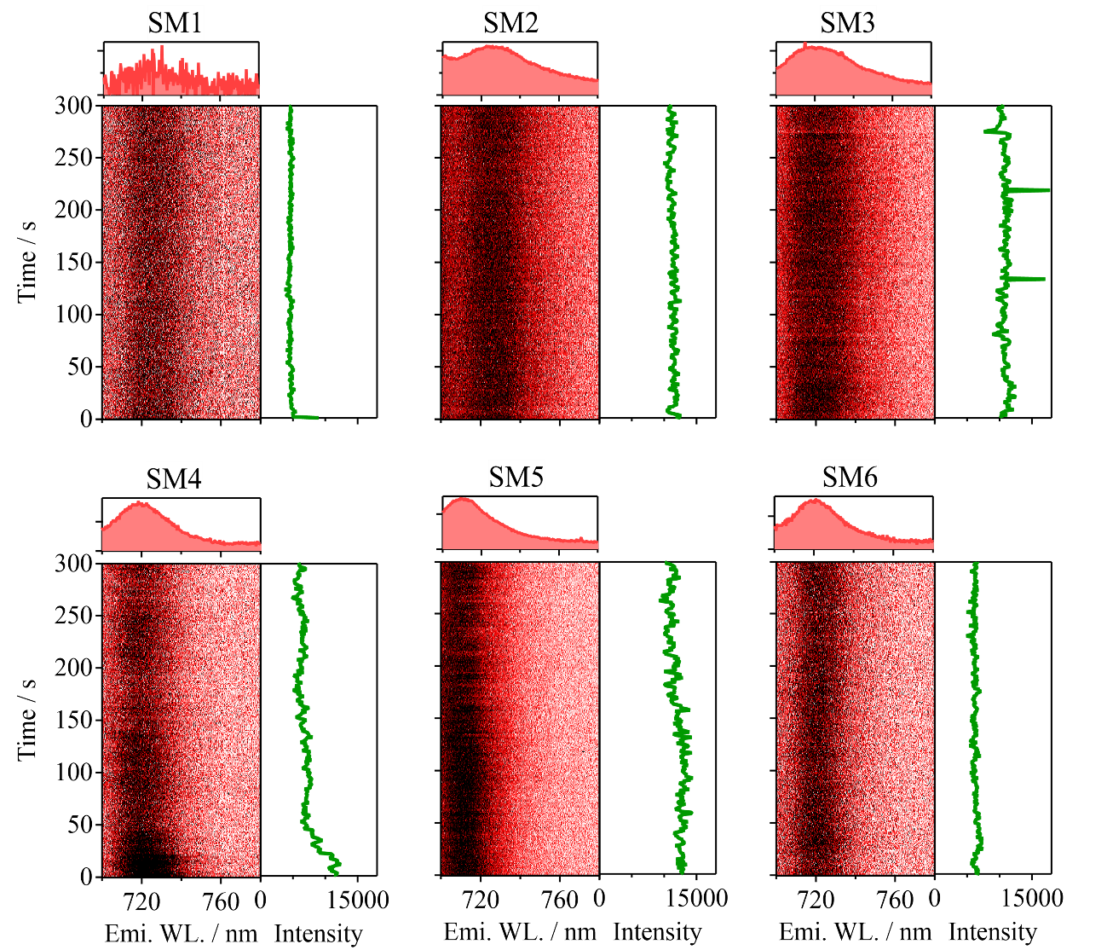
Figure S5. Time traces of the fluorescence spectra of six PSI trimers recorded for 300 s. The acquisition time is set to 1 s. The average fluorescence spectra and the intensity changes (700－740 nm) are shown on the top and right panels, respectively.
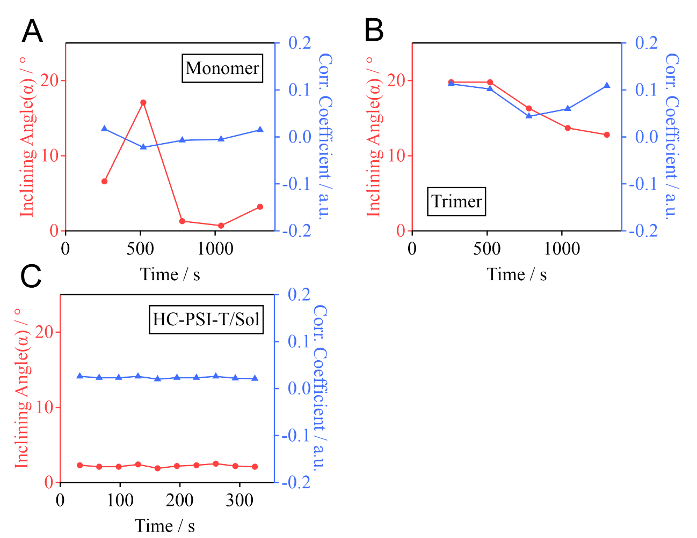Figure S6. (A) and (B) Temporal changes in the inclining angles and correlation coefficients of the molecules shown in Fig. 4 (A) and (C), respectively. (C) The HC-PSI-T/Sol at 80 K (Fig. S7).

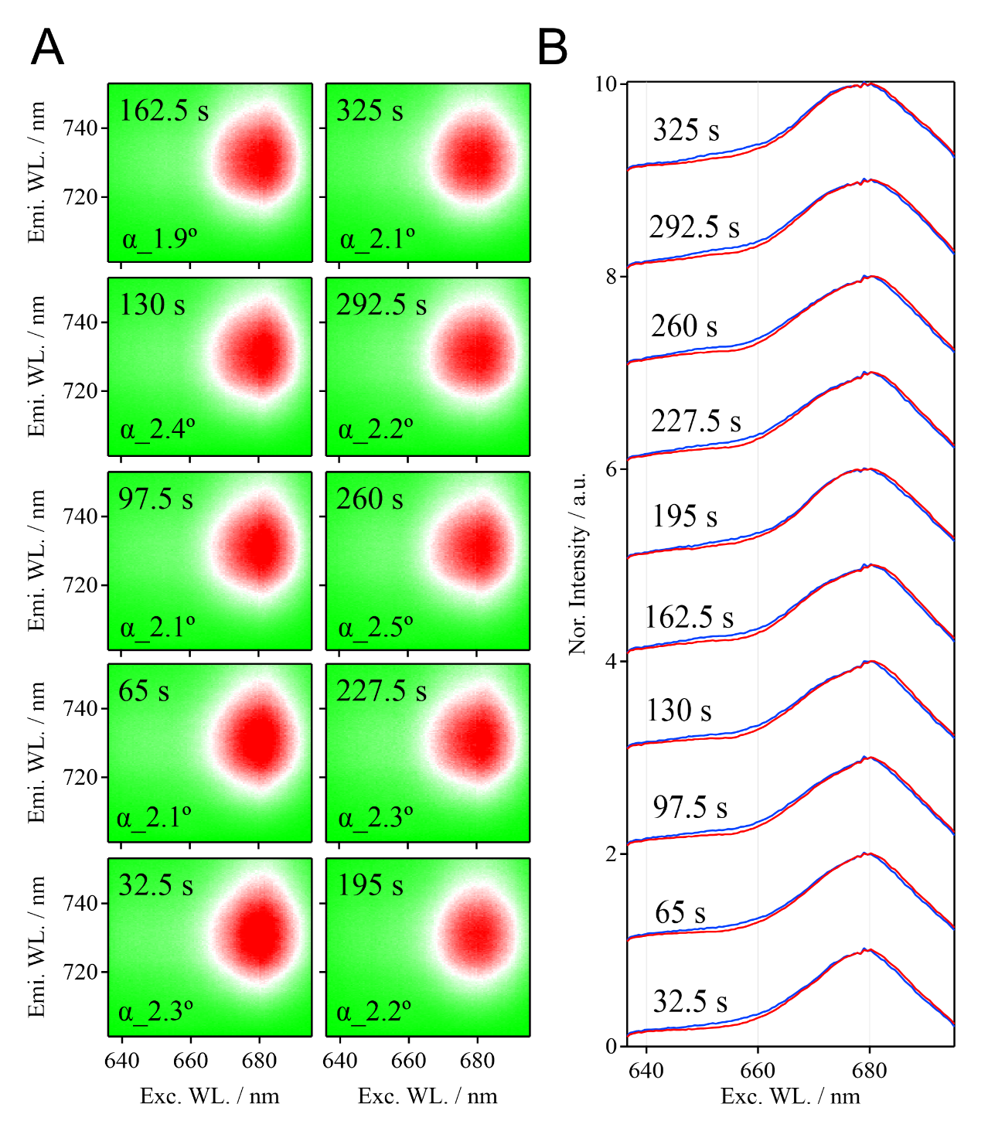
Figure S7. (A) The time course of 2D-EEM images of an HC-PSI-T/Sol of 50 nM at 80 K. α indicates the inclining angle of 2D-EEMs. (B) The individual sub-excitation spectra correspond to the red (700－725 nm, blue) and far-red (725－752 nm, red) emission wavelength regions.

REFERENCE

1. S. Jana, T. Du, R. Nagao, T. Noguchi, Y. Shibata, Redox-state dependent blinking of single photosystem I trimers at around liquid-nitrogen temperature. Biochimica et Biophysica Acta (BBA)-Bioenergetics 1860, 30-40 (2019).
2. N. V. Karapetyan, Protective dissipation of excess absorbed energy by photosynthetic apparatus of cyanobacteria: role of antenna terminal emitters. Photosynthesis research 97, 195-204 (2008).
3. S. Jana, Y. Shibata, Development of a multicolor line-focus microscope for rapid acquisitions of excitation spectra. Biophysical journal 118, 36-43 (2020).

