Germination response of the freshwater invasive Iris pseudacorus to brackish and marine salinity as well as implications for coastal invasion
Hanna M. Thomson ^{1*}(ORCiD 0000-0003-2855-063X), Nancy Shackelford¹ (ORCiD 0000-0003-4817-0423), Travis G. Gerwing¹ (ORCiD 0000-0002-4433-1843)
¹ School of Environmental Studies, University of Victoria, Victoria, British Columbia, Canada
* Corresponding author: hannamthomson@gmail.com
Appendix 1: Supplementary Information
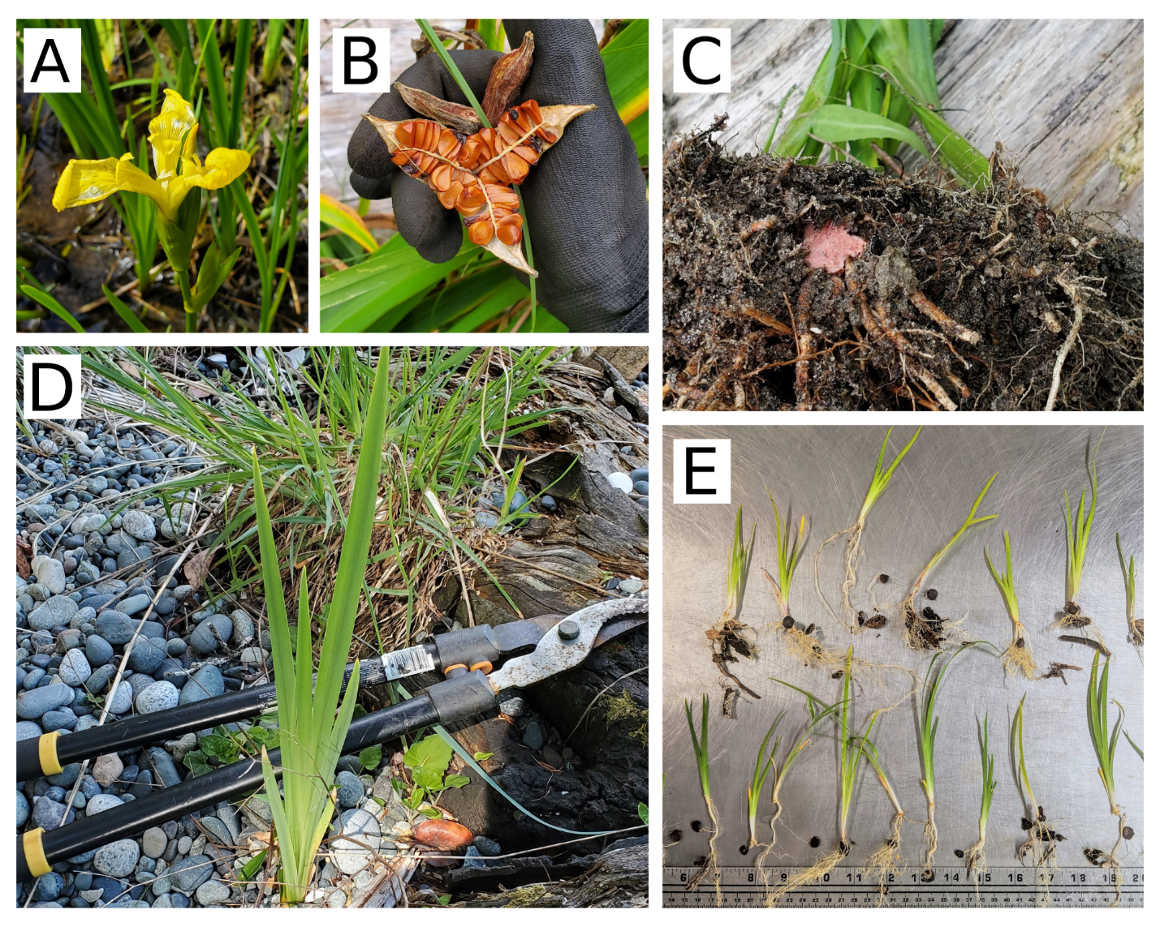
SI 1: Once pollinated, the I. pseudacorus flowers (A) develop dehiscent fruit that that release over one hundred seeds (B). Water-dispersed pink-coloured rhizome fragments (C) and buoyant seeds faciliate I. pseudacorus invasion into coastal habitat ([D] maturing plant; [E] seed-established juvenile plants)
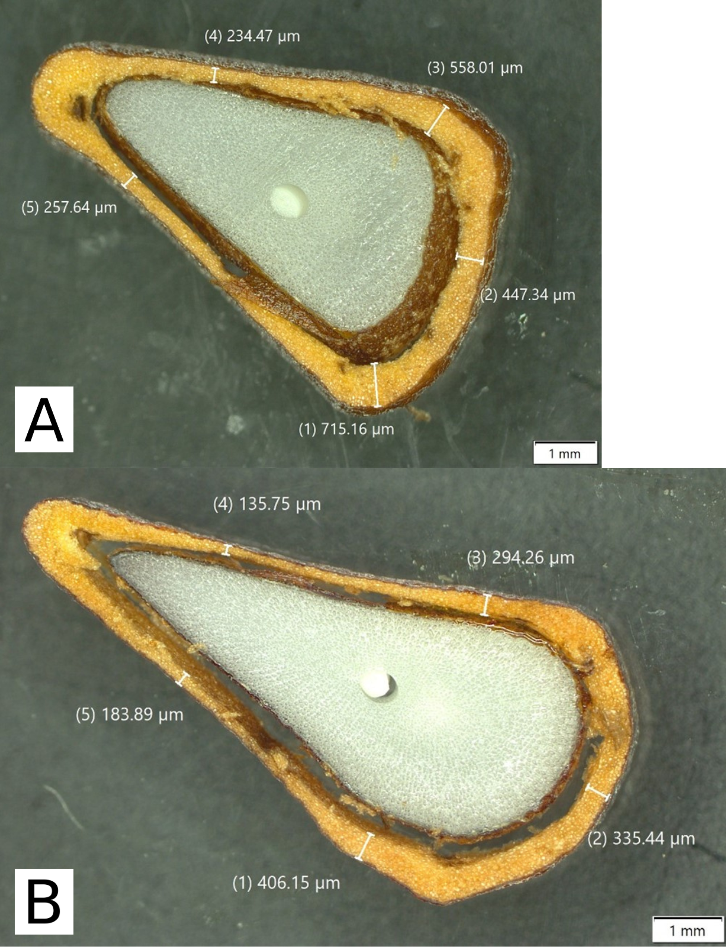
SI 2: Seed coat thickness measurements for I. pseudacorus seeds from the freshwater (A) and marine (B) populations. A purposive sampling scheme was employed to collect measurements because I. pseudacorus seed coats are not uniformly thick. Population means were derived by averaging five measurements for each seed
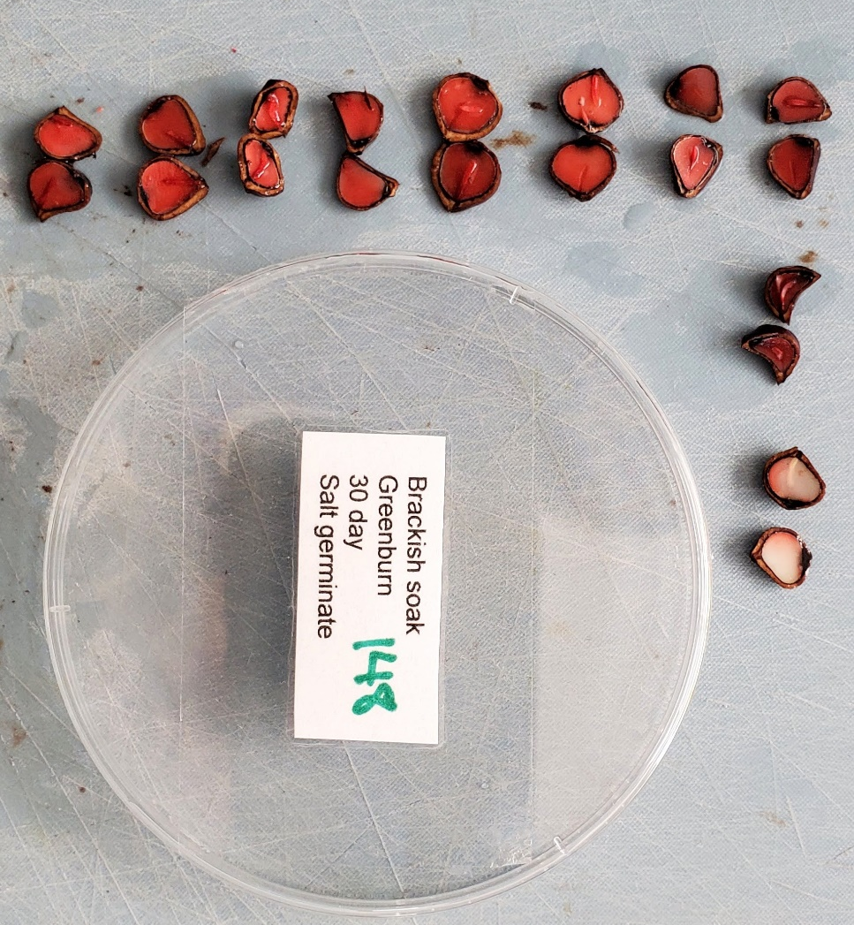
SI 3: Illustration of the seed viability analysis (tetrazolium test) conducted on ungerminated I. pseudacorus seeds at the conclusion of the germination experiment. Seeds in the green box were assessed as viable and the seed in the red box were deemed unviable
SI 4: Seed Germination Model
The following model illustrates the components of the GLM that elucidated how the germination success of I. pseudacorus seeds were influenced by the experimental fixed effects
$Germination Success \sim Seed Population+Immersion Salinity+Immersion Duration+Seed Population :Immersion Salinity+Immersion Salinity :Immersion Duration+Seed Population :Immersion Duration$
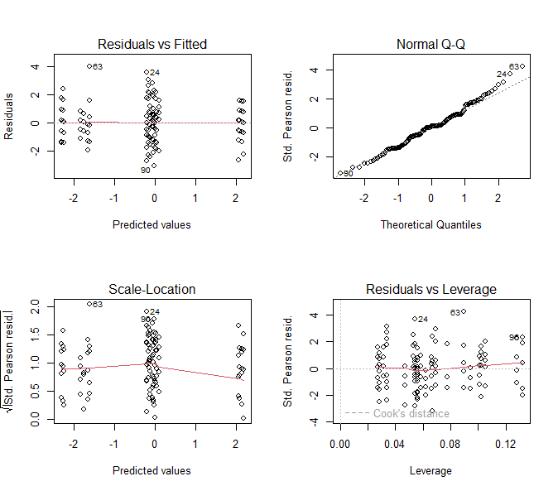
SI 5: Model validation plots consulted to assess the assumptions underpinning the Generalized Linear Model that evaluated the effect of the seed population, immersion salinity, immersion duration, and germination conditions upon the germination success of I. pseudacorus seed
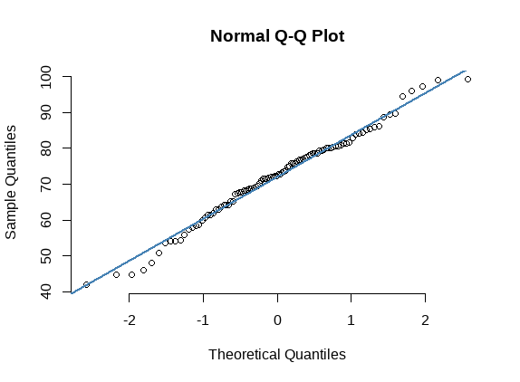 | 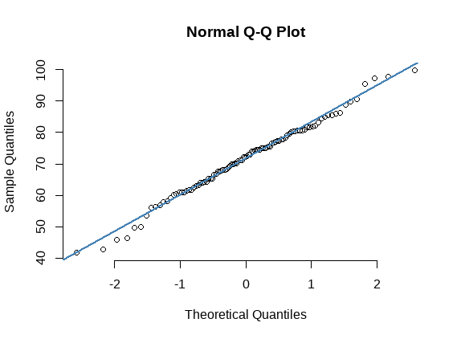
SI 6: Normal quantile-quantile plots of the dried weights of seeds from freshwater and marine populations of I. pseudacorus. The plots were assessed to confirm normal distribution of measurements from both populations

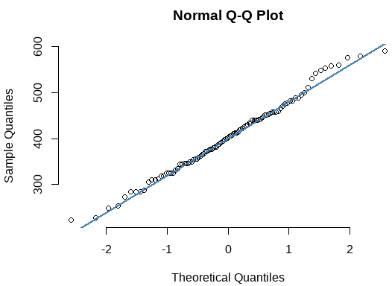 | 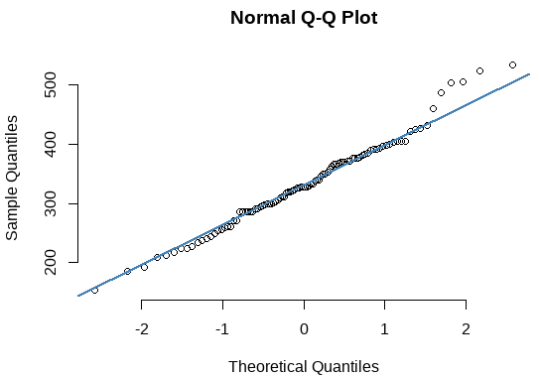
SI 7: Normal quantile-quantile plots of the seed coat thicknesses of seeds from freshwater and marine populations of I. pseudacorus. The plots were assessed to confirm normal distribution of measurements from both populations
SI 8: Seed Viability Model
The following model illustrates the components of the GLM that clarified the experimental fixed effects influence upon the viability of I. pseudacorus seeds at the termination of the germination assessment.
$Seed Viabiltiy \sim Seed Population+Immersion Duration+Germination Conditions+ Seed Population :Germination Conditions+Germination Conditions :Immersion Duration+Seed Population :Immersion Duration$

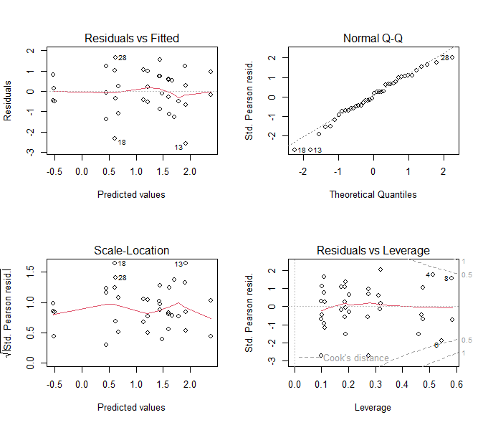
SI 9: Model validation plots consulted to assess the assumptions underpinning the Generalized Linear Model that evaluated the effect of seed population, immersion salinity, immersion duration, and germination conditions upon the tissue viability of ungerminated I. pseudacorus seed at the conclusion of the germination assessment

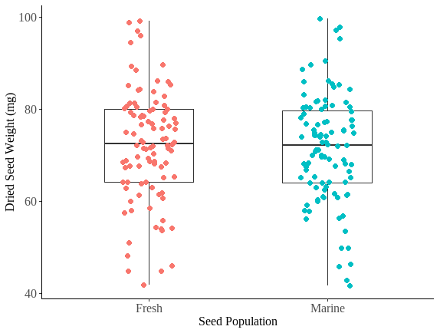
SI 10: The dried weight of seeds from freshwater and marine populations of I. pseudacorus (n=100 seeds / population)

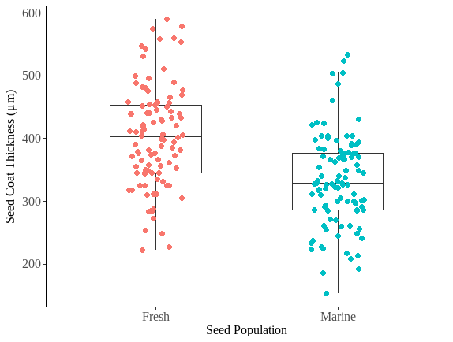
SI 11: The mean seed coat thickness of I. pseudacorus seeds (n= 5 measurements / seed) from freshwater and marine populations (n= 100 seeds / population)

