Supplemental material

Plasma Kinetics and Metabolism Analysis
No significant differences between [¹⁸F]MC225 and (R)-[¹¹C]verapamil were found in the SUV-TAC of whole-blood neither in baseline nor in after-inhibition scans. However, the metabolite-corrected SUV-TAC of plasma was higher for [¹⁸F]MC225 (SUVmean baseline: 2.88±0.28 and after-inhibition: 2.98±0.20) than for (R)-[¹¹C]verapamil (SUVmean baseline: 2.00±0.35 and after-inhibition: 1.98±0.32) (p<0.001 in both cases).
No significant differences were found in the parent fraction TACs of both tracers at baseline or after-inhibition. At 30-min after tracer injection, the mean percentage of parent (R)-[¹¹C]verapamil was (mean±SD) 56.8±6.9 % at baseline and 43.8 ±8.2 % after P-gp inhibition. A similar decrease of the parent fraction of [¹⁸F]MC225 was observed, from 53.2±2.2 % at baseline to 47.4±5.6% after P-gp inhibition. Supplemental Figure 1 shows the metabolite-corrected plasma SUV-TACs and parent fraction TACs of both tracers in baseline and after-inhibition scans.
The rate constant of elimination of the tracer from the blood (Ke) at baseline was higher for (R)-[¹¹C]verapamil (Ke=0.0175) than for [¹⁸F]MC225 (Ke=0.0155) (p=0.005). After P-gp inhibition, the Ke values of both tracers were not significantly different (Ke (R)-[¹¹C]verapamil = 0.0155 vs Ke [¹⁸F]MC225= 0.0147).

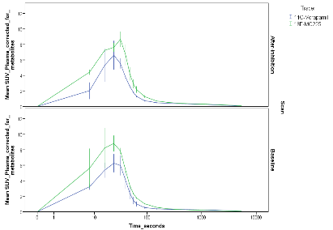
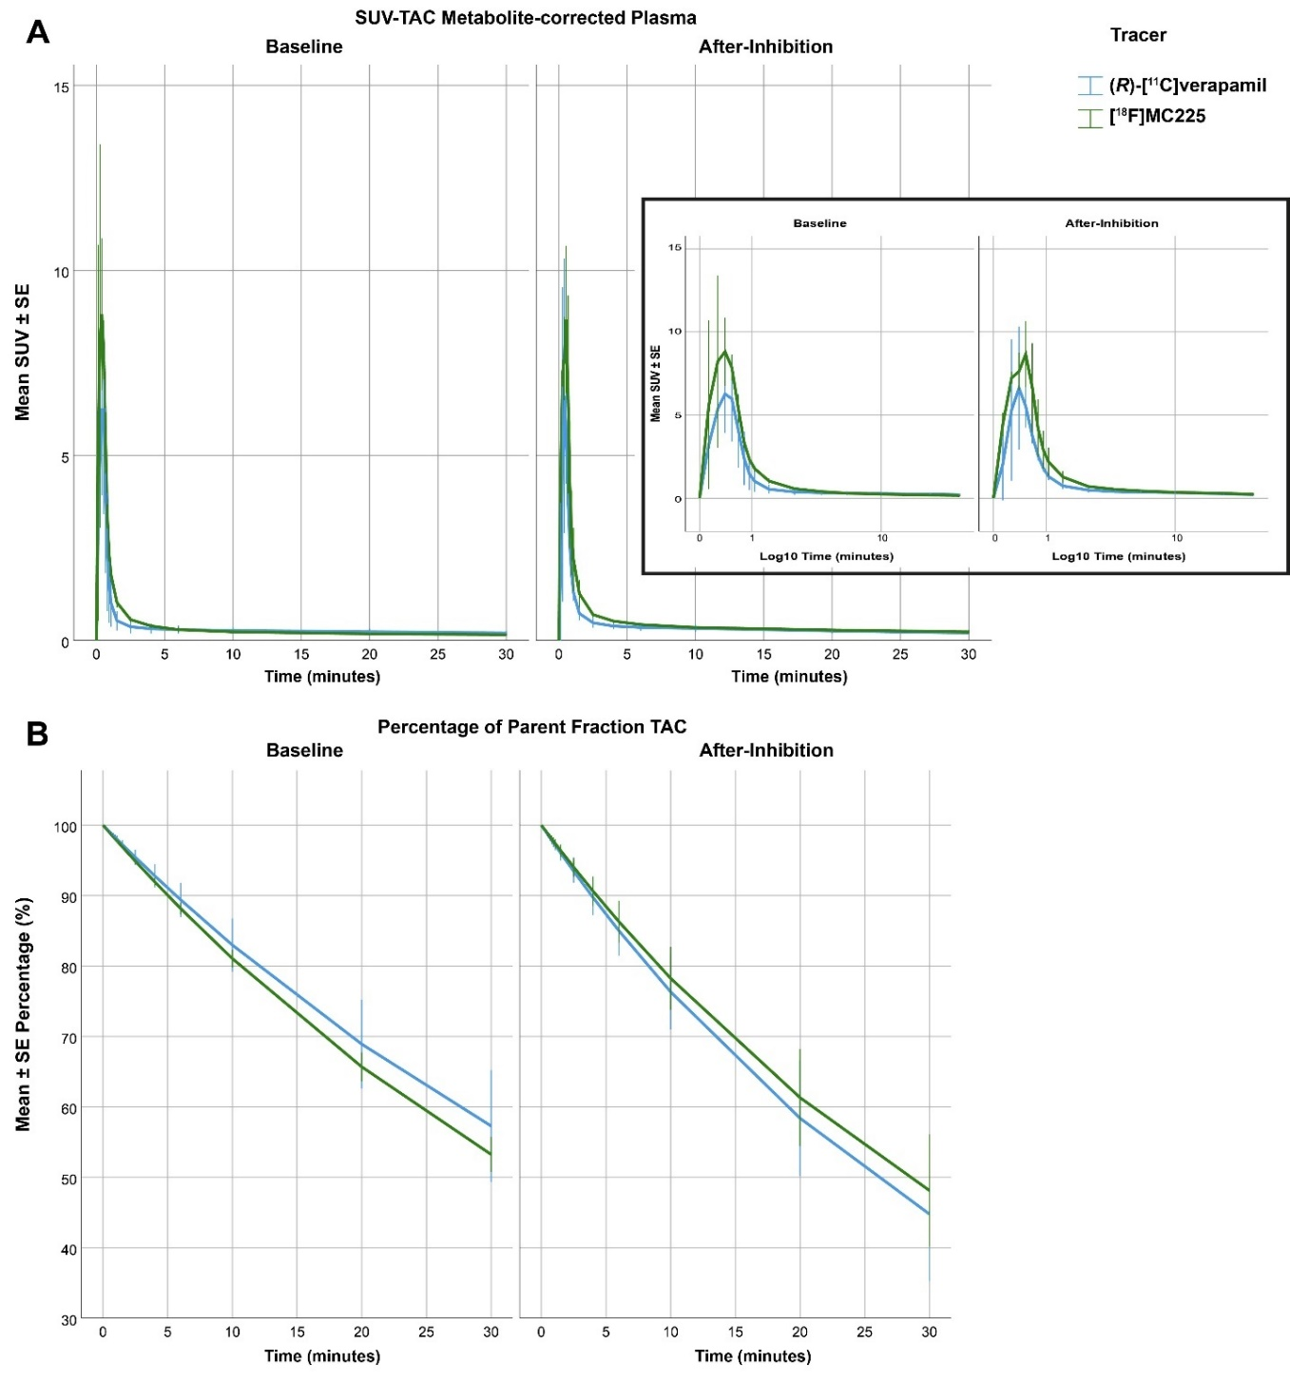
Supplemental Figure 1: Metabolite-corrected SUV-TACs of plasma for both tracers at baseline and after-inhibition (A). Parent fraction of [¹⁸F]MC225 and (R)-[¹¹C]verapamil during the 30-min PET scan (B).
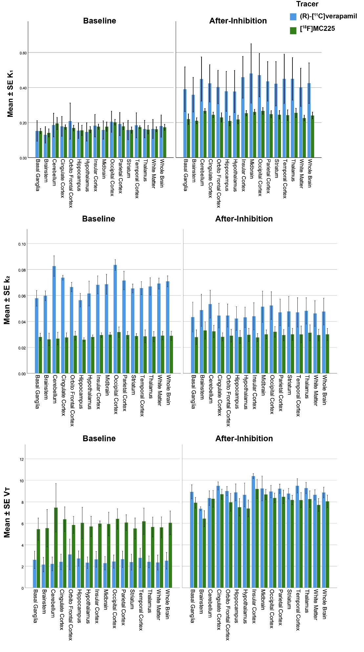
Supplemental Figure 2: K₁ (A), V_{T} (B), and k₂ (C) values of both tracers in different brain regions, at baseline (left) and after-inhibition (right).

Supplemental Table 1: Regional changes due to the P-gp inhibition in V_{T}, k₂, and K₁ relative to the whole brain region in both tracers.
Relative Changes due to P-gp inhibition
[¹⁸F]MC225
Region | Changes in K₁ | p-values | Changes in k₂ | p-values | Change V_{T} | p-values
Basal Ganglia | 4% | 0.035 | -5% | 0.069 | 9% | <0.001
Brainstem | 7% | 0.129 | 21% | <0.001 | -12% | 0.079
Cerebellum | -1% | 0.618 | 17% | <0.001 | -16% | 0.001
Cingulate Cortex | 1% | 0.776 | -2% | 0.21 | 3% | 0.042
Hippocampus | -3% | 0.004 | 3% | 0.287 | -6% | 0.019
Hypothalamus | -2% | 0.427 | 1% | 0.648 | -3% | <0.001
Insular Cortex | 3% | 0.048 | -10% | 0.072 | 14% | 0.001
Midbrain | 7% | 0.085 | -3% | 0.498 | 10% | <0.001
Occipital Cortex | -5% | 0.016 | -3% | <0.001 | -2% | 0.408
Orbito Frontal Cortex | -2% | 0.35 | -4% | 0.015 | 2% | 0.06
Parietal Cortex | 0% | 0.971 | -4% | 0.088 | 4% | 0.112
Striatum | 12% | <0.001 | 0% | 0.979 | 11% | 0.002
Temporal Cortex | 0% | 0.98 | 1% | 0.808 | -1% | 0.223
Thalamus | 16% | <0.001 | 6% | 0.182 | 9% | <0.001
White Matter | 0% | 0.917 | -3% | 0.026 | 3% | 0.119
Relative Changes due to P-gp inhibition
(R) -[¹¹C]Verapamil
Region | Change K₁ | p-value | Change k₂ | p-value | Change V_{T} | p-values
Basal Ganglia | 9% | <0.001 | 11% | <0.001 | -2% | 0.268
Brainstem | 17% | <0.001 | 21% | <0.001 | -3% | 0.558
Cerebellum | 2% | 0.168 | -4% | <0.001 | 6% | 0.004
Cingulate Cortex | 0% | 0.932 | -10% | <0.001 | 12% | <0.001
Hippocampus | 3% | 0.6 | 12% | <0.001 | -8% | 0.025
Hypothalamus | 9% | <0.001 | 5% | 0.385 | 3% | 0.487
Insular Cortex | 7% | <0.001 | -4% | 0.06 | 11% | <0.001
Midbrain | 27% | <0.001 | 11% | 0.006 | 14% | <0.001
Occipital Cortex | -4% | 0.326 | -7% | <0.001 | 3% | 0.437
Orbito Frontal Cortex | -16% | 0.021 | 0% | 0.765 | -16% | 0.026
Parietal Cortex | -4% | <0.001 | -2% | 0.307 | -2% | 0.166
Striatum | 13% | <0.001 | 8% | 0.001 | 4% | 0.029
Temporal Cortex | 3% | 0.403 | 6% | 0.014 | -3% | 0.074
Thalamus | 15% | 0.004 | 7% | 0.003 | 8% | 0.051
White Matter | 4% | 0.062 | -1% | 0.325 | 4% | <0.001

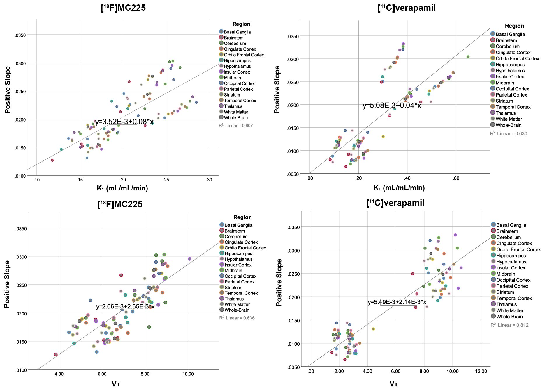
Supplemental Figure 3: Linear regression analysis of positive slope and the kinetic parameters obtained with 1-TCM.

