Supplementary Information

Methods for the Generation and Characterization of Cryomilled Micro- and Nanoplastics
Campbell J. McColley¹, Jeffrey A. Nason¹, Bryan J. Harper², Stacey L. Harper^{*1,2}
¹School of Chemical, Biological and Environmental Engineering Oregon State
University, 116 Johnson Hall, 105 SW 26th St., Corvallis, OR 97331, United States
²Department of Environmental and Molecular Toxicology, Oregon State University, 1007 Agriculture & Life Sciences Building, Corvallis, OR 97331, United States

*Corresponding Author – Stacey.Harper@oregonstate.edu

16 Figures

Validation of MP Stability in Isoton II
Time resolved dynamic light scattering (TR-DLS) was used to determine the stability of cryomilled PS MPs in ISOTON II, the Coulter Counter background electrolyte. As shown in Figure S1, the intensity-weighted hydrodynamic diameter did not increase over a ten-minute time period representative of typical Coulter Counter Measurements.
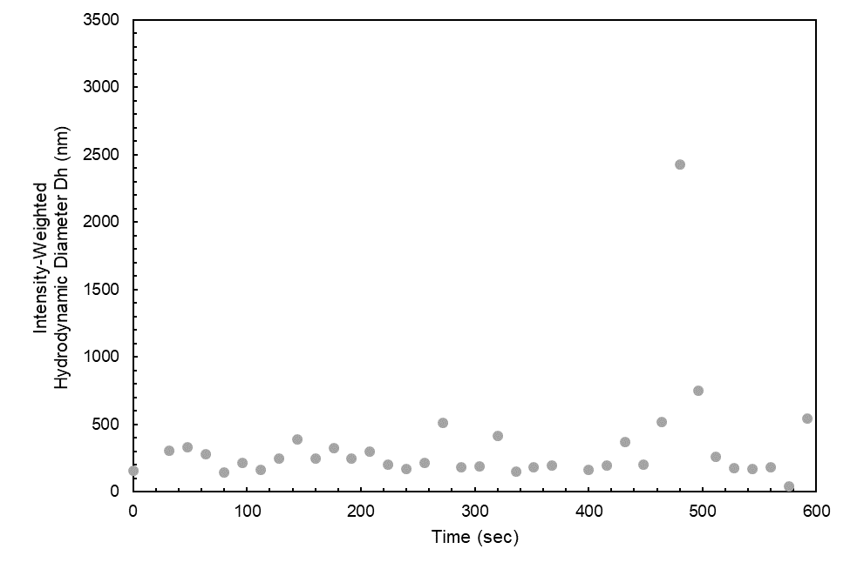
Fig. S1 Time-resolved dynamic light scattering of cryomilled PS MPs (3 cycles @ 30 Hz) in ISOTON II Coulter Counter diluent

Combining data from multiple Coulter Counter apertures
Particle size distributions in the micrometer range were measured using a Coulter Counter. As each aperture used can only measure particles ranging in size from 2 to 40% of the aperture diameter, multiple apertures were used to analyze each sample. All the data was plotted on the same chart and then edited. Fig. S2 shows the PSDF of a cryomilled PS MP sample (1 cycle, 30 Hz) before editing. Distributions for each aperture overlapped well. The editing process consisted of removing data from the lower and upper end of the distributions where the larger aperture data is used by default. Regions where there were excessive background counts or not enough counts for statistical significance were removed. For example, the lower region of the 200 µm data has a sharp peak around log(d_{p}) = 0.7. Data from the 30 µm aperture shows that the lower end of the 200 µm data had excessive counts which were removed.
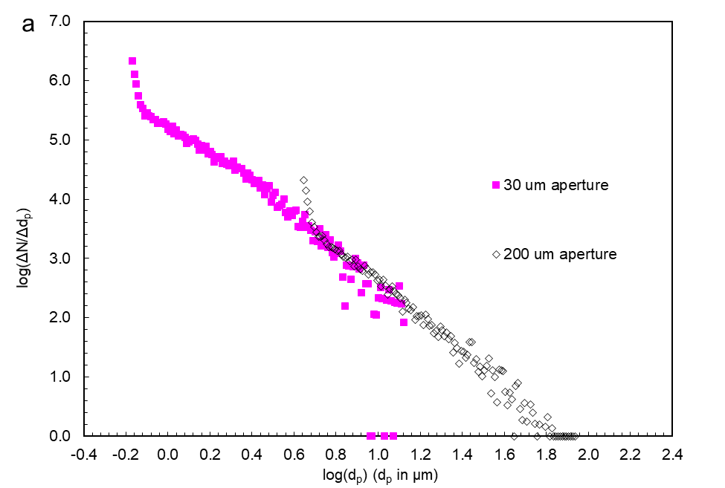
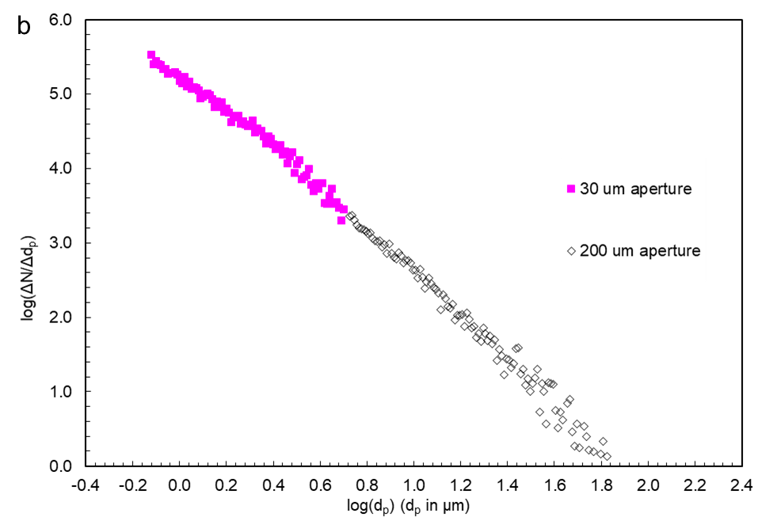
Fig. S2 Coulter Counter PSD for cryomilled polystyrene (1 cycle @ 30 Hz) measured using 30 μm and 200 μm apertures a) before editing and b) after editing

NTA Camera and Detection Settings
To evaluate the impact of NTA camera settings on resultant size distributions, five 750 nm PS microspheres replicates were measured using different camera settings. The camera setting adjusts the brightness of the instrument laser and the detection threshold sets a greyscale cutoff for identifying and counting particles. The measured mean diameter of the particles was compared to 750 nm. The concentration of particles was compared to an initial sample concentration of 0.1 mg/L. All camera settings and detection thresholds underestimated the particle size (Fig. S4 and S6). A camera setting of 14 slightly underestimated particle concentration whereas particle concentration was overestimated at all other camera settings (Fig. S4). Particle concentration was overestimated for detection thresholds 5-20 and underestimated at a setting of 25 (Fig. S6). This would indicate that the optimal detection threshold for particle concentration was between 20 and 25 at camera setting 10.
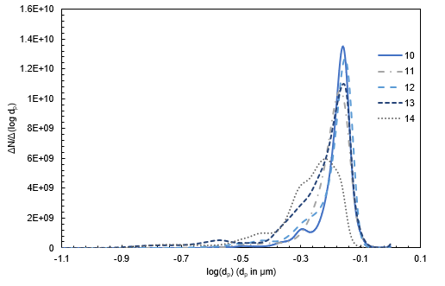

Fig. S3 NTA ND obtained from 750 nm PS microspheres using different camera settings and a detection threshold of 10

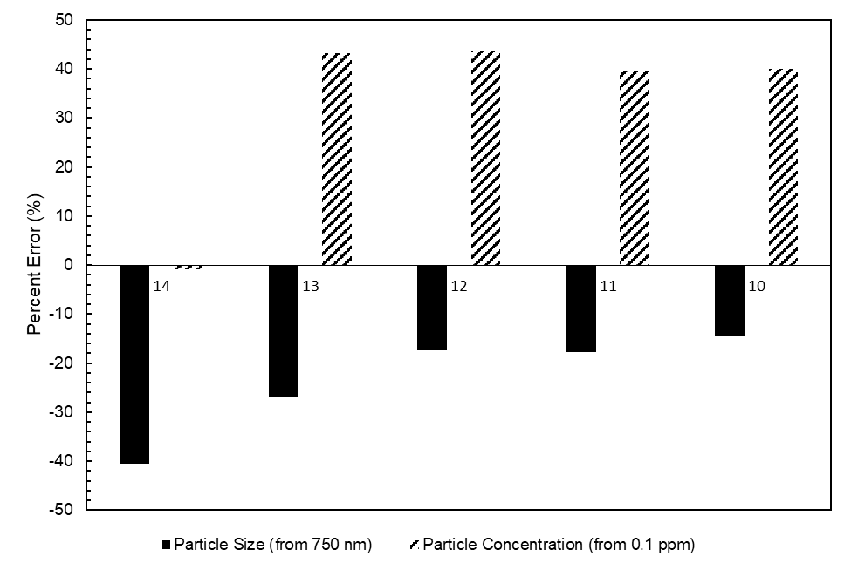
Fig. S4 NTA particle size and mass concentration error using different camera settings and a detection threshold of 10

Using the camera setting 10 data for 750 nm PS, NTA data was reprocessed using different detection thresholds.
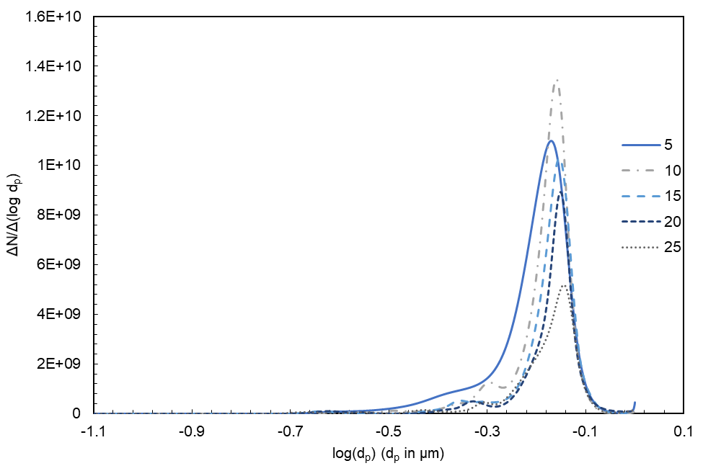
Fig. S5 NTA ND obtained from 750 nm PS microspheres using different detection thresholds and a camera setting of 10

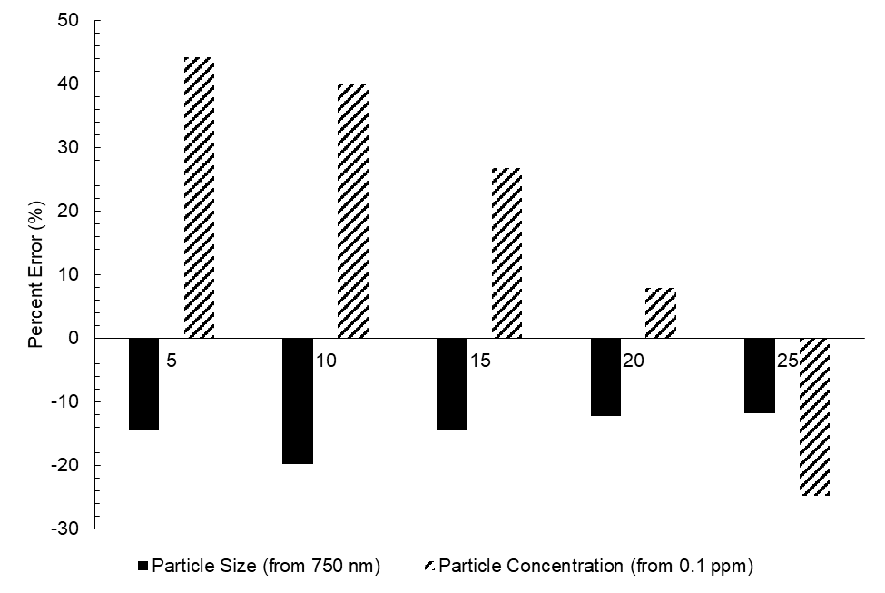
Fig. S6 NTA particle size and mass concentration error using different detection thresholds and a camera setting of 10

NTA Increasing Valid Tracks Data Averaging
Because MP samples were very polydisperse, individual videos may not be a representative sample of the distribution. The detection threshold for NTA determines the grey scale value to consider a particle noise or as a particle to be tracked. During the analysis of NTA recordings, centers of particles are tracked. If a given track length is not sufficient for a particular center, it is not considered a “valid particle.” Additionally, increasing the length and number of videos increases the likelihood of detecting larger particles that are present at much lower concentrations. Data was collected for each run and the number of valid tracks was recorded. With each subsequent measurement, data was averaged and the number of valid tracks added as depicted in Fig. S4 for MPs cryomilled for 3 cycles @ 30 Hz. At around 100,000 valid tracks per samples, the particle size distribution became continuous over the measured size range. The size distribution remained relatively unchanged with additional data collection.
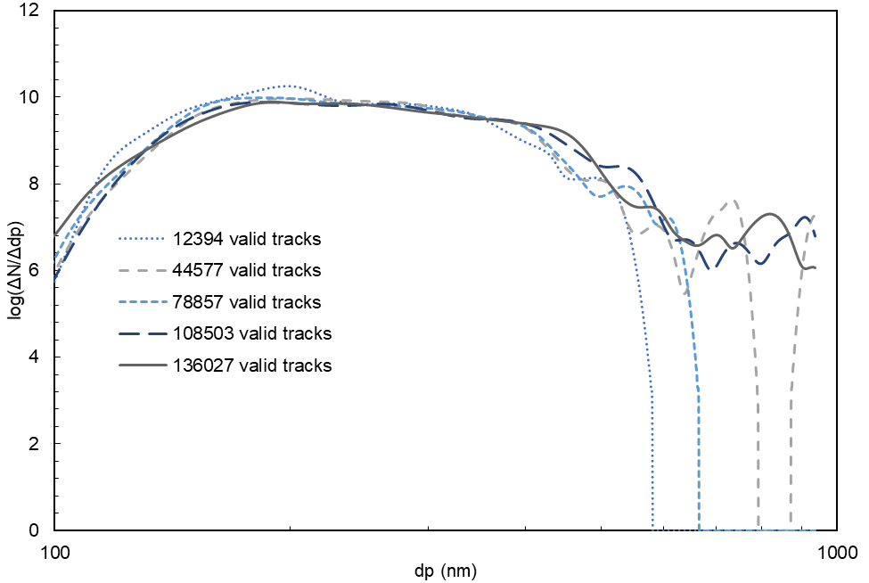
Fig. S7 NTA PSD data averaging with increasing valid tracks for PS MPs cryomilled for 3 cycles @ 30 Hz

μFTIR Confirmation of Polystyrene Test Tube before and after cryomilling
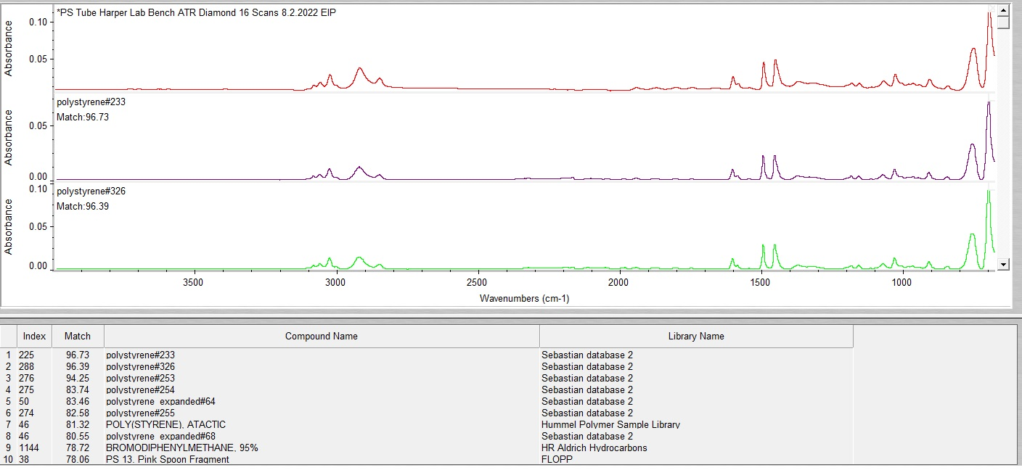
Fig. S8 μFTIR spectra match of polystyrene parent plastic and library polystyrene

Cryomilled Particle Size Distribution Function and Volume Distributions measured via Coulter Counter
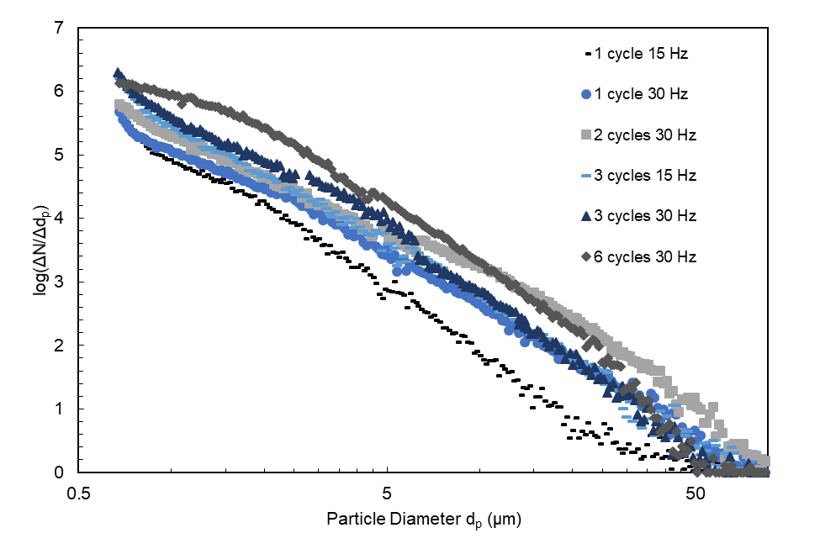
Fig. S9 Coulter Counter measured mean PSD for cryomilled polystyrene samples
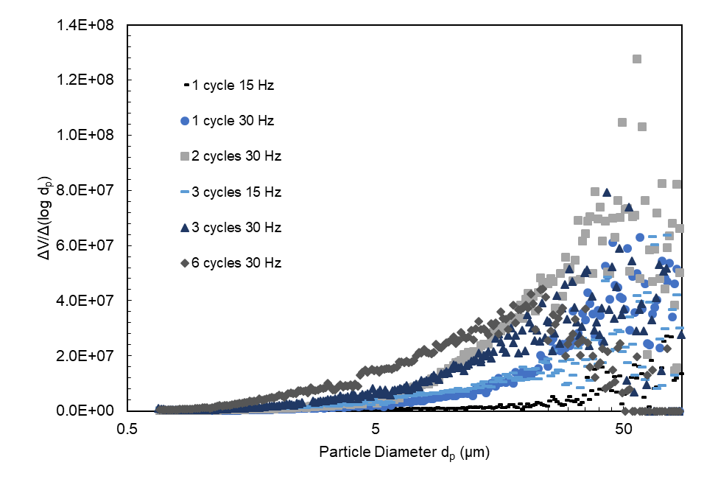
Fig. S10 Coulter Counter mean Volume Distribution obtained from cryomilled polystyrene samples

Cryomilled Particle Size Distribution and Volume Distributions for Nanoparticle Tracking Analysis
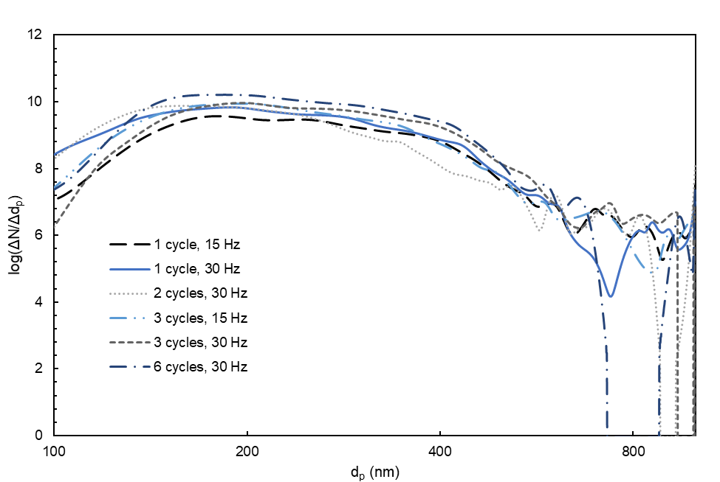
Fig. S11 Averaged NTA PSD obtained from cryomilled polystyrene samples. Measurements were averaged over multiple runs until the number of valid tracks reported were at least 100,000

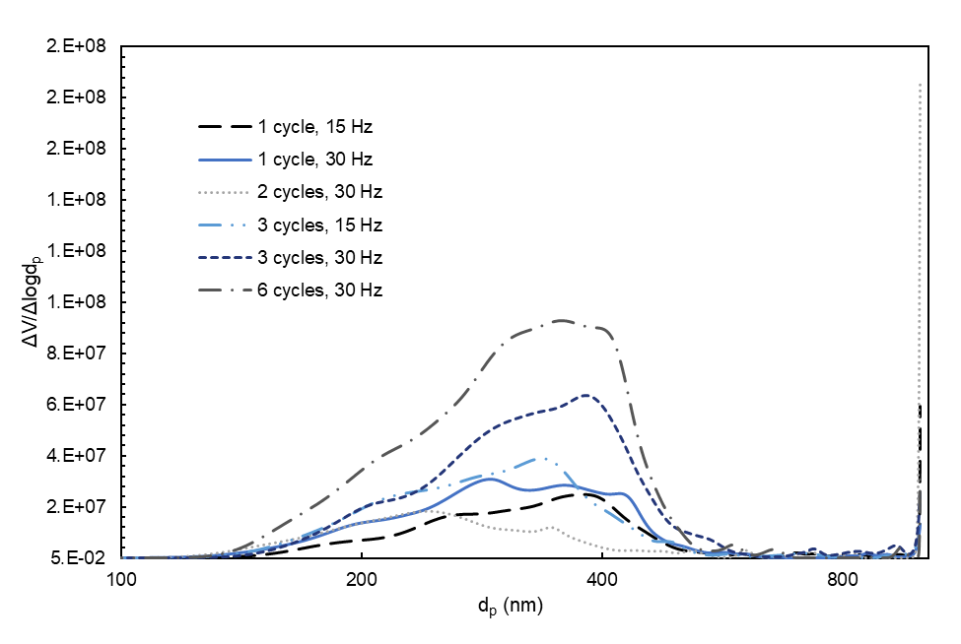
Fig. S12 Averaged NTA Volume Distribution obtained from cryomilled polystyrene samples. Measurements were averaged over multiple runs until the number of valid tracks reported were at least 100,000

Cross-Instrumental Distribution of PS Microspheres
Equal concentrations of 750 nm PS microsphere suspensions were measured on NTA and Coulter Counter and compared.
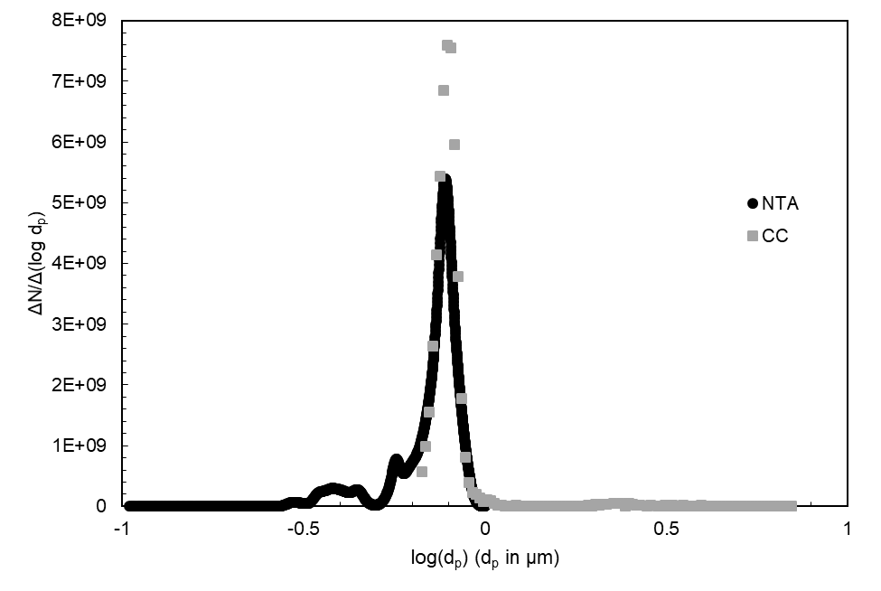
Fig. S13 Number Distribution of 750 nm PS microspheres on NTA and CC. 30 µm aperture was used for CC measurement

Cryomilling Dose Theoretical Calculations
Cryomilling dose was estimated during the milling process [1, 2]:
$D_{m}=\frac{n_{coll}E_{coll}t}{m_{p}}$ (S1)
where D_{m} is the milling dose, n_{coll} is the number of collisions between the ball and the sample, E_{coll} is the energy of collisions, t is time and m_{p} is the mass of the sample being milled. With only one ball in our apparatus, the number of collisions is assumed to be proportional to the frequency of milling:
$n_{coll}∝f$ (S2)
The energy of collisions is the sum of kinetic energy from the ball and energy due to the spin of the ball:
$E_{coll}= \frac{1}{2}m_{b}v_{b}^{2}+\frac{1}{2}I_{b}ω_{b}^{2}$ (S3)
Where m_{b} is the mass of the ball, v_{b} is the velocity of the ball, I_{b} is the moment of inertia for the ball, and ω_{b} is the angular velocity of the ball. We assume the energy due to the ball’s spin is negligible in the apparatus used (horizontal oscillations only) and that the velocity of the ball (v_{b}) is also proportional to the frequency of milling and the travel distance of the oscillations (l) ($v_{b}∝l*f)$ [1, 2]. Therefore,
$E_{coll}∝m_{b}l^{2}f^{2}$ (S4)
We then find the relationship between milling dose and cryomilling parameters to be:
$D_{m}∝\frac{f(m_{b}{l^{2}f}^{2})t}{m_{p}}$ (S5)
With the mass of the ball, the mass of plastics, and the travel length in each trial being equal, the milling dose in the experiments presented here is expected to vary with frequency and time as follows:
$D_{m}∝ f^{3}∙t$ (S6)
This simplified parameter was calculated for each cryomilled sample in Fig. S15. The dose parameter exerted from the pre-cooling and intermittent cooling stages were included for these calculations.

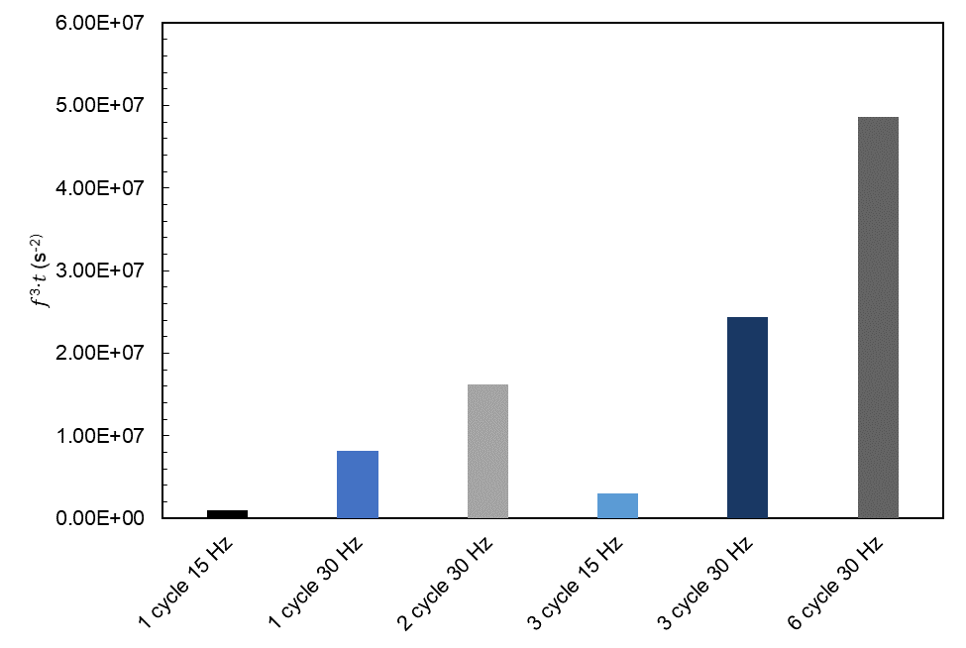
Fig. S14 Theoretical cryomilling dose for each cryomilled sample
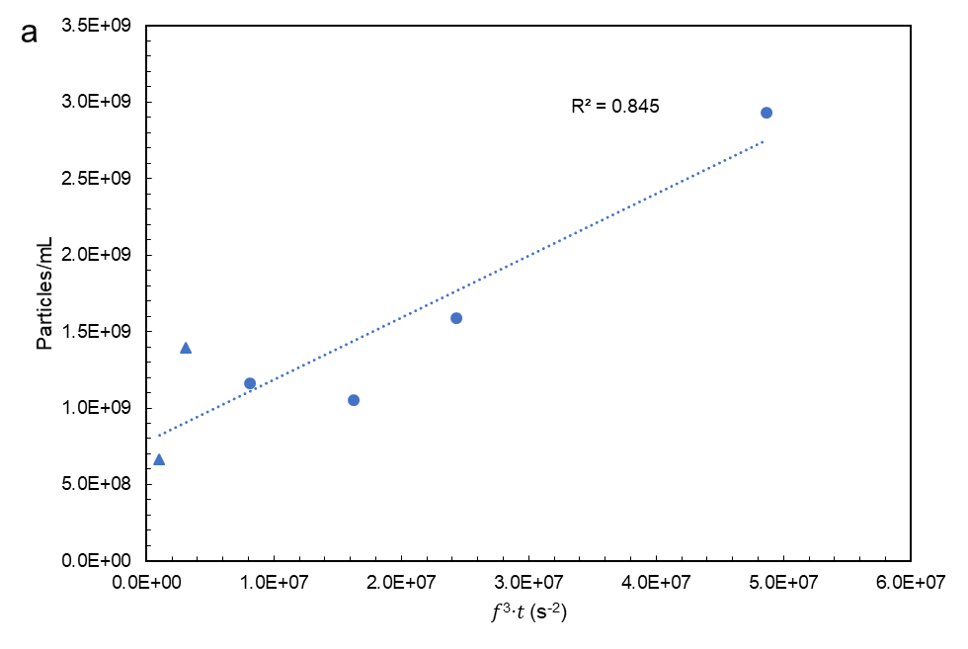
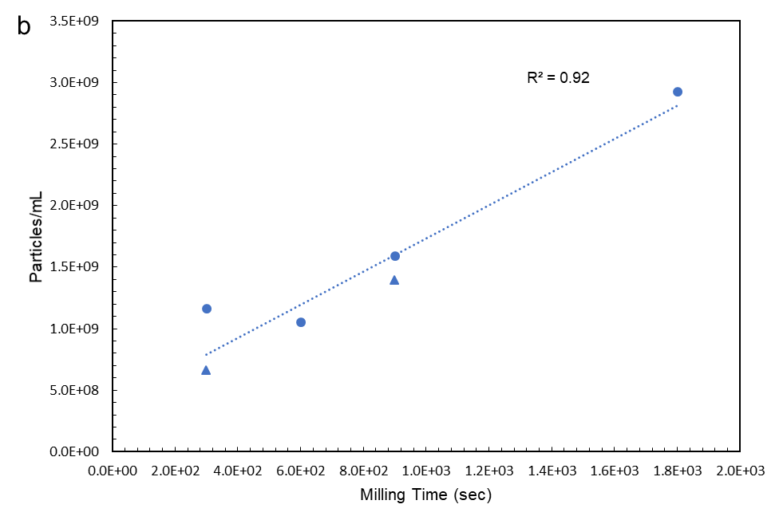
Fig. S15 Correlation of the number concentration of submicron fragments with a) theoretical cryomilling dose and b) milling time. Triangle markers indicate samples milled at a frequency of 15 Hz. Circles were samples milled at 30 Hz

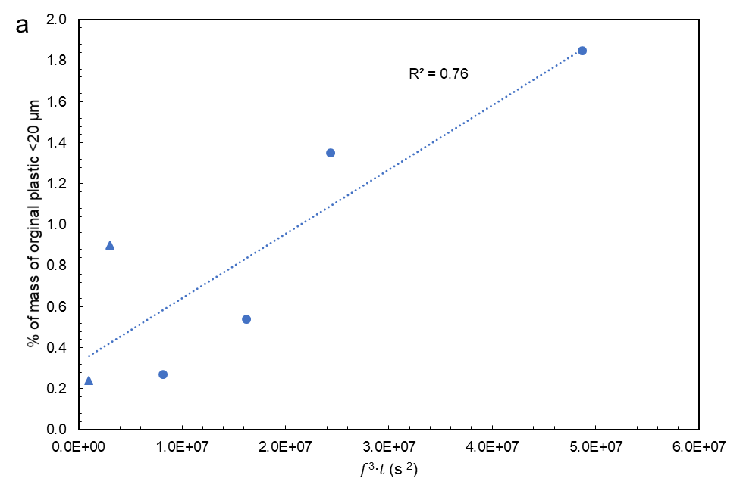
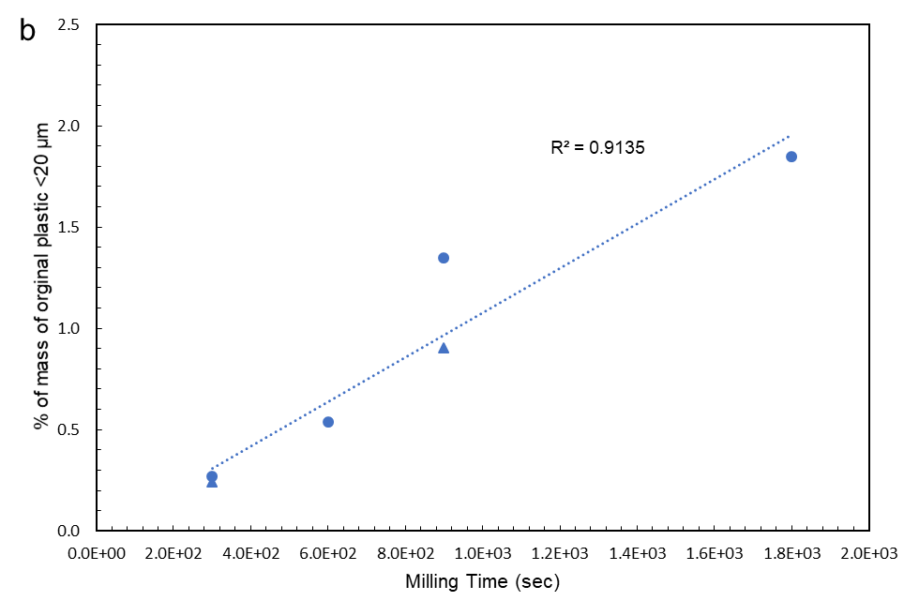
Fig. S16 Correlation of the percent of mass of original plastic < 20 µm with a) theoretical cryomilling dose and b) milling time. Triangle markers indicate samples milled at a frequency of 15 Hz. Circles were samples milled at 30 Hz

References
1. Ward TS, Chen W, Schoenitz M, Dave RN, Dreizin EL. A study of mechanical alloying processes using reactive milling and discrete element modeling. Acta Materialia. 2005;53(10):2909-18 DOI: https://doi.org/10.1016/j.actamat.2005.03.006.
2. Jiang X, Trunov MA, Schoenitz M, Dave RN, Dreizin EL. Mechanical alloying and reactive milling in a high energy planetary mill. Journal of Alloys and Compounds. 2009;478(1):246-51 DOI: https://doi.org/10.1016/j.jallcom.2008.12.021.

