Appendix A
Exploratory Analysis - Ratings
Figure 4. Ratings per type of cue
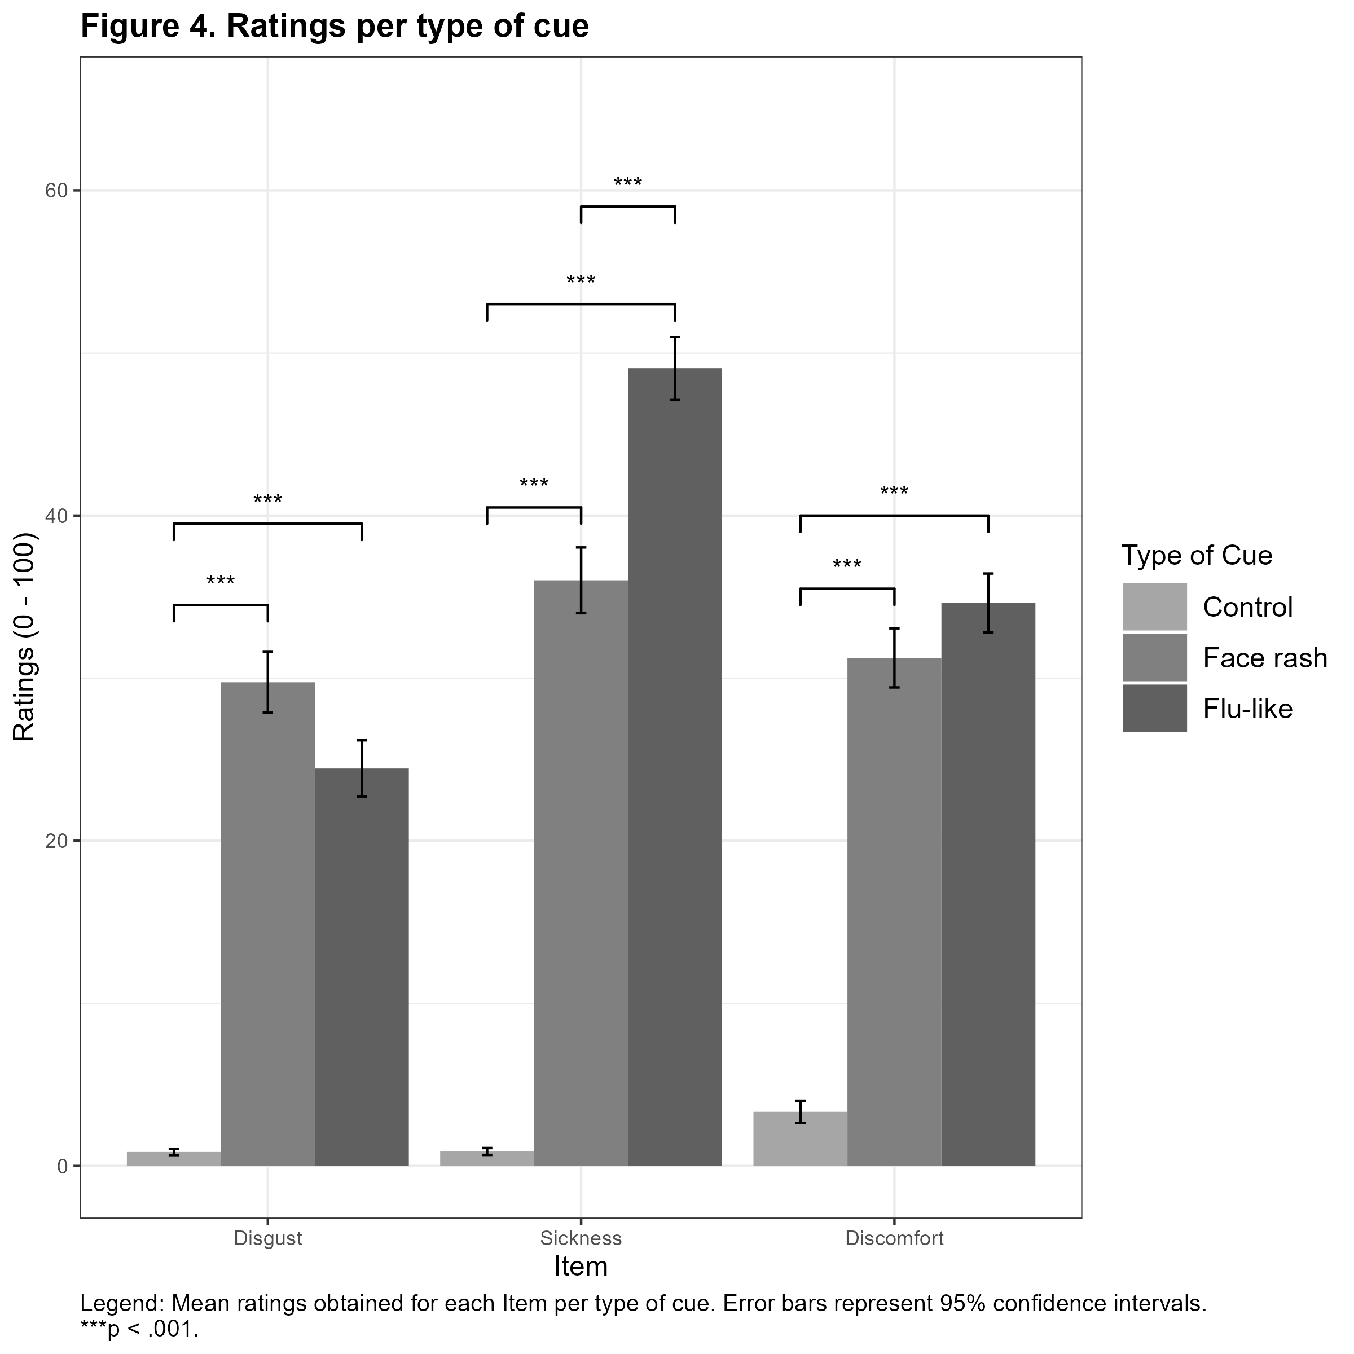
Legend: Mean ratings obtained for each rating variable per type of cue. Error bars represent 95% confidence intervals. *** p < .001

Table 2
Post-hoc comparisons obtained for each rating variable per type of cue.
Variable | Type of Cue |  | df | t | p | d | 95% CI for Cohen’s d
 |  |  |  |  |  |  | Lower | Upper
Disgust | C | F | 69 | -10.10 | < .001 | -1.38 | -1.81 | -0.94
Disgust | C | N | 69 | -8.24 | < .001 | -1.12 | -1.53 | -0.72
Disgust | F | N | 69 | 1.85 | .20 | 0.25 | -0.08 | 0.59
Disease | C | F | 69 | -10.11 | < .001 | -1.53 | -2.01 | -1.05
Disease | C | N | 69 | -13.86 | < .001 | -2.09 | -2.66 | -1.53
Disease | F | N | 69 | -3.75 | < .001 | -0.57 | -0.95 | -0.18
Discomfort | C | F | 69 | -9.22 | < .001 | -1.30 | -1.73 | -0.87
Discomfort | C | N | 69 | -10.34 | < .001 | -1.46 | -1.91 | -1.00
Discomfort | F | N | 69 | -1.12 | .80 | -0.16 | -0.50 | 0.19
Note: The p-values were adjusted with Bonferroni corrections. C = control stimuli; F = face rash stimuli; N = flu-like stimuli; df = degrees of freedom; CI = confidence intervals.

Appendix B
Exploratory Analysis – IPD behavior
Figure 5. IPD behavior per type of cue and condition.
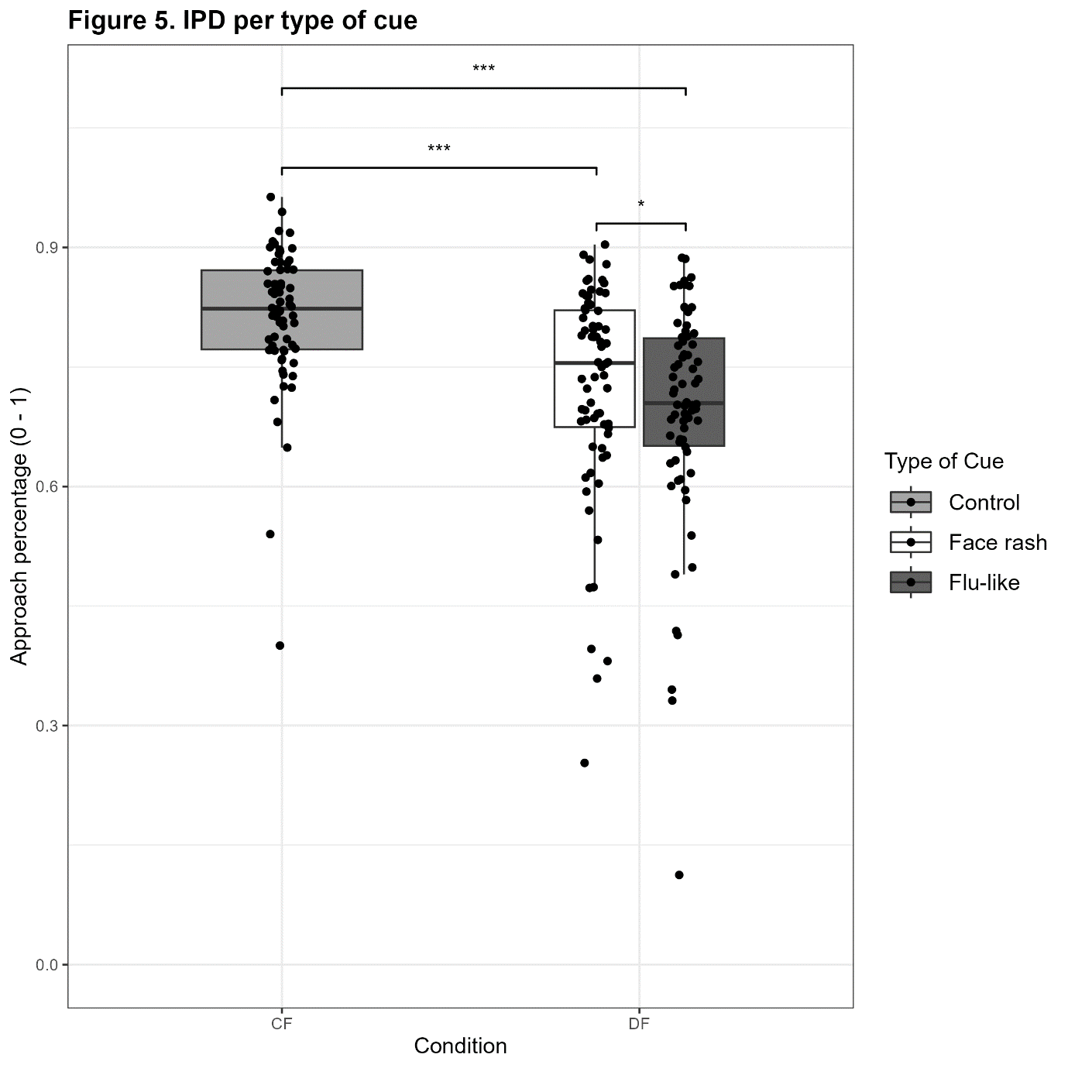
Legend: CF = control face; DF = disease cues face. *p < .05; *** p < .001.

