Impact of coagulation on SARS-CoV-2 and PMMoV viral signal in wastewater solids
Nada Hegazy¹, Xin Tian¹, Patrick M. D’Aoust¹, Lakshmi Krishnakumar Pisharody¹, Syeda Tasneem Towhid¹, Élisabeth Mercier¹, Zhihao Zhang¹, Shen Wan¹, Ocean Thakali¹, Md Pervez Kabir¹, Wanting Fang¹, Tram B. Nguyen¹, Nathan T. Ramsay¹, Alex E. MacKenzie², Tyson E. Graber², Stéphanie Guilherme¹, and Robert Delatolla^{1*}
1: Department of Civil Engineering, University of Ottawa, Ottawa, Ontario, Canada
2: Children’s Hospital of Eastern Ontario Research Institute, Ottawa, Ontario, Canada

*Corresponding author:
Dr. Robert Delatolla
Work E-mail: Robert.Delatolla@uOttawa.ca
Phone: +1 (613) 562 – 5800

Supplementary Materials
Table 1S: List of PCR primer and probe sets utilized in this study
Primer/probe & supplier | Sequence | Reference
2019-nCov_N1 forward primer (IDT) | GAC CCC AAA ATC AGC GAA AT | (CDC, 2020)
2019-nCoV_N1 reverse primer (IDT) | TCT GGT TAC TGC CAG TTG AAT CTG | (CDC, 2020)
2019-nCoV_N1 probe (IDT) | 6-FAM-ACC CCG CAT/ZEN/ TAC GTT TGG TGG ACC-IOWA BLACK FQ | (CDC, 2020)
2019-nCoV_N2 forward primer (IDT) | TTA CAA ACA TTG GCC GCA AA | (CDC, 2020)
2019-nCoV_N2 reverse primer (IDT) | GCG CGA CAT TCC GAA GAA | (CDC, 2020)
2019-nCoV_N2 probe (IDT) | 6-FAM-ACA ATT TGC/ZEN/CCC CAG CGC TTC AG-IOWA BLACK FQ | (CDC, 2020)
PMMoV forward primer (ABI) | GAG TGG TTT GAC CTT AAC GTT GA | (Haramoto et al., 2013)
PMMoV reverse primer (ABI) | TTG TCG GTT GCA ATG CAA GT | (Haramoto et al., 2013)
PMMoV probe (ABI) | 6-FAM-CCT ACC GAA GCA AAT G-MGB | (Haramoto et al., 2013)

Table 2S: Viral signal measurements (average ± standard deviation of biological replicates) from post-grit influent wastewater samples from this study at Ottawa (Ontario, Canada) WRRF with no coagulant.
 |  | Mar. 23rd, 2021 | May 2nd, 2021
Copies/g | N1 | 3.0 x 10³ ± 7.8 x 10² | 1.3 x 10⁴ ± 1.3 x 10³
Copies/g | N2 | 4.0 x 10³ ± 1.5 x 10³ | 1.1 x 10⁴ ± 3.2 x 10²
Copies/g | PMMoV | 1.4 x 10⁷ ± 1.6 x 10⁶ | 4.5 x 10⁶ ± 1.9 x 10²
Copies/L | N1 | 3.1 x 10³ ± 1.1 x 10³ | 1.5 x 10⁴ ± 1.5 x 10³
Copies/L | N2 | 4.1 x 10³ ± 1.3 x 10³ | 1.1 x 10⁴ ± 1.5 x 10³
Copies/L | PMMoV | 1.2 x 10⁷ ± 4.6 x 10⁶ | 4.9 x 10⁶ ± 5.1 x 10⁶
Copies/copies PMMoV | N1 | 2.1 x 10⁻⁴ ± 5.0 x 10⁻⁵ | 7.1 x 10⁻⁴ ± 1.0 x 10⁻⁴
Copies/copies PMMoV | N2 | 3.2 x 10⁻⁴ ± 1.2 x 10⁻⁴ | 9.6 x 10⁻⁴ ± 2.56 x 10⁻⁴
Daily COVID-19 positive cases |  | 95 | 118
Daily COVID-19 percent positivity |  | 3.3% | 6.9%

Table 3S: Analysis of correlation between total pellet weight (g) and PMMoV viral copies/g extracted mass.
mg/L Fe³⁺ | Pellet Weight (g)
mg/L Fe³⁺ | Biological Replicate 1 | Biological Replicate 2 | Biological Replicate 3
0 | 0.6682 | 0.6770 | 0.8000
5 | 0.9314 | 0.8154 | 0.6674
15 | 0.8845 | 0.6971 | 0.8416
30 | 0.9696 | 0.9932 | 1.0426
60 | 0.8943 | 1.2417 | 1.0134

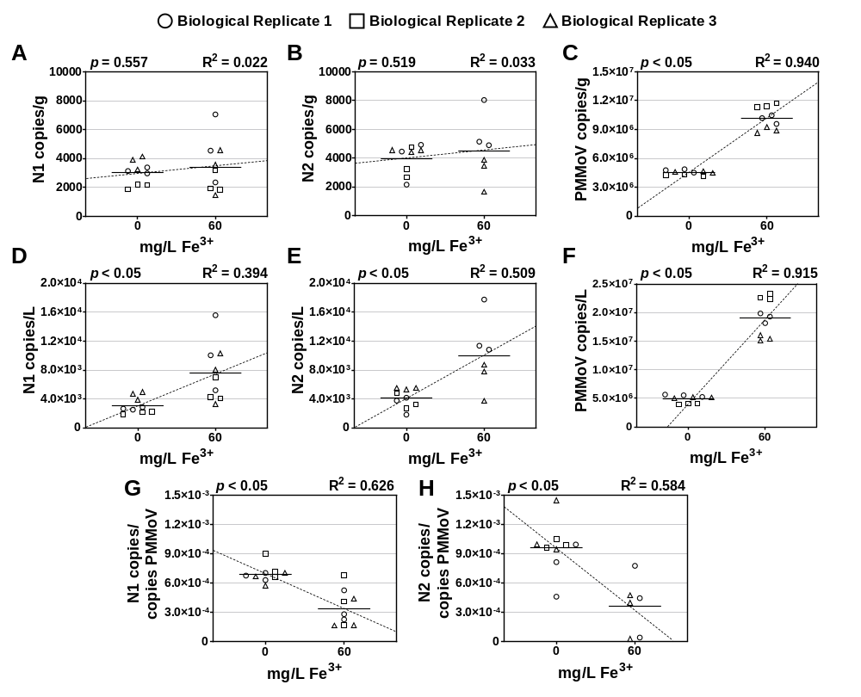
Figure 1S: Experimental replicate to investigate the effect of increasing coagulant concentrations on: (A) N1 copies/g extracted mass, (B) N2 copies/g extracted mass, (C) PMMoV copies/g of extracted mass, (D) N1 copies/L of total sample volume, (E) N2 copies/L of total sample volume, (F) PMMoV copies/L total sample volume, (G) N1 copies/copies PMMoV, and (H) N2 copies/copies PMMoV.

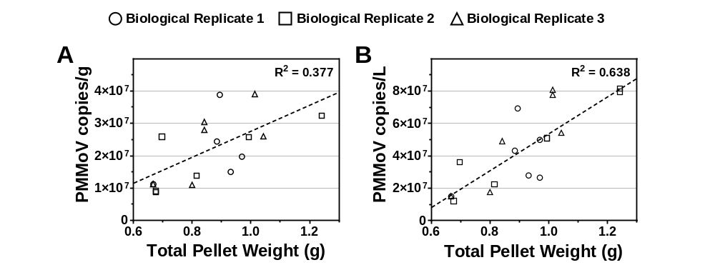
Figure 2S: Correlation between the total pellet weight after concentration of settled solids and A) PMMoV copies/g and B) PMMoV Copies/g

References
CDC, 2020. Real-Time RT-PCR diagnostic panel for emergency use only. CDC EUA.
Haramoto, E., Kitajima, M., Kishida, N., Konno, Y., Katayama, H., Asami, M., Akiba, M., 2013. Occurrence of pepper mild mottle virus in drinking water sources in Japan. Appl. Environ. Microbiol. 79, 7413–7418. https://doi.org/10.1128/AEM.02354-13

