Supplemental information
Tables
Table S1. Summary of the t-test results of Caulerpa cylindracea cover comparing the control and each disturbance treatment for the overall average data from samplings 1-5 and for the data from sampling 6 during two periods when the disturbances were performed (cold and warm). The disturbance gradient of the simulated storms ranges from several small storms (extremeness level 1) to a single large one (extremeness level 6, fig. S1).
Period of treatment simulation |  |  | Cold |  |  |  | Warm |  |  |  | Cold
Sampling times (months) |  |  | 1-5 |  |  |  | 1-5 |  |  |  | 6
 |  | df | MS | t | P |  | MS | t | P |  | MS | t | P
Control vs 1 |  | 6 | 1.60 | -1.04 | 0.34 |  | 23.05 | -1.82 | 0.12 |  | 30.25 | -0.32 | 0.76
Control vs 2 |  | 6 | 1.20 | -0.59 | 0.57 |  | 20.45 | -1.15 | 0.30 |  | 28.00 | -0.18 | 0.87
Control vs 3 |  | 6 | 0.85 | -0.10 | 0.93 |  | 16.05 | -0.14 | 0.89 |  | 25.33 | 0.03 | 0.98
Control vs 6 |  | 6 | 0.45 | 0.83 | 0.44 |  | 4.44 | 2.47 | 0.05 |  | 10.00 | 1.20 | 0.27

Table S2. Akaike information criterion (AIC) of the regression models of the trends of the cover of Caulerpa cylindracea along the total cover of all sessile species (when the mean of the overall cover of C. cylindracea during a specific sampling period was higher than 5%) and along the storm extremeness gradient, ranging from several small storms to a single large one (Fig. S1) for the overall average data from samplings 1-5 and for the data from sampling 6 during the two periods when the disturbances were performed (cold and warm; fig. 1 and 2). The most parsimonious model is indicated in bold.
 |  | AIC
Period of treatment simulation |  | Cold |  |  |  | Warm |  | Cover of Caulerpa cylindracea vs Total cover
Sampling times (months) |  | 1-5 |  | 6 |  | 1-5 |  | Cover of Caulerpa cylindracea vs Total cover
Y_{i}=β₀+β₁X_{i} |  | 44.84 |  | 126.77 |  | 93.85 |  | 618.87

Figures
Figure S1. Scheme of the disturbance gradient of the simulated storms ranging from several small storms to a single large one. All treatments have the same overall intensity (sensu Sanz-Lazaro 2016; from Sanz-Lazaro et al. 2022).
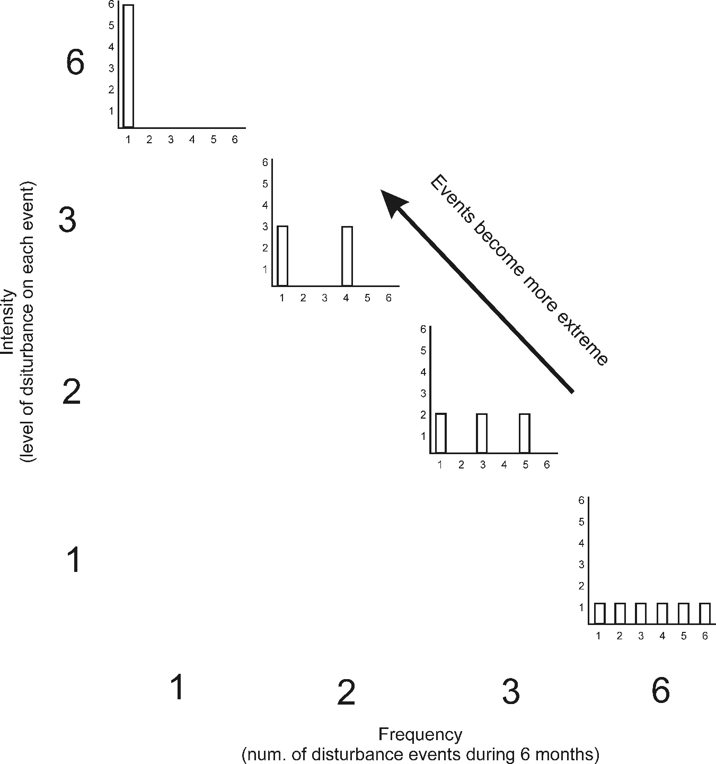

Figure S2. Scheme of the timing of the performed dsiturbances and samplings during both periods of the experiment, cold and warm. Samplings are indicated by blue and orange arrows that were used to assess the short and long-term effects, respectively. Black, red, green and purple special arrows indicate when disturbances simulating storms were applied.
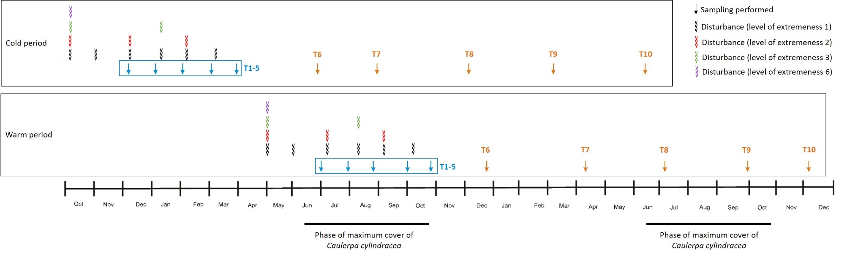

References:
Sanz-Lázaro C (2016) Climate extremes can drive biological assemblages to early successional stages compared to several mild disturbances. Sci Rep 6:1-9
Sanz-Lazaro C, Casado-Coy N, Navarro-Ortín A, Terradas-Fernández M (2022) Anthropogenic pressures enhance the deleterious effects of extreme storms on rocky shore communities. Sci Total Environ 817:152917.

