Table 1. A brief description of the top hit compounds as shown in Figure 3.
Compound No. | ZINC ID | IUPAC name | Docking Score  (kcal/mol) | 2D chemical structure
Compound 1 | ZINC000103288276 | 4-hydroxy-3-[5-[5-(2-hydroxyphenyl)-1H-pyrazol-4-yl]-4,5-dihydro-1H-pyrazol-3-yl]chromen-2-one | -8.6 | 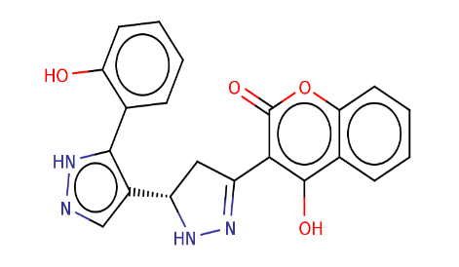
Compound 2 | ZINC000013373252 | 1,3,8,10-tetrahydroxy-5,5-dimethyl-5a,6-dihydro-5H,7H-[1]benzofuro[3,4-bc]xanthen-7-one | -8.5 | 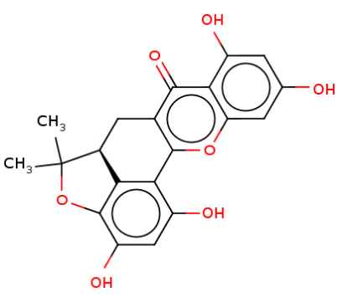
Compound 3 | ZINC000015147377 | 1-hydroxy-5,7,11,14,18-pentaoxahexacyclo[11.11.0.02,10.04,8.015,23.017,21]tetracosa-2,4(8),9,15(23),16,19,21-heptaen-24-one | -8.5 | 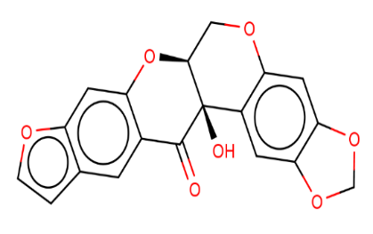
Compound 4 | ZINC000071318700 | (6aR,6bS,10aR,12aS)-5-Hydroxy-6b,10,10,12a-tetramethyl-6a,7,8,10,10a,11,12,12a-octahydro-1H-benzo[a]furo[3,4-h]xanthene-3,9(6H,6bH)-dione | -8.5 | 