Great Lakes coastal wetland biodiversity increases following invasive Phragmites australis removal.

Meghan Ward¹, Tarra Degazio², Jeff Bowman^{1,3}
¹Environmental and Life Sciences Graduate Program, Trent University. 1600 West Bank Drive Peterborough, Ontario, Canada
²Point Pelee National Park., Parks Canada. 407 Monarch Lane, Leamington, Ontario, Canada
³Wildlife Research and Monitoring Section, Ontario Ministry of Natural Resources and Forestry, Peterborough, Ontario, Canada

Contact Emails
Meghan Ward: meghanward@trentu.ca
Tarra Degazio: tarra.degazio@pc.gc.ca
Dr. Jeff Bowman: Jeff.Bowman@ontario.ca

ORCID
Meghan Ward: 0000-0002-4189-2653
Tarra Degazio: NA
Dr. Jeff Bowman: 0000-0002-1892-4469

Supplemental Information

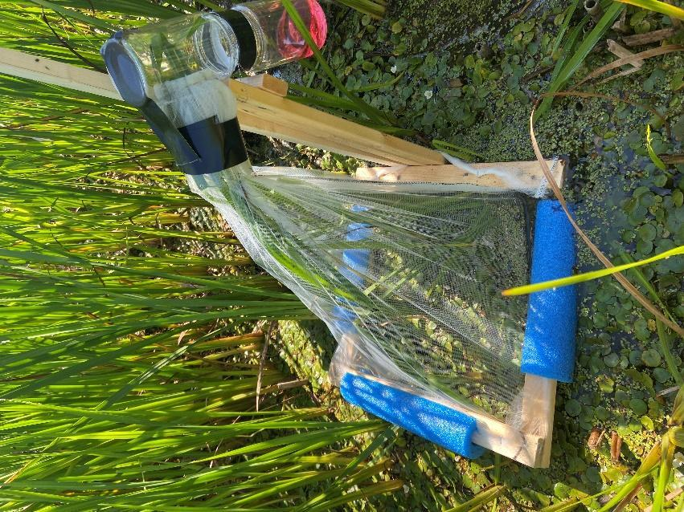
Supplemental Fig. 1 Emerging aquatic invertebrate trap in the Treated wetland at Point Pelee National Park. 500 um mesh netting was used with 200 mL of 95% propylene glycol.
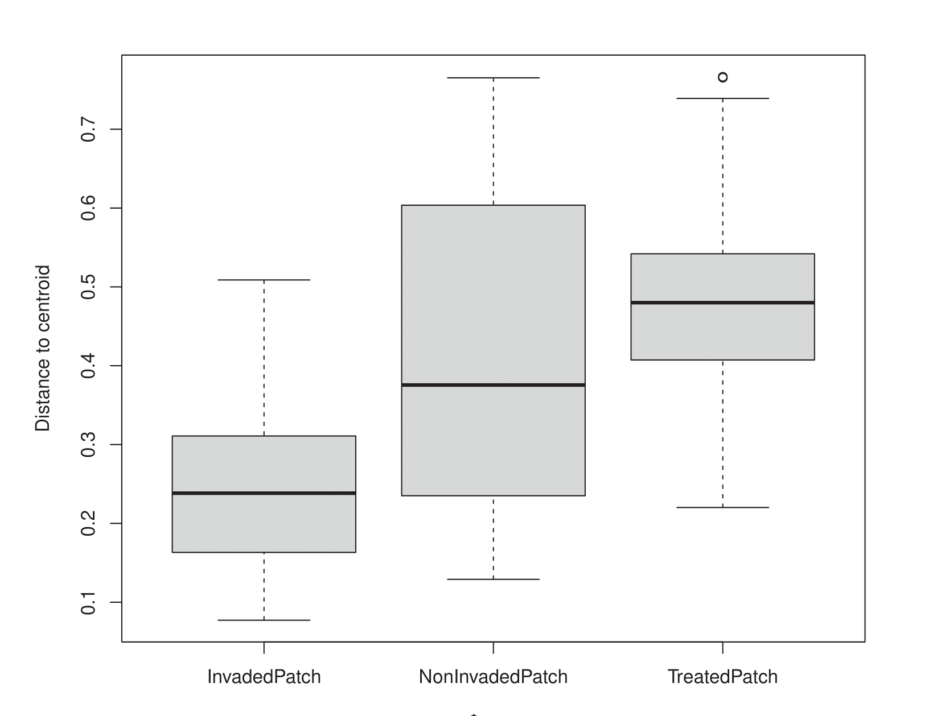
Supplemental Fig. 2 perMANOVA boxplot comparing vegetation community composition within Invaded, Non-Invaded, and Treated patch.

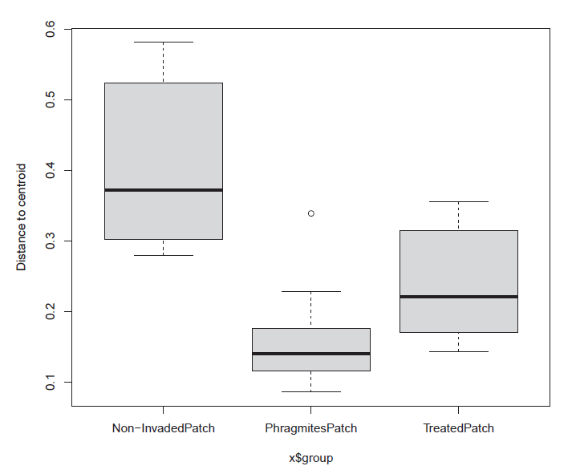
Supplemental Fig. 3 perMANOVA boxplot comparing emerging aquatic invertebrate community composition within Invaded, Non-Invaded, and Treated patch.

Table S1 Five species of emergent vegetation were removed from the dataset because they appeared less than twice across all vegetation samples. 28 families of emerging aquatic invertebrates were removed from the dataset because they appeared less than twice across all invertebrate samples.
Emergent Vegetation Species Removed | Emerging Aquatic Invertebrate Families Removed
Ceratophyllum demersum (coontail) | Asilidae
Impatiens capensis (jewel weed) | Ceratopogonidae
Sagittaria latifolia (broad leaf arrowhead) | Chloropidae
Scutellaria (skullcap) | Clastopteridae
Lysimachia thyrsiflora (tufted loosestrife) | Clusiidae
 | Corethrellidae
 | Corylophidae
 | Drosophilidae
 | Elateridae
 | Entomobryidae
 | Flatidae
 | Formicidae
 | Geometridae
 | Halictidae
 | Hybotidae
 | Keroplatidae
 | Laelapidae
  Megachilidae
 | Mesoveliidae
 | Micropezidae
 | Mordellidae
 | Pipunculidae
 | Pisauridae
 | Psocidae
 | Tabanidae
 | Tachinidae
 | Tenebrionidae
 | Tortricidae

