SUPPLEMENTARY FIGURES

Association of Significant Elevation of NET formation and Nucleosome Biomarkers with Mortality in Patients with Septic Shock

Muzhda Haem Rahimi^{1,2}, Frank Bidar³, Anne-Claire Lukaszewicz^{2,3}, Lorna Garnier⁴,
Léa Payen-Gay⁵, Fabienne Venet^{1,6}, Guillaume Monneret^{1,2}

1. Hospices Civils de Lyon, Immunology Laboratory, Hôpital E. Herriot, Lyon France
2. Université de Lyon, EA 7426 “Pathophysiology of Injury-Induced Immunosuppression”, Université Claude Bernard Lyon_1, Lyon, France
3. Hospices Civils de Lyon, Anesthesiology and Critical Care Medicine department, Hôpital E. Herriot, Lyon, France
4. Hospices Civils de Lyon, Immunology Laboratory, CH Lyon-Sud, Lyon France
5. Center for Innovation in Cancerology of Lyon (CICLY) EA 3738, Faculty of Medicine and Maieutic Lyon Sud, Claude Bernard University Lyon I, 69921 Oullins, France.
6. NLRP3 Inflammation and Immune Response to Sepsis Team, Centre International de Recherche in Infectiology (CIRI), Inserm U1111, CNRS, UMR5308, Ecole Normale Supérieure de Lyon, Claude Bernard University Lyon 1, Lyon France.

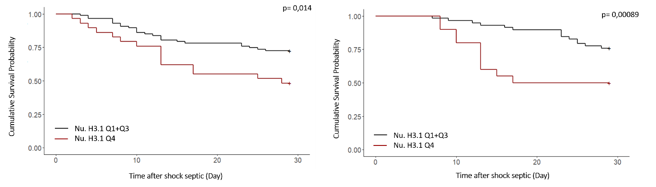

Supplementary Figure S1. Cumulative incidence of mortality up to one-month (Day 28). Patients were stratified to two groups based on Nu.H3.1 quartiles. Cumulative incidence curves of (right) D 3-4 and (left) D 6-8 based on Nu.H3.1 concentration. Cumulative incidence curves were estimated with Kaplan-Meier method. The p value was calculated by log rank test.

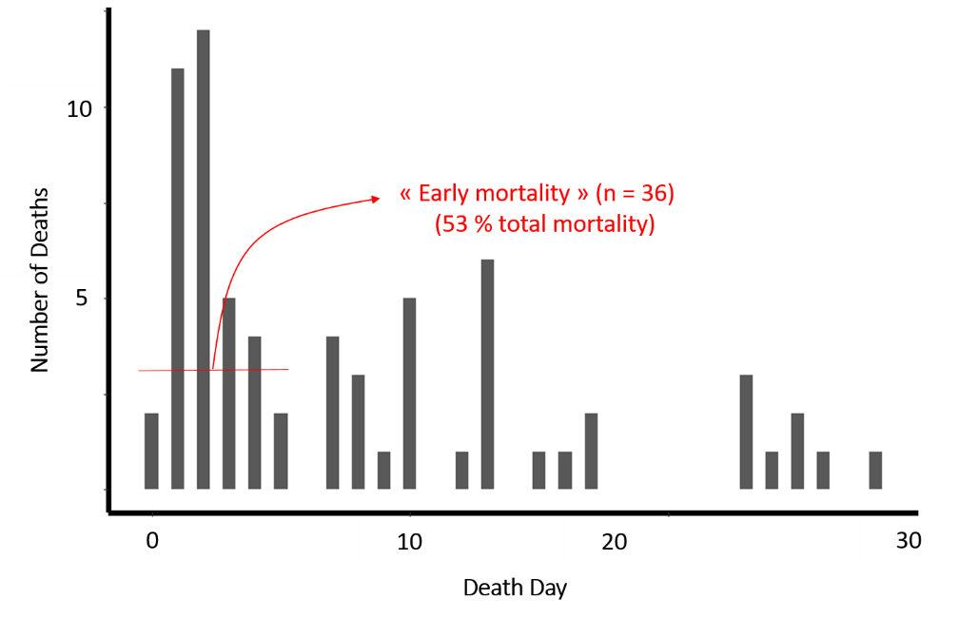
Supplementary Figure S2. Histogram of the distribution of the number of deaths per day after ICU admission.

