Calcified apoptotic bodies from PROCR⁺ fibroblasts initiate the tendon calcification at the early stages of heterotopic ossification

This PDF file includes:

Fig. S1. Quantitative SEM-EDS analysis of the element distribution of calcium (Ca), phosphorus (P), oxygen (O) and carbon (C) in the tendon from 1-week and 3-week groups.
Fig. S2. Schematic representation of the sham and HO rats injected with calcein.
Fig. S3. Micro-infrared analysis of sham and HO tendons.
Fig. S4. AFM images of sham, 1 week and 3 week HO tendon showing Amplitude, ZSensorRetrace and IndentationRetrace modality.
Fig. S5. The 5 principal cell types in tendons have marked expression variations.
Fig. S6. The histogram of the biological processes of different fibroblast clusters (GO).
Fig. S7. The histogram of the biological processes of different fibroblast clusters (KEGG).
Fig. S8. EDS elemental analysis of the selected area of the CABs containing electron-dense granules.
Fig. S9. Representative SEM and TEM images of the fibroblasts cultured in the calcified medium.
Fig. S10. AFM measurements of the fibroblasts cultured in the control and calcified medium for 7 days..
Fig. S11. The isolation and characterization of the CABs.
Fig. S12. (a) Photograph of the rat intratendon implantation model. (b) intramuscular ectopic calcification samples at 1 and 3 weeks post implantation (bars: 1 mm). 3D reconstruction of micro-CT scans of the ectopic calcification samples (bars: 0.5 mm). The collagen + CABs group showed evident ectopic calcification in the muscle tissue
Fig. S13. (a) TEM images of the CABs incubated with the collagen I for 3 and 5 days. (b) Immunofluorescence microscopy of the collagen I hydrogels after introduction of green-labeled CABs at 48 h.
Fig. S14. Molecular dynamic (MD) simulation analysis between the CABs and collagen I.
Fig. S15. Immunofluorescence microscope of the fibroblasts with high calcium and phosphorus concentrations medium for 6 and 12 hours.
Fig. S16. (a) Immunofluorescence microscopy of the CABs cultured in the collagens with high calcium and phosphorus concentrations for 12 h. (b) Representative SEM image based on a.
Fig. S17. Time-lapse images monitoring the CABs enriching calcium and the localization of Fluo-4 staining in the CABs.
Fig. S18. The unique peptides of the top 5 scores in LC-MS/MS analysis of membrane protein of the CABs from the fibroblasts with high calcium and phosphorus concentrations medium.
Fig. S19. List of candidates with top 5 scores in LC-MS/MS analysis of membrane protein of the CABs from the tendon.
Fig. S20. The polarization of macrophage from M1 to M2.
Fig. S21. The macrophage cultured in two kinds of PDMS substrates with different young’s moduli.
Fig. S22. Increased stiffness of ECM promotes the polarization of macrophage from M1 to M2.
Fig. S23. Flow chart depicting the sequence of experiments conducted in the present study.

Table S1. Primers for RT-qPCR

Supplementary Materials and Methods
Micro-CT analyses
Achilles tendons with calcaneus and lower tibias from rats in the HO and sham groups were fixed overnight in 4% paraformaldehyde and analyzed by micro-CT (Inveon micro-CT system Siemens AG, Germany). The scanner was set at a voltage of 80 kV at 500 mA and a resolution of 10 μm per pixel. Two-dimensional slices with 10 μm isotropic resolution were generated with a three dimensional (3D) image reconstruct based on the scanned information using the Inveon Research Workplace software (Siemens Medical Solutions USA, Inc., Hoffman Estates, IL, USA). A region of interest was positioned in the injury site and the bone mineral density (BMD), bone volume/tissue volume (BV/TV) and bone surface/ bone volume (BS/BV) were measured.

Histologic and immunohistochemistry evaluation
After fixation, the tissues were processed for paraffin embedding to collect 4-μm-thick sections. After deparaffinized and rehydrated in xylene and a declining graded series of ethanol, the sections were stained with hematoxylin and eosin (G1120, Solarbio, CN) and observed by microscope (Leica, DM 2500, Wetzlar, Germany).
For alizarin red S staining, the sections were stained with alizarin red S (40 mmol/L, pH 4.2; MilliporeSigma, Burlington, USA) for 20 min. The nuclei were counterstained with DAPI (Invitrogen).
For immunohistochemical staining, the sections were incubated with goat serum to block special sites and then individually incubated with cleaved caspase-3 (9661, Cell Signaling Technology) after deparaffinization, hydration and blockage of endogenous peroxidase. Followed by secondary antibody anti-rabbit IgG (Kit-5010, MXB, CN) incubation for 1 hour at 37 °C, the colorization developed with DAB solution (DAB-4033, MXB, CN) and counterstained in hematoxylin.
For immunofluorescence staining, the primary antibodies used were: PROCR (bs-9506R, Bioss, Beijing, China), PDGF receptor-α (ab96569, Abcam, Cambridge, UK), cleaved caspase-3 (9661, Cell Signaling Technology). The sections were incubated with secondary antibody (US Everbright Inc., Suzhou, China). After incubation, the sections were washed with PBS and the nuclei were counterstained with DAPI (Invitrogen).
For TUNEL staining, the terminal deoxynucleotidyl transferase-mediated deoxyuridine triphosphate nickend labeling staining was performed with the detection kit (11684795910, Roche, Mannheim, Germany) for in situ detection of fibroblasts in tendon. The percentage of TUNEL-positive cells was calculated from the number of total cells using the image-pro Plus 6.0 (Media Cybernetics, Rockville, MD).

Transmission electron microscope (TEM)
The tendons and tendon-containing collagen hydrogels were fixed in 2.5% glutaraldehyde in phosphate buffer (0.01 M, pH = 7.4). The specimens were post-fixed in 1% osmium tetroxide, dehydrated in an ascending series of ethanol, immersed in propylene oxide and embedded in epoxy resin. 90 nanometer-thick sections were obtained, stained with uranyl acetate and lead citrate and observed using a JEM-123 transmission electron microscopy (TEM, JEOL, Tokyo, Japan) at 110 kV.
For TEM observation of apoptotic bodies, an apoptotic bodies pellet was re-suspended in 200 μL of PBS and 20 μL of apoptotic bodies were deposited on 200-mesh formvar-coated copper grids and dried at room temperature. The apoptotic bodies were negatively-stained with uranyl acetate prior to imaging.

Scanning electron microscope (SEM) and energy-dispersive X-ray spectroscopy
2.5% glutaraldehyde in phosphate buffer (0.01 M, pH = 7.4) was used to fix tendons. Specimens were then dehydrated with an ascending series of ethanol and treated with hexamethyldisilane (Electron Microscopy Sciences, Hatfield, PA, USA). Field-emission scanning electron microscope (FE-SEM, S-4800, Hitachi, Tokyo, Japan) operated at 5 kV was used to observe the samples. The mineral elemental composition in the tendons was characterized by using energy-dispersive X-ray spectroscopy (Element EDS System, Ametek, Berwyn, PA, USA).

Elemental mapping
Elemental mapping was performed using a scanning TEM (STEM) equipped with EDS. Specimens used for elemental mapping were not post-fixed with osmium tetroxide to avoid interference during EDS. Unstained thin sections were examined with a Technai G2 STEM (FEI, Hillsboro, USA) at 200 kV. Elemental mapping and selected area electron diffraction (SAED) were conducted using an INCA X-sight detector (Oxford Instruments, Abingdon, UK). Mappings were acquired with the FEI TIA software using a spot dwell time of 300 ms with drift correction performed after every 30 images.

Calcein fluorescent labeling and histomorphometrical analysis
The process of microcalcification and new bone formation was assessed using a calcein fluorescent labeling method. 8 week old rats received achillotenotomy and an injection of calcein green. 20 mg/kg Calcein (Sigma) was administered intraperitoneally after achillotenotomy. The rats were euthanized 1 and 3 weeks respectively. The tissues were fixed overnight in 4% paraformaldehyde and dehydrated with 30% saccharose, and finally embedded in OCT (Leica, Wetzlar, Germany) to collect 6-μm-thick sections. Those sections were subsequently stained with DAPI (Invitrogen) for fluorescence labeling observation.

Qualitative evaluation using mFourier Transform Infrared Spectroscopy
The spotlight 400 m-FTIR imaging system (PerkinElmer, Inc., Waltham, MA, USA) was used to analyze the sections from samples of tendons in sham and HO groups. The mFTIR spectrometer was equipped with a liquid nitrogen-cooled 16-element linear array Mercury Cadmium Telluride (MCT) detector. The resolution of spectral acquisition was 4 cm⁻¹, ranging from 650 to 4000 cm⁻¹, and 2400 scans were used for each sample. Spectrum software (PerkinElmer, Inc.) was used to obtain the absorption wavelengths.

Tissue dissociation and cell purification
Tissues were transported in sterile culture dish with 10 mL 1x Dulbecco's Phosphate-Buffered Saline (DPBS; Thermo Fisher, Cat. no. 14190144) on ice to remove the residual tissue storage solution, then minced on ice. We used dissociation enzyme 0.25% Trypsin (Thermo Fisher, Cat. no. 25200-072) and 10 μg/mL lDNase I (Sigma, Cat. no. 11284932001) dissolved in PBS with 5% Fetal Bovine Serum (FBS; Thermo Fisher, Cat. no. SV30087.02) to digest the tissues. The tissues were dissociated at 37 ℃ with a shaking speed of 50 rpm for 40 min. We repeatedly collected the dissociated cells at interval of 20 min to increase cell yield and viability. Cell suspensions were filtered using a 40 um nylon cell strainer and red blood cells were removed by 1X Red Blood Cell Lysis Solution (Thermo Fisher, Cat. no. 00-4333-57). Dissociated cells were washed with 1x DPBS containing 2% FBS. Cells were stained with 0.4% Trypan blue (Thermo Fisher, Cat. no. 14190144) to check the viability on Countess® II Automated Cell Counter (Thermo Fisher).

10 x library preparation and sequencing
Beads with unique molecular identifier (UMI) and cell barcodes were loaded close to saturation, so that each cell was paired with a bead in a Gel Beads-in-emulsion(GEM). After exposure to cell lysis buffer, polyadenylated RNA molecules hybridized to the beads. Beads were retrieved into a single tube for reverse transcription. On cDNA synthesis, each cDNA molecule was tagged on the 5’end (that is, the 3’end of a messenger RNA transcript) with UMI and cell label indicating its cell of origin. Briefly, 10× beads that were then subject to second-strand cDNA synthesis, adaptor ligation, and universal amplification. Sequencing libraries were prepared using randomly interrupted whole-transcriptome amplification products to enrich the 3’end of the transcripts linked with the cell barcode and UMI. All the remaining procedures including the library construction were performed according to the standard manufacturer’s protocol (CG000206 RevD). Sequencing libraries were quantified using a high sensitivity DNA Chip (Agilent) on a Bioanalyzer 2100 and the Qubit High Sensitivity DNA assay (Thermo Fisher Scientific). The libraries were sequenced on NovaSeq6000 (Illumina) using 2x150 chemistry.

Single cell RNA-seq data processing
Beads were processed using the Cell Ranger 2.1.0 pipeline with default and recommended parameters. FASTQs generated from Illumina sequencing output were aligned to the mouse genome, version GRCm38, using the STAR algorithm [1]. Next, Gene-Barcode matrices were generated for each individual sample by counting UMIs and filtering non-cell associated barcodes. Finally, we generate a gene-barcode matrix containing the barcoded cells and gene expression counts. This output was then imported into the Seurat (v2.3.0) R toolkit for quality control and downstream analysis of our single cell RNA seq data [2]. All functions were run with default parameters, unless specified otherwise. We excluded cells with fewer than 200 or more than 6000 detected genes (where each gene had to have at least one UMI aligned in at least three cells). The expression of mitochondria genes was calculated using Percentage Feature Set function of the seurat package [3]. To remove low activity cells, cells with more than 10 percent expression of mitochondria genes were excluded. The normalized data (Normalize Data function in Seurat package) was performed for extracting a subset of variable genes. Variable genes were identified while controlling for the strong relationship between variability and average expression. Next, we integrated data from different samples after identifying ‘anchors’ between datasets using Find Integration Anchors and Integrate Data in the seurat package [3, 4]. Then we performed principal component analysis (PCA) and reduced the data to the top 30 PCA components after scaled the data. We visualized the clusters on a 2D map produced with t-distributed stochastic neighbor embedding (t-SNE) [5].

Identification of cell types and subtypes by nonlinear dimensional reduction (t-SNE)
Cells were clustered using graph-based clustering of the PCA reduced data with the Louvain Method [6] after computing a shared nearest neighbor graph [3]. For sub-clustering, we applied the same procedure of scaled, dimensionality reduction and clustering to the specific set of data (usually restricted to one type of cell). For each cluster, we used the Wilcoxon Rank-Sum Test to find significant deferentially expressed genes comparing the remaining clusters. Single R [7] and known marker genes were used to identify cell type.

Isolation of apoptotic bodies
To collect apoptotic bodies from the supernatant, fibroblasts were uniformly seeded at a density of 10 ×10⁵/mL. After culture in control and calcified medium for the designated period, the supernatant was collected and subsequently centrifuged at 800 × g for 10 min and 2,000 × g for 30 min. The apoptotic bodies were isolated from the supernatant by centrifugation at 7,000 × g for 30 min and then washed twice using filtered PBS.
To collect apoptotic bodies from the tendons of the sham and HO groups, tendons were harvested and washed with PBS on ice. The tendon was sliced and incubated with collagenase D and DNase I (both MilliporeSigma) for 60 min at 37 °C. A filtration step through a 0.70 µm pore-size filter was applied to remove the largest elements. The remaining liquid was differentially centrifuged at 800 × g for 10 min and 2,000 × g for 30 min to remove cells and tissue debris. The supernatant was then further centrifuged at 7,000 × g for 30 min to collect the apoptotic bodies, which were washed in PBS using the same ultracentrifugation conditions [8].
The pellets of apoptotic bodies from supernatant or tendons were resuspended in 400 μL of PBS for nanoparticle tracking analysis, TEM and flow cytometry, or functional assay of mineralization. The protein content of the isolated apoptotic bodies was measured through a BCA Kit (Beyotime BioTech, Jiangsu, China).

Nanoparticle-tracking analyses
The size distribution of the apoptotic bodies was evaluated using the ZetaView PMX 110 (Particle Metrix, Meerbusch, Germany) equipped with a 405 nm laser. The apoptotic bodies collected from the supernatant or tendons were resuspended in filtered PBS to achieve a final concentration between 1 × 10⁷/mL and 1 ×10⁹/mL. A video of 60-sec duration was taken with a frame rate of 30 frames/sec, and particle movement was analyzed using NTA software (ZetaView 8.02.28).

Western blot
The apoptotic bodies were mixed with lysis buffer (Beyotime BioTech, China) that was supplemented with a protease inhibitor cocktail (Roche). Total protein amount of the apoptotic bodies was measured by BCA Kit (ThermoFisher Scientific). The membrane was blocked with 5% bovine serum albumin and incubated overnight with primary antibodies. The antibodies used were anti-cleaved caspase-3 (9661, Cell Signaling Technology) and anti-caspase-3 (9662, Cell Signaling Technology). After treatment with the primary antibodies, the blotted membrane was incubated with secondary antibodies and visualized using a chemiluminescence detection system (Chemidoc, Bio-Rad, XRS, Hercules, CA, USA).

Cell culture
L929 (mouse fibroblast cell line) purchased from Procell were seeded in DMEM medium (PM150421, Pricella, CN) supplemented with 10% fetal bovine serum (FBS; PlanChemMed Biology Co., Ltd ShangHai, China) and 1% penicillin/streptomycin (Invitrogen, ThermoFisher Scientific) in 5% CO₂ at 37℃. For bone marrow-derived macrophages (BMDMs) preparation, both ends of the femur and tibia were cut and flushed with a syringe filled with FACS Buffer (HBSS + 10% FCS) to extrude bone marrow cells into a sterile petri dish. Then cells were cultured in cRPMI medium with 50 ng/ml M-CSF for 6 days for BMDMs.

PDMS substrates
PDMS substrates were prepared as described previously [9]. A polydimethylsiloxane substrate SYLGARDTM 184 Silicone Elastomer Kit (PDMS, Midland, MI, USA), comprising 2 components, a silicone elastomer and a silicone elastomer curing agent, were used. For the preparation of 15:1 (higher stiff substrate) and 45:1 (soft substrate) PDMS gels, silicone elastomer and the curing agent were thoroughly mixed together. The mixture was placed into a mold and then cross-linked on a heater at 60 ℃ for 12 h. PDMS substrate gels were next sterilized using UV overnight, and then the cells were seeded on the gels. The stiffness of the mixtures was measured using AFM.

Immunofluorescence staining of BMDMs
The time-course expression and localization of BMDMs was assessed by immunofluorescence staining. After the designated treatment, the BMDMs were washed using PBS before fixed by 4% paraformaldehyde and then blocked with goat serum before individually incubated with inducible nitric oxide synthase (iNOS) (ab15323, Abcam) and CD206 (ab64693, Abcam). Then the BMDMs were incubated with secondary antibody (US Everbright Inc., Suzhou, China). After incubation, the sections were washed with phosphate-buffered saline and the nuclei were counterstained with DAPI (Invitrogen). The immunofluorescence images were taken with the confocal microscope (FV1000, Olympus, Tokyo, Japan). Relative fluorescence intensity analysis were analyzed with Image-pro Plus 6.0 (Media Cybernetics, Rockville, MD).

Live-cell imaging
The cells were washed 3 times with Hank’s balanced salt solution. The stained cells were washed with Hank’s balanced salt solution and Live Cell Imaging Solution (Thermo Fisher Scientific). Live-cell imaging was performed with the confocal scanning laser microscopy (CLSM; Leica Microsystems, Wetzlar, Germany) according to the manufacturer’s instruction.

Immuno-TEM
Immuno-TEM was used to identify the Annexin-positive apoptotic bodies. After fixed in 2.5% glutaraldehyde, fibroblasts cultured in collagen hydrogel were blocked with bovine serum albumin (MilliporeSigma, Burlington, MA, USA), and then incubated with mouse anti-Annexin A2 primary antibodies (ab189473, Abcam, Cambridge, UK) and anti-Annexin A4 primary antibodies (ab247624, Abcam, Cambridge, UK). After incubated with gold-conjugated secondary antibodies (1.4 nm nanogold; Nanoprobes, Yaphank, NY, USA; 1:1500 dilution) and silver-enhanced with HQ Silver (Nanoprobes), the specimens were then immersed in osmic acid, dehydrated using an ascending ethanol series, immersed in propylene oxide, and embedded in epoxy resin. Sections (90 nm thick) were stained with uranyl acetate and lead citrate, and observed using a JEM-123 transmission electron microscope (TEM, JEOL, Tokyo, Japan).

Quantitative real-time reverse transcription polymerase chain reaction (qRT-PCR)
To investigate the influence of macrophages on the formation of HO, gene expression levels of iNOS, IL-1β (encoding interleukin-1 beta), TNF-α (encoding tumor necrosis factor alpha), CD206, FIZZ1, Arg1 (encoding Arginase 1), netrin 1, slit 3, netrin 3, VEGF, CD31, Emcn of the macrophages were evaluated using qRT-PCR. According to the manufacturer’s instructions. gapdh (encoding glyceraldehyde-3-phosphate dehydrogenase) was used as the housekeeping gene. Total RNA of the specimens was extracted with Tripure Isolation Reagent (Life Technologies) and quantified by ultraviolet spectroscopy at assigned time points post-induction. The concentration and purity of the extracted RNA were determined by measuring the absorbance at 260 and 280 nm (BioTek, Winooski, VT, USA). cDNA was synthesized using a PrimeScript RT reagent kit (Takara Bio Inc., Shiga, Japan). The quantitative real-time polymerase chain reaction was performed using the cDNA as the template on a 7500 Real Time PCR System (Applied Biosystems, Foster City, CA, USA). Reverse transcribed product (1 μl) and 1× SYBR green (Molecular Probes, Eugene, OR) were included in 25 μl reaction mixture (10 mM Tris–HCl, pH 8.3, 50 mM KCl, 1.5 mM MgCl₂, 200 μM of dNTP mix, 0.2 μM of each primer and 1 unit of Taq DNA polymerase). Oligonucleotide primers (Table 1) were designed using Oligo 6 primer analysis software. Each cycle consisted of 1-min denaturation at 94 °C, 1 min annealing at 58 °C and 1 min extension at 72 °C. Results obtained after calibration using the Gapdh expression level were calculated using the 2-ΔΔCt method and presented as fold increases relative to the non-stimulated control (technical replicates n = 3 for each group).

References
[1]、Le, D. T. et al. Mismatch repair deficiency predicts response of solid tumors to PD1 blockade. Science 357, 409–413 (2017).
[2]、Satija, R. et al. Spatial reconstruction of single-cell gene expression data. Nat. Biotechnol. 33, 495–502 (2015).
[3]、Satija R, Farrell JA, Gennert D, et al. Spatial reconstruction of single-cell gene expression data. Nature biotechnology 2015, 33(5):495-502.
[4]、Stuart T, Butler A, Hoffman P, et al. Comprehensive Integration of Single-Cell Data[J]. Cell 2019, 177(7):1888-1902.e21.
[5]、Maaten L, Hinton G. Visualizing data using t-SNE. Journal of machine learning research 2008, 9:2579-2605.
[6]、Blondel VD, Guillaume JL, Lambiotte R, et al. Fast unfolding of communities in large networks. Journal of statistical mechanics: theory and experiment 2008, 2008(10):P10008.
[7]、Aran D, Looney AP, Liu L, et al. Reference-based analysis of lung single-cell sequencing reveals a transitional profibrotic macrophage. Nat Immunol 2019, 20(2):163-172.
[8]、Crescitelli, R, Lasser, C & Lotvall, J. Isolation and characterization of extracellular vesicle subpopulations from tissues. Nature protocols 2021, 16: 1548-1580.
[9]、Xu, X, Zhang, Y, Wang, X, Li, S & Tang, L. Substrate Stiffness Drives Epithelial to Mesenchymal Transition and Proliferation through the NEAT1-Wnt/β-Catenin Pathway in Liver Cancer. International Journal of Molecular Sciences 2021, 22: 12066.

Supplementary figures
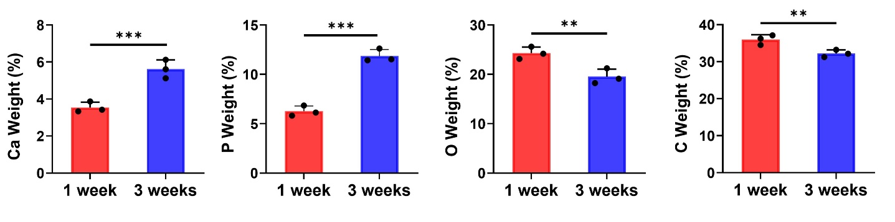

Fig. S1. Quantitative SEM-EDS analysis of the element distribution of calcium (Ca), phosphorus (P), oxygen (O) and carbon (C) in the tendon from 1-week and 3-week groups (n = 3). All data was presented as mean ± standard deviation. Statistical analyses are performed by Student’s t test. ns, no significance; *, P < 0.05; **, P < 0.01; ***, P < 0.001.

Fig. S2. Schematic representation of the sham and HO rats injected with calcein to record the formation of microcalcifications. Eight week old rats received achillotenotomy and an injection of calcein green. Injection of calcein green allowed tracing of the calcific mineral present at the initial time point. The rats were euthanized 1 and 3 weeks respectively.

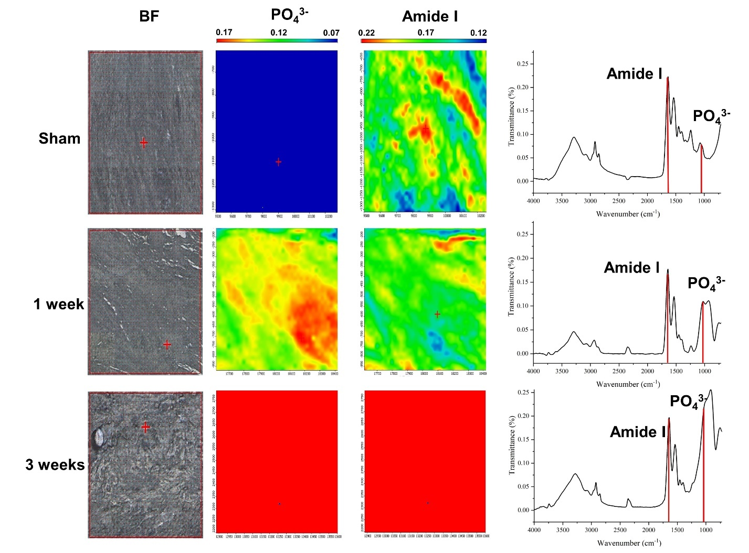

Fig. S3. Micro-infrared analysis of sham and HO tendons in 1 and 3 weeks. Infrared cartography and spectra of Amide I and PO₄³⁻ in the sham, 1 week and 3 week HO tendons were obtained.

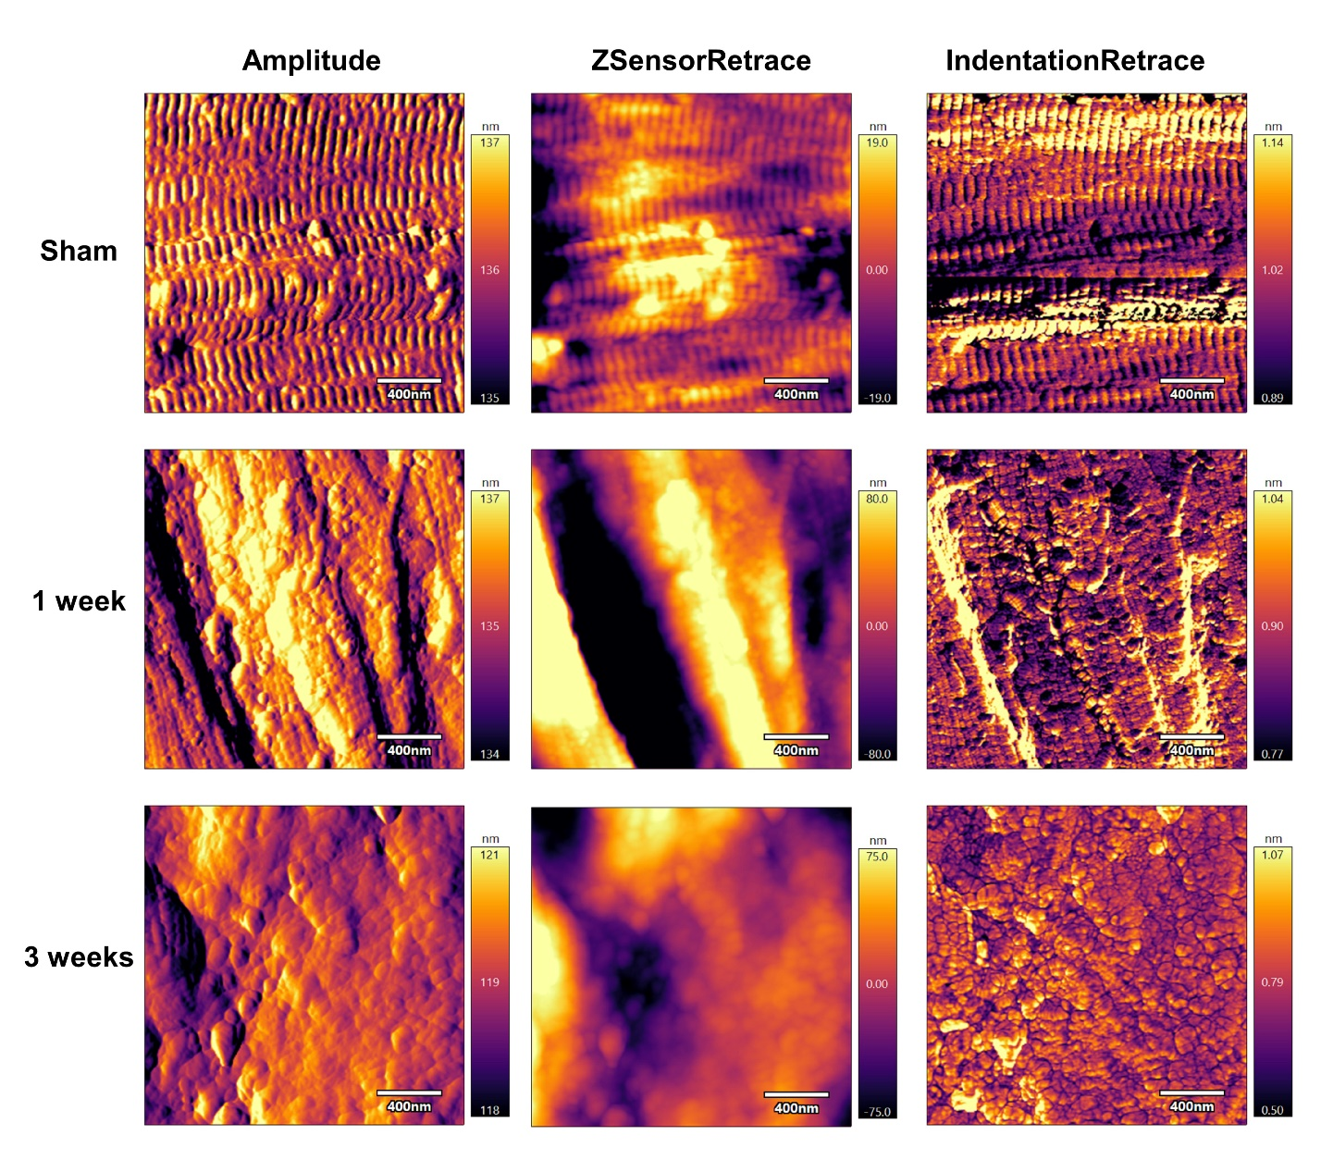Fig. S4. AFM images of sham, 1 week and 3 week HO tendon showing Amplitude, ZSensorRetrace and IndentationRetrace modality. AFM contact images were obtained in air using soft silicon nitride cantilevers with pyramidal tips. All images were processed using a first-order plane-fit function.

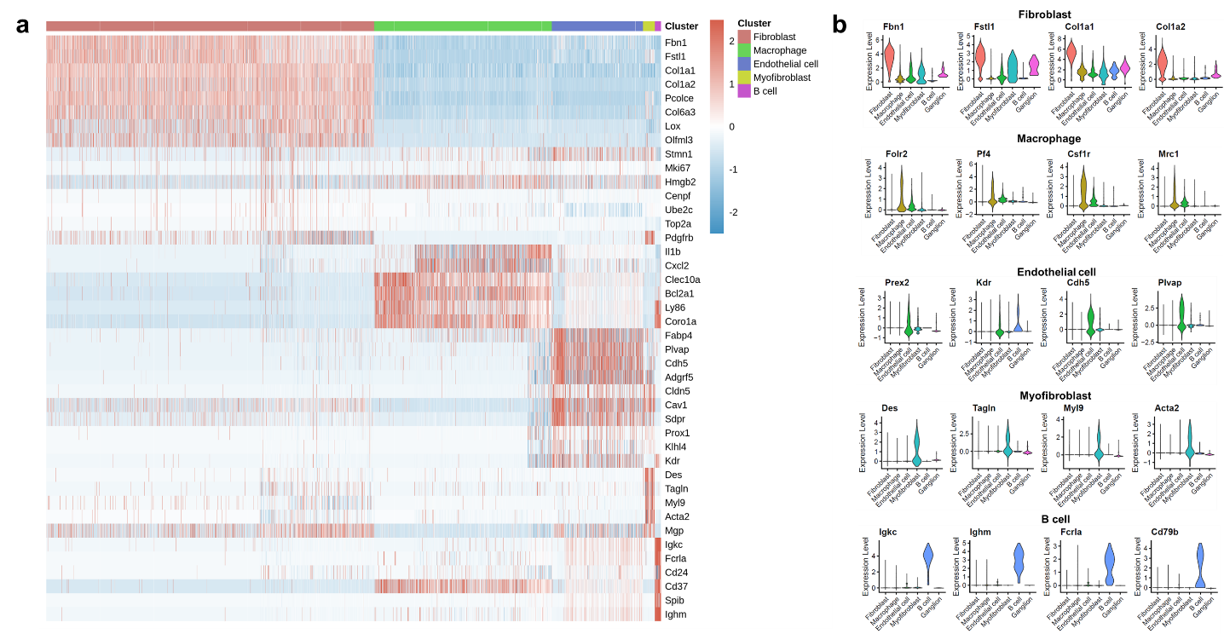

Fig. S5. The 5 principal cell types in tendons have marked expression variations. (a) Heatmap of the top 20 genes of the 5 main cell types in tendons. Expression values are normalized and scaled averages. (b) Violin plot of the expression of selected differentially expressed genes (DEGs) of fibroblasts, macrophages, endothelial cells, myofibroblasts and B cells. Expression values are nonnormalized.

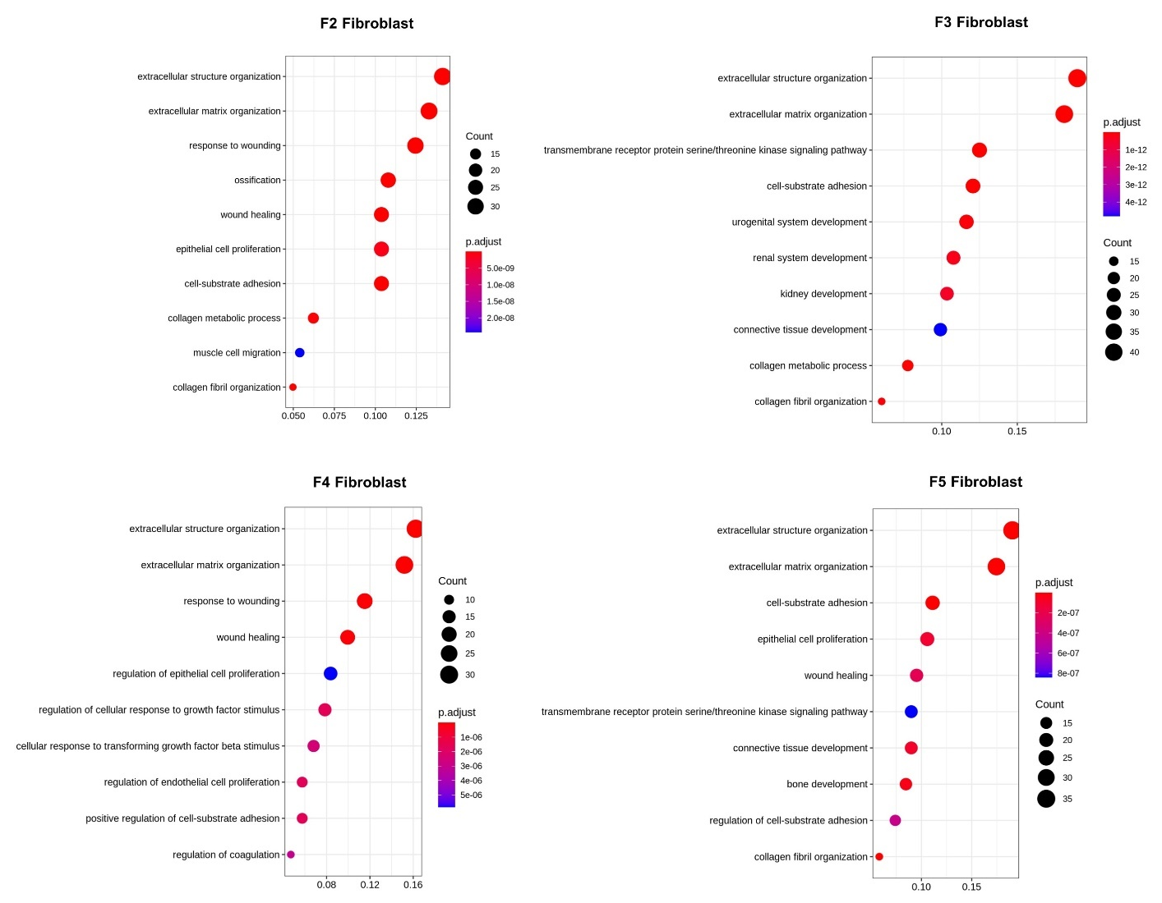

Fig. S6. The histogram of the biological processes of different fibroblast clusters. Gene Set Enrichment Analysis was used to determine p value using GO (biological process) database on FBs. We emphasized the novel GO terms related to fibroblast function.

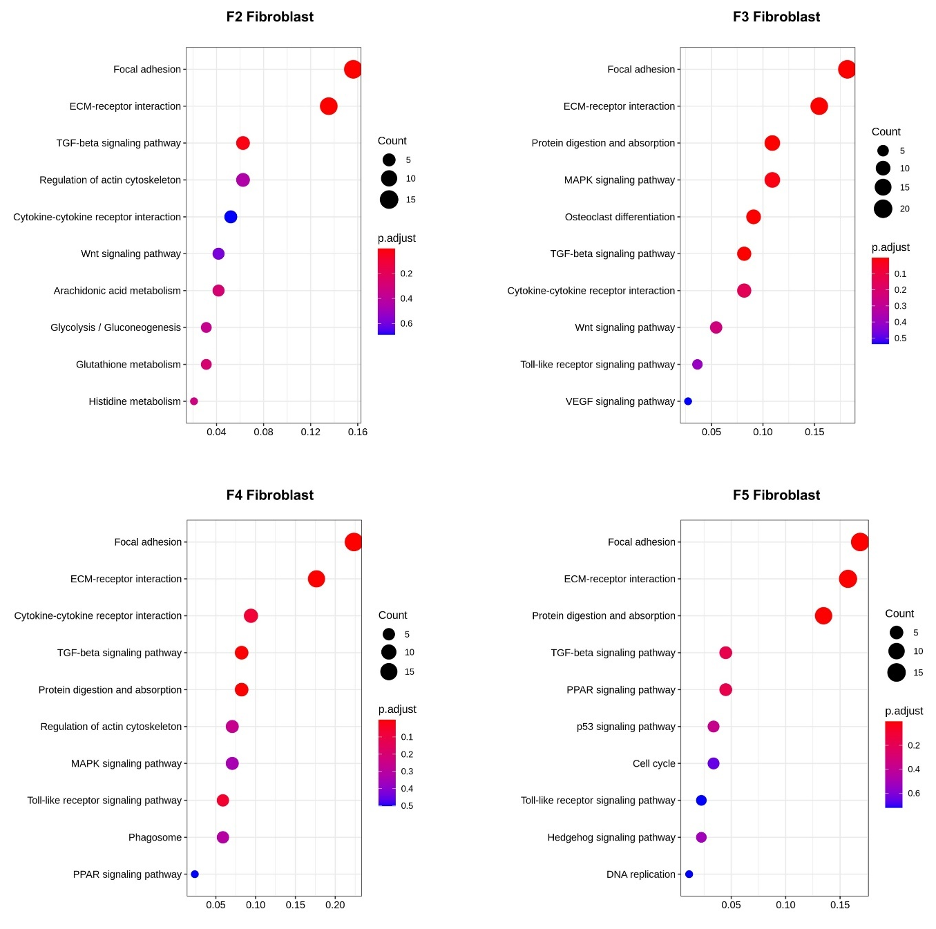

Fig. S7. The histogram of the biological processes of different fibroblast clusters. Gene Set Enrichment Analysis was used to determine p value using GO (biological process) database on FBs. We emphasized the novel KEGG terms related to fibroblast function.

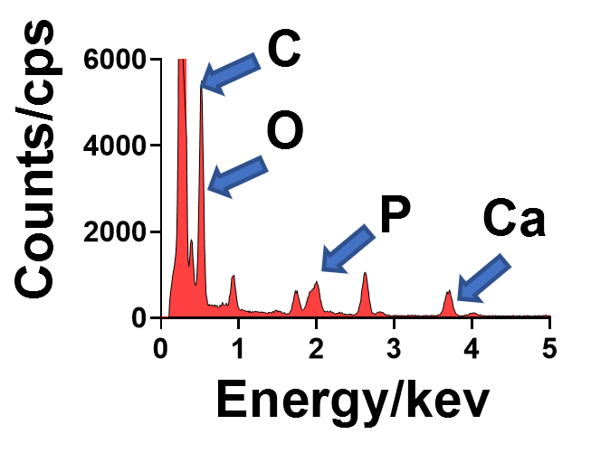

Fig. S8. EDS elemental analysis of the selected area of the CABs containing electron-dense granules.

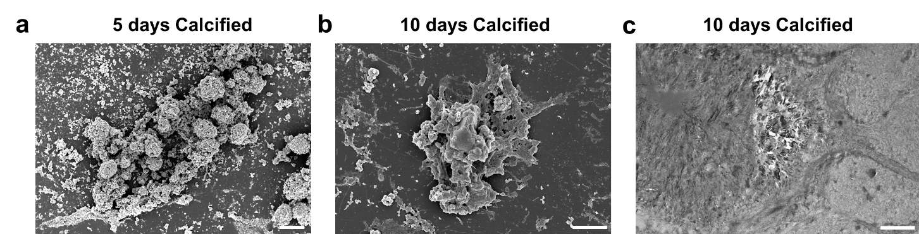

Fig. S9. Representative SEM and TEM images of the fibroblasts cultured in the calcified medium. (a) Representative SEM images of the fibroblasts cultured in the calcified medium for 5 days. Scale bar: 10 μm. (b) Representative SEM images of the fibroblasts cultured in the calcified medium for 10 days. Scale bar: 5 μm. (c) Representative TEM images of the fibroblasts cultured in the calcified medium for 10 days. Scale bar: 1 μm.

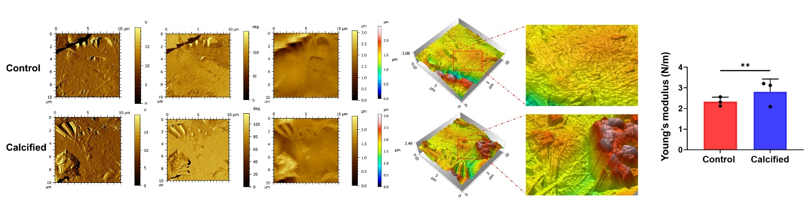

Fig. S10. AFM measurements of the fibroblasts cultured in the control and calcified medium for 7 days. Left: the images of the fibroblasts under the AFM microscope. Right, AFM quantification between control and calcified group. Data were presented as means ± standard deviations (n = 3). Statistical analyses were performed by Student’s t test. ns, no significance. *P < 0.05, **P < 0.01, ***P < 0.001.

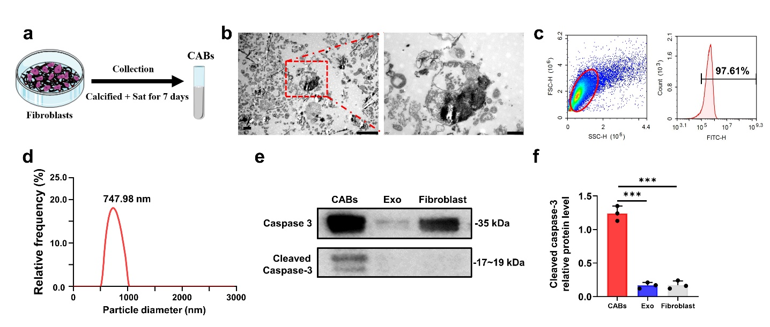
Fig. S11. The isolation and characterization of the CABs. (a) Schematic representation of the isolation of the CABs. (b) TEM images of the CABs from the fibroblasts in calcified group. Scale bar: 2 μm. High magnification of the red rectangle showing the CABs. Scale bar: 500 nm. (c) Flow cytometry of the markers of the CABs from the fibroblasts in calcified group. (d) NTA of the CABs from the fibroblasts in calcified group. (e) Western blot of the phenotype markers of the CABs. (f) Quantification of the western blot of the CABs from the fibroblasts in different groups. Data were presented as means ± standard deviations (n = 3). Statistical analyses were performed by one-way ANOVA with post-hoc Tukey’s test. ns, no significance. *P < 0.05, **P < 0.01, ***P < 0.001.

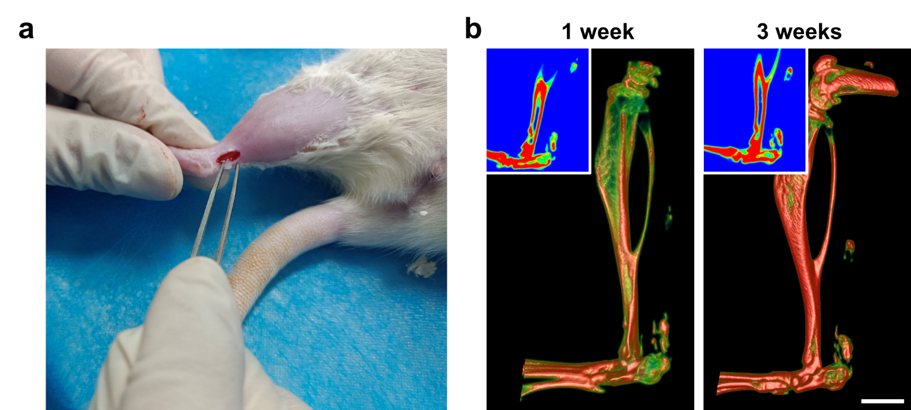

Fig. S12. (a) Photograph of the rat intratendon implantation model. (b) intramuscular ectopic calcification samples at 1 and 3 weeks post implantation (bars: 1 mm). 3D reconstruction of micro-CT scans of the ectopic calcification samples (bars: 0.5 mm). The collagen + CABs group showed evident ectopic calcification in the muscle tissue.

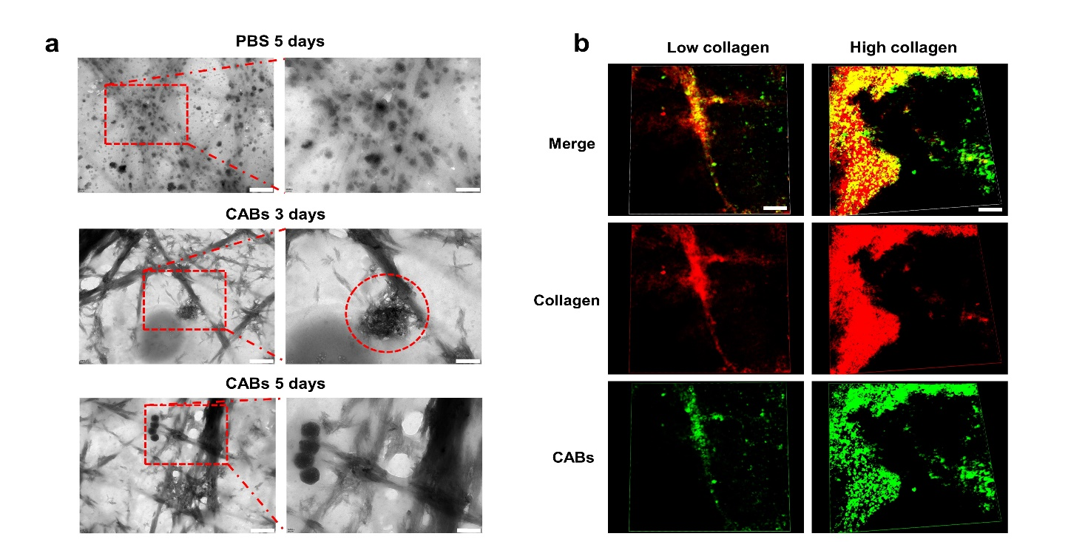

Fig. S13. (a) TEM images of the CABs incubated with the collagen I for 3 and 5 days. The CABs in a were collected from the fibroblasts cultured for 7 days in the calcified medium. Scale bar: 500 nm. High magnification of the red rectangle showing the CABs. Scale bar: 200 nm. (b) Immunofluorescence microscopy of the collagen I hydrogels after introduction of green-labeled CABs at 48 h. Scale bar: 5 μm.

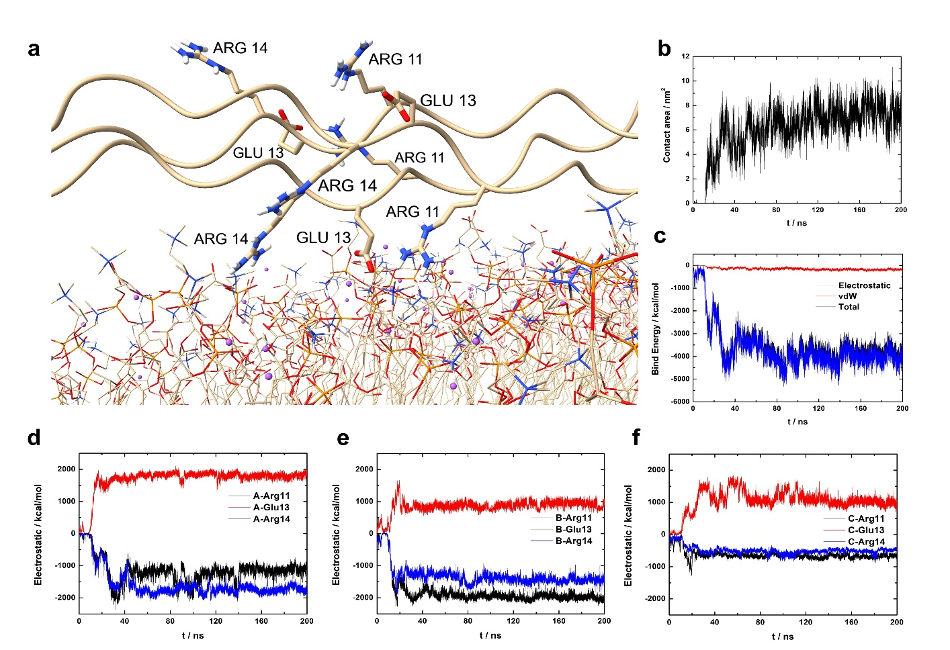

Fig. S14. Molecular dynamic (MD) simulation analysis between the CABs and collagen I. (a) Binding patterns analysis between the CABs and collagen I. (b) Contact area analysis between the CABs and collagen I (t = 200 ns). (c) Binding energy analysis between the CABs and collagen I (t = 200 ns). Electrostatic interaction is favorable for the CABs interaction with collagen fibrils. vdw, van der Waals energy. (d-f) Binding energy Electrostatic interactions of the phospholipid membrane with the key binding residues of the A, B, and C chains, (t = 200 ns).

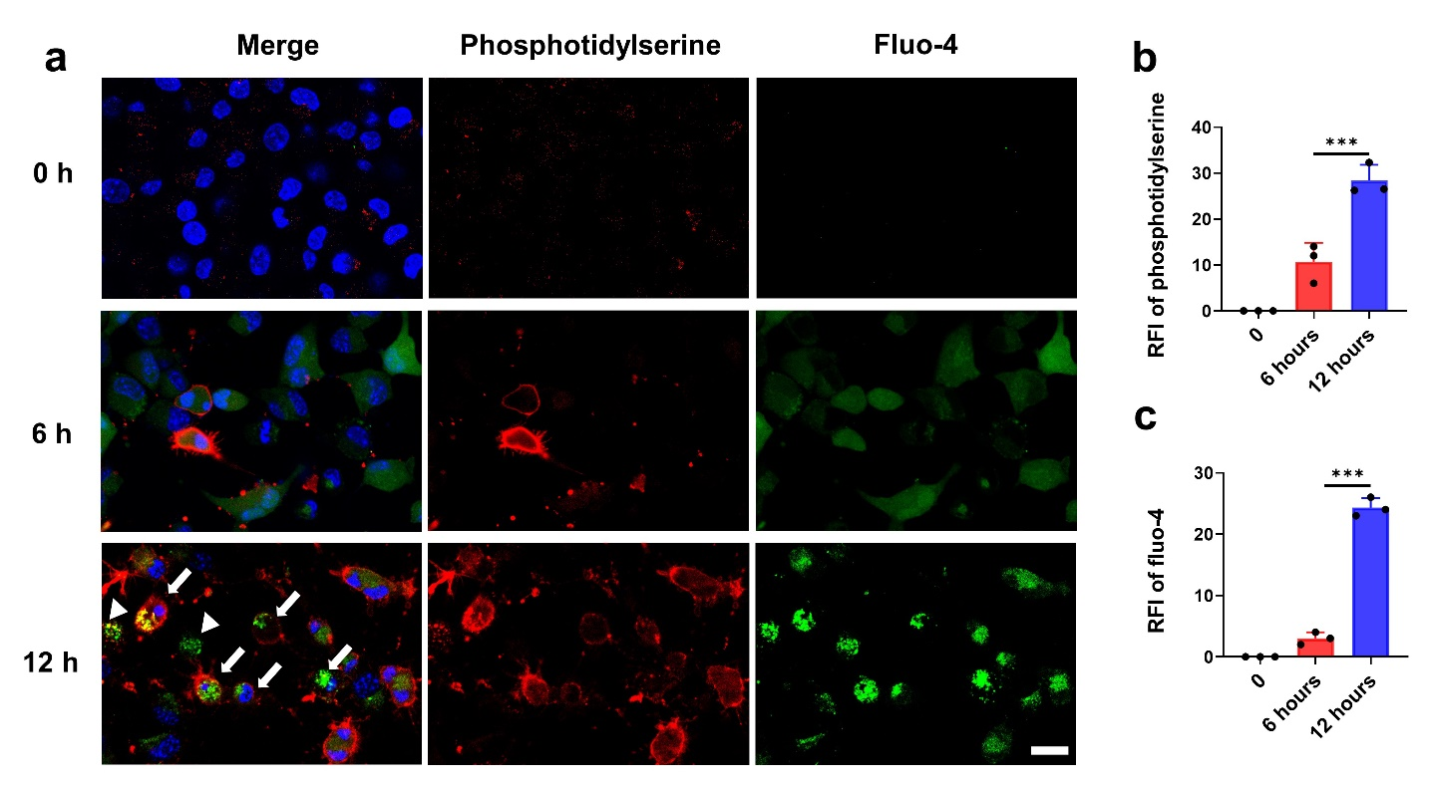

Fig. S15. Immunofluorescence microscope of the fibroblasts with high calcium and phosphorus concentrations medium for 6 and 12 hours. Phosphotidylserine, marker for apoptosis, and Fluo-4, marker for calcium, were not detected in normal control group. After 6 hours, PS was clearly detectable and significantly up-regulated after 12 hours. Phosphotidylserine, red; Fluo-4, green; Dapi, blue. Scale bar, 5 μm.



Fig. S16. The CABs continuously enrich calcium and release the microcalcification. (a) Immunofluorescence microscopy of the CABs cultured in the collagens with high calcium and phosphorus concentrations for 12 h. Phosphotidylserine, red; Fluo-4, green; Dapi, blue. Scale bar, 10 μm. (b) Representative SEM image based on a. Scale bar, 2 μm.

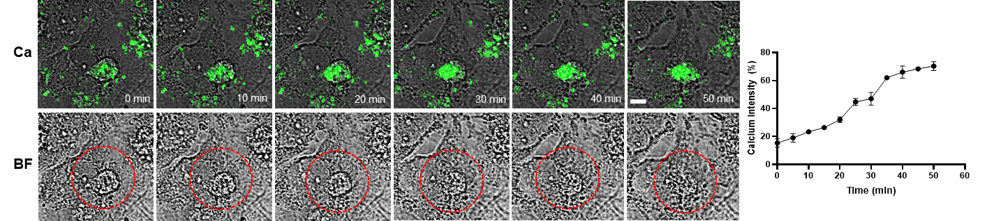

Fig. S17. Time-lapse images monitoring the CABs enriching calcium and the quantification of the intensity of Fluo-4 staining in the CABs.

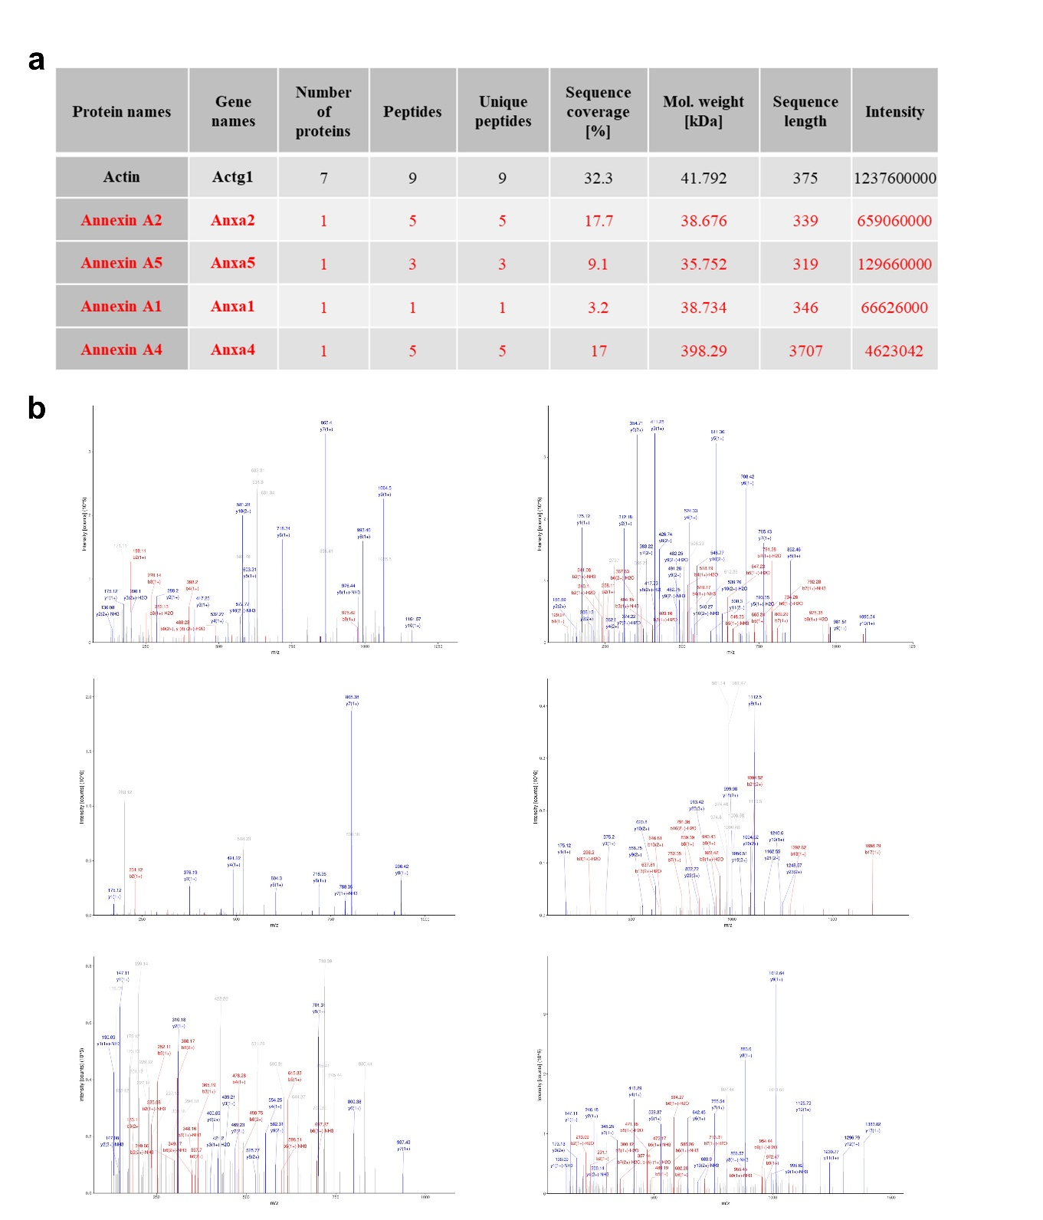

Fig. S18. The list of candidates and unique peptides of the top 5 scores in LC-MS/MS analysis of membrane protein of the CABs from the fibroblasts with high calcium and phosphorus concentrations.

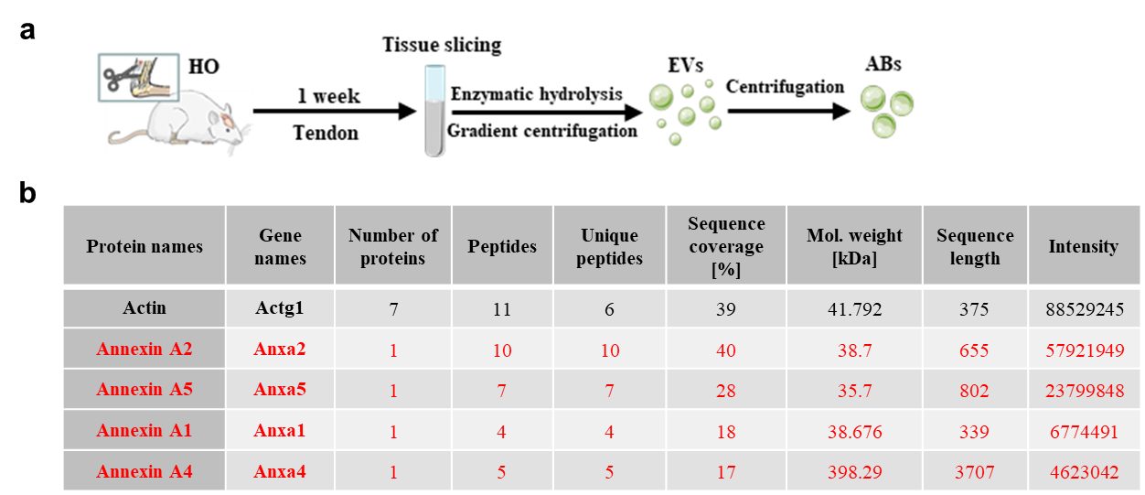

Fig. S19. List of candidates with top 5 scores in LC-MS/MS analysis of membrane protein of the CABs from the tendon. (a) Schematic representation of the isolation of the CABs. (b) List of candidates with top 5 scores in LC-MS/MS analysis of membrane protein of the CABs isolated from the 1 week HO tendons.

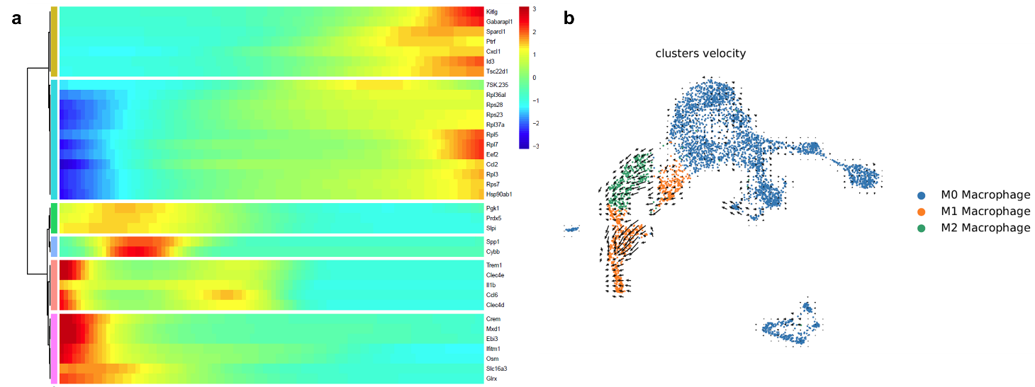

Fig. S20. The polarization of macrophage from M1 to M2. (a) Genes showing change in expression along the cell differentiation trajectory by Monocle. Red indicates higher expression, blue indicate lower expression. (b) RNA velocity cell trajectory analysis of macrophages.

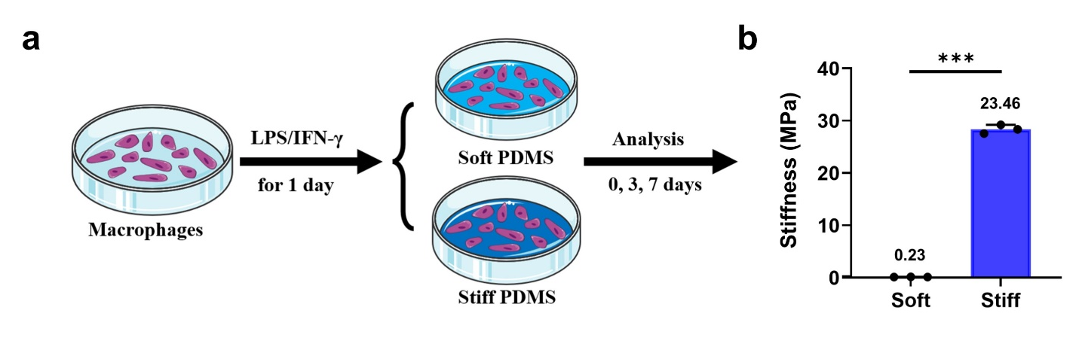

Fig. S21. The macrophage cultured in two kinds of PDMS substrates with different young’s moduli. (a) Schematic representation of the macrophage cultured in two kinds of PDMS substrates with different young’s moduli. (b) AFM quantification between two kinds of PDMS substrates. Data were presented as means ± standard deviations (n = 3). Statistical analyses were performed by Student’s t test. ns, no significance. *P < 0.05, **P < 0.01, ***P < 0.001.

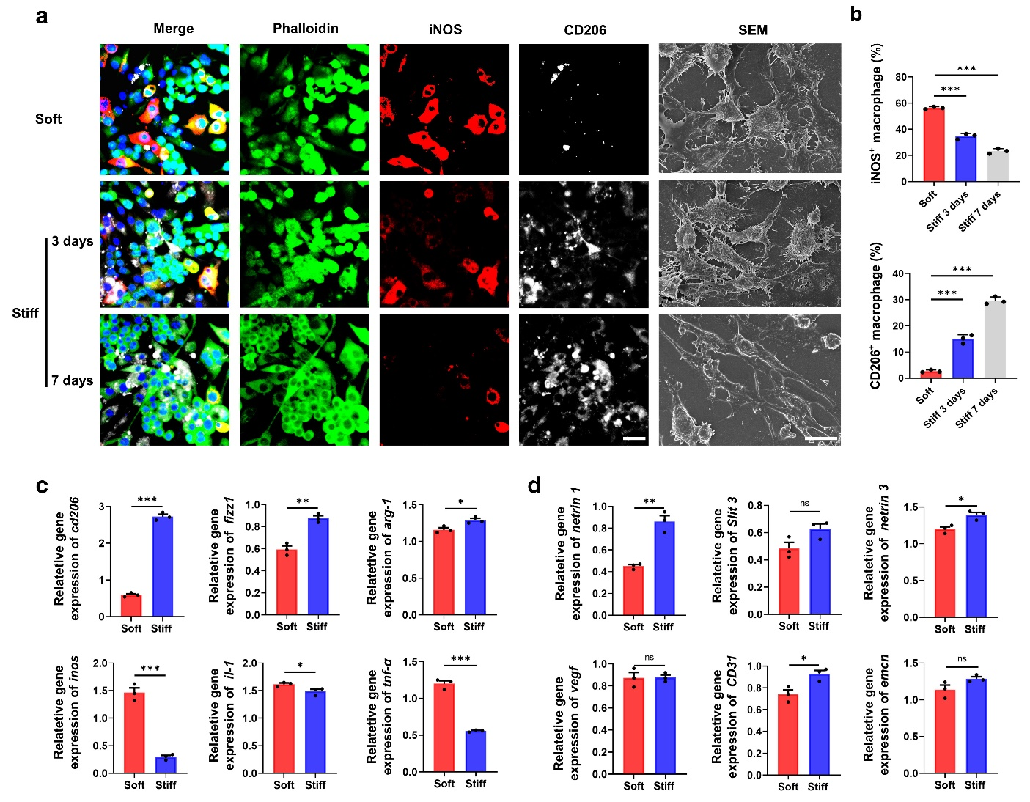

Fig. S22. Increased stiffness of ECM promotes the polarization of macrophage from M1 to M2. (a) Immunofluorescence microscopy of the macrophages in the different groups. Phalloidin, green; iNOS, red; CD206, white; DAPI, blue. Scale bar: 20 μm. (b) Quantitative analysis of iNOS⁺ cells and CD206⁺ cells in c (n = 3). (c, d) RT-qPCR analysis of the gene expression in two kinds of PDMS substrates with different young’s moduli (n = 3). Data were presented as means ± standard deviations. Statistical analyses were performed by one-way ANOVA with post-hoc Tukey’s test and Student’s t test. ns, no significance. *P < 0.05, **P < 0.01, ***P < 0.001.

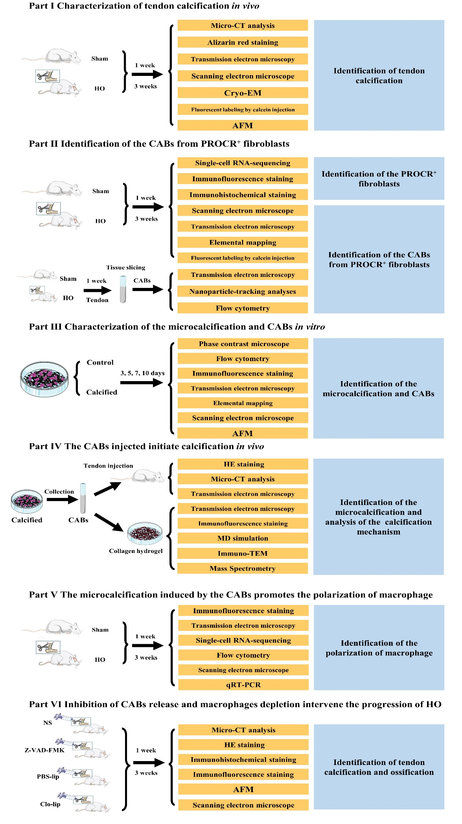
Fig. S23. Flow chart depicting the sequence of experiments conducted in the present study.

Genes | Description |  |  | Primer sequences
VEGF | m-VEGF-F |  | 5’- ACATTGGCTCACTTCCAGAAACAC-3’
 | m-VEGF-R |  | 5’- TGGTTGGAACCGGCATCTTTA-3’
iNOS | h- iNOS-F |  | 5’- CAAGCTGAACTTGAGCGAGGA-3’
 | h- iNOS-R |  | 5’- TTTACTCAGTGCCAGAAGCTGGA-3’
IL-1β | h- IL-1β-F |  | 5’- TCCAGGATGAGGACATGAGCAC-3’
 | h- IL-1β-R |  | 5’- GAACGTCACACACCAGCAGGTTA-3’
TNF-α | h- TNF-α -F |  | 5’- ACTCCAGGCGGTGCCTATGT-3’
 | h- TNF-α -R | 5’- GTGAGGGTCTGGGCCATAGAA-3’
CD206 | h- CD206-F |  | 5’- AGCTTCATCTTCGGGCCTTTG-3’
 | h- CD206-R |  | 5’- GGTGACCACTCCTGCTGCTTTAG-3’
Arg1 | h- Arg1-F |  | 5’- AGCTCTGGGAATCTGCATGG-3’
 | h- Arg1-R |  | 5’- ATGTACACGATGTCTTTGGCAGATA-3’
FIZZ1 | h- FIZZ1-F |  | 5’- CAGCTGATGGTCCCAGTGAA-3’
 | h- FIZZ1-R |  | 5’- CAAGCACACCCAGTAGCAGTC-3’
CD31 | h- CD31-F |  | 5’- TGGTTGTCATTGGAGTGGTC-3’
 | h- CD31-R |  | 5’- TTCTCGCTGTTGGAGTTCAG-3’
Emcn | h- Emcn-F |  | 5’- CCAGTCTTCTCACCAGTCTACAC-3’
 | h- Emcn-R |  | 5’- TCACAGTTCCTCCTAGCAAAGTC-3’
Slit3 | h- Slit3-F |  | 5’- AGACCCTGAACCTGGTGGTAGAC-3’
 | h- Slit3-R |  | 5’- TCTGCACCCTGGCGTAAGG-3’
netrin 1 | h- netrin 1-F |  | 5’- GTTCGGCGACGAGAACGAA-3’
 | h- netrin 1-R |  | 5’- TGTGCCTACAGTCACACACCAGA-3’
netrin 3 | h- netrin 3-F |  | 5’- AGGTCGGCCAATCGCGT-3’
 | h- netrin 3-R |  | 5’- CAGGGGCACTGTGAGGGTTAC-3’
Gapdh | h-Gapdh -F |  | 5’-TGTGTCCGTCGTGGATCTGA-3’
 | h-Gapdh-R |  | 5’-TTGCTGTTGAAGTCGCAGGAG-3’

Table S1. Primers for RT-qPCR

