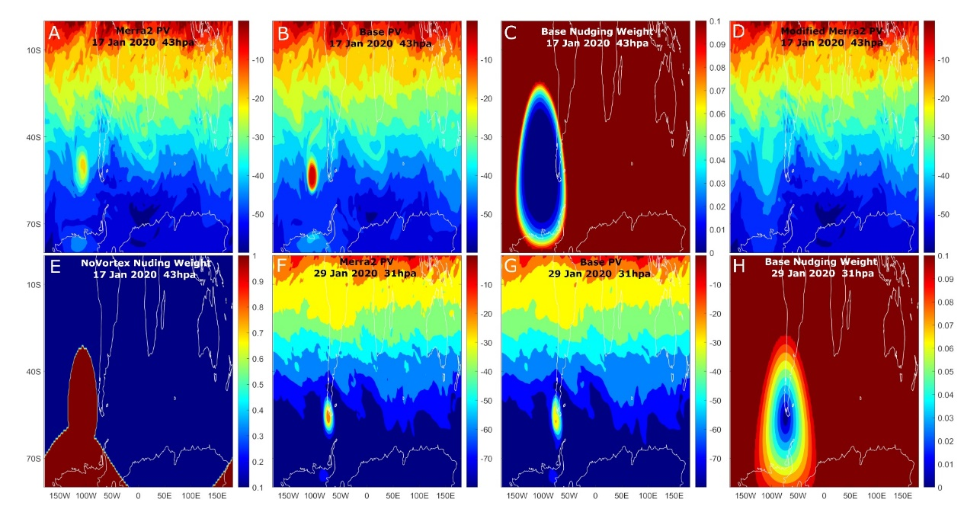

Extended Data Fig. 1 | Distribution of Ertel PV (PVU) and nudging weight. (A) Ertel PV from MERRA2 reanalysis at 43 hPa level and 00 UTC 17 January 2020; the isolated high PV patches at ~100°W above the south Pacific and Antarctic are SCV P1 and SCV P2 respectively. (B) Simulated Ertel PV map from Base. (C) Nudging weight assigned to reanalysis for Base run at 00 UTC 17 January 2020. (D) Ertel PV of the modified MERRA2 reanalysis used in NoVortex simulation. SCVs were zeroed out by moving average. (E) Nudging weight like panel (C) except for the NoVortex run. (F) Ertel PV from MERRA2 reanalysis at 31 hPa level and 00UTC 29 January 2020. (G) Ertel PV map like panel (F) but from Base simulation. (H) Nudging weight like panel (C) but at 00UTC 29 January 2020. Note that panel (E) uses a color scale different from (C) and (H) in that the weight outside the red region in panel (E) is uniformly 0.1.

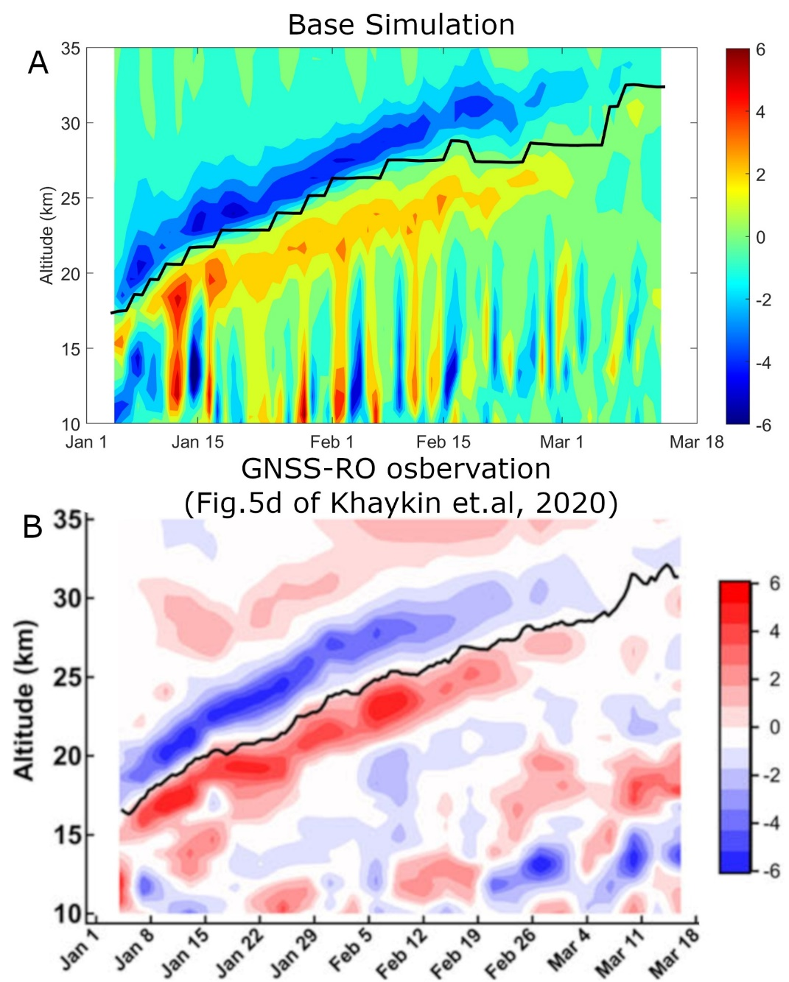

Extended Data Fig. 2 | Composite temperature perturbation (K) within the SCV. (A) Perturbation from Base simulation. The black line shows the SCV center simulated by Base. The perturbation was computed in a similar way as the Fig. 5d in Khaykin, et al. ¹¹. It is the departure of hourly temperature profiles collocated with the SCV center (Maximum LPV point) from a mean temperature profile within the corresponding spatiotemporal bin (3-day, 3° latitude, 40° longitude). The resultant hourly profiles were then lumped into daily profiles. (B) Perturbation from observations of Metop Global Navigation Satellite System (GNSS) radio occultation (RO) temperature profiles. The figure is a copy of Fig. 5d in Khaykin, et al. ¹¹. The black line shows the center of vortex identified from ECMWF relative vorticity.
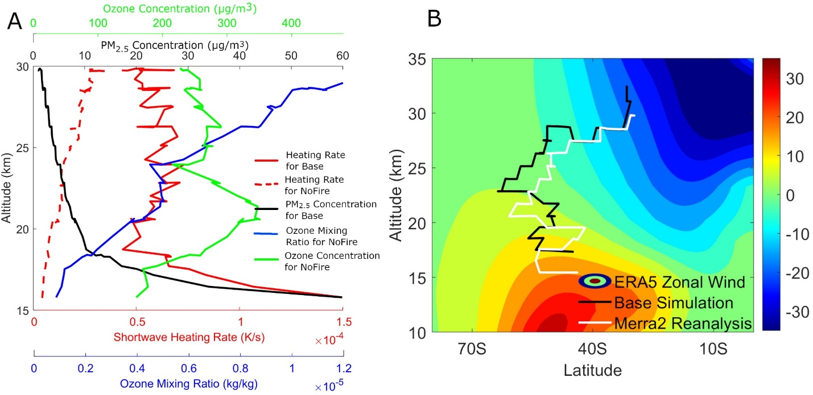

Extended Data Fig. 3 | Change of the SCV and its background with ascent. (A) Daily averaged properties sampled at the aerosol bubble center (in terms of maximum PM_{2.5} concentration) of SCV. Shortwave heating rate (red Solid, K s⁻¹) and PM_{2.5} concentration (black, μg m⁻³) were retrieved from the Base simulation to represent the change of the SCV while the shortwave heating rate (red dashed), O₃ mixing ratio (blue, kg kg⁻¹) and concentration (green, μg m⁻³) were retrieved at the same location but from NoFire to represent the change of the background. (B) Latitudinal and vertical distribution of zonal wind (color, m s⁻¹, positive value means westerlies) averaged longitudinally and from January to March of 2020. Black (white) line denotes the simulated (reanalysis) SCV trajectory in terms of maximum LPV points.

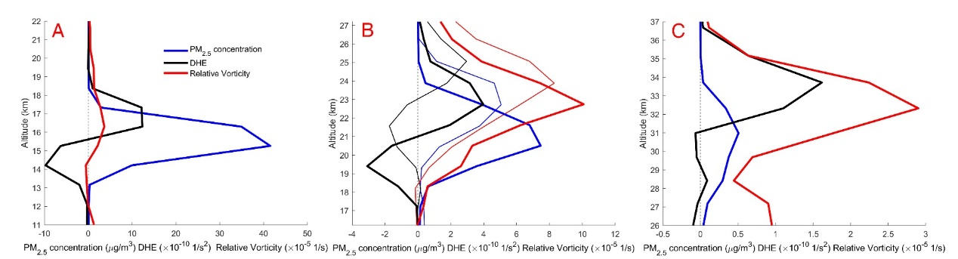

Extended Data Fig. 4 | Profiles of vorticity, DHE and PM_{2.5} concentration cross the center of the SCV at different stages of plume rise in simulations. (A) 23:00 UTC of 03 January in the formation period. (B) Thick lines are from the simulation at 19:00 UTC of 17 January and thin lines are from 17:00 UTC of 25 January. Both periods represent the maturation stage. (C) 19:00 UTC of 12 March in the dissipation period. Unlike Fig. 2A, the scale for x-axis changes from (A) to (C).
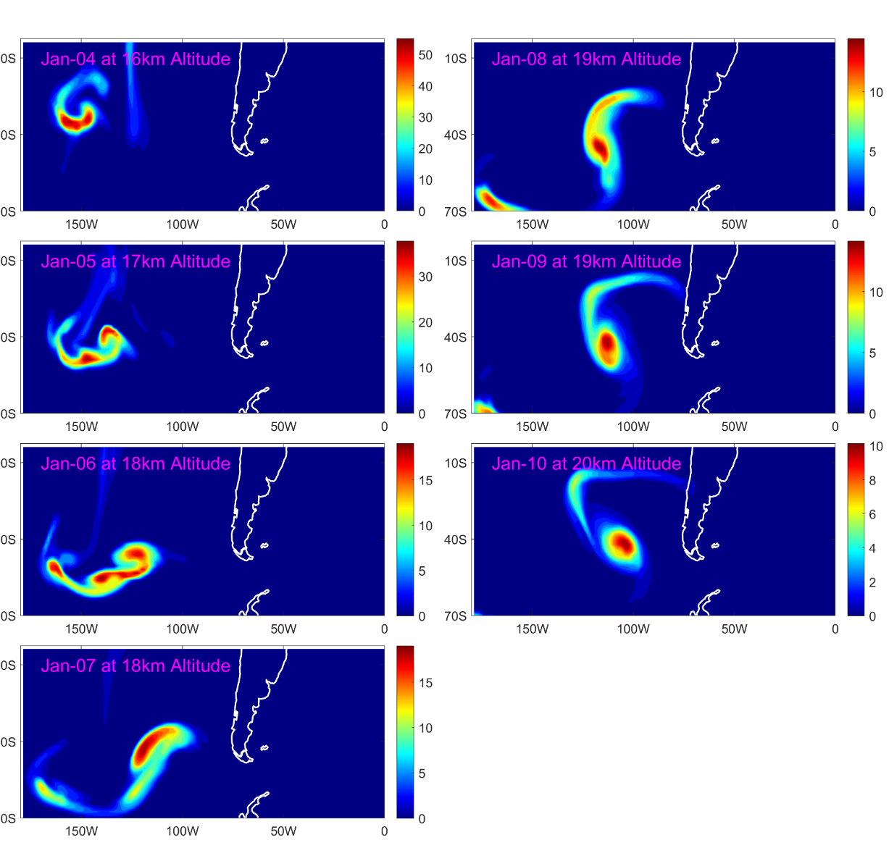

Extended Data Fig. 5 | Simulated PM_{2.5} concentrations (μg m⁻³) tracking the evolution of the SCV into maturation. The horizontal distribution is from Base_Only30 (Supplementary Information, Sect. 1.5). Note the change of color and altitude at different snapshots in time.
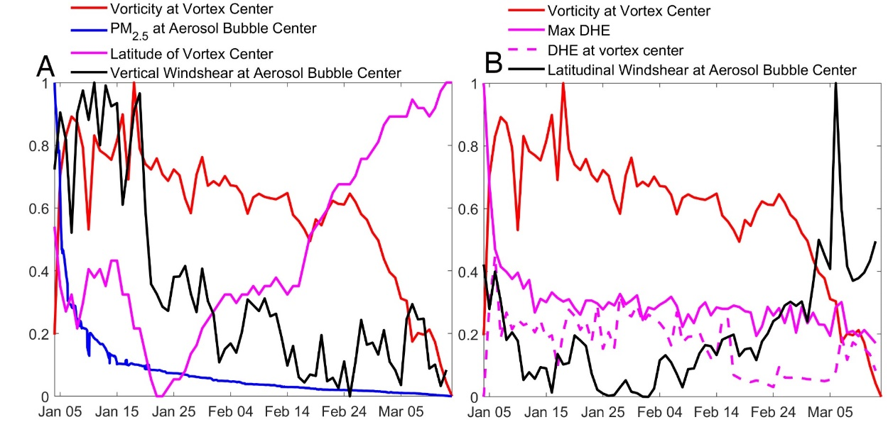

Extended Data Fig. 6 | Temporal evolution of daily averaged properties sampled along the SCV. (A) Temporal evolution of vorticity at the vortex center, PM_{2.5} concentration at the aerosol bubble center, the latitude of the vortex center and the vertical windshear at the aerosol bubble center. The vortex center refers to the point where the maximum relative vorticity is reached around the SCV and similarly the aerosol bubble center is where maximum PM_{2.5} concentration is reached. All values were scaled to [0,1] to show the relative temporal change. (B) Similar to (A) but for vorticity at the vortex center, Max DHE (the DHE at the point where it reaches its maximum inside the aerosol bubble), DHE at the vortex center and the latitudinal windshear at the aerosol bubble center. Max DHE and DHE at the vortex center were scaled together. Both vertical and latitudinal windshear only consider the zonal wind. As can be seen from panel (B) the sudden decrease of relative vorticity from mid-February was accompanied by the sudden deviation of DHE at vortex center from maximum DHE and the increase of latitudinal wind shear. Meanwhile PM_{2.5} concentration, vertical wind shear and maximum DHE only changed slowly.
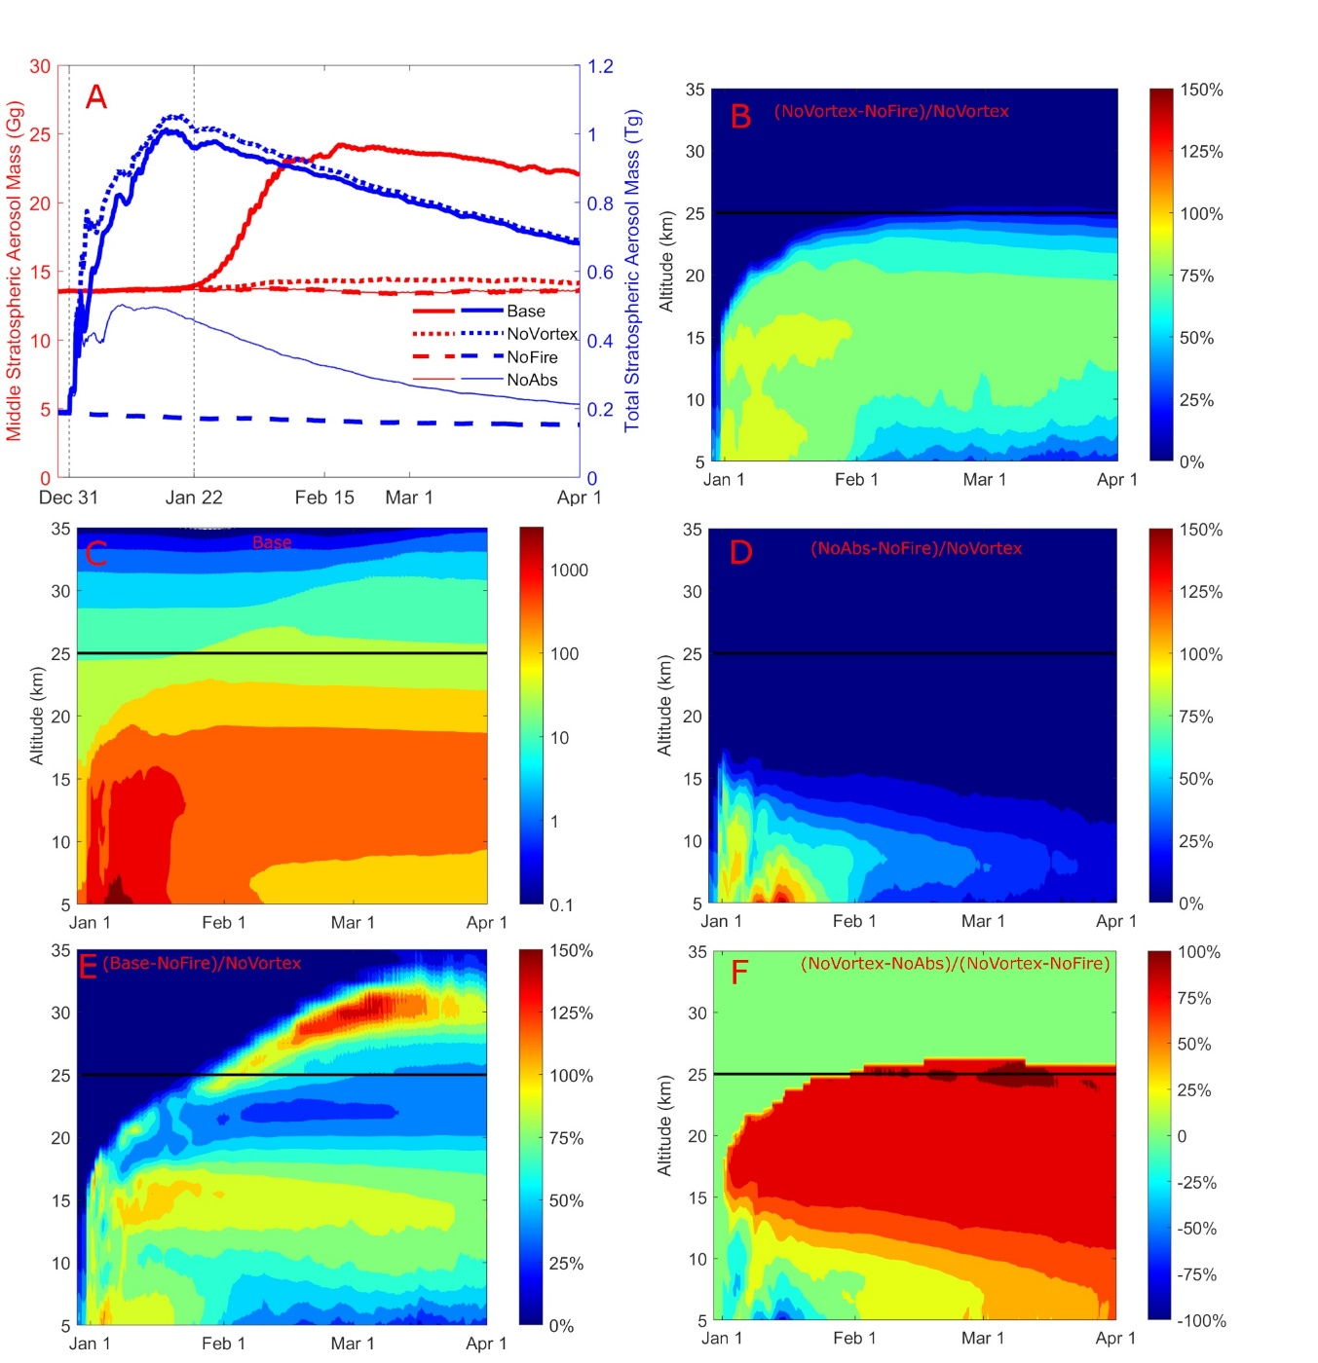

Extended Data Fig. 7 | Impact of SCV and BB on stratospheric aerosol concentration. (A) Temporal evolution of total PM_{2.5} mass like Fig. 3B except including the results of NoAbs. (B) Temporal and vertical distribution of the difference between PM_{2.5} concentrations (averaged over ESH) from NoVortex and NoFire normalized by NoVortex. (C) PM_{2.5} concentration (ng m⁻³) averaged over ESH from Base simulation. (D) The same as (B) expect difference are between NoAbs and NoFire. (E) The same as (B) expect difference are between Base and NoFire. (F) The contribution of BC heating to PM_{2.5} in the ESH during the 2019/20 Australian wildfire events estimated from NoVortex and NoAbs.
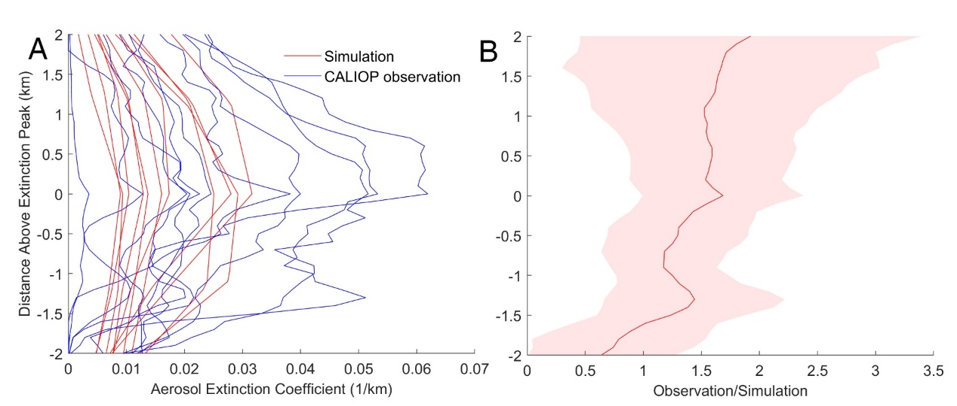

Extended Data Fig. 8 | Difference of aerosol extinction profiles between simulated and observed SCV. (A) 11 extinction profiles (averaged along the sampling track) collected from the right column of Fig. S7 and Fig. S21. Vertical profiles from either simulation or CALIOP observation were aligned to the same height coordinate according to where they reach the maximum extinction. (B) Ratio of observed profile to corresponding simulation averaged for the 11 comparisons. The ratio (defined as Observation/Simulation) was calculated for each comparison and then averaged to be the red line. The red shading denotes ±1 std across different comparisons.

