Supplementary Information for

Smoke-charged vortex doubles hemispheric aerosol in the middle stratosphere and buffers ozone depletion

Chaoqun Ma¹, Hang Su^{2*}, Jos Lelieveld³, William Randel⁴, Pengfei Yu⁵, Meinrat O. Andreae^{6,7}, Yafang Cheng^{1*}
Correspondence to: Y.C. (yafang.cheng@mpic.de) or H.S. (suhang@mail.iap.ac.cn)

1. Supplementary information for observations and model configurations

1.1 Three smoke-charged vortexes identified from MERRA2
The SCV discussed in the main text is the strongest one associated with the 2019/2020 Australian wildfires (named “P1” by Kablick III, et al. ¹ or “Koobor” by Lestrelin, et al. ²). It could be clearly and consecutively identified from 4 January 2020 at around 139 hPa above South Pacific Ocean to around 9 March 2020 at 12 hPa above Chile by tracking the Lait PV (LPV) field. From the 2019/2020 Australian wildfires, there in fact existed another two SCVs which are much weaker but could also be identified from the MERRA2 reanalysis, also showing that such conditions are not rare anomalies. One meandered above the Antarctic (named “P2” by Kablick III, et al. ¹ or “2nd Vortex” by Lestrelin, et al. ², Extended Data Fig. 1A) and the other travelled eastward across the Atlantic (named “P3” by Kablick III, et al. ¹ or “3rd Vortex” by Lestrelin, et al. ², Fig. S6C). In the main text and supplementary material, if not specifically noted, “SCV” refers to “SCV P1”. The MERRA2 reanalysis data from 2009 to 2019 was also checked manually to identify anticyclonic vortices that might be the candidates of SCVs in the stratosphere.

1.2 Reanalysis data (ERA5)
To track the stratospheric ozone (O₃) anomaly, which is another feature of SCVs ³, we used the ERA5 reanalysis ⁴ which is the last-generation global atmospheric reanalysis from the European Centre for Medium-Range Weather Forecasts (ECMWF). The data is based on the ECMWF Integrated Forecast System (IFS) which includes a simplified representation of O₃ chemistry (through including the chemistry that causes the O₃ hole). Together with the help of assimilating O₃-related satellite observations, ERA5 exhibits a relatively realistic spatial distribution of stratospheric O₃. For our study, the re-gridded 0.25° x 0.25° version of ERA5 hourly data was extracted whenever a candidate was identified from MERRA2 the Ertel PV field and checked to find a corresponding O₃ minimum.

1.3 Detailed configurations for WRF-Chem/DART
a. WRF-Chem configurations
WRF-Chem Version 4.1.1 was implemented with a domain that covers southeastern Australia and New Zealand (Fig. S13A). The horizontal resolution is 15 km and the number of vertical layers was increased to 43 by adding more layers near the tropopause. The model top is around 29 km altitude. Apart from anthropogenic and biogenic emissions, the model also simulates biomass burning (BB) emissions from the Global Fire Emissions Database (GFED4s) ⁵. To include the pyro-convection process, a 1-D smoke plume rise model was applied at each model grid which calculates the plume injection height from the background meteorological profile and fire intensity ^{6,7}.
Considering that the BB emissions appeared underestimated by a factor of 3 to 4 over Australia ^{8,9}, and aerosol amount in high altitude might be underestimated because only a fixed empirical ratio of 50% BB emission is lifted by pyro-convection in WRF-Chem, the predicted amount of BB smoke carried up by pyro-convection might be underestimated by a factor of 6 to 8 in the worst case. To account for this potential underestimation, the GFED4s source was multiplied by a factor of 7 before input into the WRF-Chem model.
The mass absorption cross section (MAC) ¹⁰ after several days following the BB emissions, defined here as the total light absorption at 550 nm per mass of BC, is lower in WRF-Chem (around 8.9 m² g⁻¹ at 550 nm) than CAM-chem (around 14.6 m² g⁻¹). This means the same mass of BC absorbs less light in WRF-Chem than in CAM-chem, although both models are assuming internal mixture of different aerosol compositions in a certain size range ^{11,12}. The discrepancy might be caused by different mass and size distribution of BC and other aerosol compositions in the two models. To be consistent with CAM-chem, the mass of BC was scaled by 1.64 in WRF-Chem only when calculating optical properties.

b. Ensemble Generation
A 20-member ensemble of WRF-Chem runs were generated by randomly perturbed the inputs and model parameters described below. At first, BB emissions were randomly perturbed with a 50% standard deviation to generate the emission ensemble. In addition, the emission factors for BC from temperate forest fires were perturbed to range from 0.56 to 0.75 g kg⁻¹ for different ensemble members, estimated by Akagi, et al. ¹³. To prevent deviation from the real meteorological condition (WRF-Chem /DART did not assimilate meteorological observations) and to represent the uncertainty from meteorological fields, an ensemble of meteorological fields was generated by perturbing the FNL reanalysis with WRFDA tool and overwrote the meteorological variables of WRF-Chem simulations every 6 hours at the beginning of each data assimilation cycle.
Another important uncertainty which needs to be accounted comes from the injection height predicted by the model. According to Paugam, et al. ¹⁴, pyro-convection systems are often weakly represented in large-scale atmospheric models which do not yet provide quantitative agreement with observed injection heights. In our case, such disagreement appeared to be constant underestimation of injection height for the most important pyro-convections in 30 December 2019. Although many parameters in the plume rise model could contain error to cause the underestimation, we accounted for the uncertainty by simply perturbing the entrainment intensity in different ensemble members. Entrainment intensity was chosen only for its simplicity and effectiveness and a perturbation magnitude of 60% was chosen by try-and-error to make the ensemble maximum injection height agree with the observations (https://pyrocb.ssec.wisc.edu/). Fortunately, the assimilation of aerosol index observations to some extent corrects the smoke vertical distribution because smoke at different levels would experience different transport paths and appear at different pixels of the satellite image. For perfect solution concerning the injection height, accurate model for plume rise ¹⁵⁻¹⁷ deserves more attention in future studies.

c. Data Assimilation Configuration
In this study, DART was applied to assimilate TROPOMI aerosol index (AI) and MODIS AOD observations which could constrain the WRF-Chem simulations of black carbon (BC) and organic carbon (OC) to provide a relatively realistic smoke aerosol distribution in the early stage. The configuration of DART is similar to Ma, et al. ¹¹. Localization using Gaspari and Cohn function was applied with localization half width 0.05 radians (318.6 km) at horizontal and a 0.075 scale height (approximately 0.65 km at 298 K) at vertical. Covariance inflation was disabled because the smoke plumes usually leave the WRF-Chem domain within two days during which assimilated observations are unable to cause filter divergence. DART did not assimilate meteorological variables. We conducted continuous 6-h cycling with WRF-Chem/DART using the 20-member ensemble to update the aerosol concentrations. The cycle times were 02:00, 08:00, 14:00 and 20:00 UTC, because 02:00 UTC is the local noon when most sun-synchronous satellites pass the domain.

1.4 More information concerning satellite data (TROPOMI, MLS, OMPS)
When assimilating TROPOMI AI, we only assimilated data points above ocean. Because of the difficulties in calculating the surface albedo, AI values over land were not assimilated, which is expected to have little impact given that the model domain is mainly oceanic. Observational errors for data assimilation were extracted from the uncertainty indicated with the AI dataset. The assimilation of AI provides important information for the final chemistry reanalysis by constraining the aerosol concentration and distribution in the smoke plume.
We used the Microwave Limb Sounder (MLS) Level 2, version 5 O₃ product to analyze the O₃ anomalies in Fig. 4B and Sect. S2.8. Because the original MLS O₃ data is in volume mixing ratio unit and at pressure level, similar MLS products for geopotential height and temperature were also downloaded to convert the O₃ mixing ratio into number density unit which were then interpolated to altitude levels.
The Ozone Mapping and Profiling Suite (OMPS) on board Suomi NPP satellite measures the global distribution ozone vertical profiles on a daily basis. We downloaded the V2.5 data from the Limb Profiler VIS algorithm to get the O₃ density profiles from cloud top to 37.5 km. OMPS O₃ profiles have been shown to agree well correlative MLS and ACE-FTS data although limited biases exist for different sampling and retrieval methods adopted by the 3 instruments ¹⁸.

1.5 CAM-chem simulation scenarios
a. Supplementary information for CAM-chem configurations
After injection by pyro-convection and early-stage spreading, the BB smoke from WRF-Chem/DART reanalysis were transferred into the CAM-chem to simulate the subsequent transport and evolution. The CAM-chem model was started in October 2020. From 29 December 2019, OC and BC concentration fields from WRF-Chem/DART reanalysis at 15 km x 15 km horizontal resolution were re-gridded to 105 km x 105 km and interpolated to replace corresponding CAM-chem grids which have a horizontal resolution of 0.94° x 1.25° with 56 vertical levels up to ~45 km altitude.
It has to be noted that BB also emits species other than BC and OC ¹⁹⁻²⁴. For example, halogen species emitted by BB may influence stratospheric chemistry. However, the amount of halogens from BB that could reach the stratosphere is estimated to be much smaller than the background concentrations and are thus not considered. For the same reason, direct emissions of halogen species from BB were not included in previous, related studies ²⁵⁻²⁷.
To be consistent with the WRF-Chem model, the light absorption by OC in CAM-chem was removed which means brown carbon was not taken into account considering its short lifetime ²⁸⁻³⁰. Apart from the BC and OC inherited from WRF-Chem/DART, CAM-Chem also included anthropogenic emission from the Community Emissions Data System (CEDS) ³¹ and BB emissions provided by GFED4s. BB emission was set to zero for grids corresponding to the WRF-Chem domain between 00 UTC on 29 December 2019 and 6 January 2020 to avoid double-counting. Both the two inventories emitted pollutants into the first model layer without considering plume rise. The model lower boundary conditions of ocean and sea ice were prescribed with the merged Hadley-OI sea surface temperature and sea ice concentration data ³².

b. Special way to nudge CAM-chem towards MERRA2 reanalysis
The nudging process performed in this study was summarized as follows:
The simulated temperature was not adjusted towards the reanalysis data at model layers above 312 hPa after 29 December 2019. By constraining temperature field in troposphere only, this measure could not only prevent the reanalysis from influencing the BC heating ³³ effect in stratosphere, but also maintain a thermal structure close to reality across all model levels during long time integration.
Because the simulated SCV cannot coincide identically with the reanalysis, the simulated vortex would be weakened and an anomalous vortex would be forced without any smoke inside at the position of the vortex if the model dynamics would be nudged everywhere. Therefore, for the “Base” simulation, simulated winds at grids within two circular windows were not nudged to reanalyses after 3 January 2020 (when the SCV could be identified in the MERRA2 reanalysis Ertel PV field). The center of the first window tracks the center of the simulated SCV and the second is centered at the reanalysis SCV (the SCV center is defined as the grid with maximum LPV among a compact LPV anomaly). The radius of the windows is around 3000 km. Extended Data Fig. 1C shows the distribution of nudging weights at 17 January 2020 as an example. To guarantee that the simulated SCV drifted along the same horizontal track as in the reanalysis, simulated winds within the windows were weakly nudged to the reanalysis data with weights linearly decreasing to zero from the edge to the center after 18 January and before 6 March. Extended Data Fig. 1H shows the distribution of nudging weights on 29 January 2020 as an example. After 6 March, the nudging was again set zero near the SCV to make sure that the dissipation process was not forced by the reanalysis. This “Base” scenario has both self-lofting and the SCV effects and provides most results for the main text.
To simulate a scenario with only self-lofting and no SCVs (NoVortex), simulated winds were strictly nudged towards a modified MERRA2 reanalysis field for model grids near SCVs. In this modified MERRA2 reanalysis, the SCVs (from P1 to P3) were forced to disappear between 4 and 31 January 2020 by replacing zonal and meridional winds inside a circular window tracking the center of reanalysis SCVs with moving-averaged winds. Extended Data Fig. 1A and 1D show an example of the Ertel PV fields before and after modification and Extended Data Fig. 1E shows the distribution of nudging weights at 17 January 2020. With the help of the modified reanalysis wind and the nudging process, the simulated vortex is constantly damped to prevent its formation. After 31 January 2020 the nudging weight was again set zero near the SCV. Readers should also be careful that the modifications of reanalysis not only influence the SCVs but also slightly change the transport of the rest part of plume. This caused the differences in total stratospheric aerosol mass between NoVortex and Base in Fig 3B but the differences are fortunately limited considering the maximum mass entering the stratosphere. The differences between Base and NoVortex could be approximately considered as the contribution by SCV effects.

c. Experiments other than Base and NoVortex
Resembling the Base simulation, several more numerical experiments were carried to evaluate different factors. A simulation without the 2019/2020 Australian wildfire events (NoFire) was carried like the Base one, except that WRF-Chem/DART aerosol reanalysis was not introduced. The NoFire simulation was the control run, and the differences between the Base and NoFire scenarios were interpreted as the overall impact from the Australian New Year Super Outbreak (ANYSO) event during 2019/2020 Australian mega-bushfire.
To disentangle the impacts of pyro-convection at 30 December 2019 and 4 January 2020 ^{34,35}, another two experiments were carried out similar to Base. One had no WRF-Chem/DART replacement before 4 January 2020 (Base_Only04) and the other had no WRF-Chem/DART replacement after 4 January 2020 (Base_Only30). To understand the effect of BC heating in the formation of SCV and the self-lofting of the plume, a simulation was implemented like Base except that the BC absorption of sunlight was switched off (NoAbs). To show the role of BC heating in maintaining the SCV, a simulation (NoAbs_After10) followed exactly the same as Base run before 10 January but BC did not absorb solar energy after 10 January when the SCV matured.

2. Supplementary Discussions

2.1 Difficulties in reproducing a SCV
Model simulations of the Australian fire event ^{25,27} have not captured the SCV and hence greatly underestimated the plume rise (only up to ~25 km).
Difficulties of reproducing SCVs in model simulations also appeared in studies on the 2017 Canadian wildfires ^{33,36}. The CALIOP profile in Fig. S1 clearly crosses a negative vortex-like PV anomaly. This SCV was named “Vortex A” by Lestrelin, et al. ² and was distinctly documented to be associated with the 2017 Canadian wildfires. However, Das, et al. ³³ simulated the plume top to be at around 20.5 km altitude at the same time and position (shown in their Figure 7) and Yu, et al. ³⁶ located it below 19 km altitude in their best-estimate simulation (shown in their Fig. S2A).
It has to be noted that the plume top height has been defined rather arbitrarily in publications, which might lead to differences in the reported results. For example, Yu, et al. ³⁶ defined the plume top as the maximum height with aerosol backscatter coefficient at 532 nm greater than 3x10⁻⁴ km⁻¹ sr⁻¹, while Das, et al. ³³ used the maximum level at which the mean aerosol extinction is greater than an unknown “background extinction”. In our results, the plume top height is defined as the maximum level at which the PM_{2.5} concentration is 50 times higher than the PM_{2.5} vertical profile averaged over the extratropical south hemisphere (ESH, which is defined between 25°S and 90°S here) from the NoFire simulation.
These issues also played a role in Doglioni, et al. ³⁷ who implemented the Goddard Earth Observing System (GEOS) model ³⁸ in a free running mode with 0.3 Tg carbonaceous aerosol injected at times and locations according to observations. Although an SCV was successfully generated, it differed from the observations ² in the following aspects. (i) Only one SCV was simulated while the observations showed one SCV split into several offspring. (ii) The track of the simulated SCV did not follow observed SCV or its offspring: all the observed ones remained north of 30 ºN while the simulated one spent most of its life cycle south of 30 ºN. (iii) The simulated SCV only lasted for 25 days while the observed SCV and offspring lasted a total of two months. (iv) The simulated SCV was larger than in the observations, with aradius of 700 km in contrast to the observed 350 km (main SCV). (v) The simulated SCV ascended too rapidly; it reached the 570 K potential temperature level almost 30 days earlier than in the observations.
The discrepancy between the simulations and observations, especially the SCV track and size, hinders the understanding of the lifecycle of such events and their impact on the aerosol budget and O₃ layer in the middle stratosphere.
By comparing our experimental setup with previous studies, and according to our experience, the difficulty of reproducing a SCV in a model is mainly related to: (a) How to inject the correct smoke amount into the model at the observed position. The initial state of the smoke not only determine the rise potential for the whole plume ^{39,40}, but also the formation of the SCV. Because in our case the SCV was formed by the part of the plume that encountered a preexisting PV anomaly (Sect. S2.9), the initial state of the smoke injected determines the plume encounter of the anomaly, the entrained amount of aerosol and the intensity of the formed SCV. We solved this by assimilating satellite observations (See Methods and Sect. S1.3). (b) How to balance the reanalysis data nudging with the model dynamics. Because nudging from reanalysis dampens the SCV forced by BC heating in the model, we preferred to refrain from nudging as also noticed by Doglioni, et al. ³⁷. However, reanalysis data nudging is also necessary for the model to realistically simulate the background meteorology, which determines the appearance of the preexisting PV anomaly as well as the trajectory and lifetime of the SCV. Our proposed solution is to set up a window tracking in the SCV with low nudging within and normal nudging outside (See Methods and Sect. S1.5).

2.2 Comparison of the simulated smoke plume with multiple observations
The WRF-Chem/DART reanalysis has been compared with TROPOMI AI (Fig. S13A and S13B) and CALIOP aerosol extinction coefficient profiles (Fig. S13C and S13D). The reanalyzed AI at 1 January is similar to the observation with the same horizontal position, shape and maximum AI value around 25 which indicates that the observed aerosol absorption is reproduced well (details in Sect. S2.5). Because TROMOPI AI was assimilated, such similarity is expected. The aerosol extinction coefficient curtains indicate the vertical position of the smoke. Although the main body of the smoke plume is misclassified by the CALIOP product as “cloud” and no signal (blank data pixels) for too high extinction (Fig. S13D), the data are nevertheless helpful to estimate the vertical position of the smoke which extends to around 17 km altitude, being reproduced by the simulation.
The main smoke plume from the Base simulation has been compared with corresponding observations from CALIOP (Fig. S2), a ground-based lidar ⁴¹ (Fig. S3A) and a spectral sun photometer of the AErosol RObotic NETwork (AERONET) ⁴² (Fig. S3B). The simulated aerosol has the same spatial distribution as the CALIOP observations and the magnitude of the extinction coefficient is also mostly similar between the two. In some instances (21:03 UTC Jan 10 for example), the simulated extinction is lower than the observed one by around 50%. A similar underestimation appeared from the comparison with ground-based observations. Although the simulated aerosol extinction reaches a maximum at the same altitude (at 15 km) as measured by the ground-based lidar, the simulated maximum value is only 0.03 km⁻¹ while the observed is around 0.06 km⁻¹. Similarly, the AOD from both the AERONET observation and simulation reached a maximum on 9 January and dropped quickly on 10 January, but the observed maximum is around 0.3 at 550 nm, higher than the simulated 0.2. The above underestimation does not necessarily mean that the aerosol mass was simulated too low, but might rather be caused by the coarse spatial resolution of CAM-Chem that could not resolve the strong concentration gradient. This is supported by the fact that the simulated extinction profile does not underestimate the maximum value if sampled 300 km north of the ground-based lidar (red line in Fig. S3A).
It is worth noting that the CALIOP track at 21:03 UTC Jan 10 shows two smoke plume fragments at similar altitude with one in the stratosphere and the other in the troposphere. This track is in the “far-field” which is assumed to not contain tropospheric smoke when estimating the stratospheric smoke aerosol mass in Hirsch and Koren ⁴³. Therefore, they might have overestimated the stratospheric mass by including part of the tropospheric mass, which explains why their final estimation of 2.1±1.0 Tg is higher than ours. For our estimation, as shown in Extended Data Fig. 7A, the Base case simulated a maximum increase of 0.8 Tg for the total stratospheric mass compared to the NoFire case in the middle of January.
Vertical profiles of the aerosol extinction coefficient from SAGE III-ISS observations have been integrated between 10 to 30 km altitude to represent the AOD contributed by the main smoke plume. By comparing the AODs sampled over the ESH between observations and the corresponding Base simulations, it is possible to reduce the influence of the limited model resolution and spatial pattern mismatch, and verify if the total simulated smoke amount is biased. In general, the comparison (Fig. S4) indicates little bias between the simulations and observations during the first 3 months. The spread of AODs from both observations and simulations is relatively large in January and February because the smoke had not mixed across the ESH yet. After April, the simulated AOD was generally somewhat lower than in the observations, indicating that the model removed the stratospheric aerosol more rapidly than in reality.

2.3 Comparison of the simulated SCV with CALIOP observations
Next to the main smoke plume, the simulated aerosol extinction within the SCV has also been compared with available CALIOP observations, sampled across the SCV. Because the track of the SCV is not fully identical between simulations and observations, the model results were sampled at the same time but at a position slightly displaced to cross the point where the maximum PM_{2.5} concentration was reached. For all 11 cases from January to February shown in Fig. S7 and S14, the observed aerosol bubble resided at a similar altitude as in the model. The CALIOP observations suggests higher extinction than the simulations but the signal is rather noisy with an irregular distribution, indicating high uncertainty from the retrieval process. By averaging the extinction curtain along the sampling track, the simulated extinction is within the uncertainty range for most cases. When considering the 11 cases together (Extended Data Fig. 8), the observed average extinction was 1-2 times that in the simulation, up to a factor of 3 in extreme cases. Considering the similar magnitude of the temperature gradient shown in Extended Data Fig. 2 |, the thermal properties of the SCV are simulated realistically. However, the above mentioned underestimation could still introduce error when evaluating the aerosol impact on middle-stratospheric O₃, which justifies the compensation applied in simulating the O₃-related heterogeneous reactions (details in Sect. S2.7).

2.4 Details of the QGPV equation and different kinds of potential vorticity
Under quasi-geostrophic condition, the behavior of the atmosphere could be described by the Quasi-geostrophic PV (QGPV) equation ⁴⁴,
$\frac{D_{g}}{Dt}q=\frac{D_{g}}{Dt}\left[\frac{1}{f_{0}}∇^{2}Φ+f+\frac{∂}{∂p}\left(\frac{f_{0}}{σ}\frac{∂Φ}{∂p}\right)\right]=-f_{0}\frac{∂}{∂p}\left(\frac{κJ}{σp}\right)$. (1)
$q$ is the QGPV which is the sum of geostrophic vorticity ($\frac{1}{f_{0}}∇^{2}Φ$), Coriolis parameter or planetary vorticity ($f$) and temperature stratification ($\frac{∂}{∂p}\left(\frac{f_{0}}{σ}\frac{∂Φ}{∂p}\right)≈-\frac{{Rf}_{0}}{pσ}\frac{∂T}{∂p}$). In the QGPV equation $Φ$ is the geopotential, $p$ is the air pressure and $J$ denotes the diabatic heating rate that mainly comes from absorption of solar radiation and radiative cooling in our study. $κ$ is defined as $\frac{R}{c_{p}}$ where $R$ is the gas constant and $c_{p}$ represents the specific heat of dry air at constant pressure. $σ$ denotes $-\frac{RT_{0}}{p}\frac{dθ_{0}}{dp}$ in which $T_{0}$ and $θ_{0}$ are the basic state temperature and potential temperature respectively. Both $σ$ and $κ$ are positive. $f$ is the Coriolis parameter whose linearized approximation is $f_{0}$ and they are positive (negative) in the northern (southern) hemisphere. $\frac{D_{g}}{Dt}=\frac{∂}{∂t}+u_{g}\frac{∂}{∂x}+v_{g}$ and means the change rate following the geostrophic wind ($u_{g}$ and $v_{g}$).
For the southern hemisphere, a positive diabatic heating effect (DHE) ($-f_{0}\frac{∂}{∂p}\left(\frac{κJ}{σp}\right)$)) happens when $J$ increases with $p$ ($J$ decreases with increasing altitude), and means an increase of $q$ which leads to a positive anomaly of $\frac{1}{f_{0}}∇^{2}Φ$ and $-\frac{{Rf}_{0}}{pσ}\frac{∂T}{∂p}$. In the southern hemisphere, positive relative vorticity means counterclockwise or anticyclonic vorticity. In simulations in which BC did not absorb solar energy (NoAbs) (Fig. S6E and Extended Data Fig. 7D), no signal of the SCV was captured and much less stratospheric aerosol remained. BC heating is therefore necessary in generating the SCV besides maintaining the high aerosol loading in the lower stratosphere.
The absence of diabatic heating means the conservation of QGPV along geostrophic wind under quasi-geostrophic conditions. It does not mean that a SCV, once formed, could be maintained forever even without the BC heating. This is because the QGPV equation does not consider ageostrophic dissipation processes. In a simulation in which BC did not absorb solar energy after the SCV became mature (NoAbs_After10) (Fig. S9), the SCV rapidly disappeared in the next 10 days.
Further, the temperature needs to decrease with increasing altitude to make $-\frac{{Rf}_{0}}{pσ}\frac{∂T}{∂p}$ positive. The temperature perturbation is also replicated by the Base simulation as shown in Extended Data Fig. 2A, which corresponds well with the observations shown in Fig. 5d of Khaykin, et al. ³ (copied as Extended Data Fig. 2B here).
Without the limitation of quasi-geostrophic conditions, a more general form of PV is the Ertel PV defined as
$Ertel PV=\frac{\vec{ω_{a}}}{ρ}∙∇θ$, (2)
in which $\vec{ω_{a}}$ is the absolute vorticity vector, which is the sum of the relative and planetary vorticity, $ρ$ is the air density and $θ$ is the potential temperature. Ertel PV is also conserved in frictionless air without diabatic heating.
LPV is defined as $(Ertel PV){\frac{θ}{420K}}^{-4}$ following Lestrelin, et al. ² to reduce the background vertical gradient of Ertel PV.
The QGPV equation is chosen instead of the often used Ertel PV because it is more straightforward to illustrate the mechanisms. In fact, QGPV, LPV and Ertel PV are approximately equivalent in our study case. QGPV is proportional to a linearized form of Ertel PV ⁴⁴ and LPV is calculated directly from Ertel PV.
To be consistent throughout the paper, if not specifically noted, the center of the aerosol bubble (or plume), SCV, and vortex are defined respectively as the grid cell with maximum PM_{2.5} concentration, LPV, and relative vorticity among a compact anomaly. The compact anomaly is usually easy to identify in the map with a clear boundary distinguish itself from the background (Extended Data Fig. 1). In most cases, however, the grid with maximum LPV also has the maximum relative vorticity because of the close relationship between LPV and relative vorticity.

2.5 Single scattering albedo and black carbon ratio of the smoke
The SSA measures the absorption efficiency of smoke aerosol and therefore is critical to the rise of BB aerosol particles. In our Base simulation, SSA at 550 nm of the stratospheric smoke plume changes from 0.866 (±0.013) at beginning of January to about 0.898 (±0.009) in the middle of January and then keeps the same value during the remaining simulation period. The increase of SSA results from the change in microphysical properties when BC and organic aerosol (OA) from BB transfer from the primary into the accumulation mode in the model ¹².
The SSA estimated from simulations is relatively reliable especially at the beginning of January for the following two reasons. Firstly, the aerosol concentration of the CAM-Chem model comes from the WRF-Chem/DART reanalysis during the early stage. The reanalysis is constrained by assimilating AI observations which depend on the total amount of aerosol and is extremely sensitive to the SSA. Given that the reanalysis AI is close to the observations (Fig. S13A and 13B) and the simulated AOD of smoke shows little bias (Fig. S4), it is reasonable to assume that the simulated SSA is close to reality. Secondly, the SSA of stratospheric BB smoke could be retrieved from remote sensing observations. For the 2017 Canadian wildfire event, smoke across the Atlantic was observed by several ground-based lidars which gave estimations of 532 nm SSA as 0.75-0.85 from Haarig, et al. ⁴⁵, 0.82-0.89 and 0.86-0.90 from Hu, et al. ⁴⁶. For the 2019/2020 Australian case, SSA was estimated to be 0.74-0.84 at 532 nm according to ground-based lidar by Ohneiser, et al. ⁴⁷ and 0.25-0.7 at visible wavelength according to AOD and radiative flux observation by Hirsch and Koren ⁴³. The estimation process of Hirsch and Koren ⁴³ contains an error by substituting a positive number as the radiative forcing which in fact should be negative. After correction, the estimate should be 0.33-0.92. Our simulation (0.853-0.909) seems realistic when compared with the observational estimations.
The SSA depends on the relative amounts of the aerosol components (BC and OA in our case) and their microphysical properties (size distribution, morphology and mixing state etc.). In our simulation, BC accounts for around 3% of the total smoke aerosol mass. However, the BC ratio estimated here is ambiguous considering that the microphysical properties of BC could be different from reality and between different models. Large uncertainty concerning the BC microphysical properties appeared from the differences of MAC between WRF-Chem and CAM-Chem. Besides remote sensing ⁴⁸, more in-situ sampling and analysis of stratospheric BB aerosol particles ⁴⁹ will be needed to improve the representation of BB processes in models.

2.6 More discussion about the SCV mechanism
During the maturation period, both negative and positive DHE existed. The positive DHE corresponds to the observed anticyclonic vortex, while no cyclonic vortex corresponds to the negative DHE, which may be confusing when trying to explain the SCV with QGPV theory in previous work ³. With highly detailed simulation results, we offer a possible explanation.
As shown in Extended Data Fig. 4B, because of the larger gradient of aerosols near the upper part of the plume, the positive DHE is stronger than the negative DHE, which leads to a net enhancement of the anticyclonic vortex. The different gradient is caused by a higher aerosol concentration and a corresponding larger buoyance at the plume center (grid with maximum PM_{2.5} concentration) than at the upper and lower edge. Air masses thus rise more at the concentration center, which compresses the upper part of the plume and expands the lower part.
The difference of rising speed within the bubble may also be the reason why the negative DHE did not form a corresponding cyclonic vortex. Because the center of the anticyclonic vortex (grid with maximum relative vorticity) is located above the concentration center, it tends to move downward relative to the concentration center. Consequently, the negative DHE works to damp the preexisting positive vorticity from above and is unable to form another cyclonic vortex.

2.7 Smoke-charged vortex increased ozone in the middle stratosphere
O₃ resides in the stratosphere absorbs most of the sun's ultraviolet radiation to protect life on earth and its concentration could be influenced by many external forcings like anthropogenic halogens ^{50,51}, volcanic eruption ⁵², etc. According to Fig. 2B of Bernath, et al. ⁵³ (shown here as the black line in Fig. 4A), in southern hemispheric mid-latitudes a significant O₃ decrease in the lower stratosphere and an increase above 23 km was observed in 2020. The increase integrates to be 0.056 mol m⁻² and compensates about 45% of the decrease (0.124 mol m⁻²). As described in the main text, the increase and decrease of O₃ at different altitudes could both be the result of the same series of heterogeneous reactions that usually happen on sulfate also happening on OA from BB, but with different dominate chemical regimes. The redistribution of aerosols between lower and middle stratosphere due to SCV leads to an overall buffering effect on the total O₃ column concentration, i.e., the observed column O₃ loss ^{25,47,54} would have been much larger if without the SCV transported aerosols and heterogeneous O₃ production in the middle stratosphere.
To verify this idea and to compare with observations, CAM-Chem was modified to add the extra aerosol surface provided by stratospheric OA to the aerosol surface of stratospheric sulfate. To account for the potential underestimation of aerosol mass within the SCV (as discussed in Sect. S2.3), for this purpose only we doubled the SAD due to OA aerosols above 25 km to mimic the overall heterogeneous chemistry impact altitude in the Base_O₃Het case. This adjustment is conservative because the simulated aerosol concentration in the SCV could partly be a third of the observed maximum.
As already mentioned in Methods of main text, Scenarios with SCV formed (Base), without SCV formed (NoVortex), and without the 2019/2020 Australian wildfires (NoFire) were simulated again with the additional heterogeneous reactions to become Base_O₃Het, NoVortex_O₃Het and NoFire_O₃Het. NoFire_O₃Het as the control was found to have little difference from the NoFire case. This is expected because NoFire has stratospheric OA concentrations two orders of magnitude smaller than stratospheric sulfate. Therefore, we did not distinguish between NoFire_O₃Het and NoFire in our study.
Recently, Strahan et al. ²⁶ indicated that the reactions happening on BB aerosols might be different from those on sulfate, given that the repartitioning of chlorine between HCl and ClONO₂ were observed ⁵⁵ but could not be modeled and explained by reactions on sulfate. A similar bias also appeared in our simulations (red lines in Fig. S12A and B). According to Solomon, et al. ⁵⁶, it might be caused by some heterogeneous reactions, which are considered not important on sulfate at midlatitude, are facilitated on smoke OA due to the higher solubility of HCl on OA than sulfate. We tried to treat OA in the same way as their parameterization to generate the results as Base_OrganicO₃Het which shows much better agreement of anomalies for ClONO₂ and HCl (blue lines in Fig. S12A and B). Because those reactions could also increase the amount of ClO and therefore deplete O₃ (to an extent even higher than the effect of N₂O₅ uptake), the sulfate-only method yielded less chemical O₃ depletion from smoke in the lowermost stratosphere than that of Base_OrganicO₃Het (Fig. S12C). However, such difference is not large enough to influence our conclusion because non-chemical effects dominate the observed O₃ anomaly lower stratosphere (as will be discussed in Sect. S2.8). In addition, its influence on the heterogeneous chemistry simulation in the middle stratosphere is limited. This is because, in the middle stratosphere, catalytic reactions with NO_{x} dominate O₃ changes, and regarding N₂O₅ hydrolysis, BB aerosol behaves similar to sulfate ²⁶.
It has to be noted that the O₃ difference between Base_O₃Het and NoFire does not only originate from the heterogeneous reactions mentioned above, but also from non-chemical effects like heating and dynamical changes induced by the smoke ²⁷. The impact of non-chemical effects can be seen in Fig S11B as the difference between Base and NoFire, and were ruled out by only considering the difference between Base_O₃Het and Base. In Fig. 4A, we show the effects from heterogeneous reactions only as the dotted area, and we calculated the column O₃ changes (DU numbers in legend) by integrating the area between profiles of Base_O₃Het and Base above the tropopause.
Although in the correct direction, the modeled O₃ changes in both lower and middle stratosphere are underestimated compared to the observations (Fig 4A and 4B). Apart from the difference between OA and sulfate in reactive halogen chemistry mentioned above, it could also be caused by other factors. For example, (I) the prescribed size distribution of OA may be incorrect and therefore underestimates SAD when converting OA mass to surface area; (II) OA in the stratosphere is likely to solidify ²⁷ and attain non-spherical shapes which may introduce additional surface area compared to our assumption of spherical particles.
Since O₃ is also a heat source in the stratosphere mostly by absorbing solar radiation, an increase of O₃ in the middle stratosphere induces additional warming (Fig. S15) besides the direct BC heating, which deserves further study considering the complex relationship between atmospheric circulation, temperature and O₃ layer ^{57,58}. It has to be noted that this work focuses on the midlatitude and the situation for Antarctic O₃ was more complex in 2020 probably because of the formation of polar stratospheric cloud ^{47,59,60}.

2.8 Discussion about the contribution from latitudinal transport to observed ozone anomaly
One of the key arguments of this work is that the observed O₃ increase in middle stratosphere over 45-60°S in June and July is caused by the chemical reactions on the BB aerosols carried by SCV to the middle stratosphere. This conclusion is supported by similar pattern between the observed O₃ anomaly (data of year 2020 minus the average of data from 2005 to 2019) and O₃ difference between simulations with and without BB aerosols (Base_O3Het and NoFire at year 2020). Such an idea has a deficiency that model simulations only consider the influence of BB aerosols while ignoring other natural variabilities that could cause the observed departure of O₃ from its climatological average. One of the most important natural variability of O₃ in mid-latitudes stratosphere comes from the latitudinal transport of the tropical O₃ variability caused by quasi-biennial oscillation (QBO). Such a process has been noticed early back to the researches of Pinatubo volcano ⁶¹⁻⁶³. Therefore, we need to exclude the possibility that BB aerosol introduce no chemical effects and the observed positive O₃ anomaly in 2020 is only a result of natural variability caused by transportation.

a. QBO effect is not enough to explain the observed O₃ increase in middle stratosphere
According to the nature of QBO influence, its effects on O₃ should originate from tropical and then propagate towards south and north hemispheres. This means the signal of QBO should be approximately symmetrical about the equator. As shown at the altitude of 24.4 km (Figure S16B), the impact of QBO could be easily identified from the deseasonalized O₃ anomaly as a positive anomaly starting at April within the tropical and a negative anomaly within tropics before March which then expanded towards mid-latitudes of both hemispheres after March. Similarly, at altitude 25.6 km, positive anomalies which are possible QBO signals are like the two positive anomalies at 20°S and 20°N before March as well as two weak positive anomalies at 10°S and 10°N in July. The positive O₃ anomaly in June and July over 45-60°S, which is of our interest, has neither north-hemispheric counterpart nor a propagation pathway from the equator, which makes it less like a result of QBO.
Diallo, et al. ⁶⁴ did a more detailed research to quantify the impact of QBO to O₃ in 2020 by a multi-linear regression approach. Their Figures 3d and S2d tell a similar story as our analysis that QBO effect only contributes a very small part of the total O₃ anomaly above 24 km at around 50°S. We reorganized their data into a vertical profile in Fig. S17 which shows clearly the trivial contribution from QBO.

b. Observational evidence of abnormal conversion from NO_{x} to HNO₃ in the middle stratosphere
Although the influence of QBO is trivial, we still need more observational evidences to support that the heterogeneous reactions did happen as proposed in the main text.
At first, we checked how N₂O is correlated with NO_{x} (defined here as NO+NO₂+2×N₂O₅) and HNO₃. As shown by the 2004-2019 climatology (Fig. 4C), NO_{x} and HNO₃ share the same correlation pattern with N₂O in which NO_{x} and HNO₃ increase with the increase of N₂O at N₂O lower than 5×10¹⁰ molecules cm⁻³ and decrease with the increase of N₂O at N₂O higher than that. Because N₂O is a rather inert trace gas in stratosphere, its variation could indicate the influence of transportation. The same correlation pattern thus means NO_{x} and HNO₃ should simultaneously increase or decrease if influenced by abnormal transportation. However, the fact of 2020 is that NO_{x} significantly decreased while HNO₃ significantly increased when compared with the climatology (Fig. 4C), which thus undermines the role of abnormal transportation in middle stratosphere.
The coincident increase (decrease) of HNO₃ (NO_{x}) has a similar amount of ~4×10⁸ molecules cm⁻³ (Fig. 4C). This phenomena indicates an abnormal chemical conversion from NO_{x} to HNO₃ at 2020, which is most likely to be the result of the proposed BB aerosol heterogeneous reaction that convert N₂O₅ (which is reversibly converted from NO₂) to HNO₃ analogous to volcanic sulfate aerosol ⁵³.

c. The role of chemical and transportation effects in ozone anomaly of lower stratosphere
Although it is not the key point of this study, another fact, the negative anomaly of O₃ in year 2020 over south mid-latitudes in lower stratosphere, has been widely discussed in previous researches. The decrease of O₃ was first attributed to the heterogeneous reactions on BB aerosols ^{25,27} but later more researches claimed transportation effects played the major role^{26,55}. We tend to think that transportation and chemistry on BB aerosols synergically contributed to the low O₃ in lower stratosphere while transportation effects might be more important. The reasons are:
(1) By comparing the Figures 3d and S2d in Diallo, et al. ⁶⁴, QBO explained most of the observed O₃ anomaly in lower stratosphere (the total percent anomaly is >10% while QBO caused a percent anomaly of >7%). That is similar to our analysis in Fig. S16A in which the negative O₃ anomaly over south mid-latitudes has a counterpart in north mid-latitudes at 19.6 km altitude, indicating possible influence of QBO. However, it needs to be noted that about 1/3 of O₃ anomaly still remains unexplained and might be the result of chemical effects. Our results in Fig. 4A also indicate chemical effects (Base_O3Het-Base) play a minor role in lower stratosphere.
(2) The observed repartition between HCl and ClONO₂ has been undisputedly attributed to the chemical reactions on BB aerosols ^{26,55,56}. According to Solomon, et al. ⁵⁶ who tried to simulate the repartition, the shift in chlorine chemistry itself could cause nontrivial O₃ depletion in addition to the impact from traditional N₂O₅ hydrolysis in lower stratosphere. So, the participation of chemical effects from BB aerosols could not be excluded.
(3) Santee, et al. ⁵⁵ presents several analysis and detects no signal of chemical O₃ loss. However, their methods are essentially not sensitive enough to detect the expected magnitude of signal from chemical effects on O₃.

2.9 Conditions for the occurrence of smoke-charged vortices
This section presents a hypothesis about the preconditions required to form an SCV. To form a SCV, a large amount of BB aerosol needs to be carried into the lower stratosphere, which requires strong pyro-convection (extratropical cyclone was also suspected to help during the Australian fire ⁶⁵ and needs more research). However, pyro-convection that is strong enough happens more frequently than SCVs, which means mere pyro-convection does not necessarily guarantee the formation of an SCV. Here, we assume that the aerosol in the lower stratosphere needs to encounter a preexisting PV anomaly (positive anomaly in the southern hemisphere and negative in the northern hemisphere) to obtain the initial vorticity that limits the dilution of BC and triggers the feedback in the formation period of the SCV. In the extratropical lowermost stratosphere the initial PV anomaly could come from the intrusion of tropical tropospheric air ⁶⁶ which happens to have lower (higher) PV than air at the same altitude of the extratropical northern (southern) hemisphere.
Fig. S18 shows the simulated evolution of the PV anomaly and the smoke plume at the beginning of this event. At 118 hPa on 30 and 31 December, no BB plume existed yet but an isolated high PV anomaly appeared between Australia and New Zealand and kept moving eastward in both Base and NoFire simulations. This anomaly might be similar to the isolated PV patches observed during subtropical wave breaking ⁶⁷. For the Base case on 1 January, the BB plume encountered this PV anomaly when it rose to this altitude over New Zealand. After that, this PV anomaly might act as the “seed” to provide the initial vorticity that was subsequently enhanced (the right column in Fig. S18 from 2 January to 5 January) by the DHE due to BC heating, thus triggering the feedback to form a SCV. For the NoFire case, however, this PV anomaly is weaker than that in the Base case after 3 January and finally almost disappeared on 5 January, highlighting the importance of BB aerosol in forming the SCV. It should be noted that, although a preexisting PV anomaly most likely triggered the formation of the SCV in this case, additional work will be needed to study if SCVs are typically formed from preexisting PV anomalies.

2.10 Frequency of SCV events under climate change
To detect SCVs, we manually checked the historical MERRA2 reanalysis Ertel PV data, searching for consecutive vortex-like PV anomalies (compact positive anomaly in the southern and negative in the northern hemisphere) in the extratropical stratosphere. As shown in Table S3, 15 cases were identified after the year 2009. By checking neighboring CALIOP profiles, only 5 of them contained aerosol anomalies and might have been SCVs. Except the typical SCVs in 2017 and 2020, the case in 2009 happened at low latitudes where geostrophic effects are weak and therefore might not form a mature SCV; the interruption of CALIOP data also hindered the further tracking of this case. The aerosol signal from CALIOP for the July 2015 case was classified as a mixture of smoke, dust and stratospheric clouds; considering the short lifetime and the absence of lofting potential, it is uncertain whether the aerosols inside were from BB and contained enough BC ⁶⁸.
The remainder of the cases in Table S3 are likely to be the isolated PV patches described in Sect. S2.9 that used to be part of a tropical air intrusion. The evidence suggests that those PV patches also appear to be negative O₃ anomalies which indicates they came from the tropics where O₃ concentrations are lower than in the extratropics. These PV patches usually have a shorter lifetime (1-3 weeks) than SCVs (2-8 weeks) and could not rise similarly.
If the theory in Sect. S2.9 is valid, the frequency of such SCVs is expected to increase in the future as a response to global warming. A tentative estimate about the trend of SCV occurrence probability in the future may be obtained by assuming the incidence of deep convection, BB events (pyro-convection was decomposed as BB event and deep convection), and PV seeds from tropical air intrusions that do not affect each other (independent events).
If the current climate warming trend persists, the incidence of deep convection is projected to increase by around 3% per decade both from the perspective of mean convective available potential energy ⁶⁹ and precipitation extremes ⁷⁰. It has to be noted that meteorological conditions favoring pyroconvection, although share many similarities, is not the same as normal moist convection ⁷¹, so the trend for normal convection here might not be accurate for pyroconvection and more investigations are needed.
Then, the intrusion of tropical air into the exratropics in the UTLS could be interpreted as the shallow and transition branch of the Brewer-Dobson circulation or the weakening of the subtropical jet stream. The shallow and transition branch is expected to increase by ~3% per decade under anthropogenic forcing ⁷². A similar trend was detected as the subtropical jet stream weakened by about 3% per decade in the past 50 years ⁷³, thus becoming increasingly conducive to intrusions.
Finally, the trend of BB activities is neither clear nor uniform in the past decades because fire activity not only depends on the climate, but is also controlled by uncertain human management ⁷⁴. If viewed from the climate perspective, both past observations ⁷⁵⁻⁷⁸ and future projections ^{79,80} indicate a trend with climate change favoring more wildfires. Although the observed fire activity decreased globally ⁸¹, it significantly increased in the western US ^{76,77} during the past decades. Model predictions are also limited by model uncertainties and yield trend projections around -5% to 5% per decade globally ⁷⁴ and -15% to 15% per decade in North America ⁷⁹.
In the worst case, the occurrence probability of SCV could increase by about 11% per decade assuming incidence probability of deep convection, BB events, and PV seeds from tropical air intrusions increasing by 5%, 3% and 3% per decade, respectively. This means that by the end of this century, the number could double for similar SCV events and much more BB aerosol could enter the middle stratosphere. BC carried into the mid-stratosphere could reside about 1-2 years and might introduce climate impacts ^{82,83} considering that a BC layer at 30 km altitude causes twice the surface cooling of one at 12 km ^{84,85}. Given that most previous researches⁸⁶⁻⁸⁹ calculate the radiative forcing for the 2019/20 Australian fire by taking the stratospheric smoke as a whole, it would be interesting to calculate the relative contribution from smoke in lower and middle stratosphere.

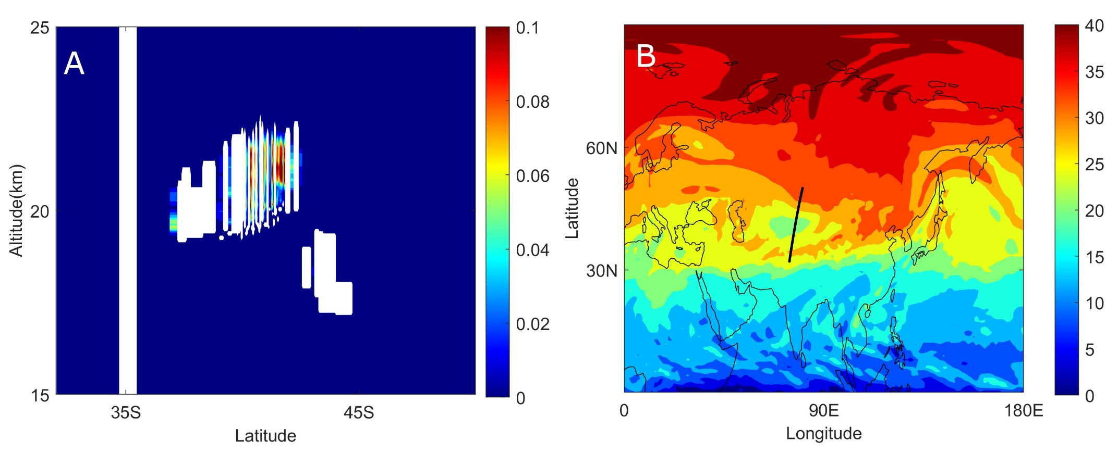

Fig. S1. Position of an SCV during the 2017 Canadian wildfire event. (A) Aerosol extinction coefficient (km⁻¹) curtains at 532 nm from a CALIOP track near 03 September 2017 21:00 UTC. An aerosol bubble with top higher than 22 km altitude could be identified. (B) Ertel PV map (PVU) at 52 hPa (~21 km altitude) from MERRA2 reanalysis of 03 September 2017 21:00 UTC. The black line denotes the CALIOP sampling trajectory of panel (A).
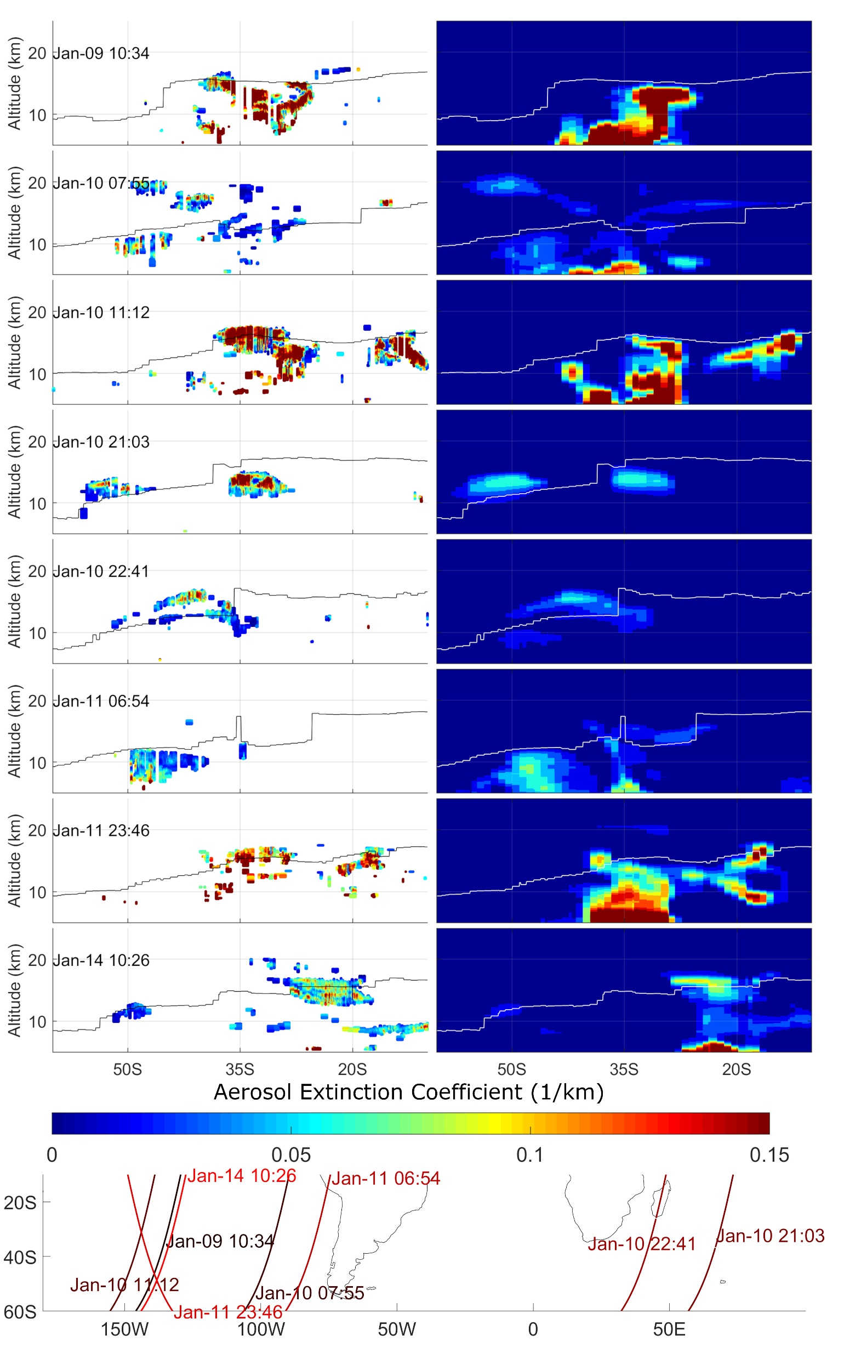

Fig. S2. Comparison of the aerosol extinction coefficient (km⁻¹) between CALIOP observation and Base simulation for plumes outside the SCV. Aerosol extinction coefficient curtains at 532 nm observed by CALIOP were plotted at the left column while corresponding data from the Base simulation at 550 nm are at the right column. Pixels classified as “Clean Air” by CALIOP were plotted as blank like other non-aerosol pixels in the left column. The black (white) lines in the left (right) column are simulated tropopause. Sampling trajectories of the CALIOP were plotted at the bottom panel.
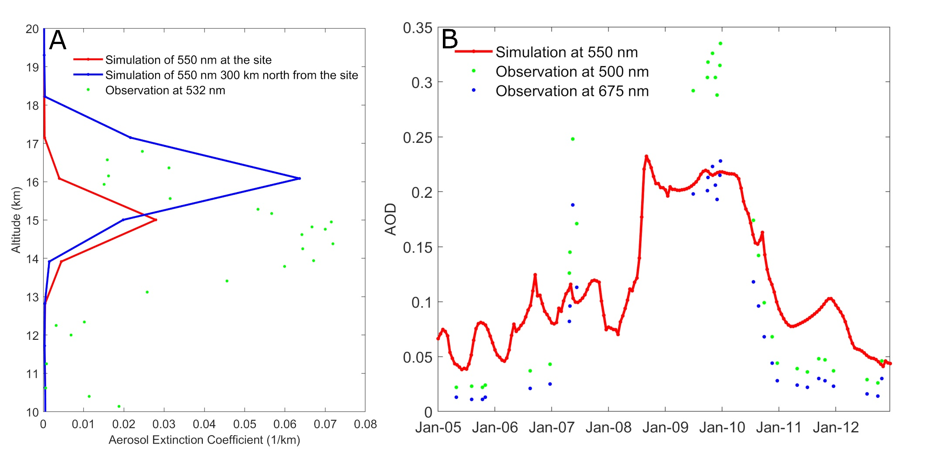

Fig. S3. Comparison of modeled and observed vertical distribution and total aerosol loading. (A) Comparison of aerosol extinction coefficient profile (averaged of 03:56–05:40 UTC in 9 January 2020) between a ground-based lidar observation and simulation. The ground-based lidar is located at Punta Arenas (53.2°S, 70.9°W) and data were imported into our plot by measuring pixels of Fig. 3 in Ohneiser, et al. ⁴¹. (B) Comparison of AOD between observation from an AERONET station and simulation. The AERONET station is at Marambio (64.240°S, 56.625°W) of which data were imported by measuring pixels of Fig. 2 in González, et al. ⁴².
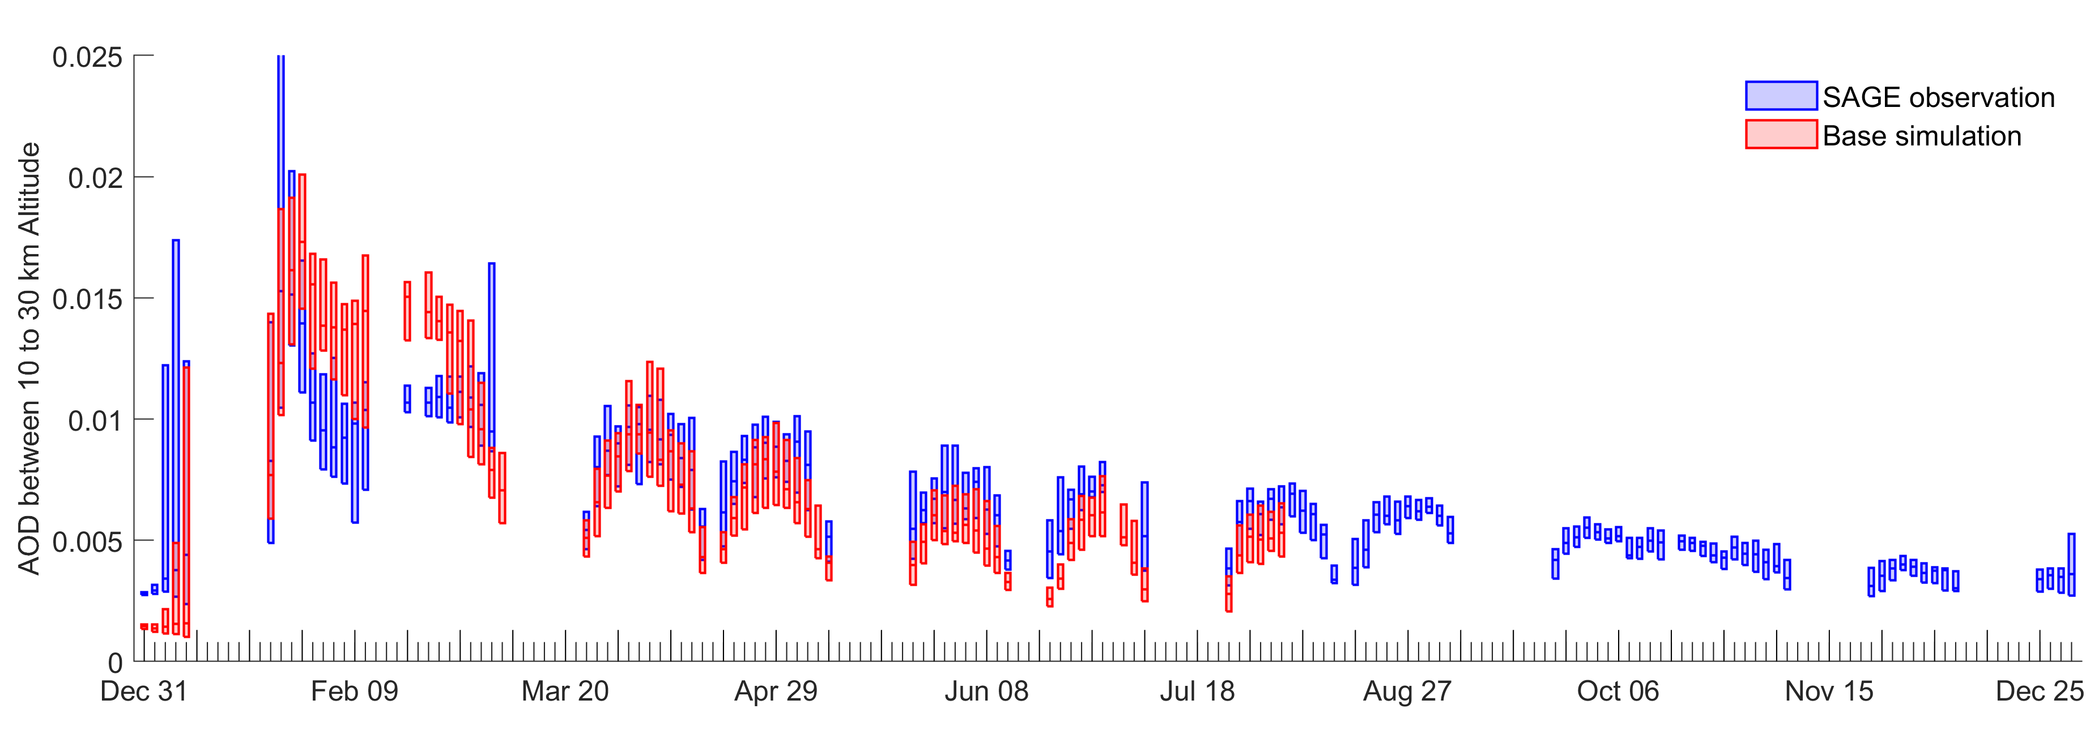

Fig. S4. Comparison of AOD at 1020 nm between SAGE III-ISS satellite observations and model simulations (Base Scenario) in the extratropical Southern hemisphere. Same as Fig. 1A except for an extended period.
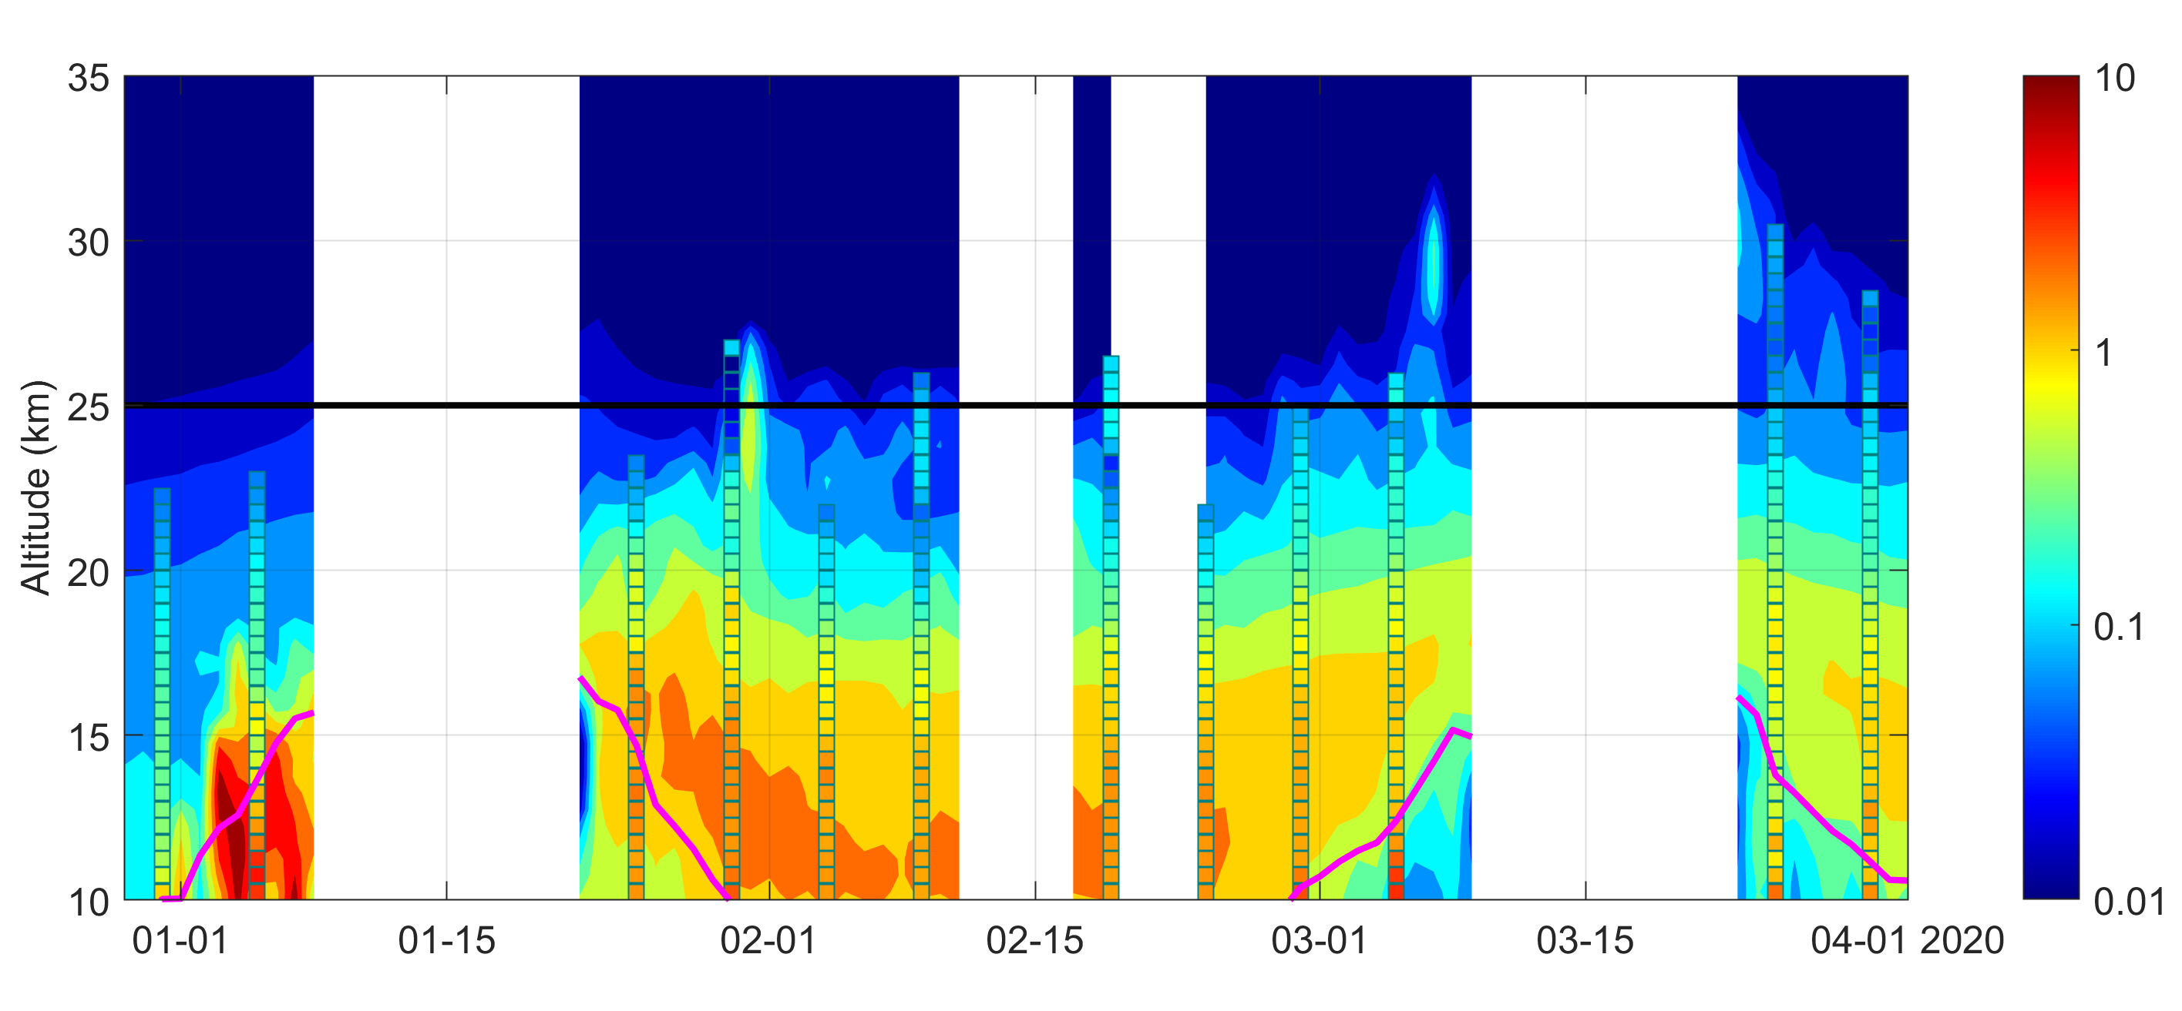

Fig. S5. Comparison of aerosol extinction coefficient at 1020 nm (Mm⁻¹) between SAGE III-ISS satellite observations (colored rectangles) and model simulations (color contour). SAGE observations were averaged every 5-days and data less than 5×10⁻² Mm⁻¹ at high altitude were not plotted. The simulation results were sampled at the same time and position of SAGE observations and daily averaged. Only profiles sampled within ESH were used here.
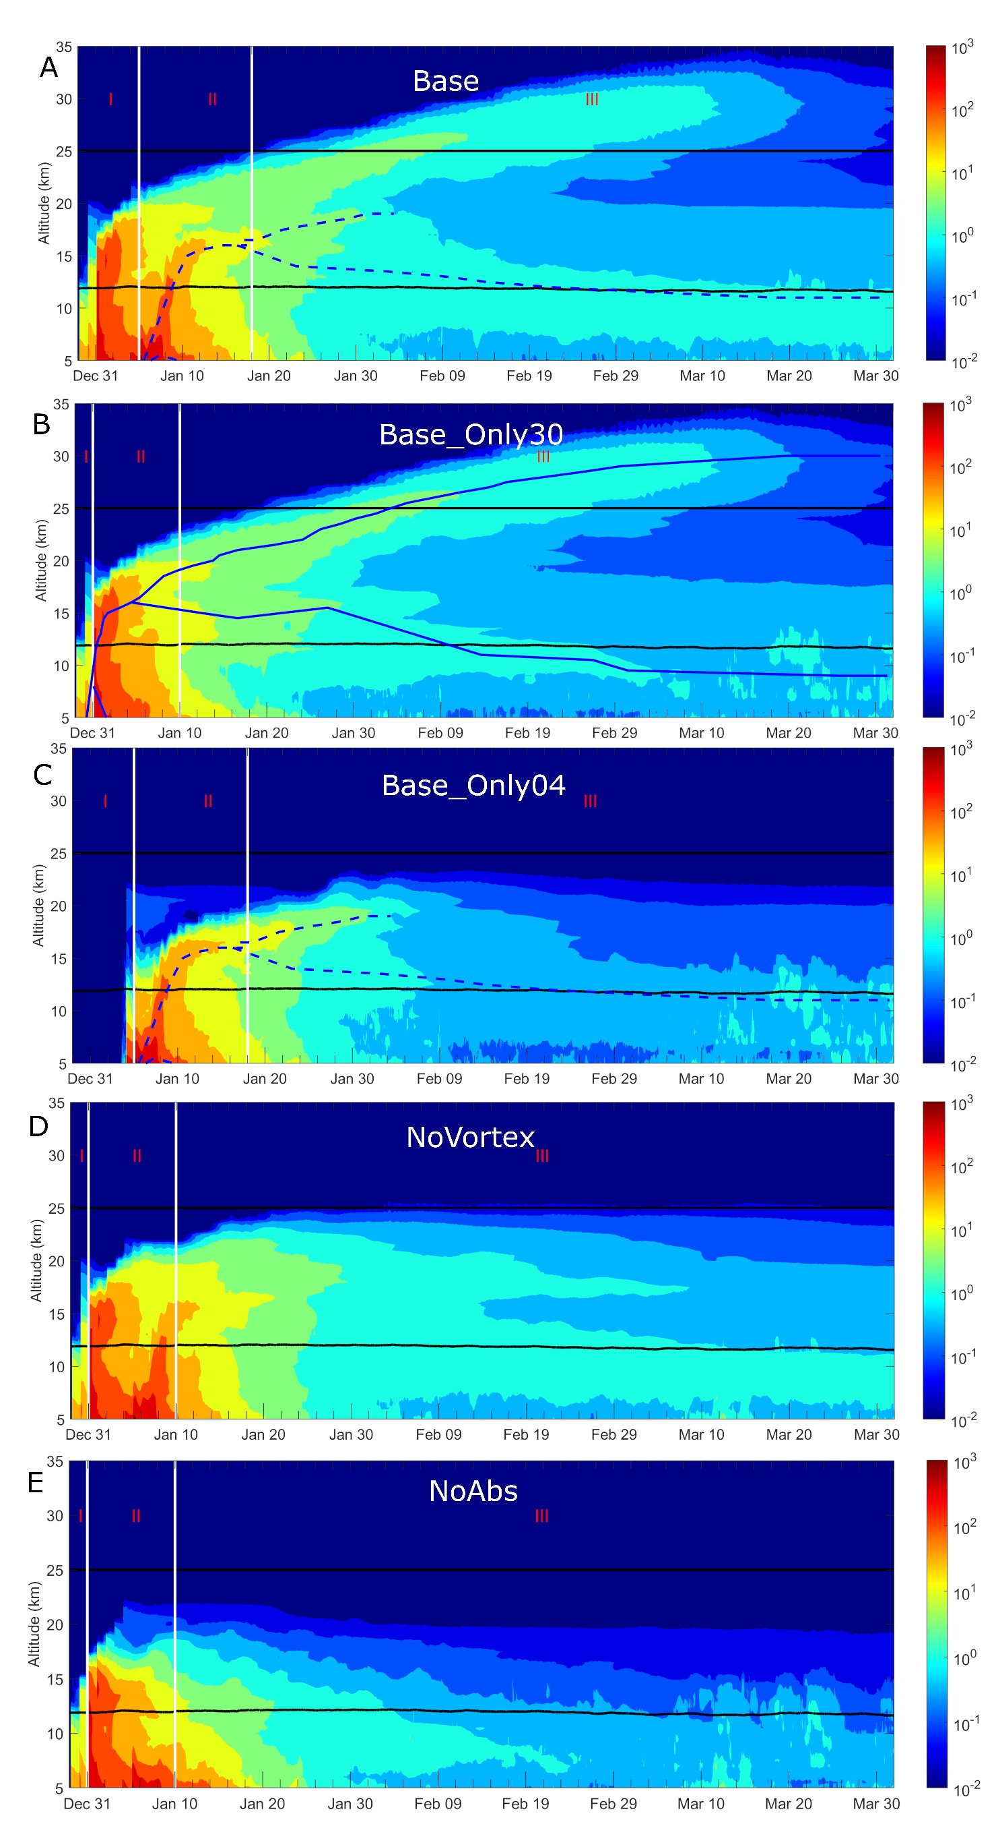

Fig. S6. Maximum PM_{2.5} concentration (μg m⁻³) in ESH, as Fig. 2C but from various simulations. Panel (A)-(E) represents results from Base, Base_Only30, Base_Only04, NoVortex, NoAbs simulations. The dashed blue lines shown in panel (A) and (C) were drawn by connecting local maxima of each vertical profiles from Base_Only04 which shows smoke from pyro-convection on 4 January 2020 and also ascends while forming the SCV P3 and therefore also experienced three stages. The solid blue lines in panel (B) were drawn by connecting local maxima of each vertical profiles from Base_Only30. Stage I and II are separated at the beginning of 31 December 2019 (5 January 2020) for smoke released by pyro-convection on 30 December 2019 (4 January 2020) because the strongest pyro-cumulonimbi were both documented (http://pyrocb.ssec.wisc.edu/archives) and simulated by WRF-Chem on 30 December (4 January 2020). After that, pyro-convection is assumed to contribute little to the rise of BB plume and smoke stopped to rise as shown by (E). (Features of smoke rise near 20 km altitude before 6 January in (E) was artificially generated by data assimilation.) Stage II and III are separated on 10 January (18 January) when SCV P1 (SCV P3) matured (when a compact ellipsoidal aerosol bubble was formed) for smoke released by pyro-convection on 30 December 2019 (4 January

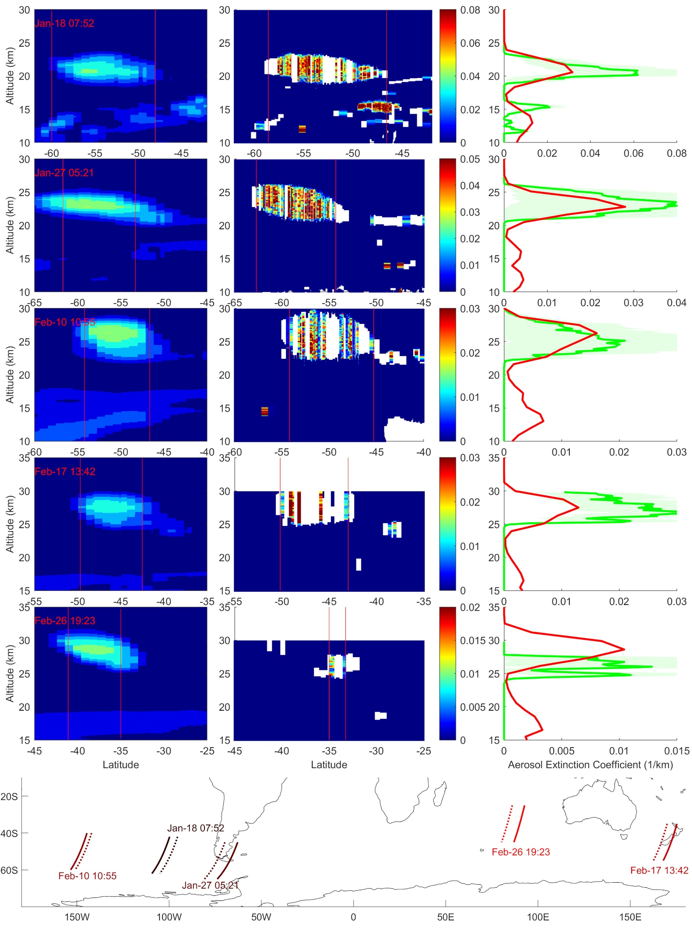

Fig. S7. Comparison of the aerosol extinction coefficient (km⁻¹) inside the SCV between CALIOP observations and Base simulation. The middle column shows the observed aerosol extinction coefficient curtain at 532 nm sampled by CALIOP crossing the SCV while the corresponding Base simulations at 550 nm are in the left column. Simulations were retrieved by displacing the CALIOP track a bit to cross the concentration center of the simulated SCV. Extinction profiles averaged horizontally between the two red vertical lines were plotted in the right column with red as the simulation and green as the observation (green shade represents the maximum uncertainty). Observed pixels classified as “Clean Air” were assumed to have zero aerosol extinction while other non-aerosol pixels were plotted blank and excluded from calculating the average. The bottom panel shows the tracks of the curtains from the observation (solid lines) and simulation (dashed lines).
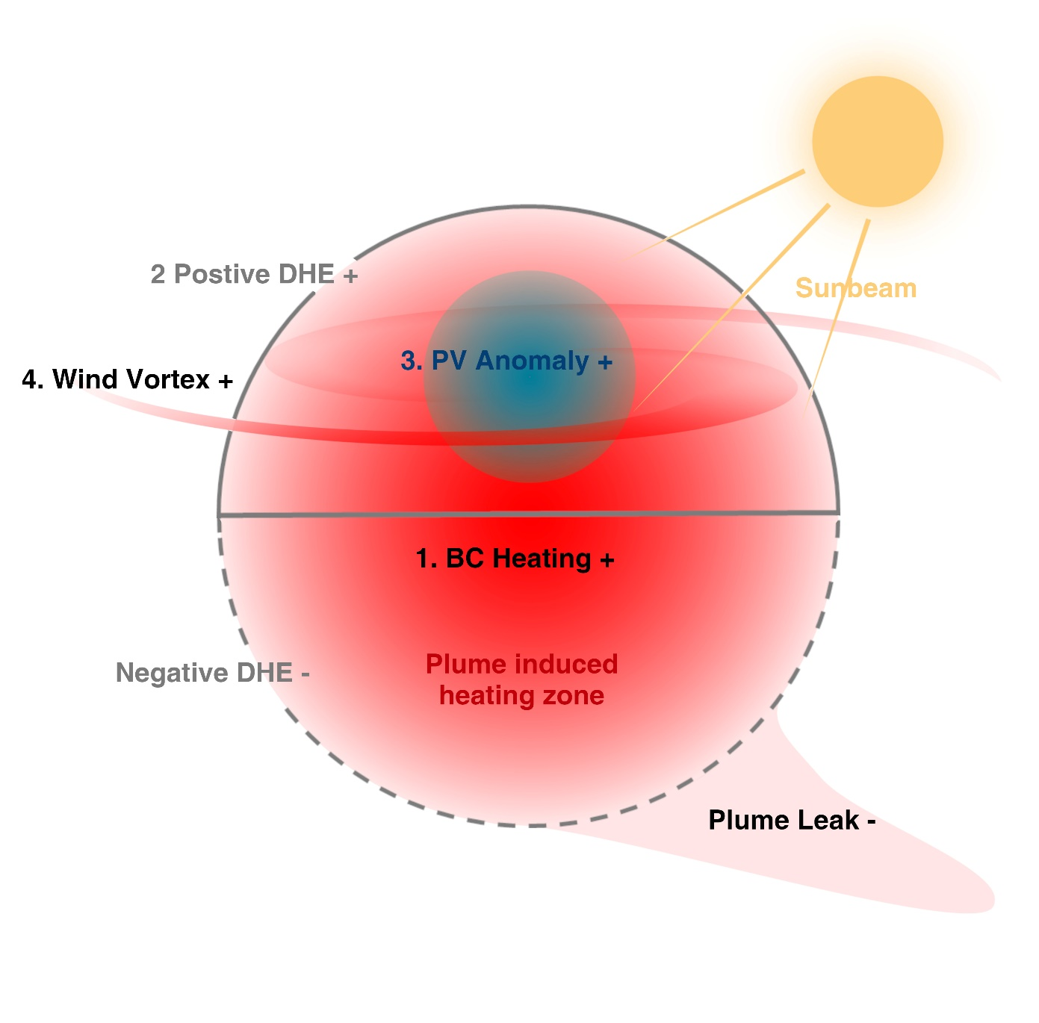

Fig. S8. Schematic illustration explaining the main processes involved during the maturation period of the SCV.
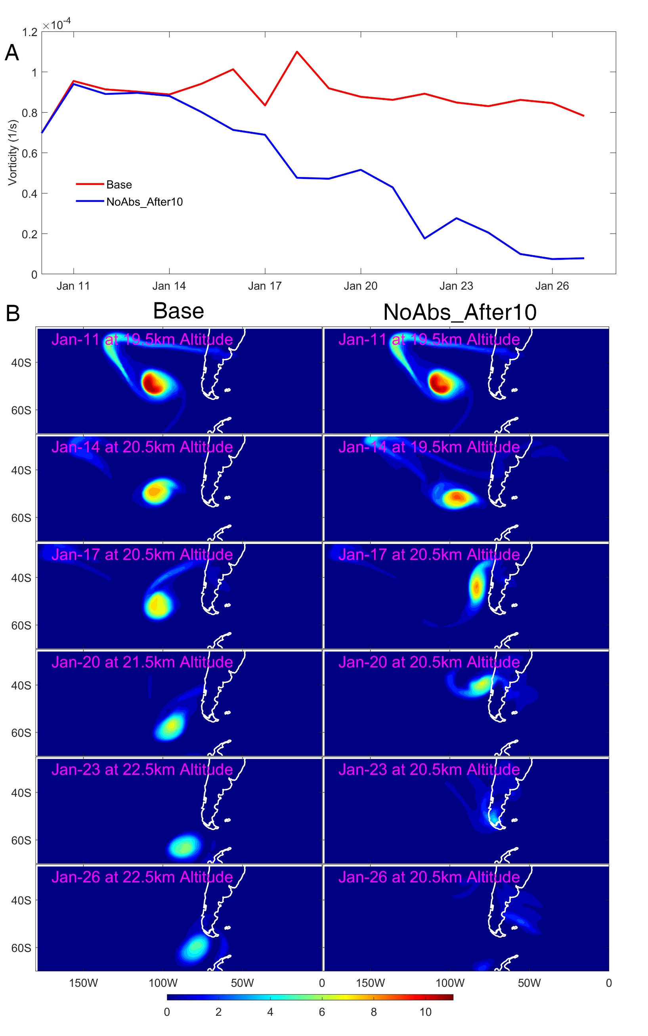

Fig. S9. Comparison of the simulated SCV evolution between Base and NoAbs_After10. (A) Evolution of the maximum relative vorticity within the SCV from the Base simulation and the simulation without BC absorption after 10 January (NoAbs_After10). (B) The horizontal distribution of PM_{2.5} concentrations (μg m⁻³) from Base and NoAbs_After10. Note the change of altitude at different time snapshots for different simulations.
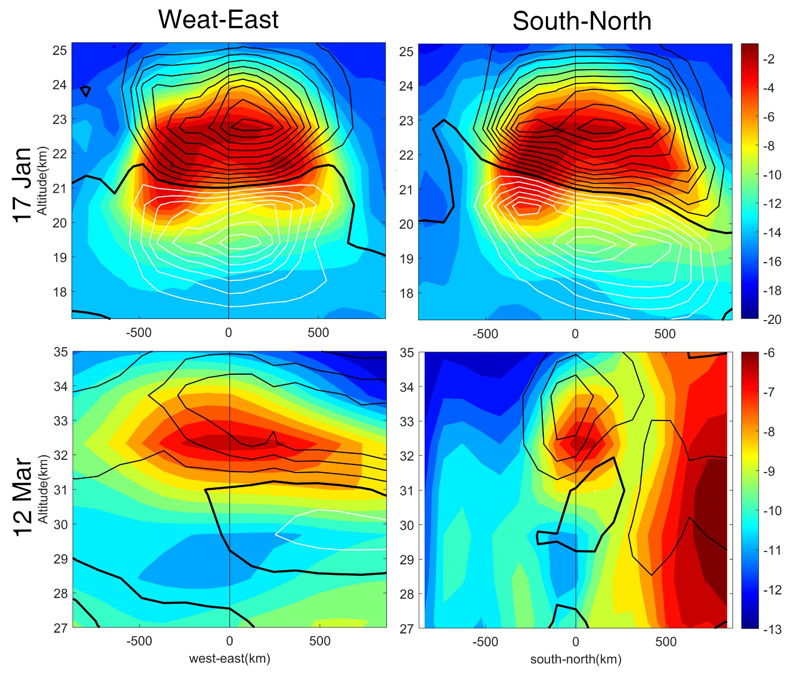

Fig. S10. Vertical cross sections of simulated LPV (color, PVU) and DHE (black contour) fields taken zonally (left) or meridionally (right) cross the center of the SCV. The upper and bottom rows correspond to the maturation and dissipation periods respectively. Contours denote the DHE with interval of 4⁻¹¹s⁻² and black (white) lines as positive (negative). By comparing the top (maturation) and bottom (dissipation) row, the shape of SCV turned into a narrow feature before dissipation.
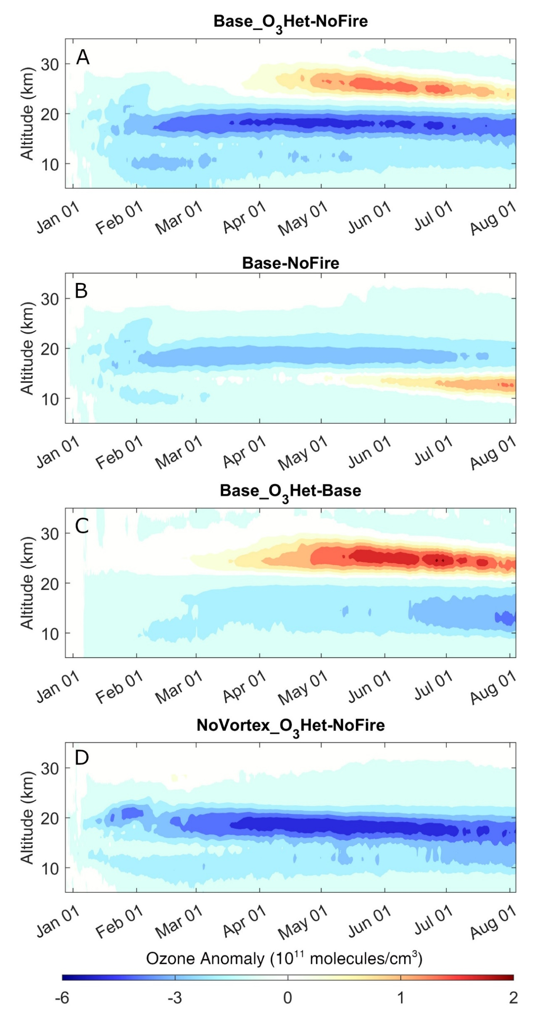

Fig. S11. Simulated temporal and vertical distribution of ozone anomaly caused by BB aerosols. (A) The contribution from both non-chemistry processes and newly introduced heterogeneous reactions. (B) Impact solely from non-chemical processes. (C) The same as Fig. 4D denoting the contribution from heterogeneous reactions only. (D) Impact from both non-chemical processes and newly introduced heterogeneous reactions but without the formation of an SCV. The O₃ anomaly was calculated as O₃ concentration averaged over 45-60°S from simulations with Australian fire events minus the NoFire scenario.
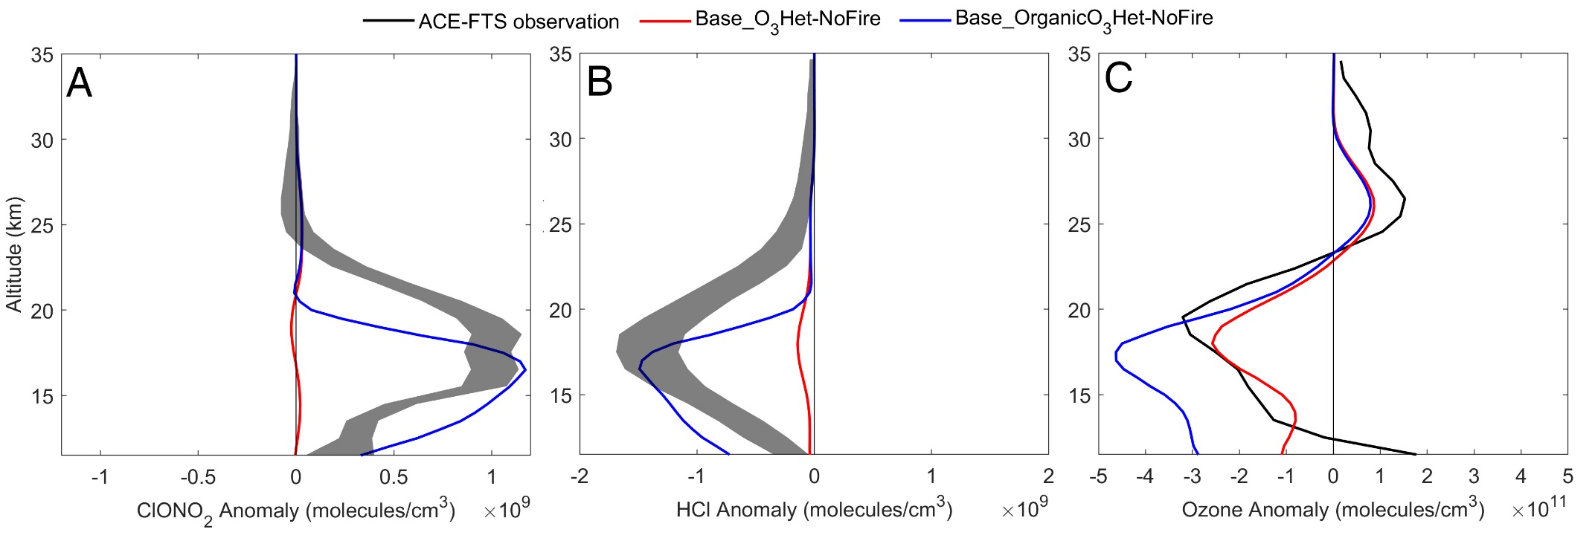

Fig. S12. Impact of the organic heterogeneous reactions proposed by Solomon et al (ref⁵⁶). (A) The anomaly profile of ClONO₂ within 45-60°S. ACE-FTS observations are copied from Fig. 3 of Bernath, et al. ⁵³, OA was treated as sulfate in Base_O₃Het while treated as organics with new parameterization for heterogeneous reactions (“Solubility” in Solomon, et al. ⁵⁶) in Base_OrganicO₃Het. (B) The same as (A) except for HCl. (C) The same as Fig. 4A except with the Base_OrganicO₃Het results.

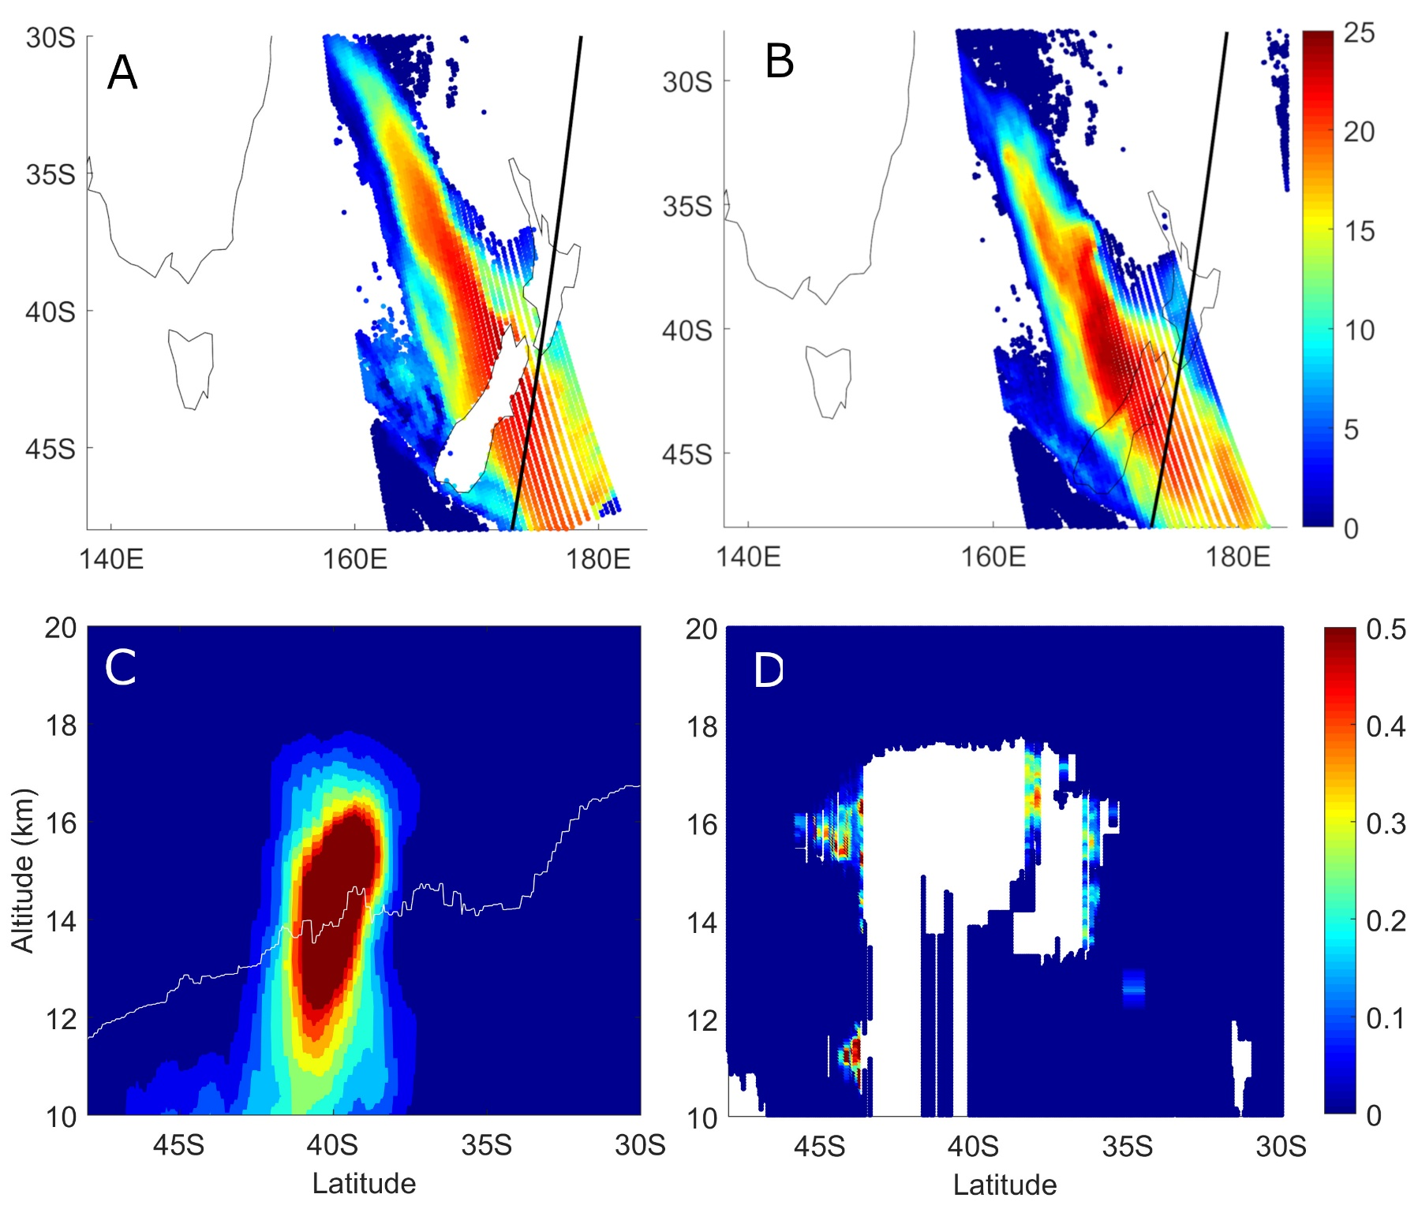

Fig. S13. Comparison of AI and aerosol extinction coefficient between WRF-Chem/DART reanalysis and observations. (A) Reanalysis AI distribution at 02:00 UTC of 1 January 2020 calculated from the aerosol concentration field of the WRF-Chem/DART reanalysis; the thick black line represents the position of the CALIOP track for panel (C) and (D). (B) AI observations near 02:00 UTC of 1 January 2020 from TROPOMI. (C) Reanalysis aerosol extinction coefficient (km⁻¹) at 532 nm of 1 January 2020 14:00 UTC; the white line is the tropopause simulated by WRF-Chem. (D) Observed aerosol extinction coefficient (km⁻¹) curtain at 532 nm from CALIOP near 14:00 UTC of 1 January 2020. Pixels classified as “Clean Air” were assumed to have zero aerosol extinction while other non-aerosol pixels were plotted blank.
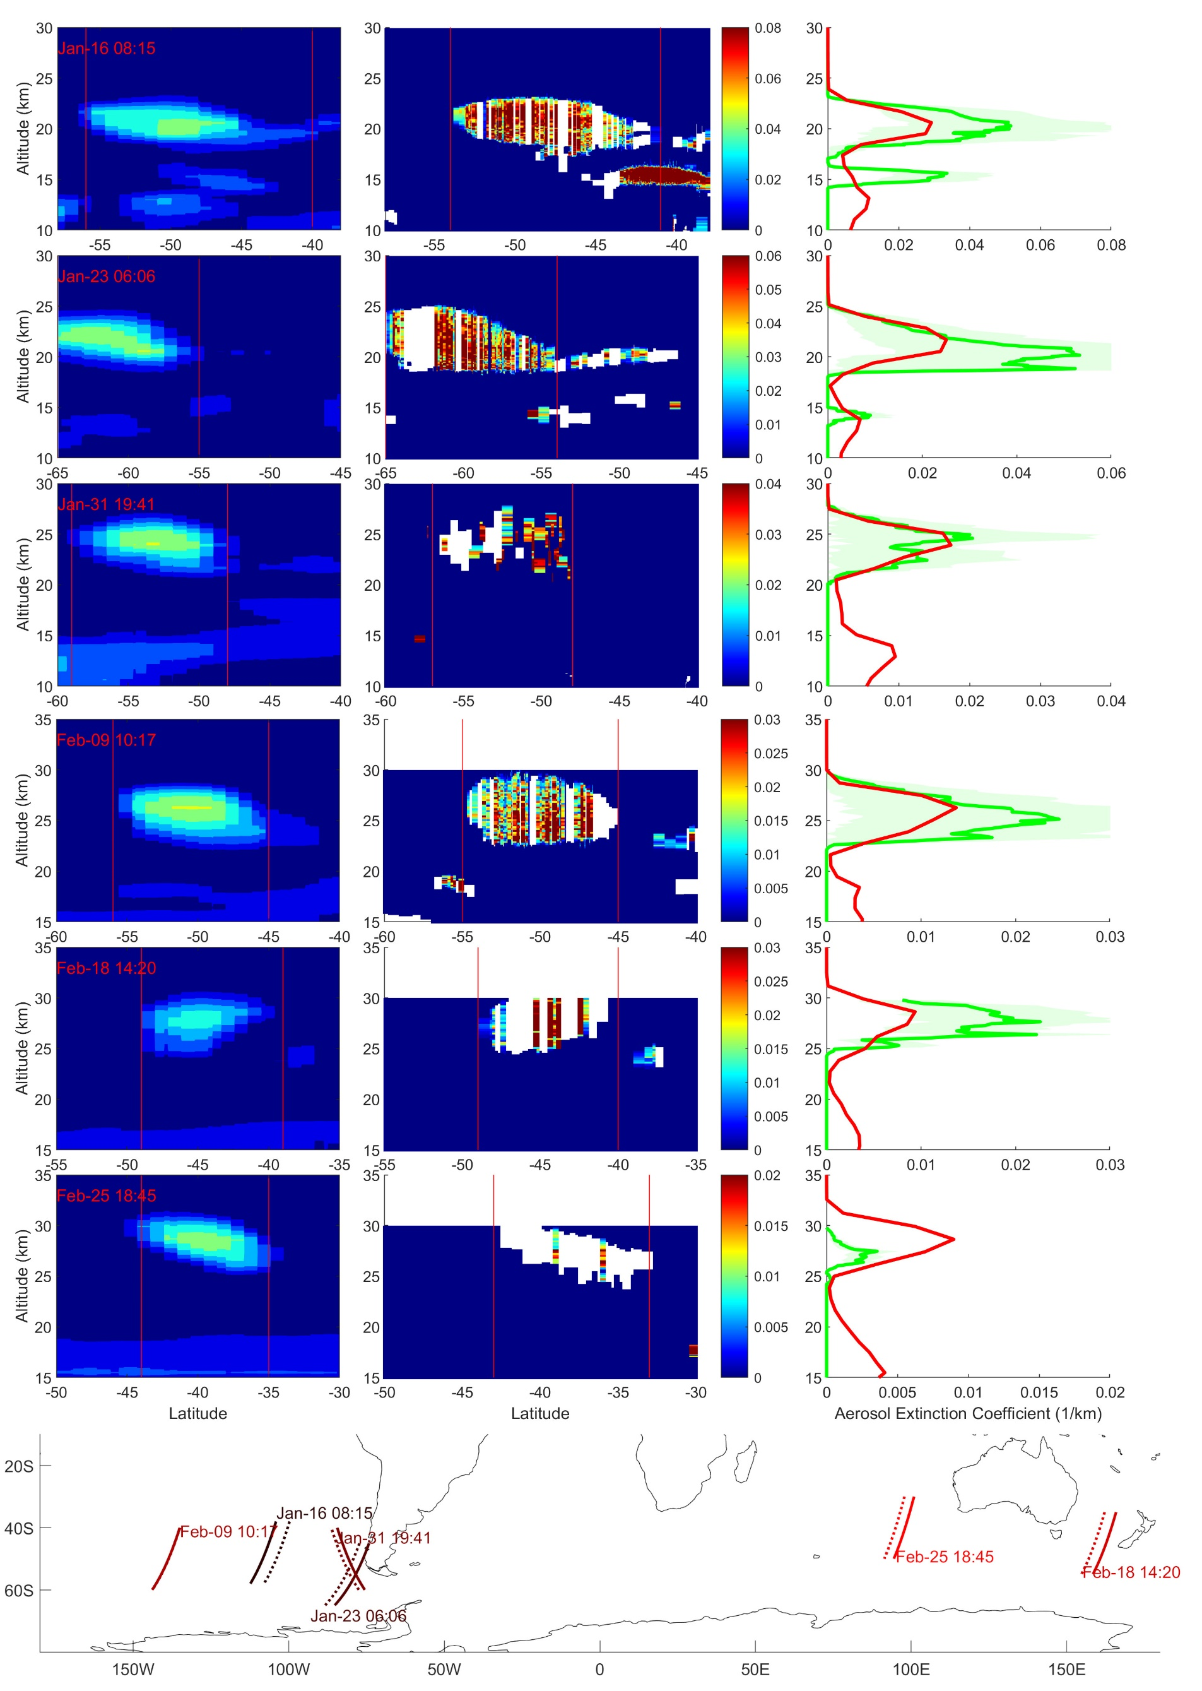

Fig. S14. Comparison of the aerosol extinction coefficient (km⁻¹) inside the SCV between CALIOP observations and Base simulation. The same as Fig. S7 except for different time periods.
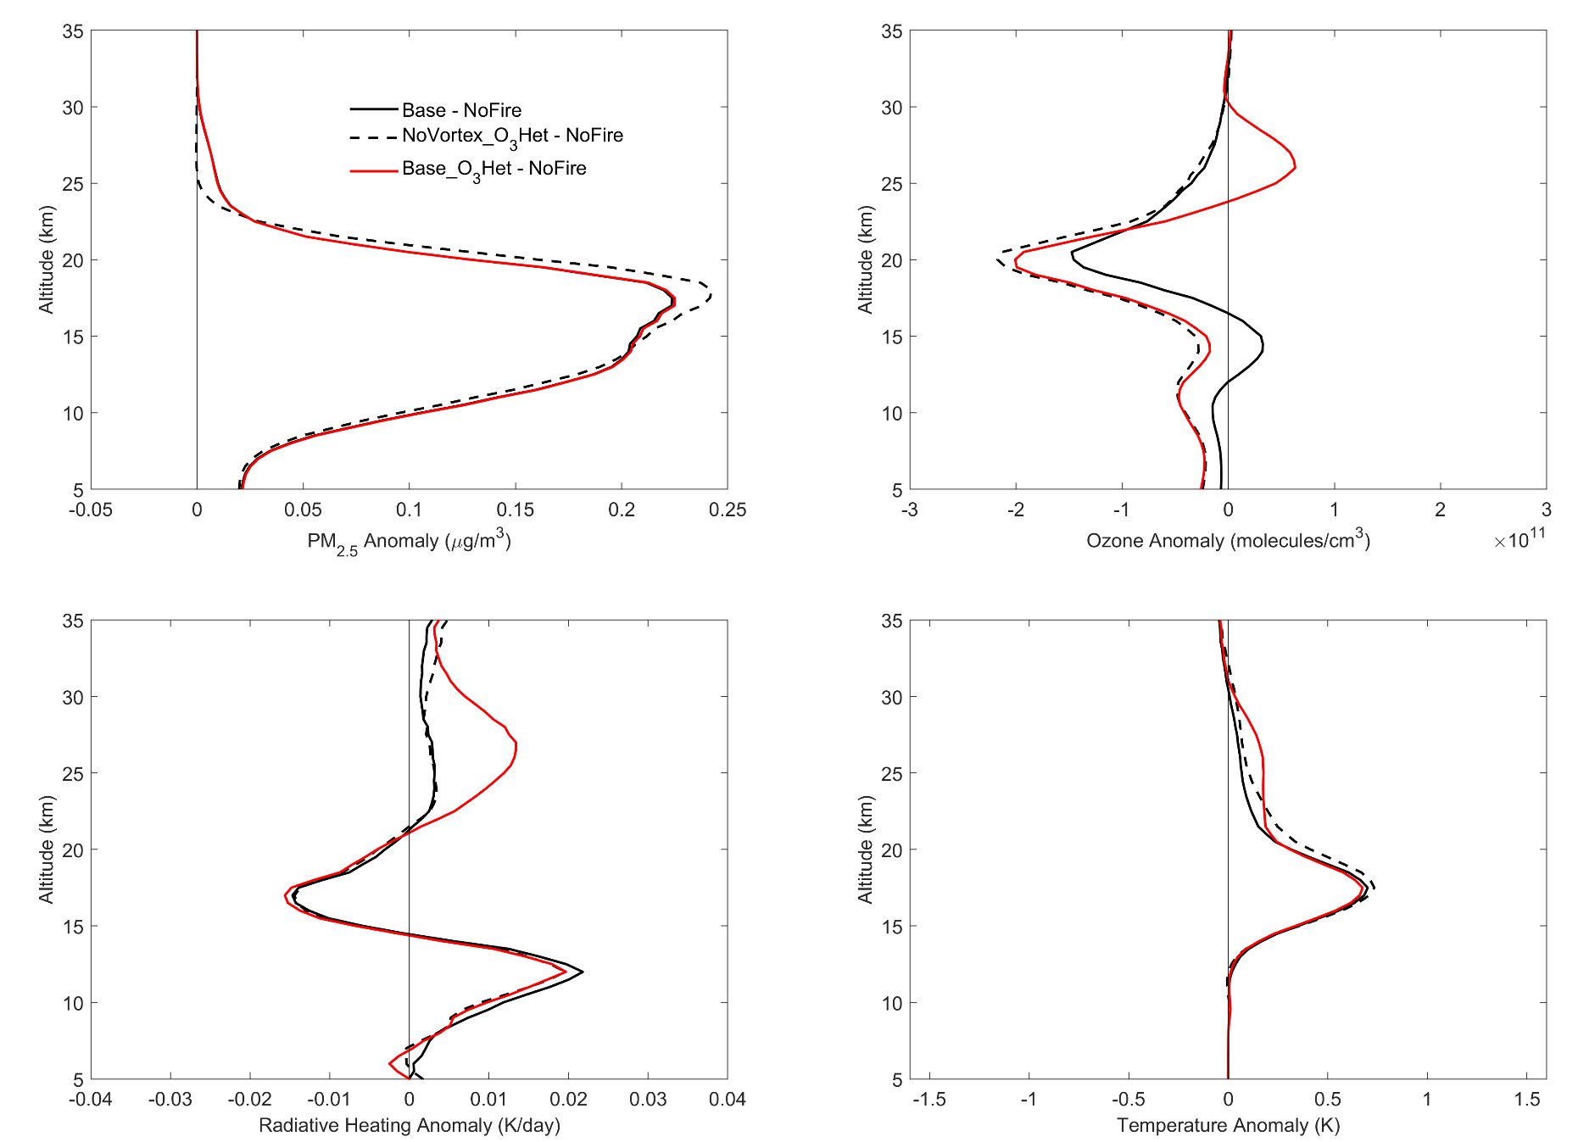

Fig. S15. Impact of SCV and BB on stratospheric ozone and thermal structures. The anomaly of PM_{2.5} (top left), O₃ (top right), radiative heating (bottom left, longwave plus shortwave) and temperature(bottom right) is the averaged difference between a simulation with BB aerosol and NoFire. The average was taken between 20°S and 60°S in May 2020. The latitude range is 20-60°S (instead of 45-60°S in Fig. 4) in order to be comparable to reanalysis temperature anomaly from previous research (Yu, et al. ²⁷, which reported a ~0.5 K temperature anomaly for the same period and latitude range at 17 km altitude).

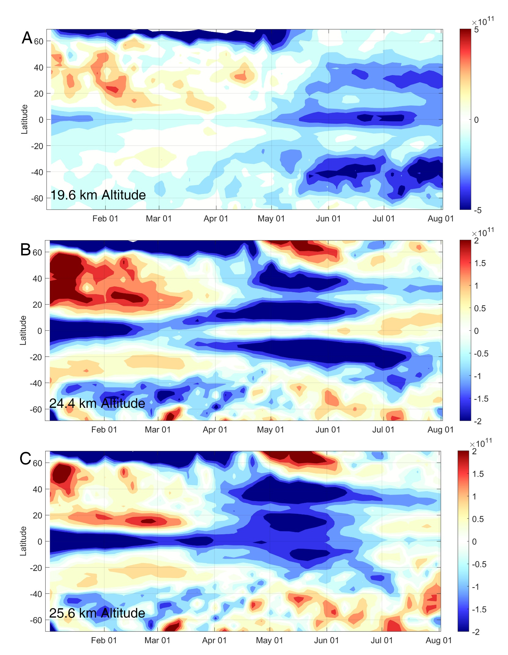

Fig. S16. MLS satellite observations for the deseasonalized ozone anomaly of year 2020 as a function of time and latitude. (A) Horizontal cross section at 19.6 km altitude where is the lower stratosphere. (B) At 24.4 km altitude. (C) At 25.6 km altitude where is the middle stratosphere. Deseasonalized O₃ anomaly (molecules cm⁻³) was calculated by averaging observations in each year by 5-day and 2°-latitude bins and then subtracting the mean of year 2005-2019 from 2020 for each bin. Note the color scale of (A) is different from that of (B) and (C).

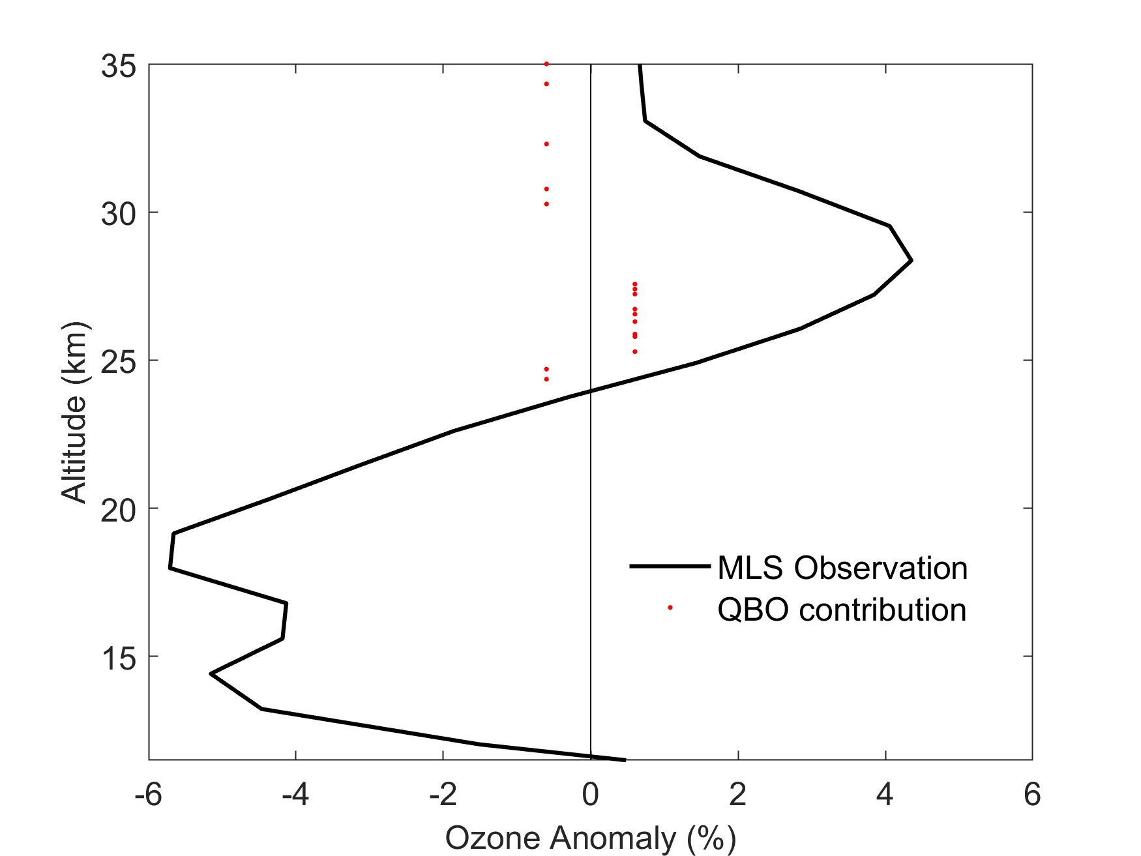

Fig. S17. Observed ozone anomaly and effects of QBO transport in the middle stratosphere. The MLS vertical profile is the percent anomaly of 45-60°S and July average while the QBO contribution is from the Figure 3d of Diallo, et al. ⁶⁴. On average, the contribution of QBO was around 0.1% above 24 km, far less than the total anomaly up to 5%.

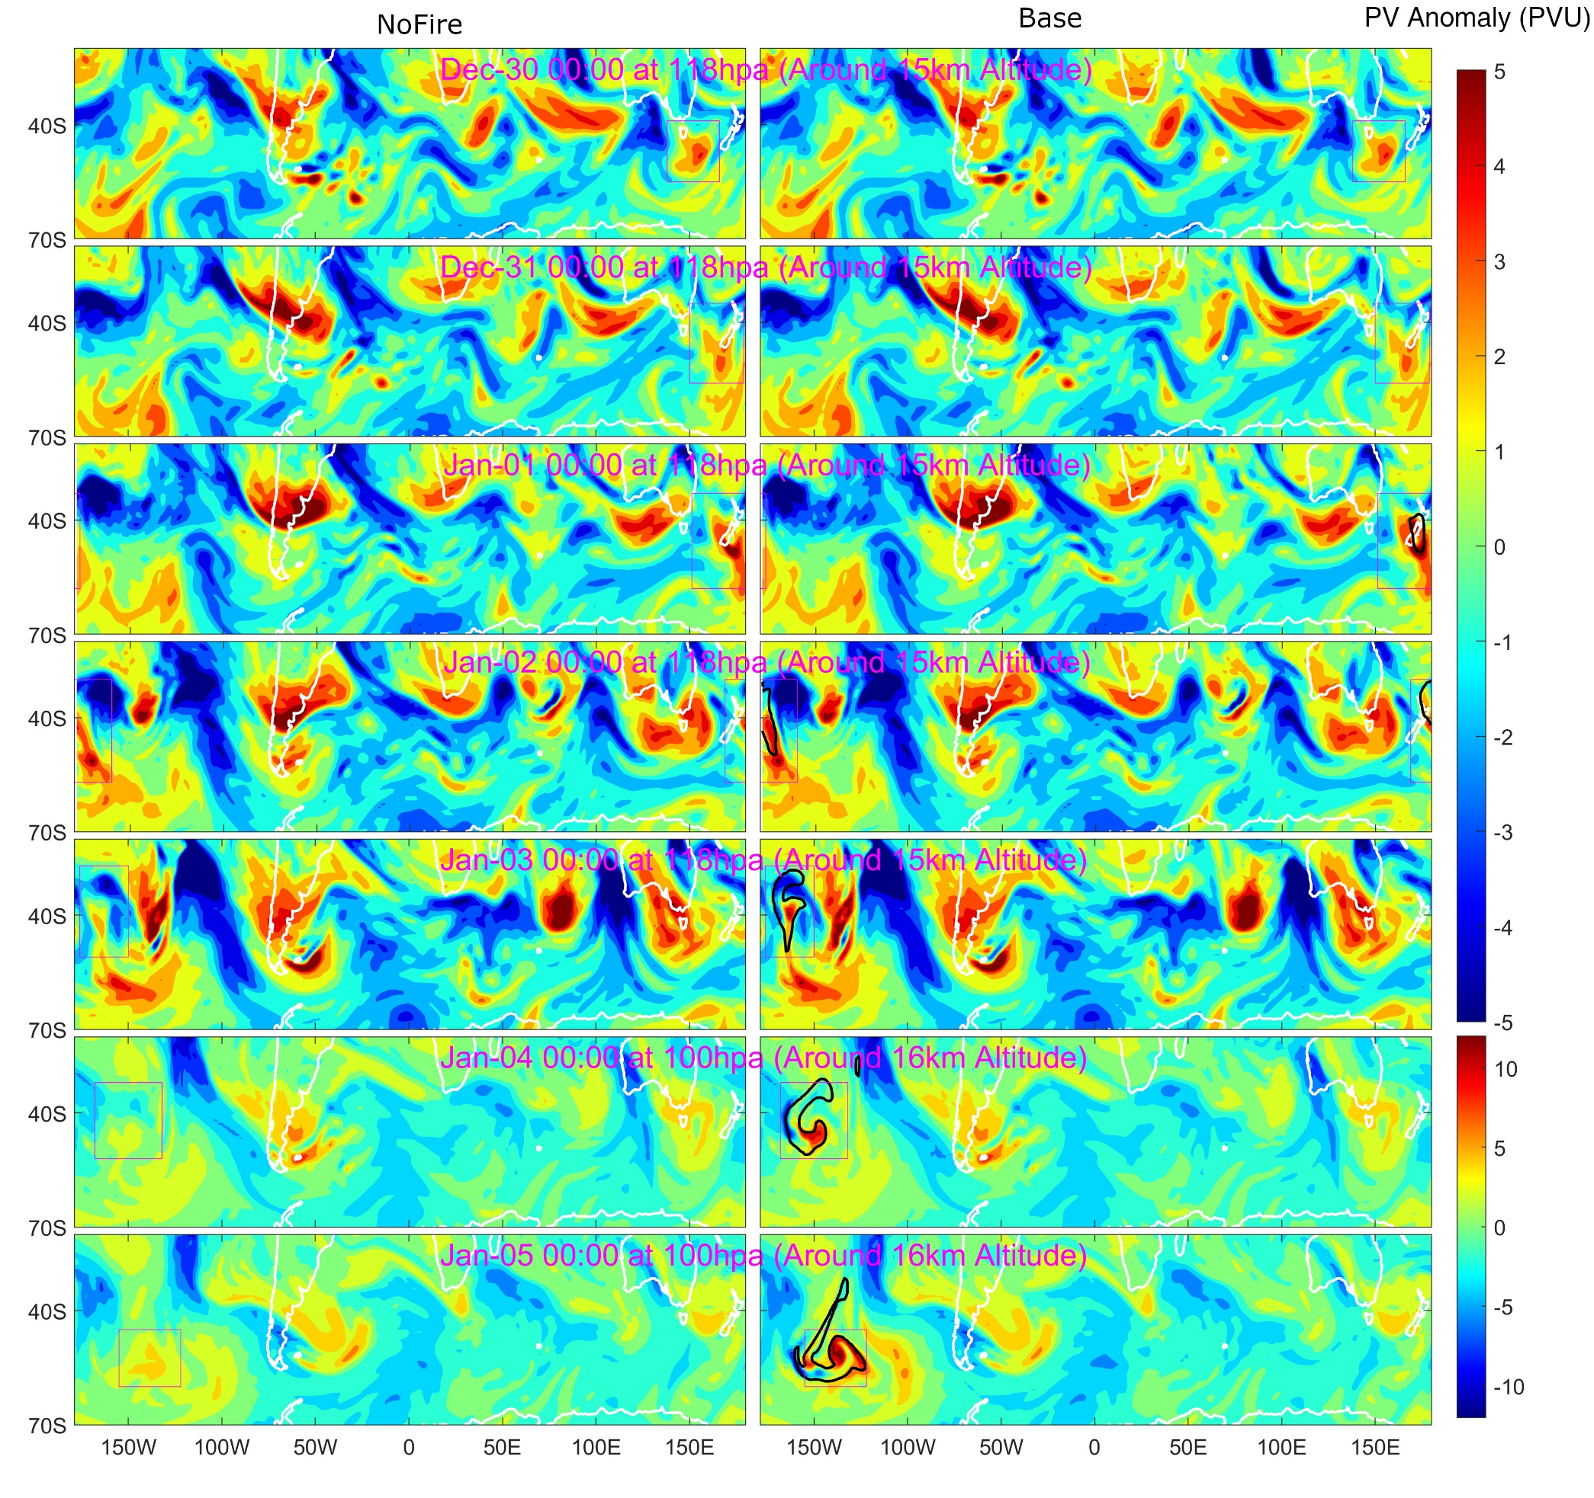

Fig. S18. Temporal evolution of Ertel PV (color, PVU) anomalies and PM_{2.5} concentrations (black contours) of the SCV during formation. Magenta rectangles show the regions of interest. PM_{2.5} concentrations shown in black contours indicate a PM_{2.5} concentration of 10 μg m⁻³. The left column shows the result from NoFire and the right is from Base. The PV anomaly is the difference between the Ertel PV and its zonal average. Note the change of altitude and color scale from 03 January to 04 January.

Table S1.
Summary of the configurations for WRF-Chem/DART.

DART Parameters | Value | WRF-Chem Parameters | Value
Filter type | Ensemble adjustment Kalman filter | Horizontal grid | 15 km, covering southeastern Australia and New Zealand
Covariance inflation | False | Vertical grid | 43 layers, 29 km model top
Localization type | Gaspari–Cohn | Chemistry scheme | MOZCART
Horizontal localization  half-width | 318.6 km | Meteorological fields | Overwritten by perturbed FNL reanalysis every 6 hours
Vertical localization  half-width | 0.075 scale height (approximately 0.65 km at 298 K) | BB emission | GFED4s scaled by 7 and perturbed by 50%. Additional perturbation of BC emission ratio was also introduced.
Ensemble members | 20 | Plume rise | 1-D smoke plume rise model with entrainment intensity perturbed by 60%
Assimilation interval | Every 6h at 02:00, 08:00, 14:00 and 20:00 UTC | BC absorption | Mass of BC was scaled by 1.64 only when calculating optical properties
Observations assimilated | TROPOMI aerosol index, MODIS AOD
Model variables updated | BC and OC

Table S2.
Summary of CAM-Chem experiments.

 | Reanalysis to nudge | Nudge style | ANYSO aerosol from WRF-Chem/DART reanalysis | BC absorption
Base | Original Merra2 | Two loosely-nudge windows following the simulated and observed SCVs (2nd paragraph of Sect. S1.5b) | From 29 December 2019 to 6 January 2020 | Considered
NoVortex | Merra2 modified to diminish SCVs | Strictly-nudge windows following the simulated SCVs (3rd paragraph of Sect. S1.5b) | The same to Base | Considered
NoFire | The same to Base | The same to Base | No ANYSO aerosol | Considered
Base_Only30 | The same to Base | The same to Base | From 29 December 2019 to 3 January 2020 | Considered
Base_Only04 | The same to Base | The same to Base | From 4 January 2020 to 6 January 2020 | Considered
NoAbs | The same to Base | The same to Base | The same to Base | Not considered
NoAbs_After10 | The same to Base | The same to Base | The same to Base | Not considered after 10 January 2020

Table S3.
Summary of candidate vortices in the stratosphere after the year 2009. The cases were identified by searching for isolated vortex-like Ertel PV anomalies in the extratropical stratosphere in the MERRA2 reanalysis data.
Duration | Position example | ERA5 Ozone Anomaly? | CALIOP Aerosol Anomaly? | Reference
2009/02/11 to 2009/03/05 | (98°E, 20°S, 52 hPa) 2009/02/25 | Yes | Yes | Trepte, et al. ⁹⁰
2015/07/09 to 2015/07/16 | (18°E, 76°N, 200 hPa) 2015/07/11 | Yes | Yes
2015/09/04 to 2015/09/10 | (5°E, 64°N, 100 hPa) 2015/09/07 | Yes | No
2016/05/14 to 2016/05/26 | (112°E, 76°N, 85 hPa) 2016/05/17 | Yes | No
2016/09/01 to 2016/09/12 | (122°W, 77°N, 100 hPa) 2016-09-05 | Yes | No
2016/10/03 to 2016/10/07 | (134°W, 77°N, 72 hPa) 2016/10/03 | Yes | No
2017/08/16 to 2017/10/18 | (28°E, 61°N, 72 hPa) 2017/09/03 | Yes | Yes | Lestrelin, et al. ²*
2017/09/21 to 2017/10/01 | (168°E, 57°N, 118 hPa) 2017/09/24 | Yes | No
2018/05/24 to 2018/05/28 | (48°E, 51°N, 100 hPa) 2018/05/27 | Yes | No
2018/07/20 to 2018/08/13 | (102°E, 40°S, 43 hPa) 2018/07/29 | Yes | No
2019/03/10 to 2019/03/19 | (27°W, 42°N, 61 hPa) 2019/03/14 | Yes | No
2019/03/05 to 2019/03/26 | (37°E, 39°N, 61 hPa) 2019/03/14 | Yes | No
2020/01/04 to 2020/03/08 | (78°W, 53°S, 31 hPa) 2020/01/31 | Yes | Yes | Kablick III, et al. 1 and Khaykin, et al. ³
2020/01/08 to 2020/03/03 | (70°W, 72°S, 36 hPa) 2020/02/02 | Yes | Yes | Kablick III, et al. 1 and Khaykin, et al. ³
2020/01/17 to 2020/02/02 | (35°E, 47°S, 85 hPa) 2020/01/23 | Yes | Yes | Kablick III, et al. 1 and Khaykin, et al. ³
* This case consisted of multiple SCVs which however all originated from one SCV (“Vortex O” as named by Lestrelin, et al. ²).

References:

1 Kablick III, G. P., Allen, D. R., Fromm, M. D. & Nedoluha, G. E. Australian PyroCb Smoke Generates Synoptic-Scale Stratospheric Anticyclones. Geophys. Res. Lett. 47, e2020GL088101, doi:https://doi.org/10.1029/2020GL088101 (2020).
2 Lestrelin, H., Legras, B., Podglajen, A. & Salihoglu, M. Smoke-charged vortices in the stratosphere generated by wildfires and their behaviour in both hemispheres: comparing Australia 2020 to Canada 2017. Atmos. Chem. Phys. 21, 7113-7134, doi:10.5194/acp-21-7113-2021 (2021).
3 Khaykin, S. et al. The 2019/20 Australian wildfires generated a persistent smoke-charged vortex rising up to 35 km altitude. Communications Earth & Environment 1, 22, doi:10.1038/s43247-020-00022-5 (2020).
4 Hersbach, H. et al. The ERA5 global reanalysis. Quarterly Journal of the Royal Meteorological Society 146, 1999-2049 (2020).
5 Van Der Werf, G. R. et al. Global fire emissions estimates during 1997-2016. Earth System Science Data 9, 697-720 (2017).
6 Freitas, S. R. et al. Including the sub-grid scale plume rise of vegetation fires in low resolution atmospheric transport models. Atmos. Chem. Phys. 7, 3385-3398 (2007).
7 Freitas, S., Longo, K., Trentmann, J. & Latham, D. Sensitivity of 1-D smoke plume rise models to the inclusion of environmental wind drag. Atmospheric Chemistry & Physics 10 (2010).
8 Pan, X. H. et al. Six global biomass burning emission datasets: intercomparison and application in one global aerosol model. Atmos. Chem. Phys. 20, 969-994, doi:10.5194/acp-20-969-2020 (2020).
9 van der Velde, I. R. et al. Vast CO2 release from Australian fires in 2019–2020 constrained by satellite. Nature 597, 366-369 (2021).
10 Bond, T. C. et al. Bounding the role of black carbon in the climate system: A scientific assessment. J. Geophys. Res. 118, 5380-5552 (2013).
11 Ma, C. et al. Importance of Bias Correction in Data Assimilation of Multiple Observations Over Eastern China Using WRF-Chem/DART. J. Geophys. Res. 125, doi:10.1029/2019jd031465 (2020).
12 Liu, X. et al. Description and evaluation of a new four-mode version of the Modal Aerosol Module (MAM4) within version 5.3 of the Community Atmosphere Model. Geoscientific Model Development (Online) 9 (2016).
13 Akagi, S. et al. Emission factors for open and domestic biomass burning for use in atmospheric models. Atmos. Chem. Phys. 11, 4039-4072 (2011).
14 Paugam, R., Wooster, M., Freitas, S. & Val Martin, M. A review of approaches to estimate wildfire plume injection height within large-scale atmospheric chemical transport models. Atmos. Chem. Phys. 16, 907-925 (2016).
15 Redfern, S. et al. Upper Troposphere Smoke Injection From Large Areal Fires. J. Geophys. Res. 126, e2020JD034332 (2021).
16 Luderer, G. et al. Small-scale mixing processes enhancing troposphere-to-stratosphere transport by pyro-cumulonimbus storms. Atmos. Chem. Phys. 7, 5945-5957 (2007).
17 Trentmann, J. et al. Modeling of biomass smoke injection into the lower stratosphere by a large forest fire (Part I): reference simulation. Atmos. Chem. Phys. 6, 5247-5260 (2006).
18 Kramarova, N. A. et al. Validation of ozone profile retrievals derived from the OMPS LP version 2.5 algorithm against correlative satellite measurements. Atmos. Meas. Tech. 11, 2837-2861 (2018).
19 Tang, W. et al. Widespread phytoplankton blooms triggered by 2019–2020 Australian wildfires. Nature 597, 370-375, doi:10.1038/s41586-021-03805-8 (2021).
20 Wang, J. et al. Spaceborne detection of XCO2 enhancement induced by Australian mega-bushfires. Environ. Res. Lett. 15, doi:10.1088/1748-9326/abc846 (2020).
21 Liu, D. et al. Wildfires enhance phytoplankton production in tropical oceans. Nat. Commun. 13, 1348, doi:10.1038/s41467-022-29013-0 (2022).
22 Li, M., Shen, F. & Sun, X. 2019‒2020 Australian bushfire air particulate pollution and impact on the South Pacific Ocean. Scientific Reports 11, 1-13 (2021).
23 Shiraishi, T. & Hirata, R. Estimation of carbon dioxide emissions from the megafires of Australia in 2019–2020. Scientific reports 11, 1-10 (2021).
24 Pope, R. J. et al. Large enhancements in southern hemisphere satellite‐observed trace gases due to the 2019/2020 Australian wildfires. J. Geophys. Res. 126, e2021JD034892 (2021).
25 Solomon, S. et al. On the stratospheric chemistry of midlatitude wildfire smoke. Proc. Natl. Acad. Sci. U.S.A. 119, e2117325119, doi:doi:10.1073/pnas.2117325119 (2022).
26 Strahan, S. E. et al. Unexpected Repartitioning of Stratospheric Inorganic Chlorine After the 2020 Australian Wildfires. Geophys. Res. Lett. 49, e2022GL098290, doi:https://doi.org/10.1029/2022GL098290 (2022).
27 Yu, P. et al. Persistent Stratospheric Warming Due to 2019–2020 Australian Wildfire Smoke. Geophys. Res. Lett. 48, e2021GL092609, doi:https://doi.org/10.1029/2021GL092609 (2021).
28 Forrister, H. et al. Evolution of brown carbon in wildfire plumes. Geophys. Res. Lett. 42, 4623-4630, doi:10.1002/2015gl063897 (2015).
29 Mok, J. et al. Impacts of brown carbon from biomass burning on surface UV and ozone photochemistry in the Amazon Basin. Scientific reports 6, 1-9 (2016).
30 Jansen, K., Browne, E. & Tolbert, M. in AGU Fall Meeting Abstracts. A55O-1609.
31 Hoesly, R. M. et al. Historical (1750–2014) anthropogenic emissions of reactive gases and aerosols from the Community Emissions Data System (CEDS). Geosci. Model Dev. 11, 369-408, doi:10.5194/gmd-11-369-2018 (2018).
32 Hurrell, J. W., Hack, J. J., Shea, D., Caron, J. M. & Rosinski, J. A new sea surface temperature and sea ice boundary dataset for the Community Atmosphere Model. Journal of Climate 21, 5145-5153 (2008).
33 Das, S., Colarco, P. R., Oman, L. D., Taha, G. & Torres, O. The long-term transport and radiative impacts of the 2017 British Columbia pyrocumulonimbus smoke aerosols in the stratosphere. Atmos. Chem. Phys. 21, 12069-12090, doi:10.5194/acp-21-12069-2021 (2021).
34 Peterson, D. A. et al. Australia’s Black Summer pyrocumulonimbus super outbreak reveals potential for increasingly extreme stratospheric smoke events. npj Climate and Atmospheric Science 4, 1-16 (2021).
35 Schwartz, M. J. et al. Australian new year's pyrocb impact on stratospheric composition. Geophys. Res. Lett. 47, e2020GL090831 (2020).
36 Yu, P. et al. Black carbon lofts wildfire smoke high into the stratosphere to form a persistent plume. Science 365, 587-590 (2019).
37 Doglioni, G., Aquila, V., Das, S., Colarco, P. R. & Zardi, D. Dynamical Perturbation of the Stratosphere by a Pyrocumulonimbus Injection of Carbonaceous Aerosols. EGUsphere, 1-24 (2022).
38 Molod, A., Takacs, L., Suarez, M. & Bacmeister, J. Development of the GEOS-5 atmospheric general circulation model: Evolution from MERRA to MERRA2. Geosci. Model. Dev. 8, 1339-1356 (2015).
39 Ohneiser, K. et al. Self-lofting of wildfire smoke in the troposphere and stratosphere caused by radiative heating: simulations vs space lidar observations. Atmos. Chem. Phys. Discuss. 2022, 1-41, doi:10.5194/acp-2022-343 (2022).
40 D’Angelo, G., Guimond, S., Reisner, J., Peterson, D. A. & Dubey, M. Contrasting stratospheric smoke mass and lifetime from 2017 Canadian and 2019/2020 Australian megafires: Global simulations and satellite observations. J. Geophys. Res. 127, e2021JD036249 (2022).
41 Ohneiser, K. et al. Smoke of extreme Australian bushfires observed in the stratosphere over Punta Arenas, Chile, in January 2020: optical thickness, lidar ratios, and depolarization ratios at 355 and 532 nm. Atmos. Chem. Phys. 20, 8003-8015 (2020).
42 González, R. et al. Characterization of Stratospheric Smoke Particles over the Antarctica by Remote Sensing Instruments. Remote Sensing 12, 3769 (2020).
43 Hirsch, E. & Koren, I. Record-breaking aerosol levels explained by smoke injection into the stratosphere. Science 371, 1269-1274, doi:10.1126/science.abe1415 (2021).
44 Holton, J. R. & Hakim, G. J. An Introduction to Dynamic Meteorology. (Academic Press, 2012).
45 Haarig, M. et al. Depolarization and lidar ratios at 355, 532, and 1064 nm and microphysical properties of aged tropospheric and stratospheric Canadian wildfire smoke. Atmos. Chem. Phys. 18, 11847-11861 (2018).
46 Hu, Q. et al. Long-range-transported Canadian smoke plumes in the lower stratosphere over northern France. Atmos. Chem. Phys. 19, 1173-1193, doi:10.5194/acp-19-1173-2019 (2019).
47 Ohneiser, K. et al. Australian wildfire smoke in the stratosphere: the decay phase in 2020/2021 and impact on ozone depletion. Atmos. Chem. Phys. 22, 7417-7442, doi:10.5194/acp-22-7417-2022 (2022).
48 Ansmann, A. et al. Tropospheric and stratospheric wildfire smoke profiling with lidar: mass, surface area, CCN, and INP retrieval. Atmos. Chem. Phys. 21, 9779-9807 (2021).
49 Ditas, J. et al. Strong impact of wildfires on the abundance and aging of black carbon in the lowermost stratosphere. Proc. Natl. Acad. Sci. U.S.A. 115, E11595-E11603 (2018).
50 Tolbert, M. A., Rossi, M. J. & Golden, D. M. Antarctic ozone depletion chemistry: Reactions of N2O5 with H2O and HCl on ice surfaces. Science 240, 1018-1021 (1988).
51 Tolbert, M. A., Rossi, M. J., Malhotra, R. & Golden, D. M. Reaction of chlorine nitrate with hydrogen chloride and water at Antarctic stratospheric temperatures. Science 238, 1258-1260 (1987).
52 Robock, A. Volcanic eruptions and climate. Reviews of geophysics 38, 191-219 (2000).
53 Bernath, P., Boone, C. & Crouse, J. Wildfire smoke destroys stratospheric ozone. Science 375, 1292-1295, doi:doi:10.1126/science.abm5611 (2022).
54 Rieger, L., Randel, W., Bourassa, A. & Solomon, S. Stratospheric temperature and ozone anomalies associated with the 2020 Australian new year fires. Geophys. Res. Lett. 48, e2021GL095898 (2021).
55 Santee, M. et al. Prolonged and Pervasive Perturbations in the Composition of the Southern Hemisphere Midlatitude Lower Stratosphere From the Australian New Year's Fires. Geophys. Res. Lett. 49, e2021GL096270 (2022).
56 Solomon, S. et al. Chlorine activation and enhanced ozone depletion induced by wildfire aerosol. Nature 615, 259-264, doi:10.1038/s41586-022-05683-0 (2023).
57 Eyring, V. et al. Long‐term ozone changes and associated climate impacts in CMIP5 simulations. J. Geophys. Res. 118, 5029-5060 (2013).
58 Stenchikov, G. et al. Arctic Oscillation response to the 1991 Mount Pinatubo eruption: Effects of volcanic aerosols and ozone depletion. J. Geophys. Res. 107, ACL 28-21-ACL 28-16 (2002).
59 Tencé, F. et al. Australian Black Summer smoke observed by lidar at the French Antarctic station Dumont d’Urville. J. Geophys. Res. 127, e2021JD035349 (2022).
60 Ansmann, A. et al. Ozone depletion in the Arctic and Antarctic stratosphere induced by wildfire smoke. Atmos. Chem. Phys. Discuss. 2022, 1-42, doi:10.5194/acp-2022-247 (2022).
61 Fiocco, G., Fu'a, D. & Visconti, G. The Mount Pinatubo eruption: Effects on the atmosphere and climate. Vol. 42 (Springer Science & Business Media, 2013).
62 Hofmann, D. et al. Ozone loss in the lower stratosphere over the United States in 1992–1993: Evidence for heterogeneous chemistry on the Pinatubo aerosol. Geophys. Res. Lett. 21, 65-68 (1994).
63 Hofmann, D. et al. Ozonesonde measurements at Hilo, Hawaii following the eruption of Pinatubo. Geophys. Res. Lett. 20, 1555-1558 (1993).
64 Diallo, M. A. et al. Stratospheric water vapour and ozone response to the quasi-biennial oscillation disruptions in 2016 and 2020. Atmos. Chem. Phys. 22, 14303-14321, doi:10.5194/acp-22-14303-2022 (2022).
65 Magaritz‐Ronen, L. & Raveh‐Rubin, S. Wildfire Smoke Highlights Troposphere‐to‐Stratosphere Pathway. Geophys. Res. Lett. 48, e2021GL095848 (2021).
66 Martinsson, B. G. et al. Formation and composition of the UTLS aerosol. npj Climate and Atmospheric Science 2, 40, doi:10.1038/s41612-019-0097-1 (2019).
67 Waugh, D. W. Subtropical stratospheric mixing linked to disturbances in the polar vortices. Nature 365, 535-537 (1993).
68 Ansmann, A., Ohneiser, K., Chudnovsky, A., Baars, H. & Engelmann, R. CALIPSO Aerosol-Typing Scheme Misclassified Stratospheric Fire Smoke: Case Study From the 2019 Siberian Wildfire Season. Frontiers in Environmental Science, 537 (2021).
69 Gertler, C. G. & O’Gorman, P. A. Changing available energy for extratropical cyclones and associated convection in Northern Hemisphere summer. Proc. Natl. Acad. Sci. U.S.A. 116, 4105-4110, doi:10.1073/pnas.1812312116 (2019).
70 O'Gorman, P. A. Precipitation Extremes Under Climate Change. Current Climate Change Reports 1, 49-59, doi:10.1007/s40641-015-0009-3 (2015).
71 Peterson, D. A., Hyer, E. J., Campbell, J. R., Solbrig, J. E. & Fromm, M. D. A conceptual model for development of intense pyrocumulonimbus in western North America. Mon. Weather. Rev. 145, 2235-2255 (2017).
72 Lin, P. & Fu, Q. Changes in various branches of the Brewer–Dobson circulation from an ensemble of chemistry climate models. J. Geophys. Res. 118, 73-84, doi:https://doi.org/10.1029/2012JD018813 (2013).
73 Abish, B., Joseph, P. & Johannessen, O. M. Climate change in the subtropical jetstream during 1950–2009. Advances in Atmospheric Sciences 32, 140-148 (2015).
74 Teckentrup, L. et al. Response of simulated burned area to historical changes in environmental and anthropogenic factors: a comparison of seven fire models. Biogeosciences 16, 3883-3910, doi:10.5194/bg-16-3883-2019 (2019).
75 Jolly, W. M. et al. Climate-induced variations in global wildfire danger from 1979 to 2013. Nat. Commun. 6, 1-11 (2015).
76 Abatzoglou, J. T. & Williams, A. P. Impact of anthropogenic climate change on wildfire across western US forests. Proc. Natl. Acad. Sci. U.S.A. 113, 11770-11775 (2016).
77 Westerling, A. L., Hidalgo, H. G., Cayan, D. R. & Swetnam, T. W. Warming and earlier spring increase western US forest wildfire activity. science 313, 940-943 (2006).
78 Abram, N. J. et al. Connections of climate change and variability to large and extreme forest fires in southeast Australia. Communications Earth & Environment 2, 1-17 (2021).
79 Kitzberger, T., Falk, D. A., Westerling, A. L. & Swetnam, T. W. Direct and indirect climate controls predict heterogeneous early-mid 21st century wildfire burned area across western and boreal North America. PloS one 12, e0188486 (2017).
80 Chen, Y. et al. Future increases in Arctic lightning and fire risk for permafrost carbon. Nature Climate Change, doi:10.1038/s41558-021-01011-y (2021).
81 Andela, N. et al. A human-driven decline in global burned area. Science 356, 1356-1361, doi:10.1126/science.aal4108 (2017).
82 Penner, J. E., Dickinson, R. E. & O'Neill, C. A. Effects of aerosol from biomass burning on the global radiation budget. Science 256, 1432-1434 (1992).
83 Toon, O. B. et al. Rapidly expanding nuclear arsenals in Pakistan and India portend regional and global catastrophe. Science Advances 5, eaay5478 (2019).
84 Ban-Weiss, G. A., Cao, L., Bala, G. & Caldeira, K. Dependence of climate forcing and response on the altitude of black carbon aerosols. Climate dynamics 38, 897-911 (2012).
85 Robock, A. & Zambri, B. Did Smoke From City Fires in World War II Cause Global Cooling? J. Geophys. Res. 123, 10,314-310,325 (2018).
86 Heinold, B. et al. Important role of stratospheric injection height for the distribution and radiative forcing of smoke aerosol from the 2019–2020 Australian wildfires. Atmos. Chem. Phys. 22, 9969-9985, doi:10.5194/acp-22-9969-2022 (2022).
87 Sellitto, P., Belhadji, R., Kloss, C. & Legras, B. Radiative impacts of the Australian bushfires 2019–2020 – Part 1: Large-scale radiative forcing. Atmos. Chem. Phys. 22, 9299-9311, doi:10.5194/acp-22-9299-2022 (2022).
88 Chang, D. Y. et al. Direct radiative forcing of biomass burning aerosols from the extensive Australian wildfires in 2019–2020. Environ. Res. Lett. 16, 044041 (2021).
89 Papanikolaou, C.-A. et al. Australian Bushfires (2019–2020): Aerosol Optical Properties and Radiative Forcing. Atmosphere 13, 867 (2022).
90 Trepte, C., Vaughan, M., Kato, S. & Young, S. in AGU Fall Meeting Abstracts. A43E-04.

