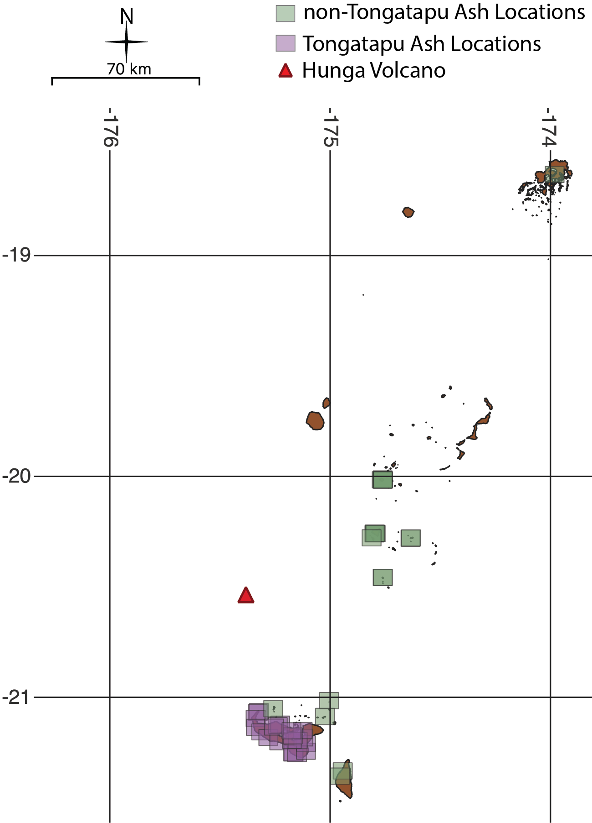
Supplemental Figure 1: Areas over which interpolated reflectance was averaged. Each polygon is ~73 km².

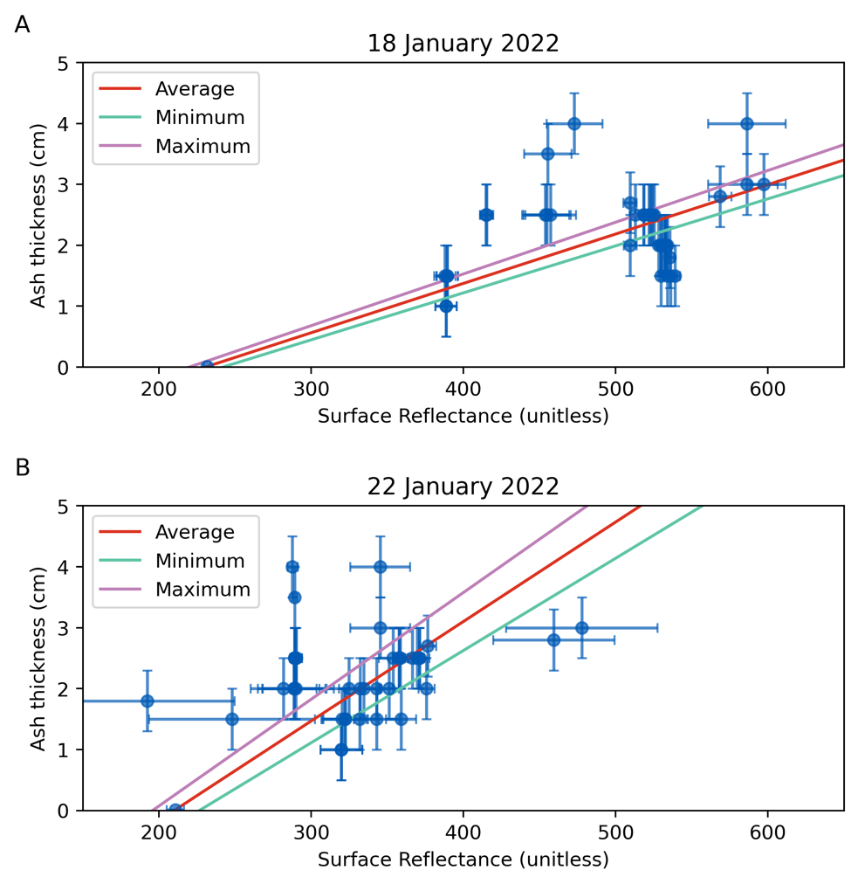
Supplemental Figure 2: Relationship between ash thickness and reflectance with linear fits, from January 18, 2022 (A) and January 22, 2022 (B). January 19th, January 20th, and January 21st are omitted because of sun-glint on the 19th and 21st, and missing data not calculated with interpolation of the 0.01 cm ash point on Vava’u on the 20th. Procedures for fitting are described in Methods.
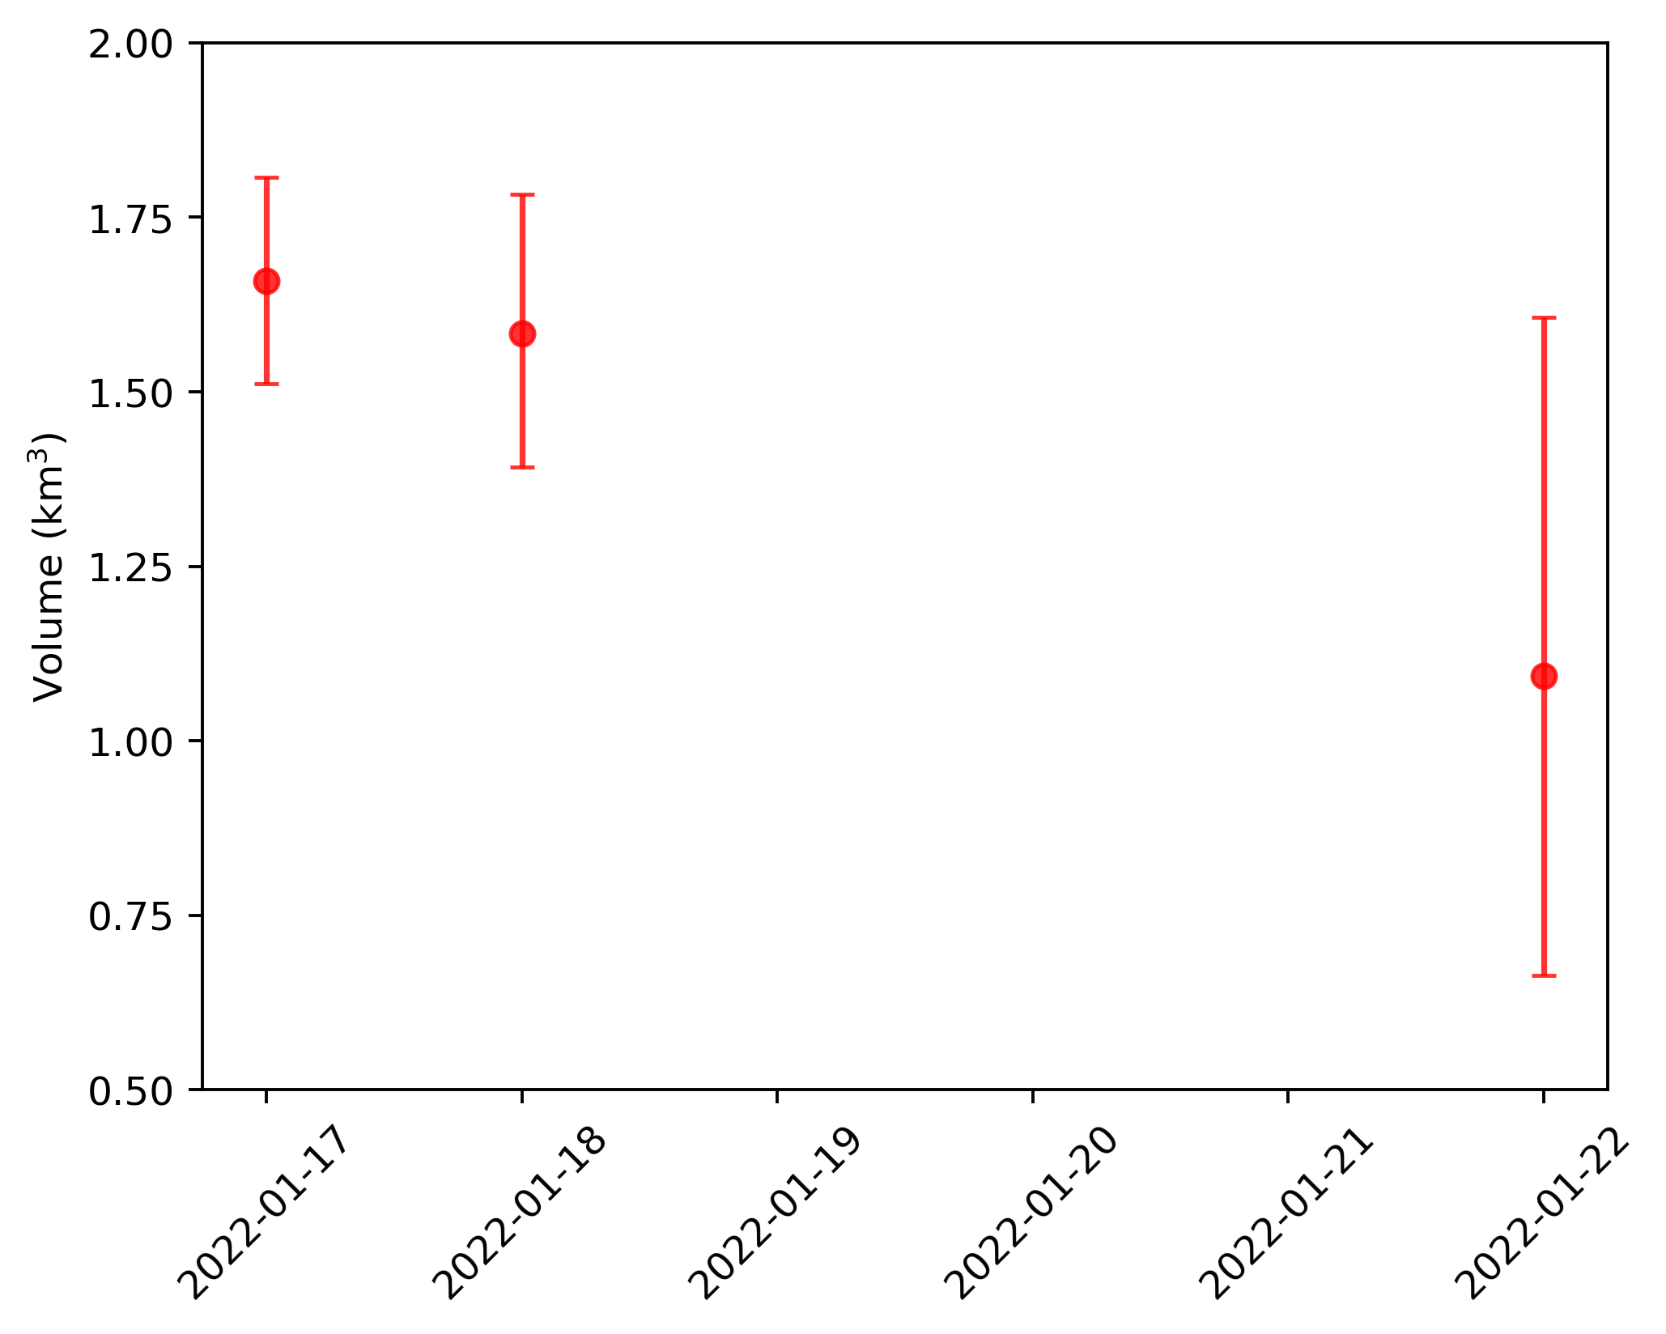
Supplemental Figure 3: Ash volume calculations for different analyzed days. Order of magnitude is preserved, and values are generally consistent. There is an increase in variance as you move further away in time from the date of the eruption.
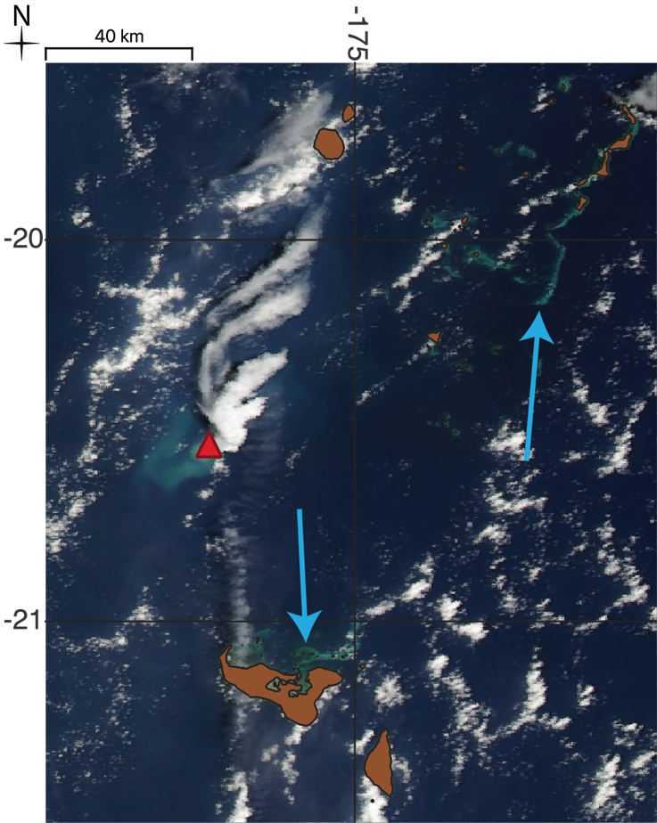
Supplemental Figure 4: Discoloration around islands in the Kingdom of Tonga on 30 December 2021. Blue arrows indicate coastal discoloration. HTHH location is shown with the red triangle.

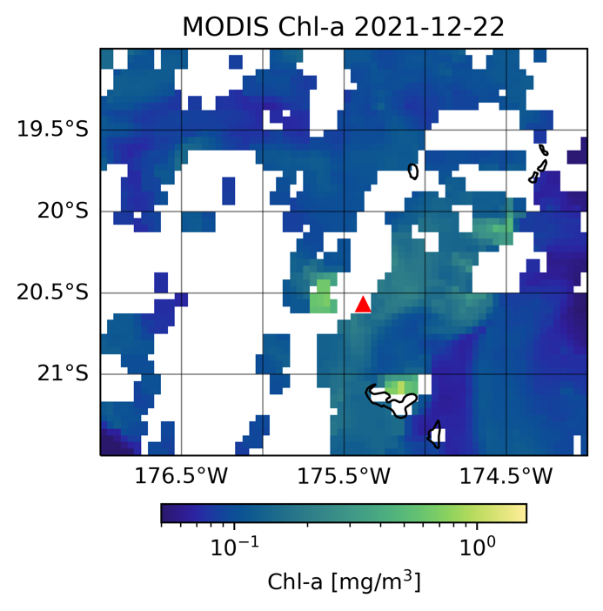
Supplemental Figure 5: Chlorophyll-a estimates from MODIS Aqua satellite. Satellite image is from December 22, 2021, shortly after the 19 December event. Comparison to Figure 3 of Barone et al., (2022) shows similar values (around 1 mg/m³), but the spatial extent of chlorophyll after the January eruption was much larger.

