Supplementary Information for

Viruses under the Antarctic Ice Shelf are active and potentially involved in global nutrient cycles

Javier Lopez¹, Marina Vila-Nistal¹, Clara Martínez-Pérez ³, Daniele de Corte⁴, Federico Baltar³ and Manuel Martinez-Garcia^{1,2}*

*Correspondence to: m.martinez@ua.es and federico.baltar@univie.ac.at
phone +34 965902161

-This supplementary material contains two figures
-Notice that the Supplementary Dataset attached to this manuscript contains more than 15 supplementary tables in an Excel spreadsheet complementing and supporting our findings on virus features, genome sequence, predicted ORFs (protein sequence), viral classification, viral network analysis, virus-host assignment, data on abundance and activity of viruses, similarity with vSAG 37-F6 virus and AMG information

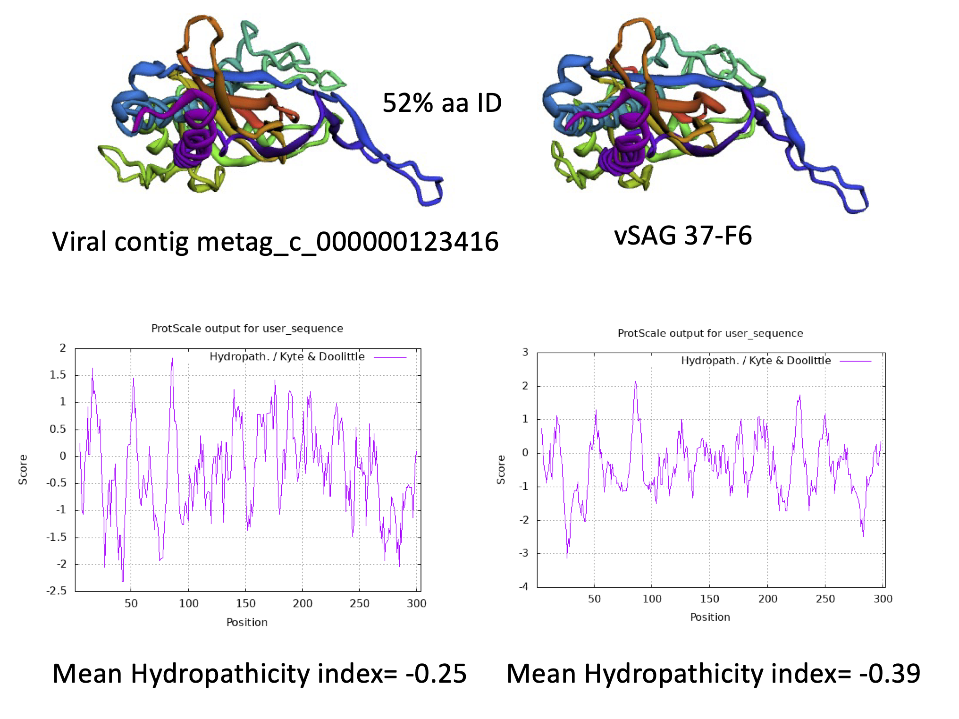
Figure S1. Genetic comparison and 3D structure prediction of capsid protein for some of the abundant viruses under the Ross Ice Shelf sharing orthologues hallmark genes with virus vSAG 37-F6. Amino acid similarity percentage is indicated for the product of ORF 9 encoding the capsid protein of virus vSAG 37-F6 also detected in viruses of the Ross Ice Shelf. 3D-structure protein prediction was made with Alphafold. Hydropathicity index for the capsid protein is indicated. See method for details.

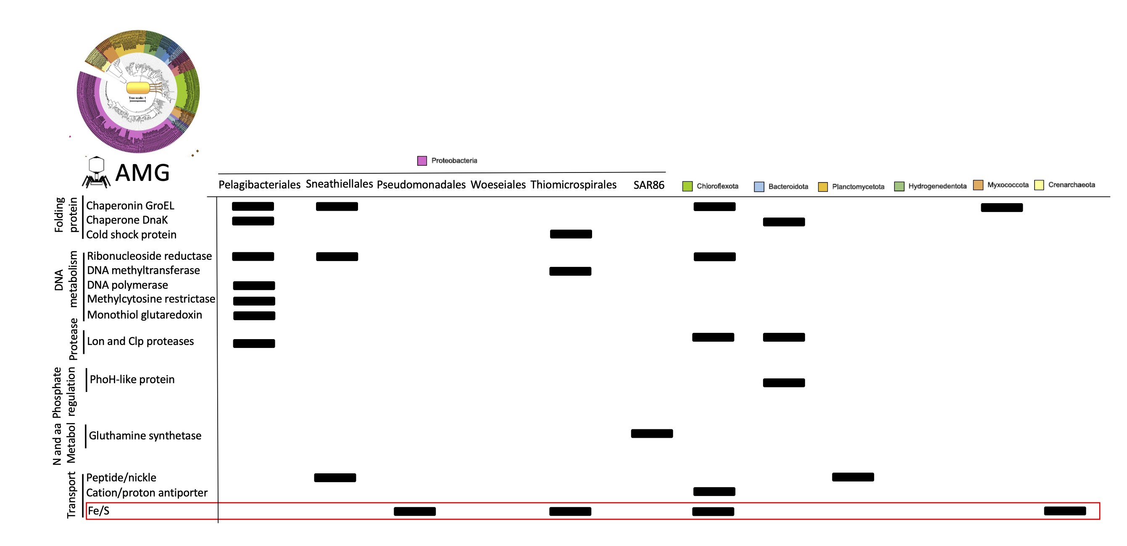

Figure S2. AMGs in viruses under the Ross Ice Shelf. Abundant viral AMG are depicted including the information of potential hosts. Some of the detected viral AMG belong to very abundant and active viruses that infect some of the most abundant and active chemolitoautotrophic bacteria contributing to primary production under the Ross Ice Shelf according to [18 see references in main text]. 3D-structure protein prediction was made for some AMG involved in sulfur transportation. Notice that the 3D structure of the homologue viral protein and that of the host are quite similar. Prediction was performed with Alphafold.

