Supplementary information

Overcoming strain degeneration in the Weizmann process for the continuous production of advanced biofuels

Muhammad Ehsaan^{1,3}, Minyeong Yoo^{1,3}, Wouter Kuit¹, Céline Foulquier², Philippe Soucaille^{1,2,4}, Nigel P. Minton¹

¹ BBSRC/EPSRC Synthetic Biology Research Centre, School of Life Sciences, Centre for Biomolecular Sciences, University of Nottingham, United Kingdom.
² TBI, Université de Toulouse, CNRS, INRAE, INSA, Toulouse, France.
³ Minyeong Yoo and Muhammad Ehsaan contributed equally to this work.
⁴ Corresponding author: correspondence and material requests should be addressed to soucaille@insa-toulouse.fr

Supplementary Table 1 | All bacterial strains, plasmids, and primers used in this study

Strain, Plasmids and Primers | Relevant characteristics | Source
Strain
E. coli
pAN2 in Top10 | In vivo methylation strain | ¹
Clostridium acetobutylicum
pyrE engineered | ACE compatible Clostridium acetobutylicum strain having a deletion in the 5′ region of pyrE | ²
CAB2018 | Entire pSOL1 megaplasmid integrated into chromosome of C. acetobutylicum at pyrE locus, ermB carried | This study
CAB2019 | Derived from CAB2018, pSOL1 integrated, pyrE deleted, ermB removed | This study
CAB2020 | Derived from CAB2019, pSOL1 integrated, full-length pyrE restored strain, no antibiotic marker carried | This study
CAB2021 | Derived from CAB2020, sadh-hydG of C. beijerinckii integrated at downstream of thlA (CA_C2873), strong expression intended under thlA promoter, ermB carried | This study
Plasmid
pMTL-pSOL1 integration | pMTL-SC7515³ was used as a backbone and a synthetic cassette including 4 homology arms and ermB gene was cloned at PmeI site. Designed to construct pSOL1 integated strain, CAB2018 strain | This study
pMTL-pSOL1-pyrE-Negative | pMTL-JH12 derived, catP, to remove erythromycin marker and initial 300bp of pyrE. Designed to construct CAB2019 strain | This study
pMTL-pSOL1-pyrE-Positive | pMTL-JH12 derived, catP, to restore deleted 300bp pyrE of the pyrE Negative strain. Designed to construct CAB2020 strain | This study
pMTL-JH16-sadh-hydG B593 | pMTL-JH12 derived, catP, to integrate ermB lacking promoter and sadh/hydG from C. beijerinckii NRRL B593 for synthetic isopropanol pathway under thlA promoter by homologous recombionations (asymmetrical homology arms to control recombination order at thlA lastly). Designed to construct CAB2021 strain | This study
Primers |  | Note
Pr1 | gctagcttattattcaaaatctatattattcacgc | To amplify CA_P0176-77 LHA and replace original fragment with NheI/AscI of JH12 to construct pMTL-pSOL1-pyrE-Negative,  NheI site, forward
Pr2 | ggcgcgccaatgtaataagtataatcaacgttaaag | To amplify CA_P0176-77 LHA and replace original fragment with NheI/AscI of JH12 to construct pMTL-pSOL1-pyrE-Negative,  AscI site, reverse
Pr3 | cggccgctaaggaggaacatattttatgaaaggttttgc | To amplify isopropanol producing operon sadh-hydG from C. beijerinckii and insert into pMTL JH16 to construct pMTL-JH16-sadh-hydG B593, forward
Pr4 | gctagcttatttatcacctctgcaaccacagcc | To amplify isopropanol producing operon sadh-hydG from C. beijerinckii and insert into pMTL JH16 to construct pMTL-JH16-sadh-hydG B593, reverse
Pr5 | tagcacaattgtatttggacttctttaaataaaaacatgg | To confirm pSOL1 integration at 5’, located on CA_C0026 on chromosome, forward
Pr6 | gaacgcagtaaggtttacaagtc | To confirm pSOL1 integration at 5’, located on CA_P0177 on pSOL1, reverse
Pr7 | tgaatccatacgagacgtaatacaa | To confirm pSOL1 integration at 3’, located on CA_P0173 on pSOL1, forward
Pr8 | gttgatcctgctatgggtactt | To confirm pSOL1 integration at 3’, located on hydA (CA_C0028) on chromosome, reverse
Pr9 | gcaggagatgctgacgtaataa | To confirm sadh-hydG integration into chromosome under thlA promoter, located on thlA, forward
Pr10 | ccatgaagaggtactggcaataa | To confirm sadh-hydG integration into chromosome under thlA promoter, located on atpB

Supplementary Table 2 | List of mutations identified in the CAB2018 strain

Gene | Position | Length | Type | Nucleotide change | AA substitution | Function | No. of mRNA molecules/cell in acidogenesis ^{A)} | No. of mRNA molecules/cell in solventogenesis ^{A)}
CA_C1879 | 2217909 | 1 | SNP | A→G | Ile260Val | Hypothetical protein | 0.068 | 0.000
CA_C2134 | 2415895 | 1 | SNP | G→A | Gly241Ser | GTP-dependent nucleic acid binding protein EngD | 2.293 | 2.852
CA_C2912  araN | 3237960 | 11 | Deletion | delATGTATATGAA | NP_349514.1:p.Met377fs | Sugar binding periplasmic protein | 0.915 | 0.667
CA_C3406 | 3780000 | 2 | Insertion | 171_172dupTG | NP_349996.1:p.Glu58fs | Transcriptional regulator | 0.111 | 0.098
^{A)} Quantitated mRNA under acidogenesis/solventogenesis in C. acetobutylicum. The minimum number of mRNA molecules per cell detected was around 0.06 while the maximum number was around 80 in this study⁴.

Supplementary Note 1 | Transformation procedure
C. acetobutylicum ATCC 824 and derived strains were electroporated as previously described ⁵, in vivo methylation of plasmid DNA was carried by transformation in TOP10 harbouring pAN2 (Supplementary Table 1) with selection by 10 ug/mL of tetracycline and by appropriate antibiotic specific for the plasmid to methylate (chloramphenicol 30 ug/mL for all catP carrying plasmids) prior to transformation of any C. acetobutylicum strains¹. After recovery in liquid 2 YTG (pH 5.2), cells were plated on CGM agar media supplemented with the appropriate antibiotics (erythromycin at 40 μg/ml and thiamphenicol at 20 μg/ml, respectively) and with uracil at 20 µg/ml in the case of pyrE negative mutant. Transformants selected on media containing antibiotics were subcultured twice on the same media for purification. The final clones screened by PCR were grown in synthetic media (GMM containing ammonium acetate) for product profile verification and spore storage.

Supplementary Note 2 | Construction of the CAB2018 strain

Plasmid pMTL-pSOL-int (Fig. 1 and Supplementary Table 1, Supplementary Figure 1) was constructed as described in the main manuscript. The vector was transformed into pyrE engineered strain ². Mutants having a clean integration of pSOL1, resulting from four crossing-overs events (Fig.1a), were directly obtained by spreading 10⁹ of pMTL-pSOL1-int plasmid containing cells on a glucose mineral medium supplemented with erythromycin (ermB) and 5FC (codA). The resultant clones were replicated on thiamphenicol supplemented medium to confirm the loss of plasmid and both 5’ and 3’ integrations of pSOL1 were checked by PCR (Supplementary Figure 2). The resultant Erm^{R} Thm^{S} 5FC^{S} strain was named CAB2018.
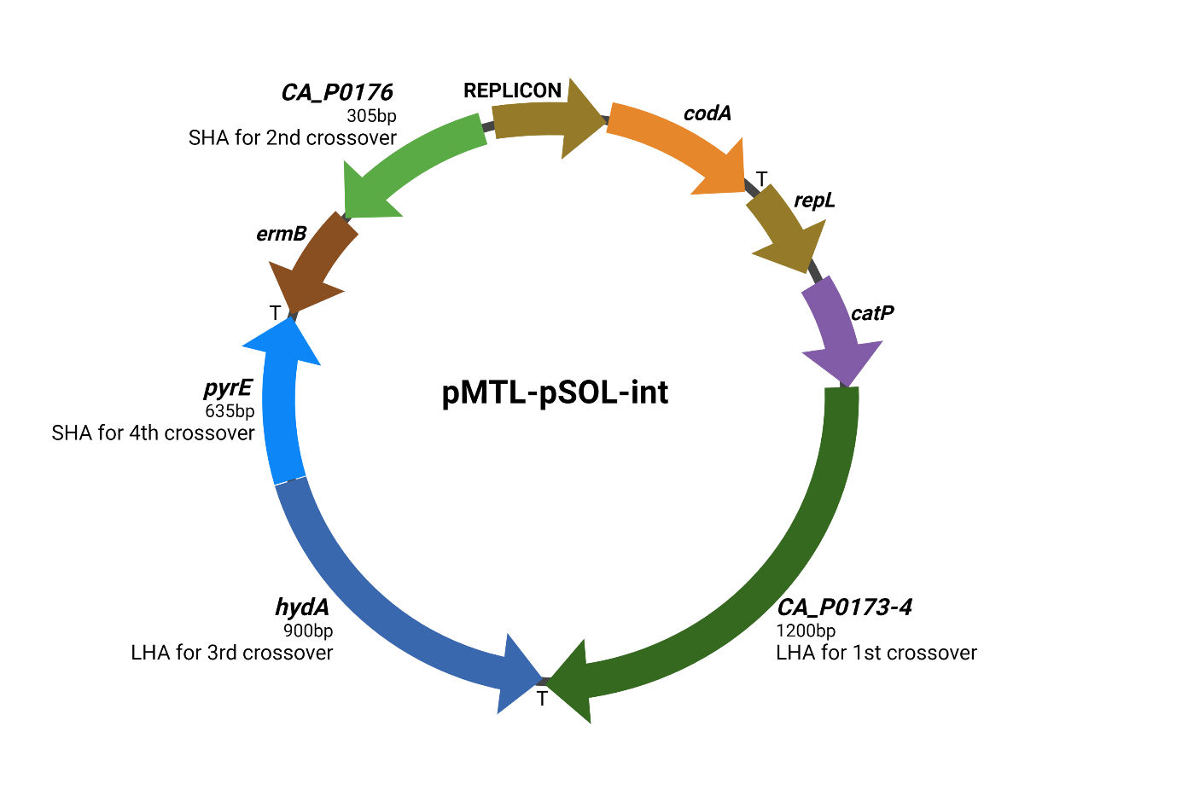
Supplementary Figure 1. Physical map of pMTL-pSOL-int

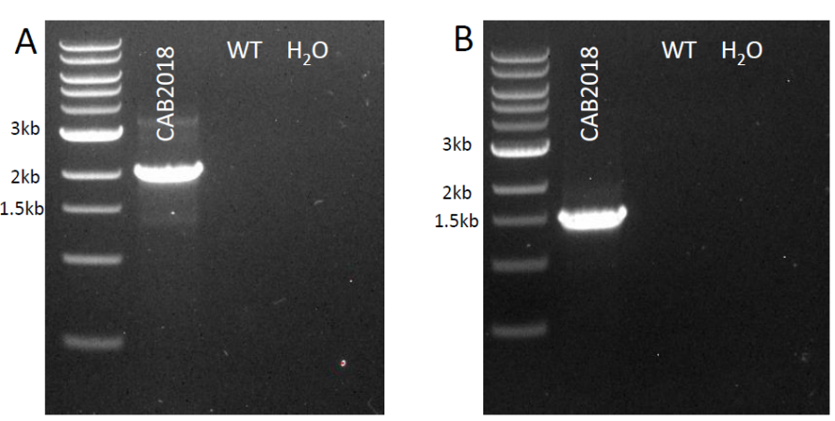

Supplementary Figure 2. pSOL1 integration verification by PCRs in CAB2018. (a) 5’ integration verification with primer pair Pr5 located on CA_C0026 on chromosome and Pr6 located on CA_P0177 on pSOL1 megaplasmid to confirm. Expected amplicon size: CAB2018, 2.1kb; WT, no amplicon. NEB 1 kb DNA Ladder was loaded on the left. (b) 3’ integration verification with primer pair Pr7 located on pSOL1 and Pr8 located on chromosome. Expected amplicon sizes: CAB2018, 1.5kb; WT, no amplicon.

Supplementary Note 3 | Construction of the CAB2019, CAB2020 and CAB2021 strains

CAB2019
CAB2018 harbouring ermB (erythromycin marker used for double-crossover selection during pSOL1 integration into chromosome and to be used for double-crossover selection later on to use its highly efficient selection in this organism) and to remove erythromycin marker it was transformed with pMTL-JH12 derived vector pMTL-pSOL1-pyrE-Negative, which was constructed as described in the main manuscript. Transformants were plated on CGM supplemented with 20 μg/mL uracil and 15 μg/mL thiamphenicol for the plasmid-borne resistance marker catP selection. The clones were subcultured twice on the same media then streaked on CBM supplemented with 20 μg/mL uracil and 1mg/ml 5-fluoroorotic acid (FOA) for counter selection. The cells resistant to FOA were streaked on CBM (Clostridial basal medium normally lacking in uracil) ⁶ supplemented with uracil and erythromycin to confirm deletion of erythromycin marker. Accordingly, the erythromycin sensitive clones were verified by PCR and subsequently streaked on CBM deficient in uracil to confirm uracil auxotrophy due to non-functional foreshortened pyrE as well as on uracil supplemented CBM containing thiamphenicol to ensure loss of integration vector. The resultant Erm^{S} Thm^{S} FOA^{R} strain was named CAB2019.

Supplementary Figure 3. PCRs validation of the CAB2019 strain
Antibiotic marker (encoded by ermB) excised and pyrE deleted strain CAB2019 verification by PCR. Primers used: Pr5 located on CA_C0026 on chromosome and Pr6 located on CA_P0177 on pSOL1 megaplasmid. Expected amplicon sizes: CAB2019 strain, 1kb; CAB2018 strain, 2.1kb; WT, no amplicon. NEB 1 kb DNA Ladder was loaded on the left.
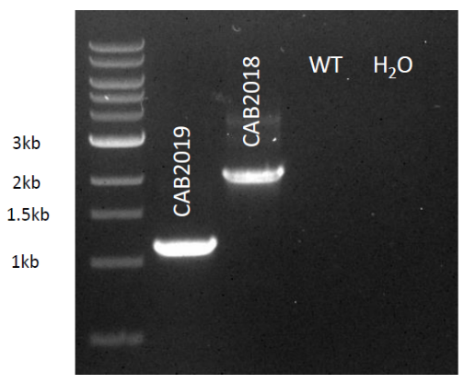

CAB2020
CAB2019 was transformed with pMTL-pSOL1-pyrE-Positive to restore deleted 300bp pyrE eventually for full-length functional pyrE by electroporation and plated on CBM supplemented with chloramphenicol and uracil. After subculturing on the same medium, the transformants were transferred to CBM lacking uracil to select uracil prototrophic cells. The cells grown on CBM were purified for PCR screening. The clones showing correct PCR profiles were streaked on CGM supplemented with FOA. The clones with sensitivity to FOA and capability of growing on CBM without uracil supplementation were streaked on CBM containing thiamphenicol to ensure loss of integration vector. The resultant Erm^{S} Thm^{S} FOA^{S} strain was named CAB2020.

Supplementary Figure 4. PCRs validation of the CAB2020 strain. Antibiotic marker (encoded by ermB) excised and pyrE recovered strain CAB2020 verification by PCR. Primers used: Pr5 located on CA_C0026 on chromosome and Pr6 located on CA_P0177 on pSOL1 megaplasmid. Expected amplicon size: CAB2020 strain, 1.3 kb; CAB2019 strain, 1 kb; CAB2018 strain, 2.1 kb; WT, no amplicon. NEB 1 kb DNA Ladder was loaded on the left.

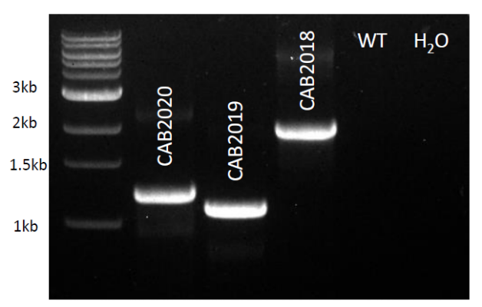

CAB2021
CAB2020 strain was transformed with pMTL-JH16-sadh-hydG B593, which was constructed as described in the main manuscript. After recovery in 2 YTG, cells were plated on CGM supplemented with thiamphenicol and subcultrued on the same medium. Purified clones were replicated on CGM supplemented with erythromycin and subcultrued on the same medium to select double-crossover clones as ermB gene was designed to be under thlA promoter after integration. Afterwards Erm^{R} clones were screened by PCR and thiamphenicol sensitivity. The resultant Erm^{R} Thm^{S} recombinant strain was named CAB2021.

Supplementary Figure 5. PCRs validation of the CAB2021 strain

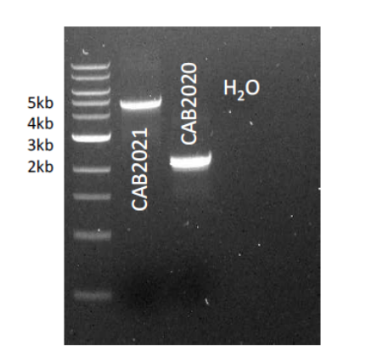
Isopropanol producing pSOL1 integrated strain (by sadh-hydG integration) CAB2021 verification by PCR. Primers used: Pr9 on thlA (CA_C2873) and Pr10 located on atpB (CA_C2871). Expected amplicon sizes: pSOL1 integrated IPA strain, 5 kb; pSOL1 integrated marker-less strain, 2.3 kb. NEB 1 kb DNA Ladder was loaded on the left.

Supplementary Note 4 | Products profile in serum bottles and sporulation ability of the wild type and CAB2018 strains.

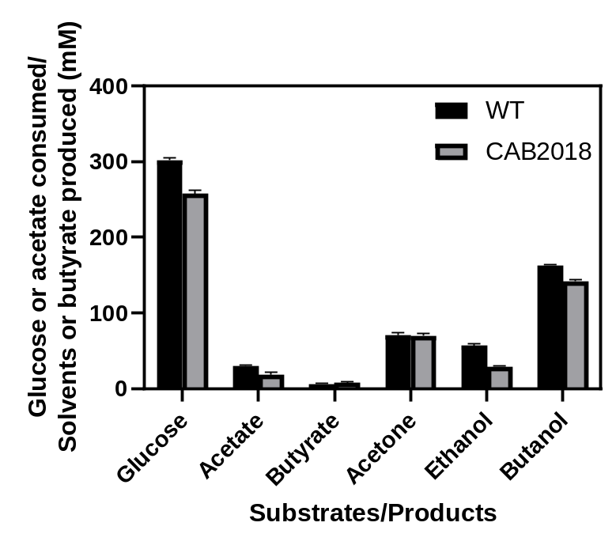
Supplementary Figure 6. Products profile in serum bottles of the wild type and CAB2018 strains
In minimal media (GMM) containing glucose and acetate under batch condition without pH regulation, CAB2018 showed slightly decreased glucose and decreased acetate consumption and consequently slight decreased butanol and decreased ethanol production. Data are shown as mean ± SD from biological replicates (n = 3)

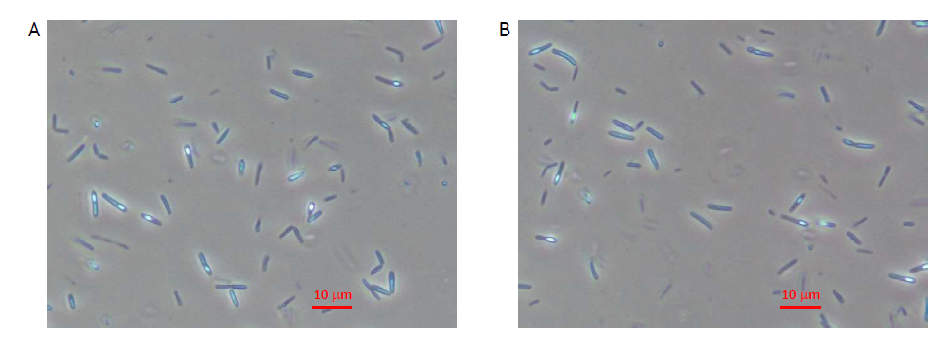
Supplementary Figure 7. Sporulation of CAB2018
Microscopic images of spore formation of C. acetobutylicum strains: (a) Wild type, (b) CAB2018. As it is known that solvent production and sporulation are involved in C. acetobutylicum and degenerated C. acetobutylicum can no longer sporulate ^{7, 8}, the sporulation ability of pSOL1 integrated strain was examined and confirmed by microscopy and heat shock (data not shown).

Supplementary Note 5 | Products profile in serum bottles of the wild type, CAB2020 and CAB2021 strains.

Supplementary Figure 8. Products profile in serum bottles of the wild type and CAB2020 strains
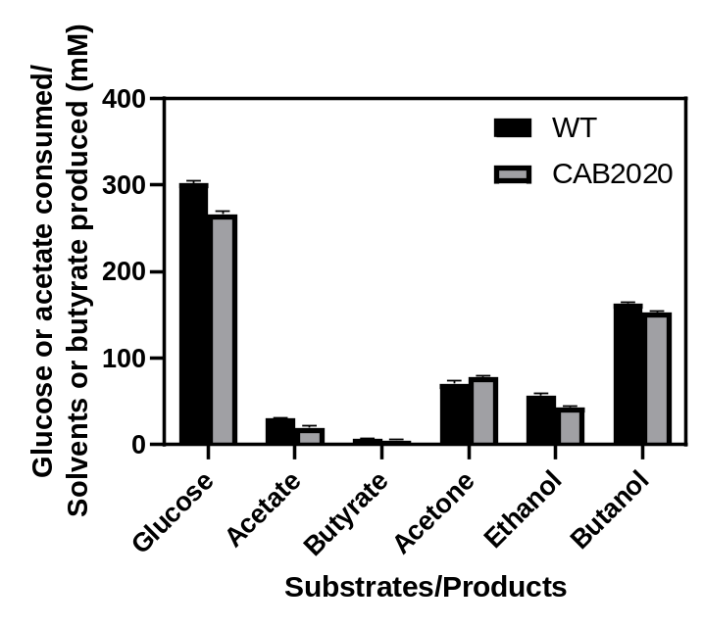
Product profile of CAB2020 in GMM under batch condition without pH regulation showed slightly decreased glucose consumption and consequently slight decreased butanol and decreased ethanol production similar to the parental strain CAB2018. Data are shown as mean ± SD from biological replicates (n = 3).

Supplementary Figure 9. Products profile in serum bottles of the wild type and CAB2021 strains

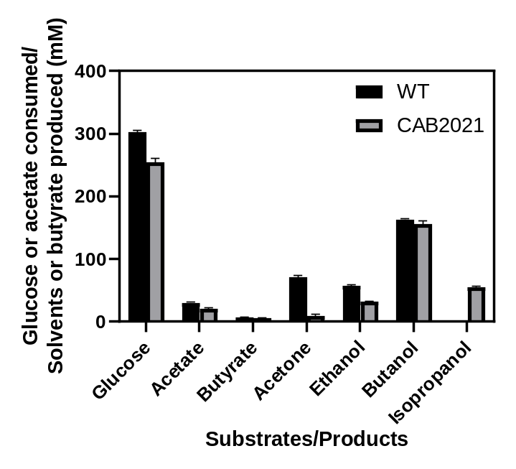

Product profile of CAB2021 in GMM under batch condition without pH regulation showed slightly decreased glucose consumption similar to its parental strains CAB2018, CAB2020. This strain showed significant production of isopropanol and very low production of acetone due to its conversion to isopropanol. Data are shown as mean ± SD from biological replicates (n = 3)

Supplementary Note 6 | Chemostat culture of the CAB2021 strains in Glucose MM medium.

Supplementary Figure 10. Biofuel titre, productivity, and yield of CAB2021 strain grown in chemostat culture on minimal media at different dilution rates.
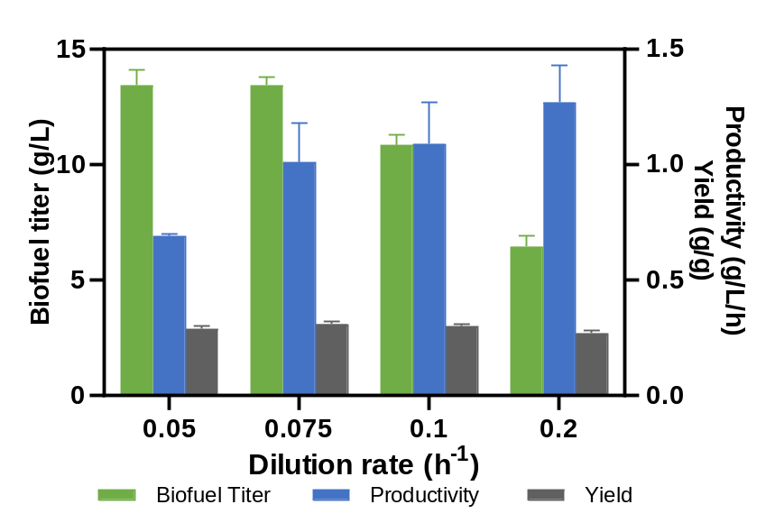
To determine the value of CAB2021 for commercial process for biofuel production, an economical mineral medium was continuously fed and different dilution rates were tested. In terms of biofuel titre, dilution rates at 0.05 and 0.075 h⁻¹ showed highest titre. In terms of productivity, dilution rate at 0.2 h⁻¹ showed highest productivity while high residual glucose was seen (Fig. 2B). In terms of yield, no significant difference was seen among all the tested dilution rates.

Supplementary Note 7 | Analysis of pSOL1 loss in wild type and CAB2019 strains.

Supplementary Figure 11. Starch based assay to analyze loss of pSOL1.
Halo formations by amylolytic activity of gene product of amyP, located on pSOL1, were monitored to determine degeneration rate^{3, 9}. As AmyP is solely able to form halo without catabolic repression, assays on starch plate supplemented with limited glucose were implemented during fermentation (Main text Figure 1). In WT fermentation, once degeneration was detected, the rate of population of no halo forming cells due to loss of pSOL1 was increased gradually while butyrate production was increased and butanol production was decreased, and finally all tested cells showed no halo formation with the accompanying no (less than 1% of average until day20) butanol production (Fig. 1 B and C) within 30days. On the other hand, as CAB2019 strain carried pSOL1 including amyP in pSOL1 integrated into chromosome, no halo forming cells were not observed through the whole fermentation period with the accompanying stable butanol production (46 days).
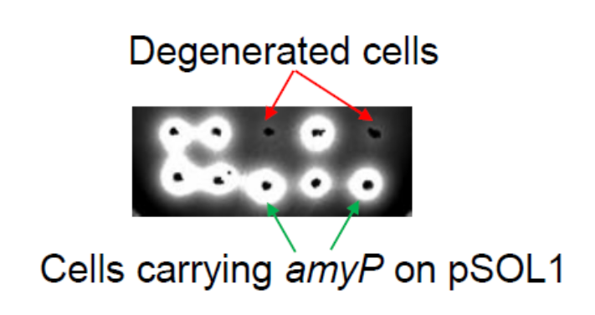

Supplementary Note 8 | Genome Sequencing of the CAB2018 strain.
Genomic DNA was isolated from overnight cultures of the C.acetobutylicum strain to be sequenced using phenol-chloroform extraction and stored in Tris-HCl buffer (10 mM, pH 7.8). Genomic DNA was sequenced using the Illumina MiSeq platform (DeepSeq, Nottingham, UK) using 500 bp V2 SBS chemistry. Analysis of the generated reads and identification of single nucleotide polymorphisms, insertions and deletions was performed using the Basic Variant Detection tool within CLC Genomics Workbench (version 22.0.2) by mapping the trimmed Illumina paired-end reads to the reference sequences NC_003030 (chromosome) and NC_001988 (pSOL1) modified according to Ehsaan et al. (2016). Variants were detected with minimum coverage and frequency of 75 and 70%, respectively, with base quality filter settings of neighbourhood radius = 5, minimum central quality = 20 and minimum neighbourhood quality = 15, applied.

References
1. Heap, J.T., Pennington, O.J., Cartman, S.T., Carter, G.P. & Minton, N.P. The ClosTron: a universal gene knock-out system for the genus Clostridium. J Microbiol Methods 70, 452-464 (2007).
2. Heap, J.T. et al. Integration of DNA into bacterial chromosomes from plasmids without a counter-selection marker. Nucleic Acids Res 40 (2012).
3. Ehsaan, M. et al. Mutant generation by allelic exchange and genome resequencing of the biobutanol organism Clostridium acetobutylicum ATCC 824. Biotechnol Biofuels 9, 4 (2016).
4. Yoo, M. et al. A quantitative system-scale characterization of the metabolism of Clostridium acetobutylicum. mBio 6, e01808-01815 (2015).
5. Mermelstein, L.D., Welker, N.E., Bennett, G.N. & Papoutsakis, E.T. Expression of cloned homologous fermentative genes in Clostridium acetobutylicum ATCC 824. Biotechnology (N Y) 10, 190-195 (1992).
6. O'Brien, R.W. & Morris, J.G. Oxygen and the growth and metabolism of Clostridium acetobutylicum. J Gen Microbiol 68, 307-318 (1971).
7. Cornillot, E., Nair, R.V., Papoutsakis, E.T. & Soucaille, P. The genes for butanol and acetone formation in Clostridium acetobutylicum ATCC 824 reside on a large plasmid whose loss leads to degeneration of the strain. J Bacteriol 179, 5442-5447 (1997).
8. Al-Hinai, M.A., Jones, S.W. & Papoutsakis, E.T. The Clostridium sporulation programs: diversity and preservation of endospore differentiation. Microbiol Mol Biol Rev 79, 19-37 (2015).
9. Sabathe, F., Croux, C., Cornillot, E. & Soucaille, P. amyP, a reporter gene to study strain degeneration in Clostridium acetobutylicum ATCC 824. FEMS Microbiol Lett 210, 93-98 (2002).

