A human monoclonal antibody produced in filamentous fungus provides protection from SARS-CoV-2 infection in a hamster and non-human primate model

Supplementary material

Supplementary Table 1. List of oligonucleotide primers to check correct integration to the cbh1 locus and the absence of the cbh1 coding region.
Primer name | Sequence | Purpose
oMYT0157_cbh1_orf_for | GCTGACGCGAATGACACAG | forward primer for cbh1 locus
oMYT0158_cbh1_orf_rev | CATGCCCTTGCCGTAGAAG | reverse primer for cbh1 locus
oMYT0127_cbh1_5int_1 | ATCAGACCACGACGGGAC | 5 'end integration PCR forward
oMYT0087_bgl_pr_s4 | GACTCTGAACGAGCCGGG | 5' end integration PCR reverse
oMYT0130_cbh1_3int_2 | CTCTAGTTAACGGCTACCTATTTAAGCT | 3' end integration PCR reverse
oMYT0087_bgl_pr_s4 | GACTCTGAACGAGCCGGG | 5'end integration PCR forward

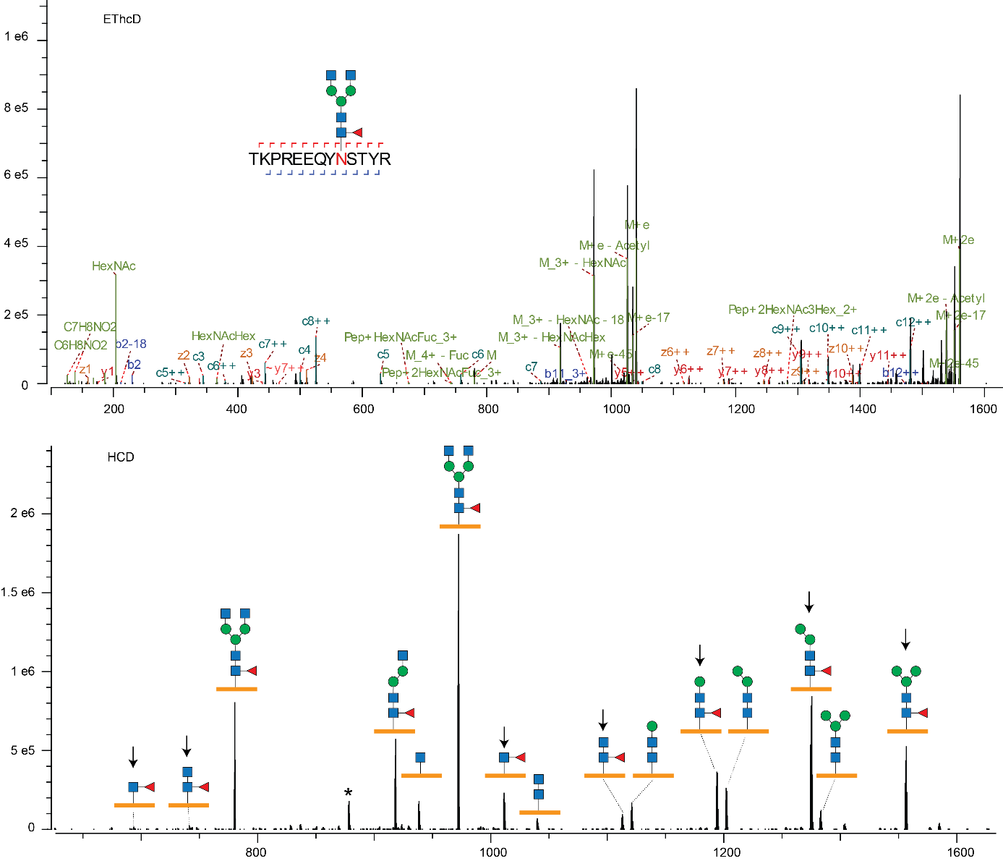
Supplementary Figure 1. Tandem mass spectrometry of fucosylated N-glycopeptide from HEK293 produced HuMab 87G7. Shown are an EThcD and HCD spectrum of the same glycopeptide precursor. The EThcD spectrum supports proper assignment of the intact glycan mass to the correct peptide sequence. The HCD spectrum contains many glycopeptide fragments supporting the presence of core fucosylation (arrows). There is one unassigned peak in the spectrum (asterisks), likely an internal fragment.

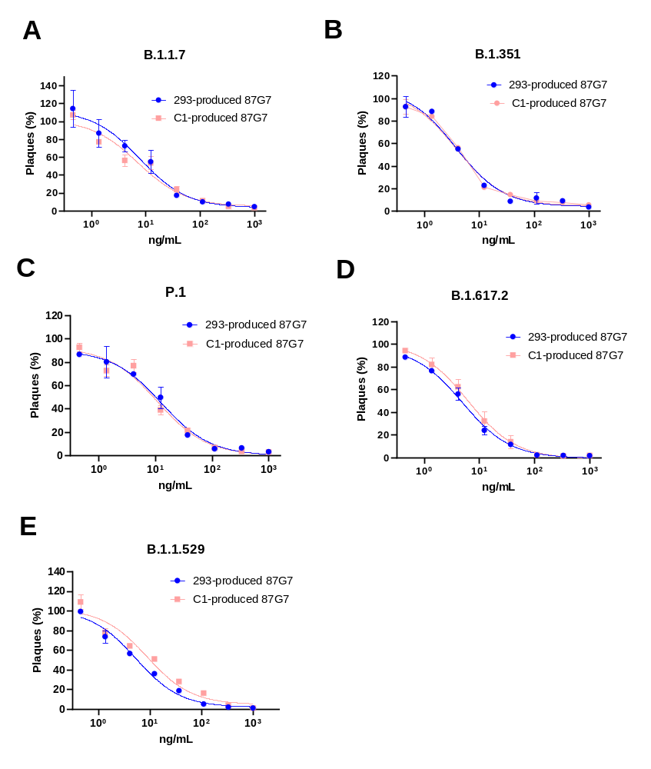
Supplementary Figure 2. C1 and HEK293T produced HuMab 87G7 bind and neutralize SARS-CoV-2 VOCS with comparable efficiency. Neutralizing activity of HuMab 87G7 against B.1..17. (A), B.1.351 ( B), P1 (C), B.1.617.2 (D) and B.1.1.529 (E). Error bars indicate SDM between two independent replicates.

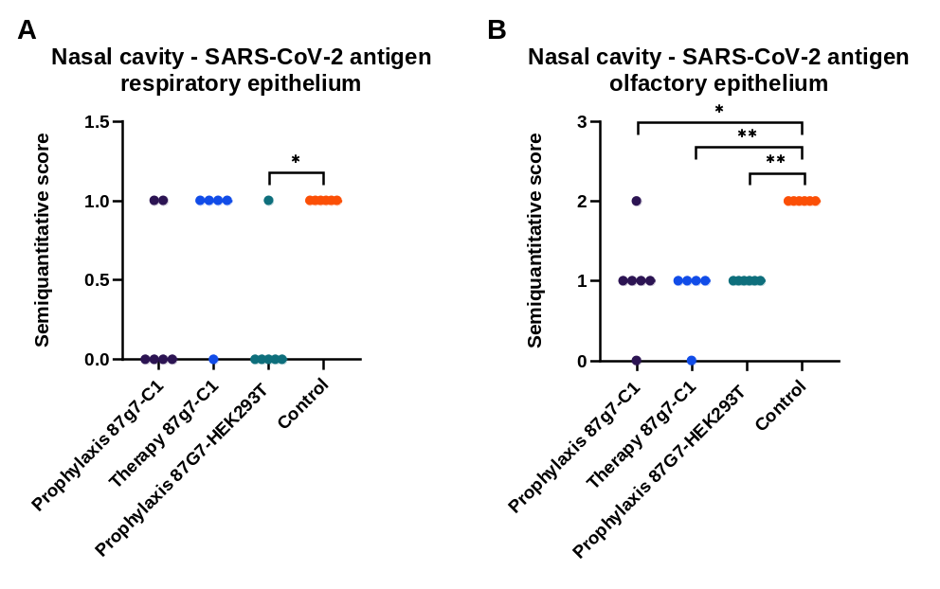
Supplementary Figure 3. IHC staining for SARS-CoV-2 nucleoprotein in nasal cavity from hamsters 4 days post infection. SARS-CoV-2 nucleoprotein was detected in (A) respiratory epithelium of the nasal cavity and (B) olfactory epithelium of the nasal cavity. n = 6 animals/group; */** indicate significant differences (P ≤ 0.05 and P ≤ 0.01 respectively); One-way ANOVA.

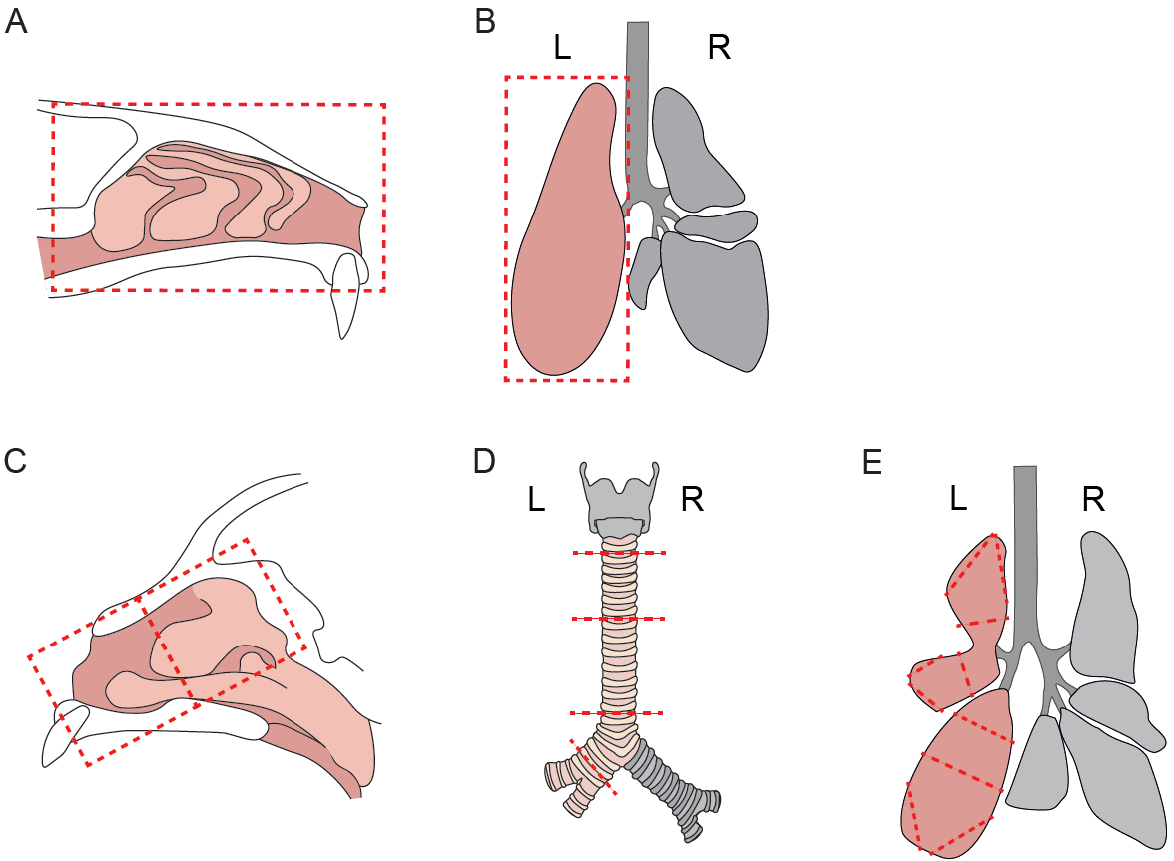
Supplementary Figure 4. Tissue trimming schematics for the evaluation of Syrian golden hamsters (A, B) and Rhesus macaques (C-E). The Evaluation of histopathological lesions and viral antigen expression was performed on total longitudinal sections of the left nasal cavity (A) and the entire left lung lobe (B) of Syrian golden hamsters. Evaluation of histopathological lesions and viral antigen expression in Rhesus macaques samples was performed on: (C) 1 slide containing the rostral portion of the nose, 1 slide containing the caudal part of the nose and 1 slide containing two cross sections of the nasal septum; (D) 3 slides containing a cross section of the cranial, middle, and caudal trachea, 1 slide containing a cross section of the extra-pulmonary bronchus; (E) 10 areas of the lung were sectioned for analysis, 3 areas were divided in 2 slides for space reason, resulting in 13 slides in total for lung lesions evaluation.

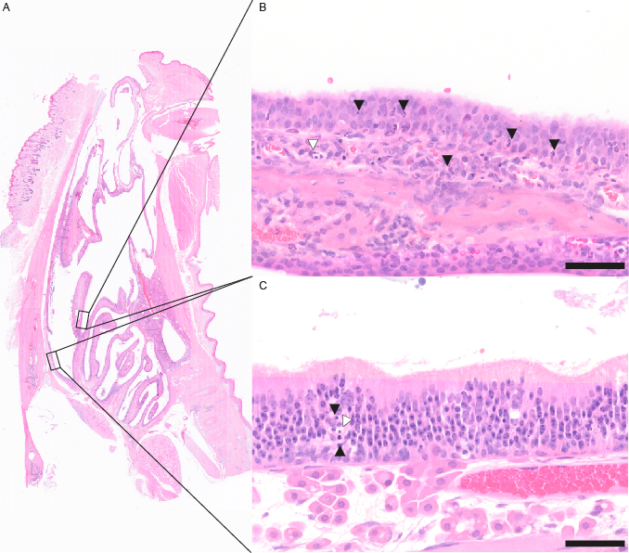
Supplementary Figure 5. Representative images of SARS-CoV-2 induced histopathological lesions in the nasal turbinates of Syrian golden hamsters (A-C). (A) Overview of the nasal cavity cross section. (B) Higher magnification of the respiratory epithelium displaying epithelial disorganization, cell death (white arrowhead), intraepithelial and subepithelial inflammatory infiltrates, characterized by macrophages and neutrophils (black arrowheads). (C) Higher magnification of the olfactory epithelium exhibiting epithelial disorganization, singe cell death (white arrowhead) and intraepithelial and inflammatory infiltrates, consisting of macrophages, lymphocytes and neutrophils (black arrowheads, (C)). Scale bars: 50 µm
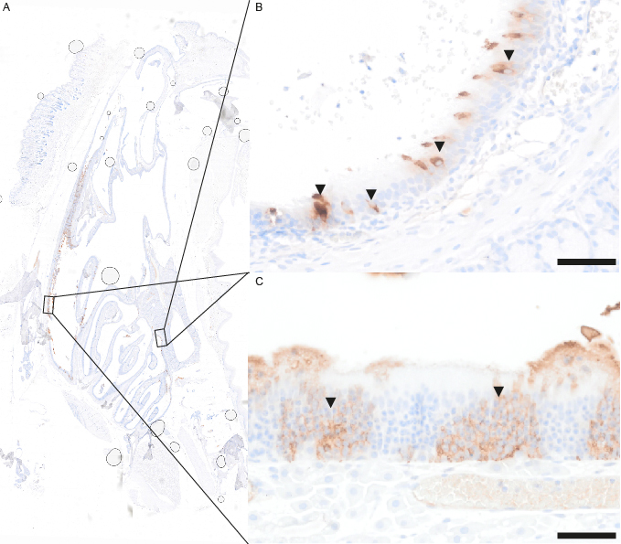
Supplementary Figure 6. Representative images of SARS-CoV antigen immunohistochemistry in nasal turbinates of of Syrian golden hamsters (A-C). (A) Overview of the nasal turbinates showing viral antigen (brown signal) in the epithelium and intraluminal exudate. (B) Higher magnification of the respiratory mucosa showing individual immunolabelled cells (arrowheads). (C) Higher magnification of olfactory mucosa showing viral antigen in many epithelial cells (arrowhead). Scale bars: 50 μm.

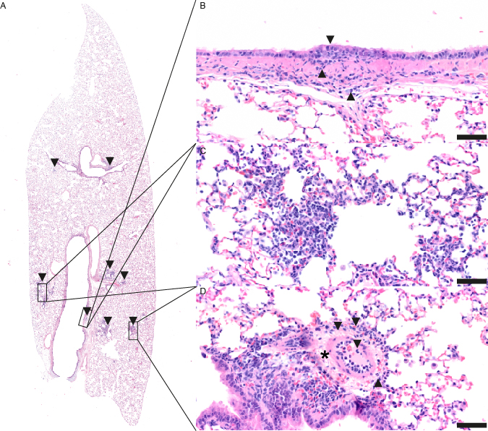
Supplementary Figure 7. Representative images of SARS-CoV-2 induced histopathological lesions in the lung of Syrian golden hamsters (A-D). A Overview of the left lung lobe showing multifocal consolidated areas (arrowheads). B Higher magnification of a bronchus with mild, focal intra- and subepithelial infiltrates (arrowheads) of lymphocytes and macrophages. C Higher magnification of alveoli displaying intraluminal and septal infiltrates mainly composed of macrophages and neutrophils. D Higher magnification of affected blood vessel with endothelialitis, mural and perivascular infiltrates (arrowheads) characterized by macrophages and neutrophils and perivascular edema (asterix). Scale bars: 50 μm.
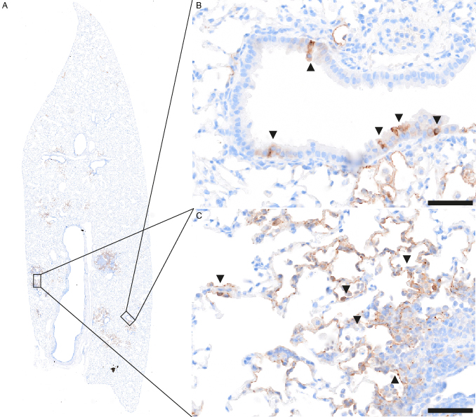
Supplementary Figure 8. Representative images of SARS-CoV antigen immunohistochemistry in lungs of hamsters (A-C). (A) Overview of the left lung lobe showing multifocal expression of viral antigen (brown signal). (B) Higher magnification of a bronchus with multiple individual immunolabelled cells (arrowheads). (C) Higher magnification of affected alveoli, showing numerous immunolabelled pneumocytes type 1 and single pneumocytes type II (arrowheads). Scale bars: 50 μm.

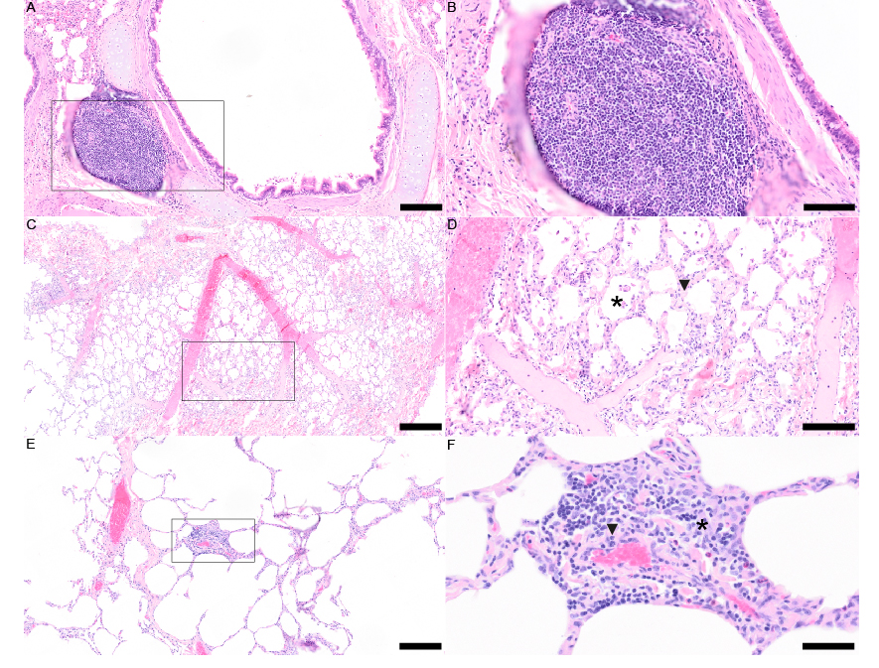

Supplementary Figure 9. Representative images of SARS-CoV-2 induced histopathological lesions in the lung of Rhesus Macaque (A) Overview of a main bronchus with associated lymphoid tissue (BALT) (B) Higher magnification of BALT showing a primary follicle structure composed of lymphocytes and histiocytes (C) Overview of a lung lobe showing multifocal consolidated areas (box). (D) Higher magnification of alveoli showing intraluminal (asterisk) and septal (arrowhead) infiltrates mainly composed of macrophages and neutrophils. (E) Overview of a lung lobe showing focal perivascular cuffing (box). (C, box) Higher magnification of vessel with endothelialitis (mitotic figure, arrowhead), mural and perivascular infiltrates composed of macrophages and neutrophils (asterisk). Scale bars A-C-E: 200 µm. Scale bars B-D: 50 µm. Scale bar F: 50 µm.

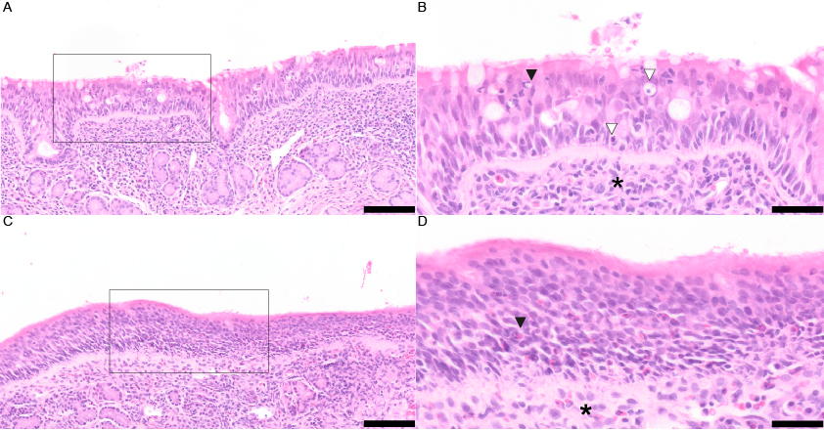
Supplementary Figure 10. Representative images of SARS-CoV-2 induced histopathological lesions in the nasal turbinates of Rhesus Macaque (A,C). B Higher magnification of the respiratory epithelium showing epithelial disorganization, cell death (white arrowheads), intraepithelial (black arrowhead) and subepithelial (asterisk) inflammatory infiltrates, composed of macrophages, lymphocytes and neutrophils. D Higher magnification of olfactory mucosa showing intraepithelial (black arrowhead) and subepithelial infiltrates of macrophages and neutrophils (asterisks) Scale bars A-C: 200 µm. Scale bars B-D: 50 µm.

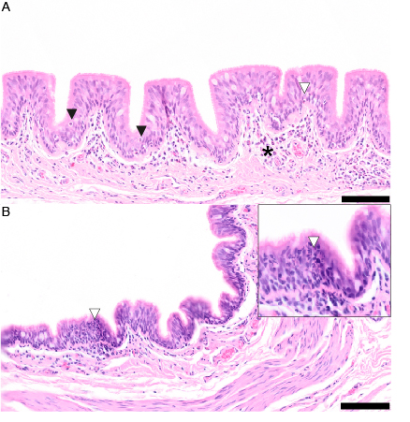
Supplementary Figure 11. Representative images of SARS-CoV-2 induced histopathological lesions in the extrapulmonary conductive airways of Rhesus Macaque (A) Tracheal respiratory epithelium showing cell death (black arrowheads), intraepithelial (white arrowhead) and subepithelial (asterisk) inflammatory infiltrates, composed of macrophages, lymphocytes and neutrophils. (B) extrapulmonary bronchial respiratory epithelium showing intraepithelial (white arrowhead) infiltrates of neutrophils (inset). Scale bars A-B: 200 µm.

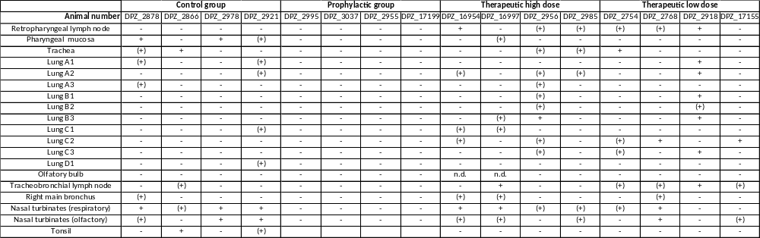
Supplementary Table 2. Virus isolation from NHP 4 days post infection for different sample sites. Read out after immunostaining against SARS-CoV-2. + isolation positive; (+) unclear result; - isolation negative

