Supplementary Information for
200-mm wafer scale integration of high performance polycrystalline MoS₂ thin film transistors
Junyoung Kwon,^{1†} Minsu Seol,^{1†} Joungeun Yoo,¹ Huije Ryu,^{1,} ² Dong-Su Ko,¹ Min-Hyun Lee,¹ Eun Kyu Lee,¹ Min Seok Yoo,¹ Gwan-Hyoung Lee,² Hyeon-Jin Shin,¹ Jeehwan Kim,^{1,3}* Kyung-Eun Byun¹*
¹Samsung Advanced Institute of Technology (SAIT), Samsung Electronics Co., Ltd., Suwon, Republic of Korea
²Department of Materials Science and Engineering, Seoul National University, Seoul, Republic of Korea
³Department of Mechanical Engineering, and Materials Science and Engineering, Massachusetts Institute of Technology, Cambridge, MA, USA
*Corresponding e-mail : jeehwan@mit.edu, ke14.byun@samsung.com,
†These authors equally contributed to this work

This file includes ;
1. 2D BEOL transistors for Monolithic 3D integration
2. Analysis of contact interfaces of bottom contact and top contact
3. Single crystal MoS₂ bottom contact FET preparation
4. Details on temperature-dependent electrical characterization
5. Details on 200 mm wafer scale fabrication of bottom contact MoS₂ FET array.
6. FET performance comparison of bottom contact FETs
7. Analysis of wafer scale device yield and uniformity
8. References

1. 2D BEOL transistors for Monolithic 3D integration (M3D)
By utilizing 2D FETs as back-end-of-line (BEOL) transistors for M3D, it becomes possible to easily transfer 2D semiconductors onto pre-patterned vias at a low temperature of less than 200 ºC without requiring additional contact formation processes. This leads to the achievement of a high-performance, cost-effective, and dense BEOL array. Moreover, the communication length between the front-end-of-line (FEOL) and BEOL transistors can be significantly reduced by directly connecting the BEOL 2D contacts to an internal via. To achieve a reduction in communication length, a bottom-contact technique-based internal via was employed. In the circuit, a longer via resulted in larger RC delays. As shown in Fig. S1, in the case of internal vias, no wasted transistor area was required for the intertier via, which indicated the availability of denser BEOL transistors.
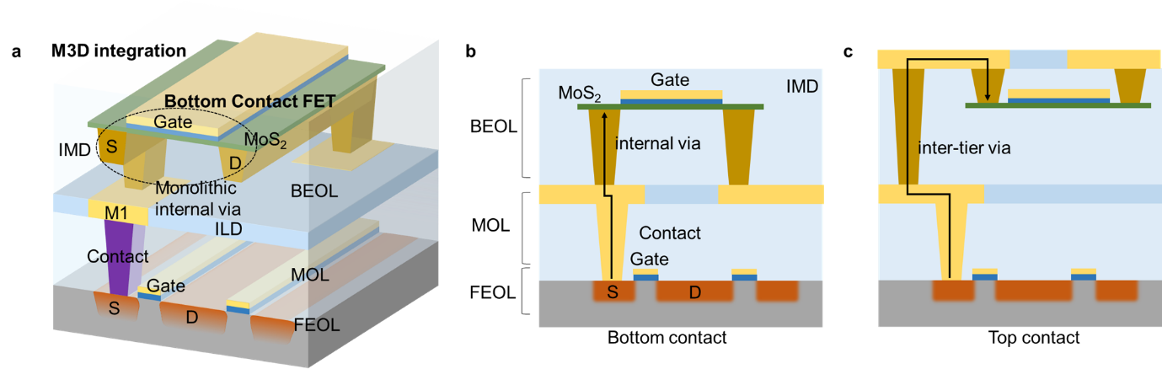
Figure S1. Advantages of 2D FETs for M3D integration
(a) Illustration of the advantages of 2D FETs for M3D. (b) Schematic showing the reduced communication length between FEOL and BEOL transistors. (c) Schematic demonstrating the communication length between FEOL and BEOL transistors fabricated using existing top contact techniques.

2. Analysis of contact interfaces of bottom contact and top contact
To compare the two different types of contacts between MoS₂ and Au fairly, we carefully prepared two intrinsic samples without any extrinsic contamination using complicated peeling-off methods designed for each case. To reproduce the top-contact interface, we deposited Au on the as-grown MoS₂. Then, we obtained the intrinsic backside of the top-contacted MoS₂ by simply peeling it off with PMMA/TRT. However, reproducing the intrinsic backside of MoS₂ in the case of a bottom contact was more difficult. First, we deposited Au on an SiO₂ substrate, where the adhesion between Au and SiO₂ was low. Subsequently, we peeled off Au using PMMA/TRT. We picked up the as-grown MoS₂ using the Au film, and finally, obtained the intrinsic surfaces of MoS₂. One of the samples reproduced the backside of the deposited Au contact, while the other reproduced the backside of the van der Waals Au contact.
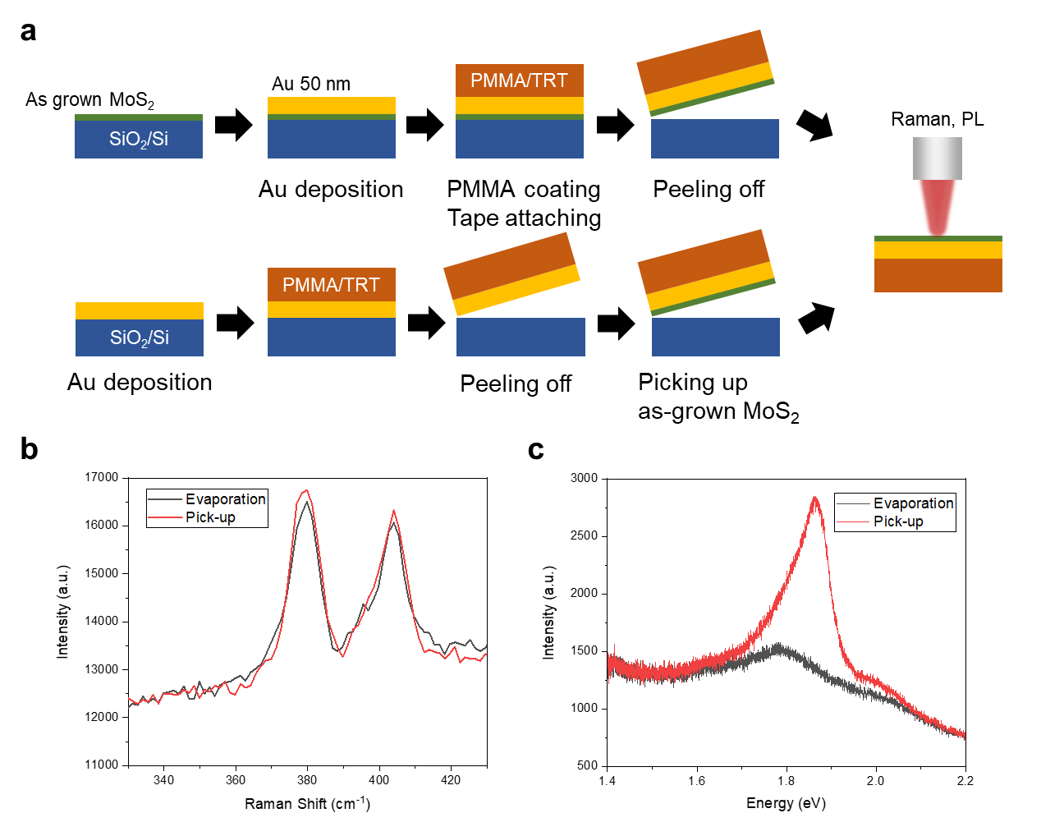

Figure S2. Raman and PL analysis for two different types of Au-MoS₂ contacts
(a) Sample preparation methods for analyzing the difference between top- and bottom-contacted MoS₂ using Raman and Photoluminescence (PL) spectra. The top reproduces the contact interface of the evaporated Au contact, while the bottom reproduces that of the picked-up Au contact with van der Waals (vdW) interface. (b) Raman spectra showing no difference between the two cases, indicating that the crystal structure of MoS₂ itself does not change with metal deposition. (c) Photoluminescence (PL) spectra for MoS₂ with evaporated Au (black) and picked-up Au (red). It is clearly shown that direct Au evaporation on MoS₂ strongly quenches the PL as the excitons dissipate quickly. However, the van der Waals type MoS₂ was not affected by Au, and the PL is still strong as the distance between them is longer than the deposited one.

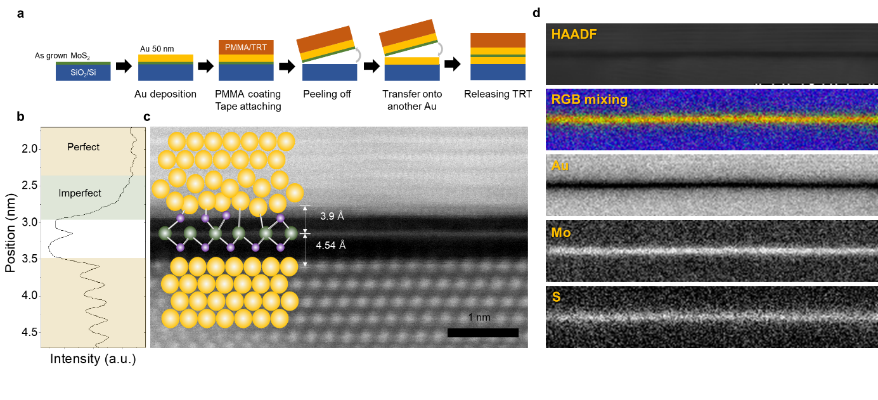
To perform a detailed comparison of the atomic distances and structures near the interface of the vdW and evaporated Au-MoS₂ contacts, we developed a highly controlled fabrication process for ultra-clean STEM imaging. As shown in Fig. S3a, the as-grown MoS₂ was first coated with a layer of Au via evaporation. The resulting films were then carefully picked up using TRT/PMMA and transferred onto another Au film. The PMMA was not removed and was instead utilized as a protective layer during FIB. This allowed us to image the sample using STEM without contamination from the wet PMMA removal process. The distance between the first layer of evaporated Au atoms and the Mo atoms of MoS₂ was found to be 3.9 Å, while the distance between the last layer of vdW Au and the Mo atoms was found to be 4.54 Å. This indicates that the vdW gap is approximately 0.5–0.6 Å. These parameters were used in the simulation shown in Fig. 2.

Figure S3. HAADF-STEM analysis on Au/MoS₂/Au sandwich structure (a) Schematics describing the sample preparation methods for analyzing the difference between a bottom-contact FET and a top-contact FET using high-angle annular dark-field scanning transmission electron microscopy (HAADF-STEM). The top interface is a deposited interface, and the bottom is a vdW interface that imitates the contact interfaces of a top- and a bottom-contact FET, respectively. (b) The intensity profiles of HAADF-STEM image in (c). The yellow region clearly shows peaks indicating the centers of Au atoms, while no clear peak is observed in the green region. When Au atoms are deposited onto the MoS₂ film, the strong interaction between Au and MoS₂ results in the imperfect crystal structure near the interface between top Au and MoS₂. The atomic distance between Mo and bottom Au is extracted as 4.54 Å by the profile, but the distance between Mo and top Au is unclear. (c) HAADF-STEM image of Au-MoS₂-Au showing the difference in atomic distance between the top and bottom interfaces. The image slightly shows the first layer of atoms of top Au, where the Mo-Au distance is approximately extracted as 3.9 Å, indicating that a vdW gap has a thickness of about 0.5–6 Å. (d) The topmost image is a HAADF-TEM image, and the second image is an elemental distribution maps acquired by electron energy loss spectroscopy (EELS) spectrum image showing the MoS₂ monolayer well-located between two Au layers. Au, Mo, and S atoms are depicted in blue, red, and green, respectively.
3. Single crystal MoS₂ bottom contact FET preparation
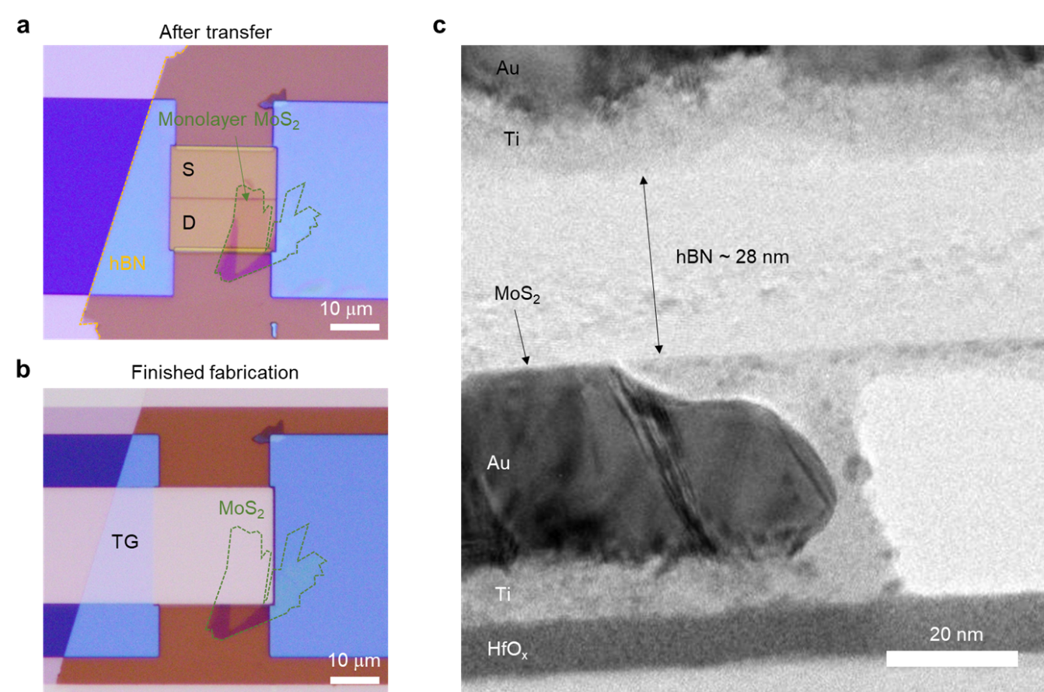
Single-crystal monolayer MoS₂ was obtained through conventional mechanical exfoliation of bulk MoS₂. To maintain a clean MoS₂ surface, it was picked up by a hexagonal boron nitride (hBN) flake.¹ Subsequently, the heterostructure was transferred onto a pre-patterned bottom electrode. The distance between the source and drain electrodes was approximately 100 nm, as it is more difficult to transfer the heterostructure onto electrodes with a wider gap due to the stiffness of hBN. The hBN layer was directly utilized as a top-gate dielectric. The details of the fabricated MoS₂ device are presented in Fig. S4, which includes optical microscopy (OM) and cross-sectional TEM images.

Figure S4. Optical image and cross-section TEM image of the single-MoS₂ bottom contact FET. (a) Optical image after pick-up transfer of MoS₂ by hBN onto bottom S-D electrode. Owing to the high stiffness of the hBN/MoS₂ heterostructure, conformal transfer is not available when the electrodes are far from each other. Instead, it is intentionally suspended by pre-patterned electrodes using e-beam lithography with a channel length of 130 nm. (b) Optical image of finished device after top gate electrode formation. (c) Cross-section TEM image of the same device. The MoS₂/hBN heterostructure is maintained to be flat after transfer and is suspended well. Furthermore, the thickness of hBN is measured to 28 nm.

4. Details on temperature-dependent electrical characterization
The shape of the output curves (I_{ds} - V_{ds}) provides qualitative information regarding the contact.
Fig. S5 shows that if the output curves obtained at room temperature have an S-shape, then it is evident that the device has a significant Schottky barrier. It can be observed that the FET with a conventional top contact with poly-MoS₂ has a lower barrier than contact with single-MoS₂. This is in agreement with the estimate obtained by comparing the curvatures of the output curves measured at 77 K, as presented in Fig. 2. The Schottky barrier height at the contact point was quantitatively determined from the temperature-dependent transfer curves, as depicted in Fig. S6. At a fixed gate voltage, we then plotted the ln(I_{ds}/T^{3/2}) versus 1000/T, as shown in Fig. S7, to determine the thermionic regimes, where the Schottky barrier can be extracted using the Arrhenius equation.
I_{ds}^{TE}=A*_{2D}T^{3/2}exp(-qϕ_{B}/kT)
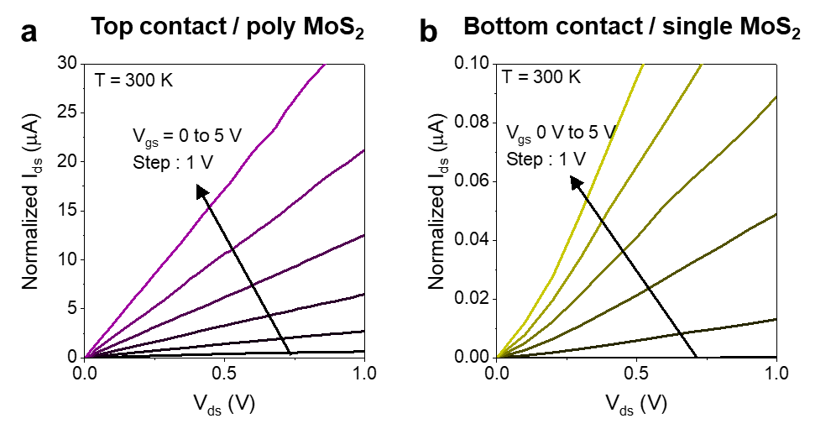
where k is the Boltzmann constant, T is temperature, A*_{2D} is the 2D Richardson constant, and _{B} is the barrier height. For 2D semiconductors, 3/2 rather than 2 is commonly used as the exponent of T.
Figure S5. Output curves of two different FETs with different contact combination. (a) Two FETs with top contact with poly-MoS₂ and (b) bottom contact with single-MoS₂ measured at 300 K. Due to higher Schottky barrier of bottom contact with single-MoS₂, the output curves are shown even at room temperature, while top contact with poly-MoS₂ became an Ohmic contact at 300 K.
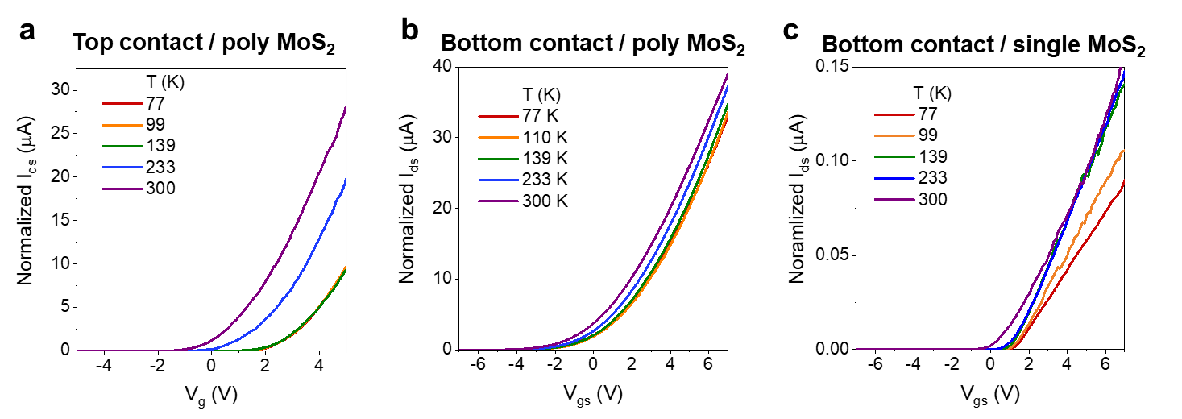
Figure S6. Temperature dependent transfer curves of 3 types of FETs. (a) Temperature dependent transfer curves of the top contact FET with poly-MoS₂. With increasing temperature, a dynamic negative V_{th} shift is observed over 139 K, which indicates that there is a significant barrier over which the effective Schottky barrier is lowered as thermal assisted tunneling or thermionic emission is activated over 139 K. (b) Temperature dependent transfer curves of the bottom contact FET with poly-MoS₂. They do not show significant changes in V_{th} with varying temperature, indicating that an only slight barrier exists. (c) Temperature dependent transfer curves of the bottom contact FET with single-MoS₂. The V_{th} shift starts between 233 K and 300 K, due to the large barrier. In addition, because of the clean nature of the single-MoS₂/hBN heterointerface, transition of the dominant scattering mechanism from optical phonon scattering to charged impurity scattering is clearly observed near 300 K where the slope of the curve starts to decrease. Hence, the 300 K curve shows different behavior compared with those of other curves.

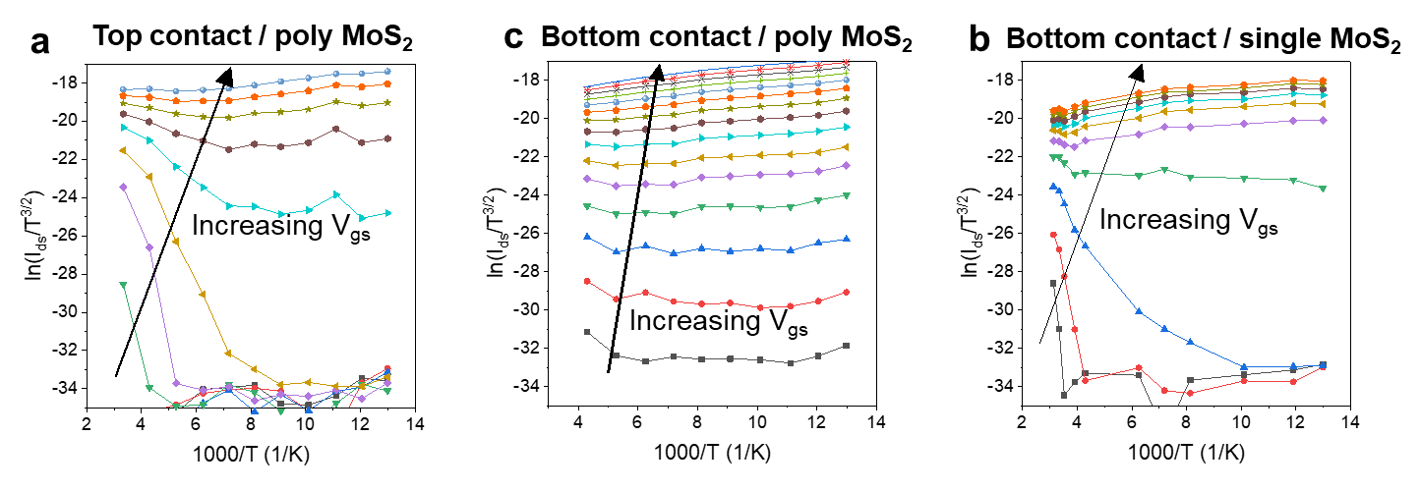
Figure S7. Arrhenius plots of 3 types of FETs. (a) Arrhenius plot of the top-contact FET with poly-MoS₂. (b) Arrhenius plot of the bottom-contact FET with poly-MoS₂. (c) Arrhenius plot of the bottom-contact FET with single-MoS₂. To draw an Arrhenius plot, the X- and Y-axes are recalculated as 1000 / T and ln (I_{ds} / T^{3/2}), respectively. After finding a linearly decreasing regime, which is a thermionic emission dominant regime, the Schottky barrier height (Φ_{SB}) at fixed V_{gs} is calculated by the slope (– qΦ_{SB}/kT), where q and k are the unit charge and Boltzmann’s constant, respectively. However, in the Arrhenius plot of (b), the linear regime is hardly shown, due to the slight thermionic emission through the near-zero Φ_{SB}. After iterating it for various V_{gs}, the Φ_{SB} versus V_{gs} is obtained as shown in Fig. 2.

5. Details on 200 mm wafer scale fabrication of bottom contact MoS₂ FET array.
This section describes the process used to fabricate bottom-contact FETs on a 200 mm wafer. Initially, deep etching of Si was carried out to form alignment marks on the bare Si wafer. Then, a 100-nm-thick SiO₂ was formed by thermal oxidation to insulate the top devices from the substrate. To enhance adhesion to MoS₂, 10 nm of HfO_{x} was deposited via atomic layer deposition (ALD). The bottom-contact electrodes were patterned using a stepper and Ti/Au e-beam evaporation. AZ5214, an image-reversal PR, was utilized to form rabbit ears at the sides of the electrodes, which prevented severe tearing of MoS₂. The heights of the bottom-contact electrodes were carefully designed. When the metal thickness exceeded 30 nm, MoS₂ transfer became difficult, resulting in decreased yield and field-effect mobility of FETs, as shown in Fig. S9. The top surface of Au underwent harsh cleaning, such as high-temperature O₂ ashing, to remove all organic contaminants. The MoS₂ peeled off from the as-grown substrate using TRT/PMMA was then transferred. As mentioned in the main text, the automatic transfer machine played an essential role in obtaining high yield and uniformity. Finally, 20 nm of AlO_{x} was deposited using ALD as the top dielectric, and the top-gate electrodes were patterned, deposited, and lifted off using the same process as for the bottom-contact electrodes.
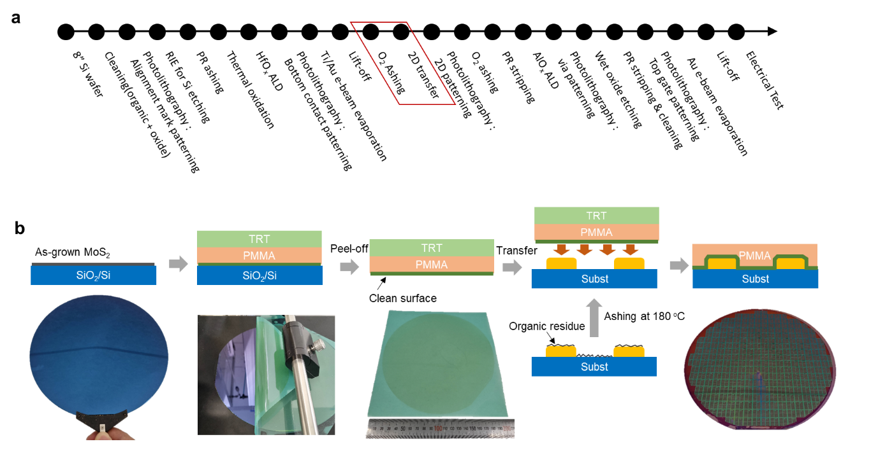
Figure S8. Fabrication process of bottom-contact FETs on 200 mm wafer. (a) Process flow for fabrication of bottom-contact FET in the 8-inch clean room facilities. (b) Detailed transfer process indicated by red box in (a). Bottom electrode is cleaned by O₂ plasma to remove contaminants at the interface between Au and pristine surface of MoS₂. Furthermore, the semi-auto transfer process produces uniform and repeatable device performances.

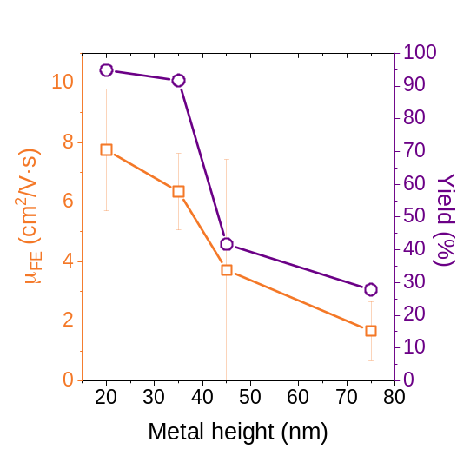
Figure S9. Effect of bottom electrode height on mobility and yield of bottom contact FETs. To optimize metal height of bottom electrodes, four wafers with different metal heights of 20, 35, 45, and 75 nm are fabricated in the same batch. They contain 5-nm-thick Ti as an adhesion layer in common, making the difference with Au thickness. Both field-effect mobility (μ_{FE}) and yield decrease as metal height increases, indicating that conformal transfer is critical for bottom contact FETs. Hence, if the bottom electrodes are totally buried in the substrate, then obtaining higher mobility and yield is expected.

6. FET performance comparison of bottom contact FETs
The bottom contact with poly-MoS₂ which underwent 200 mm fabrication, boosted the resulting FET performance compared with various other devices. Additionally, the carrier density can be further enhanced by scaling the EOT. If we use 10 nm of HfO_{x} as the top-gate dielectric rather than 20 nm of AlO_{x}, the on-current can be boosted to 120 μA/μm, as shown in Fig. S10. Furthermore, the performance of the bottom-contact FET with poly-MoS₂ is similar to that of the top-contact FET with single-MoS₂. (Fig. S11)
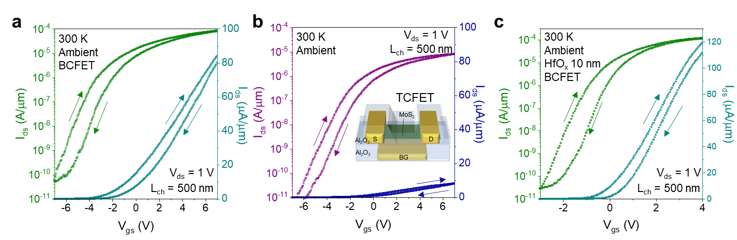
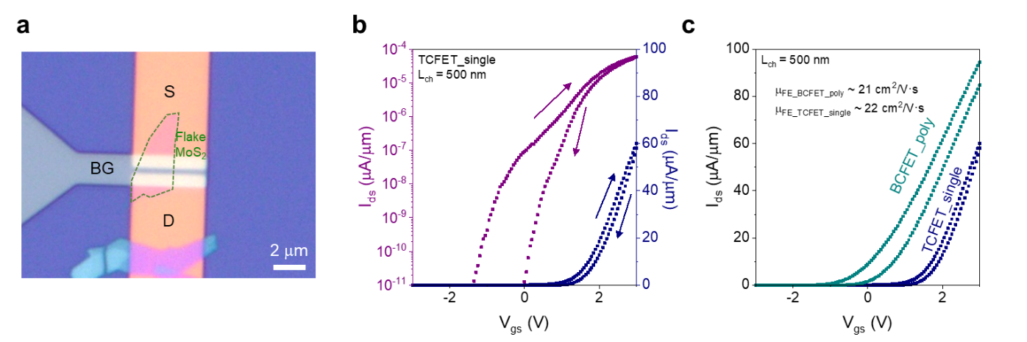
Figure S10. Comparison of bottom contact and top contact devices. (a) Transfer curves of bottom contact FET plotted in linear scale (cyan) and semi-log scale (green) (b) Transfer curves of top contact FET plotted in linear scale (navy) and semi-log scale (purple). (c) Transfer curves of bottom contact FET with HfO₂ 10 nm top gate dielectric plotted in linear scale (cyan) and semi-log scale (green). Here, I_{on} is enhanced to 120 μA/μm with μ_{FE} of 21 cm²/Vs as more charges can be accumulated.
Figure S11. Comparison of bottom-contact FET with single-MoS₂ top-contact FET. (a) Optical image of a top-contact FET with a single crystalline MoS₂ flake. The channel length and width are 500 nm and 3.2 um, respectively. (b) Transfer curves of a single-MoS₂ top contact FET plotted in semi-log (violet) and linear (navy) scale. (c) Comparison of the poly-MoS₂ bottom contact FET with the single-MoS₂ top-contact FET. The bottom-contact FET shows slightly higher I_{on} than the top-contact FET with similar μ_{FE}.

7. Analysis of wafer scale device yield and uniformity
With the implementation of well-designed fabrication processes, it is possible to obtain a high yield and uniformity of over 200 mm wafer FETs. Despite the use of almost the same facilities for fabrication and the total device geometry being similar, there exists a significant difference between the contact FETs and top-contact FETs, as mentioned in the main text. The primary reason for this difference is the ultraclean and highly adhesive bottom contact. Additionally, the use of a semiautomatic process plays a significant role in achieving high yield and uniformity. We conducted a comparison between two transferred MoS₂ films: one was manually transferred while the other was transferred using a semi-automatic transfer machine. The semi-automatic transfer machine helped detach and attach the films at a constant velocity. Otherwise, the velocity would not be regular during manual transfer, causing large holes and cracks in the MoS₂, as depicted in Fig. S13.
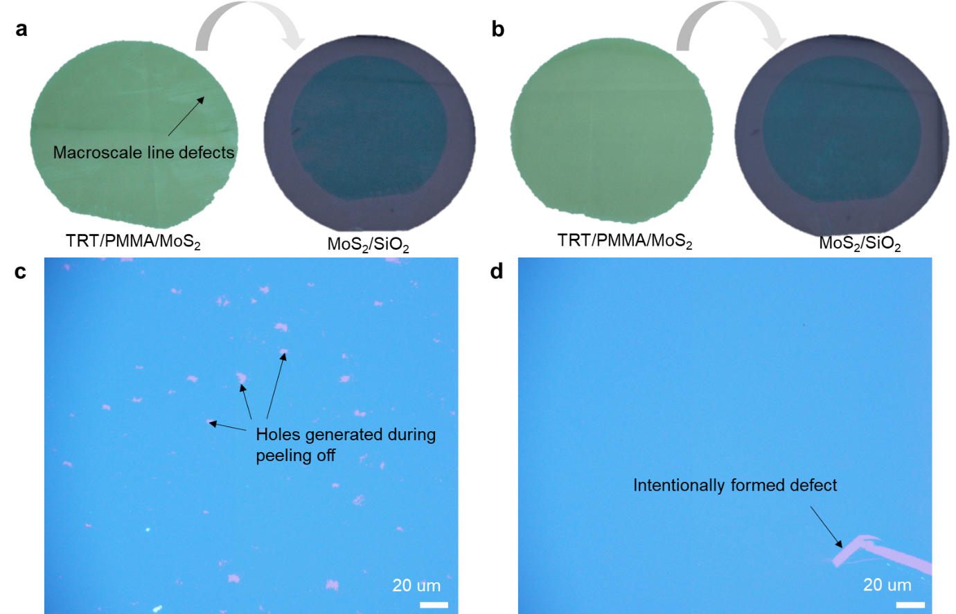

Figure S13. Comparison of manually transferred MoS₂ and automatically transferred MoS₂. (a) Camera pictures of MoS₂ films after being peeled off (left) and after transfer (right) following manual processes. (b) Camera pictures of MoS₂ films after being peeled off (left) and after transfer (right) following semi-automatic processes. The macroscopic cracks are observed only on the manually transferred MoS₂. (c) Optical microscopy image of manually transferred MoS₂ (d) Optical microscopy image of automatically transferred MoS₂. Holes with a size of tens of micrometers are observed only in the manually transferred sample, while no defects exist in the automatically transferred one.

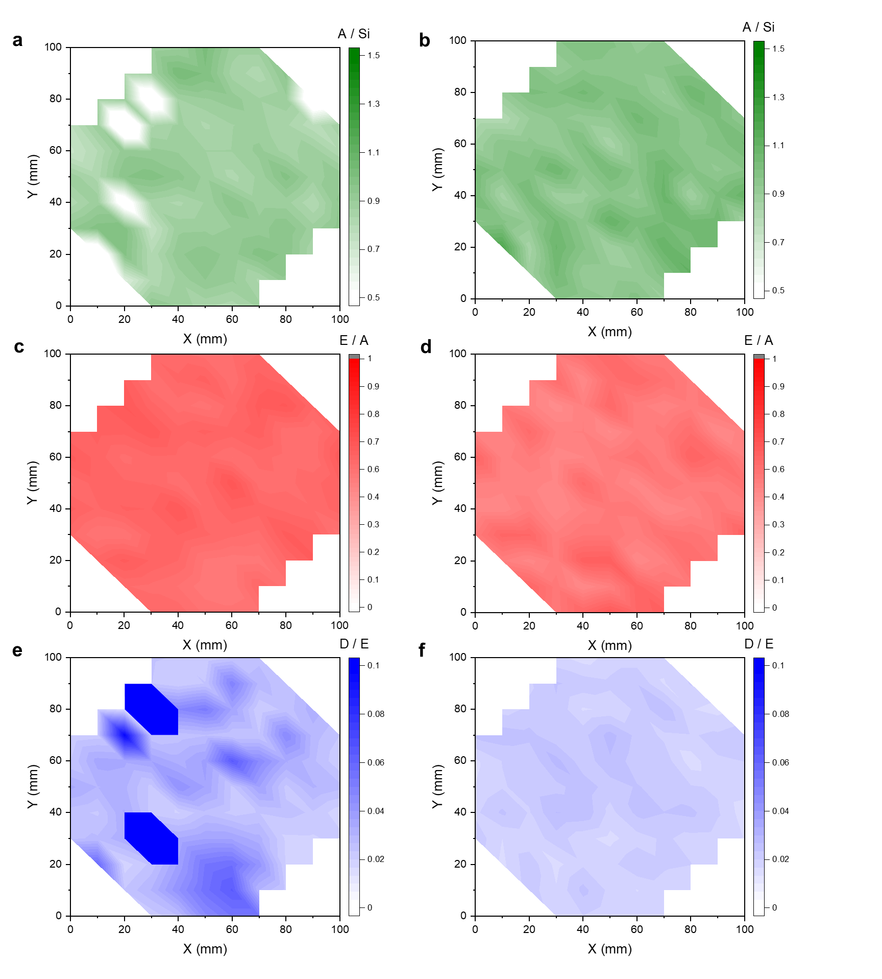
Figure S14. Raman mapping images of MoS₂ for comparison between manual and automatic transfer. (a) A_{1g} peak height maps of manually transferred MoS₂ and (b) automatically transferred one. Overall, the manually transferred sample appears similar to the automatically transferred sample, but they contain several missing points throughout. (c) E_{2g} peak height to A1 peak height ratio of manually and (d) automatically transferred MoS₂. Given the similarity between the two maps, no difference in the quality of the samples is observed. (e) D peak to E_{2g} maps of manually transferred MoS₂ and (f) automatically transferred MoS₂. The D mode is often used as a diagnostic tool for assessing the quality of MoS₂ samples. The relatively high and non-uniform D peaks observed in the manually transferred MoS₂ means that it has more mechanical disorders than the automatically transferred one.² Raman mapping was performed in a 10 cm x 10 cm area. The X and Y step size is 10 mm.

8. References
1. Pizzocchero, F. et al. The hot pick-up technique for batch assembly of van der Waals heterostructures. Nat. Commun. 7, 11894 (2016).
2. Mak, K. F., Lee, C., Hone, J., Shan, J. & Heinz, T. F. Atomically Thin MoS₂ : A New Direct-Gap Semiconductor. Phys. Rev. Lett. 105, 136805 (2010).

