Supplementary material

Annual/periodic variation of selected gaseous pollutants in Astana (Kazakhstan) and source identification for PM_{2.5} and SO₂ via conditional bivariate probability function

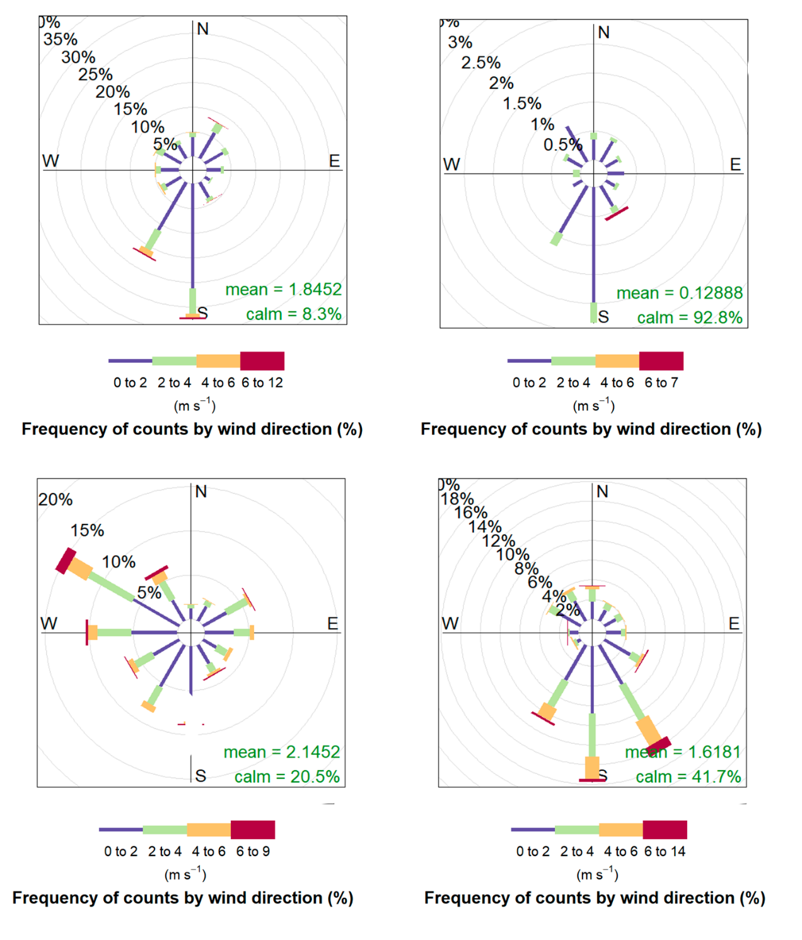
S1. Pollution profiles of TSP and selected gaseous pollutants (SO₂, CO, NO₂, HF)
Figure S1: Windrose diagrams for (a) S1, (b) S2, (c) S3, and (d) S4
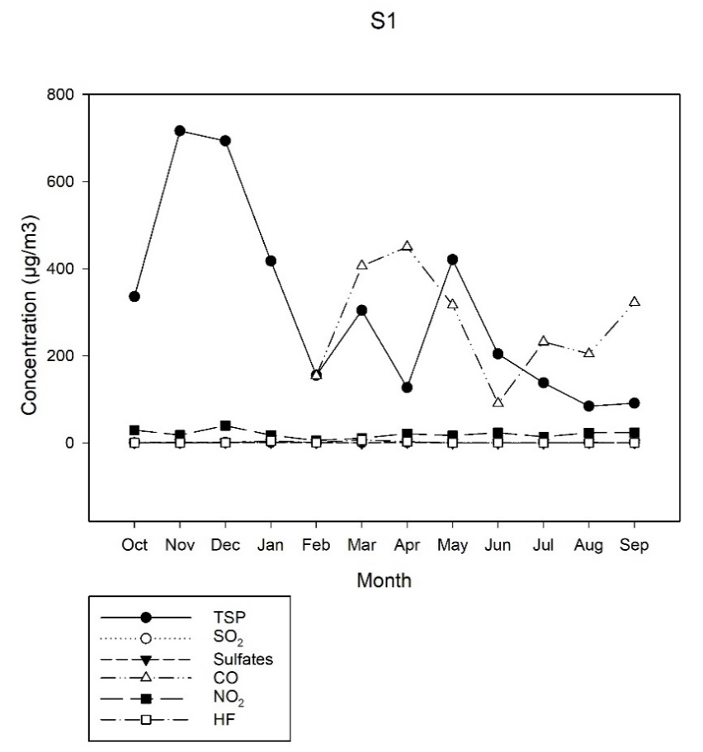
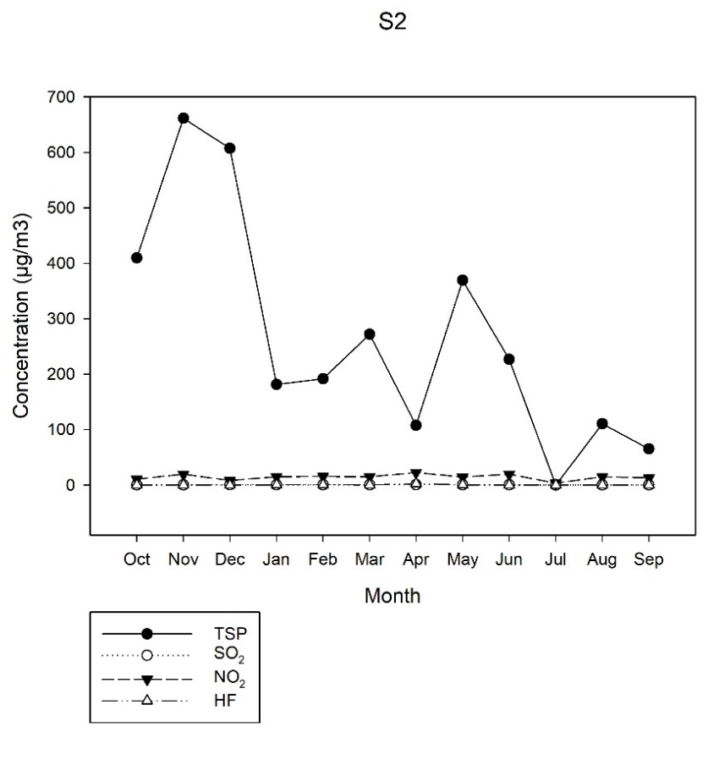
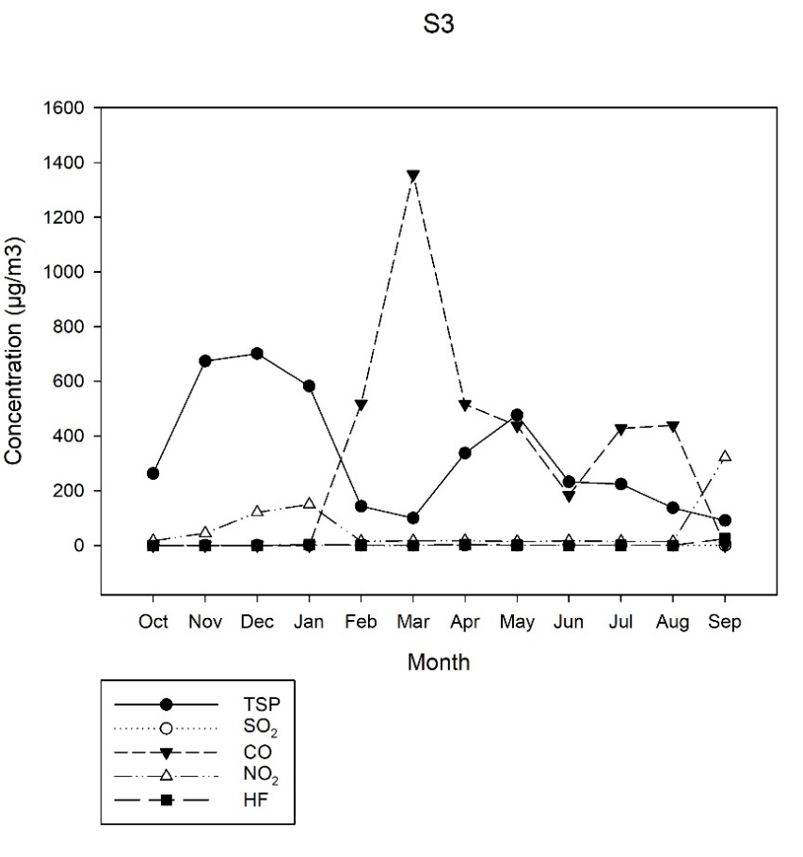
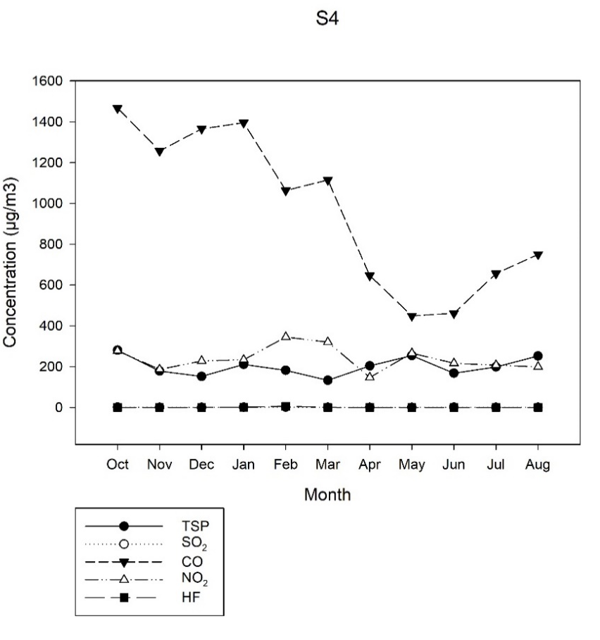
Figure S2: Average monthly concentrations (µg/m³) of TSP, SO₂, sulfates, CO, NO₂, and HF (S1, S2, S3, S4) in 2018-2019
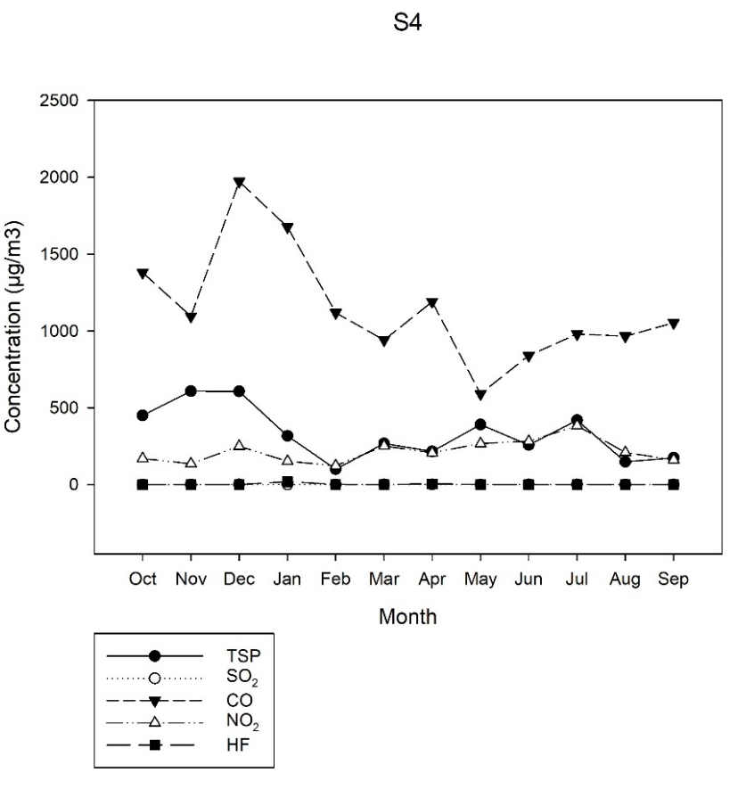
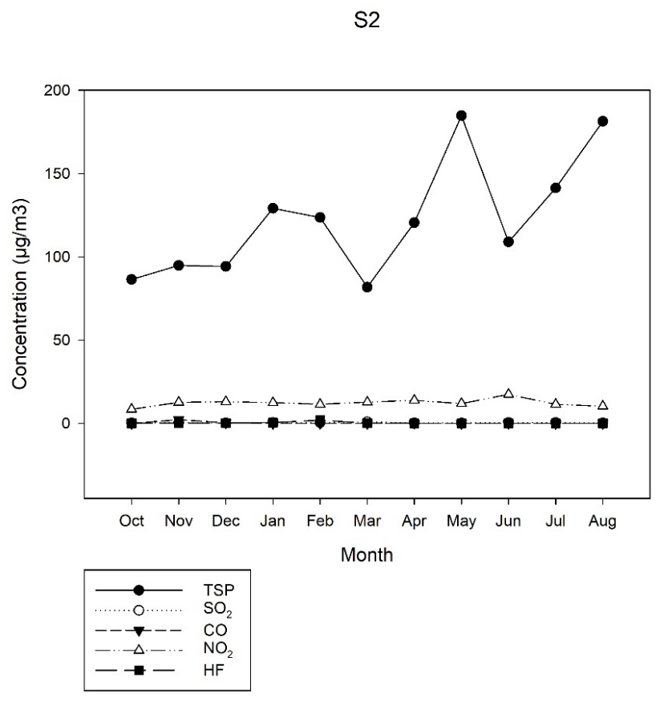
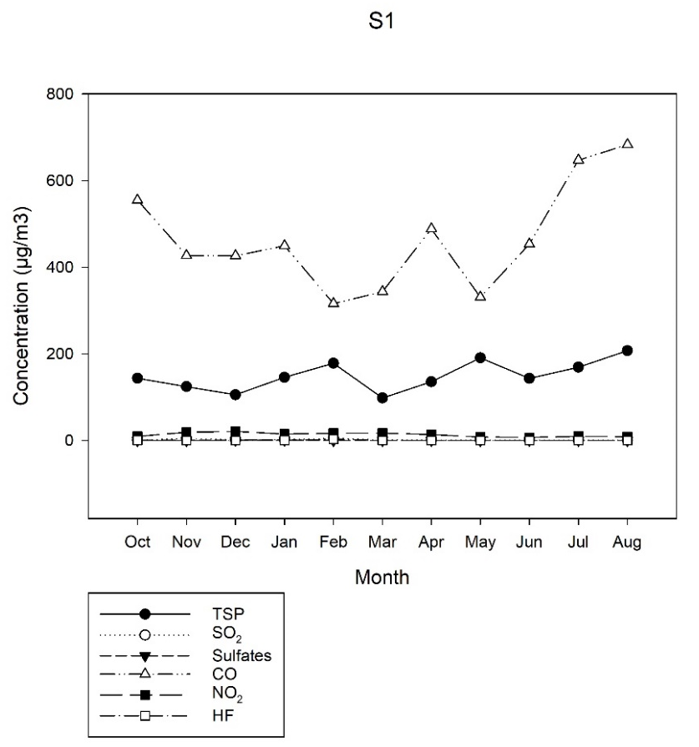
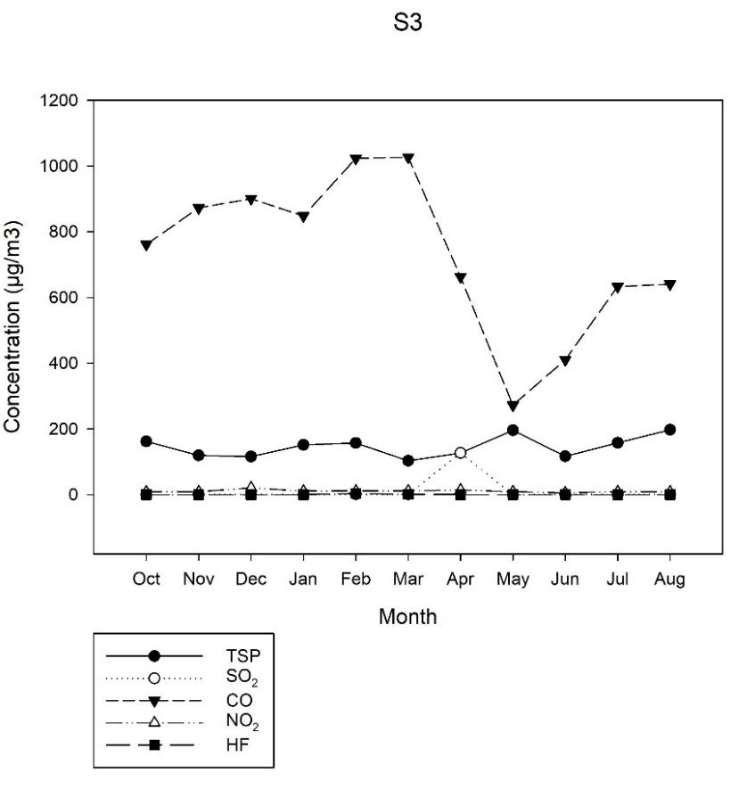
Figure S3: Average monthly concentrations (µg/m³) of TSP, SO₂, sulfates, CO, NO₂, and HF (S1, S2, S3, S4) in 2019-2020
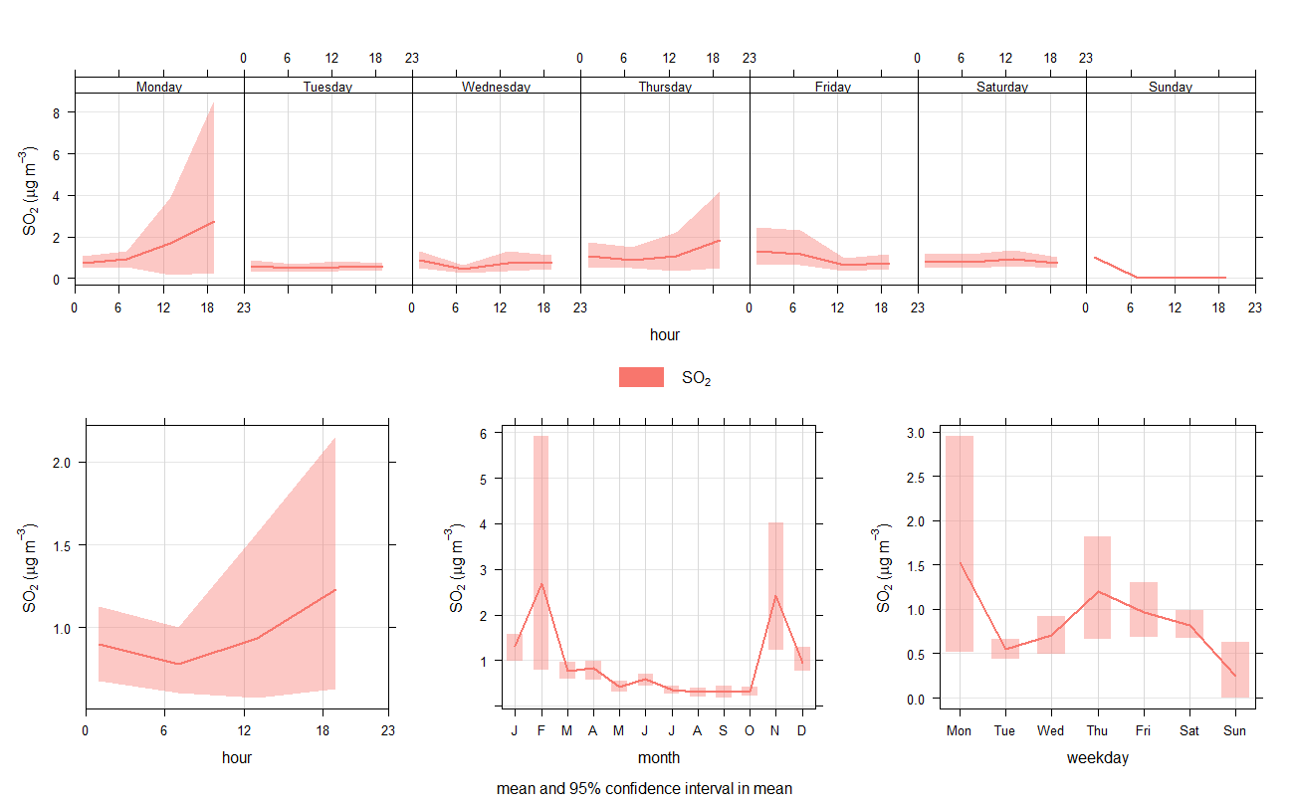
Figure S4: Diurnal and monthly variations of SO₂ (S1) concentrations for 2018-2020

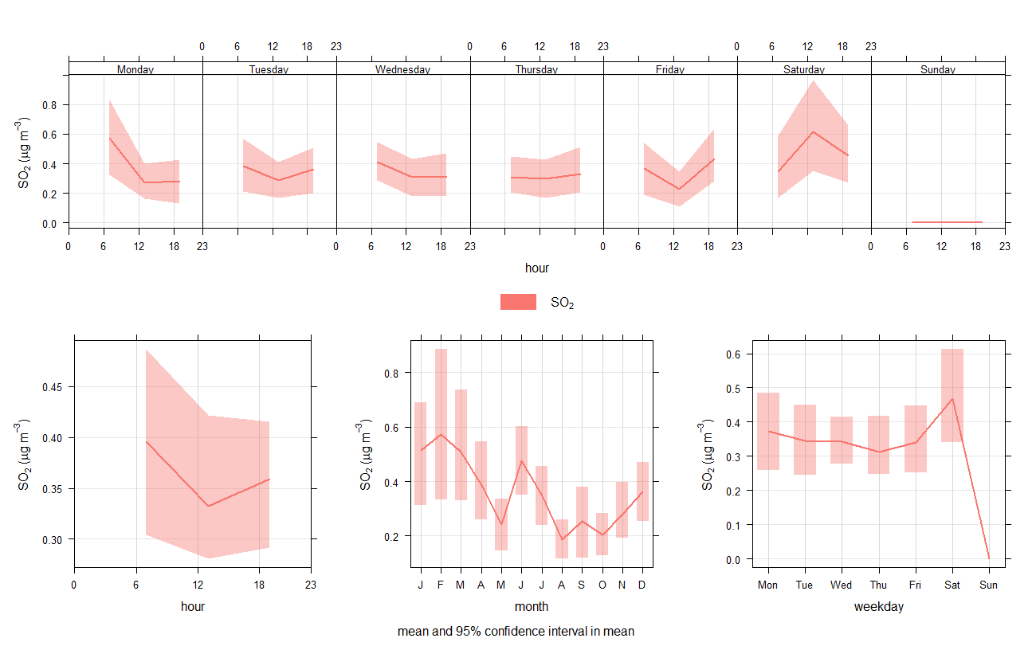
Figure S5: Diurnal and monthly variations of SO₂ (S2) concentrations for 2018-2020

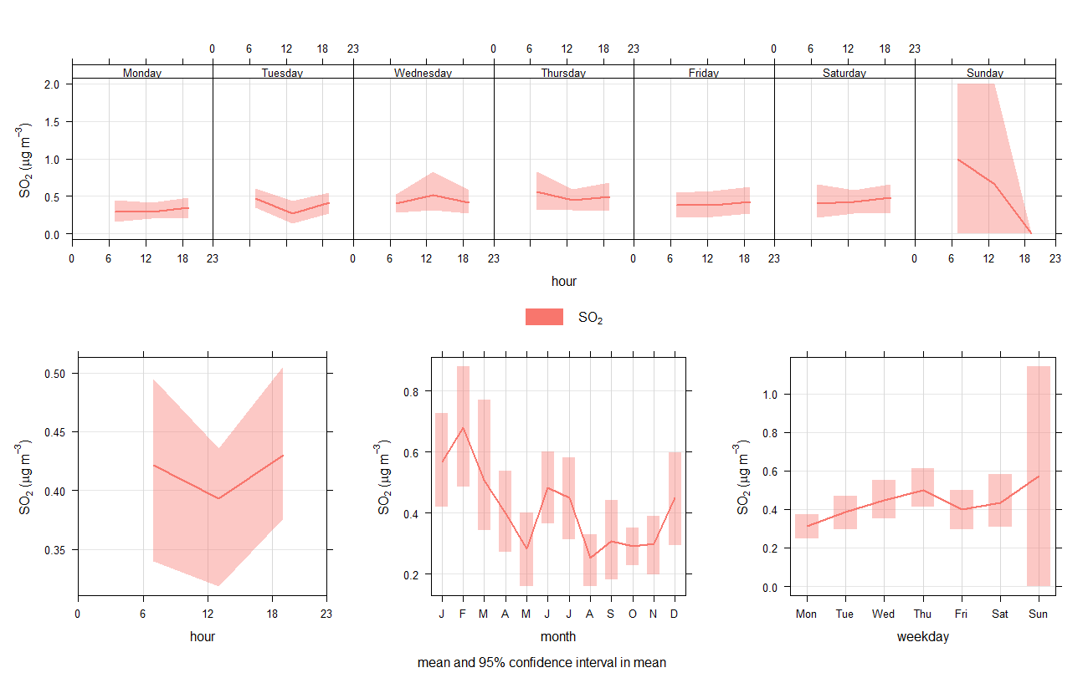
Figure S6: Diurnal and monthly variations of SO₂ (S3) concentrations for 2018-2020

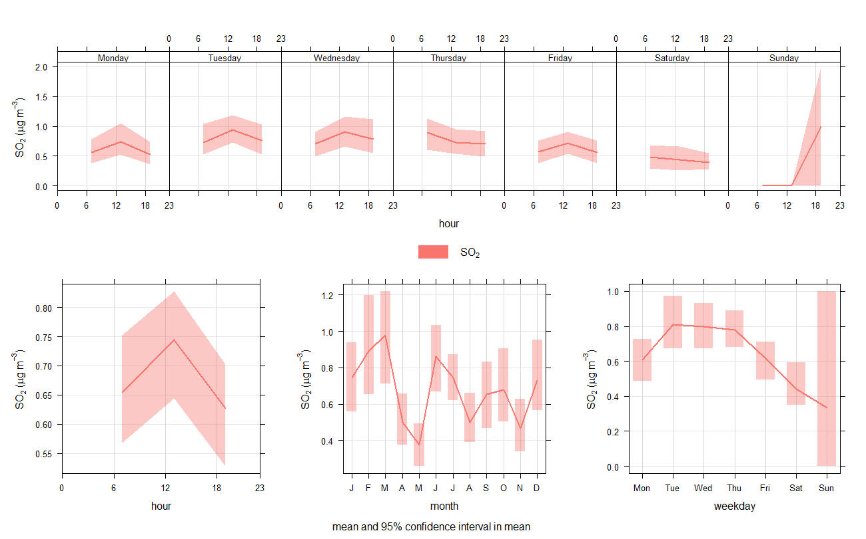

Figure S7: Diurnal and monthly variations of SO₂ (S4) concentrations for 2018-2020

S2. Potential sources of SO₂

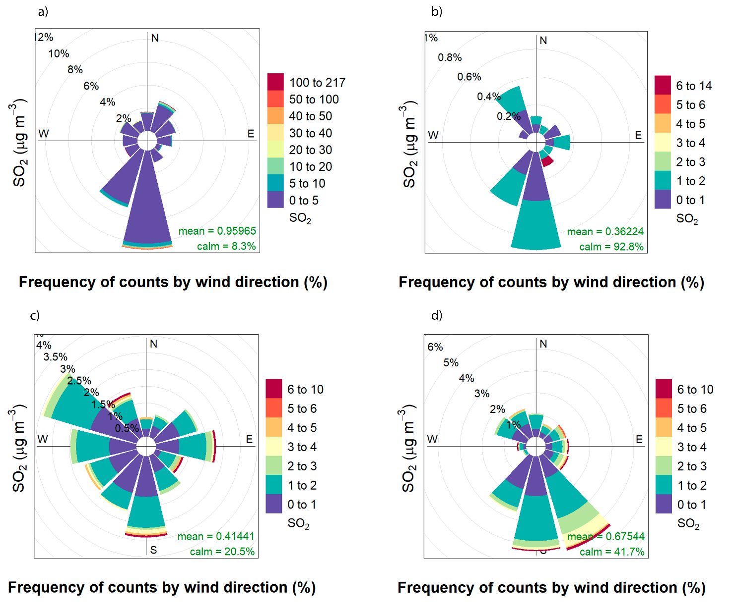
Figure S8: Pollution rose diagrams of SO₂ concentrations for (a) S1, (b) S2, (c) S3, and (d) S4

