Graphical abstract
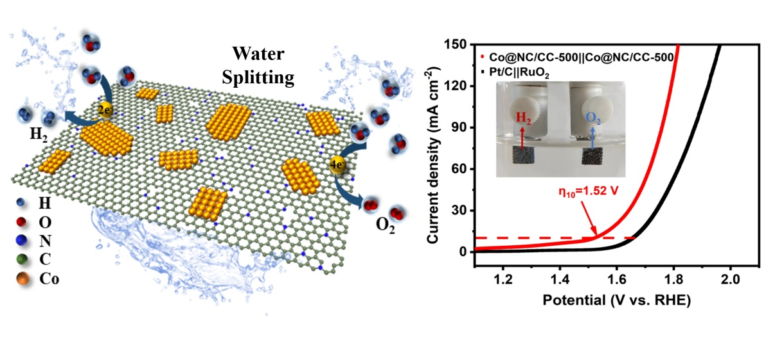

In order to improve the problems of spatial blockage of Co-N active sites and low N doped content in ZIF-67-derived Co-N-C catalyst, 2D porous ultra-high N-doped content (12 at%) carbon nanosheets decorated with a large number of Co nanoflakes catalysts (Co@NC/CC-500) were obtained by low-temperature pyrolysis of 2D ZIF-67.
Benefiting from the high content of exposed Co-N active sites and porous structure, the bifunctional Co@NC/CC-500 catalyst shows superior HER and OER performance for overall water splitting (E_{η10} = 1.52 V).

