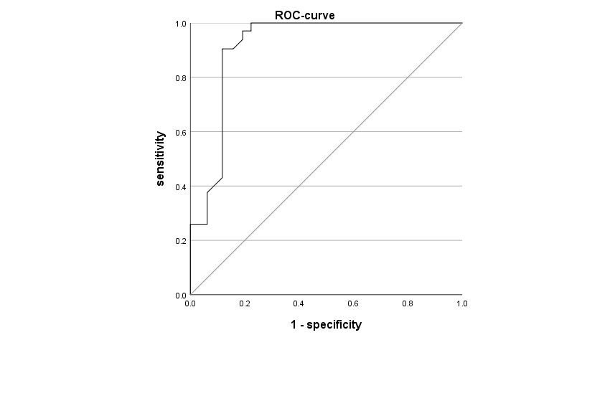

Abbreviations: TI: time interval, AUC: Areas under the curve, ROC: Receiver operating characteristic

