Supporting Information
M. Liu¹†, Z. Wang¹†, Dr. F., Wang^{1,2}, G. Zhao¹, H. Zhu¹, Z. Jia¹, Dr. T. Qin¹, Prof. F. Kang¹, Prof. C. Yang¹*
¹Institute of Materials Research, Tsinghua Shenzhen International Graduate School, Tsinghua University, Shenzhen 518055, China
Email: yang.cheng@sz.tsinghua.edu.cn
Dr. F. Wang
²Shenzhen Institute of Advanced Electronic Materials, Shenzhen Institute of Advanced Technology Chinese Academy of Sciences, Shenzhen, 518055, China
*Corresponding author. Email: yang.cheng@sz.tsinghua.edu.cn;
This PDF file includes:

Supplementary Figure 1–16
Supplementary Tables 1–4
Supplementary Discussion (Figure 3, Figure 11, Table 2 )
References

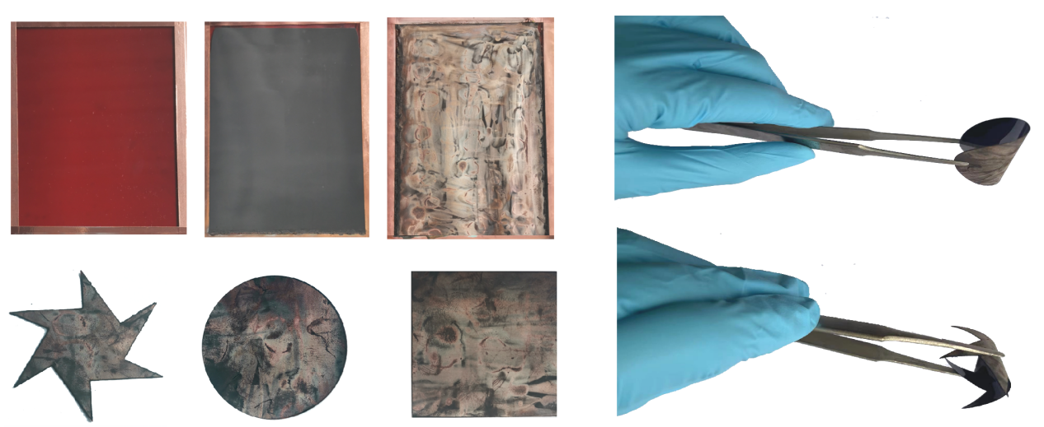
A
B
C
Supplementary Figure 1. (A) PI , LIG and rGO/LIG@NiFe₂O₄ physical photos. (B) Bending diagram for rGO/LIG@NiFe₂O₄ composite films. (C) Diagram of arbitrary cutting of rGO/LIG@NiFe₂O₄ composite film.

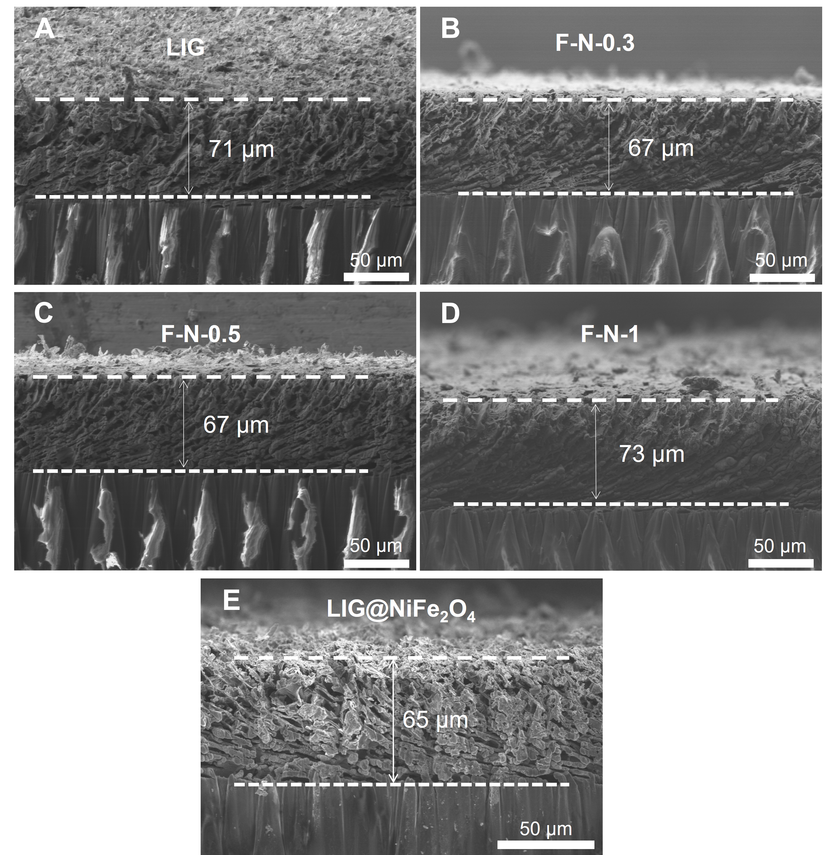
Supplementary Figure 2. Cross-sectional SEM images of LIG, LIG@NiFe₂O₄ and different rGO/LIG@NiFe₂O₄ samples

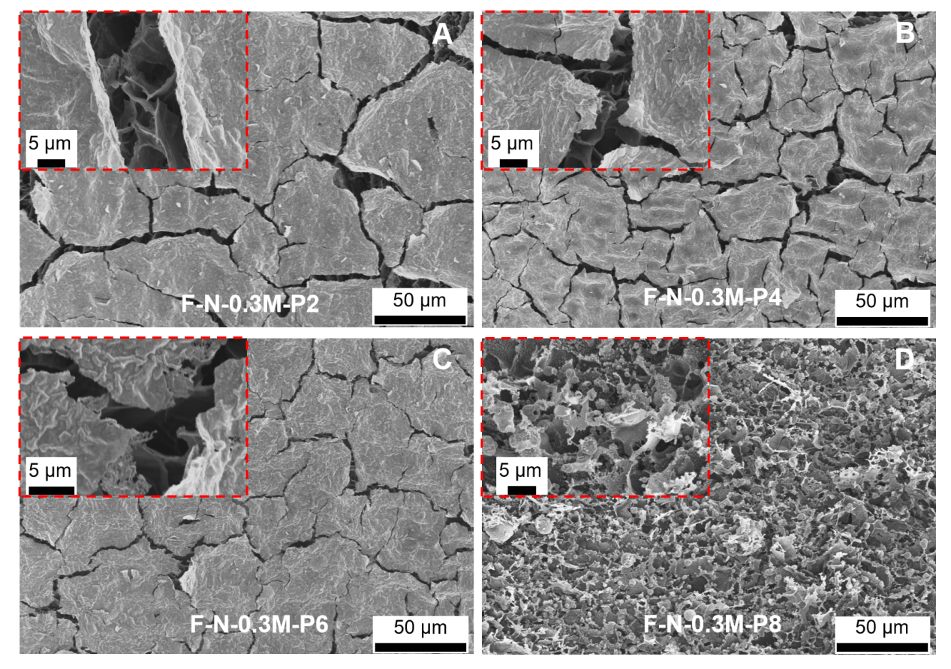
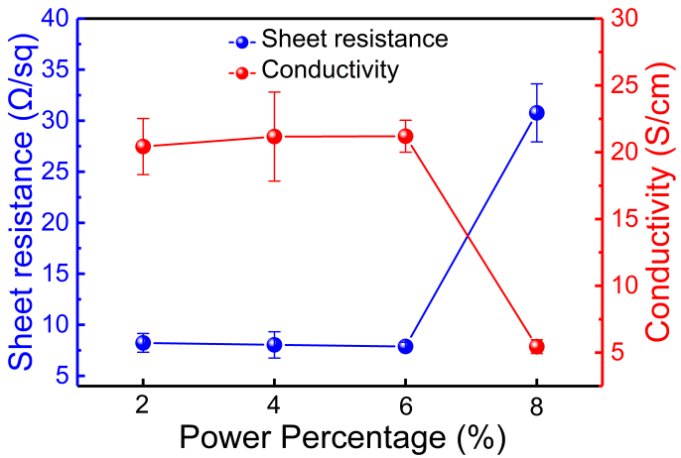
E

Supplementary Figure 3. (A-D) SEM images and (E) conductivity variation images of rGO/LIG@NiFe₂O₄ samples under different laser power percentages. (Note: xM in F-N-xM-Py represents the precursor salt concentration and Py represents the percentage of laser power)

Given the important influence of laser power on the reduction of GO and the generation and loading of nanomaterials, this variable has been carefully studied and determined. It can be seen (Supplementary Fig. 3A, B, C, D and E) that different laser power outputs can lead to different overall morphology and conductivity of rGO/LIG@NiFe₂O₄. As marked in SEM plots (Supplementary Fig. 3A, B, C and E), when the laser power output increases from 2% to 6%, the conductivity of rGO/LIG@NiFe₂O₄ gradually increased, and rGO remained flat on the surface of the LIG, protecting the integrity of LIG. In addition, the surface of rGO showed a large number of chaps due to the escape of gases generated during the preparation of the rGO/LIG@NiFe₂O₄ composite film. Since GO is almost insulating (5×10⁻⁶ S∙cm⁻¹ and 4×10⁻³ S∙cm⁻¹)^{1,2}, the overall high conductivity of rGO/LIG@NiFe₂O₄ can indicate that GO is successfully transformed into rGO. Compared with LIG, the electric conductivity of rGO/LIG@NiFe₂O₄ is slightly lower, which may be caused by the loading of NiFe₂O₄ on LIG with relatively poor electric conductivity. When the laser energy increased to 8%, the surface GO was burned and the structure of the internal LIG was also destroyed. The conductivity of rGO/LIG@NiFe₂O₄ dropped sharply compared to LIG. This indicates that a power percentage of 6% (4.22 W) is more favorable for the synthesis of the structure of the material and the reduction of GO. Ultimately, the structural integrity of LIG can be achieved to ensure that the conductivity is not greatly affected, while achieving uniform generation and loading of metal oxide nanoparticles onto the LIG and GO.

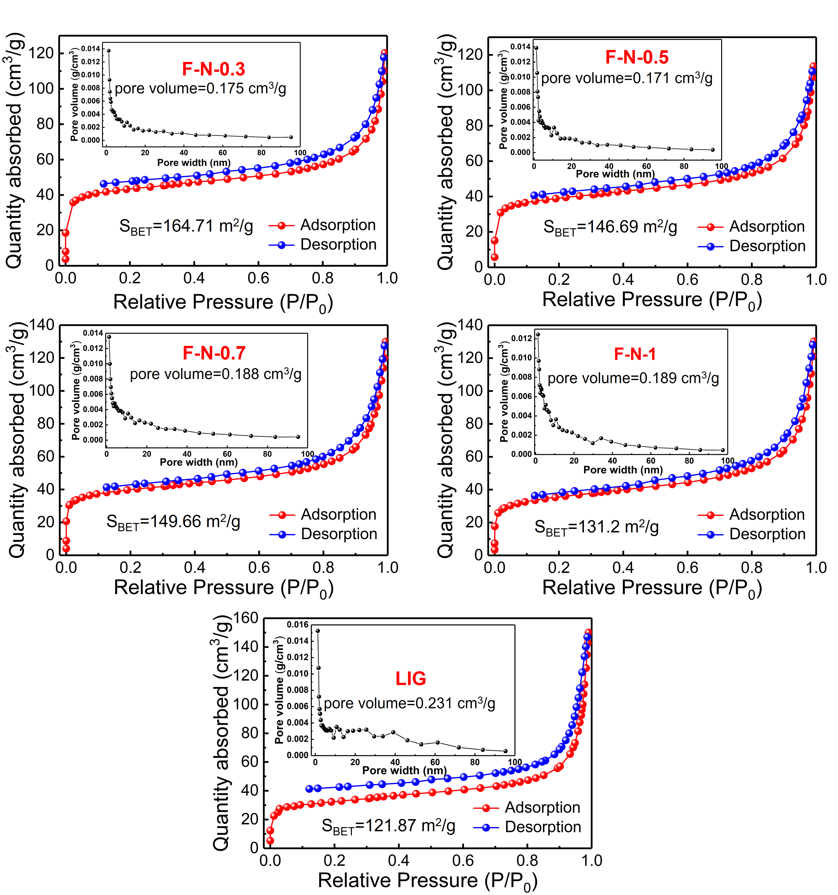

Supplementary Figure 4. Nitrogen adsorption and desorption curves of LIG and different rGO/LIG@NiFe₂O₄ samples.

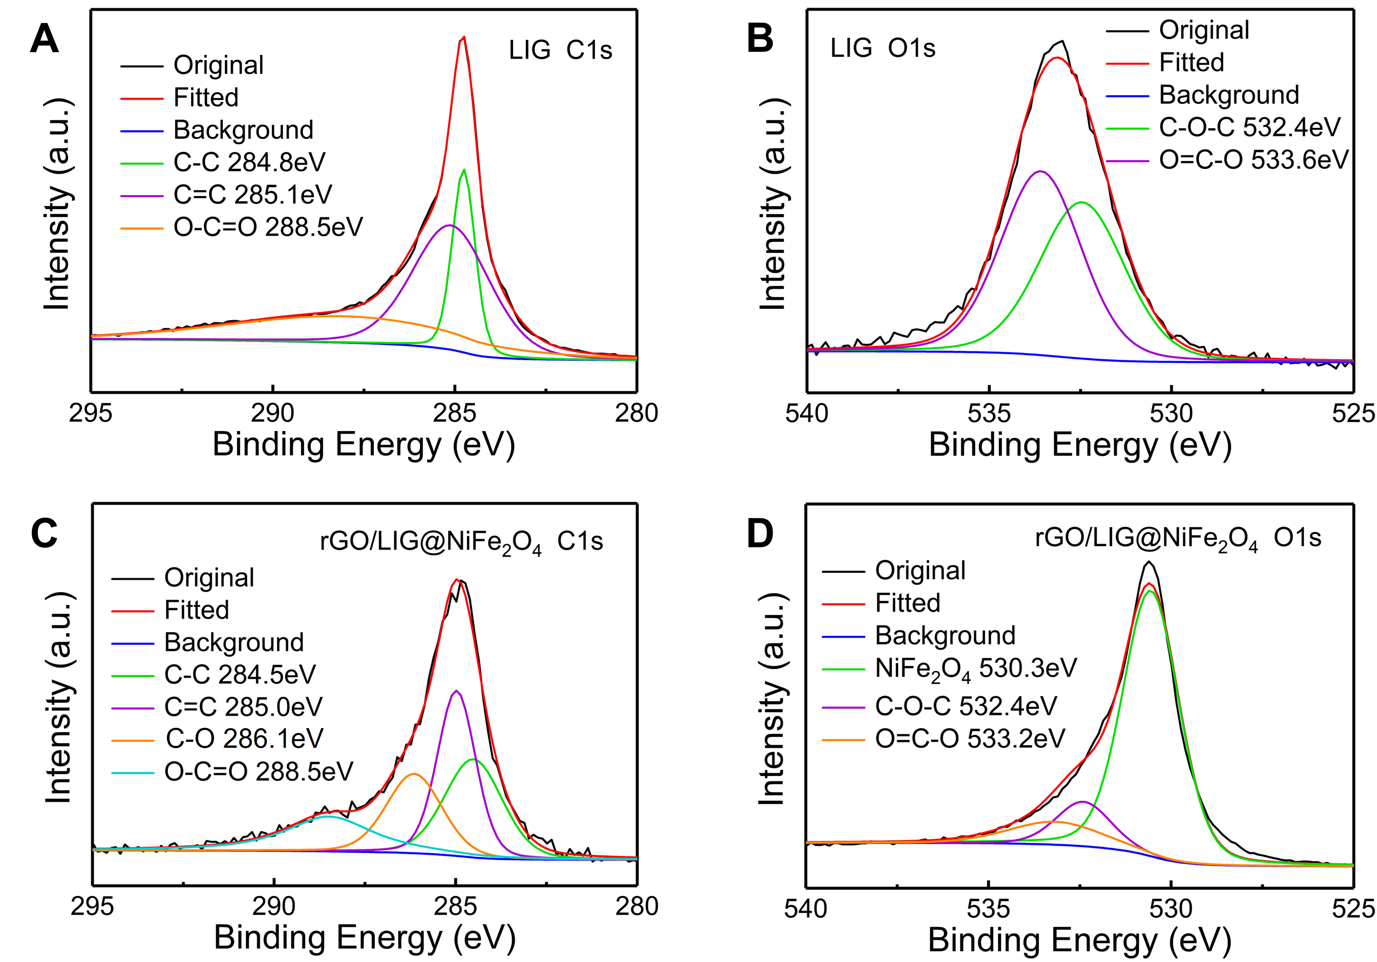
Supplementary Figure 5. XPS of LIG (A) C1s (B) O1s and rGO/LIG@NiFe₂O₄ (C) C1s (D) O1s.

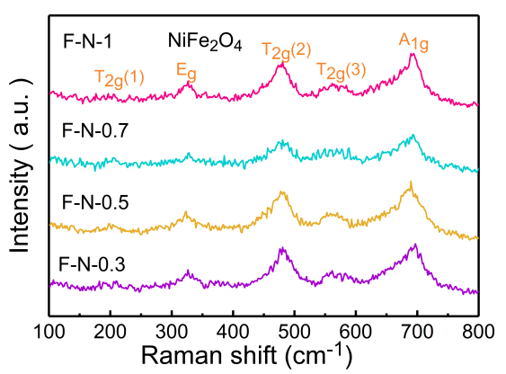
Supplementary Figure 6. Raman spectra of the NiFe₂O₄ nanoparticles.

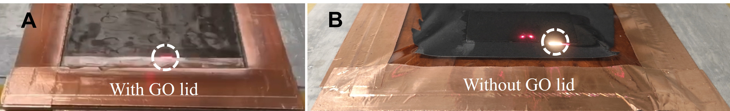
Supplementary Figure 7. (A-B) Photographic images of the laser preparation process of rGO/LIG@NiFe₂O₄ (F-N-0.7) and LIG@NiFe₂O₄. Both conditions used the same laser processing parameters, specifically: a scanning speed of 250 mm s⁻¹, a scanning pitch of 0.005 mm, and a power percentage of 6% (The power was 2.43 W).
(Note: The two red dots in Supplementary Figure 7B are laser positioning marks, which have no effect on the experimental results)

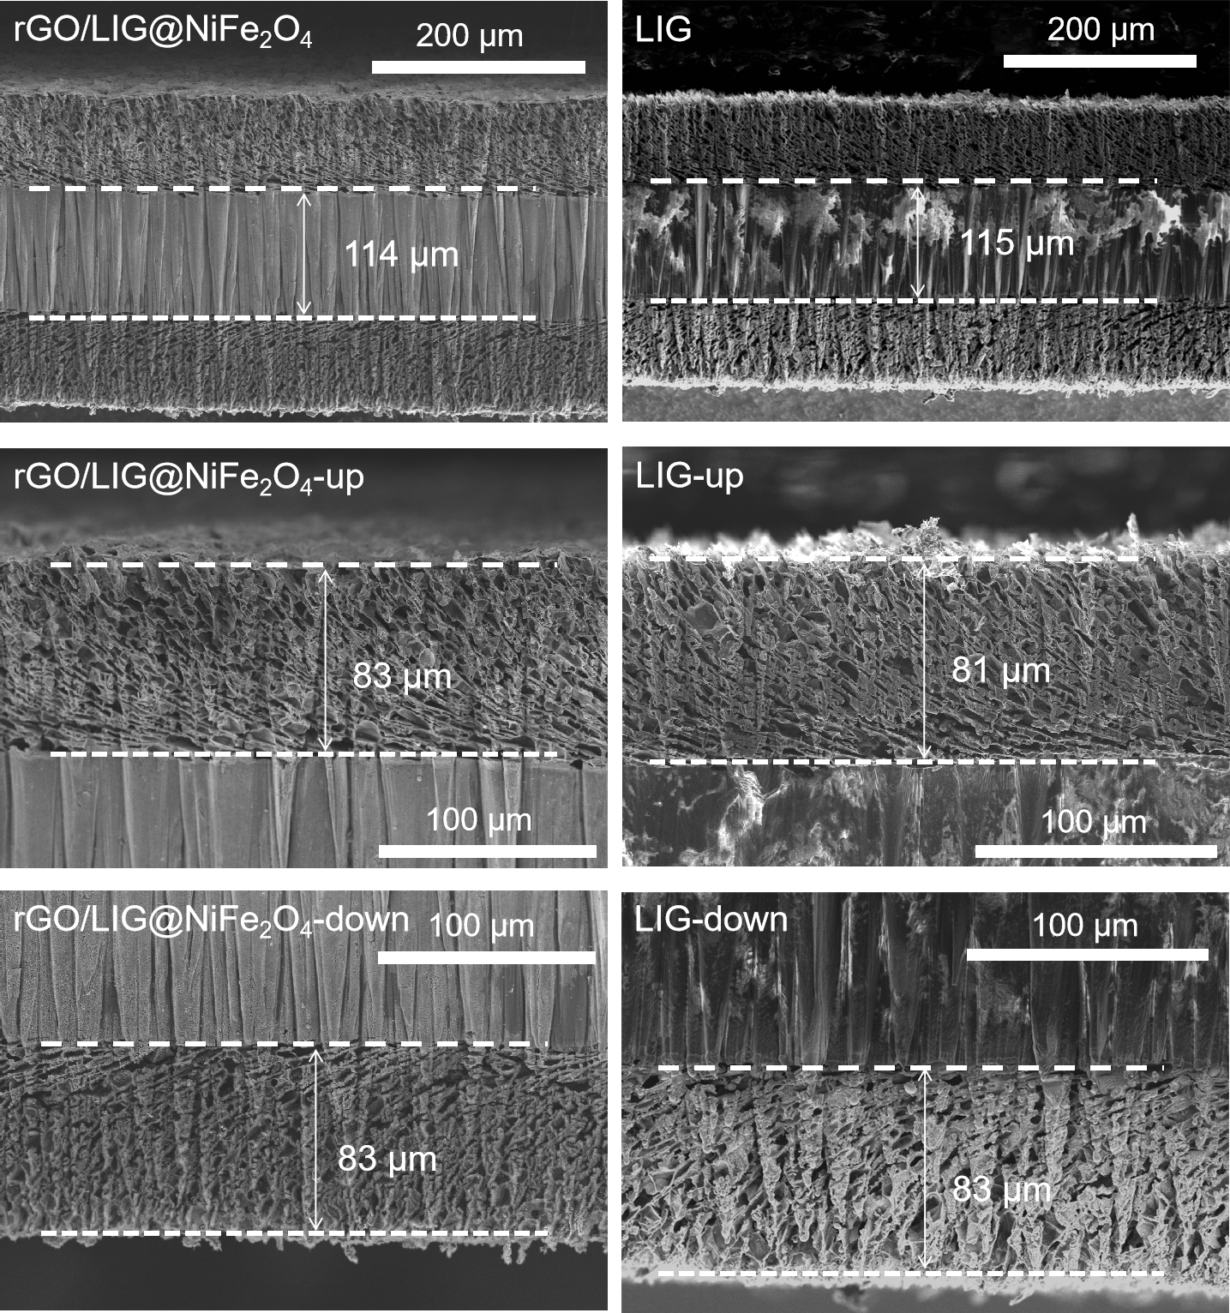
Supplementary Figure 8. Cross-sectional SEM images of double-sided LIG and rGO/LIG@NiFe₂O₄ (F-N-0.7) samples.

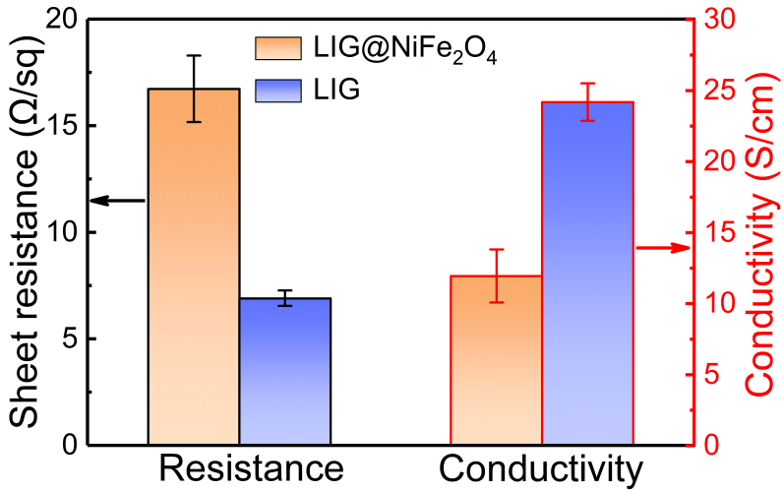
Supplementary Figure 9. Comparison of resistance and conductivity of LIG@NiFe₂O₄ and LIG.

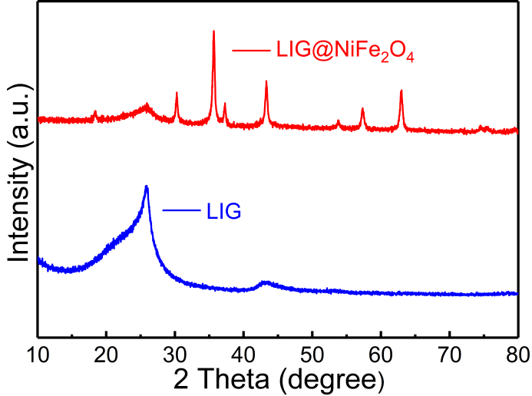
Supplementary Figure 10. XRD patterns of LIG@NiFe₂O₄ and LIG.
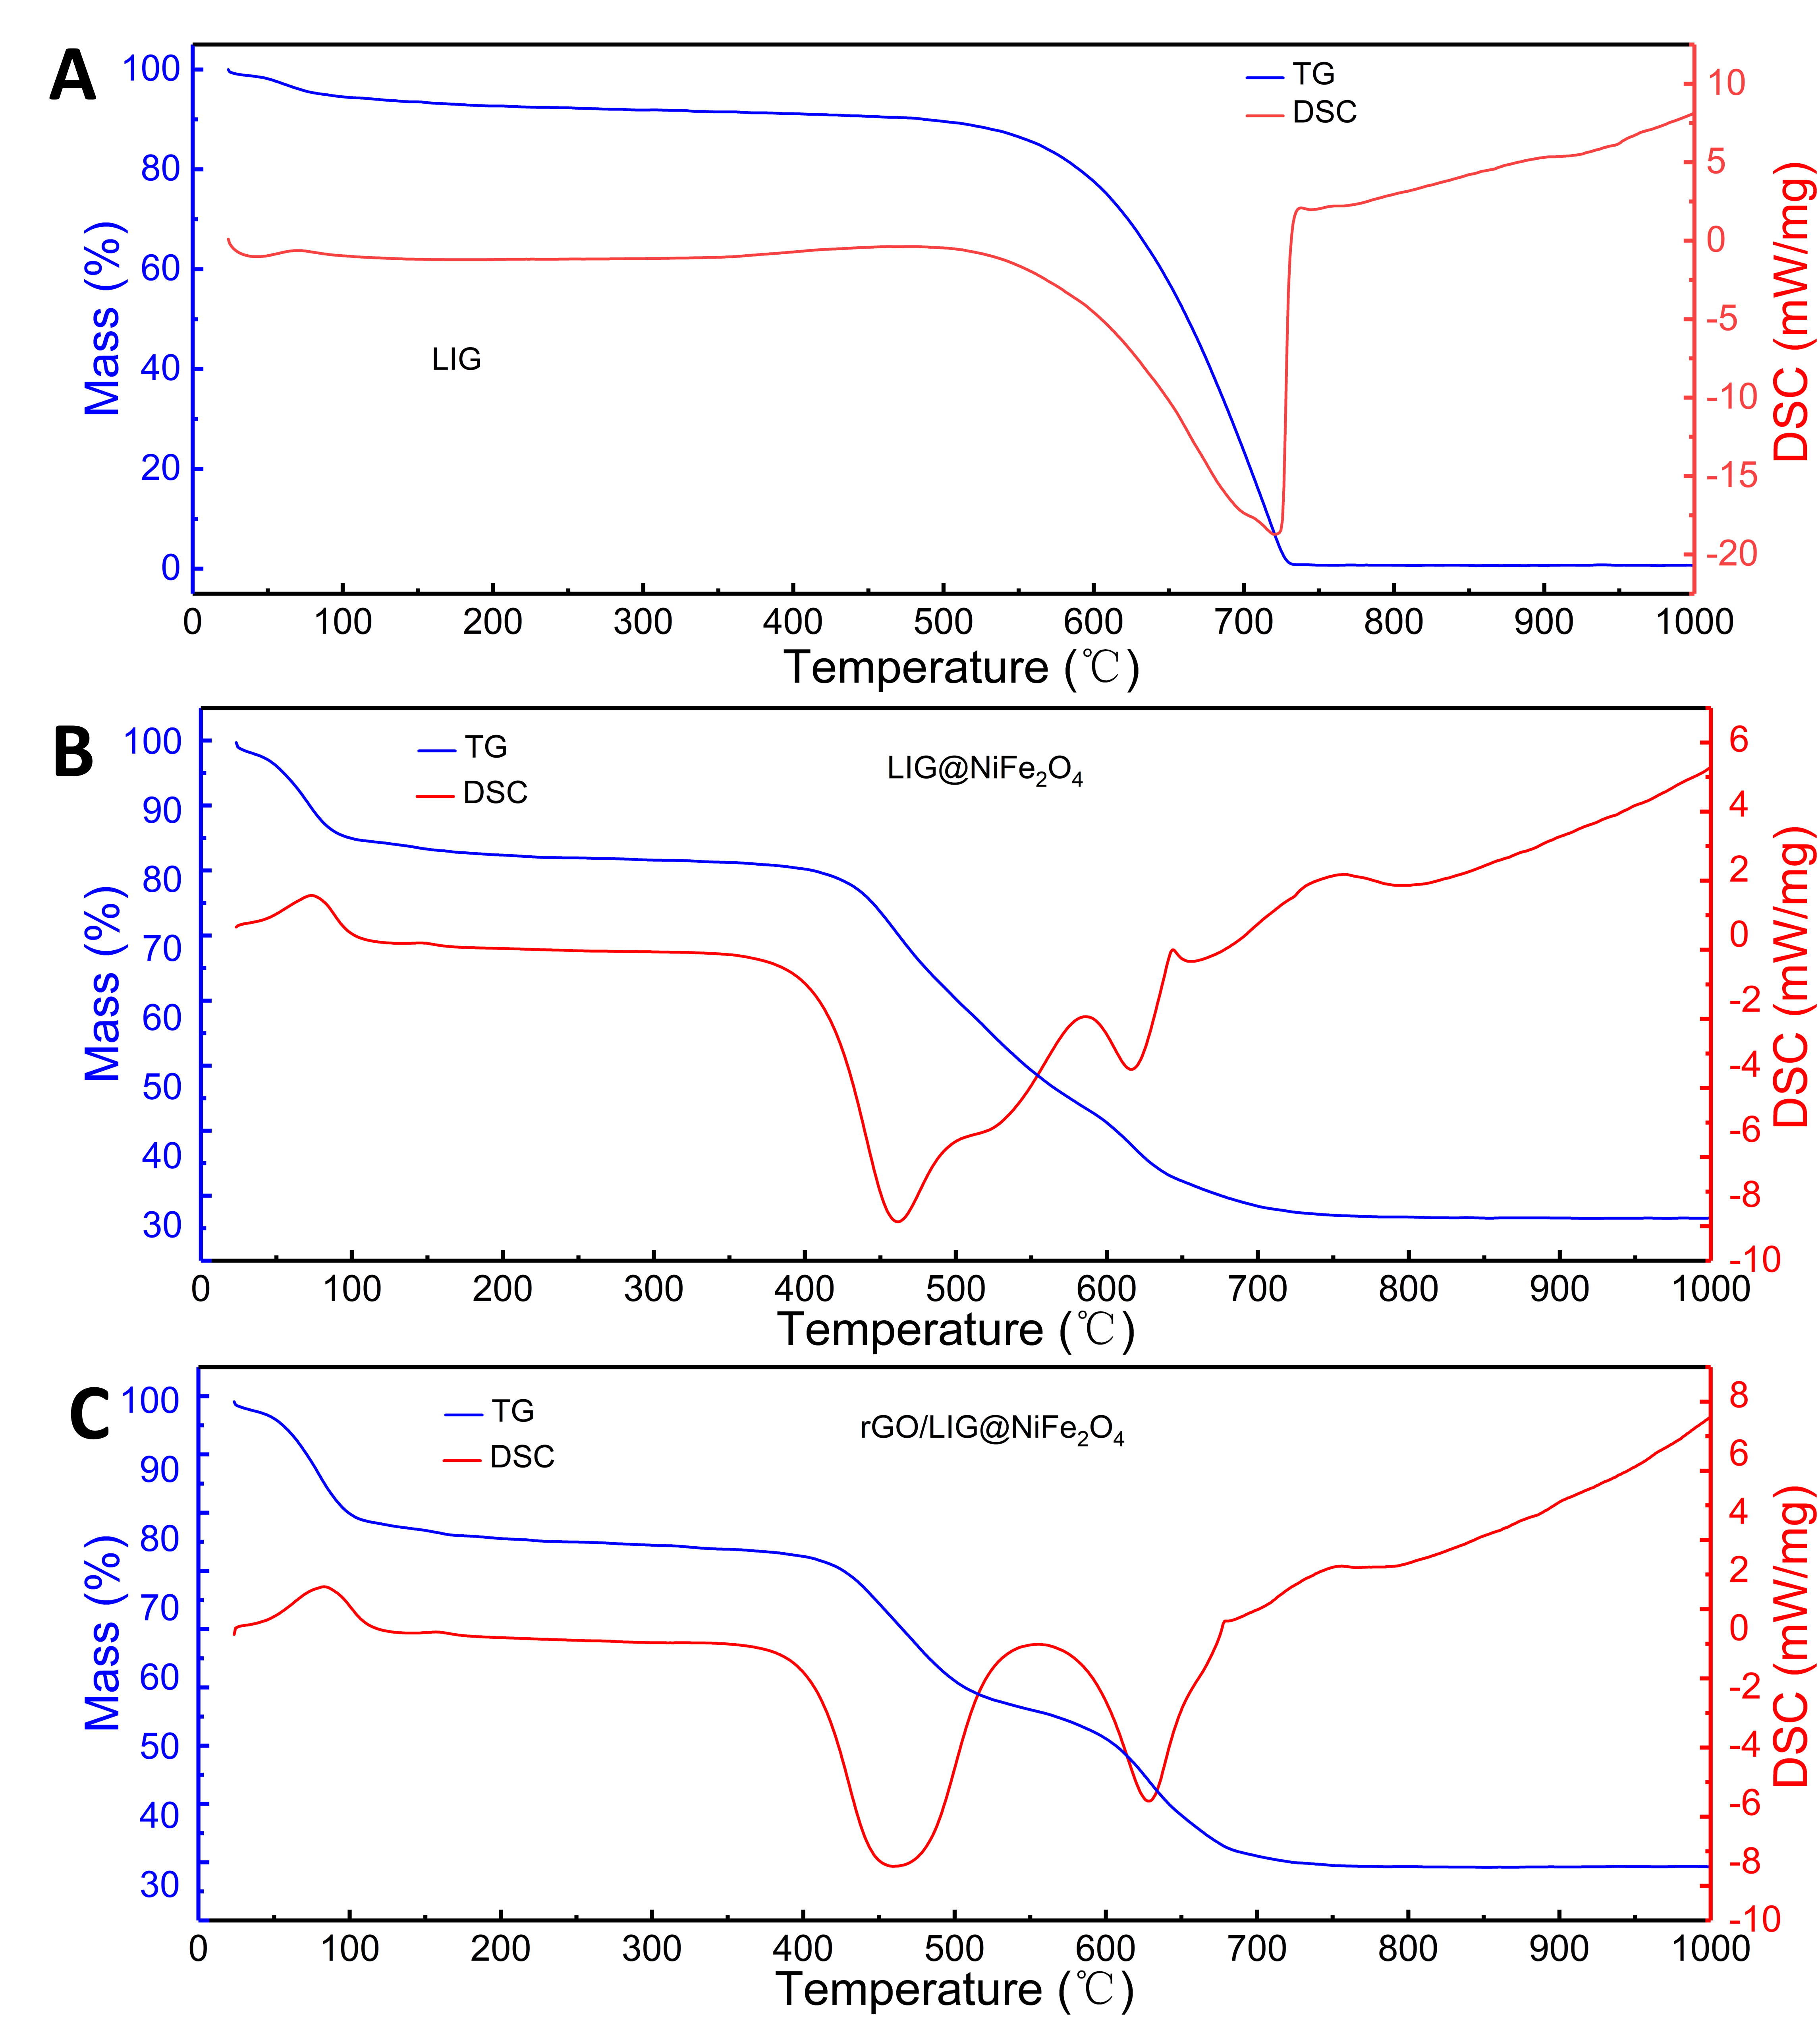
Supplementary Figure 11. (A-C) TG and DSC curves of LIG, LIG@NiFe₂O₄ and rGO/LIG@NiFe₂O₄ (F-N-0.7) (specific test conditions are heating from room temperature to 1000 ℃ at 10 ℃/min under ambient atmosphere)
In order to understand the thermal stability of LIG and LIG loaded with magnetic metal oxide nanoparticles as well as the influence of different loading levels of nanoparticles on the thermal decomposition process of LIG in air, we tested and analyzed the TGA-DSC curves of LIG. It can be seen from the TG and DSC curves of LIG in Supplementary Fig. 11 A that its mass change at 0-100℃ is related to the decomposition and vaporization of various unstable functional groups of graphene, as well as the loss of residual (or absorbed) solvents. The rapid decline of its mass from 500 to 730℃ is caused by the intense combustion of LIG in the air, and it can be seen from the DSC curve as a strog exothermic peak, which is consistent with the situation reported in literature³. It can be seen from the TG and DSC curves of LIG@NiFe₂O₄ in Supplementary Fig.11 B that its mass change at below 100℃ is related to the loss of moisture adsorbed by LIG@NiFe₂O₄ composite film. The disintegration temperature of LIG was significantly down-shifted, indicating that the loading of NiFe₂O₄ nanoparticles accelerates this process. The heat absorption peak near 760℃ is related to the high-temperature oxidation of the nanoparticles, with valence states probably reduced during the LIG disintegration and then re-oxidized at this temperature range⁴. The TG-DSC curve of the composite film with rGO lid (Supplementary Fig. 11 C) is similar to that of Supplementary Fig. 11 B, because both samples contain NiFe₂O₄ nanoparticles, but with presence of the rGO lid, the LIG's burning becomes sluggish. To note, a broad exothermic peak appears at 460℃ on the left side of the DSC curve in Supplementary Fig. 11 C. We believe that a reasonable explanation is that NiFe₂O₄ nanoparticles are evenly distributed, so the catalytically accelerate the disintegration process of LIG^{5,6}.

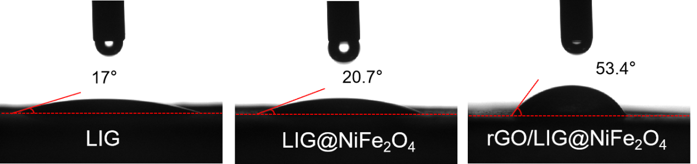Supplementary Figure 12. A comparison of contact angle characterization results of the laser induced graphene (LIG), LIG@NiFe₂O₄ and rGO/LIG@NiFe₂O₄ (F-N-0.7).

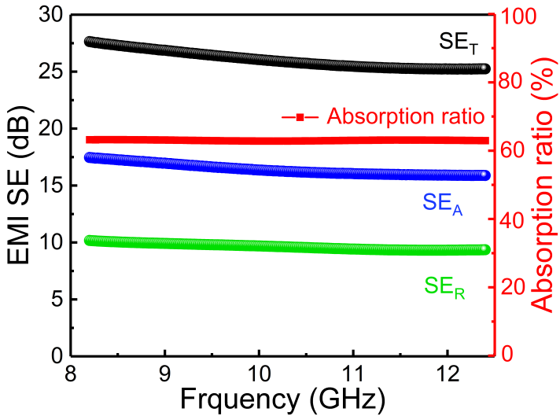
Supplementary Figure 13. EMI SE diagram of LIG@NiFe₂O₄.

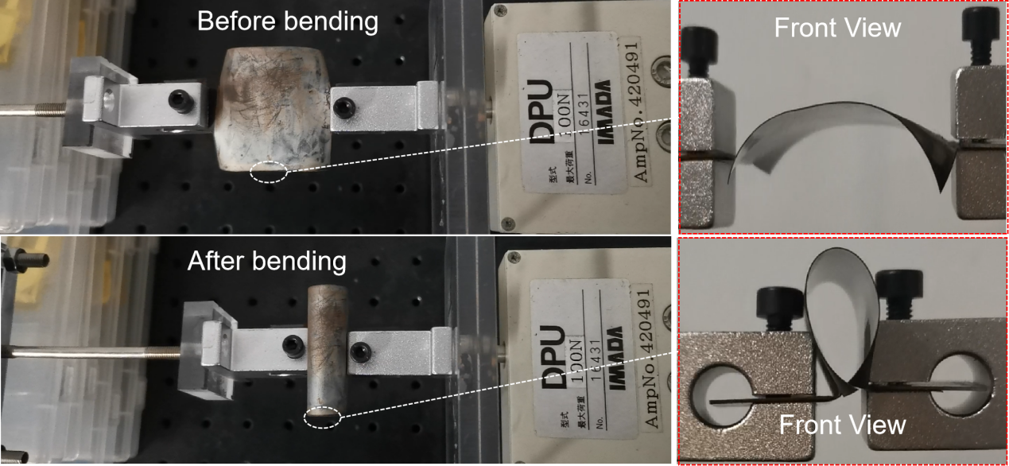
Supplementary Figure 14. Schematic diagram of mechanical bending of the rGO/LIG@NiFe₂O₄composite film.

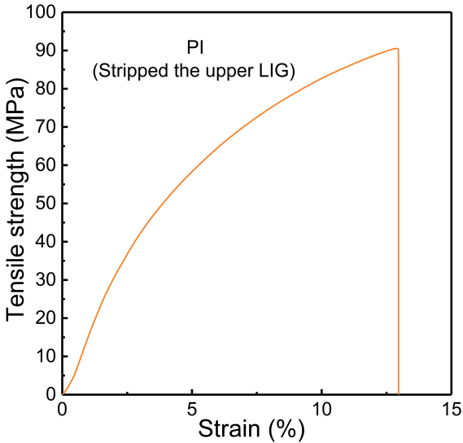
Supplementary Figure 15. The stress-strain curve of PI with the upper LIG stripped off.

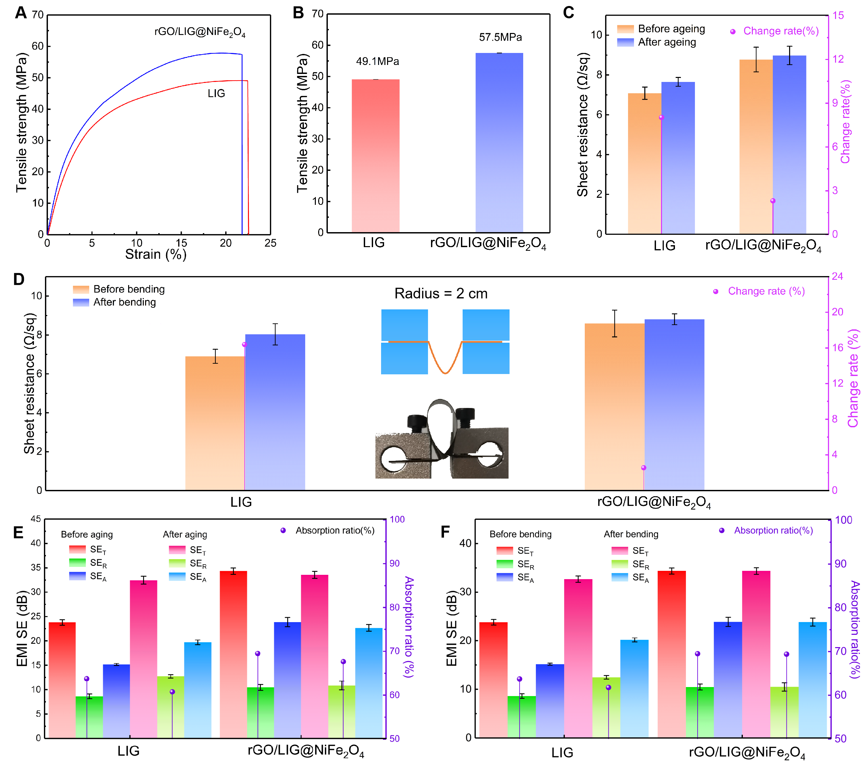
Supplementary Figure 16. Mechanical and stability performance characterizations: (A-B) Stress-strain curve and tensile strength of LIG and rGO/LIG@NiFe₂O₄ (F-N-0.7) composite film. (C-D) Square resistance and electrical conductivity of LIG and rGO/LIG@NiFe₂O₄ (F-N-0.7) composite films before and after bending and aging. (E-F) EMI shielding effectiveness of LIG and rGO/LIG@NiFe₂O₄ (F-N-0.7) composite films before and after bending and aging.

Supplementary Table 1. Thickness, density and volumetric loading of NiFe₂O₄ for LIG and different rGO/LIG@NiFe₂O₄ samples
Sample | NiFe₂O₄ loading (g/cm³) | Thickness (µm) | Density of LIG  (g/cm³) | EMI SE  (dB)
LIG | 0 | 71 | 0.26 | 25.2
rGO/LIG@NiFe₂O₄ (F-N-0.3) | 0.15 | 51 | 0.26 | 29.5
(F-N-0.5) | 0.17 | 67 | 0.26 | 34.3
(F-N-0.7) | 0.21 | 70 | 0.26 | 36.0
(F-N-1) | 0.38 | 73 | 0.26 | 33.3
double-layer LIG | 0 | 164 | 0.26 | 36.1
double-layer rGO/LIG@NiFe₂O₄  (F-N-0.7) | 0.25 | 166 | 0.26 | 50.9

Supplementary Table 2. Masses of rGO, rGO/LIG@NiFe₂O₄ (F-N-0.7) and LIG@NiFe₂O₄ with a fixed area (40 x 40 mm)
Sample | Area (mm²) | Mass (mg) | Thickness (µm)
LIG | 40 x 40 | 29.20 | 71
rGO/LIG@NiFe₂O₄ (F-N-0.7) | 40 x 40 | 48.80 | 70
rGO | 40 x 40 | 7.40 | 2.01-2.20
LIG@NiFe₂O₄ | 40 x 40 | 37.55 | 65

We calculated the masses of rGO, LIG, rGO/LIG@NiFe₂O₄ (F-N-0.7), and LIG@NiFe₂O₄ with a fixed area (40 x 40 mm). The mass of the LIG was obtained by subtracting the mass of the substrate PI. To obtain the mass of the surface layer of rGO, we first applied an aqueous phase dispersion of GO (2 g of GO dispersed in 10 g of water, 300 µL drip coating) to the LIG, and then processed it by laser to obtain the rGO covering the LIG. Finally, the mass of rGO was obtained by subtracting the mass of the substrate and LIG. In addition, we calculated the theoretical thickness of the surface rGO lid to be 2.01-2.20 μm based on the previously reported density of graphene (2.1-2.3 g/cm³). It is remarkable that the mass of rGO/LIG@NiFe₂O₄(F-N-0.7) minus that of the surface rGO is 3.85 mg larger than the mass of LIG@NiFe₂O₄, which indicates that with the GO protection the mass retention is improved over 10% of the original weight after the laser treatment, which displays a significant difference.

SupplementaryTable 3. Detailed parameters and references for each dimension of the six-dimensional radar plot

Filler | Thickness  (µm) | Flexibliity | Density  (g/cm³) | EMI SE  (dB) | SSE  (dB*cm³/g) | SSE/t  (dB*cm²/g) | Ref
Graphene/Fe₃O₄ | 300 | 1 | 0.77 | 24 | 31.17 | 1038.96 | ⁷
Cu foil | 10 | 3 | 8.97 | 70 | 7.80 | 7803.79 | ⁸
SWCNT/MWCNT film | 130 | 3 | 0.85 | 65 | 76.83 | 5910.17 | ⁹
MXene/ANF | 20 | 3 | 1.25 | 28 | 22.4 | 11200 | ¹⁰
LIG | 71 | 4 | 0.26 | 25.2 | 102.44 | 14428.03 | This  work
(F-N-0.7)  rGO/LIG@NiFe₂O₄ | 70 | 4 | 0.26 | 36.1 | 146.34 | 20905.92 | This  work
double-side  rGO/LIG@NiFe₂O₄  (F-N-0.7) | 166 | 4 | 0.26 | 50.9 | 206.91 | 12464.49 | This  work
(Notes on flexibility properties: The number of bends not indicated in the literature is marked as number 1, the number of bends illustrated with a bending schematic but not detailed is marked as number 2, the number of bends between 5,000 and 10,000 is marked as number 3 and the number of bends greater than 10,000 revolutions is marked as number 4)

Supplementary Table 4. Detailed parameters and references for the comprehensive performance comparison chart (thickness, EMI shielding performance and absorption rate)

Materials | Thickness  (µm) | Density  (g cm³) | EMI SE  (dB) | SSE  (dB cm³ g⁻¹) | SSE/t  (dB cm² g⁻¹) | Absorption  (SE_{A}/SE_{T}) | Ref
Graphene/Fe₃O₄ | 200 | 0.77 | 24 | 31.17 | 1038.96 | 63% | 1¹¹
MWCNT/MCMB | 150 | 0.26 | 70 | 119.23 | 7948.72 | 63.7% | 2¹²
LIG/Fe₃O₄ | 53 | 0.22 | 32.7 | 148.64 | 28044.6 | 60% | 3¹³
Graphene/Fe₃O₄ | 200 | / | 24 | / | / | 63% | 4⁷
sulfonated graphene nanosheets (S-GNS) | 300 | / | 34.4 | / | / | 67% | 5¹⁴
MXene/ANF | 20 | 1.25 | 28 | 22.4 | 11200 | 62.5% | 6¹⁰
graphene/waterborne polyurethane | 150 | 1.4 | 30 | 21.43 | 1428.57 | 60% | 7¹⁵
Carbon nanofber/carbon black/  PI flm | 350 | 1.2 | 23.9 | 19.92 | 569.05 | 62.8% | 8¹⁶
Ag/CNTs/PDMS | 1500 | / | 56 | / | / | 81% | 9¹⁷
EG film | 100 | / | 33.1 | / | / | 72% | 10¹⁸
CF/RGO/Ni | 3300 | / | 61.3 | / | / | 88% | 11¹⁹
C-MXene@PI foam | 500 | 0.041 | 43.77 | 1065.85 | 21317.07 | / | 12²⁰
CNT/graphene/PI foam | 2000 | 0.02 | 28.2 | 1410 | 7050 | / | 13²¹
Graphene/PS | 2500 | 1.04 | 45.1 | 43.37 | 173.46 | / | 14²²
LIG | 71 | 0.26 | 25.2 | 102.44 | 14428.03 | 66% | This  work
double-side LIG | 164 | 0.26 | 36.1 | 146.75 | 8948.05 | 71% | This  work
(F-N-0.7) | 70 | 0.26 | 36.1 | 146.34 | 20905.92 | 75% | This  work
double-side rGO/LIG@NiFe₂O₄  (F-N-0.7) | 166 | 0.26 | 50.9 | 206.91 | 12464.49 | 73% | This  work

Reference
1. Gao, W., Alemany, L. B., Ci, L. & Ajayan, P. M. New insights into the structure and reduction of graphite oxide. Nat. Chem. 1, 403-408, (2009).
2. Park, S. et al. Aqueous suspension and characterization of chemically modified graphene sheets. Chem. Mater. 20, 6592-6594, (2008).
3. Chen, C. M. et al. Annealing a graphene oxide film to produce a free standing high conductive graphene film. Carbon 50, 659-667, (2012).
4. Pang, H. et al. Facile synthesis of a hierarchical multi-layered CNT-NiFe₂O₄@ MnO₂ composite with enhanced microwave absorbing performance. Appl. Surf. Sci. 581, 152363, (2022).
5. Yao, Y. et al. Magnetic CoFe₂O₄-graphene hybrids: facile synthesis, characterization, and catalytic properties. Ind. Eng. Chem. Res. 51, 6044-6051, (2012).
6. Xu, J. L. et al. In-situ plantation of Fe₃O₄@C nanoparticles on reduced graphene oxide nanosheet as high-performance anode for lithium/sodium-ion batteries. Appl. Surf. Sci. 546, 149163, (2021).
7. Song, W. L. et al. Magnetic and conductive graphene papers toward thin layers of effective electromagnetic shielding. J. Mater. Chem. A 3, 2097-2107, (2015).
8. Shahzad, F. et al. Electromagnetic interference shielding with 2D transition metal carbides (MXenes). Science 353, 1137-1140, (2016).
9. Lu, S. et al. Flexible, mechanically resilient carbon nanotube composite films for high-efficiency electromagnetic interference shielding. Carbon 136, 387-394, (2018).
10. Xie, F. et al. Ultrathin MXene/aramid nanofiber composite paper with excellent mechanical properties for efficient electromagnetic interference shielding. Nanoscale 11, 23382-23391, (2019).
11. Xi, J. et al. Graphene aerogel films with expansion enhancement effect of high-performance electromagnetic interference shielding. Carbon 135, 44-51, (2018).
12. Chaudhary, A. et al. Lightweight and easily foldable MCMB-MWCNTs composite paper with exceptional electromagnetic interference shielding. ACS Appl. Mater. Interfaces 8, 10600-10608, (2016).
13. Yu, W., Peng, Y., Cao, L., Zhao, W. & Liu, X. Free-standing laser-induced graphene films for high-performance electromagnetic interference shielding. Carbon 183, 600-611, (2021).
14. Wei, L. et al. π-π stacking interface design for improving the strength and electromagnetic interference shielding of ultrathin and flexible water-borne polymer/sulfonated graphene composites. Carbon 149, 679-692, (2019).
15. Yang, W. et al. Flexible and densified graphene/waterborne polyurethane composite film with thermal conducting property for high performance electromagnetic interference shielding. Nano Res. 15, 9926-9935, (2022).
16. Kong, D., Li, J., Guo, A. & Xiao, X. High temperature electromagnetic shielding shape memory polymer composite. Chem. Eng. J. 408, 127365, (2021).
17. Zhang, J. et al. Homogeneous silver nanoparticles decorating 3D carbon nanotube sponges as flexible high-performance electromagnetic shielding composite materials. Carbon 165, 404-411, (2020).
18. Liu, Y. et al. Utilizing ammonium persulfate assisted expansion to fabricate flexible expanded graphite films with excellent thermal conductivity by introducing wrinkles. Carbon 153, 565-574, (2019).
19. Bian, X. M. et al. Construction of three-dimensional graphene interfaces into carbon fiber textiles for increasing deposition of nickel nanoparticles: flexible hierarchical magnetic textile composites for strong electromagnetic shielding. Nanotechnology 28, 045710, (2016).
20. Zeng, Z. H. et al. Porous and ultra-flexible crosslinked MXene/polyimide composites for multifunctional electromagnetic interference shielding. Nano Micro Lett. 14, 59, (2022).
21. Wang, Y. Y., Sun, W. J., Yan, D. X., Dai, K. & Li, Z. M. Ultralight carbon nanotube/graphene/polyimide foam with heterogeneous interfaces for efficient electromagnetic interference shielding and electromagnetic wave absorption. Carbon 176, 118-125, (2021).
22. Yan, D. X. et al. Structured reduced graphene oxide/polymer composites for ultra-efficient electromagnetic interference shielding. Adv. Funct. Mater. 25, 559-566, (2015).

