Supplementary fig. 1:

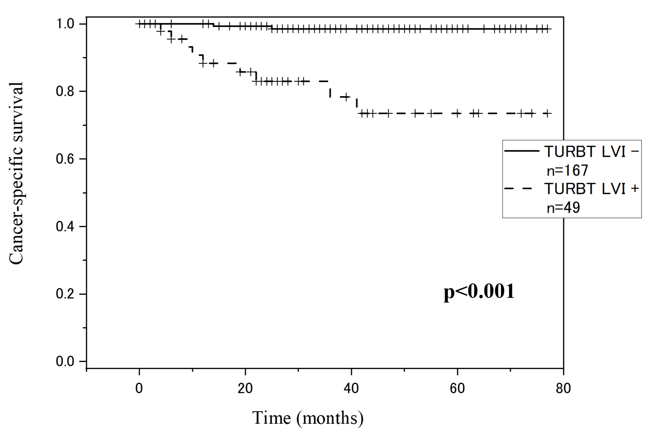

LVI: lymphovascular invasion; TURBT: transurethral resection of bladder tumor
Supplementary fig. 2:

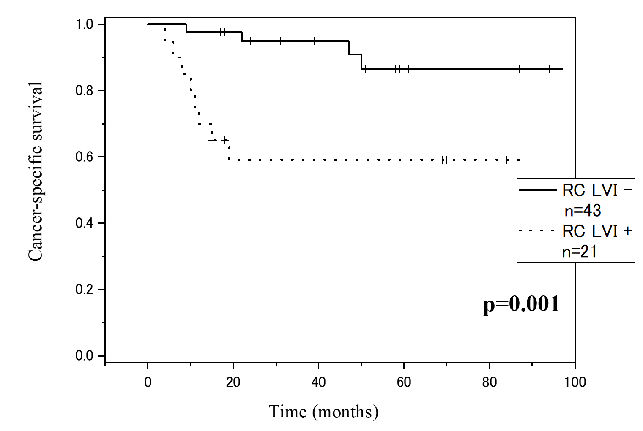

LVI: lymphovascular invasion; RC: radical cystectomy

