Supplementary Materials
for
The Clinical relevance of Polygenic Risk Scores to
Type 2 Diabetes Mellitus in Korean Population
Na Yeon Kim¹, Haekyung Lee², Sehee Kim³, Ye-Jee Kim³, Hyunsuk Lee^{4,5}, Junhyeong Lee¹, Soo Heon Kwak⁴, Seunggeun Lee^{1,*}

Corresponding author
Seunggeun Lee
Graduate School of Data Science
Seoul National University, Seoul, South Korea
lee7801@snu.ac.kr

Supplementary Figures
Supplementary Fig. S1 Manhattan plot of meta-analysis of East Asian T2DM
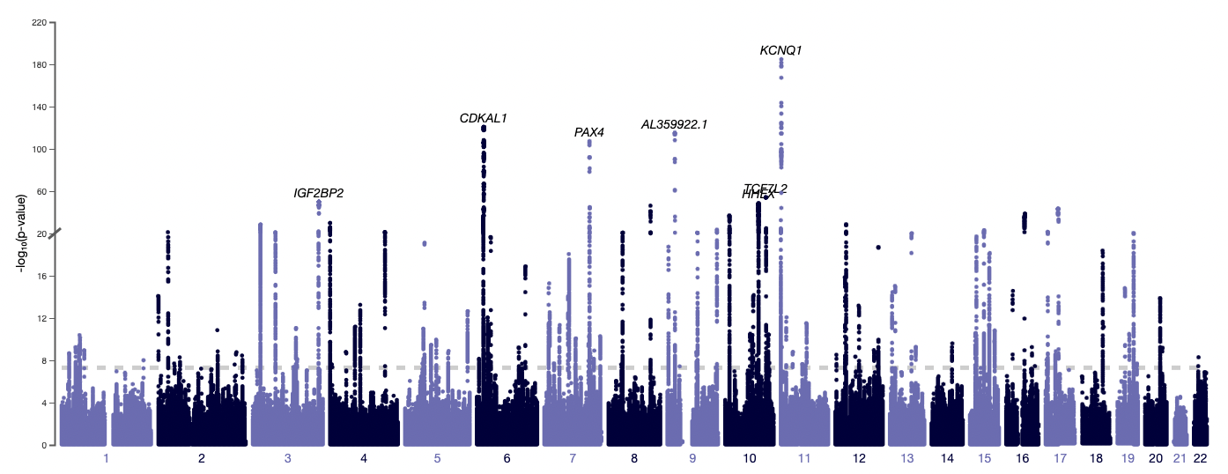

Supplementary Fig. S2 KoGES Ansan and Ansung: Kaplan-Meier curve for cumulative prevalence of T2DM by PRS group
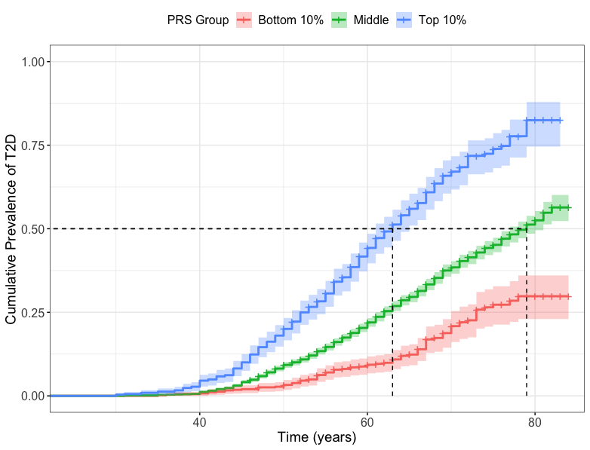
Each shaded area represents 95% confidence band for each curve. Each dash line indicates median age-at-T2DM diagnosis for each PRS group.

Supplementary Fig. S3 UKBB East Asian validation: Kaplan-Meier curve for cumulative prevalence of T2DM by PRS Group
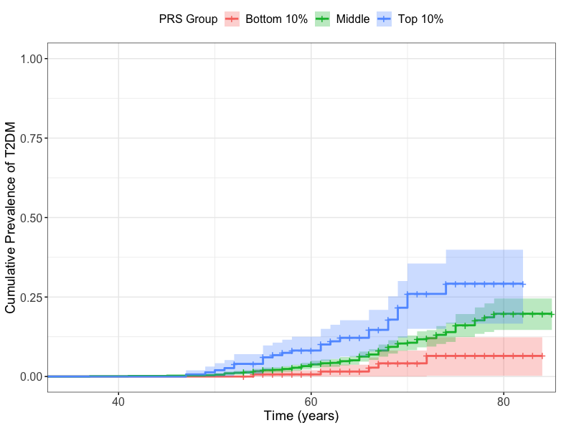
Each shaded area represents 95% confidence band for each curve.

Supplementary Fig. S4 Retrograde trajectory of HOMA-IR and HOMA-B. A. Diabetes (HOMA-IR) B. Non-Diabetes (HOMA-IR) C. Diabetes (HOMA-B) D. Non-Diabetes (HOMA-B)
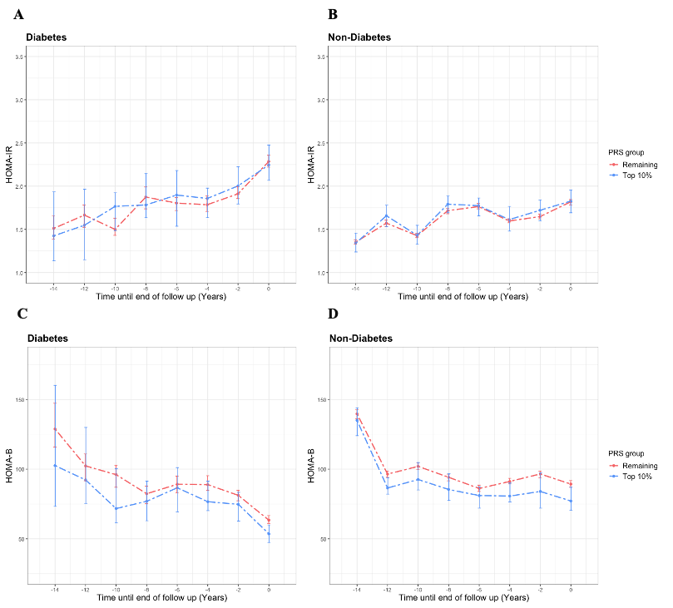
Each bar represents 95% confidence interval at each time point.
Supplementary Fig. S5 Novel diabetic subgroup characteristics

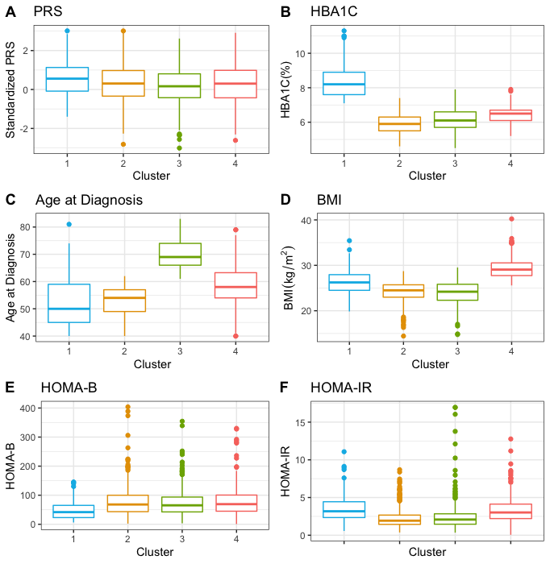

Supplementary Tables
Supplementary Table S1 Area under the receiver operating characteristics curve (AUC) of different methods
 | T2DM ~ PRS | T2DM ~ PRS + sex + age
Lassosum | 0.64859 | 0.67599
PRS-CS | 0.64766 | 0.67691

Supplementary Table S2 Cumulative prevalence of T2DM for baseline and each follow-up of Koges_Ansan and Ansung dataset

Follow-up | Baseline | 1st | 2nd | 3rd | 4th | 5th | 6th | 7th
NGT | 2572 | 2539 | 1821 | 1351 | 975 | 838 | 711 | 600
Prediabetes | 2172 | 2015 | 2544 | 2832 | 3043 | 3039 | 3048 | 2995
Diabetes | 746 | 936 | 1125 | 1307 | 1472 | 1613 | 1731 | 1895

Supplementary Table S3 Results of Cox regression analysis for predicting T2DM complication specified as macrovascular complications and nephropathy
T2DM  Complications | PRS | Hazard Ratio | 95% CI | P-value
Macrovascular Complications | Categorized PRS
Macrovascular Complications | Bottom Decile | 0.6047 | 0.2233 – 1.637 | 0.322
Macrovascular Complications | Middle (10-90%) | 1.00  (reference)
Macrovascular Complications | Top Decile | 0.7980 | 0.5325 – 1.196 | 0.275
Macrovascular Complications | Standardized PRS | 0.9816 | 0.8415 – 1.145 | 0.813
Nephropathy | Categorized PRS
Nephropathy | Bottom Decile | 0.9122 | 0.4675 – 1.780 | 0.788
Nephropathy | Middle (10-90%) | 1.00  (reference)
Nephropathy | Top Decile | 0.8548 | 0.6197 – 1.179 | 0.339
 | Standardized PRS | 0.9177 | 0.8110 – 1.038 | 0.173

Macrovascular complications include myocardial infarction, coronary artery disease, congestive heart failure, cerebrovascular disease, peripheral artery disease.

Supplementary Table S4 Characteristics at the baseline of the KoGES_Ansan and Ansung non-diabetic population dataset

 | PRS  Bottom Decile  (n = 348) | Middle  (10-90%)  (n = 2075) | PRS  Top Decile  (n = 149) | P-value
Basic Information
Male (%) | 173 (49.71) | 941 (45.35) | 66 (44.30) | 0.295
Age (year) | 50.73 $± 8.24$ | 49.69 $± 8.46$ | 48.61 $± 7.41$ | 0.014
Physical Measurements
BMI (kg/m²) | 24.08$±$ 2.89 | 24.10 $± 2.87$ | 24.41 $± 2.80$ | 0.424
SBP (mmHg) | 117.62 $± 16.03$ | 117.98 $± 17.07$ | 118.74 $± 18.08$ | 0.796
DBP (mmHg) | 79.03 $± 10.74$ | 78.85 $± 11. 41$ | 79.03 $± 11.85$ | 0.95
Clinical Risk Factors
HDL (mg/dL) | 50.07 $± 11.75$ | 50.48 $± 11.69$ | 50.01 $± 11.39$ | 0.764
LDL (mg/dL) | 115.64 $± 30.30$ | 115.72 $± 31.63$ | 115.55 $±29.62$ | 0.997
TG (mg/dL) | 133.18 $± 81.57$ | 152.93 $± 111.57$ | 126.77 $±61.24$ | 0.759
Fasting Glucose (mg/dL) | 84.29 $±11.47$ | 131.97 $± 93.41$ | 87.20 $± 7.00$ | 6.06e-05
Fasting Insulin ($μ$IU/mL) | 7.05 $± 3.58$ | 7.29 $± 4.76$ | 7.74 $± 7.61$ | 0.348
HbA1C (%) | 5.29 $± 0.32$ | 5.34 $± 0.22$ | 5.34 $± 0.22$ | 0.00719
Others
Current Smoking (%) | 89 (25.58) | 460 (22.17) | 30 (20.13) | 0.254
Family History (%) | 21 (6.03) | 200 (9.64) | 15 (10.07) | 0.091

BMI: Body Mass Index; SBP: Systolic Blood Pressure; DBP: Diastolic Blood Pressure; HDL: High-Density Lipoprotein; LDL: Low-Density Lipoprotein; TG: Triglyceride. Obtained P-value using one-way ANOVA analysis.

