The article title: Role of seed bank in aboveground vegetation regeneration signal ecosystem transition from arid grassland to shrubland with decreasing soil moisture
Journal name: plant and soil
Authors: Yunpeng Zhao¹, Guozhen Du¹, Wei Qi¹, Hang An¹, Lipei Wang¹, Shuaiwei Luo¹, Beibei Ma¹, Miaojun Ma¹*
1. State Key Laboratory of Grassland and Agro-ecosystems, School of Life Sciences, Lanzhou University, Lanzhou, Gansu Province 730000, P.R. China.
*Corresponding author: Miaojun Ma, Tel./ fax : +86 13919361389; E-mail: mjma@lzu.edu.cn or mamiaojun@gmail.com. Address: Room 1014, Yifu Biology Building, School of Life Sciences, Lanzhou University, Lanzhou 730000, China.

Table S1 Characteristics of 29 sampling sites around the Qaidam Basin in the northeastern part of the Tibetan Plateau.
Sites | Vegetation type | Quadrat (m²) | Longitude | Latitude | Altitude (m)
1 | Shrubland | 3 m×3 m | 97.54 | 36.39 | 2981
2 | Shrubland | 5 m×5 m | 98.12 | 37.00 | 2967
3 | Shrubland | 5 m×5 m | 97.34 | 37.11 | 2821
4 | Shrubland | 3 m×3 m | 97.48 | 37.03 | 2868
5 | Shrubland | 5 m×5 m | 97.41 | 36.47 | 2948
6 | Shrubland | 5 m×5 m | 97.03 | 37.22 | 2929
7 | Shrubland | 5 m×5 m | 96.37 | 37.23 | 2915
8 | Shrubland | 10 m×10 m | 96.51 | 37.12 | 2762
9 | Shrubland | 10 m×10 m | 96.35 | 37.07 | 3035
10 | Shrubland | 20 m×20 m | 96.28 | 36.54 | 3035
11 | Shrubland | 5 m×5 m | 96.23 | 37.25 | 3391
12 | Shrubland | 10 m×10 m | 95.22 | 37.47 | 3148
13 | Shrubland | 20 m×20 m | 94.37 | 38.01 | 2838
14 | Shrubland | 10 m×10 m | 95.01 | 38.01 | 3176
15 | Shrubland | 10 m×10 m | 95.23 | 37.29 | 3150
16 | Shrubland | 3 m×3 m | 94.29 | 35.53 | 3591
17 | Shrubland | 5 m×5 m | 94.49 | 36.02 | 3229
18 | Shrubland | 10 m×10 m | 95.11 | 36.18 | 2917
19 | Shrubland | 20 m×20 m | 95.47 | 36.22 | 2821
20 | Shrubland | 10 m×10 m | 97.18 | 36.07 | 2856
21 | Shrubland | 3 m×3 m | 98.53 | 36.43 | 3116
22 | Arid grassland | 2 m×2 m | 98.37 | 36.27 | 3591
23 | Arid grassland | 2 m×2 m | 98.11 | 36.26 | 3171
24 | Arid grassland | 2 m×2 m | 99.16 | 36.43 | 3125
25 | Arid grassland | 2 m×2 m | 99.44 | 36.28 | 3132
26 | Arid grassland | 1 m×1 m | 100.17 | 36.21 | 3076
27 | Arid grassland | 1 m×1 m | 99.56 | 35.37 | 3308
28 | Arid grassland | 1 m×1 m | 100.09 | 35.58 | 3076
29 | Arid grassland | 1 m×1 m | 100.57 | 36.25 | 3235

Fig. S1. Map of the study area in the Qaidam Basin on the northeastern Tibetan Plateau. The red points are the sites where the large-scale investigation was carried out in August 2014. The upper left of the map shows the location of the Tibetan Plateau in China, and the red box indicates the location of the study area on the Tibetan Plateau.
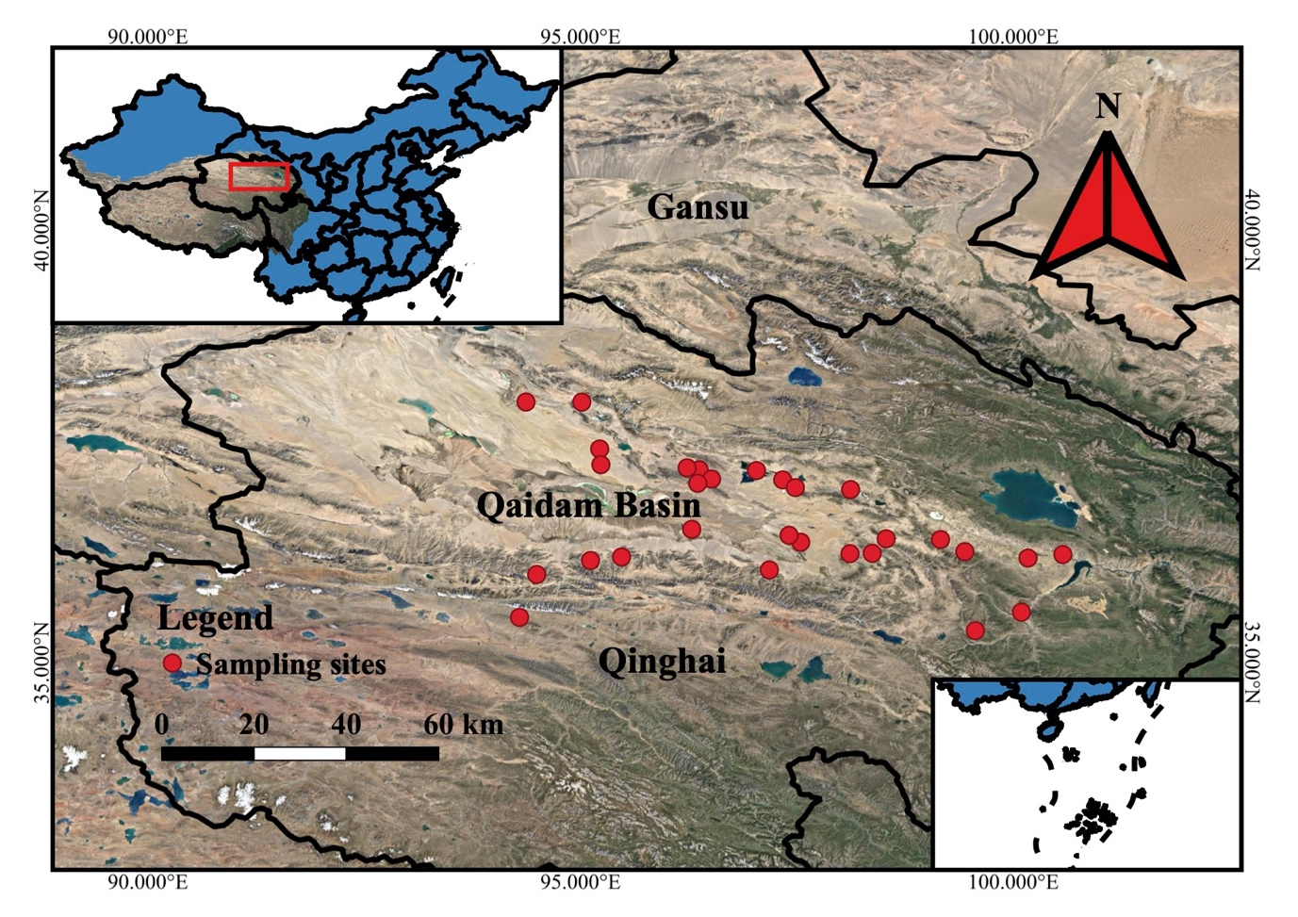

Fig. S2 Nonmetric multidimensional scaling (NMDS) ordination of both aboveground vegetation and the seed bank. The ordination is based on species relative abundance of species. Triangles represent aboveground vegetation, and dots represent the soil seed bank. The size of the point represents the soil moisture value. Green and blue represent shrubland and arid grassland, respectively.
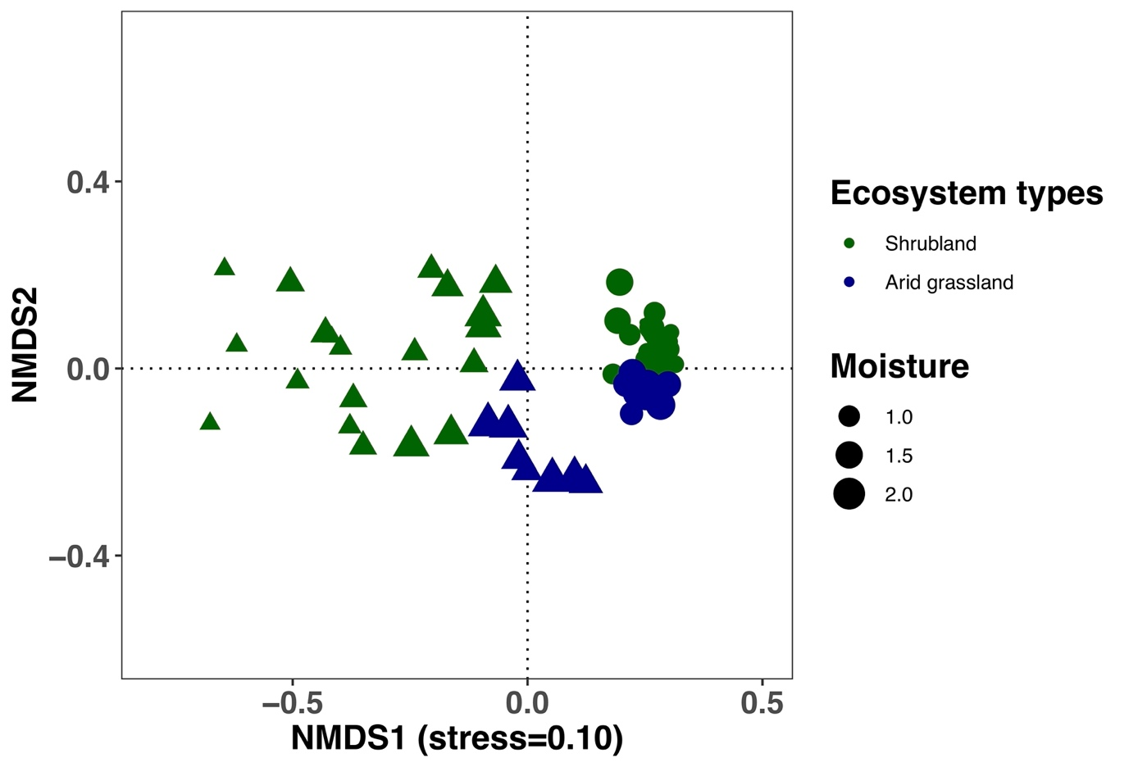

Fig. S3 Nonmetric multidimensional scaling (NMDS) ordination of the relationships between aboveground vegetation (a), the seed bank (b) and soil environmental factors. The ordination is based on relative abundance data of species. The blue triangle and dots represent aboveground vegetation and the seed bank, respectively. The arrows represent environmental factors, with red arrows indicating a significant effect on the species composition of aboveground vegetation or the seed bank. AN: available nitrogen; TN: total nitrogen; SOM: soil organic matter; AP: available phosphorus; TP: total phosphorus; SM: soil moisture.
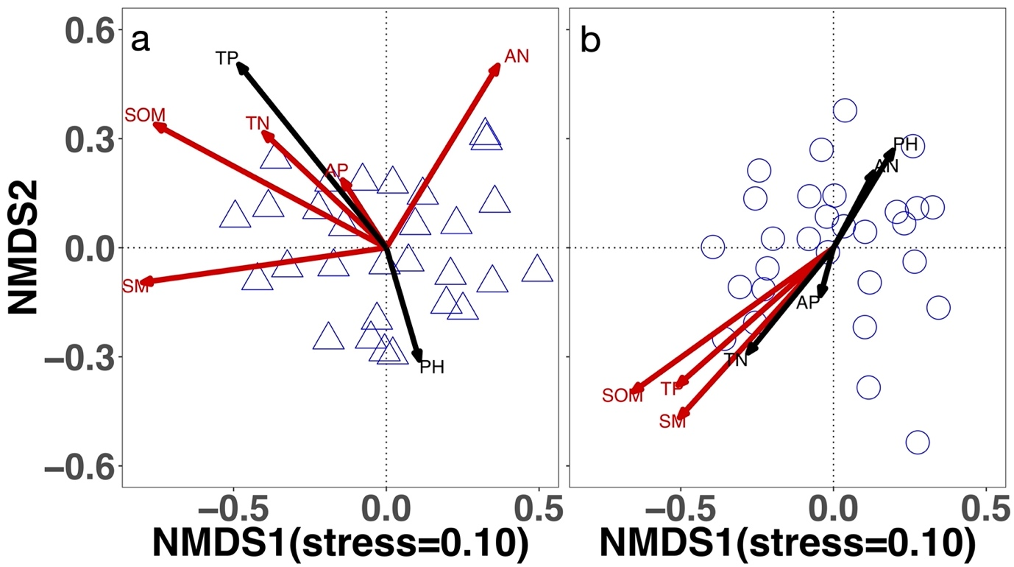

Fig. S4 Average abundance (a) and species richness (b) of different life forms (annual and perennial) of aboveground vegetation at each site.
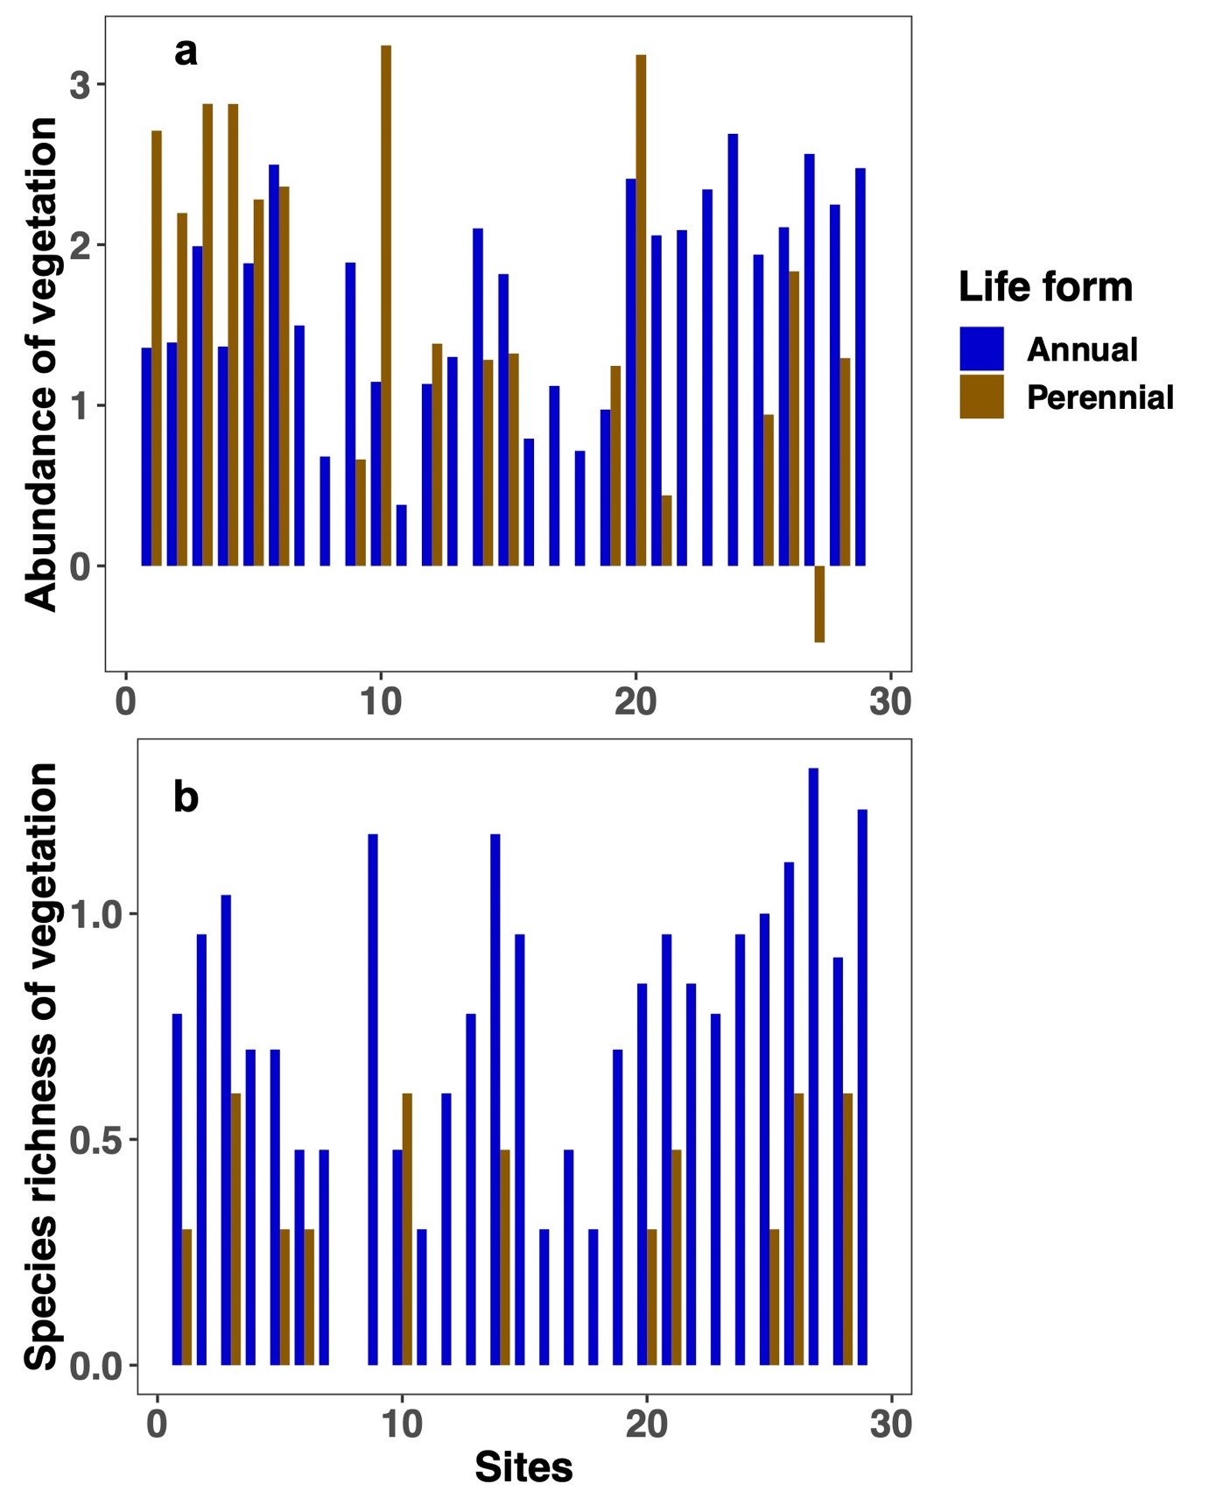

Fig. S5 Average seed density (a) and species richness (b) of different life forms (annual and perennial) in the seed bank at each site.
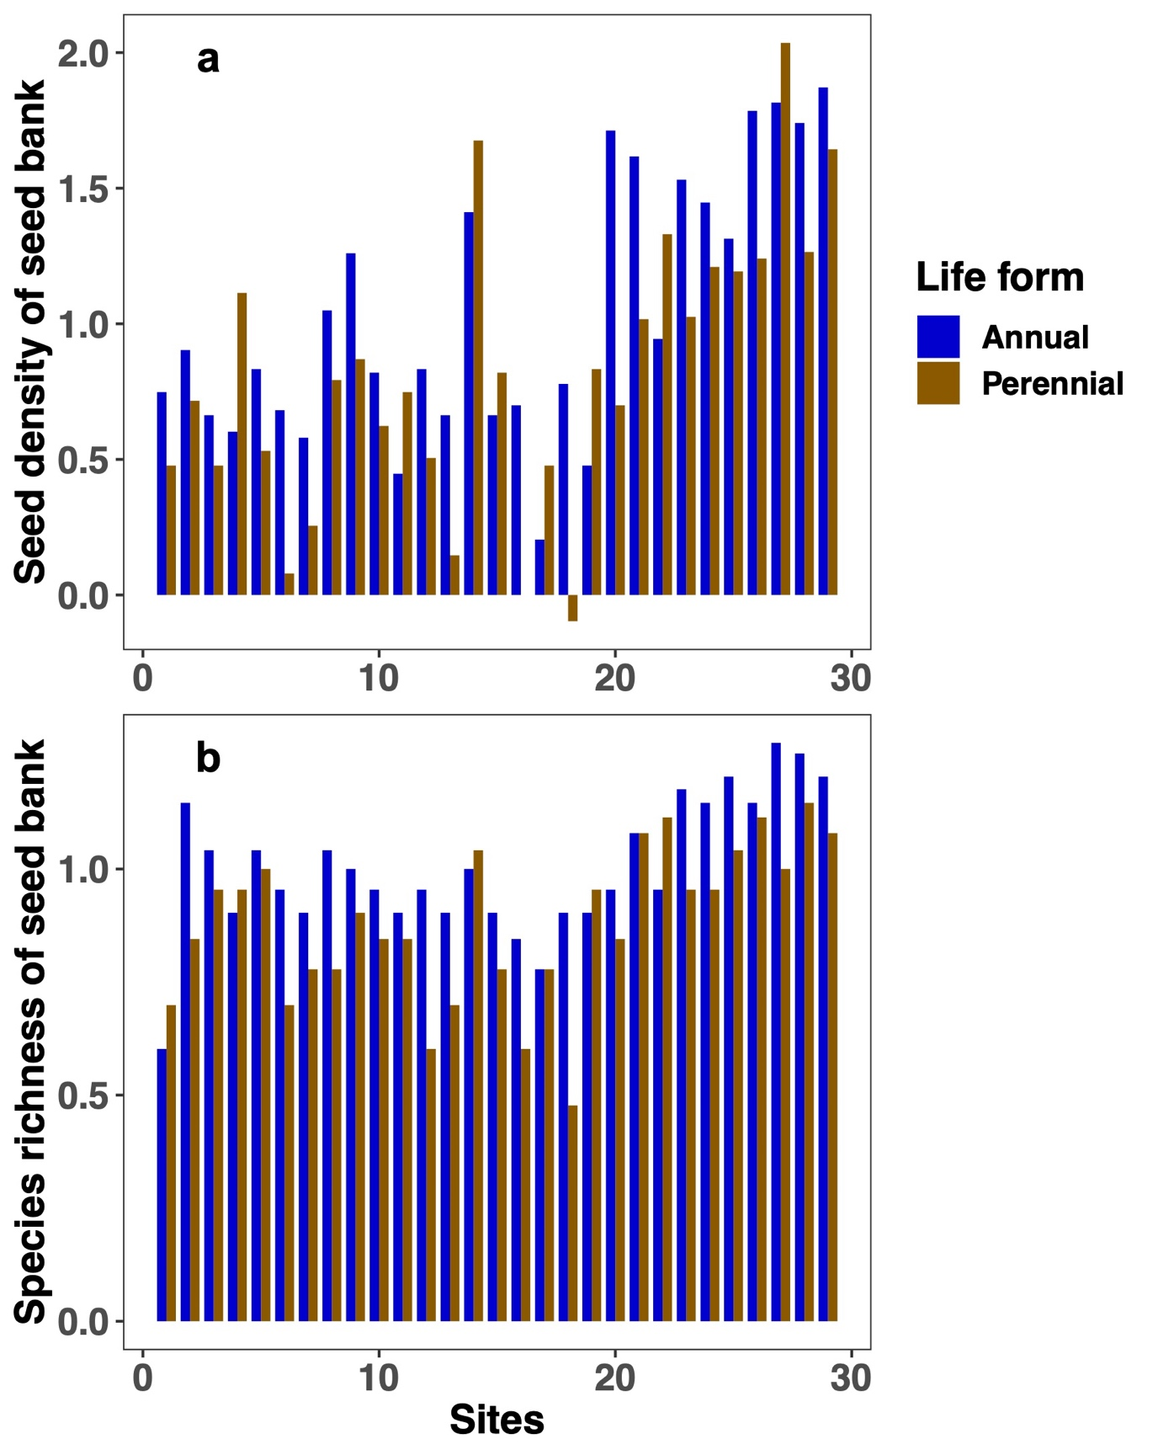

Fig. S6 Best-fitting models of soil environmental factors (a-f) along a soil moisture gradient. The vertical dashed lines indicate the threshold zones of the state transition from arid grassland to shrubland. Green and blue represent shrubland and arid grassland, respectively. (a)TN: total nitrogen; (b) AN: available nitrogen; (c) TP: total phosphorus; (d) AP: available phosphorus; (e) SOM: soil organic matter; (f) pH.
