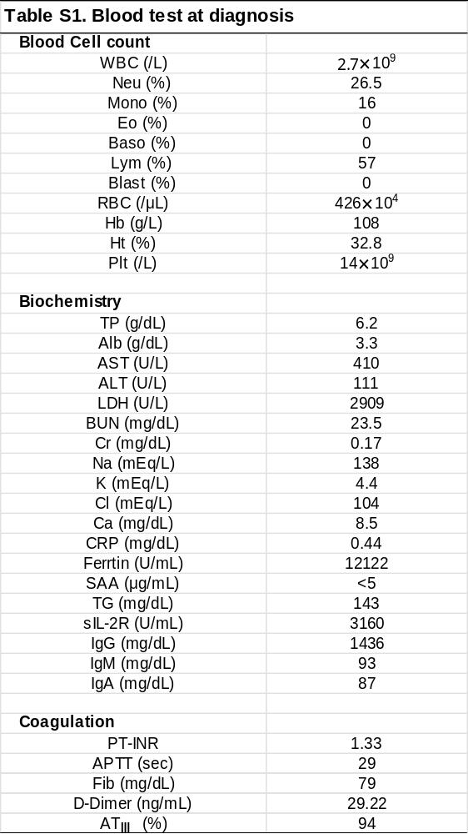

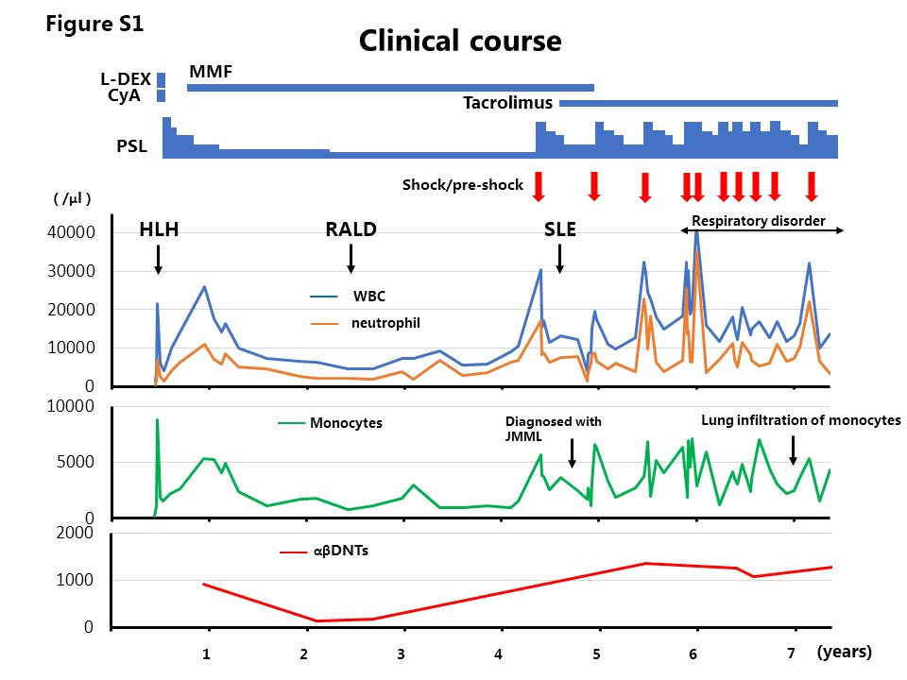
Fig S1. Clinical course from diagnosis to hematopoietic cell transplantation.

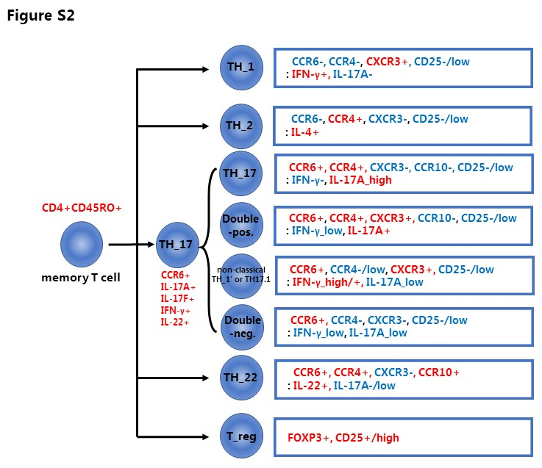
Figure S2. Classification of CD4+CD45RO+. The expression of cell surface molecules of αβDNTs in RALD is similar to that of Th17.

