Supplementary Figures
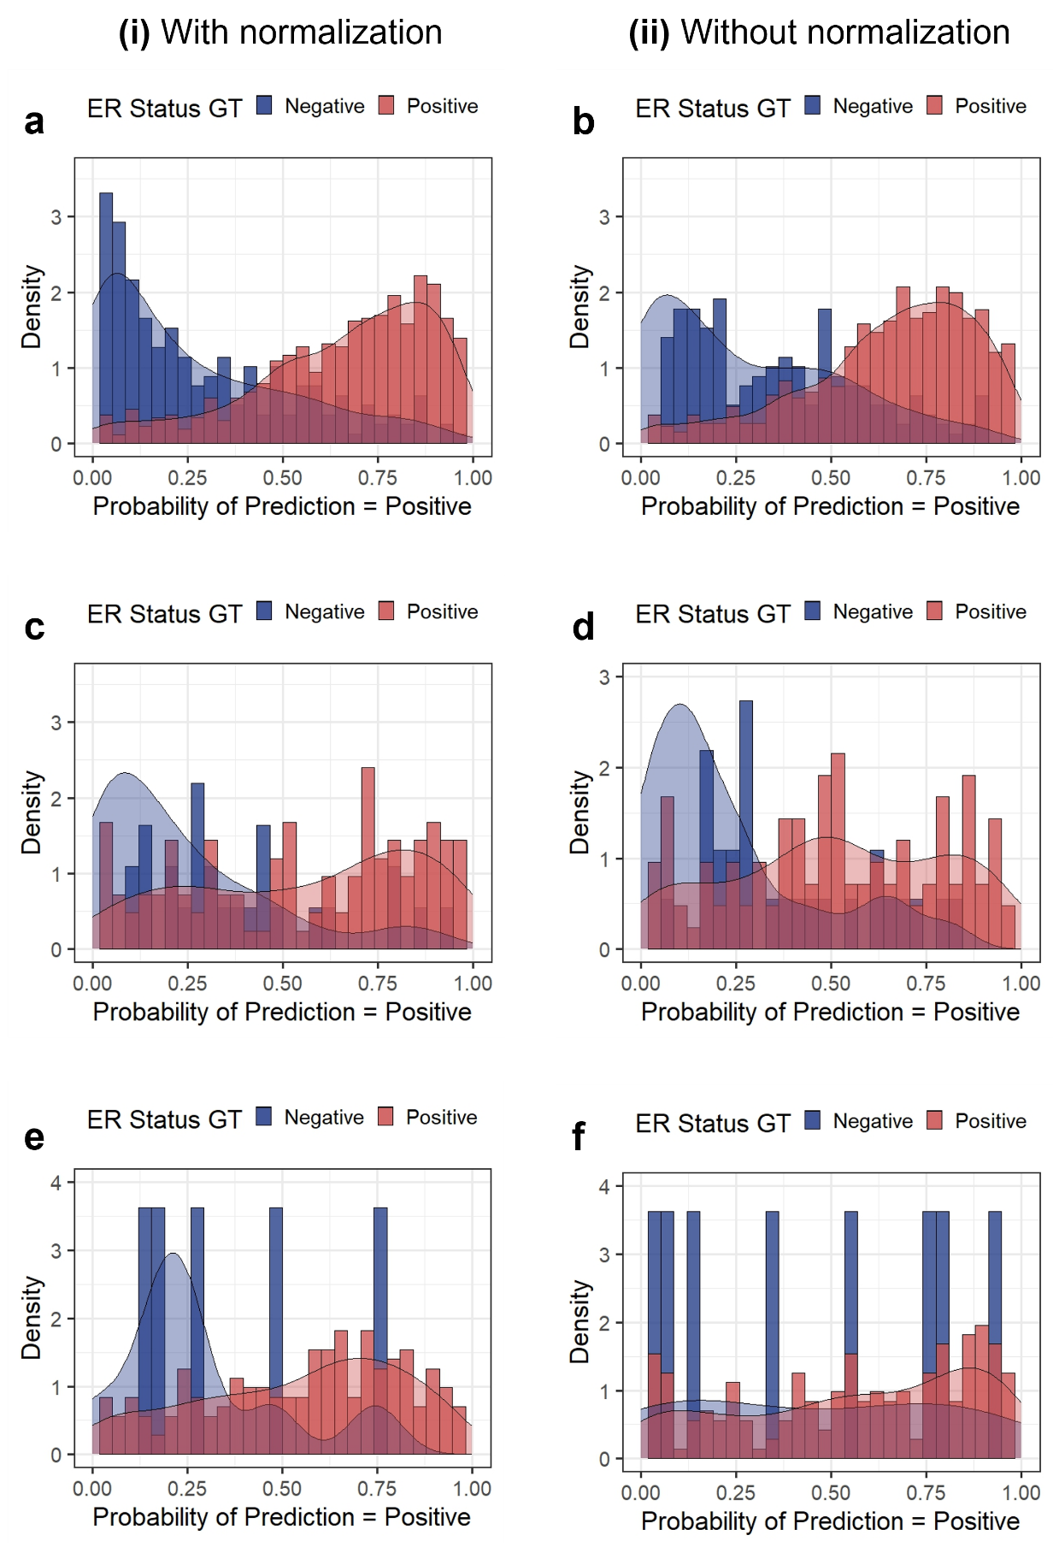

Supplementary Figure S1: Visualization of domain shift between ERα prediction models with and without Macenko normalization
Distribution of ERα model prediction scores (i) with and (ii) without Macenko normalization for (a-b) FBC TCGA internal validation cohort, (c-d) FBC external validation cohort, and (e-f) MBC cohort. GT = Ground Truth

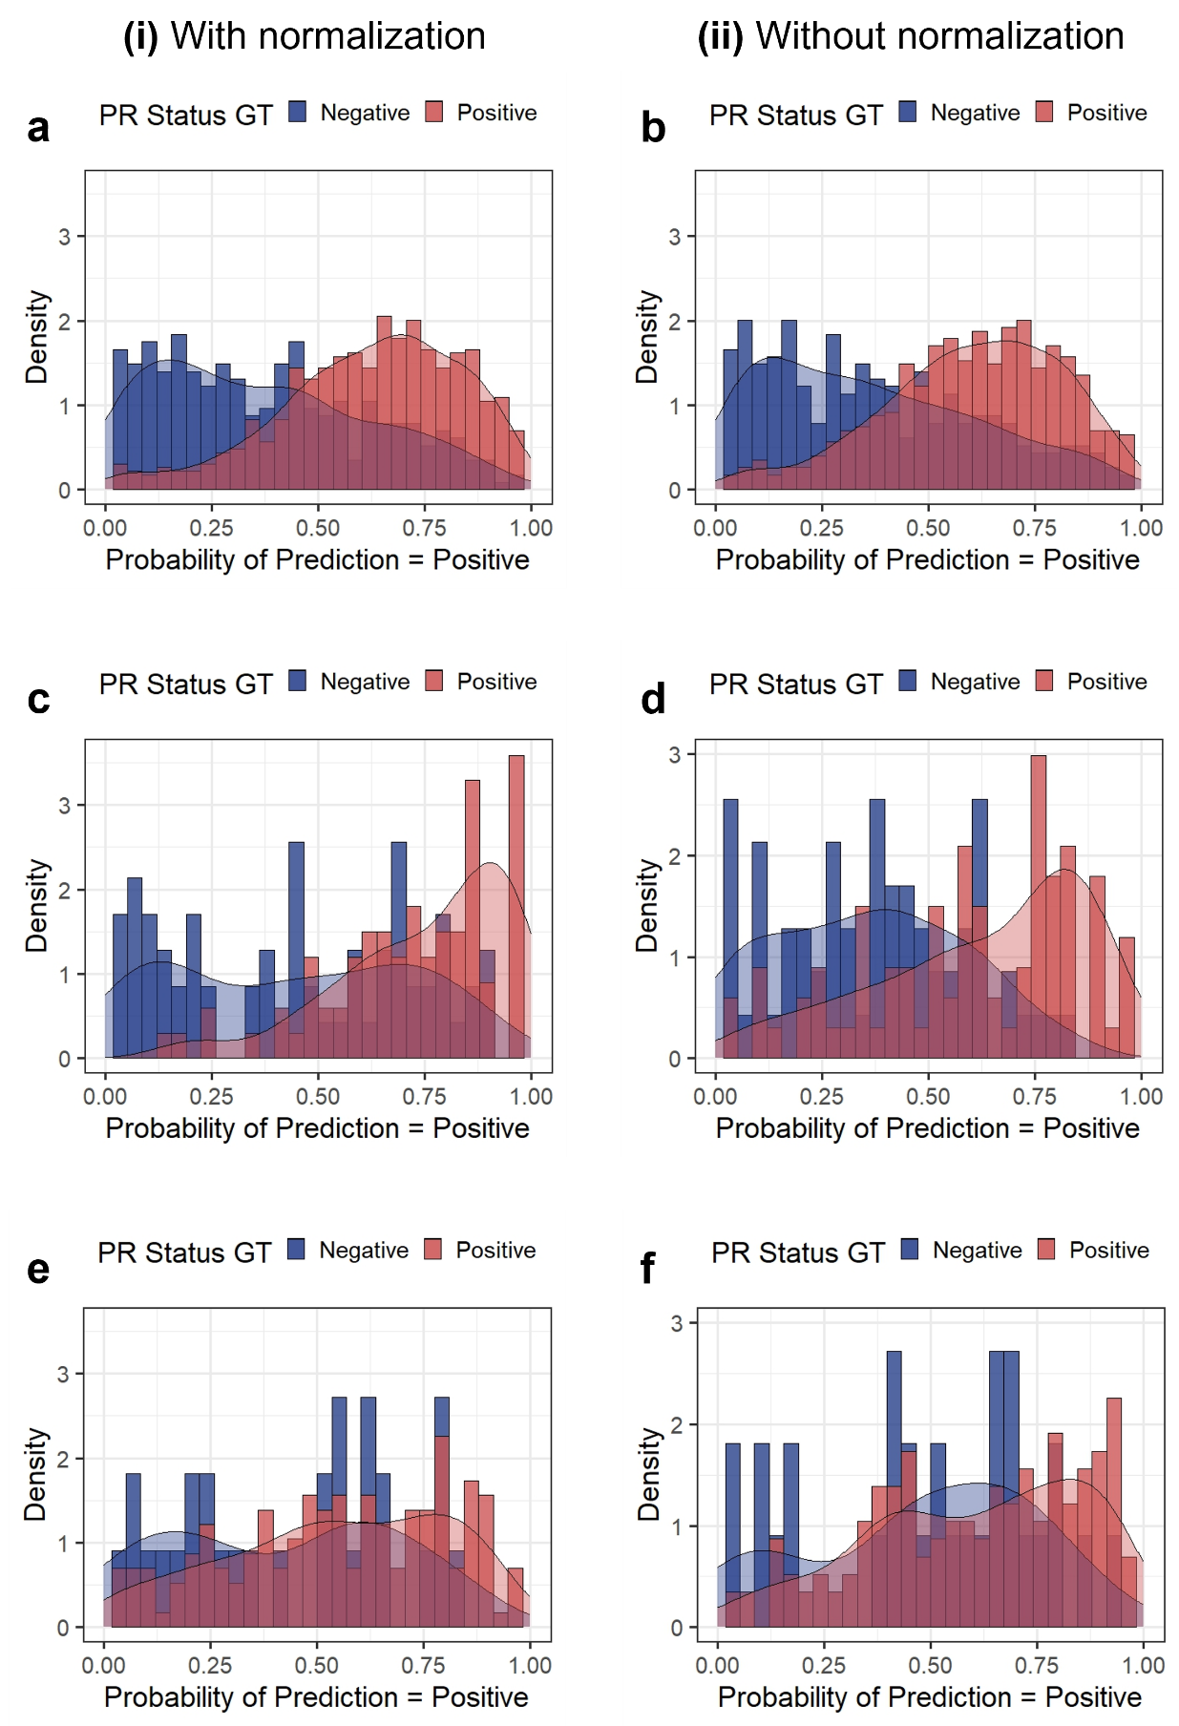

Supplementary Figure S2: Visualization of domain shift between the PR prediction models with and without Macenko normalization
Distribution of PR model prediction scores (i) with and (ii) without Macenko normalization for (a-b) FBC TCGA internal validation cohort, (c-d) FBC external validation cohort, and (e-f) MBC cohort. GT = Ground Truth

Supplementary Tables

Table S1: Performance metrics of prediction models for ERα and PR in each female and male breast cancer cohort

Target | Training Set | Test Set | AUROC | AUPRC (+ve) | AUPRC (-ve)
ERα | FBC TCGA | FBC TCGA | 0.86 ± 0.02 | 0.95 ± 0.01 | 0.67 ± 0.08
ERα | FBC TCGA | FBC EXT-VAL | 0.78 ± 0.03 | 0.88 ± 0.03 | 0.58 ± 0.04
ERα | FBC TCGA | MBC | 0.66 ± 0.14 | 0.98 ± 0.01 | 0.11 ± 0.04
PR | FBC TCGA | FBC TCGA | 0.76 ± 0.03 | 0.83 ± 0.03 | 0.66 ± 0.05
PR | FBC TCGA | FBC EXT-VAL | 0.80 ± 0.04 | 0.86 ± 0.04 | 0.74 ± 0.05
PR | FBC TCGA | MBC | 0.63 ± 0.04 | 0.89 ± 0.02 | 0.27 ± 0.02
Abbreviations: ERα = Estrogen Receptor α; PR = Progesterone Receptor; FBC = Female Breast Cancer; MBC = Male Breast Cancer; TCGA = The Cancer Genome Atlas; EXT-VAL = External Validation; AUROC = Area Under Receiver Operating Curve; AUPRC = Area Under Precision Recall Curve

