Table S1. Bacterial strains and plasmids used in this study.
Name | Characteristics | Reference or source
Bacterial strains
Escherichia coli
DH5α | F-eNDA1 glnV44 thi-1 recA1 relA1 gyrA96 deoR nupG Φ80dlacZΔM15 Δ(lacZYA-argF)U169, hsdR17 (rK-mK),λ– | Laboratory stock
Corynebacterium glutamicum
ATCC 13869 | Wild type | American Type Culture Collection (ATCC)
HK1220 | Single cross-over integration of the cpf1 gene in ATCC 13869 | This study
Plasmids
pK18mobsacB | sacB, lacZa, Km^{r}, mcs mobilizable vector, allows for selection of double crossover C. glutamicum | [1]
pJYS1Ptac | pBL1^{ts} oriV_{C.glutamicum} Km^{r} pSC101 oriV_{E. coli} lacIq, PlacM-FnCpf1, Ptac-RecT | Addgene #85545
pJYS2_crtYf | rep oriV_{C.glutamicum} Sp^{r} pMB1 oriV_{E. Coli} Pj23119-crRNA targeting crtYf | Addgene #85544
pSL360 | pSK1Cat carrying P180 | [2]
pHK432 | Deletion of cpf1 gene from pJYS1Ptac | This study
pHK473 | pBL1^{ts} oriV_{C. glutamicum} Sp^{r} pMB1 oriV_{E. coli} Pj23119-crRNA targeting crtYf | This study
pHK475 | Deletion of crRNA region from pHK473 | This study
pHK487 | pK18mobsacB containing HR1 and the cpf1 gene for integration between cg1121 and cg1122 | This study
pHK489 | pBL1^{ts} oriV_{C.glutamicum} Cm^{r} pSC101 oriV_{E. coli} lacIq, Ptac-RecT | This study
pHK493 | pBL1^{ts} oriV_{C. glutamicum} Sp^{r} pMB1 oriV_{E. coli} Pj23119-crRNA targeting crtEb (¹⁴⁰TTATCCCGTATAACATCGCCA¹⁶⁰) | This study
pHK494 | pBL1^{ts} oriV_{C. glutamicum} Sp^{r} pMB1 oriV_{E. coli} Pj23119-crRNA targeting crtEb (¹⁴⁰TTATCCCGTCTAACATCGCCA¹⁶⁰) | This study
pHK495 | pBL1^{ts} oriV_{C. glutamicum} Sp^{r} pMB1 oriV_{E. coli} Pj23119-crRNA targeting crtEb (¹⁴⁰TTATCCCGGCTAACATCGCCA¹⁶⁰) | This study
pHK496 | pBL1^{ts} oriV_{C. glutamicum} Sp^{r} pMB1 oriV_{E. coli} Pj23119-crRNA targeting crtEb (¹⁴⁰TTATCCCCGCTAACATCGCCA¹⁶⁰) | This study
pHK497 | pBL1^{ts} oriV_{C. glutamicum} Sp^{r} pMB1 oriV_{E. coli} Pj23119-crRNA targeting crtEb (¹⁴⁰TTATCCCGTATCACATCGCCA¹⁶⁰) | This study
pHK498 | pBL1^{ts} oriV_{C. glutamicum} Sp^{r} pMB1 oriV_{E. coli} Pj23119-crRNA targeting crtEb (¹⁴⁰TTATCCCGTATCCCATCGCCA¹⁶⁰) | This study
pHK499 | pBL1^{ts} oriV_{C. glutamicum} Sp^{r} pMB1 oriV_{E. coli} Pj23119-crRNA targeting crtEb (¹⁴⁰TTATCCCGTATCCAATCGCCA¹⁶⁰) | This study

Table S2. Primers used in this study.
Name | Sequence (5'→3') | Features
Mutagenic oligonucleotides (T150G at the crtEb gene for stop codon)
59mer-S | GTAGGCATAGTATTTTTTCTTATCCCGTAGAACATCGCCATGTATGGCATCAACGATGT | Single-mutagenic (¹⁵⁰T to G)
59mer-D | GTAGGCATAGTATTTTTTCTTATCCCGTAGCACATCGCCATGTATGGCATCAACGATGT | Double-mutagenic (¹⁵⁰TA to GC)
59mer-T | GTAGGCATAGTATTTTTTCTTATCCCGTAGCCCATCGCCATGTATGGCATCAACGATGT | Triple-mutagenic (¹⁵⁰TAA to GCC)
59mer-4 | GTAGGCATAGTATTTTTTCTTATCCCGTAGCCAATCGCCATGTATGGCATCAACGATGT | Quadruple-mutagenic (¹⁵⁰TAAC to GCCA)
Construction of the Cpf1 integrated vector
P1 | CAATAACTAAGTCCCTTTGAGTGAGCTGATACCGCTCGCCG | Construction of pHK487
P2 | CAAGAACCAGGACCGGTAATACGGTTATCCACAGAATCAGG | Construction of pHK487
P3 | AACCGTATTACCGGTCCTGGTTCTTGTCCTGGGCAACGTTG | Construction of pHK487
P4 | GATTCCGCGAACCCCAGAGTCCCGCAGGAGCCTCAAAAATCGAGCTCGCTTTGGTC | Construction of pHK487
P5 | CAAAGCGAGCTCGATTTTTGAGGCTCCT GCGGGACTCTGGGGTTCGCGGAATCATG | Construction of pHK487
P6 | GCTCACTCAAAGGGACTTAGTTATTGCGGTTCTGGACAAAT | Construction of pHK487
Construction of the RecT expression vector
P7 | [5’-Phosphorylated] CACACATGGTACCACACGATGATTAATTG | Construction of pHK432
P8 | [5’-Phosphorylated] GAAAGGCCCAGTCTTTCGACTGAGCCTTTC | Construction of pHK432
P9 | TTTTTTTCTCCATGCGAAACGATCCTCATCCTGTCTCTTGA | Construction of pHK489
P10 | GCAGGGCGGGGCGGCGGGACTCTGGGGTTCGCGGAATCATG | Construction of pHK489
P11 | AGGATCGTTTCGCATGGAGAAAAAAATCACTGGATATACCA | Construction of pHK489
P12 | CCCAGAGTCCCGCCGCCCCGCCCTGCCACTCATCGCAGTAC | Construction of pHK489
Construction of the crRNA expression vector
P13 | GAAAGCACTCAAGACGTGCGAGCTACCAACTCATATGCACGGG | Construction of pHK473
P14 | CGGTGTTTCGTTTAGTGGGTGCGAAGAATAGTCTGCTCATTAC | Construction of pHK473
P15 | ATTCTTCGCACCCACTAAACGAAACACCGTCAGCAGAAAACGG | Construction of pHK473
P16 | GTTGGTAGCTCGCACGTCTTGAGTGCTTTCTCCCAGCTGATGAC | Construction of pHK473
P17 | [5’-Phosphorylated] TTCGAGTCGAGGAAGAGCCAGAGCAGAAGGC | Construction of pHK475
P18 | [5’-Phosphorylated] TTCGTTTGTCGGTGAACGCTCTCCTGAGTAG | Construction of pHK475
P19 | GATATTCCATTTTCTGATGTGAGAAGAGCCATTATGGATTC | Construction of crRNA plasmids
P20 | CTTCTCACATCAGAAAATGGAATATCAGGTAGTAATTCCTC | Construction of crRNA plasmids
P21 | TTATCCCGTATAACATCGCCAATTTAAATAAAACGAAAGGCTCAG | Construction of pHK493
P22 | TGGCGATGTTATACGGGATAAATCTACAACAGTAGAAATTCGGAT | Construction of pHK493
P23 | TTATCCCGTCTAACATCGCCAATTTAAATAAAACGAAAGGCTCAG | Construction of pHK494
P24 | TGGCGATGTTAGACGGGATAAATCTACAACAGTAGAAATTCGGAT | Construction of pHK494
P25 | TTATCCCGGCTAACATCGCCAATTTAAATAAAACGAAAGGCTCAG | Construction of pHK495
P26 | TGGCGATGTTAGCCGGGATAAATCTACAACAGTAGAAATTCGGAT | Construction of pHK495
P27 | TTATCCCCGCTAACATCGCCAATTTAAATAAAACGAAAGGCTCAG | Construction of pHK496
P28 | TGGCGATGTTAGCGGGGATAAATCTACAACAGTAGAAATTCGGAT | Construction of pHK496
P29 | TTATCCCGTATCACATCGCCAATTTAAATAAAACGAAAGGCTCAG | Construction of pHK497
P30 | TGGCGATGTGATACGGGATAAATCTACAACAGTAGAAATTCGGAT | Construction of pHK497
P31 | TTATCCCGTATCCCATCGCCAATTTAAATAAAACGAAAGGCTCAG | Construction of pHK498
P32 | TGGCGATGGGATACGGGATAAATCTACAACAGTAGAAATTCGGAT | Construction of pHK498
P33 | TTATCCCGTATCCAATCGCCAATTTAAATAAAACGAAAGGCTCAG | Construction of pHK499
P34 | TGGCGATTGGATACGGGATAAATCTACAACAGTAGAAATTCGGAT | Construction of pHK499
P35 | GAGCTTGCAGGCGAACTAGGTGTCAGTG | Sequencing of crRNA plasmids
Cpf1 integration in the C. glutamicum genome
P36 | CAGAACCCATACGGTGGTTACGACAAC | Upstream of HR region
P37 | GTTGGCTCCGTTGTTCACGTCTACTACG | Downstream of HR region
P38 | GAGCTCTTCGGCCAGGTCCTTCTTGATC | Reverse primer of the cpf1 gene
P39 | CGAGACCTTCAAGAAGATGGGCAAGCAG | Forward primer of the cpf1 gene
Sequencing of crtEb
P40 | CTTCTGATTCCTGCCCTATGGTTGCCTG | Sequencing of the edited target
P41 | GTTGTGGAGCTTGAACGCATCGAGGTCG | Sequencing of the edited target

Figure S1. Transformation agar plates after electroporation of single-, double-, triple-, and quadruple-base mutagenic oligonucleotides and perfect-matched crRNA (pHK493) plasmid into IPTG-induced HK1220/pHK489 cells.
Single base mutagenic oligo, perfect-matched crRNA (pHK493) | Double base mutagenic oligo, perfect-matched crRNA (pHK493)
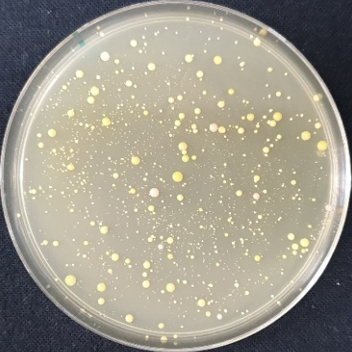 | 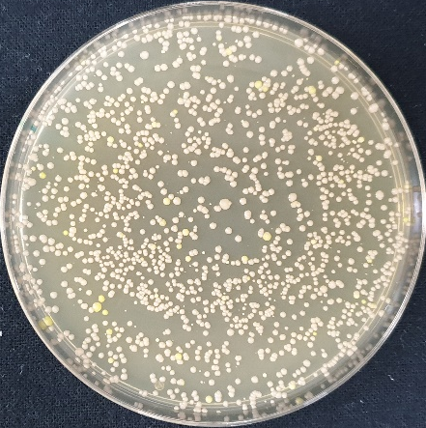
Triple base mutagenic oligo, perfect-matched crRNA (pHK493) | Quadruple base mutagenic oligo, perfect-matched crRNA (pHK493)
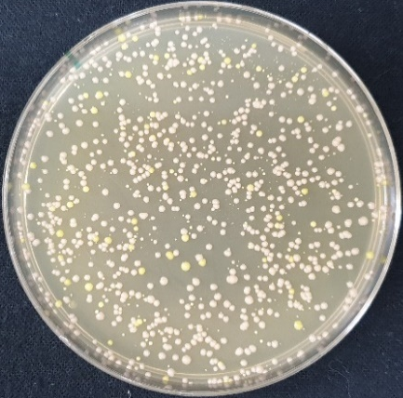 | 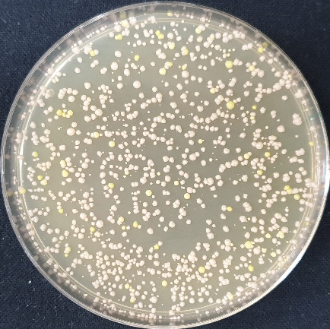
Figure S2. Transformation agar plates after electroporation of single-base-mutagenic oligonucleotides and mismatched crRNA plasmids into IPTG-induced HK1220/pHK489 cells.
Single base mutagenic oligo, single-mismatched crRNA (pHK494) | Single base mutagenic oligo, single-mismatched crRNA (pHK497)
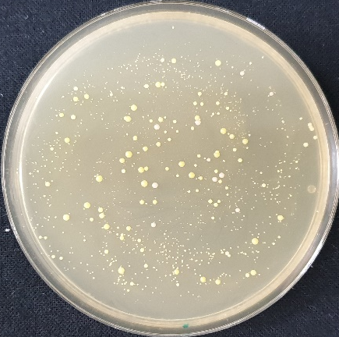 | 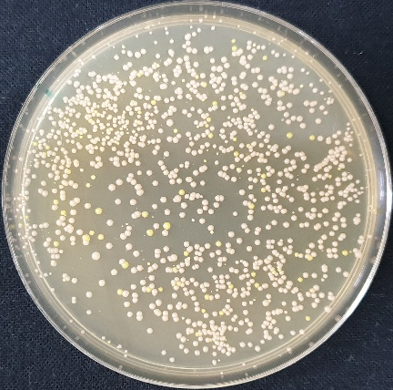
Single base mutagenic oligo, double-mismatched crRNA (pHK495)
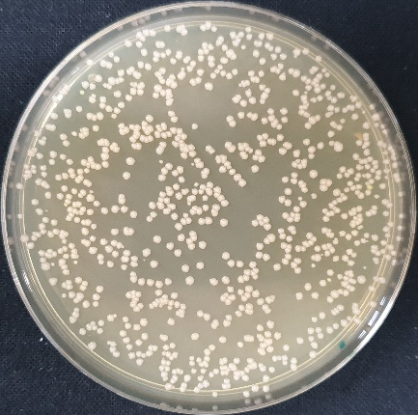

Figure S3. Chromatogram of the edited sequences of crtEb.
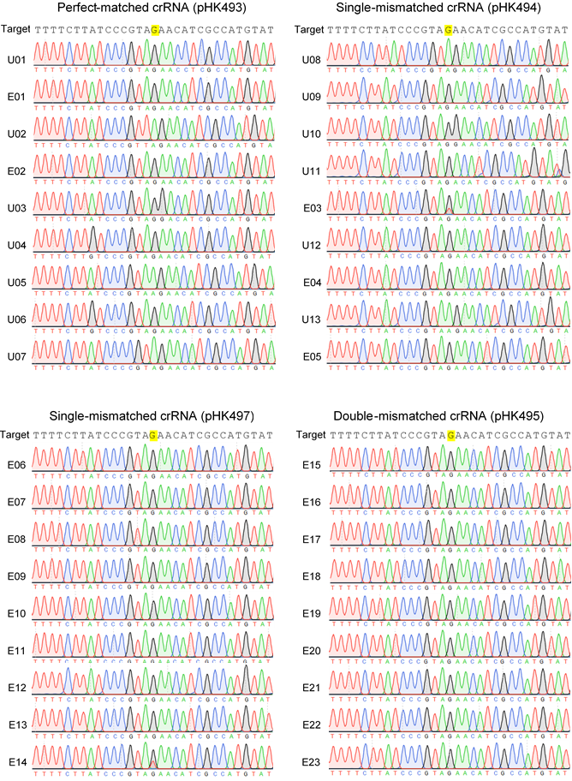

References
1. Schafer A, Tauch A, Jager W, Kalinowski J, Thierbach G, Puhler A: Small mobilizable multi-purpose cloning vectors derived from the Escherichia coli plasmids pK18 and pK19: selection of defined deletions in the chromosome of Corynebacterium glutamicum. Gene 1994, 145:69-73.
2. Park S-D, Lee S-N, Park I-H, Choi J-S, Jeong W-K, Kim Y, Lee H-S: Isolation and characterization of transcriptional elements from Corynebacterium glutamicum. Journal of Microbial Biotehcnology 2004, 14:789-795.

