Table 1. Meteorological stations used in the study with their spatial information
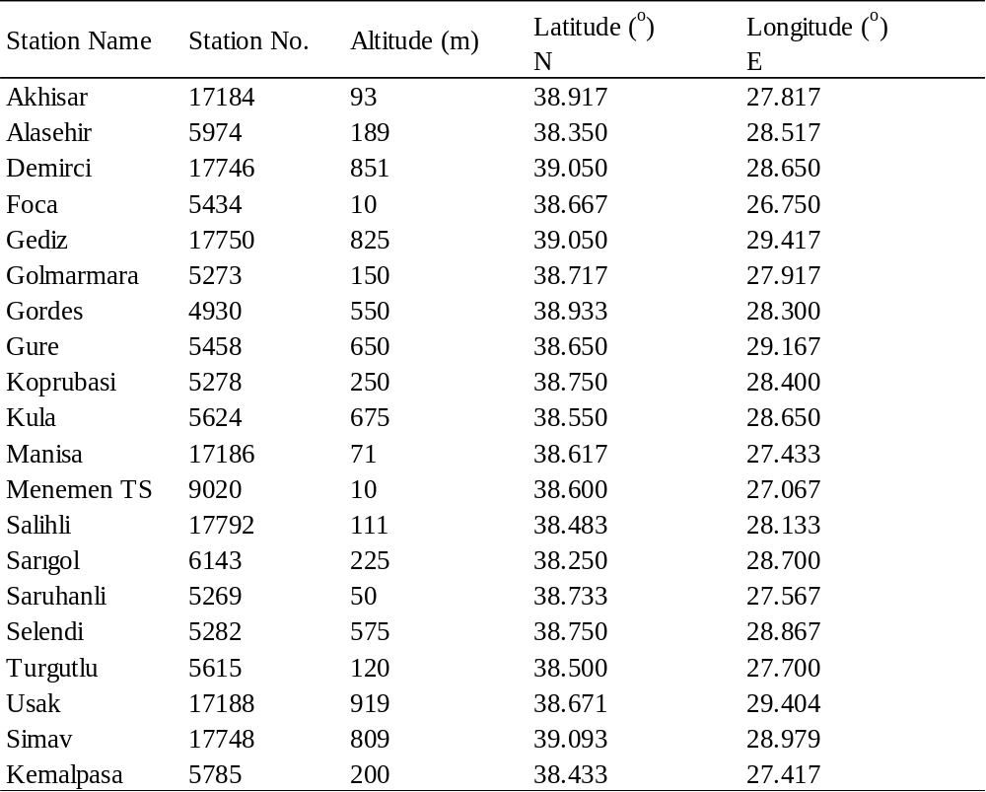

Table 2. Climatic zones corresponding to aridity index
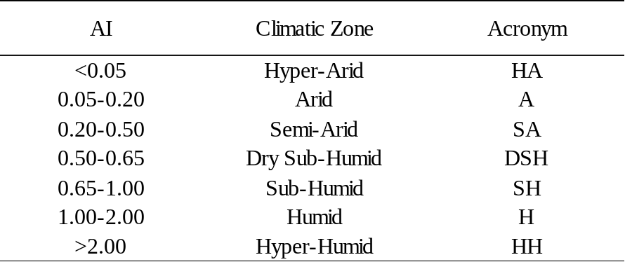

Table 3. Testing performances of ANN and LSSVM as temperature downscaling models (better performing results are underlined. n.n.h: number of neurons in hidden layer, γ: regularization parameter, σ: RBF width).
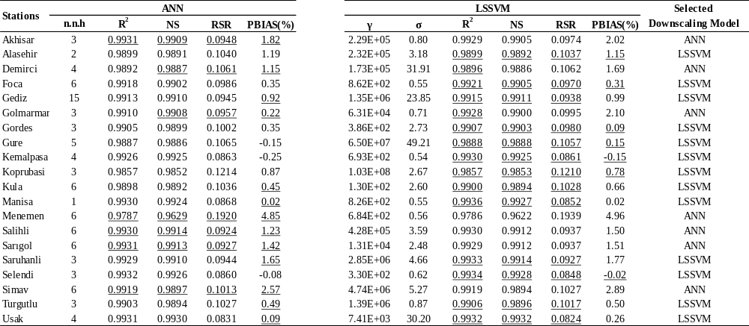

Table 4. The weights of each GCM obtained for the meteorological stations (Maximum values are coloured for wet and dry periods separately).
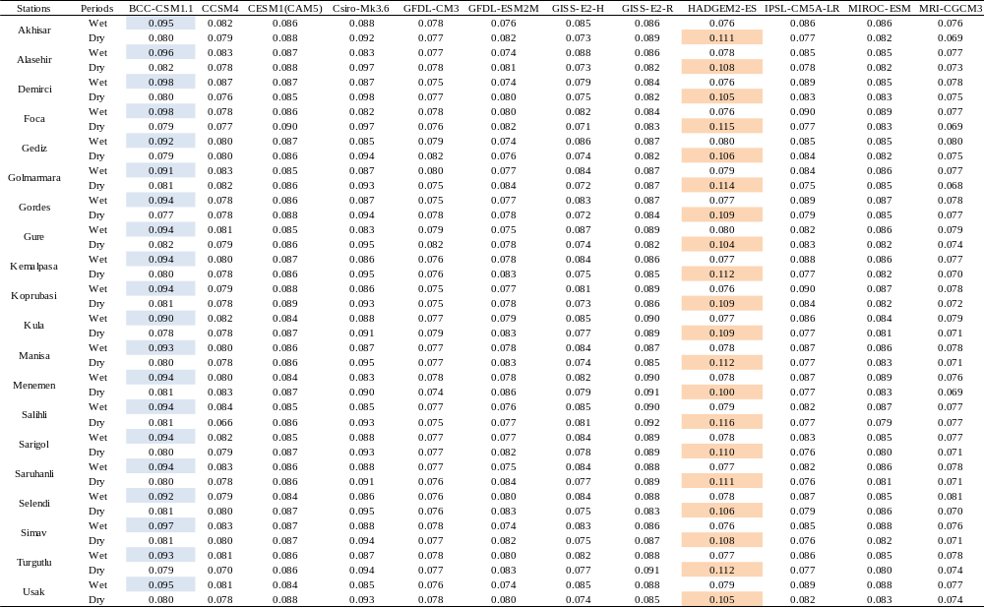
Table 5. The statistical performances of modified temperature-based PET methods. The coefficients a,b,c, and d are calibrated in accordance with PM method. The formulas given on the right are analogous with the original Ham, Bl-Cr and Thw methods. The recalibrated coefficients of Hamon formula and scatter plot of Ham-based PM simulations are also given for Akhisar meteorological station. The underlined values denote the best performances in each station.
