Extended Data Figure S1

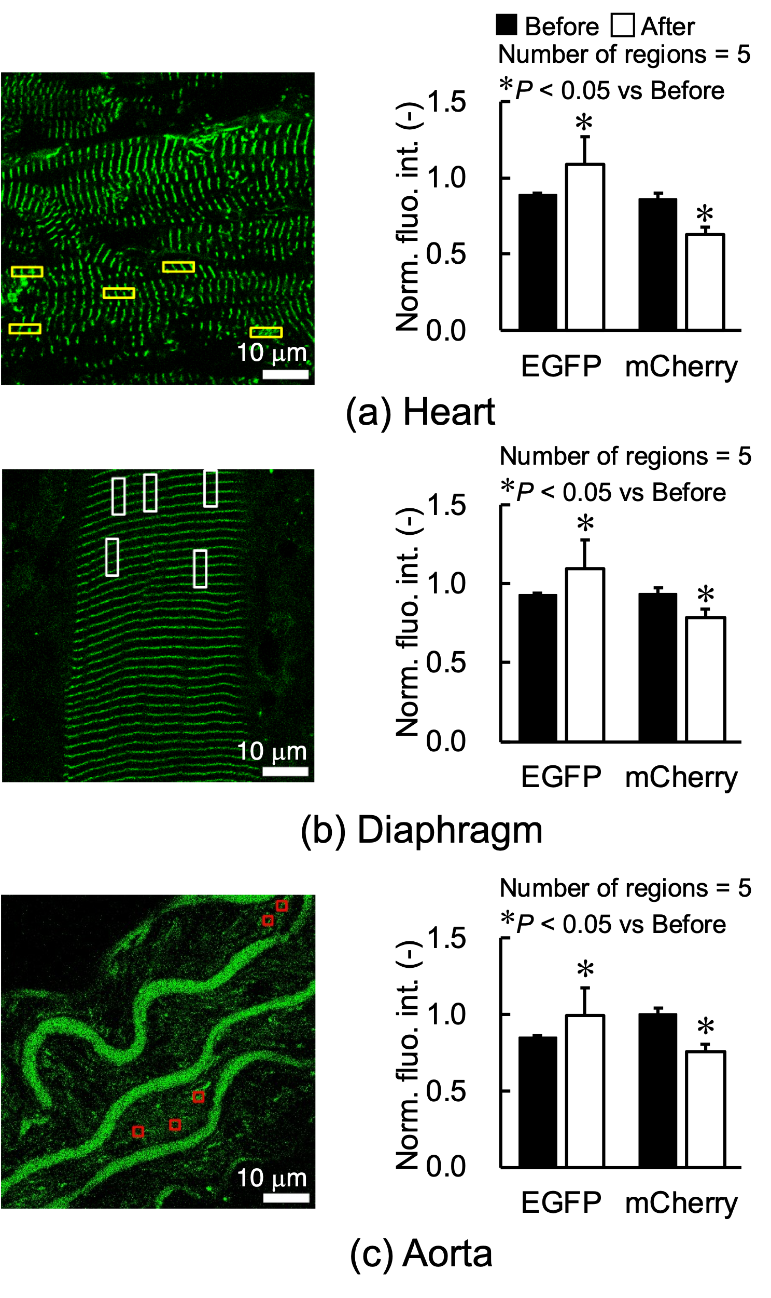
Photobleaching experiments with heart (a), diaphragm (b) and aorta (c) as shown in Figure 4. Left, fluorescent image of EGFP and ROIs (open rectangles in yellow, white or red). Right, Comparisons of normalized fluorescence intensity of EGFP and mCherry before and after photobleaching. Data were obtained from S2 tension sensors.s

