Extended Data Figure S2

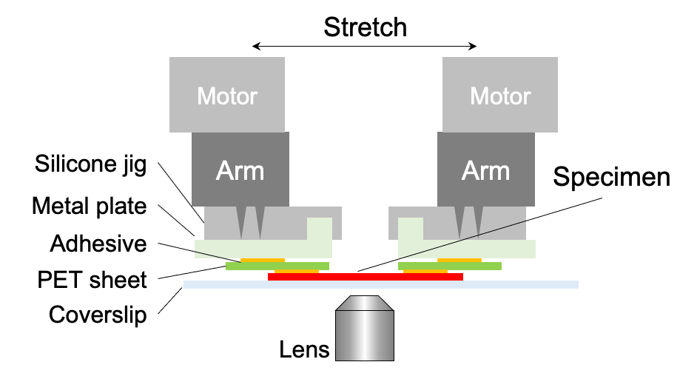

Tensile stretching apparatus and custom-made jigs for application of tensile strain to tissue explants and isolated cells¹³.

