Table S1. the prevalence of CAC score in each percentile by gender, age category, and diabetes mellitus
CAC score  Age sex specific | Men |  |  |  | Women
CAC score  Age sex specific | < 55 | 55-64 | >64 |  | < 55 |  | 55-64 | >64
Total patients
(n=440)
P25 | 0 | 0.8 | 38.6 |  | 0 | 0 |  | 0.2
P50 | 3.9 | 16.1 | 225.8 |  | 0 | 2.7 |  | 123.7
P75 | 107.3 | 264.9 | 575.8 |  | 8.7 | 44.5 |  | 273.15
P90 | 293.4 | 789.8 | 1726.9 |  | 110.8 | 266.5 |  | 788.1
Patient with DM
(n=96)
P25 | 0 | 1.1 | 105.9 |  | 0 |  | 0 | 17.9
P50 | 28.5 | 10.9 | 403 |  | 13.35 |  | 1 | 147.1
P75 | 100.7 | 528.3 | 1368.3 |  | 29.9 |  | 85.5 | 365.8
P90 | 468.8 | 1102.2 | 2174.5 |  | 528.9 |  | 365.8 | 974.3
P-value for gender | 0.008
Patient without DM
(n=332)
P25 | 0 | 0.4 | 23.7 |  | 0 |  | 0 | 0
P50 | 1.9 | 16.3 | 139.5 |  | 0 |  | 2.85 | 47.5
P75 | 107.3 | 229.2 | 396.2 |  | 3.1 |  | 40.3 | 257.7
P90 | 293.4 | 786.6 | 1410 |  | 98.7 |  | 266.5 | 689
P-value for gender  P-value for DM  (male) | <0.001  0.028 |  |  | P-value for DM  (female) | 0.049
P-value for DM  (all) | 0.005 |  |  | P value for gender (all) | <0.001
Abbreviations: DM, diabetes mellitus

Table S2. Prevalence of Major adverse cardiovascular event
Events | Frequency (%)
Revascularization (PCI + CABG) | 60 (73.2)
Stroke | 9 (11.0)
Acute coronary syndrome | 7 (8.5)
Hospitalization for heart failure | 5 (6.1)
Cardiovascular death | 1 (1.2)
Total | 82
Abbreviations: PCI; percutaneous coronary intervention, CABG; coronary artery bypass grafting

Figure 1S. The distribution of CAC score stratified by sex, age groups and DM
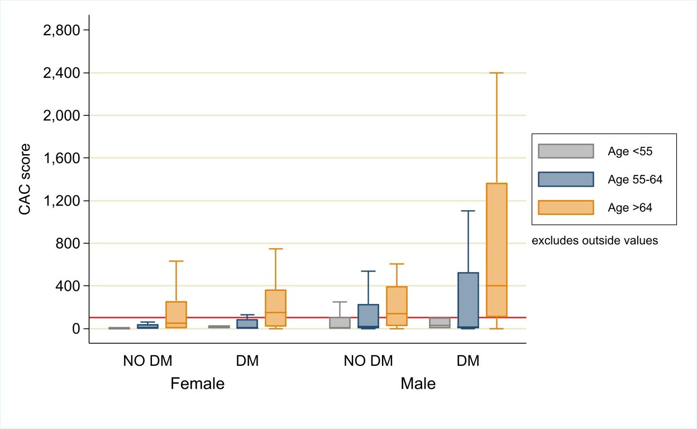
Caption: Patients distribution in each subgroup were presented in percentile using box plot. Red solid line is CAC score at 100. For all patients, p-value between sex was < 0.001 and p-value between DM and no DM was 0.005. Abbreviation: DM; Diabetes mellitus, CAC; coronary artery calcium

