Figure 1a shows the whole blot after cutting membrane at molecular weight 100 kDa, 75 kDa, 50 kDa, 37 kDa and 25 kDa for BiP (73 kDa), GFP (26 kDa), and Sigma-1R-GFP (50 kDa).
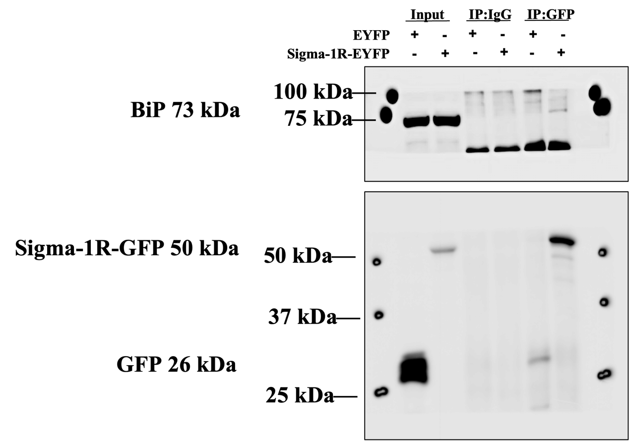

Figure 1b shows the whole blot after cutting membrane at molecular weight 75 kDa, and 50 kDa for BiP (73 kDa), and Sigma-1R-GFP (50 kDa).
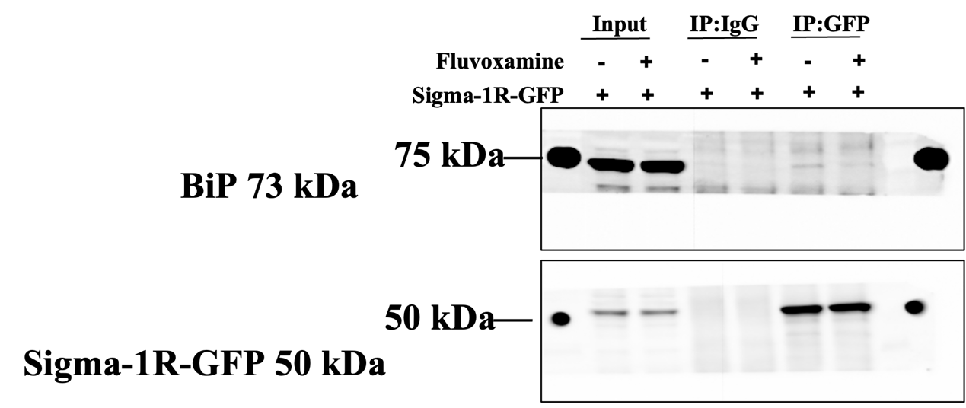

Figure 3a shows the whole blot (4 times repeats) after cutting membrane at molecular weight 150 kDa, 250 kDa, 50 kDa and 37kDa for Pom121 (155 kDa), and Sigma-1R-GFP (50 kDa).
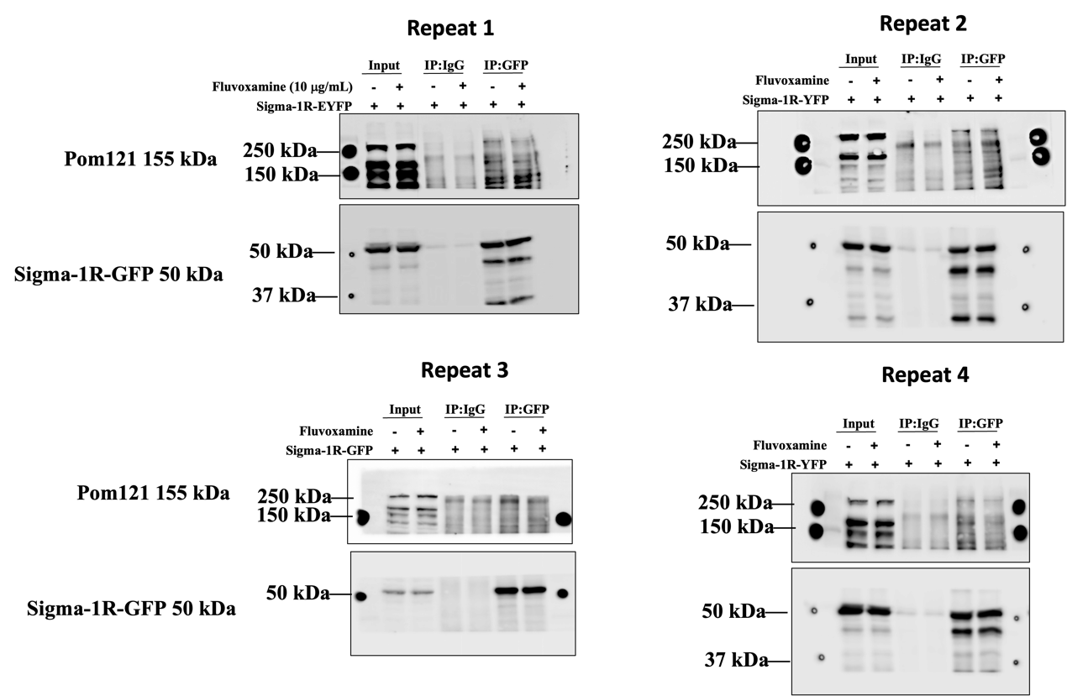

Figure 3c-3e show the whole blot (3 times repeats) after cutting membrane at molecular weight 250 kDa, 150 kDa, 75 kDa, 50 kDa, 37kDa and 25 kDa for Pom121 (155 kDa), α-Tubulin (55 kDa), and EGFP-(G4C2)31 (26 kDa).
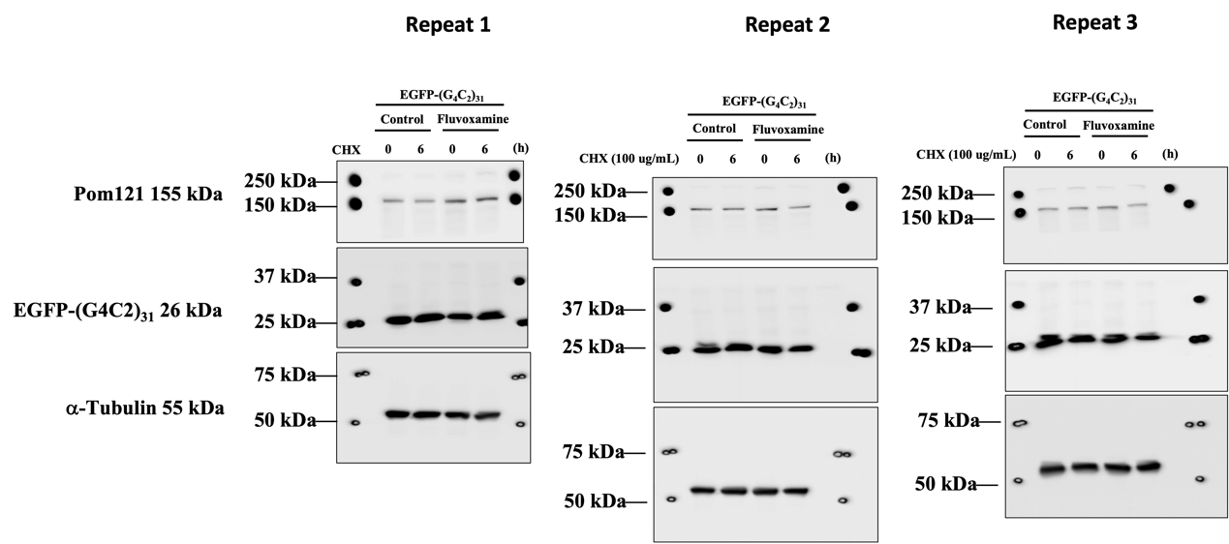

Figure 4a-4c show the whole blot (4 times repeats) after cutting membrane at molecular weight 100 kDa, 75 kDa 37 kDa, and 25 kDa for TFEB (65-70 kDa), Importinβ1 (97 kDa), HDAC2 (60 kDa), β-Actin (43 kDa) and EGFP-(G4C2)31 (26 kDa).
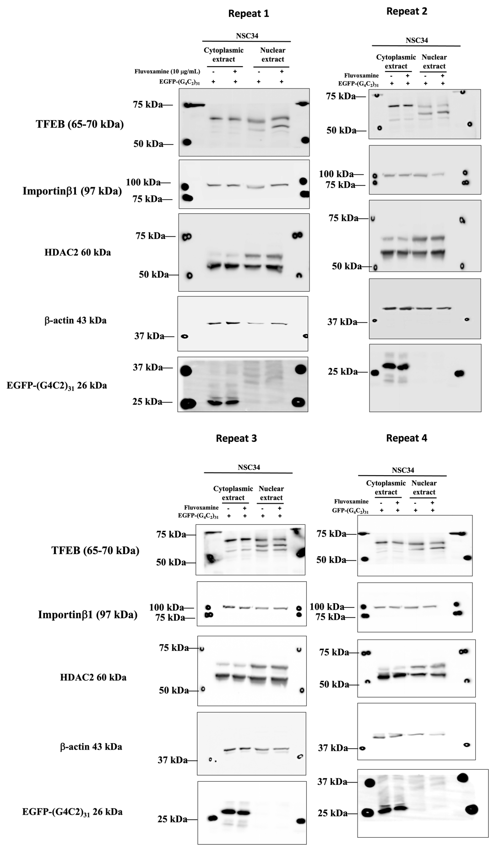
Figure 4d-4e show the whole blot (5 times repeats) after cutting membrane at molecular weight 50 kDa, 25 kDa, and 15 kDa for LC3 (14-16 kDa), GFP (26 kDa), and Tubulin (55 kDa).
