Supplementary Material
Viperin inhibits interferon-γ production to promote Mycobacteria tuberculosis infection by disrupting TBK1-IKKε-IRF3-axis and JAK-STAT signaling
Yao Liang, Yun Liang, Qi Wang, Qianna Li, Yingqi Huang, Rong Li, Xiaoxin Pan, Linmiao Lie, Hui Xu, Zhenyu Han, Honglin Liu, Qian Wen, Chaoying Zhou, Li Ma*, Xinying Zhou*
* Correspondence: Xinying Zhou: zxyforever@smu.edu.cn, Li Ma: mali_61648322@smu.edu.cn

Supplementary Figures and Tables

Supplementary Figures
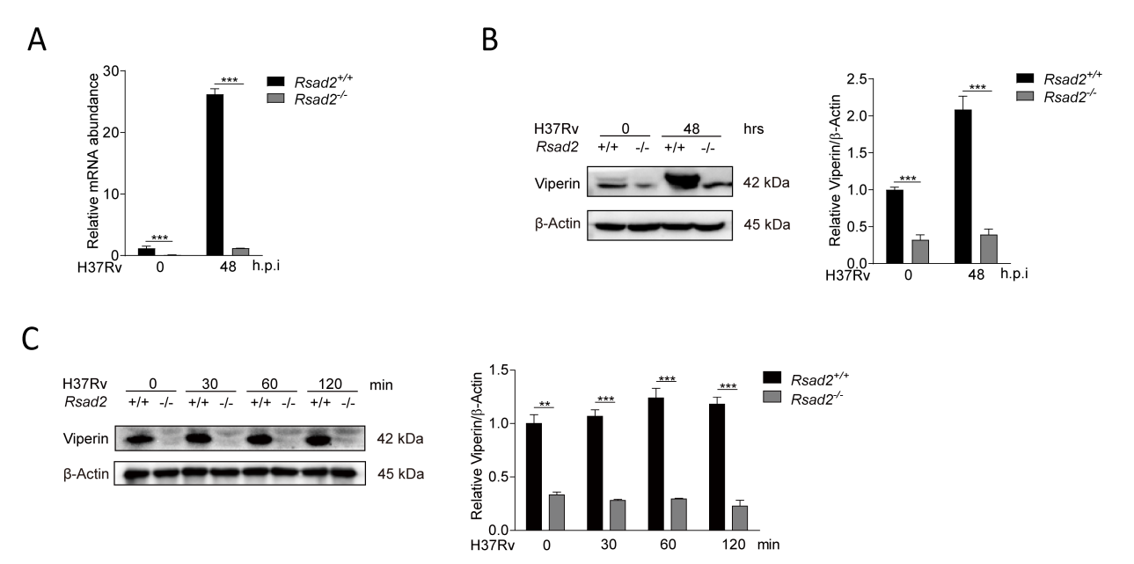
Supplementary Fig. 1. Viperin expression in BMDM of Rsad2^{+/+} and Rsad2^{-/-} BMDM.
(A, B) Intracellular mRNA (A) and protein expression (B) of Viperin were detected in Rsad2^{+/+} and Rsad2^{-/-} BMDMs upon Mtb infection at MOI of 1 for 48 hrs by qRT-PCR and Western blot analyses.
(C) Expression of Viperin was detected in Rsad2^{+/+} and Rsad2^{-/-} BMDMs upon Mtb infection at MOI of 5 for 0, 30, 60 and 120 min by Western blot assay.
(A) Data were presented as fold change in mRNA abundance relative to that in uninfected controls of Rsad2^{+/+} BMDMs. β-Actin served as an internal reference.
(B, C) Data were subjected to densitometric analysis on basis of Western blot assay. β-Actin served as an internal reference.
(A-C) Western blot results were representative of three independent experiments with similar results. Data shown were the mean ± SD and are from at least three independent experiments with each 3-4 replicates. Data were analyzed by T-test, **p ≤ 0.01, ***p ≤ 0.001.
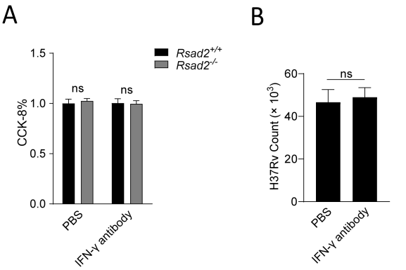
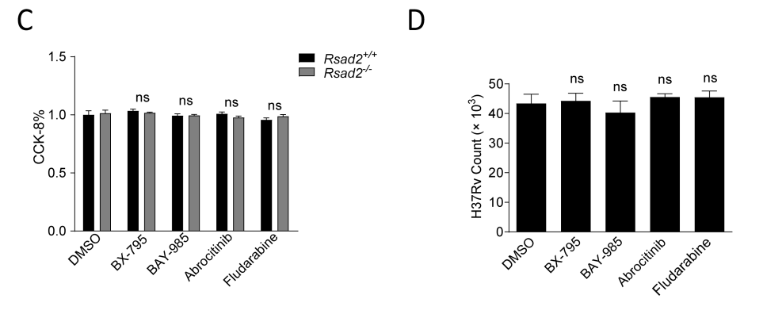
Supplementary Fig. 2. Treatment of different reagents did not affect cytotoxicity of BMDM and Mtb growth.
(A) Rsad2^{+/+} and Rsad2^{-/-} BMDMs were pretreated with IFN-γ neutralizing antibody. Cytotoxicity was detected by CCK-8 assay at 48 hrs of IFN-γ neutralizing antibody treatment. Treatment of PBS at the same concentration was normalized to 100%.
(B) The direct effect of IFN-γ neutralizing antibody on Mtb infection was detected by CFU assay at 48 hrs.
(C) Rsad2^{+/+} and Rsad2^{-/-} BMDMs were pretreated with BX-795, BAY-985, Abrocitinib, and Fludarabine. Cytotoxicity was detected by CCK-8 assay at 48 hrs of these reagent treatments. Treatment of DMSO at the same concentration was normalized to 100%.
(D) The direct effect of inhibitors including BX-795, BAY-985, Abrocitinib, and Fludarabine on Mtb infection was detected by CFU assay at 48 hrs.
(A-D) Data shown were the mean ± SD and are from at least three independent experiments with each 3-4 replicates. Data were analyzed by T-test, ns., not significant.
IFN-γ antibody: IFN-γ neutralizing antibody; BX-795: TBK1/IKKε inhibitor; BAY-985: IRF3 inhibitor; Abrocitinib: JAK1 inhibitor; Fludarabine: STAT1 inhibitor; INH: anti-TB drug isoniazid.

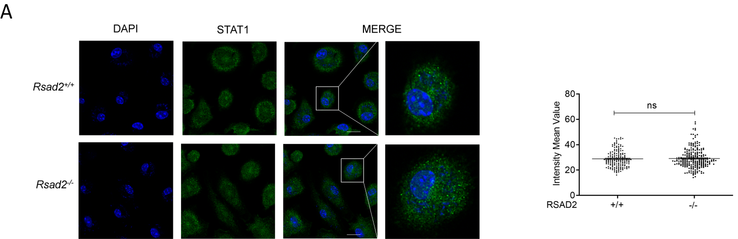
Supplementary Fig. 3. Viperin deficiency did not affect translocation of total protein of STAT1 from cytoplasm to nucleus.
(A) Rsad2^{+/+} and Rsad2^{-/-} BMDMs infected with Mtb at MOI of 5 for 2 hrs. Total protein level of STAT1 was detected with Alexa Fluor 488 (green) by immunofluorescence confocal microscope assay. DAPI (blue) was used to stain for the nuclear of the cells. Fluorescence intensity mean value of totle STAT1 Alexa Fluor 488 was detected in 200 cells in the nuclear of each group. Scale bar: 10 μm. Data were analyzed by T-test, ns., not significant.

Supplementary Tables
Supplementary Table 1. List of reagents.
Reagent | type | Approach | Source
IFN-γ antibody | IFN-γ neutralizing antibody | 7.5 μg/mL | Selleckchem, USA, A2105
BX795 | TBK1/IKKε inhibitor | 2 μM, pretreatment 2 hrs | MCE, USA, HY-10514
BAY-985 | IRF3 inhibitor | 200 nM, pretreatment 18 hrs | MCE, USA, HY-133117
Abrocitinib | JAK1 inhibitor | 200 nM, pretreatment 18 hrs | MCE, USA,HY-107429
Fludarabine | STAT1 inhibitor | 30 μM, pretreatment 2 hrs | MCE, USA, HY-B0069
INH | anti-TB drug isoniazid | 1 and 10 μM, pretreatment 2 hrs | MCE, USA, HY-B0329

Supplementary Table 2. List of mouse genes and corresponding primers for qRT-PCR assay.
No. | Gene symbol | Full name | Primers (5’ - 3’)
1 | ACTIN | ACTIN | F: CATTGCTGACAGGATGCAGAAGG  R: TGCTGGAAGGTGGACAGTGAGG
2 | Rsad2 | Radical S-adenosyl methionine domain containing 2 | F: GGAAGGTTTTCCAGTGCCTCCT  R: ACAGGACACCTCTTTGTGACGC
3 | IFN-α | Interferon alpha | F: ATCCAGAAGGCTCAAGCCATCC  R: GGAGGGTTGTATTCCAAGCAGC
4 | IFN-β | Interferon beta | F: GCCTTTGCCATCCAAGAGATGC  R: ACACTGTCTGCTGGTGGAGTTC
5 | IFN-γ | Interferon gamma | F: CAGCAACAGCAAGGCGAAAAAGG  R: TTTCCGCTTCCTGAGGCTGGAT
F: forward primer; R: reverse primer.

Supplementary Table 3. List of antibodies.
Antibodies | Application | Dosage | Supplier
β-actin | WB | 1:2000 | CST #8457
Viperin [MaP.VIP] | WB | 1:50 | Abcam ab107359
TBK1 | WB | 1:1000 | CST #3013
Phospho-TBK1 (Ser172) | WB | 1:1000 | CST #5483
IKKε | Neutralization | 1:8333 | CST #3416S
Phospho-IKKε (Ser172) | WB | 1:1000 | CST #8766S
IRF3 | WB | 1:1000 | Bioworld BS6921
Phospho-IRF3 (Ser396) | WB | 1:1000 | Affintiy Biosciences AF2436
JAK1 | WB | 1:1000 | CST #3344
Phospho-JAK1 (Tyr1034/1035) | WB | 1:1000 | CST #74129S
STAT1 | WB  IF | 1:1000  1:400 | CST #14994
Phospho-STAT1 (Tyr701) | WB  IF | 1:1000  1:300 | CST #9167S
F4/80 | IHC | 1:100 | Invitrogen MA5-16363
IFN-γ | IHC | 1:200 | Abclonal A12450
WB, Western Blot; IHC, Immunohistochemistry; IF, Immunofluorescence.

