Appendix A1: Computations of ${SACF}_{1θ_{H},1θ_{V}}^{k}$
Considers two seasons $(k=1$ and $k=2$), below represent a sample computation for 5 years in the Black River for the second season. It should be noted that to synthesize 4 years of streamflow, it is necessary (as explained earlier in the methodology) to have data spanning 5 years.

$$G^{k=1}=[ ]$$ |  |  | $$G^{k=2}=[ ]$$
 | 1915 1916 1917 1918 1919 |  | 1916 1917 1918 1919 1920
$$\begin{matrix}OC \\ NO \\ \begin{matrix}DE \\ JA \\ \begin{matrix}FE \\ MR\end{matrix}\end{matrix}\end{matrix}$$ | $$\left[\begin{matrix} 39 & 22 & \begin{matrix}22 & 49 & 13\end{matrix} \\ 33 & 62 & \begin{matrix}37 & 79 & 89\end{matrix} \\ \begin{matrix} 42 \\ 73 \\ \begin{matrix}128 \\ 82\end{matrix}\end{matrix} & \begin{matrix}138 \\ 40 \\ \begin{matrix} 18 \\ 84\end{matrix}\end{matrix} & \begin{matrix} \begin{matrix} 23 \\ 11 \\ \begin{matrix} 8 \\ 99\end{matrix}\end{matrix} & \begin{matrix} 125 \\ 143 \\ \begin{matrix} 40 \\ 188\end{matrix}\end{matrix} & \begin{matrix}98 \\ 18 \\ \begin{matrix}11 \\ 157\end{matrix}\end{matrix}\end{matrix}\end{matrix}\right]$$ |  | $$\begin{matrix}AL \\ MY \\ \begin{matrix}JN \\ JL \\ \begin{matrix}AU \\ SE\end{matrix}\end{matrix}\end{matrix}$$ | $$\left[\begin{matrix}221 & 187 & \begin{matrix}161 & 133 & 126\end{matrix} \\ 103 & 77 & \begin{matrix}58 & 81 & 55\end{matrix} \\ \begin{matrix}40 \\ 12 \\ \begin{matrix}3 \\ 1\end{matrix}\end{matrix} & \begin{matrix}35 \\ 26 \\ \begin{matrix}13 \\ 4\end{matrix}\end{matrix} & \begin{matrix}\begin{matrix}33 \\ 11 \\ \begin{matrix}5 \\ 12\end{matrix}\end{matrix} & \begin{matrix}45 \\ 12 \\ \begin{matrix}3 \\ 2\end{matrix}\end{matrix} & \begin{matrix} 30 \\ 7 \\ \begin{matrix} 1 \\ 1\end{matrix}\end{matrix}\end{matrix}\end{matrix}\right]$$

For each row (month): $μ_{i}^{k=2}={[165.6 74.8 36.60 13.60 5.00 4.00 ]}^{T}$
$$\left(S_{i}^{k=2}\right)={[39.30 19.45 5.94 7.23 4.69 4.64 ]}^{T}$$
For each column (year): $μ_{j}^{k=2}$= [$63.34 57.00 46.67 46.00 36.67$]
$(S_{j}^{k=2})$= [$86.18 68.54 59.32 52.41 48.55]$
$${SACF}_{1θ_{H},1θ_{V}}^{k=2}=\left[\begin{matrix}- & - & - - - \\ - & {\left[\left(77-74.8\right)\left(103-74.8\right)\left(77-57\right)\left(187-57\right)\right]}/{{[19.45}^{2}×{68.54}^{2}]}=0.091 & \begin{matrix}-0.036 & -0.305 & -0.225\end{matrix} \\ \begin{matrix}\begin{matrix}- \\ -\end{matrix} \\ - \\ -\end{matrix} & \begin{matrix}{[\left(35-57\right)\left(77-57\right)\left(35-36.3\right)\left(40-36.3\right)]}/{{[68.54}^{2}×{5.94}^{2}]}=0.014 \\ - 0.055 \\ \begin{matrix}- 0.211 \\ 0\end{matrix}\end{matrix} & \begin{matrix}\begin{matrix}-0.007 \\ -0.085 \\ \begin{matrix}0 \\ 0\end{matrix}\end{matrix} & \begin{matrix}0.011 \\ 0.001 \\ \begin{matrix}0 \\ -0.51\end{matrix}\end{matrix} & \begin{matrix}0.081 \\ 0.016 \\ \begin{matrix}0.163 \\ 0.151\end{matrix}\end{matrix}\end{matrix}\end{matrix}\right]$$

To compute, the values for the first non-overlapping row (due to shifting/lagging to the right and also the downward process), ${SMC}^{k=2}$ needs to be computed. Therefore, the first row of $G^{k=2}$ and the last raw of $G^{k=1}$ should be considered and compared to their means ($μ_{i=6}^{k=1}=122$ and $μ_{i=1}^{k=2}=165.6$). Therefore, the probability of transition from state $i$ in the season $k=1$ to state $j$ in the season $k=2$ is obtained using a comparison between $G^{k=1}\left(6,j\right)$ and $G^{k=2}\left(1,j\right)$ as follows.

 | $$P=\left[\begin{matrix}0.333 & 0.667 \\ 1 & 0\end{matrix}\right]$$
  Transition From State$G^{k=1}\left(6,j\right)$  to  $$G^{k=2}\left(1,j\right)$$ |  | $$G^{k=2}\left(1,j\right)$$
   |  | $$g^{k=2}\left(1,j\right)<μ_{i=1}^{k=2}$$ | $$g^{k=2}\left(1,j\right)≥μ_{i=1}^{k=2}$$
  $$G^{k=1}\left(6,j\right)$$ | $$g^{k=1}\left(6,j\right)<μ_{i=6}^{k=1}$$ | 1 | 2
  $$G^{k=1}\left(6,j\right)$$ | $$g^{k=1}\left(6,j\right)≥μ_{i=6}^{k=1}$$ | 2 | 0

Moreover, to determine the probability of transition ($\hat{P}$) from one pixel to the next pixel in the same row $j$ within the same season $k=2$ is obtained as follows.

 | $$\hat{P}=\left[\begin{matrix}1 & 0 \\ 1/2 & 1/2\end{matrix}\right]$$
  Transition From State$G^{k=2}\left(1,j-1\right)$  to  $$G^{k=2}\left(1,j\right)$$ |  | $$G^{k=2}\left(1,j\right)$$
   |  | $$g^{k=2}\left(1,j\right) <μ_{i=1}^{k=2}$$ | $$g^{k=2}\left(1,j\right)≥μ_{i=1}^{k=2}$$
  $$G^{k=2}\left(1,j-1\right)$$ | $$g^{k=2}\left(1,j-1\right)<μ_{i=1}^{k=2}$$ | 2 | 0
  $$G^{k=2}\left(1,j-1\right)$$ | $$g^{k=2}\left(1,j-1\right)≥μ_{i=1}^{k=2}$$ | 1 | 1

${SMC}^{k=2}(i,j)$ for the first row of ${SACF}_{1ω,1θ}^{k=2}$ will be as follows.

${SMC}^{k=2} = [- \frac{2}{3}×0.5 \frac{2}{3}×0.5 1×1 1×1$]

Finally, ${SACF}_{1θ_{H},1θ_{V}}^{k=2}=\left[\begin{matrix}- & 0.333 & \begin{matrix}0.333 & 1 & 1\end{matrix} \\ - & 0.091 & \begin{matrix}-0.036 & -0.305 & -0.255\end{matrix} \\ \begin{matrix}- \\ - \\ \begin{matrix}- \\ -\end{matrix}\end{matrix} & \begin{matrix}0.014 \\ -0.055 \\ \begin{matrix}-0.211 \\ 0\end{matrix}\end{matrix} & \begin{matrix}\begin{matrix}-0.007 \\ -0.085 \\ \begin{matrix}0 \\ 0\end{matrix}\end{matrix} & \begin{matrix}0.011 \\ 0.001 \\ \begin{matrix}0 \\ -0.51\end{matrix}\end{matrix} & \begin{matrix}0.081 \\ 0.0169 \\ \begin{matrix}0.163 \\ 0.151\end{matrix}\end{matrix}\end{matrix}\end{matrix}\right]$

Appendix A2: The Back Transformation of ${SACF}_{1θ_{H},1θ_{V}}^{k}'$ to Synthesize the Grayscale
Image ${g^{k}(i,j)}^{'}$

To transform ${SACF}_{1θ_{H},1θ_{V}}^{k}'$ into synthesized seasonal grayscale textural images, two possible roots are obtained using the solution of a quadratic equation as below:
$${g^{k}(i,j)}^{'}=\frac{\left(μ_{j}^{k}+μ_{i}^{k}\right)±\sqrt{{\left(μ_{j}^{k}+μ_{i}^{k}\right)}^{2}-4×[μ_{j}^{k}×μ_{i}^{k}-\frac{{{SACF}_{1θ_{H},1θ_{V}}^{k}\left(i,j\right)}^{'}×{{(S}_{j}^{k})}^{2}×{{(S}_{i}^{k})}^{2}}{\left[{g^{k}(i-1θ_{H},j)}^{'}-μ_{j}^{k}\right]\left[{g^{k}(i,j-1θ_{V})}^{'}-μ_{i}^{k}\right]}]}}{2}$$

The outcomes of selecting either a positive or negative root are displayed in Table A2-1, Fig. A2-15 and Fig. A2-2. As observed, the model can capture the pattern and periodicity of an image very well, regardless of the sign chosen. However, Table A2-1 and Fig. A2-16 demonstrate that selecting a positive sign tends to overestimate the synthesized streamflow while choosing a negative sign underestimates it. Hence, there is a need for a threshold value to select an appropriate sign.
This cut-off point is defined based on the mean value of the original grayscale image. This implies that each pixel is assigned either to the group with values higher than the mean or the group with values lower than the mean. If a pixel belongs to the former group, a positive sign is selected otherwise a negative sign is selected.

Table A2-1 A summary of the model performance to synthesize the grayscale image using two
different roots.

Sample Time Series
Streamflow Time Series | Mean (m³/s) | Std. Dev. (m³/s)
Historical | 272.91 | 292.61
Considering Positive sign
$$\frac{\left(μ_{j}^{k}+μ_{i}^{k}\right)+\sqrt{{\left(μ_{j}^{k}+μ_{i}^{k}\right)}^{2}-4×[μ_{j}^{k}×μ_{i}^{k}-\frac{{SACF}_{1θ_{H},1θ_{v}}^{k}'\left(i,j\right)×{{(S}_{j}^{k})}^{2}×{{(S}_{i}^{k})}^{2}}{\left[G'\left(i-1η,j\right)-μ_{j}^{k}\right]\left[G'\left(i,j-1θ_{V}\right)-μ_{i}^{k}\right]}]}}{2}$$
Streamflow Time Series | Mean (m³/s) | Std. Dev. (m³/s)
Synthesized | 388.58 | 286.68
Considering Negative sign
$$\frac{\left(μ_{j}^{k}+μ_{i}^{k}\right)-\sqrt{{\left(μ_{j}^{k}+μ_{i}^{k}\right)}^{2}-4×[μ_{j}^{k}×μ_{i}^{k}-\frac{{SACF}_{1θ_{H},1θ_{v}}^{k}'\left(i,j\right)×{{(S}_{j}^{k})}^{2}×{{(S}_{i}^{k})}^{2}}{\left[G'\left(i-1η,j\right)-μ_{j}^{k}\right]\left[G'\left(i,j-1θ_{V}\right)-μ_{i}^{k}\right]}]}}{2}$$
Streamflow Time Series | Mean (m³/s) | Std. Dev. (m³/s)
Synthesized | 174.49 | 154.48

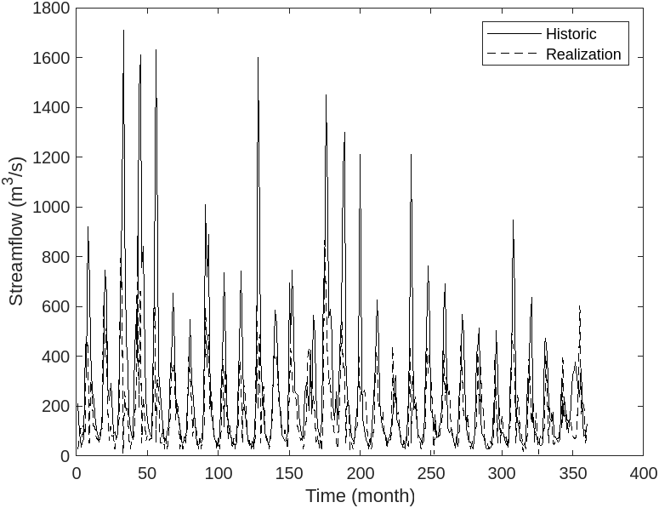  (a) | 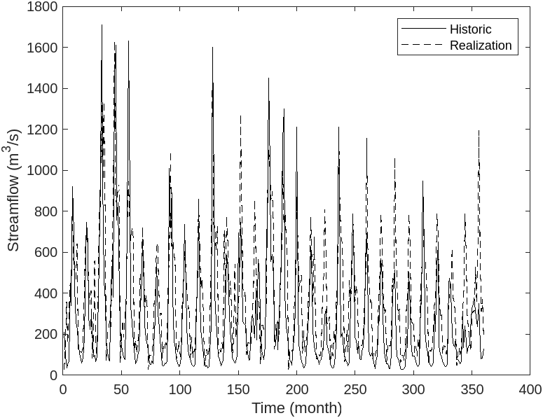  (b)

Fig. A2-17 Historical streamflow and a synthesized realization of the South Saskatchewan River (Nov 1912 –
Oct 1941) obtained using a) a positive sign in the root and b) a negative sign in the root.

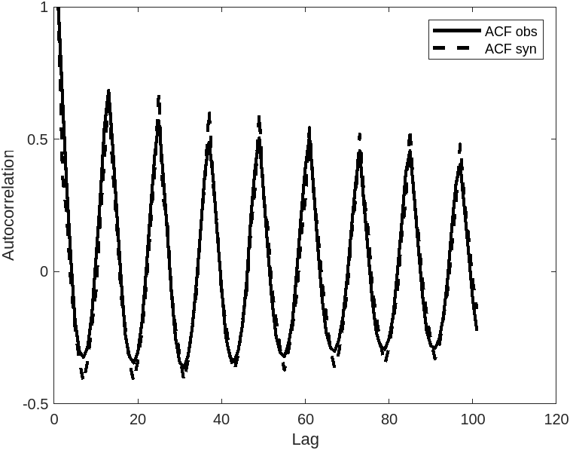(a) | 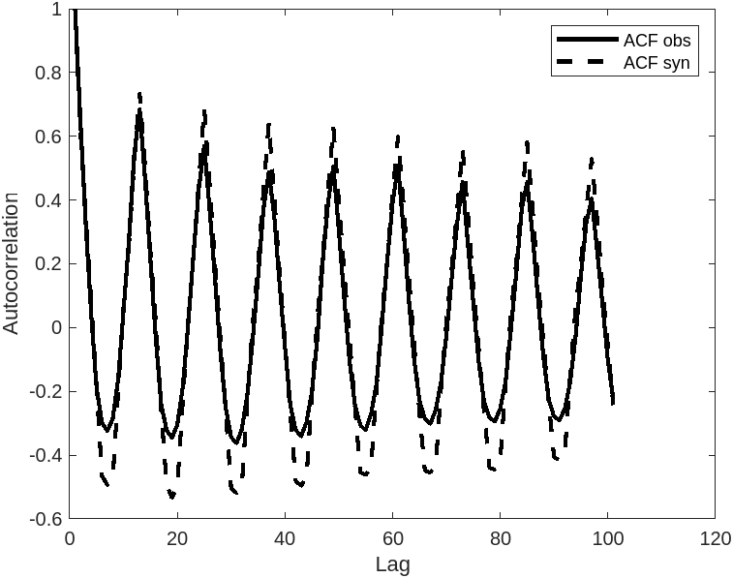(b)

Fig. A2-2 ACF of historical and synthesized streamflow of South Saskatchewan River obtained using
a) a positive sign in the root and b) a negative sign in the root.

