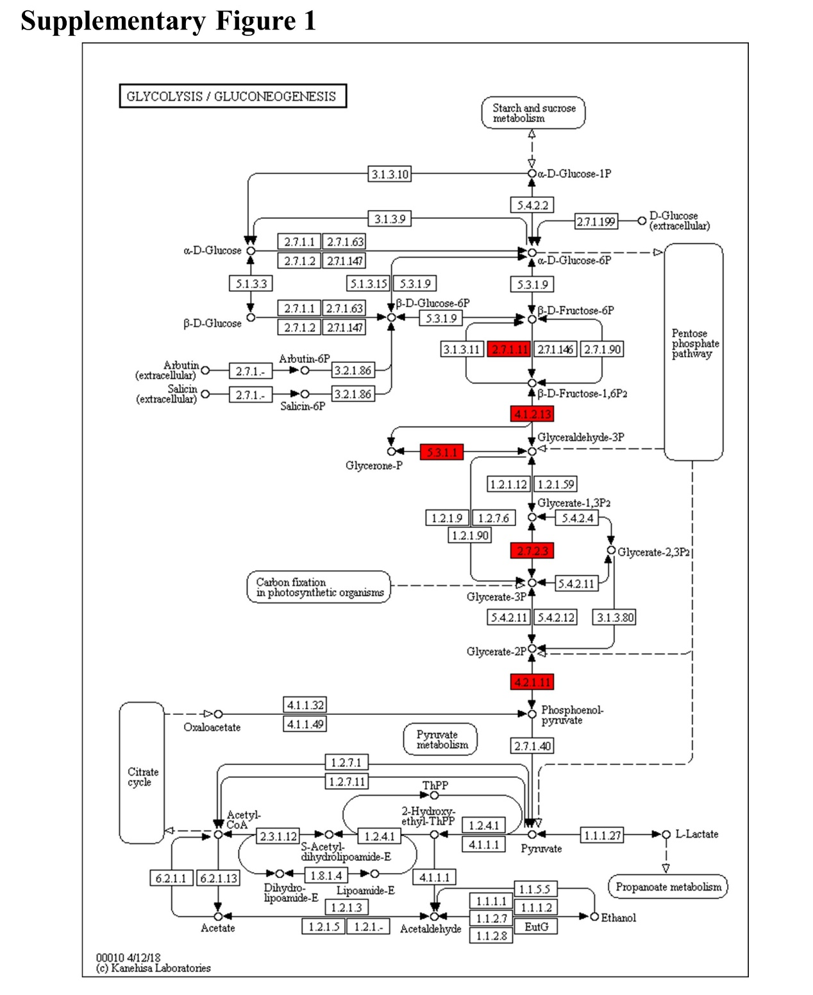
Supplementary Figure 1 The differential crotonylated proteins in glycolysis signaling pathway. Notes: 2.7.1.11, PFK, phosphofructokinase; 4.1.2.13, ALDOA, Fructose-bisphosphate aldolase A; 5.3.1.1, TPI1, Triosephosphate isomerase; 2.7.2.3, PGK, Phosphoglycerate kinase; 4.2.1.11, ENO1, Alpha-enolase.

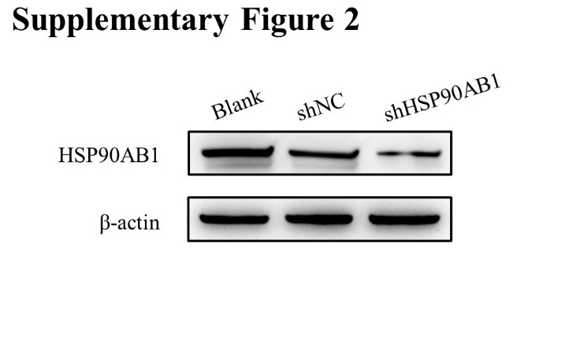
Supplementary Figure 2 Verification of HSP90AB1 knockdown efficiency in CAL27 cells.

